|  |
| --- |
|  |

Lesson 7: Secant and the Co-Functions

Student Outcomes

* Students define the secant function and the co-functions in terms of points on the unit circle. They relate these names for these functions to the geometric relationships among lines, angles, and right triangles in a unit circle diagram.
* Students use reciprocal relationships to relate the trigonometric functions and use these relationships to evaluate trigonometric functions for multiples of , , and degrees.

Lesson Notes

The geometry of the unit circle and related triangles provide a clue as to how the different reciprocal functions got their names. This lesson draws out the connections among tangent and secant lines of a circle, angle relationships, and the trigonometric functions. The names for the various trigonometric functions will make more sense to students when viewed through the lens of geometric figures, providing students with an opportunity to practice MP.7. Students make sense of the domain and range of these functions and use the definitions to evaluate the trigonometric functions for rotations that are multiples of , , and degrees.

The relevant vocabulary upon which this lesson is based appears below.

**Secant Function** (description). The *secant function*,

can be defined as follows: Let be any real number such that for all integers . In the Cartesian plane, rotate the initial ray by degrees about the origin. Intersect the resulting terminal ray with the unit circle to get a point . The value of is .

**Cosecant Function** (description). The *cosecant function*,

can be defined as follows: Let be any real number such that for all integers . In the Cartesian plane, rotate the initial ray by degrees about the origin. Intersect the resulting terminal ray with the unit circle to get a point . The value of is .

**Cotangent Function** (description). The *cotangent function*,

can be defined as follows: Let be any real number such that for all integers . In the Cartesian plane, rotate the initial ray by degrees about the origin. Intersect the resulting terminal ray with the unit circle to get a point . The value of is .

Classwork

Opening Exercise (5 minutes)

Give students a short time to work independently on this Opening Exercise (about 2 minutes). Lead a whole-class discussion afterwards to reinforce the reasons why the different segments have the given measures. If students have difficulty naming these segments in terms of trigonometric functions they have already studied, remind them of the conclusions of the previous few lessons.

Opening Exercise

Give the measure of each segment below in terms of a trigonometric function.

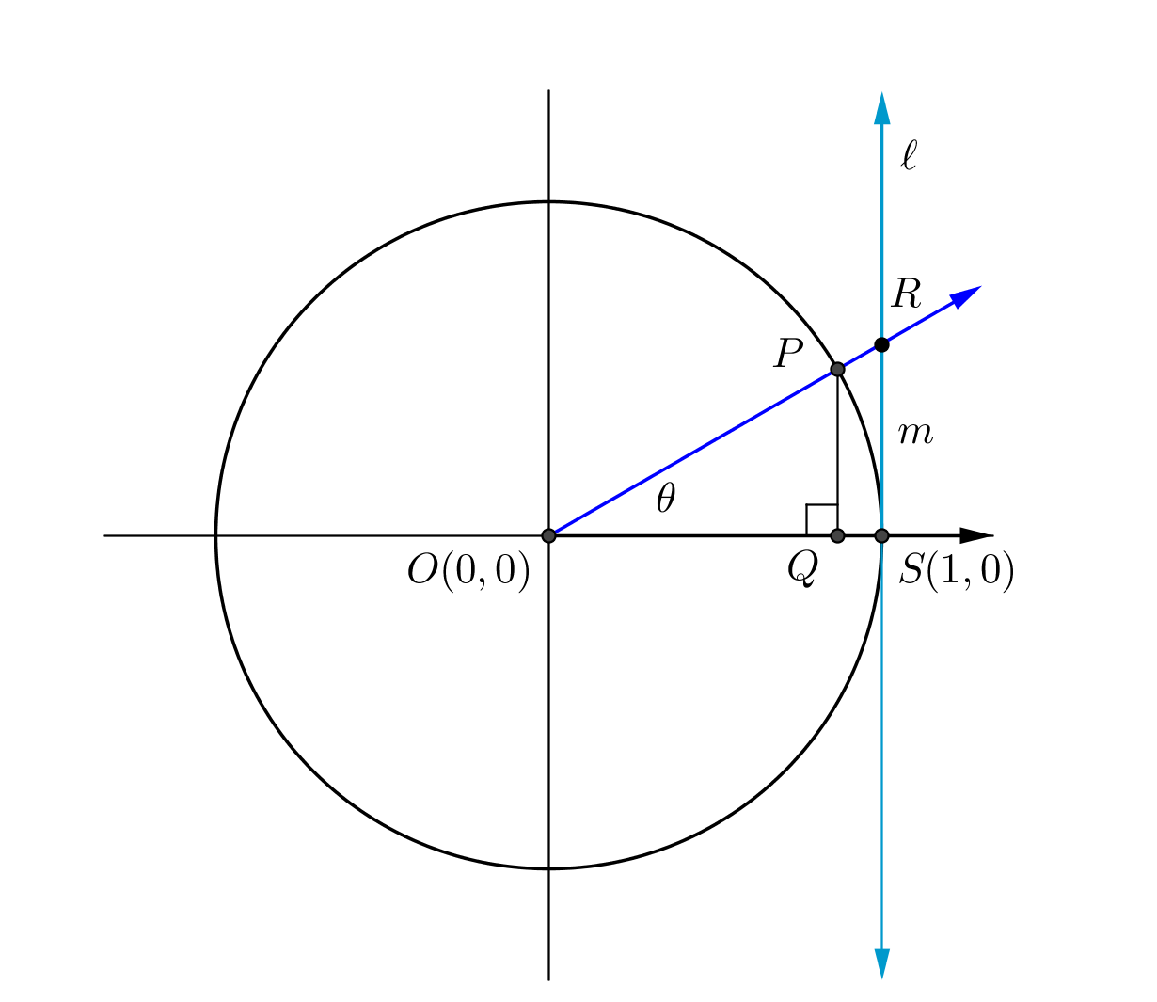 ___________ ____________ ____________

Debrief this exercise with a short discussion. For the purposes of this section, we will limit the values of to be between and . Make sure that each student has labeled the proper line segments on his or her paper as , , , and before moving on to Example 1.

* Why is ? Why is ?
  + *The values of the sine and cosine functions correspond to the - and -coordinates of a point on the unit circle where the terminal ray intersects the circle after a rotation of degrees about the origin.*
* Why is ?
  + *In Lesson 5, we used similar triangles to show that had length . This quotient is .*

Since we have ways to calculate lengths for nearly every line segment in this diagram using the length of the radius or the cosine, sine, or tangent functions, it makes sense to find the length of , the line segment on the terminal ray that intersects the tangent line.

*Scaffolding:*

* Have students use different colored highlighters or pencils to mark proportional segments.
* Consider writing out the proportional relationships using the segment names first. For example,

.

* Provide a numeric example for students to work first.

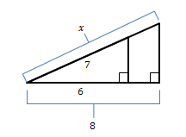

* For more advanced students, skip the Opening Exercise and start by stating that we will define a new function, , since segment is on the secant line that passes through the center of the circle.
* What do you call a line that intersects a circle at more than one point?
  + *It is called a secant line.*
* In Lesson 6, we saw that , where lies on the line tangent to the unit circle at , which helped to explain how this trigonometric function got its name. Let’s define a new function the secant of , denoted by to be the length of segment since this segment is on the secant line that contains the terminal ray. Then the *secant* of is .

**Example 1 (5 minutes)**

Direct students to label the appropriate segments on their papers if they have not already done so. Reproduce the Opening Exercise diagram on chart paper, and label the segments on the diagram in a different color than the rest of the diagram so they are easy to see. Refer back to this chart often in the next section of the lesson.

Example 1

Use similar triangles to find the value of in terms of one other trigonometric function.

***Approach 1:***

***By similar triangles, so ; thus,***

***Approach 2:***

***By similar triangles, , so ; thus, .***

**Exercise 1 (5 minutes)**

Following the same technique as in the previous lesson with the tangent function, we use this working definition of the secant function to extend it outside of the first quadrant. Present the definition of secant, and then ask students to answer the following questions with a partner or in writing. Circulate around the classroom to informally assess understanding and provide guidance. Lead a whole-class discussion around these questions after giving individuals or partners a few minutes to record their thoughts. Encourage students to revise what they wrote as the discussion progresses. Start a bulleted list of the main points of this discussion on the board. Encourage students to draw a picture representing both the circle description of the secant function and its relationship to to assist them in answering the question. A series of guided questions follows that will help you to scaffold this discussion.

Exercise 1

A description of the secant function is offered below. Answer the questions to better understand this definition and the domain and range of this function. Be prepared to discuss your responses with others in your class.

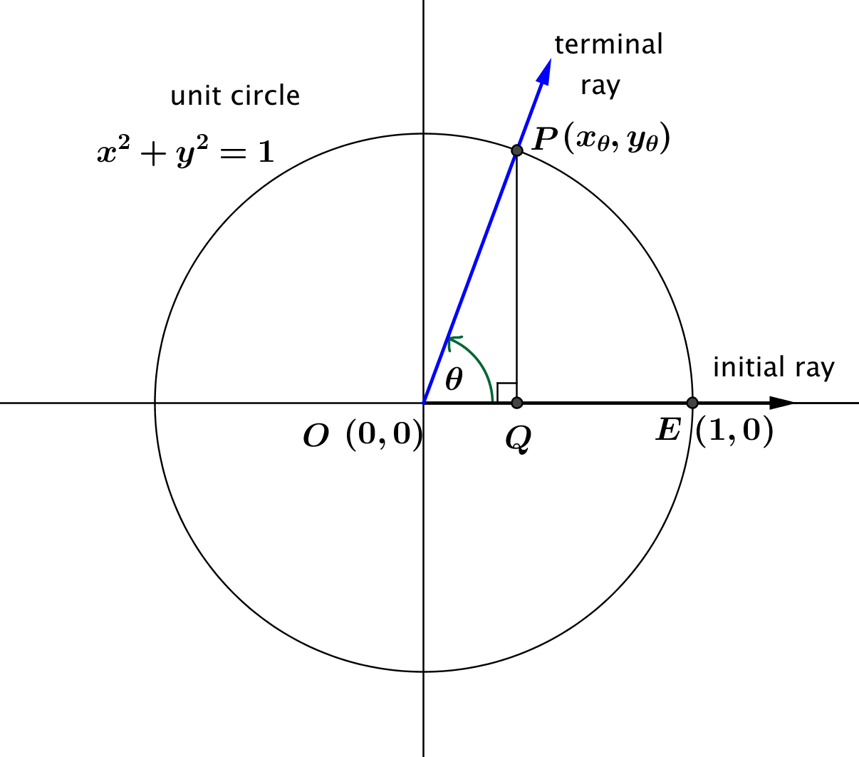

Let be any real number.

In the Cartesian plane, rotate the non-negative -axis by degrees about the origin. Intersect this new ray with the unit circle to get a point .

If , then the value of is . Otherwise, is undefined.

In terms of the cosine function, for .

* 1. What is the domain of the secant function?

The domain of the secant function is all real numbers such that , for all integers .

* 1. The domains of the secant and tangent functions are the same. Why?

***Both the tangent and secant functions are defined as rational expressions with in the denominator. That is, and . Since the restricted values in their domains occur when the denominator is zero, it makes sense that they have the same domain.***

**MP.3**

* 1. What is the range of the secant function? How is this range related to the range of the cosine function?

***Since , and , we see that either , or . Thus, the range of the secant function is .***

* 1. Is the secant function a periodic function? If so, what is its period?

**Yes, its period is .**

Discussion (5 minutes)

Use these questions to scaffold the discussion to debrief the preceding exercise.

* What are the values of when the terminal ray is horizontal? When the terminal ray is vertical?
  + *When the terminal ray is horizontal, it will coincide with the positive or negative -axis, and   
    , or .*
  + *When the terminal ray is vertical, the -coordinate of point is zero, so , which is undefined. If we use the geometric interpretation of as the length of the segment from the origin to the intersection of the terminal ray and the tangent line to the circle at , then is undefined because the secant line containing the terminal ray and the tangent line will be parallel and will not intersect.*
* Name several values of for which is undefined. Explain your reasoning.
  + *The secant of*  *is undefined when or when the terminal ray intersects the unit circle at the -axis. Some values of that meet these conditions include , , and .*
* What is the domain of the secant function?
  + Answers will vary but should be equivalent to all real numbers except , where is an integer. Students may also use set-builder notation such as .
* The domains of the tangent and secant functions are the same. Why?
  + *Approach 1 (circle approach):*
    - *The tangent and secant segments are defined based on their intersection, so at times when they are parallel, these segments do not exist.*
  + *Approach 2 (working definition approach):*
    - *Both the tangent and secant functions are defined as rational expressions with in the denominator. That is, and . Since the restricted values in their domains occur when the denominator is zero, it makes sense that they have the same domain.*
* How do the values of the secant and cosine functions vary with each other? As gets larger, what happens to the value of ? As gets smaller but stays positive, what happens to the value of ? What about when ?
  + *We know that*  *and are reciprocals of each other, so as the magnitude of one gets larger, the magnitude of the other gets smaller and vice versa. As increases, gets closer to . As decreases but stays positive, increases without bound. When is negative, as increases but stays negative, decreases without bound. As decreases, gets closer to .*

*Scaffolding:*

Students struggling to see the complementary relationships among the trigonometric functions may benefit from drawing the unit circle on a transparency or patty paper and reflecting across the diagonal line so that the -axis and -axis are interchanged.

* What is the smallest positive value of ? Where does this occur?
  + *The smallest positive value of is and occurs when , that is, when , for an integer.*
* What is the largest negative value of ? Where does this occur?
  + *The largest negative value of and occurs when ; that is, when , for an integer.*
* What is the range of the secant function?
  + *All real numbers outside of the interval , including and .*
* Is the secant function a periodic function? If so, what is its period?
  + *The secant function is periodic, and the period is.*

Exercise 2 (5 minutes)

These questions will get students thinking about the origin of the names of the co-functions. They start with the diagram from the Opening Exercise and ask students how the diagram below compares to it. Then, the point of Example 2 is to introduce the sine, secant, and tangent ratios of the complement to and justify why we name these functions cosine, cosecant, and cotangent.

Exercise 2

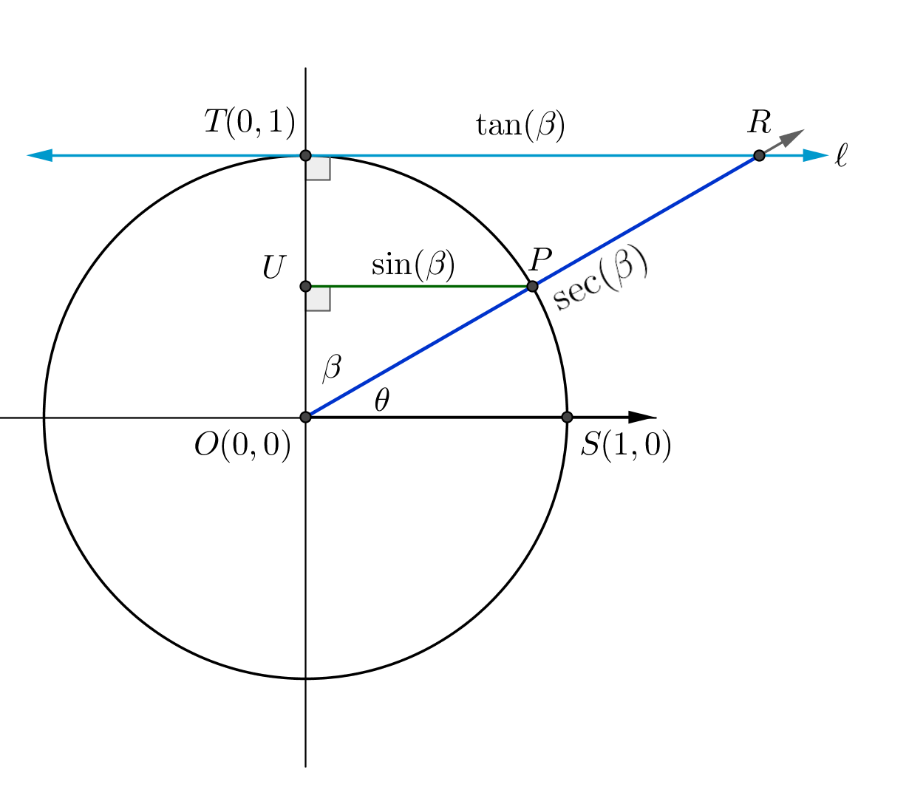In the diagram below, the blue line is tangent to the unit circle at .

* 1. How does this diagram compare to the one given in the Opening Exercise?

It is basically the same diagram with different angles and lengths marked. We can consider a rotation through degrees measured clockwise from the -axis instead of a rotation through degrees measured counterclockwise from the -axis. It is essentially a reflection of the diagram from the Opening Exercise across the diagonal line with equation .

*Scaffolding:*

* To help students to get their bearings, re-label the diagram writing out “secant of the complement of ” and “tangent of the complement of ,” instead of and .
* Students may need to be shown where is on the diagram as well.
  1. What is the relationship between and ?

They are complements: .

**MP.7**

* 1. Which segment in the figure has length ? Which segment has length ?

***and*** *.*

* 1. Which segment in the figure has length ? Which segment has length ?

***and***

* 1. How can you write and in terms of the trigonometric functions of ?

**, and .**

Briefly review the solutions to these exercises before moving on. Reinforce the result of part (e) that the cosine of an acute angle is same as the sine of its complement. Ask students to consider whether the trigonometric ratios of the complement of an angle might be related to the original angle in a similar fashion. Record student responses to the exercises and any other predictions or thoughts on another sheet of chart paper.

**Example 2 (5 minutes)**

You will use similar triangles to show that if , then and the . Depending on the level of your students, you can provide additional scaffolding or just have groups work independently on this example while you circulate about the classroom.

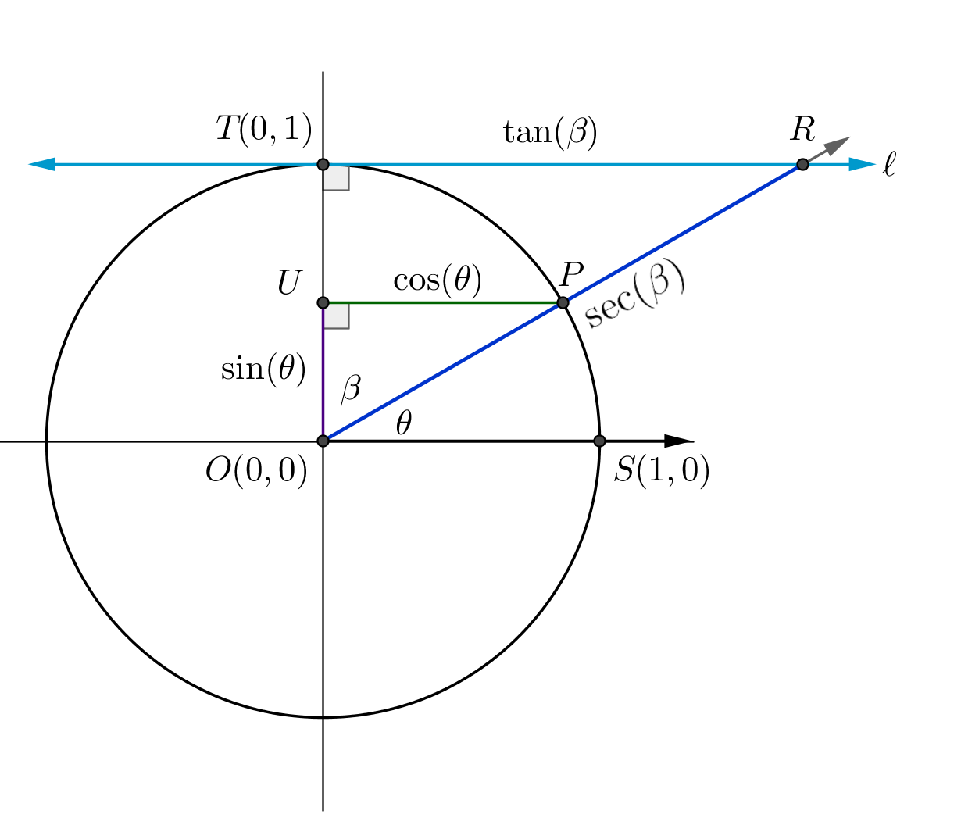  
Example 2

The blue line is tangent to the circle at .

* 1. **If two angles are complements with measures and as shown in the diagram above,** use similar triangles to show that .

***Consider triangles and . Then , so Since and we can write***

* 1. If **two angles are complements with measures and as shown in the diagram above**, use similar triangles to show that .

***Using triangles and we have . Then. Since , then ; so, .***

Discussion (7 minutes)

The reciprocal functions and are called the cosecant and cotangent functions. We have already defined the cosine function in terms of a point on the unit circle. We can do the same with the cosecant and cotangent functions. All three functions introduced in this lesson are defined below.

*Scaffolding:*

To help students keep track of the reciprocal definitions, mention that “every trigonometric function has a co-function.”

For each of the reciprocal functions, use the facts that , , and to extend the definitions of these functions beyond the first quadrant and to help with the following ideas. Have students work in pairs to answer the following questions before sharing their conclusions with the class.

Discussion

Descriptions of the cosecant and cotangent functions are offered below. Answer the questions to better understand the definitions and the domains and ranges of these functions. Be prepared to discuss your responses with others in your class.

**Let be any real number such that , for all integers .**

**In the Cartesian plane, rotate the initial ray by degrees about the origin. Intersect the resulting terminal ray with the unit circle to get a point .**

**The value of is .**

**The value of is .**

The secant, cosecant, and cotangent functions are often referred to as reciprocal functions. Why do you think these functions are so named?

*, ,* ***and*** *.*

Why is the domain of these functions restricted?

We restrict the domain to prevent division by zero.

We restrict the domain because the geometric shapes defining the functions no longer make sense (i.e., based on the intersection of distinct parallel lines).

The domains of the cosecant and cotangent functions are the same. Why?

***Both the cosecant and cotangent functions are equal to rational expressions that have in the denominator.***

What is the range of the cosecant function? How is this range related to the range of the sine function?

The sine function has range , so the cosecant function has range . The two ranges only intersect at and at .

What is the range of the cotangent function? How is this range related to the range of the tangent function?

The range of the cotangent function is all real numbers. This is the same as the range of the tangent function.

* Why are the secant, cosecant, and cotangent functions called reciprocal functions?
  + *Each one is a reciprocal of cosine, sine, or tangent according to their definitions. For example, is equal to , the reciprocal of .*
* Which two of the reciprocal functions share the same domain? Why? What is their domain?
  + The cosecant and cotangent functions *share the same domain. Both functions can be written as a rational expression with in the denominator, so whenever , they are undefined. The domain is all real numbers except such that . More specifically, the domain is .*
* What is the smallest positive value of the cosecant function?
  + *As with the secant function, the smallest positive value of the cosecant function is . This is because the cosecant function is the reciprocal of the sine function, which has a maximum value of . Also, the secant and cosecant functions have values based on the length of line segments from the center of the circle to the intersection with the tangent line. Thus, when positive, they must always be greater than or equal to the radius of the circle.*
* What is the greatest negative value of the cosecant function?
  + *The greatest negative value of the cosecant function* *is .*
* What is the range of the cosecant function? What other trigonometric function has this range?
  + *The range of the cosecant function is all real numbers except between and ; that is, the range of the cosecant function is , which is the same as the range of* *the secant function.*
* Can or be a number between and ? Can ? Explain why or why not.
  + *No,* *and*  *cannot be between and , but can. Both the secant and cosecant functions are reciprocals of functions that range from to , while the cotangent function is the reciprocal of a function that ranges across all real numbers. Whenever , .*
* What is the value of ?
  + *.*
* How does the range of the cotangent function compare to the range of the tangent function? Why?
  + *The ranges of the tangent and cotangent functions are the same. When is close to , is far from , either positive or negative depending on the sign of . When is far from , then is close to . Finally, when one function is undefined, the other is .*

Closing (4 minutes)

* The secant and cosecant functions are complements of each other and reciprocals of the complements cosine and sine. The tangent and cotangent functions are both complements of each other and reciprocals of each other. It is helpful to draw the circle diagram used to define the tangent and secant functions to ensure mistakes are not made with the relationships derived from similar triangles.
* This is a good time to summarize all the trigonometric functions so far. With a partner, in writing, or as a class, have students summarize the definitions for sine, cosine, tangent, and the three reciprocal functions along with their domains. Use this as an opportunity to check for any gaps in understanding. Use the following summary as a model:

|  |  |  |  |
| --- | --- | --- | --- |
| Let be any real number. In the Cartesian plane, rotate the initial ray by degrees about the origin. Intersect the resulting terminal ray with the unit circle to get a point . Then: | | | |
| Function | Value | For any such that… | Formula |
| Sine |  | is a real number |  |
| Cosine |  | is a real number |  |
| Tangent |  | , for all integers |  |
| Secant |  | , for all integers |  |
| Cosecant |  | , for all integers |  |
| Cotangent |  | , for all integers |  |

Exit Ticket (4 minutes)

Name Date

Lesson 7: Secant and the Co-Functions

Exit Ticket

Consider the following diagram, where segment is tangent to the circle at Right triangles , , , and are similar. Identify each length , , , and as one of the following: , , and .

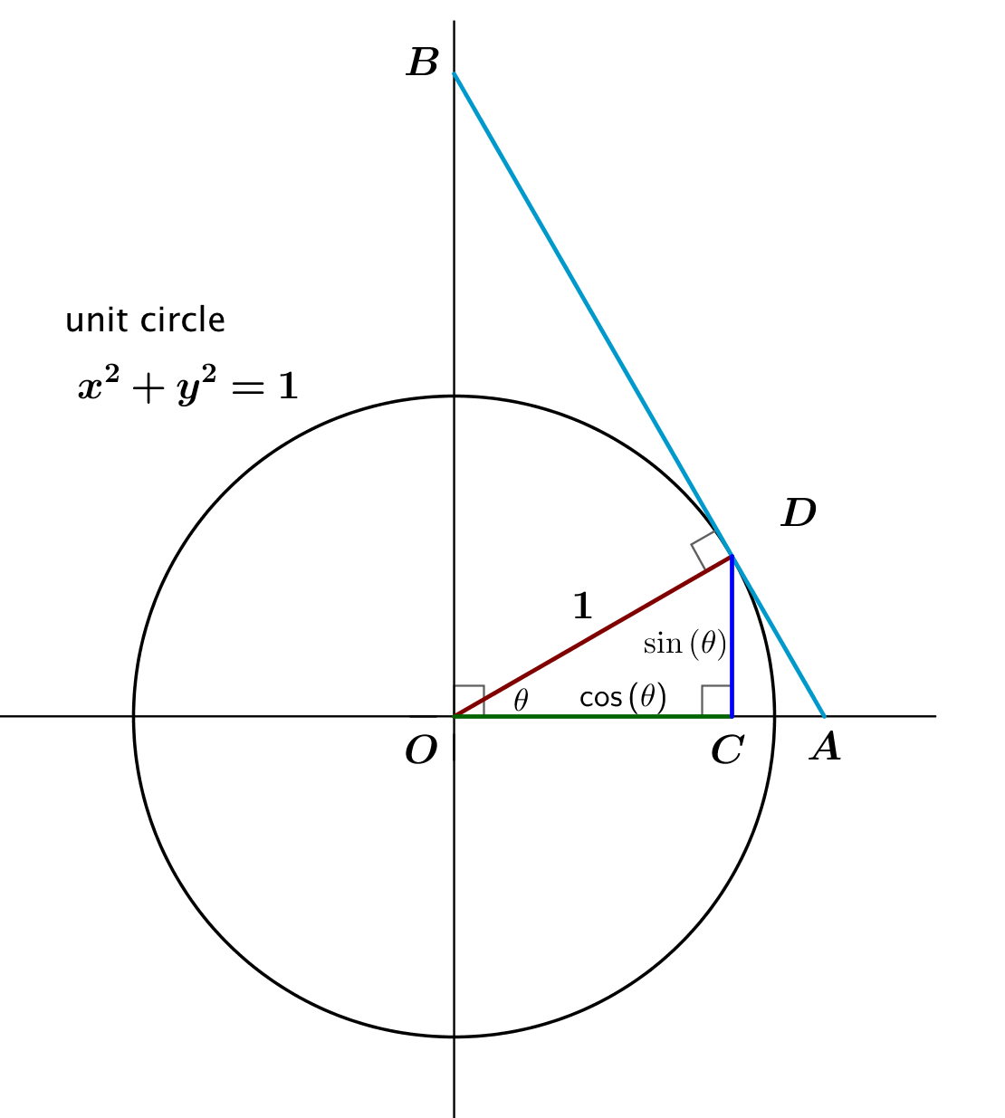

Exit Ticket Sample Solutions

Consider the following diagram, where segment is tangent to the circle at Right triangles , , , and are similar. Identify each length , , , and as one of the following: , , and .



***Since , so and thus***

***Since , so and thus***

***Since , so and thus***

***Since , so and thus***

Problem Set Sample Solutions

1. Use the reciprocal interpretations of , , and and the unit circle provided to complete the table.

|  |  |  |  |
| --- | --- | --- | --- |
|  |  |  |  |
|  |  | Undefined | Undefined |
|  |  |  |  |
|  |  |  |  |
|  |  |  |  |
|  | Undefined |  |  |
|  |  |  |  |
|  |  | Undefined | Undefined |
|  |  |  |  |
|  |  |  |  |
|  | Undefined |  |  |
|  |  |  |  |
|  |  |  |  |

1. Find the following values from the information given.

|  |  |
| --- | --- |
| ; |  |
| b. ; |  |
| c. ; |  |
| d. ; |  |
| e. ; | , ***but this is undefined.*** |
| f. ; |  |

1. Choose three values from the table in Problem for which and are defined and not zero. Show that for these values of ,.

***For , , and . Thus, for ,***

***For , , and. Thus, for ,***

***For , and Thus, for ,***

1. Find the value of for the following values of .

***We know that , so, and then .***

***We know that , so* s*, and then .***

***We know that so and then.***

* 1. Explain the reasons for the pattern you see in your responses to parts (a)–(c).

***If , then , so we know that***

1. 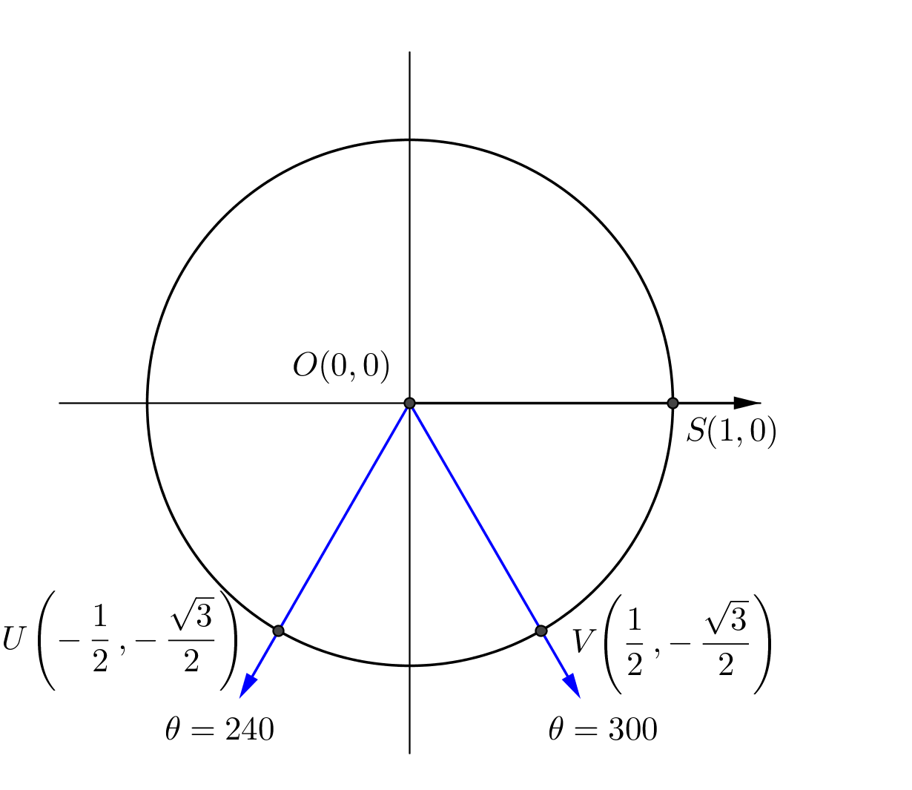Draw a diagram representing the two values of between and so that . Find the values of , , and for each value of .

*,* ***and*** *.*

*,*  ***and*** *.*

1. Find the value of when .
2. Find the value of when

Extension Problems:

1. Using the descriptions , and , show that , where these functions are defined and not zero.
2. Tara showed that , for values of for which the functions are defined and , and then concluded that and . Explain what is wrong with her reasoning.

***Just because , this does not mean that and . It only means that they are equivalent fractions. For instance, . Plugging in any value into a calculator verifies that Tara is incorrect. Also, since the only values of in the range of both secant and sine are and , we would have either or . Since the value of the sine function is either , the value of the cosine function would be zero. Since , we would have or . Since cannot be simultaneously zero and nonzero, it is impossible to have and***

1. From Lesson 6, Ren remembered that the tangent function is odd, meaning that for all in the domain of the tangent function. He concluded because of the relationship between the secant function, cosecant function, and tangent function developed in Problem 9, it is impossible for both the secant and the cosecant functions to be odd. Explain why he is correct.

***If we assume that both the secant and cosecant functions are odd, then the tangent function could not be odd. That is, we would get***

***but that would contradict . Thus, it is impossible for both the secant and cosecant functions to be odd.***