Lesson 7: Secant and the Co-Functions

Classwork

Opening Exercise

Give the measure of each segment below in terms of a trigonometric function.

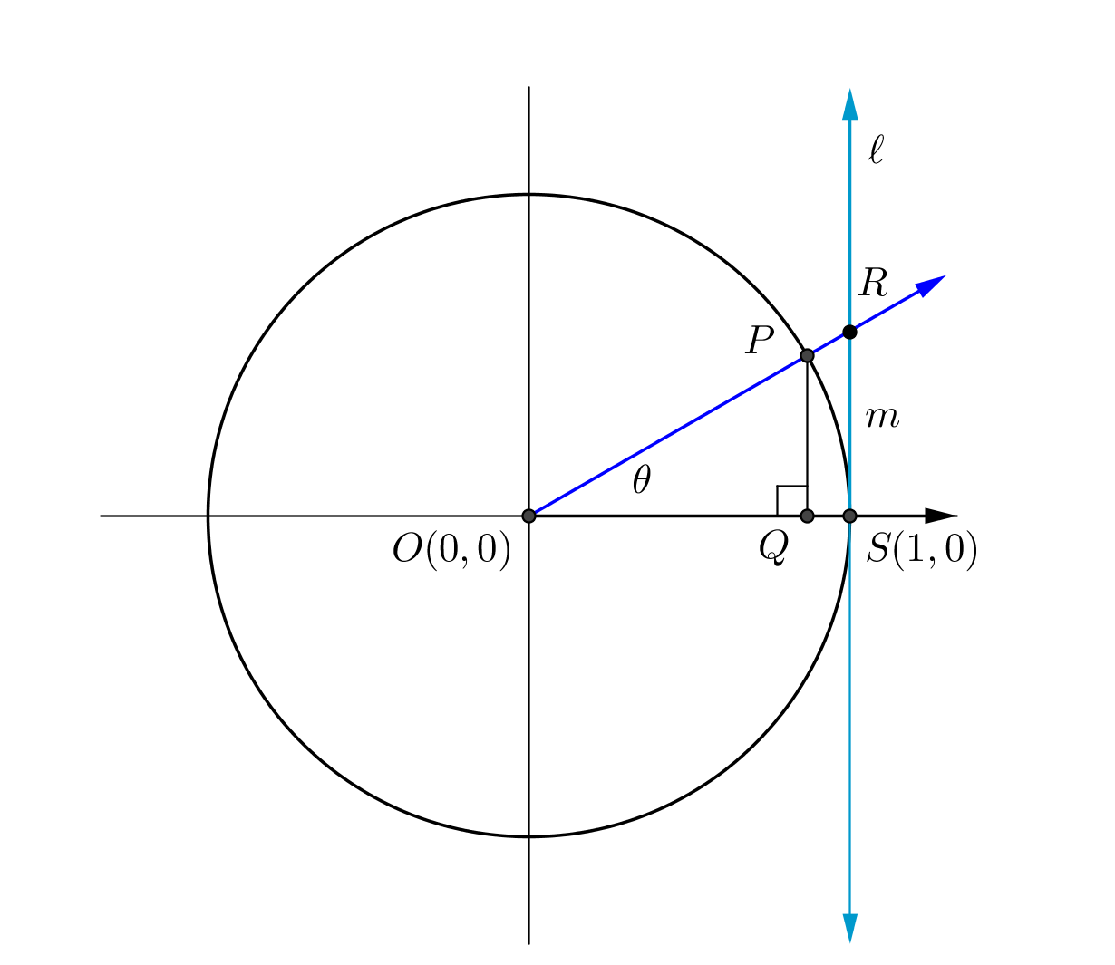 ___________ ____________ ____________

**Example 1**

Use similar triangles to find the value of in terms of one other trigonometric function.

Exercise 1

A definition of the secant function is offered below. Answer the questions to better understand this definition and the domain and range of this function. Be prepared to discuss your responses with others in your class.

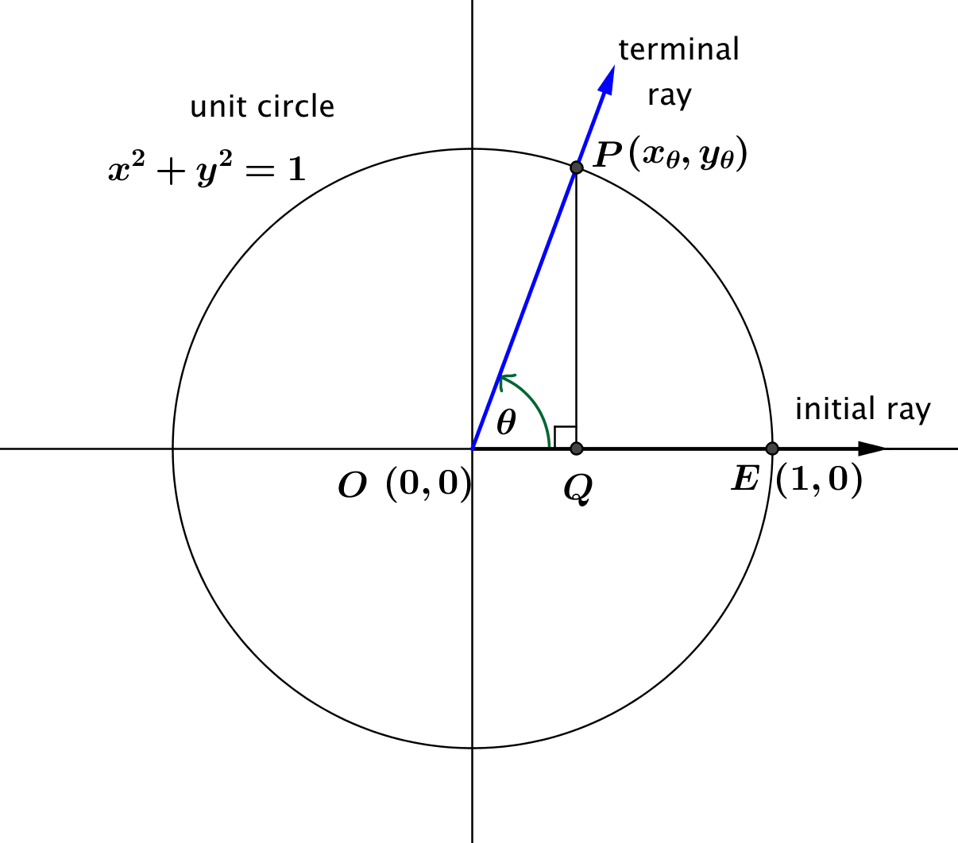

Let be any real number.

In the Cartesian plane, rotate the non-negative -axis by degrees about the origin. Intersect this new ray with the unit circle to get a point .

If , then the value of is . Otherwise, is undefined.

In terms of the cosine function, for .

* 1. What is the domain of the secant function?
  2. The domains of the secant and tangent functions are the same. Why?
  3. What is the range of the secant function? How is this range related to the range of the cosine function?
  4. Is the secant function a periodic function? If so, what is its period?

Exercise 2

In the diagram below, the blue line is tangent to the unit circle at .

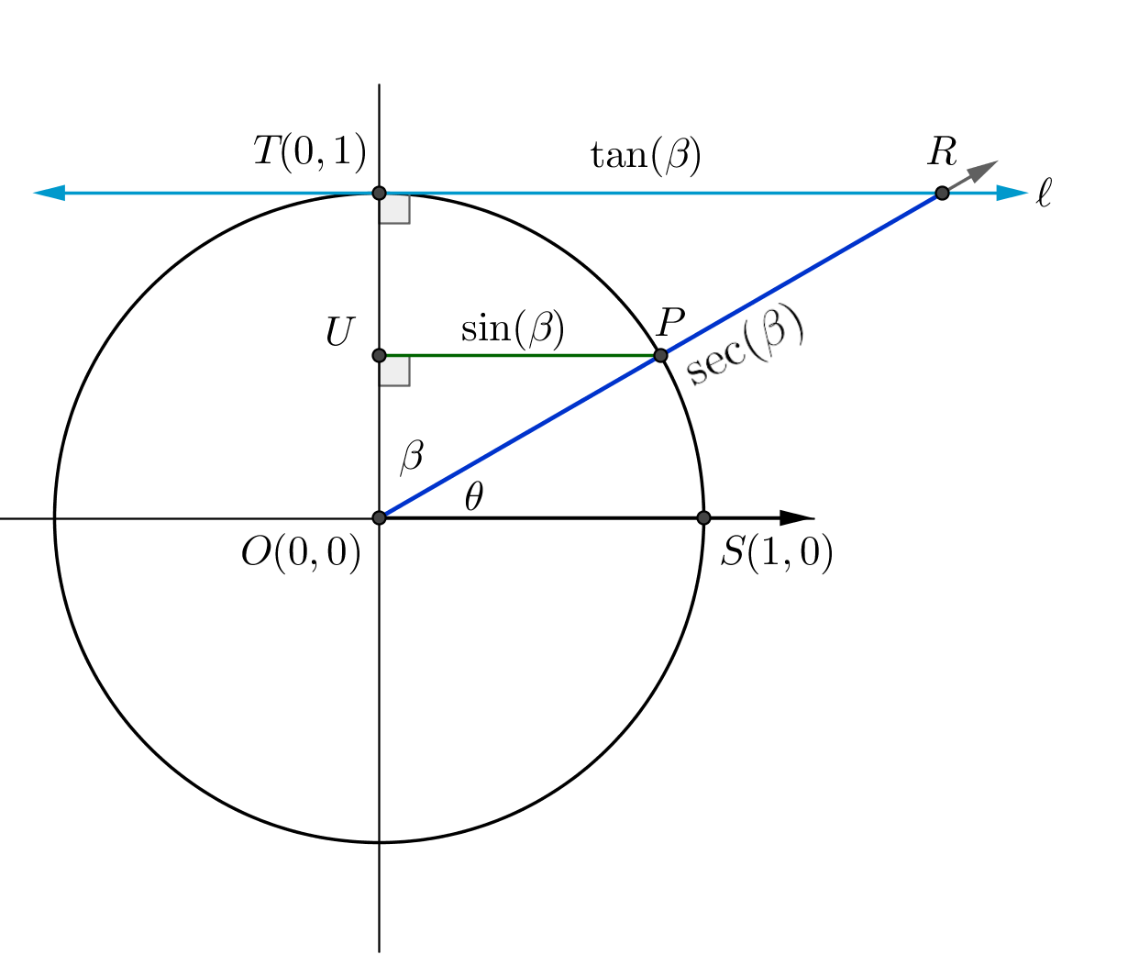

* 1. How does this diagram compare to the one given in the Opening Exercise?
  2. What is the relationship between and ?
  3. Which segment in the figure has length ? Which segment has length ?
  4. Which segment in the figure has length ? Which segment has length ?
  5. How can you write and in terms of the trigonometric functions of ?

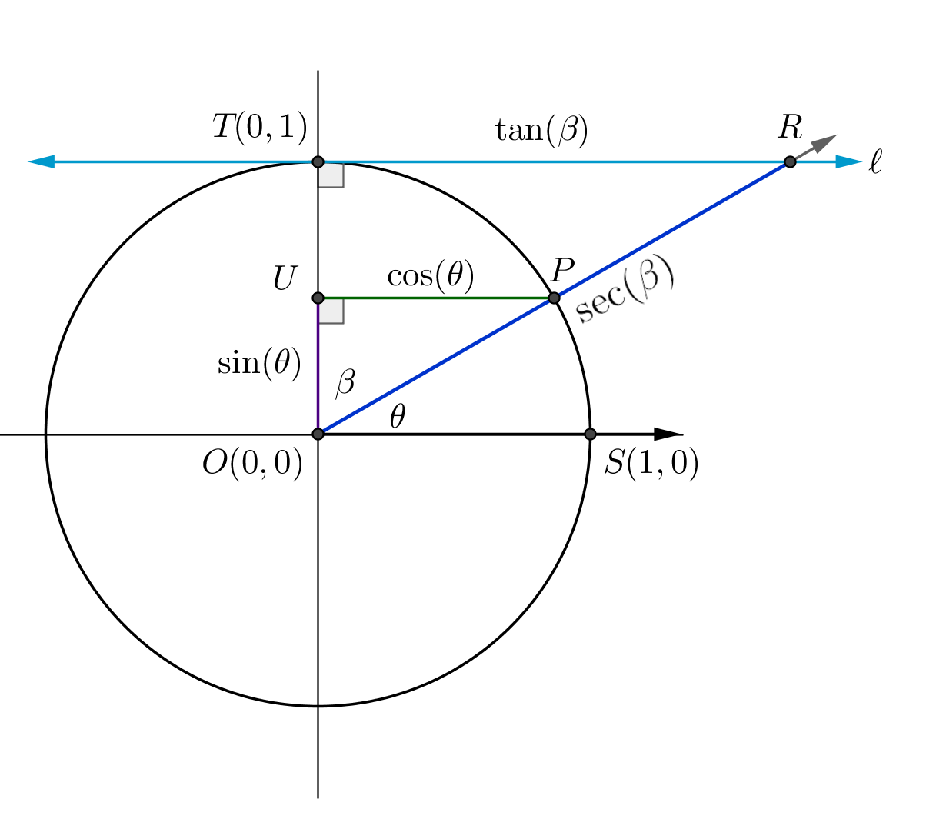**Example 2**

The blue line is tangent to the circle at.

* 1. If two angles are complements with measures and as shown in the diagram at right, use similar triangles to show that
  2. If two angles are complements with measures and as shown in the diagram above, use similar triangles to show that .

Discussion

Descriptions of the cosecant and cotangent functions are offered below. Answer the questions to better understand the definitions and the domains and ranges of these functions. Be prepared to discuss your responses with others in your class.

Let be any real number such that for all integers .

In the Cartesian plane, rotate the initial ray by degrees about the origin. Intersect the resulting terminal ray with the unit circle to get a point .

The value of is .

The value of is .

The secant, cosecant, and cotangent functions are often referred to as reciprocal functions. Why do you think these functions are so named?

Why is the domain of these functions restricted?

The domains of the cosecant and cotangent functions are the same. Why?

What is the range of the cosecant function? How is this range related to the range of the sine function?

What is the range of the cotangent function? How is this range related to the range of the tangent function?

|  |  |  |  |
| --- | --- | --- | --- |
| Let be any real number. In the Cartesian plane, rotate the initial ray by degrees about the origin. Intersect the resulting terminal ray with the unit circle to get a point . Then: | | | |
| Function | Value | For any such that… | Formula |
| Sine |  | is a real number |  |
| Cosine |  | is a real number |  |
| Tangent |  | , for all integers |  |
| Secant |  | , for all integers |  |
| Cosecant |  | , for all integers |  |
| Cotangent |  | , for all integers |  |

Problem Set

1. ****Use the reciprocal interpretations of , , and and the unit circle provided to complete the table.

|  |  |  |  |
| --- | --- | --- | --- |
|  |  |  |  |
|  |  |  |  |
|  |  |  |  |
|  |  |  |  |
|  |  |  |  |
|  |  |  |  |
|  |  |  |  |
|  |  |  |  |
|  |  |  |  |
|  |  |  |  |
|  |  |  |  |
|  |  |  |  |
|  |  |  |  |

1. Find the following values from the information given.

|  |  |
| --- | --- |
| a. ; |  |
| b. ; |  |
| c. ; |  |
| d. ; |  |
| e. ; |  |
| f. ; |  |

1. Choose three values from the table in Problem for which and are defined and not zero. Show that for these values of , .
2. Find the value of for the following values of .
   1. Explain the reasons for the pattern you see in your responses to parts (a)–(c).
3. Draw a diagram representing the two values of between and so that . Find the values of , , and for each value of .
4. Find the value of when .
5. Find the value of when

Extension Problems:

1. Using the descriptions , and , show that . where these functions are defined and not zero.
2. Tara showed that , for values of for which the functions are defined and , and then concluded that and . Explain what is wrong with her reasoning.
3. From Lesson 6, Ren remembered that the tangent function is odd, meaning that for all in the domain of the tangent function. He concluded because of the relationship between the secant function, cosecant function, and tangent function developed in Problem 9, it is impossible for both the secant and the cosecant functions to be odd. Explain why he is correct.