Lesson 6: Why Call It Tangent?

Student Outcomes
- Students define the tangent function and understand the historic reason for its name.
- Students use special triangles to determine geometrically the values of the tangent function for $30°$, $45°$, and $60°$.

Lesson Notes
In this lesson, we extend the right triangle definition of the tangent ratio of an acute angle $θ$, $\tan\left(θ\right)=\frac{\sin\left(θ\right)}{\cos\left(θ\right)},$ to the tangent function defined for all real numbers $θ$ where $\cos\left(θ\right)≠0.$ The word “tangent” already has geometric meaning, so we investigate the historical reasons for naming this particular function “tangent.” Additionally, we note the correlation of $\tan\left(θ\right)$ with the slope of the line that coincides with the terminal ray after rotation by $θ$ degrees. These three different interpretations of the tangent function can be used immediately to analyze properties and compute values of the tangent function. Students look for and make use of structure to develop the definitions in Exercises 7 and 8 and look for and express regularity in repeated reasoning using what they know about the sine and cosine functions applied to the tangent function in Exercise 3.
MP.7
&
MP.8
This lesson will depend somewhat on vocabulary from geometry such as secant lines and tangent lines. The terms provided below for reference will be used in this lesson and in subsequent lessons.
Tangent Function (description). The tangent function,
$$tan:\left\{x∈R \right| x≠90+180k for all integers k\}→R,$$
can be defined as follows: Let $θ$ be any real number such that $θ≠90+180k$, for all integers $k$. In the Cartesian plane, rotate the initial ray by $θ$ degrees about the origin. Intersect the resulting terminal ray with the unit circle to get a point $(x_{θ},y_{θ})$. The value of $tan(θ)$ is $\frac{y_{θ}}{x_{θ}}$.
The following trigonometric identity,
$\tan{(θ)}=\frac{\sin{(θ)}}{\cos{(θ)}}$ for all $θ≠90+180k$, for all integers $k$,
or simply, $\tan{θ=\sin{θ}}/\cos{θ}$, should be talked about almost immediately and used as the working definition of tangent.
Secant to a Circle. A secant line to a circle is a line that intersects a circle in exactly two points.
Tangent to a Circle. A tangent line to a circle is a line in the same plane that intersects the circle in one and only one point.
Classwork
Opening Exercise (4 minutes)
The Opening Exercise leads students to the description of $\tan\left(θ\right)$ as the quotient of $y_{θ}$ and $x_{θ}$ using right triangle trigonometry.
Opening Exercise
Scaffolding:
For students not ready for this level of abstraction, use $θ=30$ for this example instead of the generic value $θ.$
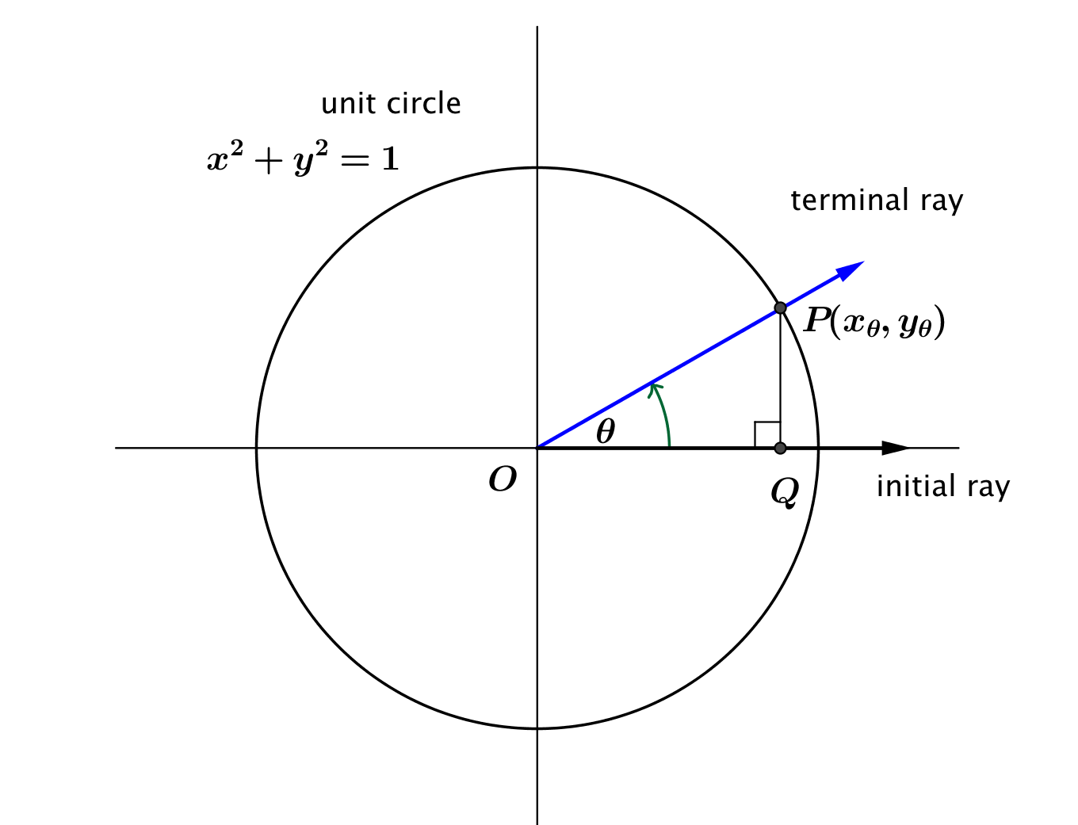
Let $P\left(x_{θ}, y_{θ}\right)$ be the point where the terminal ray intersects the unit circle after rotation by $θ$ degrees, as shown in the diagram below.
  - Using triangle trigonometry, what are the values of $x_{θ}$ and $y_{θ}$ in terms of $θ$?
$x_{θ}=\cos\left(θ\right)$, and $y_{θ}=\sin\left(θ\right)$

  - Using triangle trigonometry, what is the value of $\tan\left(θ\right)$ in terms of $x_{θ}$ and $y_{θ}$?
$\tan\left(θ\right)=\frac{y_{θ}}{x_{θ}}$

  - What is the value of $\tan\left(θ\right)$ in terms of $θ$?
$tan\left(θ\right)=\frac{sin\left(θ\right)}{cos\left(θ\right)}$

Discussion (6 minutes)
In the previous lessons, we extended the idea of the sine and cosine ratios of a triangle to the sine and cosine functions of a real number, $θ$, that represents the number of degrees of rotation of the initial ray in the coordinate plane. In the following discussion, we will similarly extend the idea of the tangent ratio of an acute angle of a triangle to the tangent function $\tan\left(θ\right)=\sin\left(θ\right)/\cos\left(θ\right)$ on a subset of the real numbers.
MP.3
In this discussion, students should notice that the tangent ratio of an angle in a triangle does not extend to the entire real line because we need to avoid division by zero. Encourage students to find a symbolic representation for the points excluded from the domain of the tangent function; that is, the tangent function is defined for all real numbers $θ$ except $θ = 90+180k$, for all integers $k$.
As you work through the discussion, refer frequently to the image of the unit circle with the initial ray along the positive $x$-axis and the terminal ray intersecting the unit circle at a point $P$ with coordinates $(x_{θ}, y_{θ}),$ as we did in the Opening Exercise. Encourage students to draw similar diagrams in their own notes as well.
Discussion
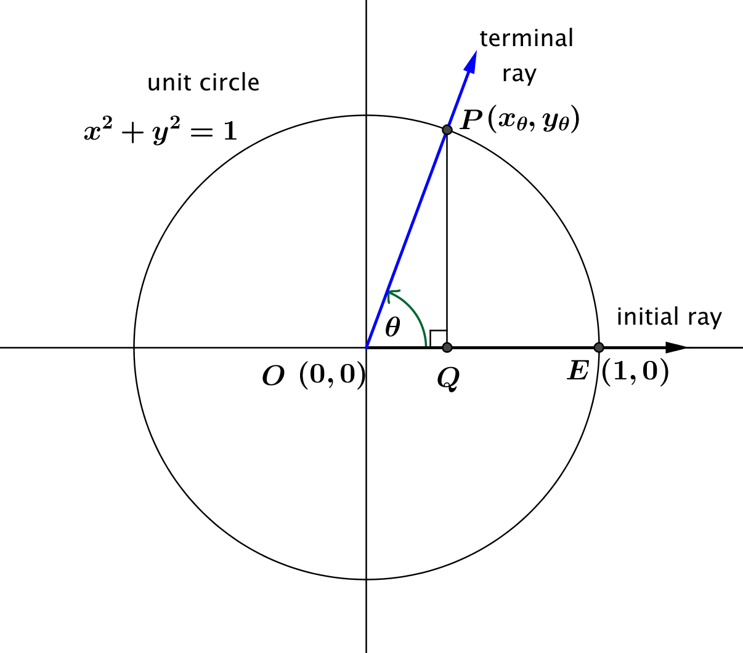
A description of the tangent function is provided below. Be prepared to answer questions based on your understanding of this function and to discuss your responses with others in your class.
Let $θ$ be any real number. In the Cartesian plane, rotate the non-negative $x$-axis by $θ$ degrees about the origin. Intersect the resulting terminal ray with the unit circle to get a point $(x_{θ},y_{θ})$. If $x_{θ}≠0$; then, the value of $tan⁡(θ)$ is $\frac{y_{θ}}{x_{θ}}$. In terms of the sine and cosine functions, $\tan\left(θ\right)=\frac{\sin\left(θ\right)}{cos⁡(θ)}$ for $\cos\left(θ\right)≠0$.

Scaffolding:
To recall some of the information students have developed in the last few lessons, drawing the unit circle on the board with a reference angle and sine and cosine labeled may be helpful. A picture is included.

- We have defined the tangent function to be the quotient $tan(θ)=\frac{sin(θ)}{cos⁡(θ)}$ for $cos(θ)≠0$. Why do we specify that $cos(θ)≠0$?
  - We cannot divide by zero, so the tangent function cannot be defined where the denominator is zero.
- Looking at the unit circle in the above figure, which segment has a measure equal to $\sin\left(θ\right),$ and which segment has a measure equal to $\cos{(θ)}$?
  - $PQ=\sin\left(θ\right)$, and $OQ=\cos\left(θ\right)$.
- Looking at the unit circle, identify several values of $θ$ that will cause $\tan\left(θ\right)$ to be undefined. (Scaffolding: When will the $x$-coordinate of point $P$ be zero?)
  - When $cos\left(θ\right)=0$, then $\tan\left(θ\right)$ will be undefined, which happens when the terminal ray is vertical so that point $P$ lies along the $y$-axis. The following numbers of degrees of rotation will locate the terminal ray along the $y$-axis: $90$, $270$, $-90$, $450$.
- Describe all numbers $θ$ for which $\cos\left(θ\right)=0$.
  - $90+180k$, for any integer $k$

- How can we describe the domain of the tangent function, other than “all real numbers $θ$with $\cos{(θ)}≠0$”?
  - The domain of the tangent function is all real numbers $θ$ such that $θ ≠ 90+180k$, for all integers $k$.

Exercise 1 (8 minutes)
Have students work in pairs or small groups to complete this table and answer the questions that follow. Then debrief the groups in a discussion.
Exercise 1
- For each value of $θ$ in the table below, use the given values of $\sin{(θ)}$ and $\cos{(θ)}$ to approximate $\tan\left(θ\right)$ to two decimal places.
$$θ$$  (degrees) | $$\sin\left(θ\right)$$ | $$\cos\left(θ\right)$$ | $$\tan\left(θ\right)$$
$$-89.9$$ | $$-0.999998$$ | $$0.00175$$ | $$-572.96$$
$$-89$$ | $$-0.9998$$ | $$0.0175$$ | $$-57.29$$
$$-85$$ | $$-0.996$$ | $$0.087$$ | $$-11.43$$
$$-80$$ | $$-0.98$$ | $$0.17$$ | $$-5.67$$
$$-60$$ | $$-0.87$$ | $$0.50$$ | $$-1.73$$
$$-40$$ | $$-0.64$$ | $$0.77$$ | $$-0.84$$
$$-20$$ | $$-0.34$$ | $$0.94$$ | $$-0.36$$
$$0$$ | $$0$$ | $$1.00$$ | $$0$$
$$20$$ | $$0.34$$ | $$0.94$$ | $$0.36$$
$$40$$ | $$0.64$$ | $$0.77$$ | $$0.84$$
$$60$$ | $$0.87$$ | $$0.50$$ | $$1.73$$
$$80$$ | $$0.98$$ | $$0.17$$ | $$5.67$$
$$85$$ | $$0.996$$ | $$0.087$$ | $$11.43$$
$$89$$ | $$0.9998$$ | $$0.0175$$ | $$57.29$$
$$89.9$$ | $$0.999998$$ | $$0.00175$$ | $$572.96$$

  - As $θ →-90$ and $θ>-90$, what value does$sin(θ)$ approach?
$-1$

  - As $θ →-90$ and $θ>-90$, what value does $cos(θ)$ approach?
$0$

  - As $θ →-90$ and $θ>-90$, how would you describe the value of $tan\left(θ\right)=sin(θ)/cos(θ)$?
$-∞$
  - As $θ → 90$ and $θ < 90$, what value does $sin\left(θ\right)$ approach?
$1$

  - As $θ → 90$ and $θ < 90$, what value does $cos(θ)$ approach?
$0$

  - As $θ → 90$ and $θ < 90$, how would you describe the behavior of $tan(θ)=sin(θ)/cos(θ)$?
$∞$

  - How can we describe the range of the tangent function?
The range of the tangent function is $(-∞,∞)$, which is the set of all real numbers.

Example 1 (2 minutes)
Now that we have established the domain and range of the tangent function, go through a concrete example of computing the value of the tangent function at a specific value of $θ$; here we use $θ=30$ degrees. With students you can use either $tan\left(θ\right)=\frac{y_{θ}}{x_{θ}}$ or $\tan\left(θ\right)=\frac{\sin\left(θ\right)}{cos⁡(θ)}$ as a working definition for the tangent function, whichever seems more appropriate for a given task.
Example 1
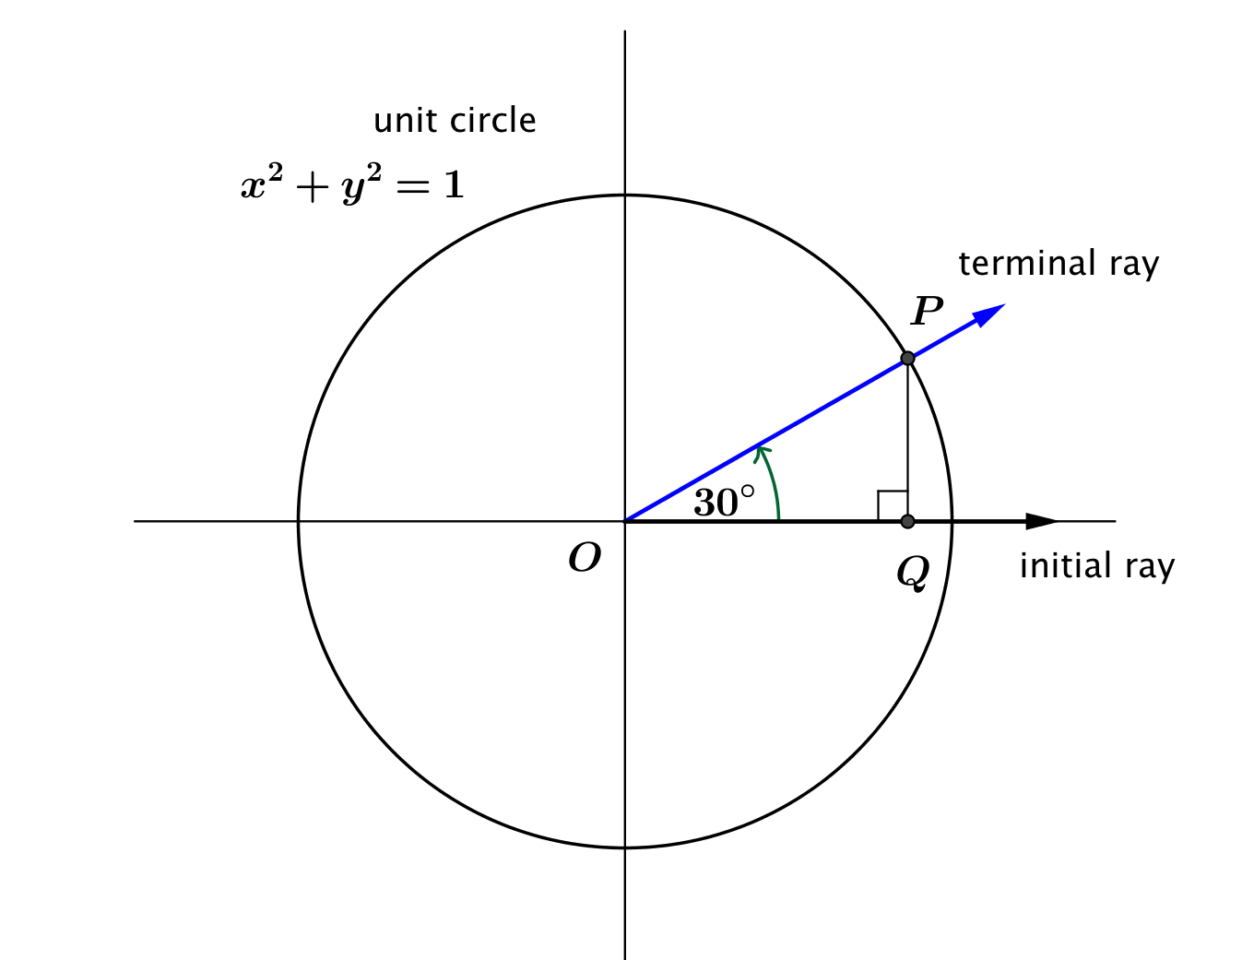
Suppose that point $P$ is the point on the unit circle obtained by rotating the initial ray through $30°$. Find $tan(30°)$.
Scaffolding:
For struggling students, provide a review of the side lengths of $30°$-$60°$-$90°$ and $45°$-$45°$-$90°$ triangles.

- What is the length $OQ$ of the horizontal leg of $ΔOPQ$?
  - By remembering the special triangles from geometry, we have $OQ=\frac{\sqrt{3}}{2}$.
- What is the length $QP$ of the vertical leg of $ΔOPQ$?
  - Either by the Pythagorean Theorem or by remembering the special triangles from geometry, we have $QP=\frac{1}{2}$.
- What are the coordinates of point $P$?
  - $\left(\frac{\sqrt{3}}{2},\frac{1}{2}\right)$
- What are $\cos\left(30°\right)$ and $\sin\left(30°\right)$?
  - $\cos\left(30°\right)=\frac{\sqrt{3}}{2}$, and $\sin\left(30°\right)=\frac{1}{2}$.
- What is $\tan\left(30°\right)$?
  - $tan\left(30°\right)=\frac{1}{\sqrt{3}}$. With no radicals in the denominator, this is $\tan\left(30°\right)=\frac{\sqrt{3}}{3}$ .

Exercise 2–6 (8 minutes): Why Do We Call It Tangent?
In this set of exercises, we begin to answer the question posed in the lesson’s title: Why Call It Tangent? Ask students if they can see any reason to name the function $f\left(θ\right)=\frac{\sin\left(θ\right)}{\cos\left(θ\right)}$ the tangent function. It is unlikely that they will have a reasonable answer.
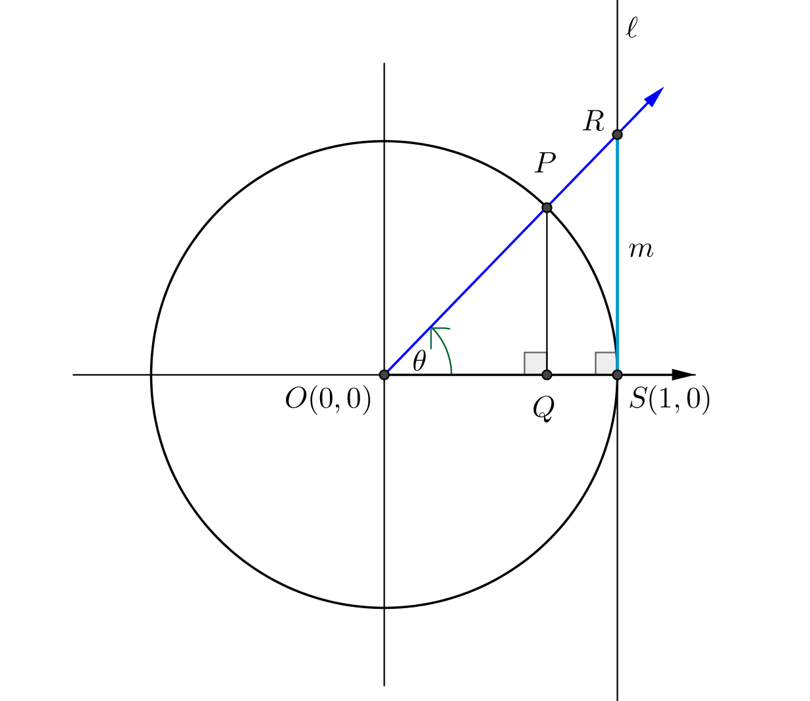
Exercises 2–6
- Let $P$ be the point on the unit circle with center $O$ that is the intersection of the terminal ray after rotation by $θ$ degrees as shown in the diagram at right. Let $Q$ be the foot of the perpendicular line from $P$ to the $x$-axis, and let the line $l$ be the line perpendicular to the $x$-axis at $S(1,0)$. Let $R$ be the point where the secant line $\overset{⃡}{OP}$ intersects the line $l$. Let $m$ be the length of the segment $\overline{RS}$.

  - Show that $m=tan\left(θ\right)$.
The side opposite $∠ROS$ has length $m,$ and we know the adjacent side has length $1,$ so we use tangent:
$$tan(θ)=\frac{m}{1}=m$$
Thus, $m=tan\left(θ\right)$.
Scaffolding:
- It may help students who struggle to see the diagram drawn both with and without the half-chord $\overline{PQ}$ drawn.
- For Exercise 2, part (b), students may need to be reminded that the side lengths of $ΔPOQ$ are $\sin\left(θ\right)$ and $\cos\left(θ\right)$.
MP.3
  - Using a segment in the figure, make a conjecture why mathematicians named the function $f\left(θ\right)=\frac{sin\left(θ\right)}{cos\left(θ\right)}$ the tangent function.
Mathematicians named the function “tangent” because the value of the function is the length of the segment $\overline{RS}$ that is tangent to the circle.

  - Why can you use either triangle $ΔPOQ$ or $ΔROS$ to calculate the length $m$?
These triangles are similar by AA similiarity (both are right triangles that share a common acute angle); hence, their sides are proportional.

  - Imagine that YOU are the mathematician who gets to name the function (how cool would that be?). Based upon what you know about the equations of lines, what might you have named the function instead?
I would have called it the “slope” function instead because the slope of the secant line $\overset{⃡}{OR}$ is also $m$.

- Draw four pictures similar to the diagram above to illustrate what happens to the value of $tan\left(θ\right)$ as the rotation of the terminal ray contained on a secant line through the origin increases towards $90°$. How does your diagram relate to the work done in Exercise 1?
MP.7
&
MP.8
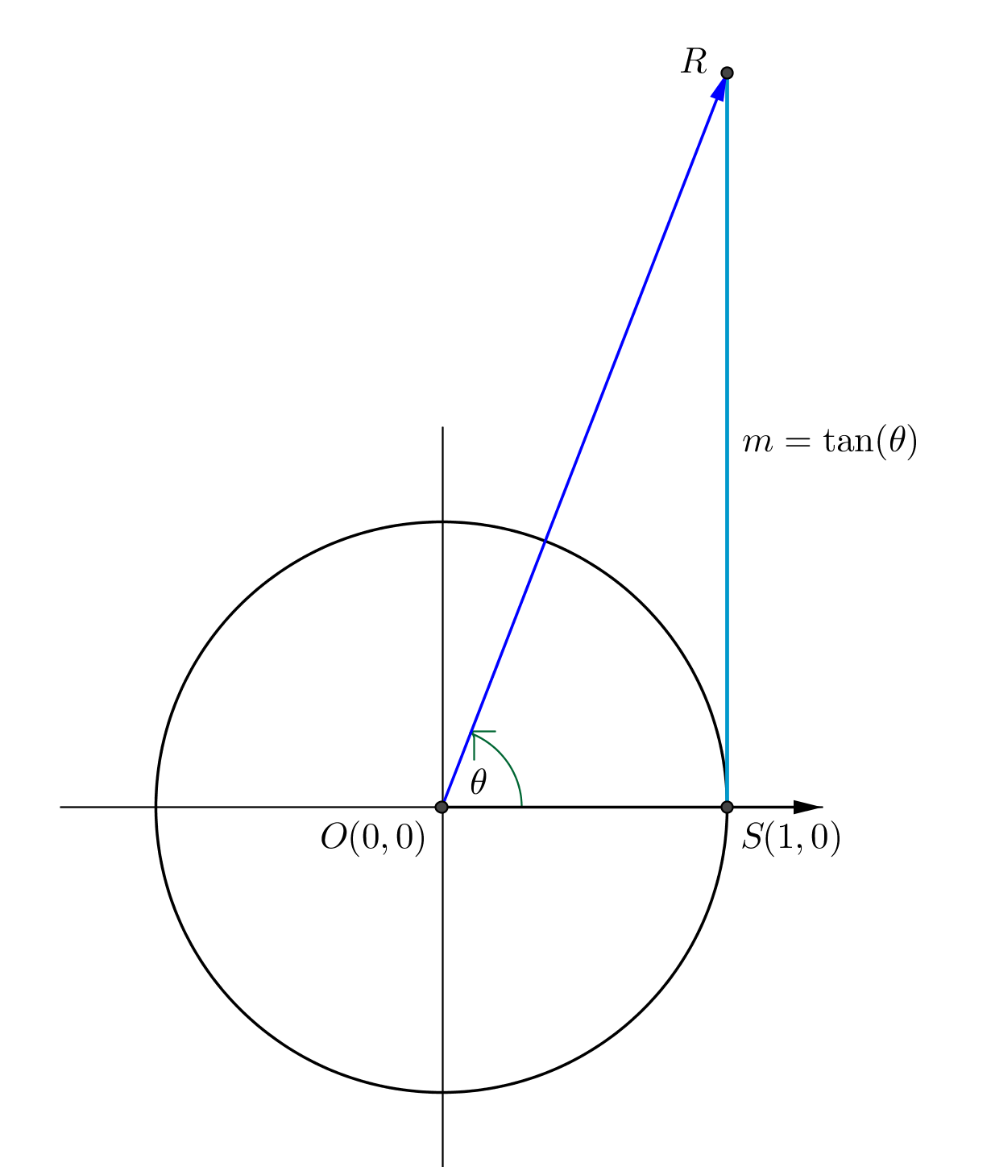
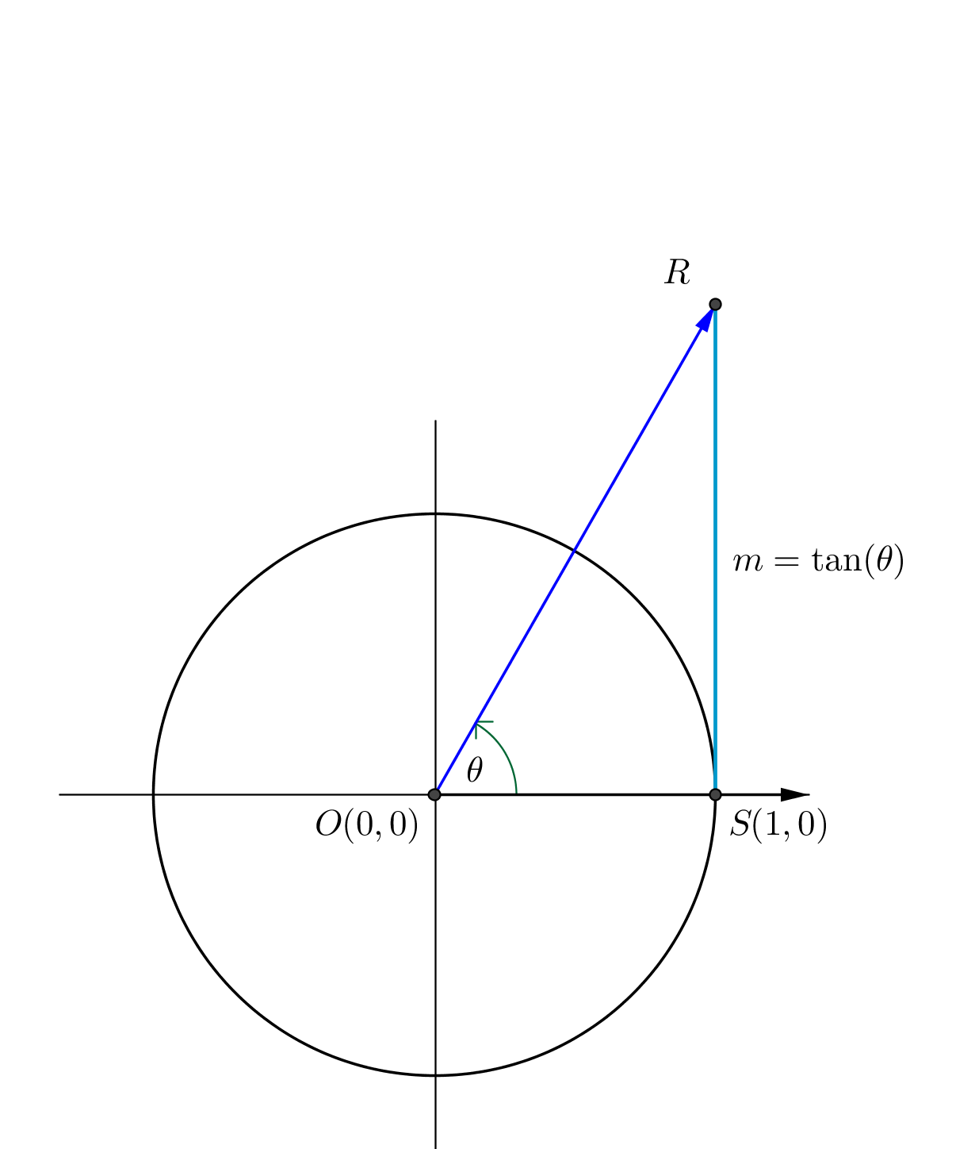
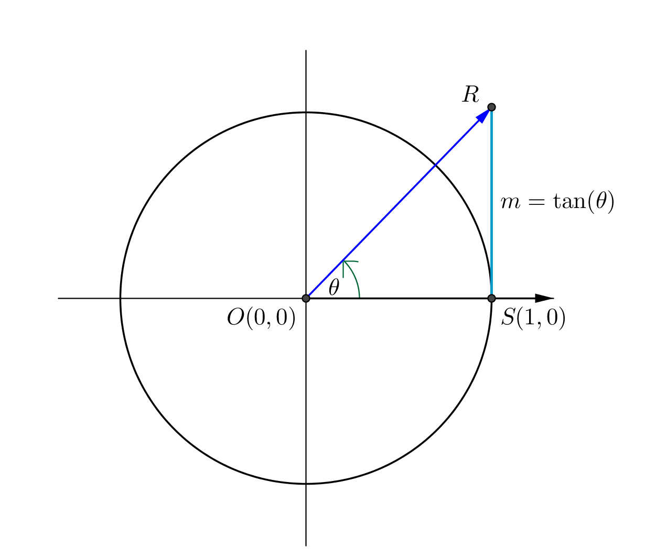
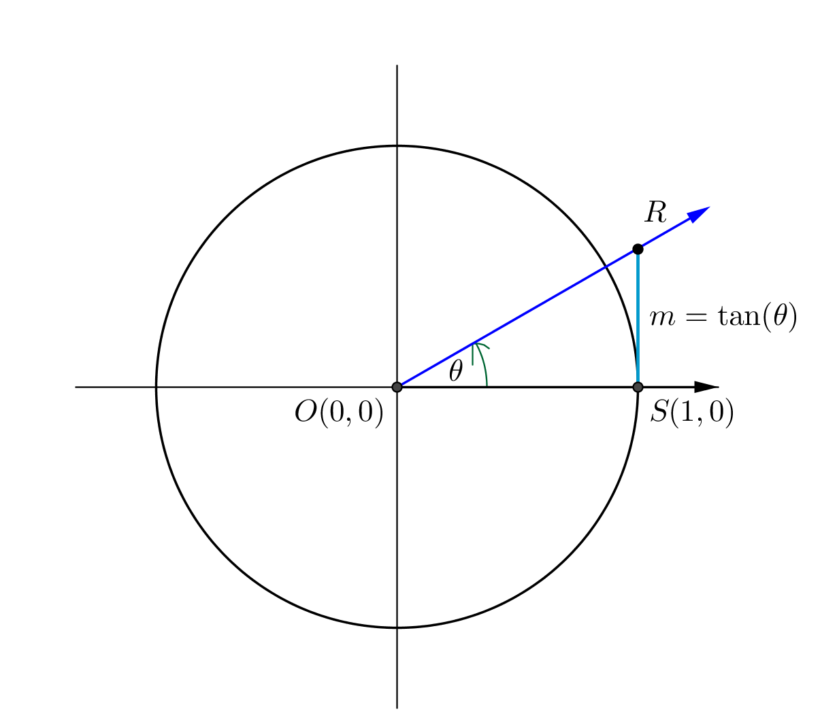
As the rotation increases to $90$ degrees, the value of $m$ increases to positive infinity. Since $m=\tan{(θ)}$, the value of $\tan\left(θ\right)$ also increases to positive infinity. This is what was observed numerically in Exercise 1.

- When the terminal ray is vertical, what is the relationship between the secant line and the tangent line? Explain why you cannot determine the measure of $m$ in this instance. What is the value of $tan\left(90°\right)$?
The secant line and tangent line are parallel when the terminal ray is vertical. The value of $m$ cannot be determined because parallel lines do not intersect. Therefore, no triangle is formed, and triangle trigonometry does not apply. The tangent function is undefined at $θ=90$.

- When the terminal ray is horizontal, what is the relationship between this secant line and the $x$-axis? Explain what happens to the value of $m$ in this instance. What is the value of $tan\left(0°\right)$?
The secant line coincides with the $x$-axis. The value of $m$ is zero since the points $R$ and $S$ are the same. Then, $m=0$, and thus$tan\left(0°\right)=0$.

- When the terminal ray is rotated counterclockwise about the origin by $45°$, what is relationship between the value of $m$ and length of $\overline{OS}$? What is the value of $tan(45°)$?
In this case, $m=OS$. Since $\overline{OS}$ is a radius of the unit circle, $m=1$. Thus, $tan\left(45°\right)=1$.
As you debrief this set of exercises, make sure to emphasize the following points:
- For rotations from $0$ to $90$ degrees, the length of the tangent segment formed by intersecting the terminal ray with the line tangent to the unit circle at $(1,0)$ is equal to $\tan\left(θ\right)$.
- The tangent function is undefined when $θ=90$. This fact can now be related to fact that the terminal ray and the line tangent to the unit circle at $(1,0)$ will be parallel after a $90$ degree rotation; thus, a tangent segment for this rotation does not exist.
- The value of the tangent function when $θ=0$ is $0$ because the point where the terminal ray intersects the tangent line is the point $\left(1,0\right)$, and the distance between a point and itself is $0.$

Exercises 7–8 (9 minutes)
Scaffolding:
Students who are struggling to remember the sine values may be encouraged to recall the sequence $\frac{\sqrt{0}}{2},\frac{\sqrt{1}}{2},\frac{\sqrt{2}}{2},\frac{\sqrt{3}}{2},\frac{\sqrt{4}}{2}$ as these are the values of sine at$0$, $30$, $45$, $60,$ and $90$ degrees.
In these exercises, students discover the relationship between $\tan\left(θ\right)$ and the slope of the secant line through the origin that makes an angle of $θ$ degrees with the $x$-axis for rotations that place the terminal ray in the first and third quadrants. The interpretation of the tangent of $θ$ as the slope of this secant line provides an explanation why the fundamental period of the tangent function is $180$, as opposed to the fundamental period of $360$ for the sine and cosine functions.
MP.7
Students should work in collaborative groups or with a partner on these exercises. Then as a whole group, debrief the results and provide time for students to revise what they wrote initially.
Exercises 7–8
- Rotate the initial ray about the origin the stated number of degrees. Draw a sketch and label the coordinates of point $P$ where the terminal ray intersects the unit circle. What is the slope of the line containing this ray?
- $30$ | - $45$ | - $60$
$$m=\frac{y_{1}-y_{2}}{x_{1}-x_{2}}=\frac{\frac{1}{2}-0}{\frac{\sqrt{3}}{2}-0}= \frac{\sqrt{3}}{3}$$ | $$m=\frac{\sqrt{2}}{2}÷\frac{\sqrt{2}}{2}=1$$ | $$m=\frac{1}{2}÷\frac{\sqrt{3}}{2}=\sqrt{3}$$
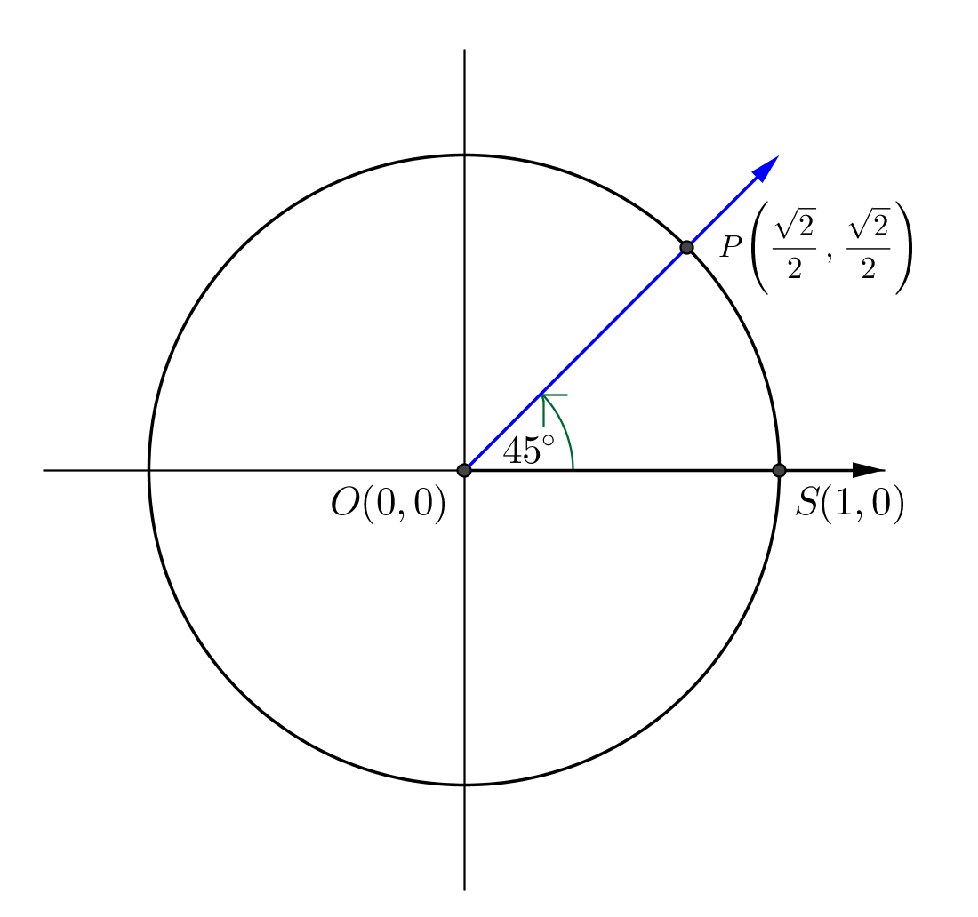
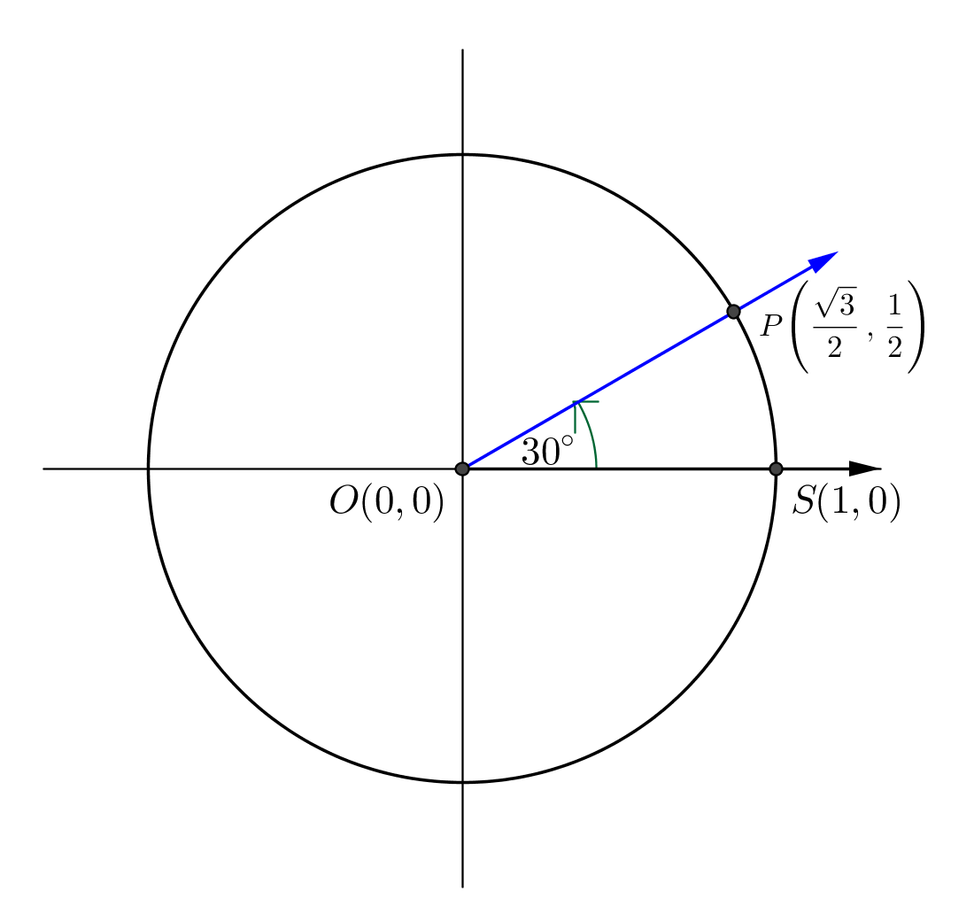
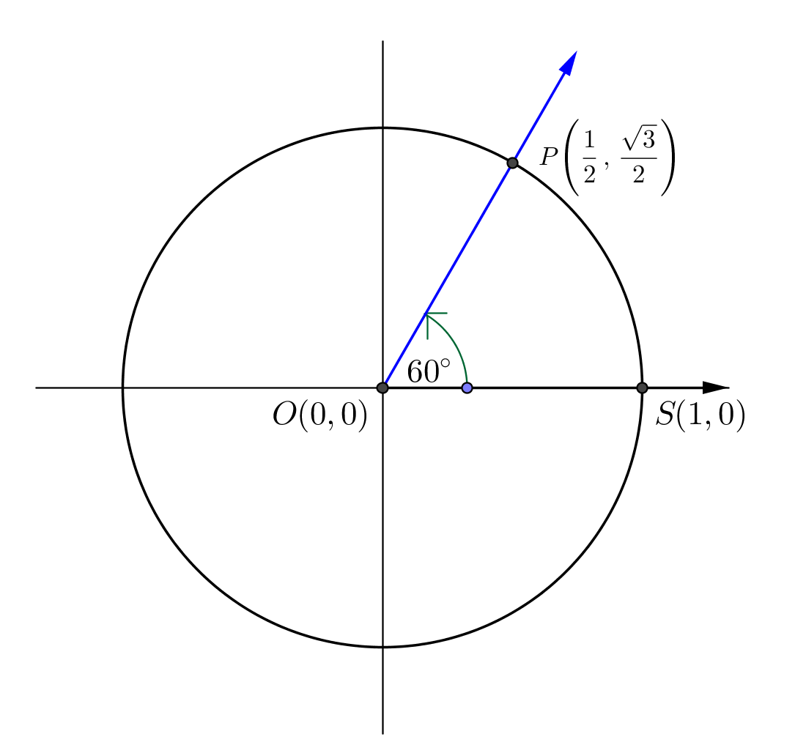

  - Use the definition of tangent to find $tan⁡(30°)$, $tan⁡(45°)$, and $tan⁡(60°)$. How do your answers compare your work in parts (a)–(c)?
The slopes and the values of the tangent functions at each rotation were the same. That is, $tan(30°) =\frac{\sqrt{3}}{3}$, $\tan\left(45°\right)=1,$ and$\tan\left(60°\right)=\sqrt{3}$.

  - If the initial ray is rotated $θ$ degrees about the origin, show that the slope of the line containing the terminal ray is equal to $\tan\left(θ\right)$. Explain your reasoning.
The terminal ray will always intersect the unit circle at $\left(x_{θ},y_{θ}\right)=\left(cos\left(θ\right), sin\left(θ\right)\right)$ and will always pass through the origin, $\left(0,0\right)$. Thus, the slope of the line containing the terminal ray will always be given by
$m=\frac{sin\left(θ\right)-0}{cos\left(θ\right)-0}=\frac{sin\left(θ\right)}{cos\left(θ\right)}=tan\left(θ\right)$.

  - Now that you have shown that the tangent function is equal to the slope of the terminal ray, would you prefer using the name “tangent function” or “slope function”? Why do you think we use “tangent” instead of “slope” as the name of the tangent function?
Answers may vary for the first question. Possible reasons include familiarity or comfort with one of the concepts. “Tangent” is probably used instead of “slope” due to the historical ideas of trigonometry and geometry.

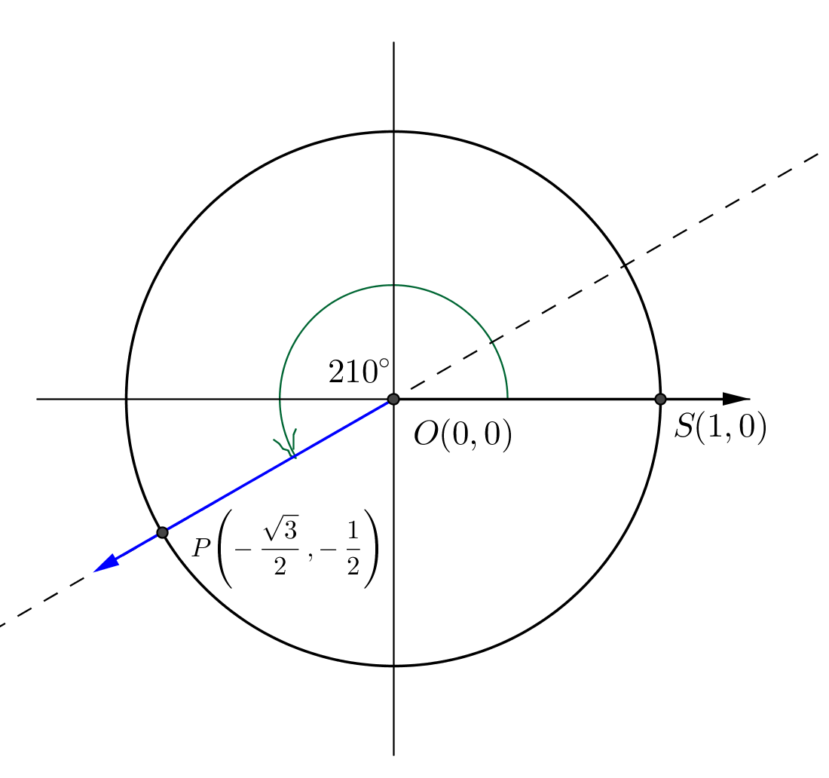
- Rotate the initial ray about the origin the stated number of degrees. Draw a sketch and label the coordinates of point $P$ where the terminal ray intersects the unit circle. How does your diagram in this exercise relate to the diagram in the corresponding part of Exercise 7? What is $tan(θ)$for these values of $θ$?
  - $210$
From the picture, we can see that the secant is the same line produced by a rotation by $30°$, so $tan\left(210°\right)=tan\left(30°\right)=\frac{\sqrt{3}}{3}$.

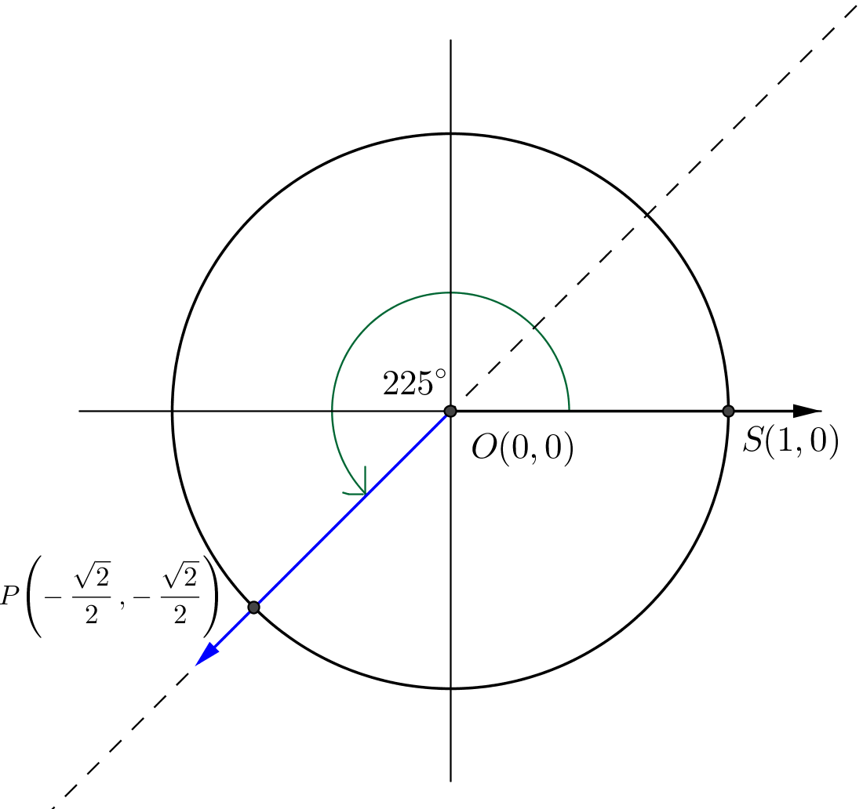

  - $225$
From the picture, we can see that the secant is the same line produced by a rotation by $45°$, so $tan\left(225°\right)=tan\left(45°\right)=1$.

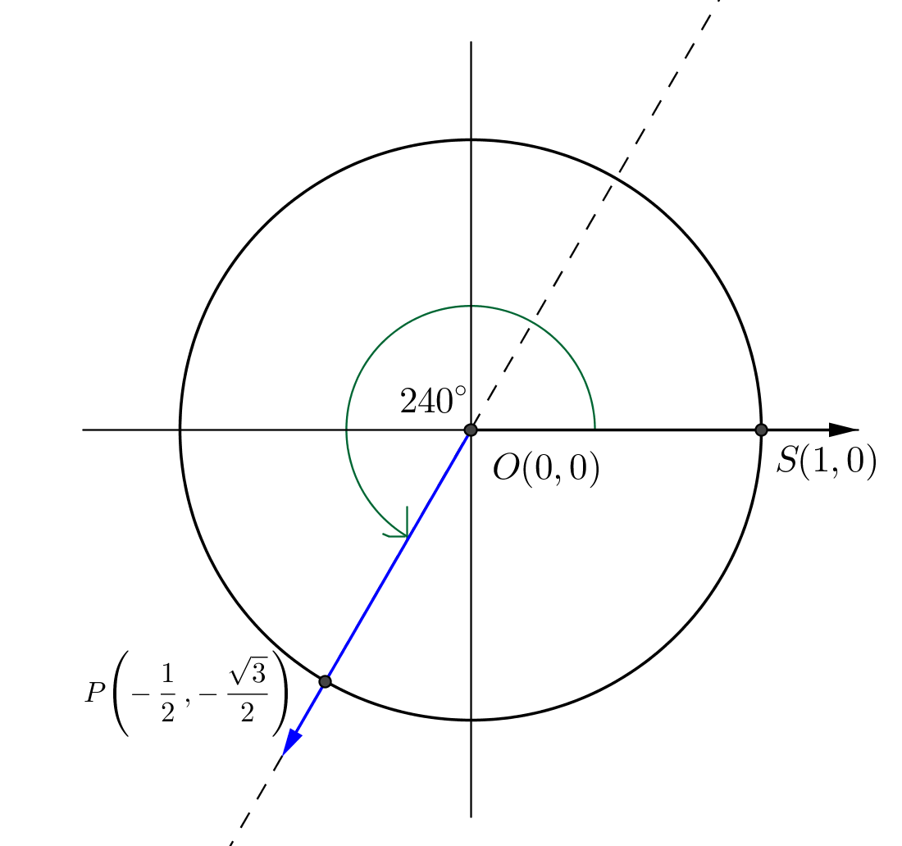
  - $240$
From the picture, we can see that the secant is the same line produced by a rotation by $60°$, so $tan\left(240°\right)=tan\left(60°\right)=\sqrt{3}$.

  - What do the results of parts (a)–(c) suggest about the value of the tangent function after rotating an additional $180$ degrees?
If the initial ray is rotated by $180+θ$ degrees, then the terminal ray is on the same line as the terminal ray when the initial ray is rotated by $θ$ degrees. Since the slope of the line containing the two terminal rays is the same, the value of the tangent function for both $θ$ and $180+θ$ will be the same.

  - What is the period of the tangent function? Discuss with a classmate and write your conclusions.
The period is $180$, since rotation by $180$ degrees will rotate a line to itself.

  - Use the results of Exercise 7(d) to explain why $tan\left(0°\right)=0$.
The slope of any horizontal line is zero.

  - Use the results of Exercise 7(d) to explain why $tan(90°)$ is undefined.
The slope of any vertical line is undefined.

Closing (3 minutes)
In this lesson, we saw three ways to interpret the tangent function:
- $\tan\left(θ\right)=\frac{\sin\left(θ\right)}{\cos\left(θ\right)}$.
- $\tan\left(θ\right)=m$, where $m$ is the length of the line segment contained in the line $l$ tangent to the unit circle at $(1,0)$ between the point $(1,0)$ and the point of intersection of the terminal ray and line $l$.
- $\tan\left(θ\right)=m$, where $m$ is the slope of the secant line that contains the terminal ray of a rotation by $θ$ degrees.

Have students summarize these interpretations of $\tan\left(θ\right)$ in this lesson along with the domain and range of this new function, as well as any other information they learned that they feel is important either as a class or with a partner. Use this as an opportunity to check for any gaps in understanding.
Lesson Summary
- $\tan\left(θ\right)=\frac{\sin\left(θ\right)}{\cos\left(θ\right)}$, where $\cos\left(θ\right)≠0$.
- The value of $\tan\left(θ\right)$ is the length of the line segment on the tangent line to the unit circle centered at the origin from the intersection with the unit circle and the intersection with the secant line created by the $x$-axis rotated $θ°$ (this is why we call it tangent).
- The value of $\tan\left(θ\right)$ is the slope of the line obtained by rotating the $x$-axis $θ$ degrees about the origin.
- The domain of the tangent function is $\left\{θ∈R | θ≠90+180k, for all integers k\right\}$ which is equivalent to $\left\{θ∈R | \cos\left(θ\right)≠0\right\}$.
- The range of the tangent function is all real numbers.
- The period of the tangent function is $180$.
$$tan(0°)$$ | $$tan(30°)$$ | $$tan\left(45°\right)$$ | $$tan\left(60°\right)$$ | $$tan\left(90°\right)$$
$$0$$ | $$\frac{\sqrt{3}}{3}$$ | $$1$$ | $$\sqrt{3}$$ | undefined

Exit Ticket (5 minutes)

Name Date
Lesson 6: Why Call It Tangent?

Exit Ticket

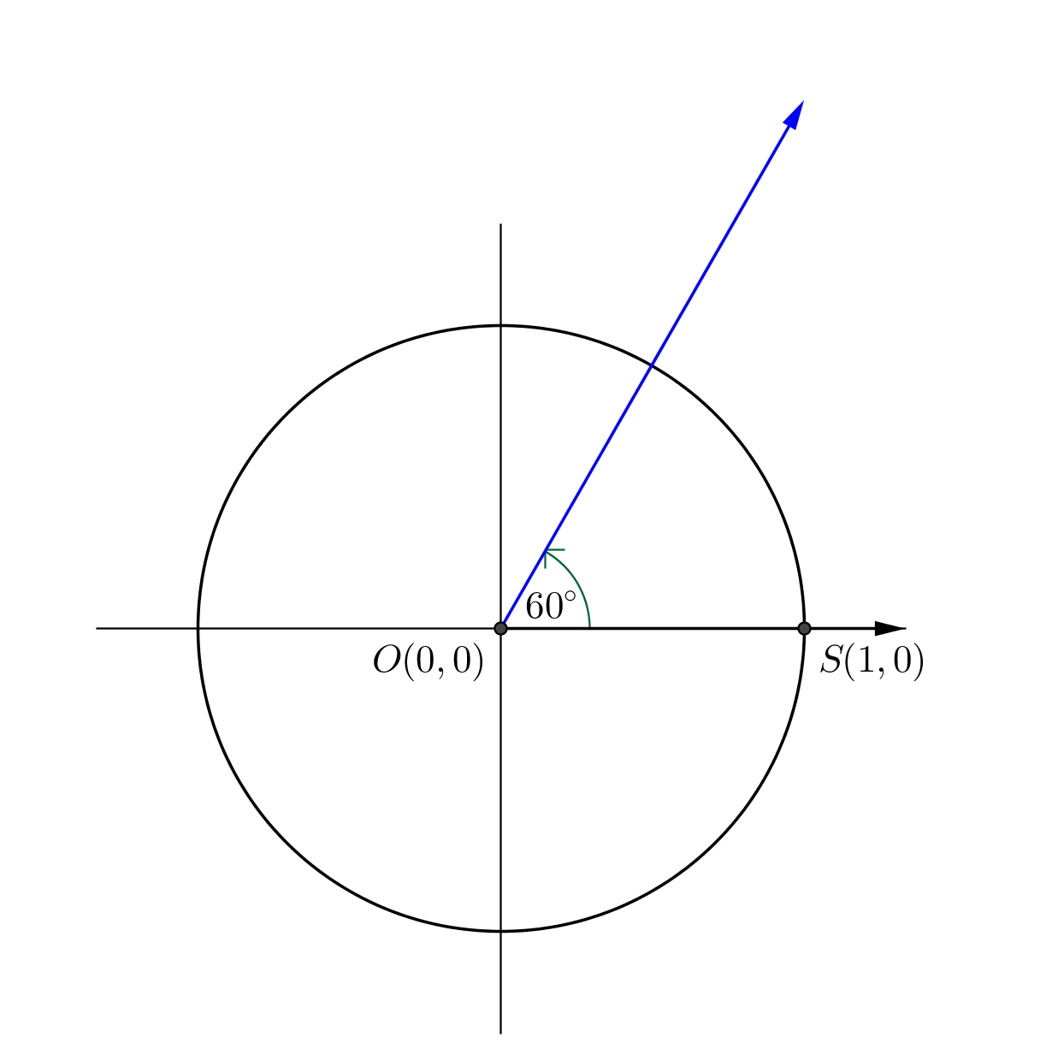
Draw and label a figure on the circle below that illustrates the relationship of the trigonometric tangent function $\tan\left(θ\right)=\frac{\sin{(θ)}}{\cos{(θ)}}$ and the geometric tangent line to a circle through the point $\left(1,0\right)$, when $θ= 60$. Explain the relationship, labeling the figure as needed.

Exit Ticket Sample Solutions

Draw and label a figure on the circle below that illustrates the relationship of the trigonometric tangent function $\tan\left(θ\right)=\frac{\sin{(θ)}}{\cos{(θ)}}$ and the geometric tangent line to a circle through the point $\left(1,0\right)$, when $θ= 60$. Explain the relationship, labeling the figure as needed.
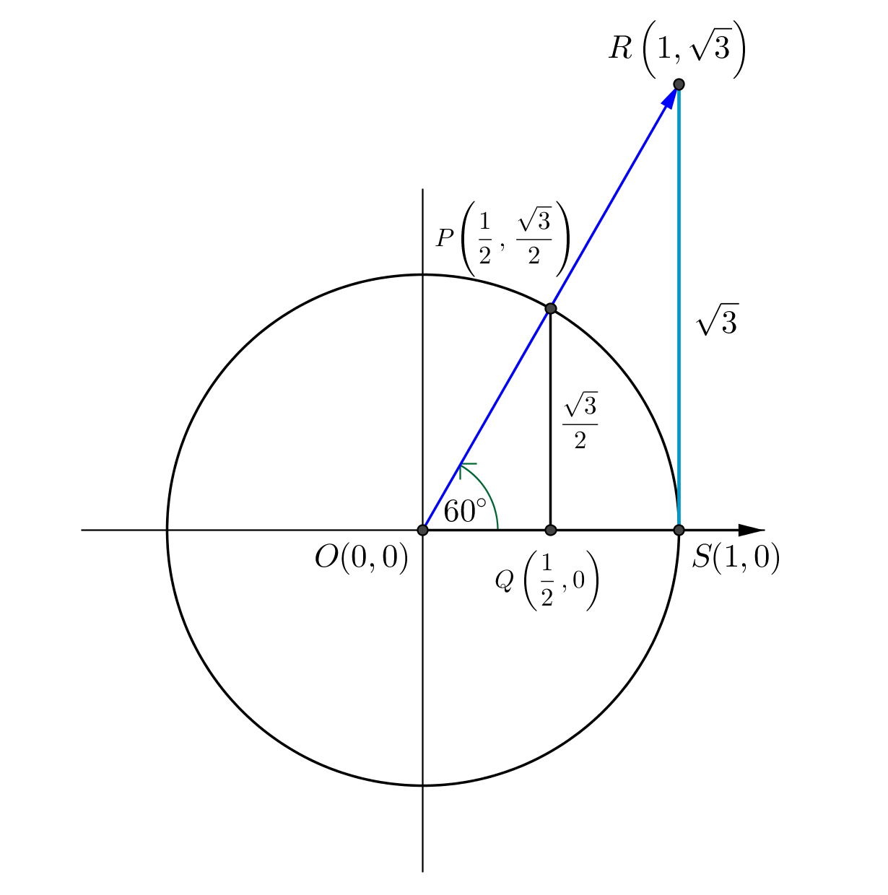
Labeling as shown, lengths are $OS=1$, $QP=sin\left(60°\right)=\frac{\sqrt{3}}{2},$ and $OQ=cos\left(60°\right)=\frac{1}{2}$. Then by similar triangles, we have $\frac{QP}{OQ}=\frac{SR}{OS}$; thus, $SR=tan\left(60°\right)=\frac{{\sqrt{3}}/2}{1/2}=\sqrt{3}$.

Problem Set Sample Solutions

- Label the missing side lengths, and find the value of $tan\left(θ\right)$ in the following right triangles.
  - $θ=30°$
$$30°$$
$$1$$

$$tan\left(30°\right)=\frac{sin\left(30°\right)}{cos\left(30°\right)}=\frac{\frac{1}{2}}{\frac{\sqrt{3}}{2}}=\frac{1}{\sqrt{3}}= \frac{\sqrt{3}}{3}$$

  - $θ=45°$
$$45°$$
$$1$$

$$tan\left(45°\right)=\frac{sin\left(45°\right)}{cos\left(45°\right)}=\frac{\frac{\sqrt{2}}{2}}{\frac{\sqrt{2}}{2}}=1$$

  - $θ=60°$
$$60°$$
$$1$$

$$tan\left(60°\right)=\frac{sin\left(60°\right)}{cos\left(60°\right)}=\frac{\frac{\sqrt{3}}{2}}{\frac{1}{2}}=\frac{\sqrt{3}}{1}=\sqrt{3}$$

- Let $θ$ be any real number. In the Cartesian plane, rotate the initial ray by $θ$ degrees about the origin. Intersect the resulting terminal ray with the unit circle to get point $P\left(x_{θ}, y_{θ}\right)$.
  - Complete the table by finding the slope of the line through the origin and the point $P$.
$$θ$$ | Slope | $$θ$$ | Slope
$$0$$ | $$0$$ | $$180$$ | $$0$$
$$30$$ | $$\frac{1}{\sqrt{3}}$$ | $$210$$ | $$\frac{1}{\sqrt{3}}$$
$$45$$ | $$1$$ | $$225$$ | $$1$$
$$60$$ | $$\sqrt{3}$$ | $$240$$ | $$\sqrt{3}$$
$$90$$ | Undefined | $$270$$ | Undefined
$$120$$ | $$-\sqrt{3}$$ | $$300$$ | $$-\sqrt{3}$$
$$135$$ | $$-1$$ | $$315$$ | $$-1$$
$$150$$ | $$-\frac{1}{\sqrt{3}}$$ | $$330$$ | $$-\frac{1}{\sqrt{3}}$$

  - Explain how these slopes are related to the tangent function.
The slope of the line through the origin and $P\left(x_{θ},y_{θ}\right)$ is equal to $\tan\left(θ\right)$.

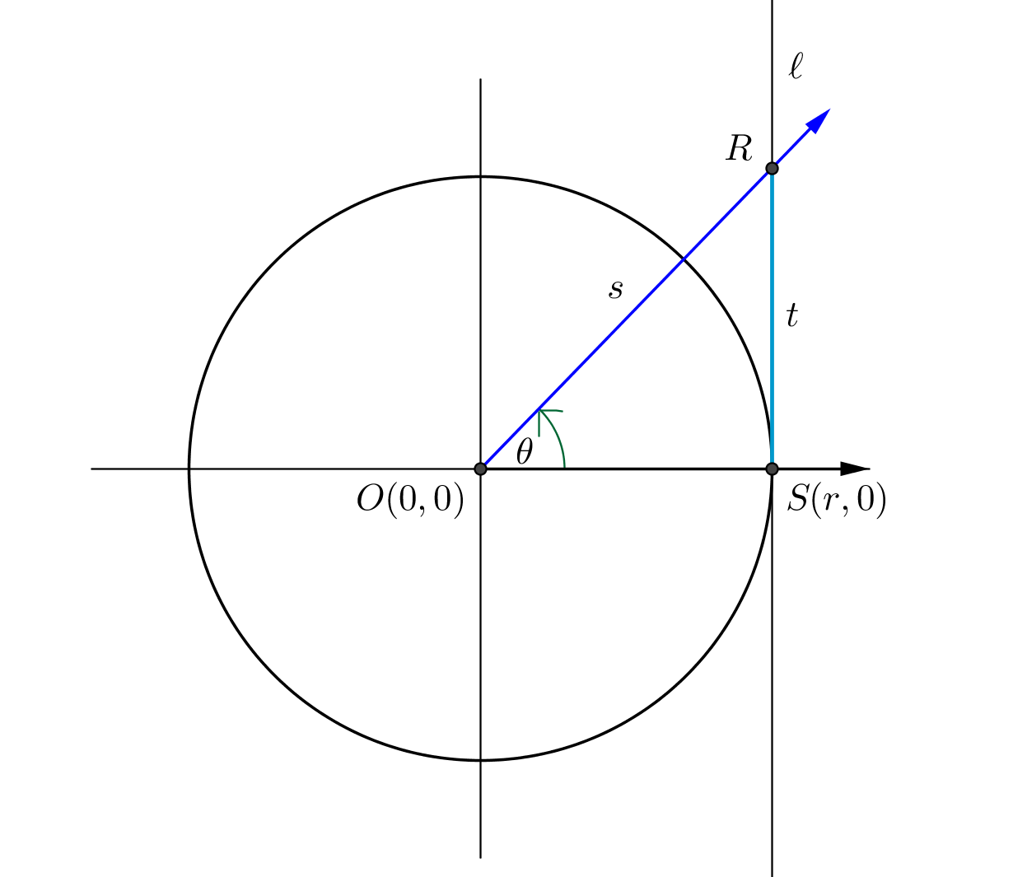
- Consider the following diagram of a circle of radius $r$ centered at the origin. The line $l$ is tangent to the circle at $S\left(r,0\right)$, so $l$ is perpendicular to the $x$-axis.
  - If $r=1$, then state the value of $t$ in terms of one of the trigonometric functions.
$$t= tan\left(θ\right)$$

  - If $r$ is any positive value, then state the value of $t$ in terms of one of the trigonometric functions.
$$t=r tan\left(θ\right)$$

For the given values of $r$ and $θ$, find $t$.
  - $θ=30$, $r=2$
$$t=2⋅tan\left(30°\right)=\frac{2}{\sqrt{3}}$$

  - $θ=45, r=2$
$$t=2⋅tan\left(45°\right)=2⋅1=2$$

  - $θ=60, r=2$
$$t=2⋅tan\left(60°\right)=2⋅\sqrt{3}=2\sqrt{3}$$

  - $θ=45, r=4$
$$t=4⋅tan\left(45°\right)=4⋅1=4$$

  - $θ=30, r=3.5$
$$t=3.5⋅tan\left(30°\right)=\frac{3.5\sqrt{3}}{3}=\frac{7\sqrt{3}}{6}$$

  - $θ=0, r=9$
$$t=9⋅tan\left(0°\right)=9⋅0=0$$
  - $θ=90, r=5$
Lines $\overset{⃡}{OR}$ and $l$ are distinct parallel lines when $θ=90$. Thus, they will never intersect, and the line segment defined by their intersection does not exist.

  - $θ=60, r=\sqrt{3}$
$$t=\sqrt{3}⋅tan\left(60°\right)=\sqrt{3}⋅\sqrt{3}=3$$

  - $θ=30, r=2.1$
$$t=2.1⋅tan\left(30°\right)=\frac{2.1}{\sqrt{3}}=\frac{21}{10\sqrt{3}}=\frac{7\sqrt{3}}{10}$$

  - $θ=A, r=3$
$t=3⋅tan\left(A°\right)=3 tan\left(A°\right)$, for $A≠90+180k$, for all integers $k$.

  - $θ=30, r=b$
$$t=b⋅tan\left(30°\right)=\frac{b\sqrt{3}}{3}$$

  - Knowing that $tan\left(θ\right)=\frac{sin\left(θ\right)}{cos\left(θ\right)}$, for $r=1$, find the value of $s$ in terms of one of the trigonometric functions.
Using right-triangle trigonometry, $sin\left(θ\right)=\frac{t}{s}=\frac{tan\left(θ\right)}{s}$.
So, $sin\left(θ\right)=\frac{tan\left(θ\right)}{s}$, which tells us $\frac{1}{sin\left(θ\right)}=\frac{s}{tan\left(θ\right)}$.
Thus, $s=\frac{tan\left(θ\right)}{sin\left(θ\right)}=\frac{sin\left(θ\right)/cos\left(θ\right)}{sin\left(θ\right)}=\frac{sin\left(θ\right)}{cos\left(θ\right)}⋅\frac{1}{sin\left(θ\right)}=\frac{1}{cos\left(θ\right)}$.
So, $s=\frac{1}{cos\left(θ\right)}$.

- Using what you know of the tangent function, show that $-tan\left(θ\right)=tan\left(-θ\right)$ for $θ≠90+180k$, for all integers $k$.
The tangent function could also be called the “slope” function due to the fact that $tan\left(θ\right)$ is the slope of the secant line passing through the origin and intersecting the tangent line perpendicular to the $x$-axis. If $θ$ is a counterclockwise rotation of the secant line, then $-θ$ is a clockwise rotation. The secant lines will have opposite slopes, so the tangent values will also be opposites. Thus, $-tan\left(θ\right)=tan\left(-θ\right)$.

