Lesson 6: Why Call It Tangent?

Classwork
Opening Exercise
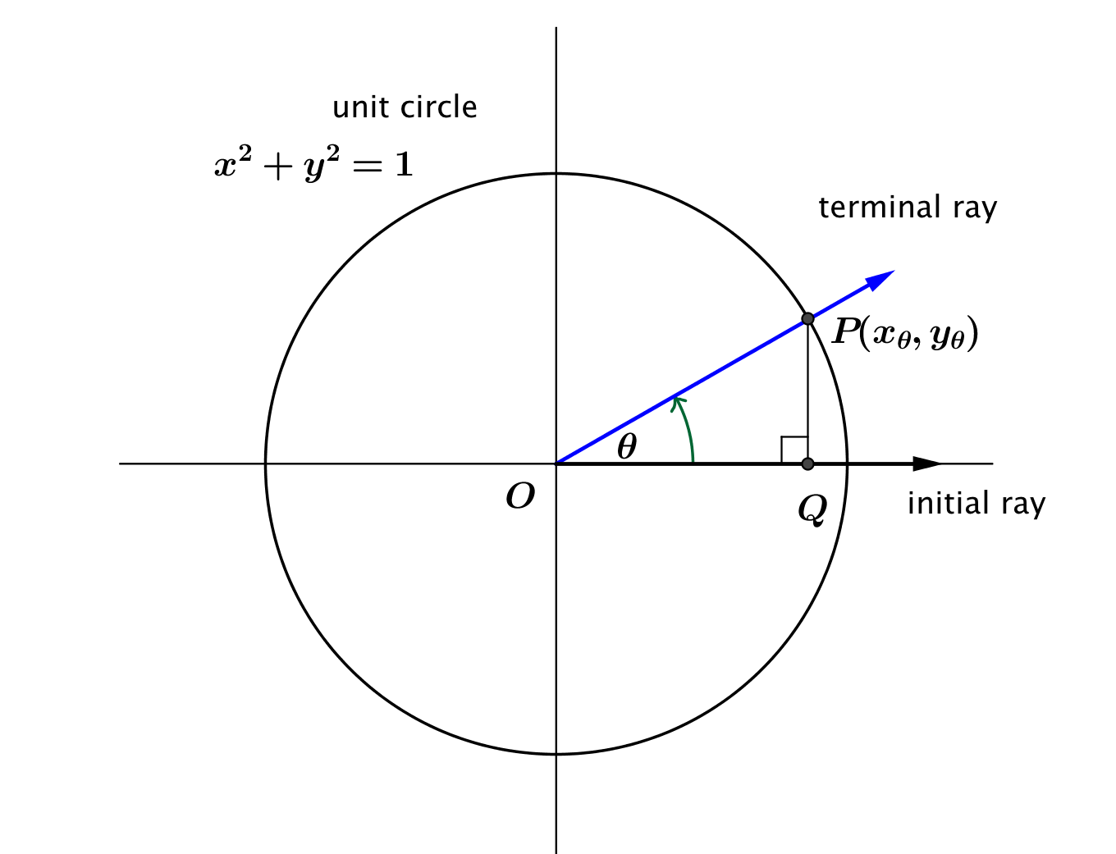
Let $P\left(x_{θ}, y_{θ}\right)$ be the point where the terminal ray intersects the unit circle after rotation by $θ$ degrees, as shown in the diagram below.

  - Using triangle trigonometry, what are the values of $x_{θ}$ and $y_{θ}$ in terms of $θ$?

  - Using triangle trigonometry, what is the value of $\tan\left(θ\right)$ in terms of $x_{θ}$ and $y_{θ}$?

  - What is the value of $\tan\left(θ\right)$ in terms of $θ$?

Discussion
A description of the tangent function is provided below. Be prepared to answer questions based on your understanding of this function and to discuss your responses with others in your class.
Let $θ$ be any real number. In the Cartesian plane, rotate the non-negative $x$-axis by $θ$ degrees about the origin. Intersect the resulting terminal ray with the unit circle to get a point $(x_{θ},y_{θ})$. If $x_{θ}≠0$, then the value of $tan⁡(θ)$ is $\frac{y_{θ}}{x_{θ}}$. In terms of the sine and cosine functions, $\tan\left(θ\right)=\frac{\sin\left(θ\right)}{cos⁡(θ)}$ for $\cos\left(θ\right)≠0$.

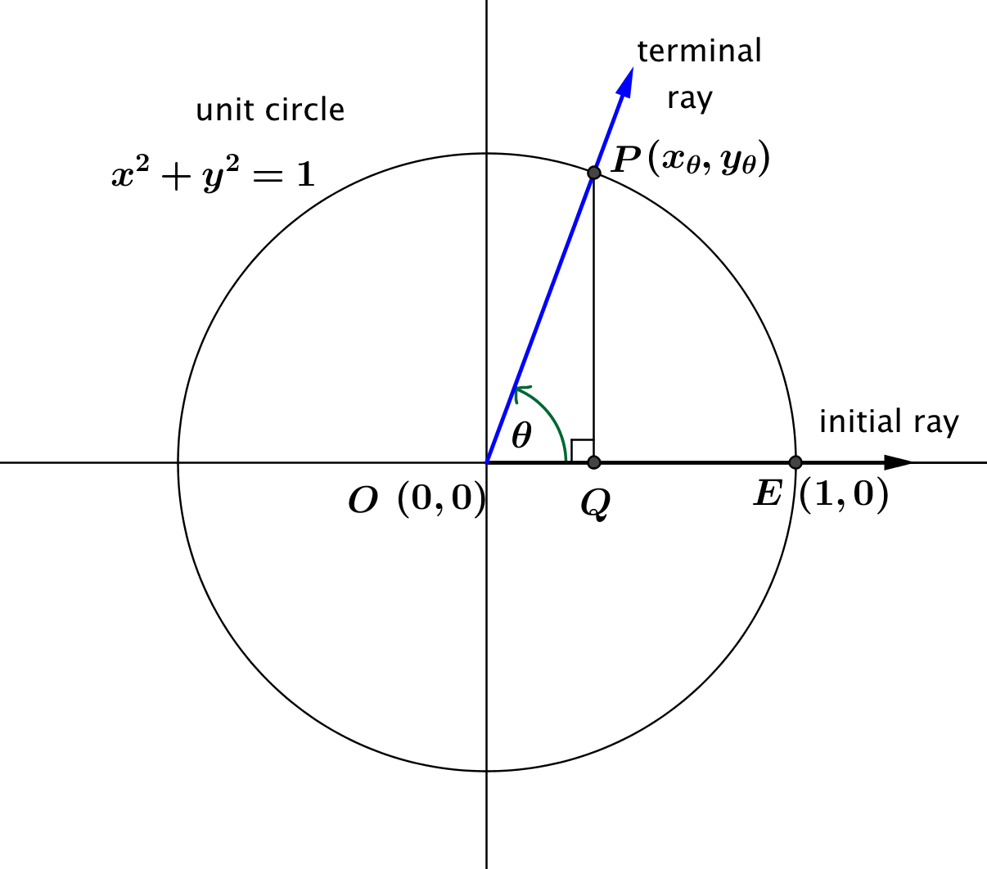

Exercise 1
- For each value of $θ$ in the table below, use the given values of $\sin{(θ)}$ and $\cos{(θ)}$ to approximate $\tan\left(θ\right)$ to two decimal places.
$$θ$$  (degrees) | $$\sin\left(θ\right)$$ | $$\cos\left(θ\right)$$ | $$\tan\left(θ\right)$$
$$-89.9$$ | $$-0.999998$$ | $$0.00175$$
$$-89$$ | $$-0.9998$$ | $$0.0175$$
$$-85$$ | $$-0.996$$ | $$0.087$$
$$-80$$ | $$-0.98$$ | $$0.17$$
$$-60$$ | $$-0.87$$ | $$0.50$$
$$-40$$ | $$-0.64$$ | $$0.77$$
$$-20$$ | $$-0.34$$ | $$0.94$$
$$0$$ | $$0$$ | $$1.00$$
$$20$$ | $$0.34$$ | $$0.94$$
$$40$$ | $$0.64$$ | $$0.77$$
$$60$$ | $$0.87$$ | $$0.50$$
$$80$$ | $$0.98$$ | $$0.17$$
$$85$$ | $$0.996$$ | $$0.087$$
$$89$$ | $$0.9998$$ | $$0.0175$$
$$89.9$$ | $$0.999998$$ | $$0.00175$$

  - As $θ → -90$ and $θ>-90$, what value does$sin(θ)$ approach?

  - As $θ → -90$ and $θ>-90$, what value does $cos(θ)$ approach?

  - As $θ → -90$ and $θ>-90$, how would you describe the value of $tan\left(θ\right)=\frac{sin\left(θ\right)}{cos\left(θ\right)}$?

  - As $θ → 90$ and $θ<90$, what value does $sin\left(θ\right)$ approach?

  - As $θ → 90$ and $θ<90$, what value does $cos(θ)$ approach?

  - As $θ → 90$ and $θ<90$, how would you describe the behavior of $tan(θ)=sin(θ)/cos(θ)$?

  - How can we describe the range of the tangent function?

Example 1
Suppose that point $P$ is the point on the unit circle obtained by rotating the initial ray through $30°$. Find $tan(30°)$.
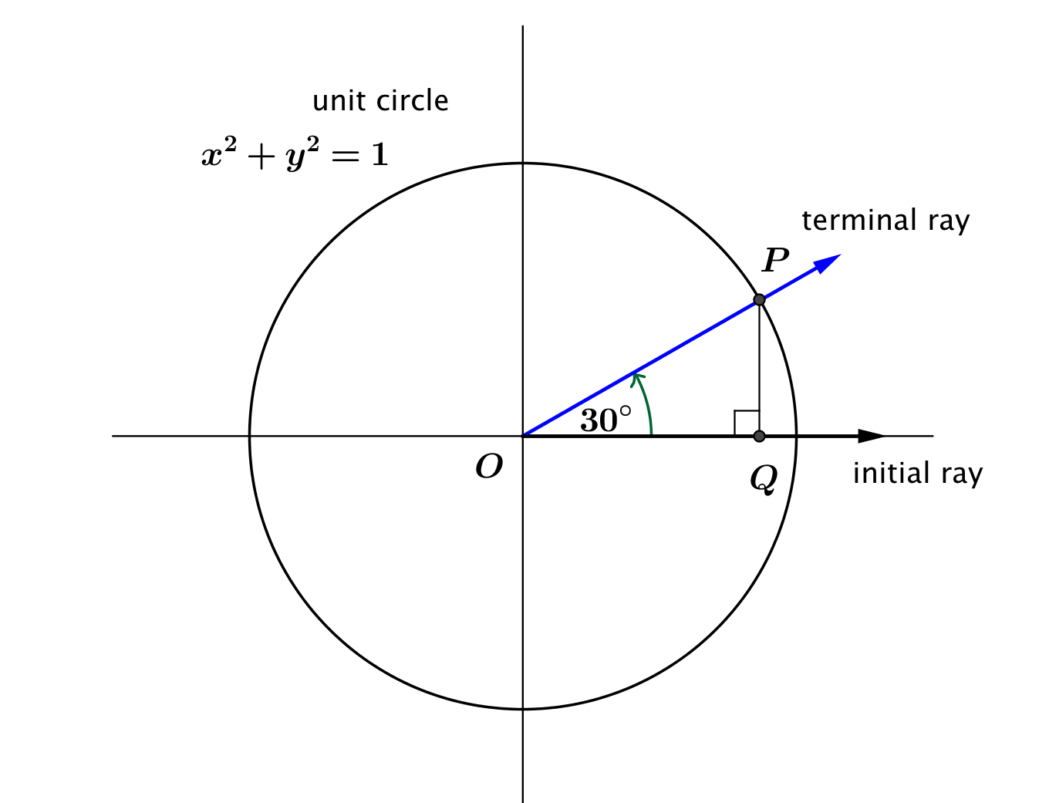

Exercises 2–6: Why Do We Call it Tangent?
- Let $P$ be the point on the unit circle with center $O$ that is the intersection of the terminal ray after rotation by $θ$ degrees as shown in the diagram at right. Let $Q$ be the foot of the perpendicular line from $P$ to the $x$-axis, and let the line $l$ be the line perpendicular to the $x$-axis at $S(1,0)$. Let $R$ be the point where the secant line $\overset{⃡}{OP}$ intersects the line $l$. Let $m$ be the length of the segment $\overline{RS}$.

  - Show that $m=tan\left(θ\right)$.

  - Using a segment in the figure, make a conjecture why mathematicians named the function $f\left(θ\right)=\frac{sin\left(θ\right)}{cos\left(θ\right)}$ the tangent function.

  - Why can you use either triangle, $ΔPOQ$ or $ΔROS$, to calculate the length $m$?

  - Imagine that YOU are the mathematician who gets to name the function (how cool would that be?). Based upon what you know about the equations of lines, what might you have named the function instead?

- Draw four pictures similar to the diagram above to illustrate what happens to the value of $tan\left(θ\right)$ as the rotation of the terminal ray contained on a secant line through the origin increases towards $90°$. How does your diagram relate to the work done in Exercise 1?

- When the terminal ray is vertical, what is the relationship between the secant line and the tangent line? Explain why you cannot determine the measure of $m$ in this instance. What is the value of $tan\left(90°\right)$?

- When the terminal ray is horizontal, what is the relationship between this secant line and the $x$-axis? Explain what happens to the value of $m$ in this instance. What is the value of $tan\left(0°\right)$?

- When the terminal ray is rotated counterclockwise about the origin by $45°$, what is relationship between the value of $m$ and length of $\overline{OS}$? What is the value of $tan(45°)$?

Exercises 7–8
- Rotate the initial ray about the origin the stated number of degrees. Draw a sketch and label the coordinates of point $P$ where the terminal ray intersects the unit circle. What is the slope of the line containing this ray?

  - $30$

  - $45$

  - $60$

  - Use the definition of tangent to find $tan⁡(30°)$, $tan⁡(45°)$, and $tan⁡(60°)$. How do your answers compare your work in parts (a)–(c)?

  - If the initial ray is rotated $θ$ degrees about the origin, show that the slope of the line containing the terminal ray is equal to $\tan\left(θ\right)$. Explain your reasoning.

  - Now that you have shown that the tangent function is equal to the slope of the terminal ray, would you prefer using the name “tangent function” or “slope function”? Why do you think we use “tangent” instead of “slope” as the name of the tangent function?

- Rotate the initial ray about the origin the stated number of degrees. Draw a sketch and label the coordinates of point $P$ where the terminal ray intersects the unit circle. How does your diagram in this Exercise relate to the diagram in the corresponding part of Exercise $7$? What is $tan(θ)$for these values of $θ$?

  - $210$

  - $225$

  - $240$

  - What do the results of parts (a)–(c) suggest about the value of the tangent function after rotating an additional $180$ degrees?

  - What is the period of the tangent function? Discuss with a classmate and write your conclusions.

  - Use the results of Exercise 7(d) to explain why $tan\left(0°\right)=0$.

  - Use the results of Exercise 7(d) to explain why $tan(90°)$ is undefined.

Lesson Summary
- $\tan\left(θ\right)=\frac{\sin\left(θ\right)}{\cos\left(θ\right)}$, where $\cos\left(θ\right)≠0$.
- The value of $\tan\left(θ\right)$ is the length of the line segment on the tangent line to the unit circle centered at the origin from the intersection with the unit circle and the intersection with the secant line created by the $x$-axis rotated $θ°$ (this is why we call it tangent).
- The value of $\tan\left(θ\right)$ is the slope of the line obtained by rotating the $x$-axis $θ$ degrees about the origin.
- The domain of the tangent function is $\left\{θ∈R | θ≠90+180k, for all integers k\right\}$ which is equivalent to $\left\{θ∈R | \cos\left(θ\right)≠0\right\}$.
- The range of the tangent function is all real numbers.
- The period of the tangent function is $180$.
$$tan(0°)$$ | $$tan(30°)$$ | $$tan\left(45°\right)$$ | $$tan\left(60°\right)$$ | $$tan\left(90°\right)$$
$$0$$ | $$\frac{\sqrt{3}}{3}$$ | $$1$$ | $$\sqrt{3}$$ | undefined

Problem Set

- Label the missing side lengths, and find the value of $tan\left(θ\right)$ in the following right triangles.
  - $θ=30°$
$$30°$$
$$1$$

  - $θ=45°$

$$1$$

$$45°$$

  - $θ=60°$

$$1$$

$$60°$$

- Let $θ$ be any real number. In the Cartesian plane, rotate the initial ray by $θ$ degrees about the origin. Intersect the resulting terminal ray with the unit circle to get point $P\left(x_{θ}, y_{θ}\right)$.
  - Complete the table by finding the slope of the line through the origin and the point $P$.
$$θ$$ | Slope | $$θ$$ | Slope
$$0$$ |  | $$180$$
$$30$$ |  | $$210$$
$$45$$ |  | $$225$$
$$60$$ |  | $$240$$
$$90$$ |  | $$270$$
$$120$$ |  | $$300$$
$$135$$ |  | $$315$$
$$150$$ |  | $$330$$
  - Explain how these slopes are related to the tangent function.

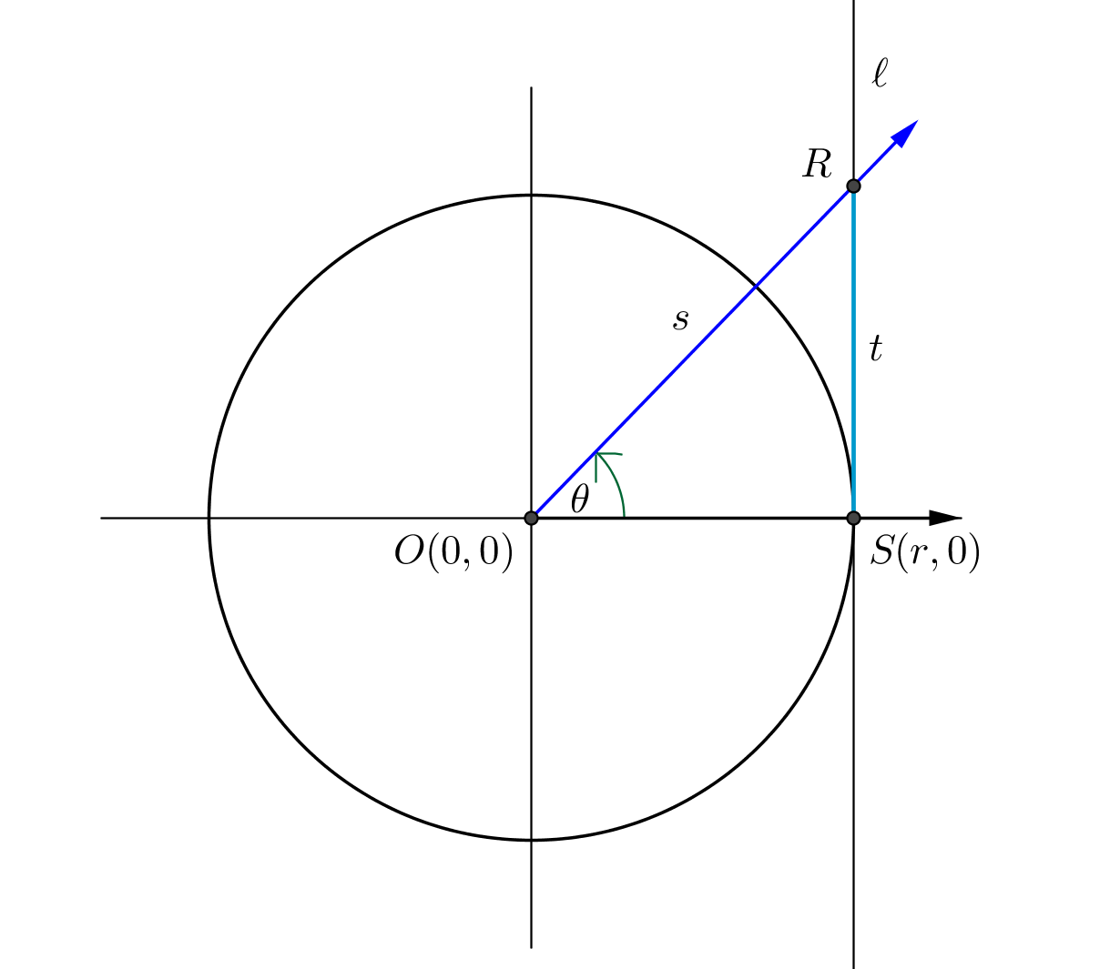
- Consider the following diagram of a circle of radius $r$ centered at the origin. The line $l$ is tangent to the circle at $S\left(r,0\right)$, so $l$ is perpendicular to the $x$-axis.

  - If $r=1$, then state the value of $t$ in terms of one of the trigonometric functions.
  - If $r$ is any positive value, then state the value of $t$ in terms of one of the trigonometric functions.
For the given values of $r$ and $θ$, find $t$.
  - $θ=30$, $r=2$
  - $θ=45, r=2$
  - $θ=60, r=2$
  - $θ=45, r=4$
  - $θ=30, r=3.5$
  - $θ=0, r=9$
  - $θ=90, r=5$
  - $θ=60, r=\sqrt{3}$
  - $θ=30, r=2.1$
  - $θ=A, r=3$
  - $θ=30, r=b$
  - Knowing that $tan\left(θ\right)=\frac{sin\left(θ\right)}{cos\left(θ\right)}$, for $r=1$, find the value of $s$ in terms of one of the trigonometric functions.

- Using what you know of the tangent function, show that $-tan\left(θ\right)=tan\left(-θ\right)$ for $θ≠90+180k$, for all integers $k$.

