Lesson 5: Extending the Domain of Sine and Cosine to All Real Numbers

Student Outcomes
- Students define sine and cosine as functions for all real numbers measured in degrees.
- Students evaluate the sine and cosine functions at multiples of $30$ and $45$.

Lesson Notes
In the preceding lesson, students extended the previous definition of sine and cosine from $0<θ<90$ to $0<θ<360$ using right triangle trigonometry, connecting the sine function to the height function of the Ferris wheel and the cosine function to the co-height function. In this lesson, students extend the domain of the sine and cosine functions to the entire real number line, at which point we can finally provide a complete definition of these two functions. We continue to use the context of the Ferris wheel to understand the implications of counterclockwise rotation through $θ≥360$ and clockwise rotation through $θ≤0$.
As with the previous lesson, we are developing theoretical understanding of the process of extending the sine and cosine functions to the entire real line, so calculators should not be allowed for any part of this lesson, including the problem set. All rotations are multiples of $30°$ or $45°$, so the focus of this lesson is assigning the proper positive or negative signs to the value of the sine and cosine functions.

Opening Exercises (4 minutes)
The opening exercises serve to remind students of the concept of a remainder and lead us into finding sine and cosine for a number of rotations greater than $360$ degrees. While the context of these exercises is artificial, it leads students to think about the amount leftover when we rotate more than one full turn, which they will need in the upcoming tasks.
Allow students to work individually or in pairs on the following division problems:
Opening Exercise
  - Suppose that a group of $360$ coworkers pool their money, buying a single lottery ticket every day with the understanding that if any ticket was a winning ticket, the group would split the winnings evenly, and they would donate any left over money to the local high school. Using this strategy, the group won $\$1,000$. How much money was donated to the school?
Since $\$1,000=\$2\left(360\right)+\$280$, each coworker won $\$2$, and the local school received the leftover $\$280.$

  - What if the winning ticket was worth $\$250,000$? Using the same plan as in part (a), how much money would be donated to the school?
Since$\$250,000 = \$694(360)+\$160$, each coworker won $\$694$, and the school received the leftover $\$160.$

  - What if the winning ticket was worth $\$540,000$? Using the same plan as in part (a), how much money would be donated to the school?
Since$\$540,000 = \$1,500(360)+\$0$, each coworker won $\$1,500,$ and the school received nothing$.$

Discussion (3 minutes)
- During yesterday’s lesson, we found a way to calculate the sine and cosine functions for rotations of the initial ray (made from the positive $x$-axis) through $θ$ degrees, for $0<θ<360.$ Today, we will investigate what happens if $θ$ takes on a value outside of the interval $(0, 360)$. Remember that our motivating examples for the sine and cosine functions were the height and co-height functions associated with a rotating Ferris wheel. Let’s return to that context for this discussion.
- In reality, a Ferris wheel doesn’t just go around once and then stop. It rotates a number of times and then stops to let the riders off. How can we extend our ideas about sine and cosine to a counterclockwise rotation through more than $360°$?
  - Ask for ideas from the class. Guide them to notice the periodicity of rotation about the origin; once a rotation passes $360°,$ the position of the point $P$ “starts over.”

Example 1 (4 minutes)
Suppose that $P$ is the point on the unit circle obtained from rotating the initial ray through $390°$. Find $sin(390°)$ and $\cos\left(390°\right).$
- Does it make sense to think of a reference angle for this rotation?
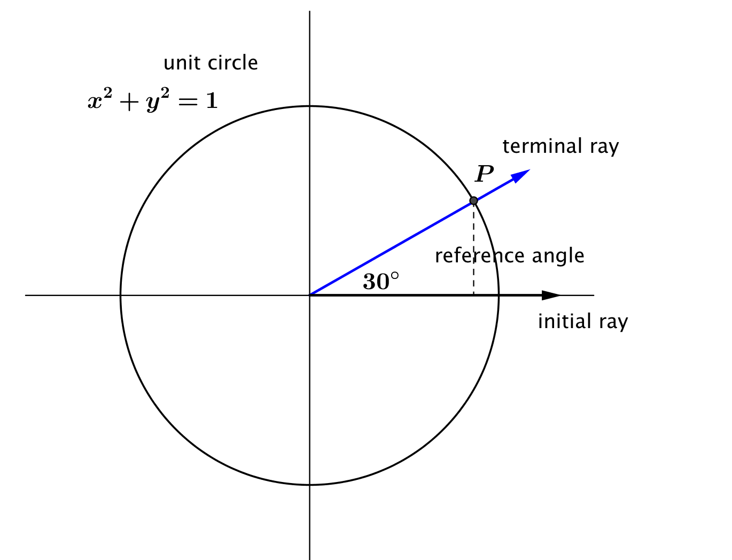
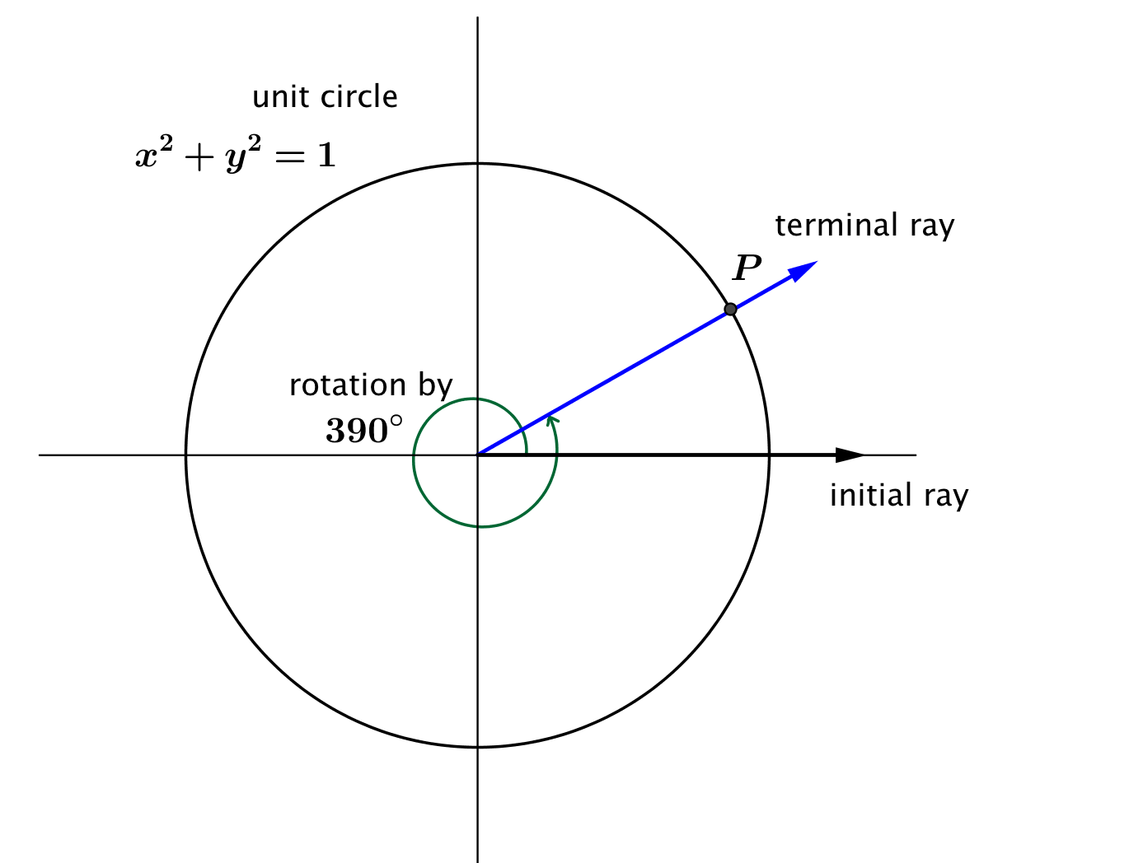
  - Yes, because $390=360+30.$
- What is the measure of the reference angle for this rotation?
  - The reference angle is a $30°$ angle.
- What are the coordinates $(x_{θ},y_{θ})$ of point $P$?
  - The terminal ray lands in the same place after a $390°$ rotation as it did after a $30°$ rotation. Thus, point $P$ is at the same location as if we hade only rotated by $30°.$Thus we have
$$\left(x_{θ},y_{θ}\right)=\left(\cos\left(30°\right), sin\left(30°\right)\right)=\left(\frac{\sqrt{3}}{2},\frac{1}{2}\right).$$

- What is $\sin\left(390°\right)$?
  - $sin\left(390°\right)=\frac{1}{2}$
- What is $cos⁡(390°)$?
  - $\cos\left(390°\right)=\frac{\sqrt{3}}{2}$

Exercises 1–5 (7 minutes)
Allow students to work in pairs or small groups on these exercises. Do not allow the use of calculators. Circulate around the room while students are working and remind them to think about remainders, as they did in the Opening Exercise.
Exercises 1–5
- Find $cos(405°)$ and $sin\left(405°\right).$ Identify the measure of the reference angle.
Since $405=360+45,$ and a $45°$ rotation places the terminal ray in the first quadrant, the reference angle measures $45°.$Then, we have $cos\left(405°\right)=cos\left(45°\right)=\frac{\sqrt{2}}{2}$, and $sin\left(405°\right)=sin\left(45°\right)=\frac{\sqrt{2}}{2}$.

- Find $cos(840°)$ and $sin\left(840°\right).$ Identify the measure of the reference angle.
Since $840=2(360)+120$, and a $120°$ rotation places the terminal ray in the second quadrant, the reference angle measures $60°.$Then, we have $cos\left(840°\right)=-cos\left(60°\right)=-\frac{1}{2}$, and $sin\left(840°\right)=sin\left(60°\right)=\frac{\sqrt{3}}{2}$.

- Find $cos(1680°)$ and $sin\left(1680°\right).$ Identify the measure of the reference angle.
Since $1680=4(360)+240,$ and a $240°$ rotation places the terminal ray in the third quadrant, the reference angle measures $60°.$Then, we have $cos\left(840°\right)=-cos\left(60°\right)=-\frac{1}{2}$, and $sin\left(840°\right)=-sin\left(60°\right)=-\frac{\sqrt{3}}{2}$.

- Find $cos(2115°)$ and $sin\left(2115°\right).$ Identify the measure of the reference angle.
Since $2115=5(360)+315,$ and a $315°$ rotation places the terminal ray in the fourth quadrant, the reference angle measures $45°$. Then, we have $cos\left(2115°\right)=cos\left(45°\right)=\frac{\sqrt{2}}{2}$, and$sin\left(2115°\right)=-sin\left(45°\right)=-\frac{\sqrt{2}}{2}.$

- Find $cos(720030°)$ and $sin\left(720030°\right).$ Identify the measure of the reference angle.
Since $720030=2000(360)+30,$ and a $30°$ rotation places the terminal ray in the first quadrant, the reference angle measures $30°.$Then, we have $cos\left(720030°\right)=cos\left(30°\right)=\frac{\sqrt{3}}{2}$, and$sin\left(720030°\right)=sin\left(30°\right)=\frac{1}{2}$.
Scaffolding:
- Remind students to draw pictures of the terminal ray and the reference angle.
- Ask struggling students to think about how many times the ray is rotated around a full circle before coming to a stop.

Discussion (2 minutes)
- Now we know how to calculate the values of the sine and cosine functions for rotating further than $360°$ counterclockwise. But what if the Ferris wheel malfunctions and starts rotating backwards? Does it still make sense to talk about the height and co-height functions if the Ferris wheel is turning the wrong way?
  - Solicit ideas from the class. Guide them to realize that the height and co-height functions only depend on the final position of the point after the rotation, not the direction in which the wheel was rotated. Thus, it makes perfect sense to define sine and cosine functions for a ray rotating backwards around the circle.
- In our definition of sine and cosine, how can we indicate that the rotation is happening in the opposite direction from our normal counter-clockwise rotation?
  - We use a negative sign to indicate rotation in the clockwise direction. That is, $θ=-60$ indicates a clockwise rotation by $60°$.

Example 2 (3 minutes)
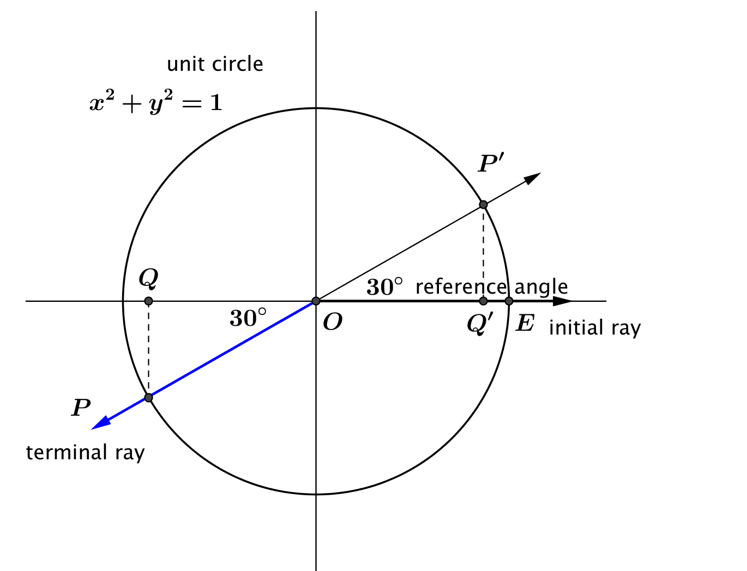
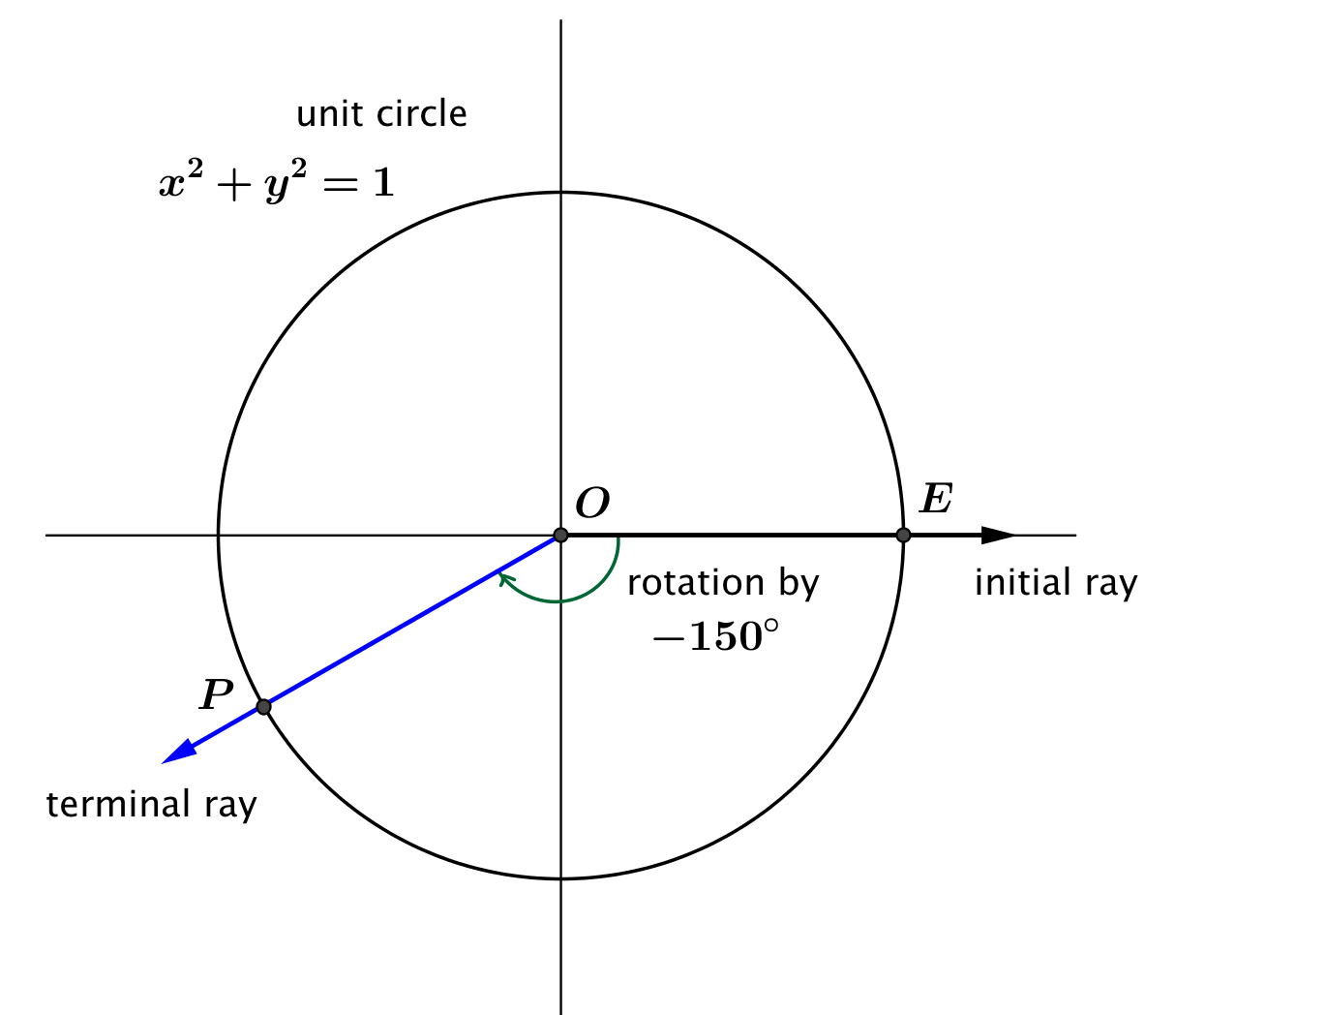
Suppose that $P$ is the point on the unit circle obtained from rotating the initial ray through $-150°$. Find $sin⁡(-150°)$ and $\cos\left(-150°\right).$
- What is the measure of the reference angle for $∠POE$?
The reference angle is $∠POQ$, which has measure $30°$since $180-150=30.$

- What are the coordinates $(x_{θ},y_{θ})$ of point $P$?
Point $P$ lands in the same place after the initial ray is rotated by $150°$ clockwise as it did after a $210°$ counterclockwise rotation. Thus, $\left(x_{θ},y_{θ}\right)=\left(-\frac{\sqrt{3}}{2},-\frac{1}{2}\right)$.

- What is $\sin\left(-150°\right)$?
$$sin\left(-150°\right)=-\frac{1}{2}$$

- What is $cos⁡(-150°)$?
$\cos\left(-150°\right)=-\frac{\sqrt{3}}{2}$
Exercises 6–10 (6 minutes)
Allow students to work in pairs or small groups on these exercises. Allow only the use of calculators without trigonometric capabilities; for example, it might be helpful to use a calculator to express $-2205$ as $-6\left(360\right)-45.$ Circulate around the room while students are working and remind them to think about writing a rotation in terms of whole $360°$ rotations, beginning with Exercise 8.
Exercises 6–10
- Find $cos(-30°)$ and $sin\left(-30°\right).$ Identify the measure of the reference angle.
Since a $–30°$ rotation places the terminal ray in the fourth quadrant, the reference angle measures $30°.$Then, we have $\text{cos}\left(-30°\right)=\text{cos}\left(30°\right)=\frac{\sqrt{3}}{2}$, and $\text{sin}\left(-30°\right)=-\text{sin}\left(30°\right)=-\frac{1}{2}.$

- Find $cos(-135°)$ and $sin\left(-135°\right).$ Identify the measure of the reference angle.
Since the terminal ray of a $-135°$rotation aligns with the terminal ray of a $225°$ rotation in the third quadrant, the reference angle measures $45°.$Then, we have$\text{cos}\left(-135°\right)=-\text{cos}\left(45°\right)=-\frac{\sqrt{2}}{2}$, and $\text{sin}\left(-135°\right)=-\text{sin}\left(45°\right)=-\frac{\sqrt{2}}{2}$.

- Find $cos(-1320°)$ and $sin\left(-1320°\right).$ Identify the measure of the reference angle.
Since the terminal ray of a $-1320°$ rotation aligns with the terminal ray of a $120°$ rotation in the second quadrant, the reference angle measures $60°$. Then, we have $cos\left(-1320°\right)=-cos\left(60°\right)=-\frac{1}{2}$, and $sin\left(-1320°\right)=sin\left(60°\right)=\frac{\sqrt{3}}{2}$.

- Find $cos(-2205°)$ and $sin\left(-2205°\right).$ Identify the measure of the reference angle.
Since the terminal ray of a$-2205°$ rotation aligns with the terminal ray of a $-45°$ rotation in the fourth quadrant, the reference angle measures $45°$. Then, we have $cos\left(-2205°\right)=cos\left(45°\right)=\frac{\sqrt{2}}{2}$, and $sin\left(-2205°\right)=-sin\left(45°\right)=-\frac{\sqrt{2}}{2}$.
Scaffolding:
- Remind students to draw pictures of the terminal ray and the reference angle.
- To help find the reference angle, ask students to count the number of whole rotations and then find the remaining amount of rotation. Then apply the techniques of Lesson 4 to find the reference angle.

- Find $cos(-2835°)$ and $sin\left(-2835°\right).$ Identify the measure of the reference angle.
Since the terminal ray of a $-2835°$ aligns with the terminal ray of a $45°$ rotation in the first quadrant, the reference angle measures $45°.$Then, we have $cos\left(-2835°\right)=-cos\left(45°\right)=\frac{\sqrt{2}}{2}$, and $sin\left(-2835°\right)=sin\left(45°\right)=\frac{\sqrt{2}}{2}$.

Discussion (2 minutes)
- At this point, we have defined the sine and cosine functions for almost any positive or negative rotation, but there are a few cases we have not dealt with. What if the Ferris wheel completely breaks down and will not move at all once you have been loaded into your car? Does it still make sense to talk about the height and co-height functions if the Ferris wheel never gets started? Can this situation still be considered as a rotation through an angle?
  - If the Ferris wheel never moves, then point $P$ has technically rotated through $0°$. In this case, our position starts and ends at point $P$ with coordinates $\left(x_{θ},y_{θ}\right)=\left(1,0\right)$. We then have $\sin\left(0°\right)= 0$, which makes sense since the height hasn’t changed since the machine is not working, and we have $\cos\left(0°\right)= 1$.

Discussion (7 minutes)
If your students will benefit from repetition, you may choose to model all four of the cases in the discussion below. Otherwise, model the first case, and assign student groups to work through the remaining three cases and report back to the class. When modeling these cases, allow students a few minutes to sketch the rotation and try to find the reference angle, and then begin the discussion.
Discussion
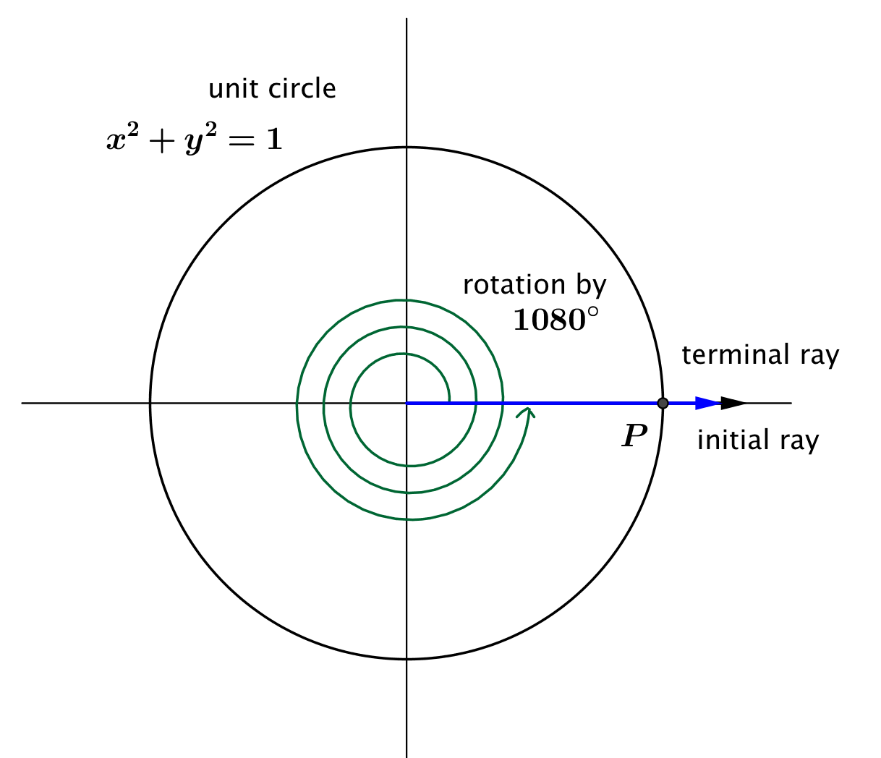
Case 1: What about the values of the sine and cosine function of other amounts of rotation that produce a terminal ray along the positive $x$-axis, such as $1080°$?
Our definition of a reference angle is the angle formed by the terminal ray and the $x$-axis, but our terminal ray lies along the $x$-axis, so the terminal ray and the $x$-axis form a zero angle.
How would we assign values to $cos(1080°)$ and $\sin{(1080°)}$?
Use the coordinates of point $P$, which are $(1,0)$. Then, $\cos\left(1080°\right)=1,$ and $\sin\left(1080°\right)=0$.
What if we rotated around $24000°$, which is $400$ turns? What are $cos⁡(24000°)$ and $\sin\left(24000°\right)$?
The terminal ray is the same as it was for $0°$, so the intersection point $P$ has coordinates $(1,0)$. Thus, $\cos\left(24000°\right)=1,$ and $\sin\left(24000°\right)=0.$
State a generalization of these results:
If $θ=n∙360°$, for some integer $n,$ then $\cos\left(θ\right)=_____$, and $\sin\left(θ\right)=______$.
If $θ=n∙360°$, for some integer $n,$ then $\cos\left(θ\right)=1,$ and $\sin\left(θ\right)=0$.

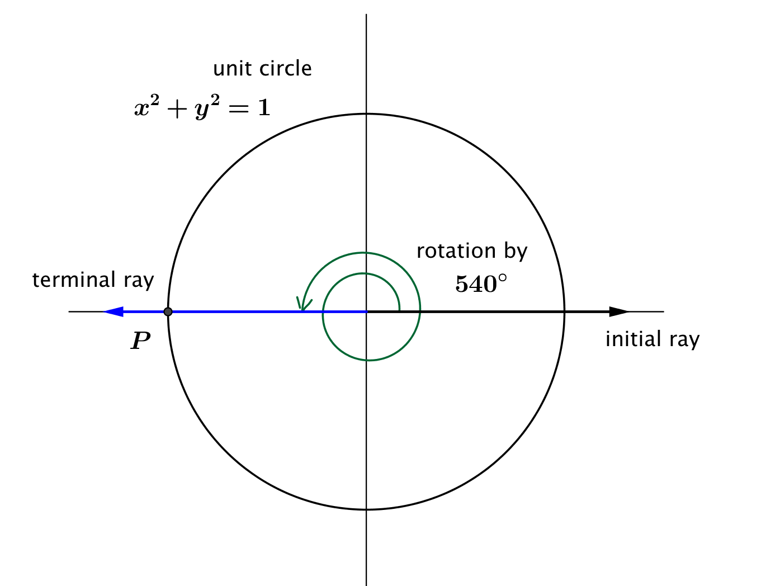
Case 2: What about the values of the sine and cosine function of other amounts of rotation that produce a terminal ray along the negative $x$-axis, such as $540°$?
How would we assign values to $cos(540°)$ and $\sin{(540°)}$?
Use the coordinates of point $P$, which are $(-1,0)$. Then $\text{cos}\left(540°\right)=-1,$ and $\text{sin}\left(540°\right)=0$.
What are the values of $cos⁡(900°)$ and $\sin{(900°)}$? How do you know?
Since the terminal ray of rotation by $900°$ lies along the negative $x$-axis, it coincides with the terminal ray of rotation by $540°$. Thus, the coordinates of the intersection point $P$ are $(-1,0)$, and we have $\text{cos}\left(900°\right)=-1$, and $\text{sin}\left(900°\right)=0$.
State a generalization of these results:
If $θ=n∙360°+180°$, for some integer $n,$ then $\cos\left(θ\right)=_____$, and $\sin\left(θ\right)=______$.
If $θ=n∙360°+180°$, for some integer $n,$ then $\cos\left(θ\right)=-1,$ and $\sin\left(θ\right)=0$.

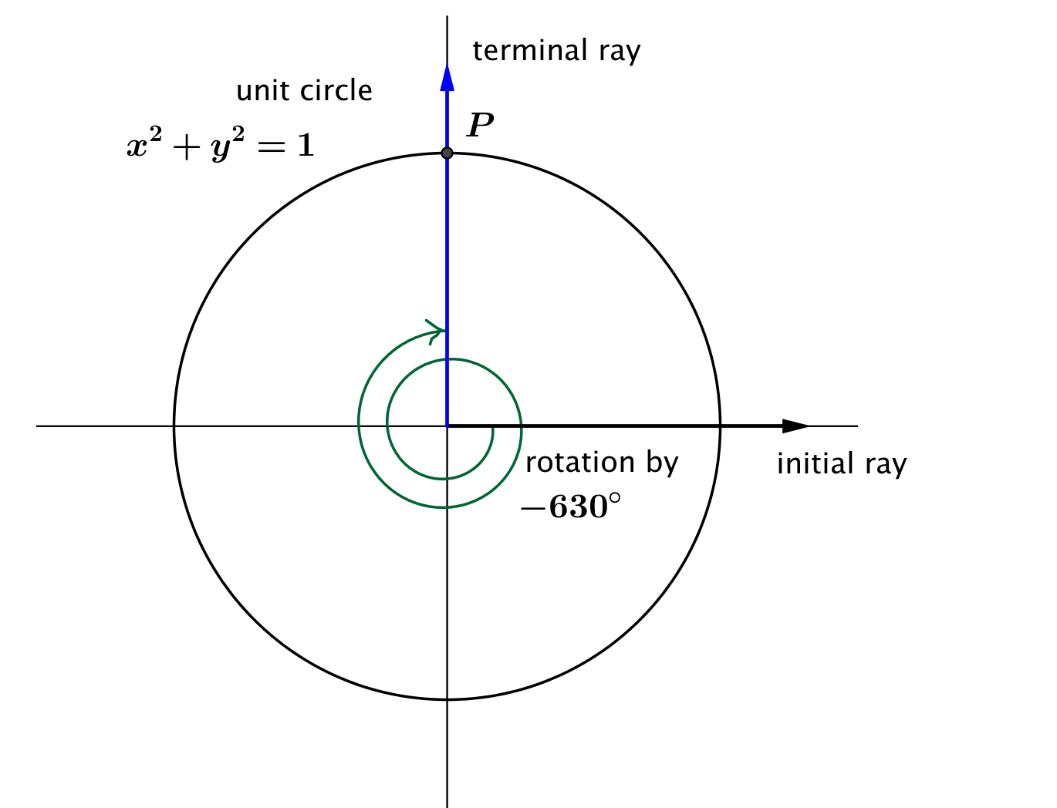
Case 3: What about the values of the sine and cosine function for rotations that are $90°$ more than a number of full turns, such as $-630°$?
How would we assign values to $cos\left(-630°\right),$ and $\sin{(-630°)}?$
Use the coordinates of point $P$, which are $(0,1)$. Then, $\cos\left(-630°\right)=0,$ and $\sin\left(-630°\right)=1$.
Can we generalize to any rotation that produces a terminal ray along the positive $y$-axis?
Yes.
State a generalization of these results:
If $θ=n∙360°+90°$, for some integer $n,$ then $\cos\left(θ\right)=_____$, and $\sin\left(θ\right)=______$.
If $θ=n∙360°+90°$, for some integer $n,$ then $\cos\left(θ\right)=0,$ and $\sin\left(θ\right)=1$.
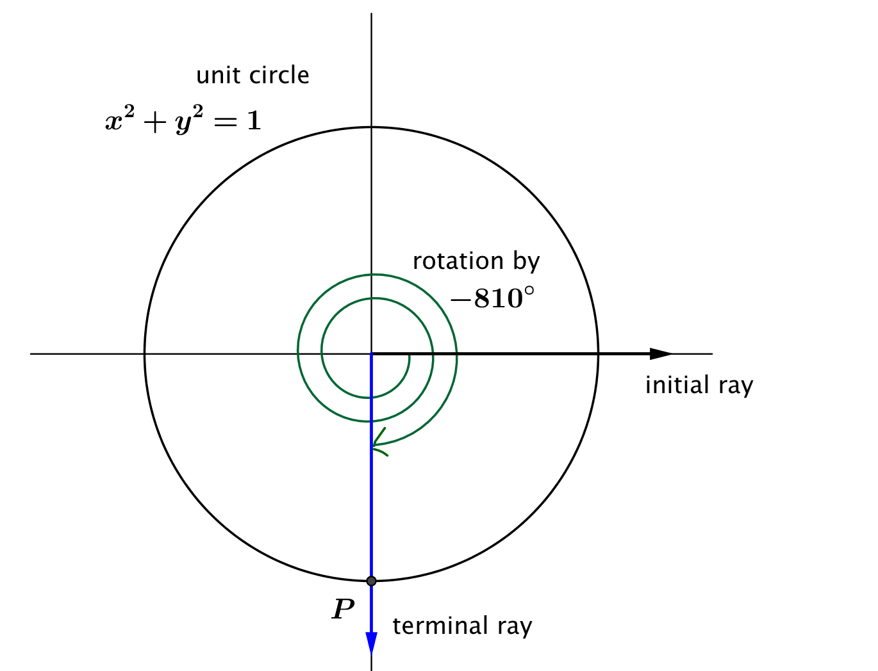
Case 4: What about the values of the sine and cosine function for rotations whose terminal ray lies along the negative $y$-axis, such as $-810°$?
How would we assign values to $cos(-810°)$ and $\sin{(-810°)}?$
Use the coordinates of point $P$, which are $(0,-1)$. Then, $\cos\left(-810°\right)=0$,and $\sin\left(-810°\right)=-1$.
Can we generalize to any rotation that produces a terminal ray along the negative $y$-axis?
Yes.

State a generalization of these results:
If $θ=n∙360°+270°$, for some integer $n,$ then, $\cos\left(θ\right)=_____$, and $\sin\left(θ\right)=______$.
If $θ=n∙360°+270°$, for some integer $n,$ then $\cos\left(θ\right)=0,$ and $\sin\left(θ\right)=-1$.

Discussion (2 minutes)
We have now made sense of the sine and cosine functions for any number of degrees of rotation, whether positive, negative, or zero. We are now ready to define sine and cosine as functions of any real number.
Let $θ$ be any real number. In the Cartesian plane, rotate the initial ray by $θ$ degrees about the origin. Intersect the resulting terminal ray with the unit circle to get a point $(x_{θ},y_{θ})$ in the coordinate plane. The value of $sin⁡(θ)$ is $y_{θ},$ and the value of $\cos\left(θ\right)$ is $x_{θ}$.

- What is the domain of the sine function?
- The domain of the sine function is all real numbers.
- What is the range of the sine function?
- The range of the sine function is $[-1,1]$.
- What is the domain of the cosine function?
- The domain of the cosine function is all real numbers.
- What is the range of the cosine function?
- The range of the cosine function is $[-1,1]$.

Closing (2 minutes)
Ask students to summarize the important parts of the lesson, either in writing, to a partner, or as a class. Use this as an opportunity to informally assess understanding of the lesson. The following are some important summary elements:
Lesson Summary
In this lesson we formalized the definition of the sine and cosine functions of a number of degrees of rotation, $θ$. We rotate the initial ray made from the positive $x$-axis through $θ$ degrees, going counterclockwise if $θ>0$ and clockwise if $θ<0$. The point $P$ is defined by the intersection of the terminal ray and the unit circle.
- The value of $cos\left(θ\right)$ is the $x$-coordinate of $P$.
- The value of $sin\left(θ\right)$ is the $y$-coordinate of $P$.
- The sine and cosine functions have domain of all real numbers and range $[-1,1]$.
Exit Ticket (3 minutes)
Name Date
Lesson 5: Extending the Domain of Sine and Cosine to All Real Numbers

Exit Ticket

- Calculate $cos(480°)$ and $\sin{(480°)}$.

- Explain how we calculate the sine and cosine functions for a value of $θ$ so that $540<θ<630.$
Exit Ticket Sample Solutions

- Calculate $cos⁡(480°)$ and $\sin{(480°)}$.
Since $480°=360°+120°$, the terminal ray of the rotated initial ray is in the 2nd quadrant. The reference angle is a $60°$ angle, so we have $cos\left(480°\right)=-cos\left(60°\right)=-\frac{1}{2}$, and $sin\left(480°\right)= sin\left(60°\right)=\frac{\sqrt{3}}{2}.$

- Explain how we calculate the sine and cosine functions for a value of $θ$ so that $540<θ<630.$
Since $540<θ<630$, the terminal ray is in the 3rd quadrant. The reference angle is the angle formed by the terminal ray and the negative $x$-axis; let the reference angle have measure $ϕ$. Thus, the sine and cosine of $θ$ will be the opposite of the sine and cosine of $ϕ:$ $cos\left(θ\right)=-cos\left(ϕ\right),$ and $sin\left(θ\right)=sin\left(ϕ\right).$

Problem Set Sample Solutions

- Fill in the chart; write the quadrant where the terminal ray is located after rotation by $θ,$the measures of the reference angles, and the values of the sine and cosine functions for the indicated rotation numbers.

Number of degrees of rotation,  $$θ$$ | Quadrant | Measure of Reference  Angle | $$cos(θ)$$ | $$sin(θ)$$
$$690$$ | IV | $$30°$$ | $$\frac{\sqrt{3}}{2}$$ | $$-\frac{1}{2}$$
$$810$$ | None | $$90°$$ | $$0$$ | $$1$$
$$1560$$ | II | $$60°$$ | $$-\frac{1}{2}$$ | $$\frac{\sqrt{3}}{2}$$
$$1440$$ | None | $$0°$$ | $$1$$ | $$0$$
$$855$$ | II | $$45°$$ | $$-\frac{\sqrt{2}}{2}$$ | $$\frac{\sqrt{2}}{2}$$
$$-330$$ | I | $$30°$$ | $$\frac{\sqrt{3}}{2}$$ | $$\frac{1}{2}$$
$$-4500$$ | None | $$0°$$ | $$-1$$ | $$0$$
$$-510$$ | III | $$30°$$ | $$-\frac{\sqrt{3}}{2}$$ | $$-\frac{1}{2}$$
$$-135$$ | III | $$45°$$ | $$-\frac{\sqrt{2}}{2}$$ | $$-\frac{\sqrt{2}}{2}$$
$$-1170$$ | None | $$90°$$ | $$0$$ | $$-1$$

- Using geometry, Jennifer correctly calculated that $\sin{15°=}\frac{1}{2}\sqrt{2-\sqrt{3}}$ . Based on this information, fill in the chart:

Number of degrees of rotation,  $$θ$$ | Quadrant | Measure of Reference Angle | $$\cos{(θ)}$$ | $$\sin{(θ)}$$
$$525$$ | II | $$15°$$ | $$-\frac{1}{2}\sqrt{2+\sqrt{3}}$$ | $$\frac{1}{2}\sqrt{2-\sqrt{3}}$$
$$705$$ | IV | $$15°$$ | $$\frac{1}{2}\sqrt{2+\sqrt{3}}$$ | $$-\frac{1}{2}\sqrt{2-\sqrt{3}}$$
$$915$$ | III | $$15°$$ | $$-\frac{1}{2}\sqrt{2+\sqrt{3}}$$ | $$-\frac{1}{2}\sqrt{2-\sqrt{3}}$$
$$-15$$ | IV | $$15°$$ | $$\frac{1}{2}\sqrt{2+\sqrt{3}}$$ | $$-\frac{1}{2}\sqrt{2-\sqrt{3}}$$
$$-165$$ | III | $$15°$$ | $$-\frac{1}{2}\sqrt{2+\sqrt{3}}$$ | $$-\frac{1}{2}\sqrt{2-\sqrt{3}}$$
$$-705$$ | I | $$15°$$ | $$\frac{1}{2}\sqrt{2+\sqrt{3}}$$ | $$\frac{1}{2}\sqrt{2-\sqrt{3}}$$

- Suppose $θ$ represents a quantity in degrees, and that $\sin{(θ)=0.5}$. List the first six possible positive values that $θ$ can take.
$$30, 150,390, 510, 750, 870$$

- Suppose $θ$ represents a quantity in degrees, and that $\sin{(θ°)=-0.5}$. List six possible negative values that $θ$ can take.
$-30, -150,-390, -510, -750, -870$

- Suppose $θ$ represents a quantity in degrees. Is it possible that $cos\left(θ°\right)=\frac{1}{2}$ and $\text{sin}\left(θ°\right)=\frac{1}{2}$ ?
No. If $cos\left(θ°\right)=\frac{1}{2}$ and $sin\left(θ°\right)=\frac{1}{2}$, then the coordinates of point $P$are$\left(\frac{1}{2} ,\frac{1}{2}\right)$, but this point doesn’t lie on the unit circle.

- Jane says that since the reference angle for a rotation through $-765°$ has measure $45°$, then $cos\left(-765°\right)=cos\left(45°\right),$ and $sin\left(-765°\right)=sin(45°)$. Explain why she is or is not correct.
Jane is wrong. Because the terminal ray of the rotated initial ray lies in the fourth quadrant, we know that the $y$-coordinate changes sign. Thus $cos\left(-765°\right)=cos\left(45°\right),$ but $sin\left(-765°\right)=-sin\left(45°\right).$

- Doug says that since the reference angle for a rotation through $765°$ has measure $45°$, then $cos\left(765°\right)=cos\left(45°\right),$ and $sin\left(765°\right)=sin(45°)$. Explain why he is or is not correct.
Doug’s conclusion is true, but his logic may be faulty. The reason that $cos\left(765°\right)=cos\left(45°\right)$ and $sin\left(765°\right)=sin(45°)$ is because the terminal angle of the rotated ray lies in the first quadrant.

