Lesson 5: Extending the Domain of Sine and Cosine to All Real Numbers

Classwork
Opening Exercises
  - Suppose that a group of $360$ coworkers pool their money, buying a single lottery ticket every day with the understanding that if any ticket was a winning ticket, the group would split the winnings evenly, and they would donate any left over money to the local high school. Using this strategy, the group won $\$1,000$. How much money was donated to the school?

  - What if the winning ticket was worth $\$250,000$? Using the same plan as in part (a), how much money would be donated to the school?

  - What if the winning ticket was worth $\$540,000$? Using the same plan as in part (a), how much money would be donated to the school?

Exercises 1–5
- Find $cos(405°)$ and $sin\left(405°\right).$ Identify the measure of the reference angle.

- Find $cos(840°)$ and $sin\left(840°\right).$ Identify the measure of the reference angle.

- Find $cos(1680°)$ and $sin\left(1680°\right).$ Identify the measure of the reference angle.

- Find $cos(2115°)$ and $sin\left(2115°\right).$ Identify the measure of the reference angle.

- Find $cos(720030°)$ and $sin\left(720030°\right).$ Identify the measure of the reference angle.

Exercises 6–10
- Find $cos(-30°)$ and $sin\left(-30°\right).$ Identify the measure of the reference angle.

- Find $cos(-135°)$ and $sin\left(-135°\right).$ Identify the measure of the reference angle.

- Find $cos(-1320°)$ and $sin\left(-1320°\right).$ Identify the measure of the reference angle.

- Find $cos(-2205°)$ and $sin\left(-2205°\right).$ Identify the measure of the reference angle.

- Find $cos(-2835°)$ and $sin\left(-2835°\right).$ Identify the measure of the reference angle.

Discussion
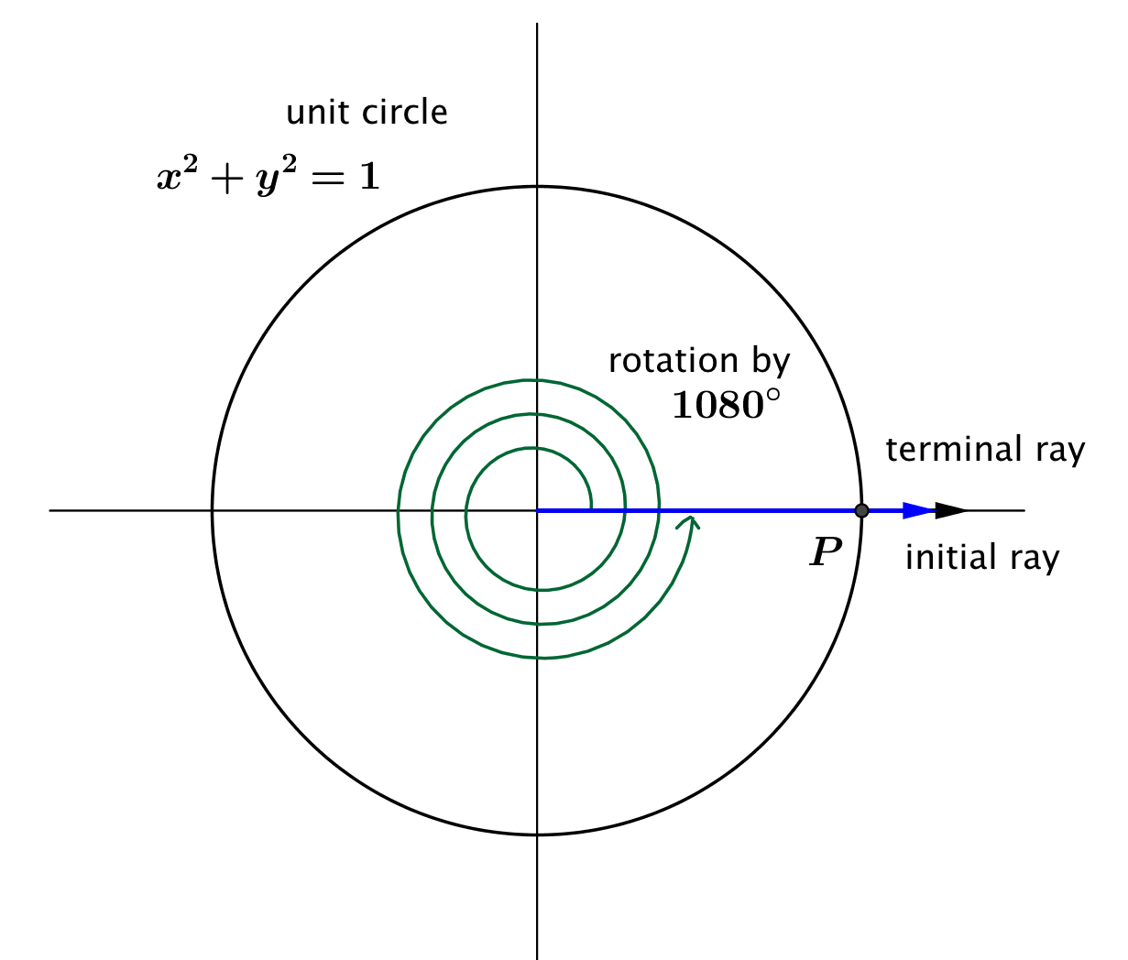
Case 1: What about the values of the sine and cosine function of other amounts of rotation that produce a terminal ray along the positive $x$-axis, such as $1080°$?
Our definition of a reference angle is the angle formed by the terminal ray and the $x$-axis, but our terminal ray lies along the $x$-axis so the terminal ray and the $x$-axis form a zero angle.
How would we assign values to $cos(1080°)$ and $\sin{(1080°)}$?

What if we rotated around $24000°$, which is $400$ turns? What are $cos⁡(24000°)$ and $\sin\left(24000°\right)$?

State a generalization of these results:
If $θ=n∙360°$, for some integer $n,$ then $\cos\left(θ\right)=_____$, and $\sin\left(θ\right)=______$.

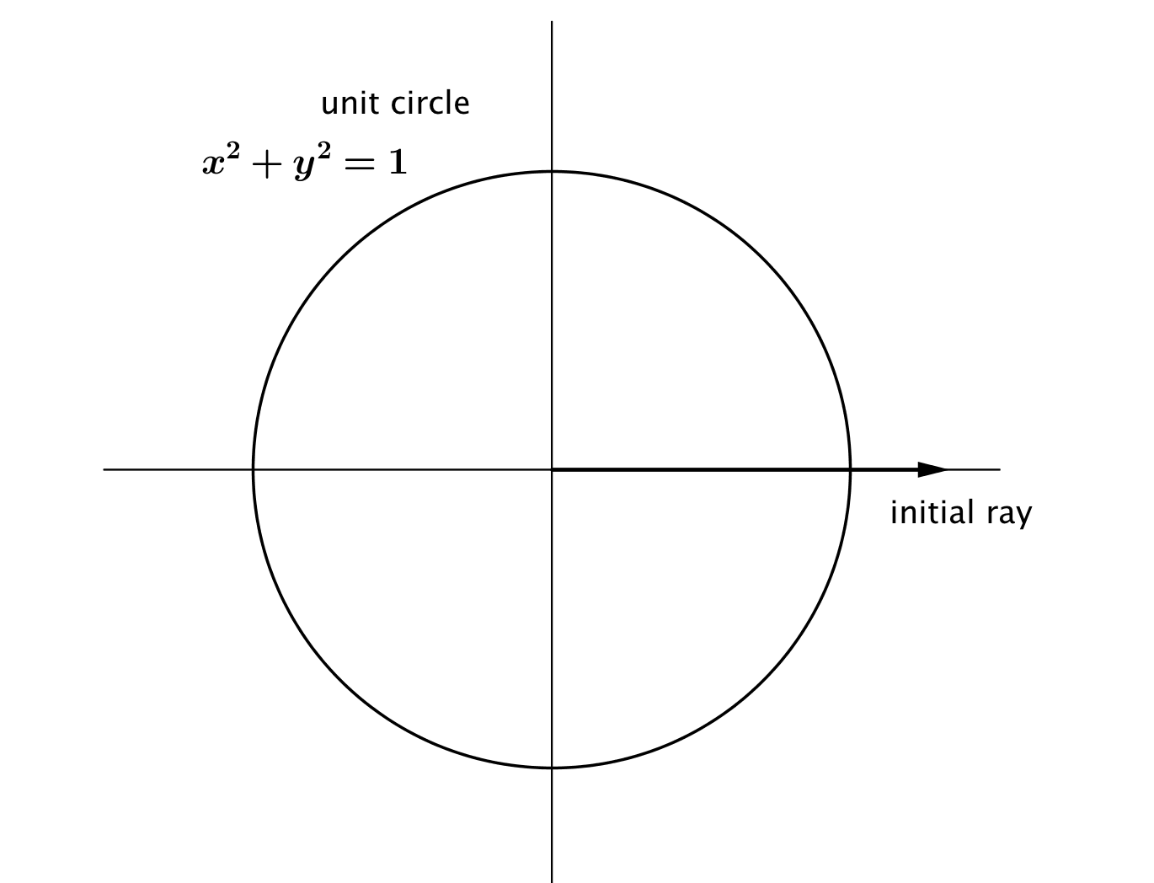
Case 2: What about the values of the sine and cosine function of other amounts of rotation that produce a terminal ray along the negative $x$-axis, such as $540°$?
How would we assign values to $cos(540°)$ and $\sin{(540°)}$?

What are the values of $cos⁡(900°)$ and $\sin{(900°)}$? How do you know?

State a generalization of these results:
If $θ=n∙360°+180°$, for some integer $n,$ then $\cos\left(θ\right)=_____$, and $\sin\left(θ\right)=______$.

Case 3: What about the values of the sine and cosine function for rotations that are $90°$ more than a number of full turns, such as $-630°$?
How would we assign values to $cos\left(-630°\right),$ and $\sin{(-630°)}?$

Can we generalize to any rotation that produces a terminal ray along the positive $y$-axis?

State a generalization of these results:
If $θ=n∙360°+90°$, for some integer $n,$ then $\cos\left(θ\right)=_____$, and $\sin\left(θ\right)=______$.

Case 4: What about the values of the sine and cosine function for rotations whose terminal ray lies along the negative $y$-axis, such as $-810°$?
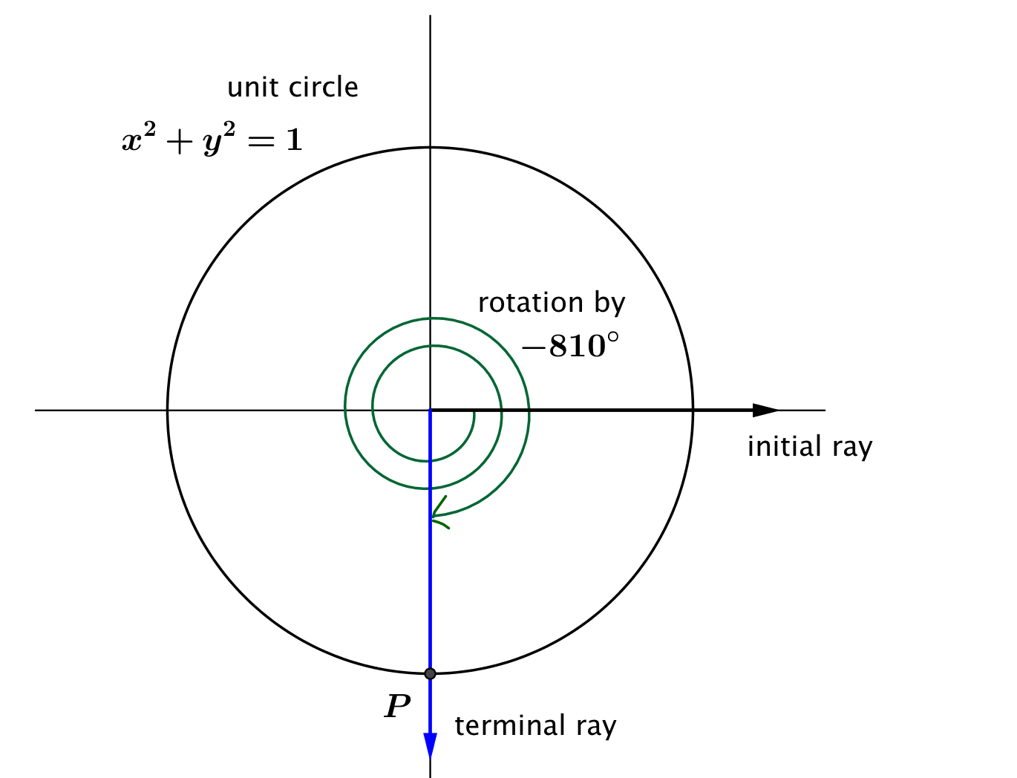
How would we assign values to $cos(-810°)$ and $\sin{(-810°)}$?

Can we generalize to any rotation that produces a terminal ray along the negative $y$-axis?

State a generalization of these results:
If $θ=n∙360°+270°$, for some integer $n,$ then $\cos\left(θ\right)=_____$, and $\sin\left(θ\right)=______$.

Discussion
Let $θ$ be any real number. In the Cartesian plane, rotate the initial ray by $θ$ degrees about the origin. Intersect the resulting terminal ray with the unit circle to get a point $(x_{θ},y_{θ})$ in the coordinate plane. The value of $sin⁡(θ)$ is $y_{θ},$ and the value of $\cos\left(θ\right)$ is $x_{θ}$.

Lesson Summary
In this lesson we formalized the definition of the sine and cosine functions of a number of degrees of rotation, $θ$. We rotate the initial ray made from the positive $x$-axis through $θ$ degrees, going counterclockwise if $θ>0$ and clockwise if $θ<0$. The point $P$ is defined by the intersection of the terminal ray and the unit circle.
- The value of $cos\left(θ\right)$ is the $x$-coordinate of $P$.
- The value of $sin\left(θ\right)$ is the $y$-coordinate of $P$.
- The sine and cosine functions have domain of all real numbers and range $[-1,1]$.

Problem Set

- Fill in the chart; write the quadrant where the terminal ray is located after rotation by $θ,$the measures of the reference angles, and the values of the sine and cosine functions for the indicated rotation numbers.

Number of degrees of rotation,  $$θ$$ | Quadrant | Measure of Reference  Angle | $$cos(θ)$$ | $$sin(θ)$$
$$690$$
$$810$$
$$1560$$
$$1440$$
$$855$$
$$-330$$
$$-4500$$
$$-510$$
$$-135$$
$$-1170$$

- Using geometry, Jennifer correctly calculated that $\sin{15°=}\frac{1}{2}\sqrt{2-\sqrt{3}}$ . Based on this information, fill in the chart:

Number of degrees of rotation,  $$θ$$ | Quadrant | Measure of Reference Angle | $$\cos{(θ)}$$ | $$\sin{(θ)}$$
$$525$$
$$705$$
$$915$$
$$-15$$
$$-165$$
$$-705$$

- Suppose $θ$ represents a quantity in degrees, and that $\sin{(θ)=0.5}$. List the first six possible positive values that $θ$ can take.

- Suppose $θ$ represents a quantity in degrees, and that $\sin{(θ°)=-0.5}$. List six possible negative values that $θ$ can take.

- Suppose $θ$ represents a quantity in degrees. Is it possible that $cos\left(θ°\right)=\frac{1}{2}$ and $\text{sin}\left(θ°\right)=\frac{1}{2}$?

- Jane says that since the reference angle for a rotation through $-765°$ has measure $45°$, then $cos\left(-765°\right)=cos\left(45°\right),$ and $sin\left(-765°\right)=sin(45°)$. Explain why she is or is not correct.

- Doug says that since the reference angle for a rotation through $765°$ has measure $45°$, then $cos\left(765°\right)=cos\left(45°\right),$ and $sin\left(765°\right)=sin(45°)$. Explain why he is or is not correct.

