Grade PK • Module 3 • Topics A–D
Family Math Newsletter

Key Standards
- Know number names and the count sequence.
- Count to tell the number of objects.
- Understand that each successive number name refers to a quantity that is 1 larger.
Looking Back
In Module 2, we identified, described, and built shapes.
Looking Ahead
In Topics E–H of Module 3, we will explore 0, 9, and 10. We will spend the most time with 10, since it is foundational to understanding place value.

Counting to 10
In the first half of Module 3, students build on their work with numbers to 5 as they explore groups of 6, 7, and 8 objects. Children learn to touch and count up to 8 objects arranged in different ways (e.g., in a straight line or in rows) and extend their ability to make tallies, recognize numerals, and count on their fingers the Math Way (from left to right). Additionally, students strengthen their understanding of 1 more and discover different ways to take apart numbers (e.g., 7 cubes can be broken up into 5 cubes and 2 cubes).
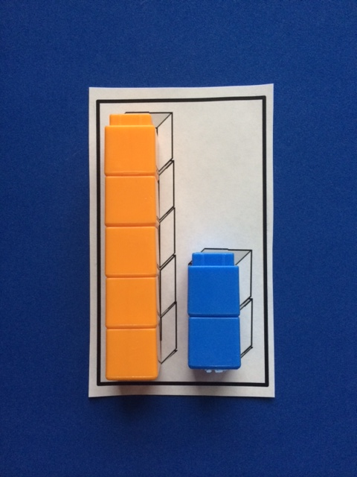
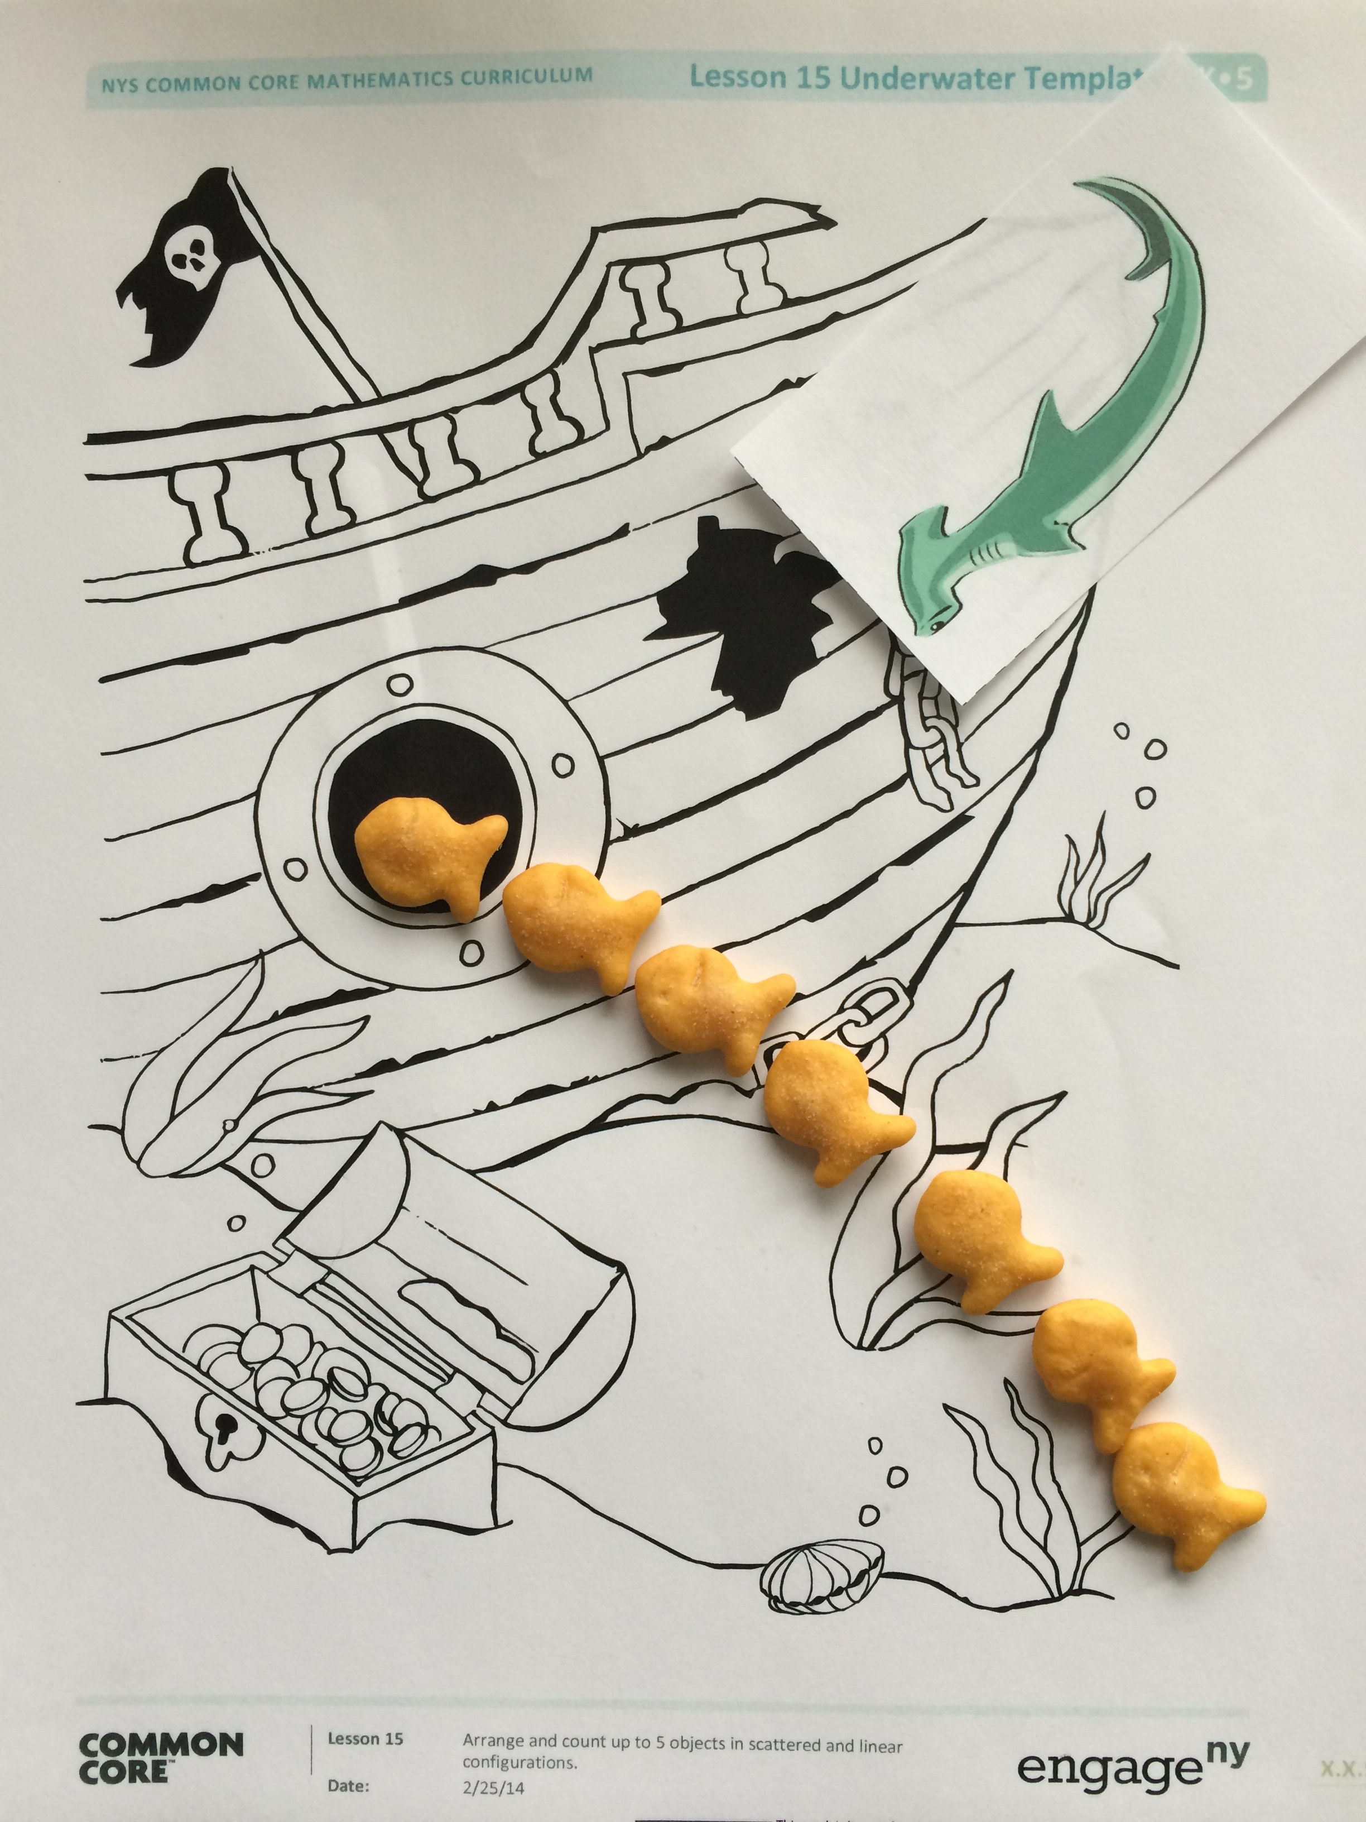
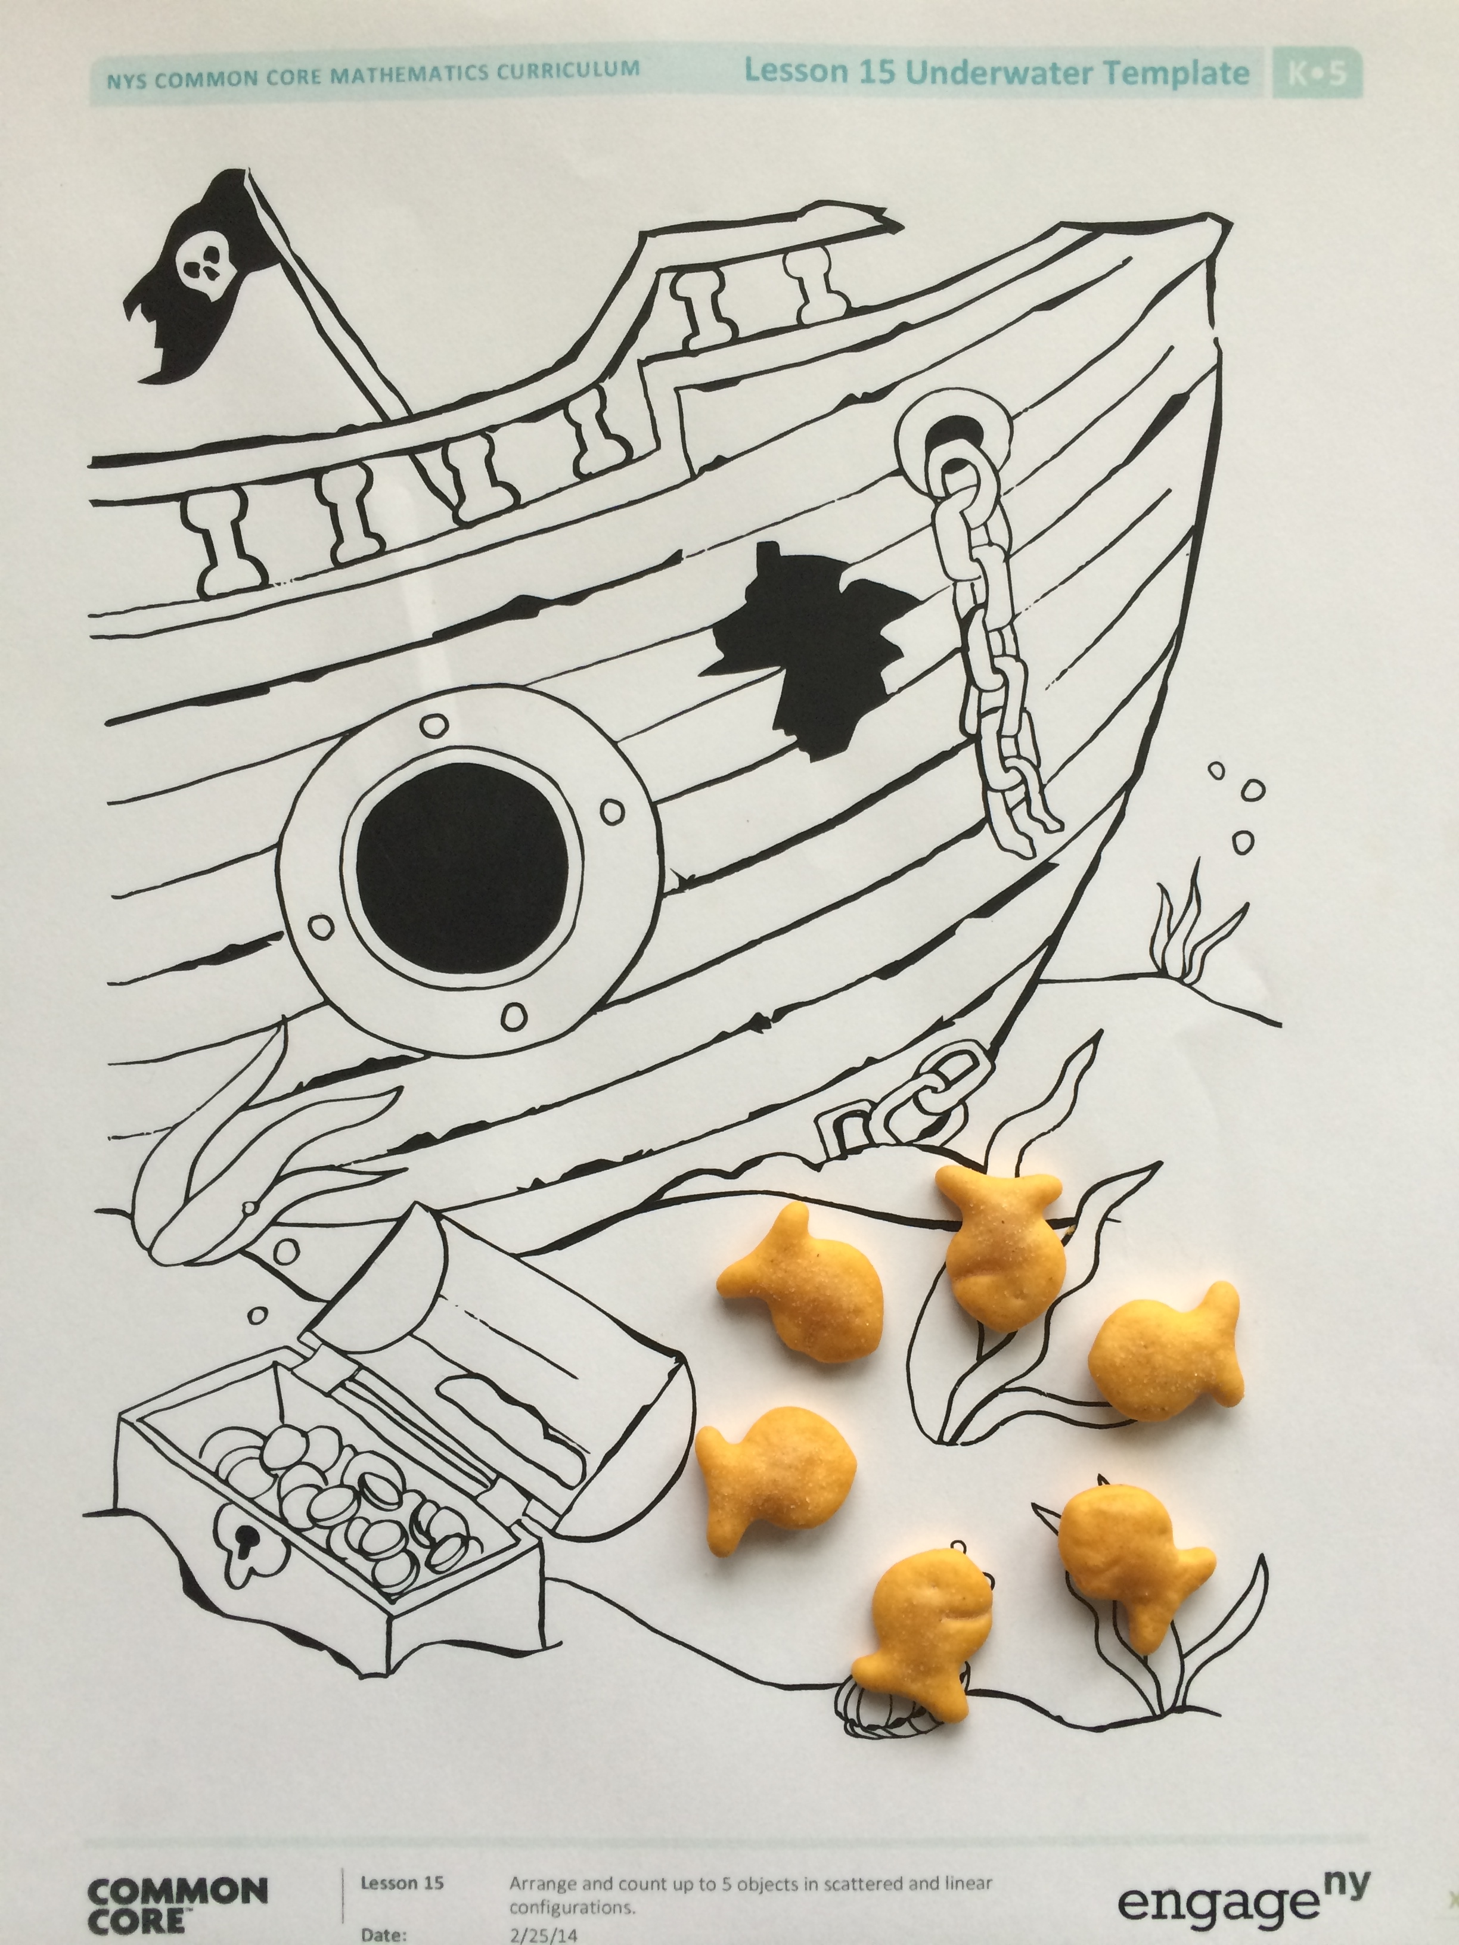
(Below) Students touch and count objects arranged in lines and circles.
(Above) Students learn to take apart 7 by matching linking cubes to a Partners of 7 Puzzle piece.

Words and Key Terms
How to Help at Home
- Touch and count up to 8 objects together. During playtime, count up to 8 toy cars. Move the cars into a line or a circle and count again.
- Buy or make a set of numerals from 1 to 8 (paper, foam, or magnets work well). Show a number on your fingers. Ask, “Which number shows how many fingers I am holding up?” Switch roles and let your child show a number on his fingers.
- Ask for help with counting during everyday experiences. While cooking, say, “I need 6 mushrooms. Can you count out 6 mushrooms for me?”
- Continue to sing songs that involve counting forward or back, such as “The Ants Go Marching,” “This Old Man,” “Eight Little Ducks Went Out to Play,” or “Eight Little Monkeys Jumping on the Bed.”
Terminology
- Counting the Math Way
- Eight (8)
- How many?
- Number path
- One more/larger
- One less/smaller
- Pair
- Seven (7)
- Six (6)
- Tally mark

Spotlight on Math Models
Children will use key mathematical models throughout their elementary years. One of these models is the 5-group, a tool Pre-Kindergarten students will use to show and work with numbers 1–10.
Sample Chant  (from Module 3, Lesson 12)  One Potato, Two Potato  Students say the “One Potato, Two Potato” rhyme to help their teacher count the potatoes she will slice to make French fries:  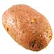  One potato, two potato,  Three potato, four,  Five potato, six potato,  Seven potato, more.  The teacher then asks, “What does more mean?” She adds another potato to the group and says, “What is 7 and 1 more? Let’s count!”  This task reviews counting up to 7 objects, as well as the concept of 1 more. In the lesson that follows, students build on this understanding to relate 7 and 1 more to 8. | 5-Groups  Five is a key number in helping children understand 6, 7, 8, 9, and 10. 5-groups organize these numbers as 5 and some more (e.g., 6 is 5 and 1 more or 5 + 1). One easy way to see this relationship is with dots lined up in groups of 5 as pictured below. These make it easy to see each number in relation to 5 (5 + 1, 5 + 2, 5 + 3, 5 + 4, 5 + 5). Without experience with 5-groups, children have little understanding of numbers 6–10 other a general sense that the numbers are getting larger.  Why is this important? The patterns that you see in the dot cards above can be used as tools for solving addition and subtraction problems in Kindergarten and Grade 1. For example, you can easily see that 8 – 3 = 5 and 8 – 5 = 3. You can also see that 8 needs 2 more to make 10.  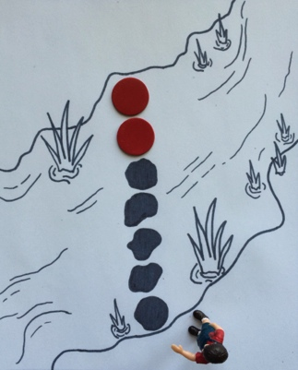  Dots are not the only way to show 5-group formations. Fingers clearly show the relationship between 5 and the numbers 6–10 (5 fingers on one hand and some more fingers on the other hand). A color change at 5 or organization of objects or drawings in groups of 5 can also help children see this important relationship.

