Grade PK • Module 3 • Topics E–H
Family Math Newsletter
Key Standards
- Know number names and the count sequence.
- Count to tell the number of objects.
- Understand that each successive number name refers to a quantity that is 1 larger.
Looking Back
In the first half of Module 3, we expanded on our work with numbers to 5 to explore 6, 7, and 8.
Looking Ahead
In Module 4, students will learn to compare as they explore length, weight, and capacity. They will also strengthen their understanding of numbers as they compare sets of up to 5 objects.

Counting to 10
In the second half of Module 3, students build on their previous number work as they explore groups of 0, 9, and 10 objects. More time is spent with 10, since it is important for understanding place value in later grades. Children learn to touch and count up to 10 objects arranged in different ways (e.g., in a straight line or in a circle) and extend their ability to make tallies, recognize numerals, and count on their fingers the Math Way (from left to right). Students strengthen their understanding of 1 more and discover different ways to take apart numbers (e.g., 10 cubes can be broken up into 9 cubes and 1 cube).
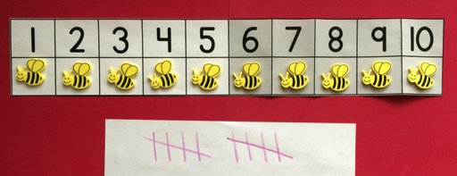
At the Pollen Café, students place bee customers in their seats on the number path and learn to identify the total number of bees both by counting and using the corresponding numerals on the number path. The teacher models how to make tallies before students practice on their own.

Words and Key Terms
Terminology

- Counting the Math Way
- Counting in a circle
- Counting in a line
- Counting in rows
- How many?
- Nine (9)
- Number path
- One more/larger
- One less/smaller
- Put together
- Take apart
- Tally mark
- Ten (10)
- Zero (0)

How to Help at Home
- Touch and count up to ten objects together. During playtime, count up to 10 blocks, lining them up as you count. Stack the blocks and count again. The number of blocks stays the same!
- Look for numerals when walking, driving, or taking the bus. “I see the number 10. Let’s clap 10 times!”
- At snack time, line up 10 blueberries and ask your child to count them. Each time she eats a berry, have her touch and count how many are left.
- Use the illustrations in picture books to count as you read together. “I wonder how many vegetables Mr. McGregor planted in his garden. Let’s count them!”
- Share information about your child’s counting with the teacher. If you notice that your child is skipping a number while counting, communicate that in a note to the teacher.

Spotlight on Math Models
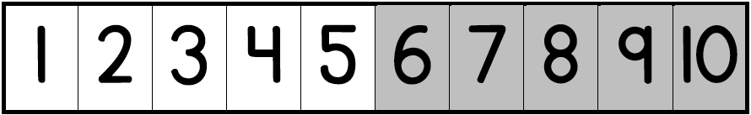
Children will use key mathematical models throughout their elementary years. One of these models is the number path, a tool Pre-K students will use to connect counting and numbers 1–10.

Sample Activity  (from Module 3, Lesson 29)  Pollen Café  As waiters at the Pollen Café, students place bee customers in special seats on the number path. Then, they tally the orders for flowers.  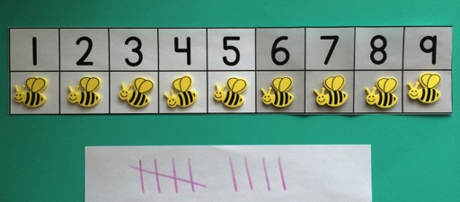  Children bring back the correct number of flowers and give each bee a snack.  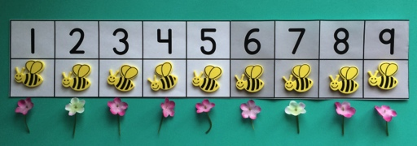  This task reviews counting up to 9 objects and introduces tallying to 9. The number path supports children in counting and matching their count to a numeral. | Number Path  The number path is used in Pre-K, Kindergarten, and Grade 1 to help children work with numbers and visualize the number sequence. The number path starts at 1 and has a single space for each number. A color change at 5 shows the relationship between 5 and the numbers 6, 7, 8, 9, and 10.  Starting in Module 1, children began to see the number path to 5 using stairs that show the total number at each step (as pictured on right). In this module, children continue to build the number path to 10, noticing that each number in the sequence is 1 larger.  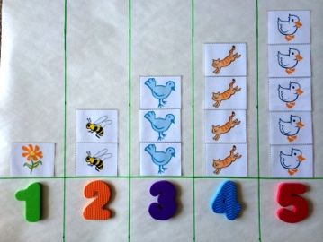  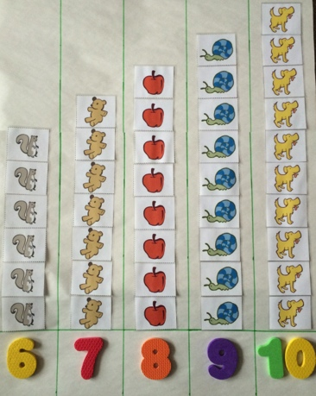  In Module 3, children work with the path in a new way, placing one object in each space on the number path. Children also see that the last number said (and the last space filled) tells the number of objects counted. For example, in the image of the sheep below, the student can touch and count the sheep and come to understand that the numeral 6 tells the total number of sheep.  In Kindergarten and Grade 1, students will learn to use the number path to solve addition and subtraction problems.

