|  |
| --- |
|  |

Lesson 4: From Circle-ometry to Trigonometry

Student Outcomes

* Students define sine and cosine as functions for degrees of rotation of the ray formed by the positive -axis up to one full turn.
* Students use special triangles to geometrically determine the values of sine and cosine for , , and degrees.

Lesson Notes

In the preceding lessons, students have developed the height and co-height functions of a moving car on a Ferris wheel and considered the historical roots of trigonometry through developments in astronomy. In this lesson, we abstract away from these particular examples to define the sine and cosine of a number of degrees of rotation. For consistency with their past experiences with triangle trigonometry, we need to demonstrate that our new functions of sine and cosine are generalizations of the sine and cosine functions of an angle in a triangle studied in geometry. For this lesson we will confine our discussion to rotations by a number of degrees between and . In Lesson 5, we will extend the domain of the sine and cosine functions to the entire real line, and in Lesson 8, we will transition from measuring rotation in degrees to measuring rotation in radians. This entire lesson should be taught without using calculators.

**Notating Trigonometric Functions:** It is convenient, as adults, to use the notation “” to refer to the value of the square of the sine function. However, rushing too fast to this abbreviated notation for trigonometric functions leads to incorrect understandings of how functions are manipulated, which can lead students to think that is short for “” and incorrectly divide out the variable, so that “” becomes “”

To reduce these types of common notation-driven errors later, this curriculum is very deliberate about how and when we use abbreviated function notation for sine, cosine, and tangent:

1. In Geometry, sine, cosine, and tangent are thought of as the value of ratios of triangles, not as functions. No attempt is made to describe the trigonometric ratios as functions on the real line. Therefore, the notation is just an abbreviation for the “sine of an angle” () or “sine of an angle measure” (). Parentheses are used more for grouping and clarity reasons than as symbols used to represent a function.
2. In Algebra II, to distinguish between the ratio version of sine in geometry, all sine functions are notated as functions: is the value of the sine function for the real number , just like is the value of the function for the real number. In this grade, we maintain function notation integrity and strictly maintain parentheses as part of function notation, writing for example, , instead of .
3. By Precalculus, students have had two full years of working with sine, cosine, and tangent as both ratios and functions. It is finally in this year that we begin to blur the distinction between ratio and function notations and write, for example, as the value of the square of the sine function for the real number *,* which is how most calculus textbooks notate these functions.

Classwork

We begin the lesson with an opening exercise that requires that the students find the sine and cosine of an angle in a right triangle with given side lengths so that they recall the previous definitions of the trigonometric ratios. We need students to recall the side lengths of the “special triangles” from geometry, so that is also part of the opening exercise.

Opening Exercises (4 minutes)

Allow students to work in pairs or small groups to encourage recall of triangle trigonometry from geometry. Do not allow the use of calculators.

*Scaffolding:*

* Place a chart at the front of the room showing the relationships between the special triangles (example shown below). Additionally, a visual of the definitions of and in terms of right triangles helps as well.

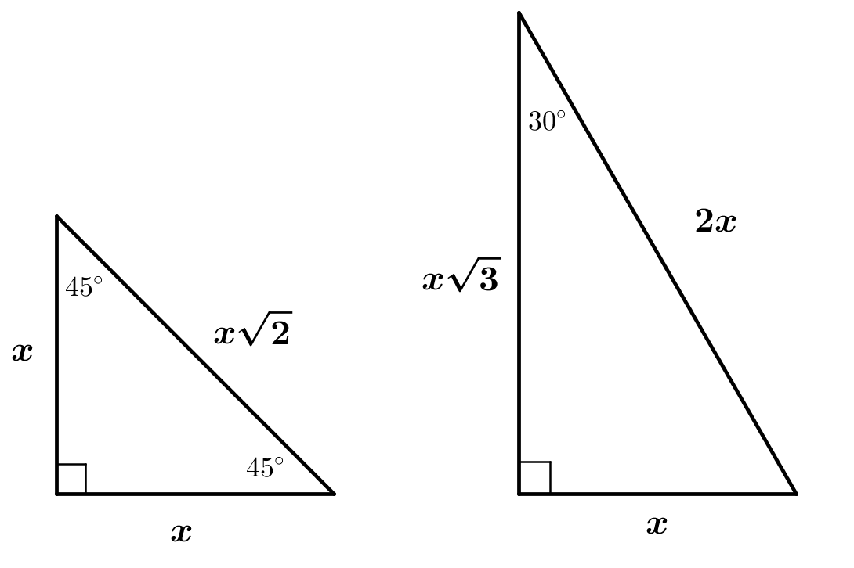

* For students who may be above grade level, show a diagram with a angle and hypotenuse . Ask them to hypothesize about the side lengths and justify their reasoning.

Opening Exercises

1. 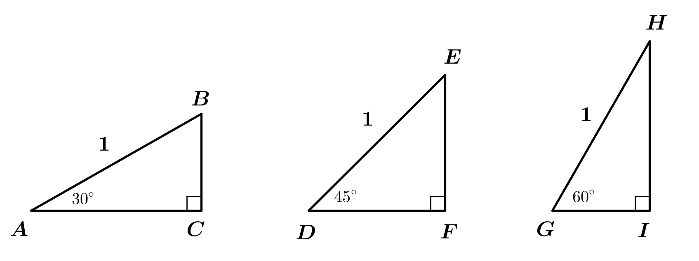Find the lengths of the sides of the right triangles below, each of which has hypotenuse of length .
2. 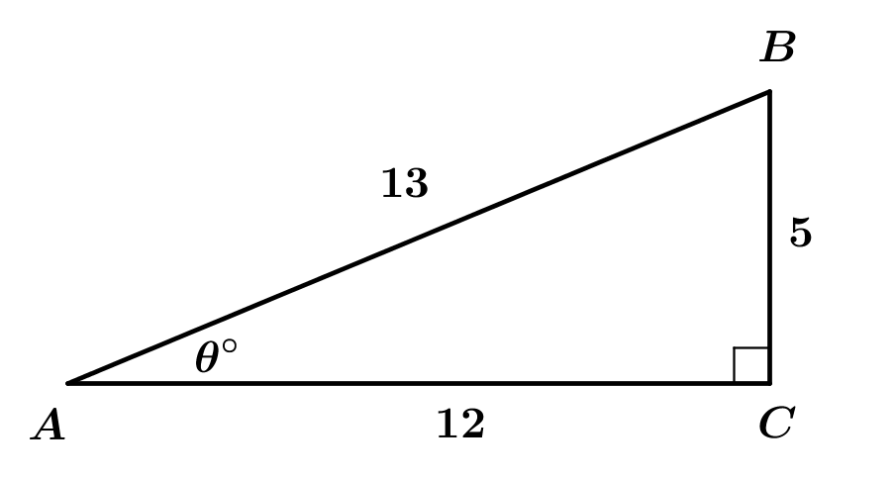Given the following right triangle with , find and .

**Discussion (6 minutes)**

In Lessons 1 and 2 of this module, we defined the height and co-height functions for a passenger car travelling around a Ferris wheel. The following discussion builds students’ abilities to employ MP.4 as they develop a function to model the real-world behavior of the Ferris wheel.

* What was the independent variable for these functions?
  + *The variable was the degrees of rotation of the Ferris wheel from the horizontal reference position to its current position.*
* Since cars on a Ferris wheel travel in a giant circle, can we just generalize height and co-height for movement around any circle? How could we do that?
  + *We can measure the vertical distance from the current point to the horizontal axis as we do on a Ferris wheel for the height function and measure the horizontal distance from the current point to the vertical axis for the co-height function.*
* The radius of the circle doesn’t matter for our discussion since we are concerned with the degrees of rotation of the car on the wheel. So, for simplicity we just count “one radius length” as our unit, and then we’re working on a circle with radius unit. So, we suppose that our circle has radius unit, and we will put the circle on a coordinate grid. The simplest place to put the circle is centered at the origin. What is the equation of this circle?
  + *The equation of the circle is* .
* The circle with equation is known as the *unit circle* because its radius is one unit.
* Just as the sun rises in the east and has an angle of elevation of at its easternmost point, we will consider the point furthest to the right to be our point of reference. What are the coordinates of this point on the unit circle?

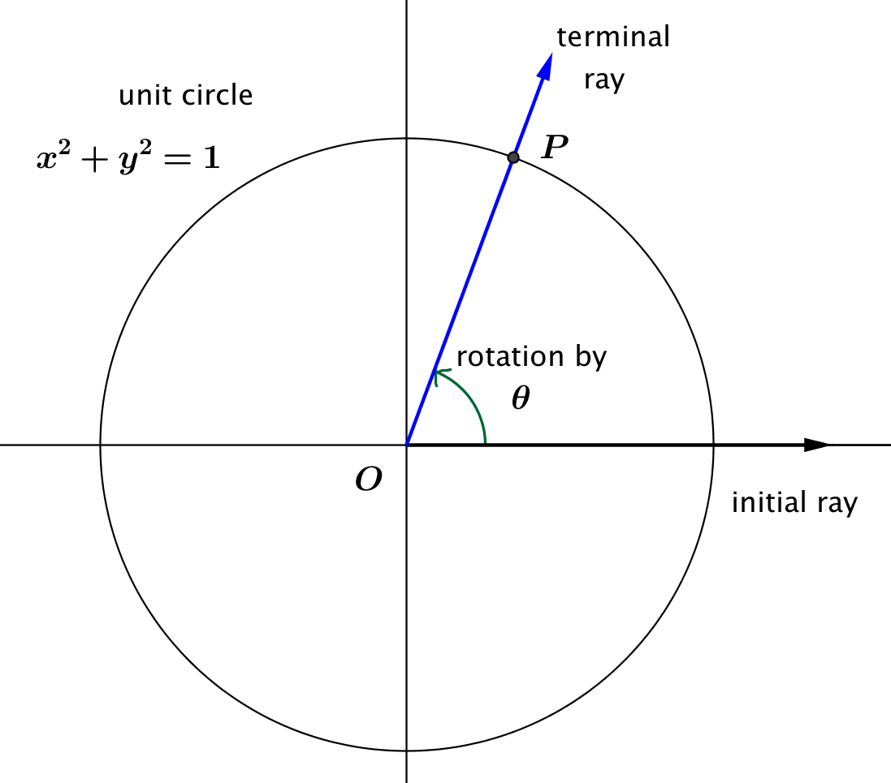

* We will consider the rotation of the *initial ray*, which is the ray formed by the positive -axis, and let point be the intersection of the initial ray with the unit circle. Suppose that the initial ray has been rotated degrees counterclockwise around the unit circle, where , so that point stays in the first quadrant.
* After the rotation of the initial ray by degrees, let the coordinates of point be . Let denote the center of the circle, and let denote the reference point . Drop a perpendicular segment from to ray that intersects at point . What are the coordinates of point ?

*Scaffolding:*

For students not quite ready for this level of abstraction, use the specific point instead of the generic point to make the connection between height/co-height and sine/cosine. Then skip Example 1.

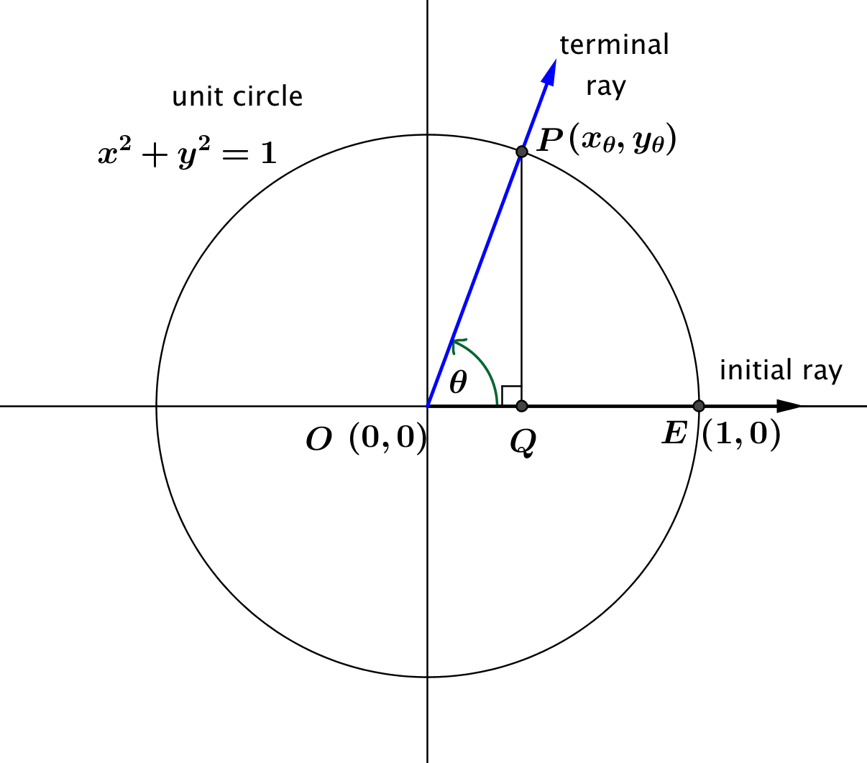

* + *The coordinates of are .*
* What do we know about the lengths , , and ?
* *We know that because this is a circle of radius . Also, , and .*
* What are the height and co-height of point ?
  + *The height of is , and the co-height of is .*
* What kind of triangle is ?

**MP.4**

* *A right triangle with right angle at .*
* Using triangle trigonometry, what are and ?
* *By trigonometry*, , *and .*
* What can we conclude about the height and co-height of point and the sine and cosine of where   
  ? In this case, the corresponding point is in the first quadrant.
* *If , then is the same as the height of the corresponding point , and is the same as the co-height of .*

Example 1 (3 minutes)

Example 1

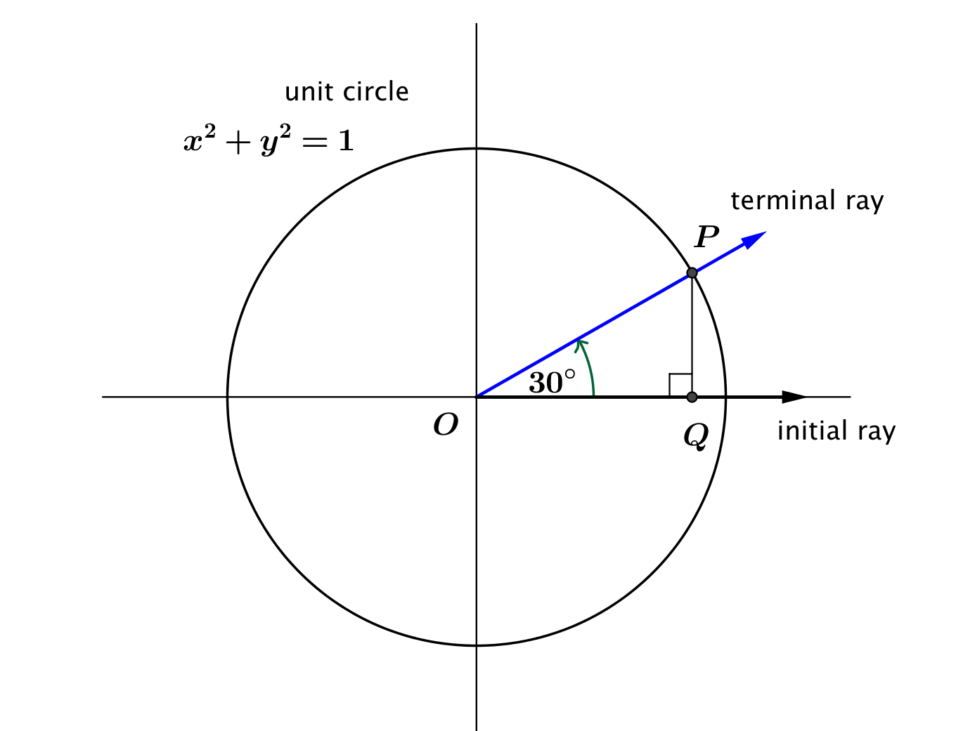Suppose that point is the point on the unit circle obtained by rotating the initial ray through . Find and

*Scaffolding:*

For struggling students, provide a review of the side lengths of -- and -- triangles.



What is the length of the horizontal leg of our triangle?

By remembering the special triangles from geometry, we have .

**What is the length of the vertical leg of our triangle?**

Either by the Pythagorean theorem or by remembering the special triangles from geometry, we have .

What is ?

What is ?

Exercises 1–2 (4 minutes)

These exercises serve to review the special triangles from geometry and to tie together the ideas of the height and   
co-height functions and the sine and cosine functions. Have students complete these exercises in pairs.

Exercises 1–2

1. Suppose that is the point on the unit circle obtained by rotating the initial ray through . Find and .

**We have and .**

1. Suppose that is the point on the unit circle obtained by rotating the initial ray through . Find and .

**We have and .**

**Discussion (3 minutes)**

* Remember that sine and cosine are functions of the number of degrees of rotation of the initial horizontal ray moving counterclockwise about the origin. So far, we have only made sense of sine and cosine for degrees of rotation between and , but the Ferris wheel doesn’t just rotate and then stop; it continues going around the full circle. How can we extend our ideas about sine and cosine to any counterclockwise rotation up to ?
* *Solicit ideas from the class. Guide them to realize that since the height and co-height functions are defined on all points of the circle, we can define sine and cosine for any number of degrees of rotation around the circle.*

Example 2 (3 minutes)

For this example, you might choose to ask the students to develop conjectures for and and to justify these conjectures with words or diagrams. This is an opportunity to build students’ abilities with MP.3.

Example 2

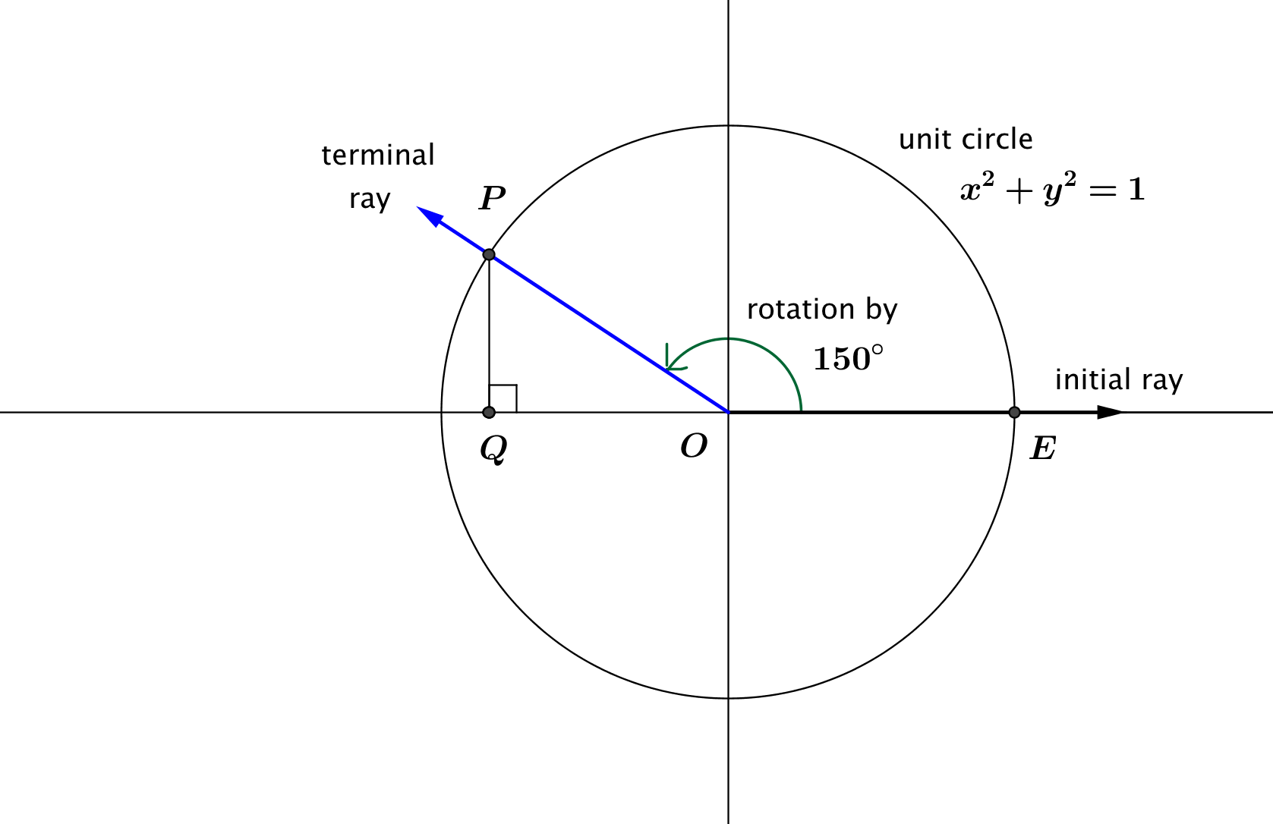Suppose that is the point on the unit circle obtained by rotating the initial ray through . Find and

Notice that the angle formed by rays and is exterior to the right triangle . Angle is the *reference angle* for rotation by . We can use symmetry and the fact that we know the sine and cosine ratios of to find the values of the sine and cosine functions for degrees of rotation.

* What are the coordinates of point ?
  + *Using symmetry, we see that the -coordinate of is the same as it was for a rotation but that the -coordinate is the opposite sign as it was for a rotation. Thus*

**MP.3**

* What is ?
* What is ?

Discussion (8 minutes)

* In general if we rotate the initial ray through more than , then the *reference angle* is the acute angle formed by the terminal ray and the -axis. In the following diagrams, the measure of the reference angle is denoted by , the Greek letter phi. Let’s start with the case where the terminal ray is rotated into the second quadrant.

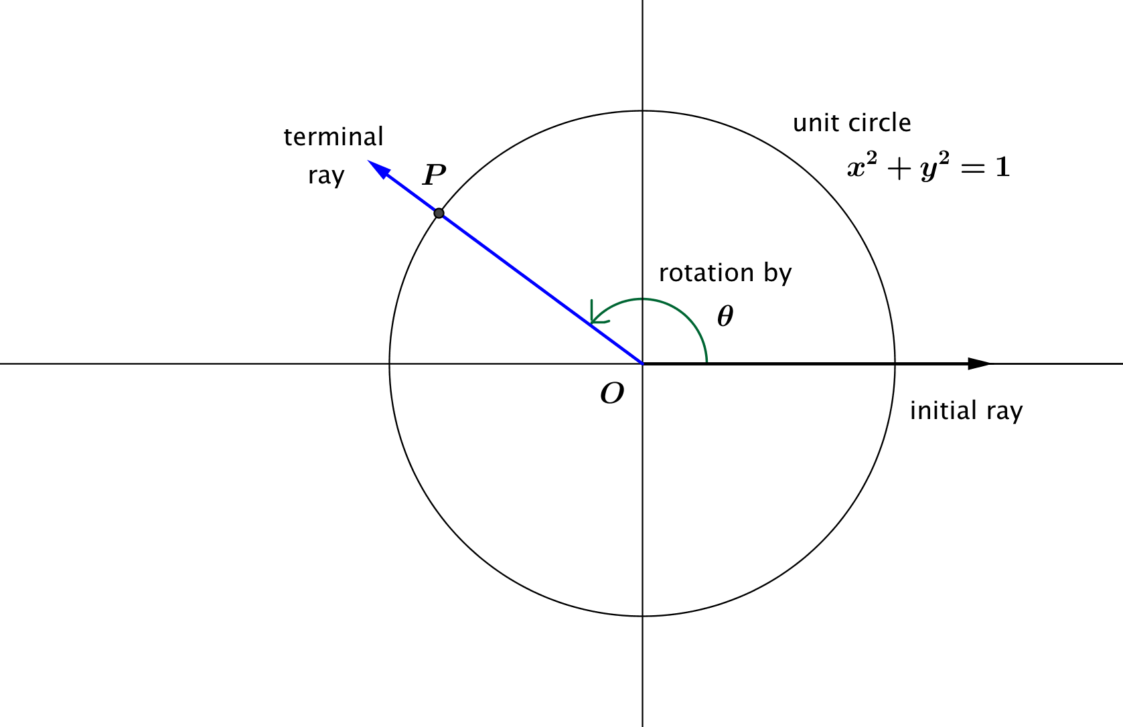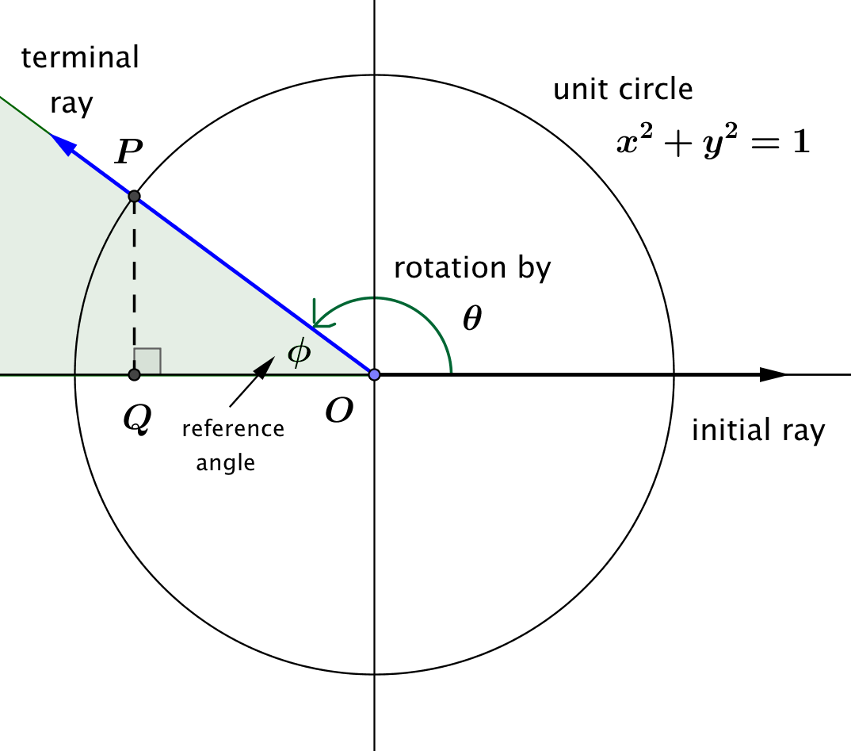

*Scaffolding:*

To provide support with the term *reference angle*, have students create a graphic organizer in which they divide the page into four quadrants, draw a unit circle in the 1st quadrant with the terminal ray in quadrant I, draw a unit circle in the 2nd quadrant with the terminal ray in quadrant II, etc. Have students shade in the interior of the reference angles in all four cases before proceeding.

* If , then the terminal ray of the rotation by lies in the second quadrant. The reference angle formed by the terminal ray and the -axis has measure and is shaded in green in the figure on the right above. How does relate to ?
* If we let be the foot of the perpendicular from to the -axis, then is a right triangle. How can we find the lengths and ?

*Scaffolding:*

For students not quite ready for this level of abstraction, use for this discussion instead of a generic number .

* + *We can use triangle trigonometry:* *and*
* How can we use these lengths to find the coordinates of point ?
  + *Since the -coordinate of is negative, and is the origin, then the  
    -coordinate of*  *is* . *Since the -coordinate of is positive, then the -coordinate of is* .
* Summarize by filling in the blanks: If , then rotation by degrees places in the second quadrant, with reference angle of measure . Then ? ?
* For example, what is ?
* What is

Ask students to turn to their neighbor or partner and summarize the main points of the previous discussion. Ask for a volunteer to present their summary to the class.

* + *The sine and cosine of a degree measure that rotates point outside of the first quadrant can be found by looking at the sine and cosine of the measure of the reference angle. We can find coordinates of point by looking at the sine and cosine for the measure of the reference angle and then assign negative signs where the coordinate would be negative.*

You might choose to assign half of your students to work on the case when the terminal ray is located in the third quadrant and the other half to work on the case when the terminal ray is located in the fourth quadrant, or you might choose to continue to lead the whole class in a discussion for these cases. In either case, be sure to summarize the results for the remaining two quadrants.

* In the diagram below, , so that point is in the third quadrant. Then, we know that both the   
  -coordinate and -coordinate of will be negative.

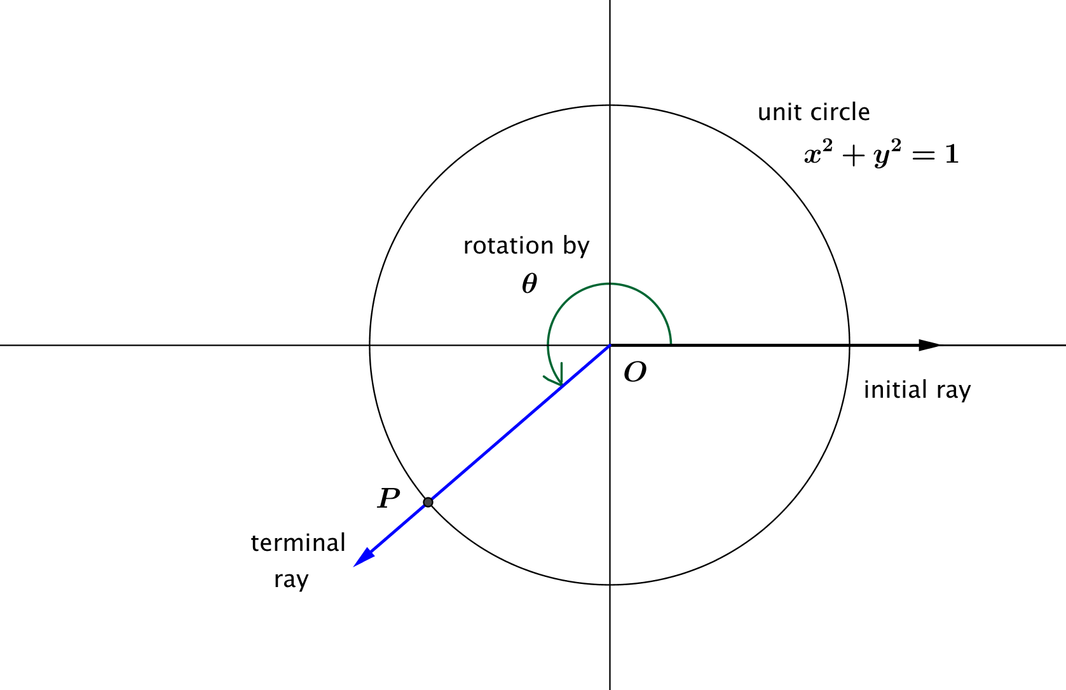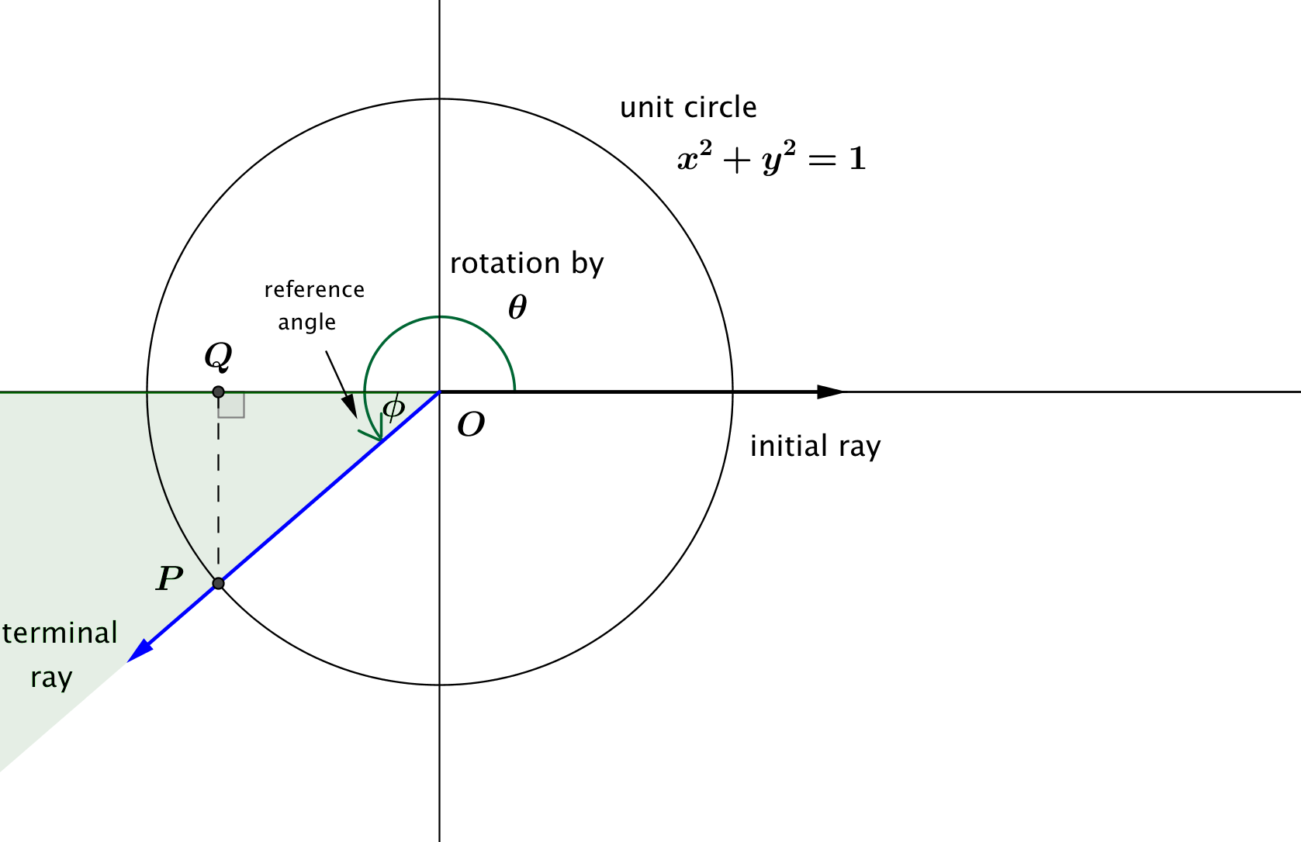

* If , then the terminal ray of the rotation by lies in the third quadrant. The reference angle formed by the terminal ray and the -axis has measure and is shaded in green in the figure on the right above. How does relate to ?
* If we let be the foot of the perpendicular from to the -axis, then is a right triangle. How can we find the lengths and ?
  + *We can use triangle trigonometry:* *and*
* How can we use these lengths to find the coordinates of point ?
  + *Since the -coordinate of is negative, and is the origin, then the -coordinate of is . Since the -coordinate of is also negative, then the -coordinate of is .*
* Summarize by filling in the blanks: If , then rotation by degrees places in the third quadrant, with reference angle of measure . Then ? ?
* For example, what is ?
* What is ?
* In the diagram below, , so that point is in the fourth quadrant. Then, we know that both the -coordinate and -coordinate of will be negative.

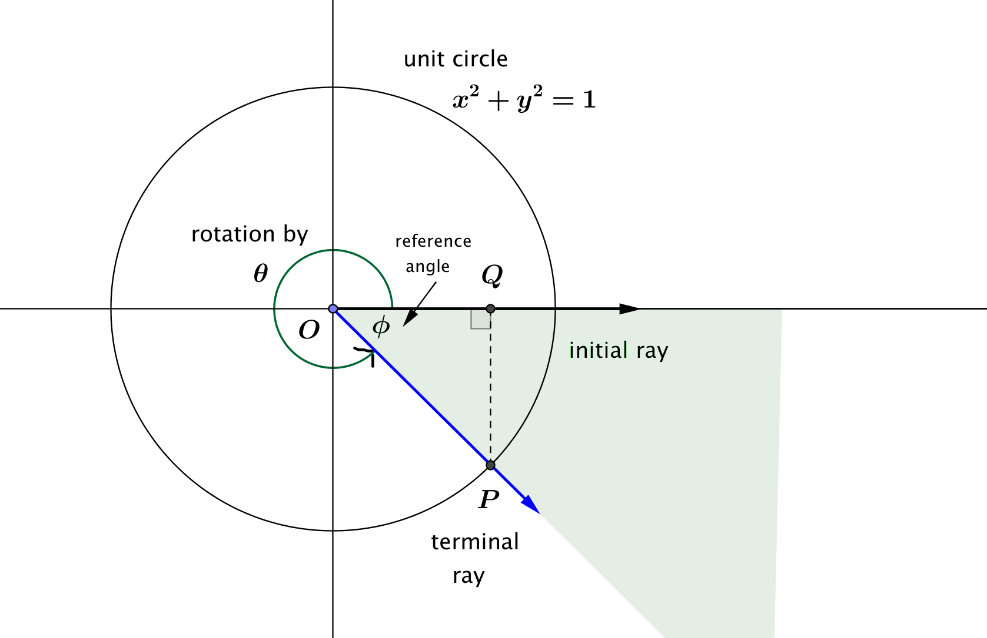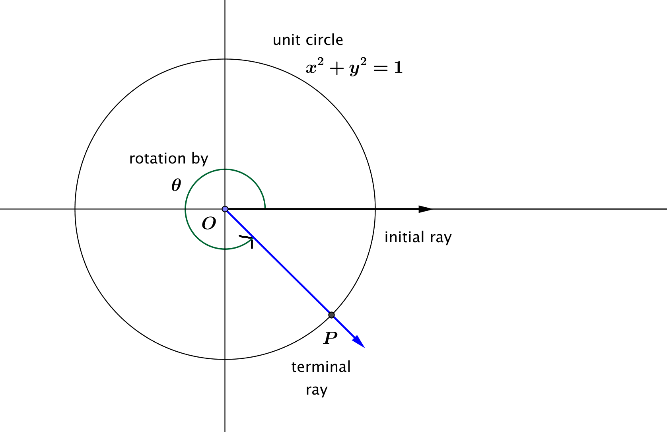

* If , then the terminal ray of the rotation by lies in the fourth quadrant. The reference angle formed by the terminal ray and the -axis has measure and is shaded in green in the figure on the right above. How does relate to ?
* Again, we let be the foot of the perpendicular from to the -axis, then is a right triangle.
* How can we use the lengths and to find the coordinates of point ?
  + *Since the -coordinate of is positive, and is the origin, then the -coordinate of*  *is* . *Since the -coordinate of is negative, then the -coordinate of is* .
* Summarize by filling in the blanks: If , then rotation by degrees places in the fourth quadrant, with reference angle of measure . Then ? ?

*Scaffolding:*

For students not quite ready for this level of abstraction, use for this discussion instead of a generic number .

* For example, what is ?
* What is ?

What we have just concluded is very important. We have just extended the definitions of sine and cosine from geometry to most number of degrees of rotation between and , when they were previously only defined on acute angles. In Lesson 5, we’ll extend the domain of the sine and cosine even further by exploring what happens if and what happens if .

Discussion (2 minutes)

Ask students to discuss the following question with their neighbor. After a minute of discussion, lead the students in completing the diagram below to indicate the positive and negative signs of the sine and cosine functions in the four quadrants of the plane.

* How do you know whether and are positive or negative in each quadrant?

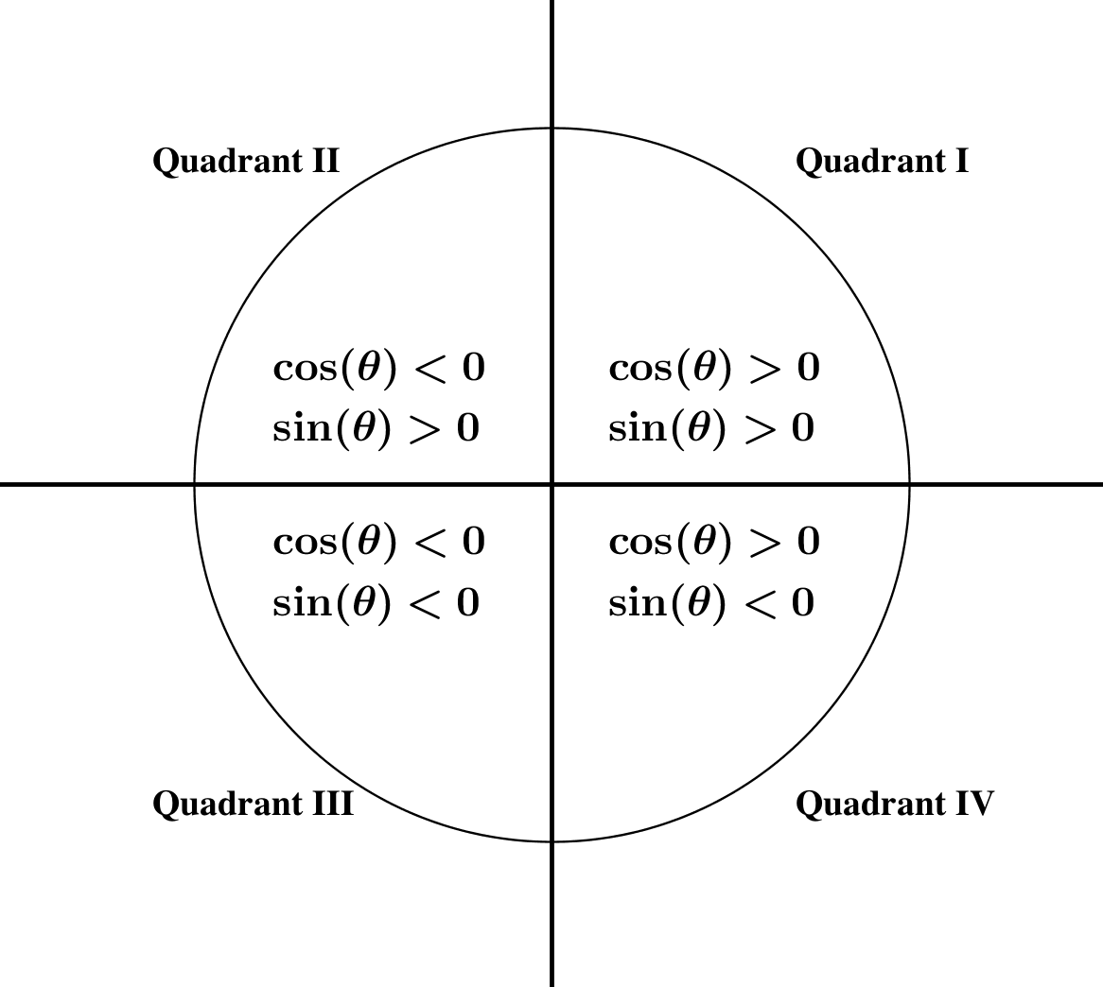  
Discussion

Exercises 3–5 (4 minutes)

These exercises serve to extend our working definition of sine and cosine from to most numbers of degrees of rotation such that . Have students complete these exercises in pairs while the teacher circulates around the room and models as necessary.

Exercises 3–5

1. Suppose that is the point on the unit circle obtained by rotating the initial ray through degrees. Find the measure of the reference angle for , then find and .

**The measure of the reference angle for is . We have and**

1. Suppose that is the point on the unit circle obtained by rotating the initial ray through . Find the measure of the reference angle for , then find and .

**The measure of the reference angle for is . We have and**

1. Suppose that is the point on the unit circle obtained by rotating the initial ray through degrees. Find the measure of the reference angle for , then find and .

**The measure of the reference angle for is . We have and**

**Discussion (2 minutes)**

* We have now made sense of the sine and cosine functions for most numbers of degrees of rotation such that . In the next lesson, we will extend the domains of these two functions even further, so that they will be defined for any real number .
* The values of the sine and cosine functions at rotations of , , and degrees and multiples of these rotations come up often in trigonometry. The diagram below summarizes the coordinates of these commonly referenced points.

  
Discussion

* Use the diagram to find .
* Use the diagram to find .

Closing (2 minutes)

Ask students to summarize the important parts of the lesson, either in writing, to a partner, or as a class. Use this as an opportunity to informally assess understanding of the lesson. The following are some important summary elements:

Lesson Summary

**In this lesson we formalized the idea of the height and co-height of a Ferris wheel and defined the sine and cosine functions that give the and coordinates of the intersection of the unit circle and the initial ray rotated through   
 degrees, for most values of with .**

* **The value of is the -coordinate of the intersection point of the terminal ray and the unit circle.**
* **The value of is the -coordinate of the intersection point of the terminal ray and the unit circle.**
* **The sine and cosine functions have domain of all real numbers and range .**

Exit Ticket (4 minutes)

Name Date

Lesson 4: From Circle-ometry to Trigonometry

Exit Ticket

1. How did we define the sine function for a number of degrees of rotation , where ?
2. Explain how to find the value of without using a calculator.

Exit Ticket Sample Solutions

1. How did we define the sine function for a number of degrees of rotation , where ?

**First we rotate the initial ray counterclockwise through degrees and find the intersection of the terminal ray with the unit circle. This intersection is point The -coordinate of point is the value of .**

1. Explain how to find the value of without using a calculator.

**The reference angle for and angle of measure has measure , and a rotation by counterclockwise places the terminal ray in the 3rd quadrant, where both coordinates of the intersection point will be negative. So, .**

Problem Set Sample Solutions

1. Fill in the chart, and write in the reference angles and the values of the sine and cosine for the indicated rotation numbers.

|  |  |  |  |
| --- | --- | --- | --- |
| Amount of rotation,  , in degrees | Measure of  Reference Angle |  |  |
|  |  |  |  |
|  |  |  |  |
|  |  |  |  |
|  |  |  |  |
|  |  |  |  |
|  |  |  |  |
|  |  |  |  |

1. Using geometry, Jennifer correctly calculated that . Based on this information, fill in the chart:

|  |  |  |  |
| --- | --- | --- | --- |
| Amount of rotation,  *,* in degrees | Measure of  Reference Angle |  |  |
|  |  |  |  |
|  |  |  |  |
|  |  |  |  |
|  |  |  |  |

1. Suppose and What is the value of ?
2. Suppose and . What is the value of ?
3. If , what are two possible values of ?

**or**

1. Johnny rotated the initial ray through degrees, found the intersection of the terminal ray with the unit circle, and calculated that . Ernesto insists that Johnny made a mistake in his calculation. Explain why Ernesto is correct.

Johnny must have made a mistake since the sine of a number cannot be greater than .

1. If and we know that , then what is the smallest possible positive value of ?
2. The vertices of triangle have coordinates , and .
   1. Argue that is a right triangle.

Clearly is horizontal and is vertical, so is a right triangle.

* 1. What are the coordinates where the hypotenuse of intersects the unit circle ?

Using similar triangles, the hypotenuse crosses the unit circle at .

* 1. Let denote the degrees of rotation from to . Calculate and .

**By the answer to part (b), , and .**

1. The vertices of triangle have coordinates and . The vertices of triangle are at the points and .
   1. Argue that is a right triangle.

Clearly is horizontal and is vertical, so is a right triangle.

* 1. What are the coordinates where the hypotenuse of intersects the unit circle ?

Using similar triangles, the hypotenuse crosses the unit circle at .

* 1. Let denote the degrees of rotation from to . Calculate and .

**By the answer to part (b), and .**

* 1. Argue that is a right triangle.

The lengths of the sides of the triangle satisfy the Pythagorean theorem, so is a right triangle.

* 1. What are the coordinates where the hypotenuse of intersects the unit circle ?

Using similar triangles, the hypotenuse crosses the unit circle at .

* 1. Let denote the degrees of rotation from to . Calculate and .

**By the answer to part (e), and .**

* 1. What is the relation between the sine and cosine of and the sine and cosine of ?

**We find that and .**

1. Use a diagram to explain why but

**Let be the center of the circle, let and be the points where the terminal rays of rotation by and and let and be the feet of the perpendicular lines from and to the -axis, respectively. Then and are both isosceles right triangles with hypotenuses of length , so they are congruent. Thus, , and . Let the coordinates of and be and . Then ,and . Then we have and**

