Lesson 4: From Circle-ometry to Trigonometry

Classwork

Opening Exercises

1. 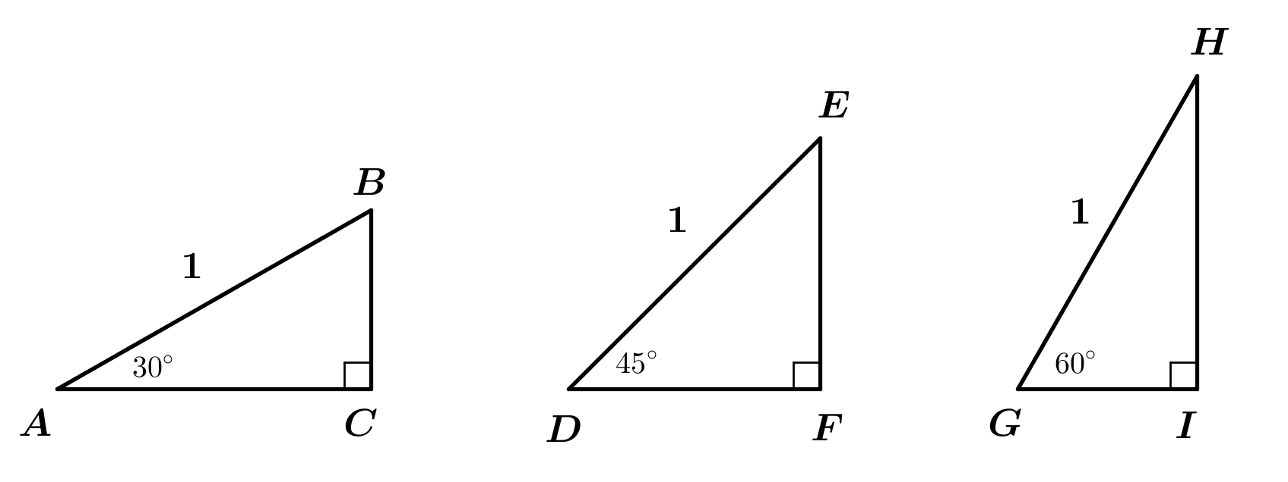Find the lengths of the sides of the right triangles below, each of which has hypotenuse of length .
2. 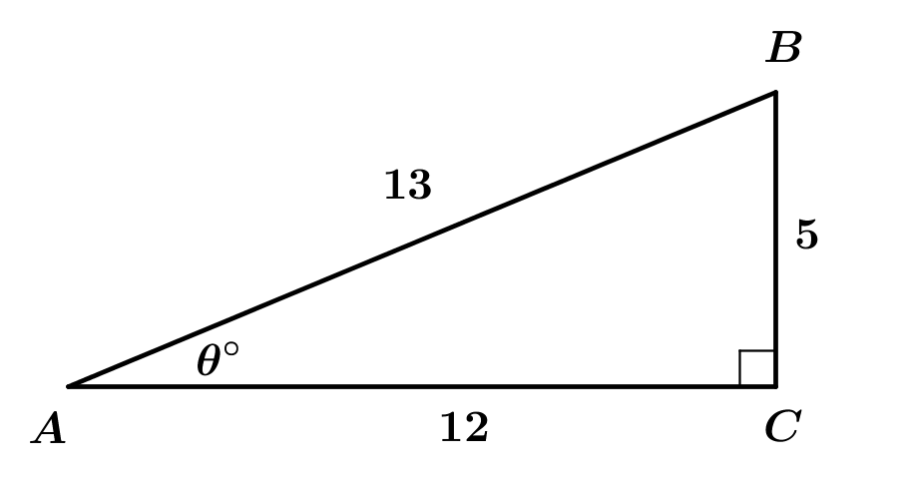Given the following right triangle with , find and .

**Example 1**

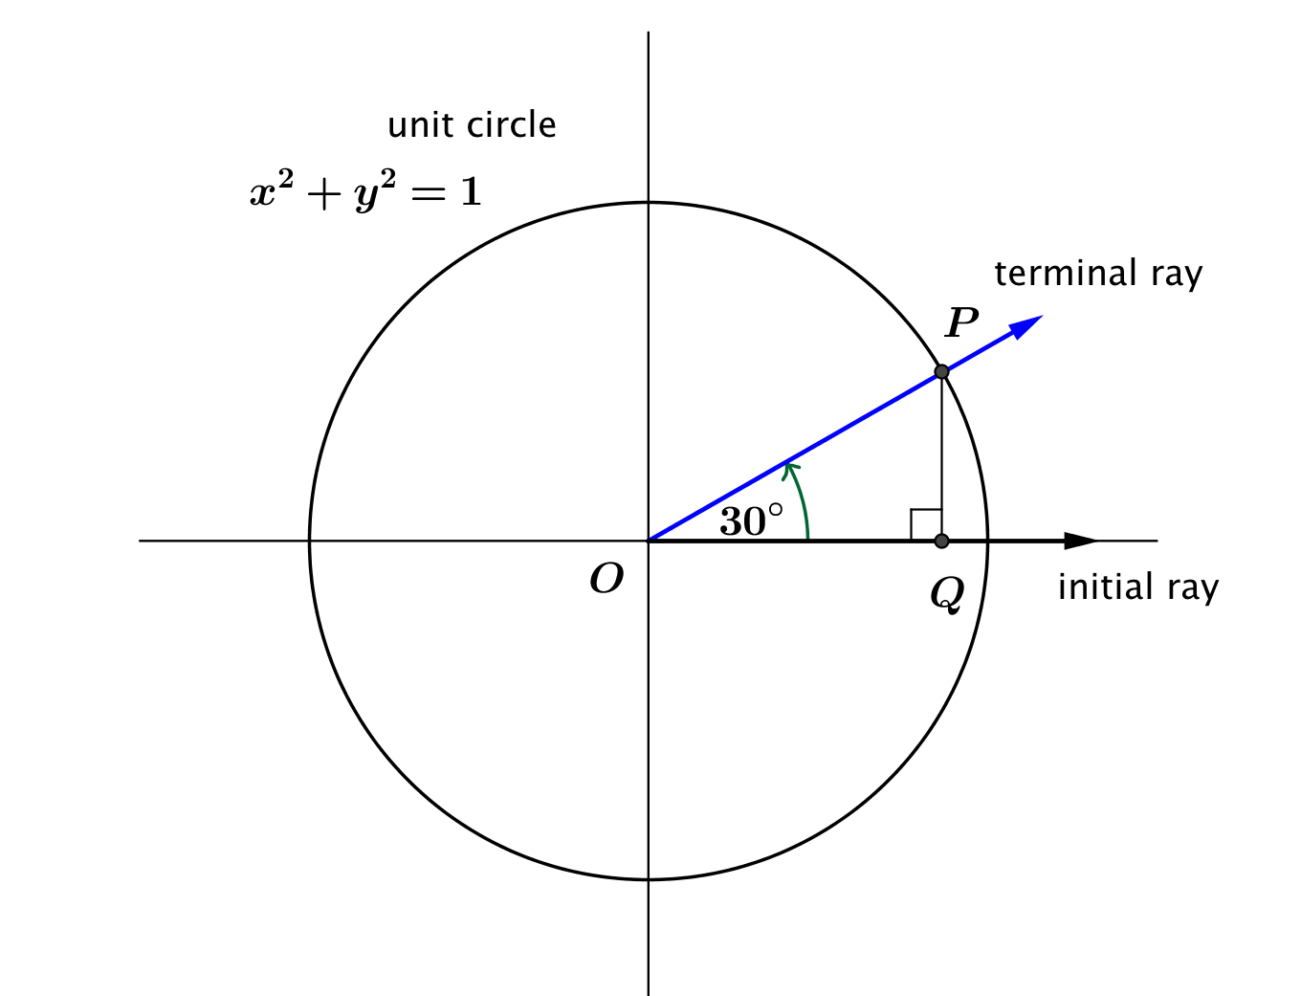Suppose that point is the point on the unit circle obtained by rotating the initial ray through . Find and

What is the length of the horizontal leg of our triangle?

What is the length of the vertical leg of our triangle?

What is ?

What is ?

Exercises 1–2

1. Suppose that is the point on the unit circle obtained by rotating the initial ray through . Find and .
2. Suppose that is the point on the unit circle obtained by rotating the initial ray through . Find and .

**Example 2**

Suppose that is the point on the unit circle obtained by rotating the initial ray through . Find and

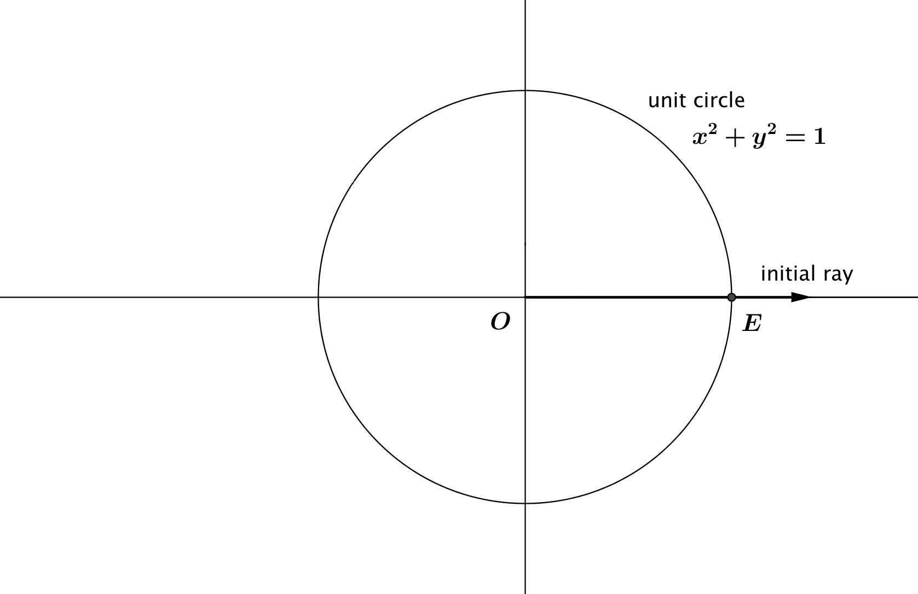

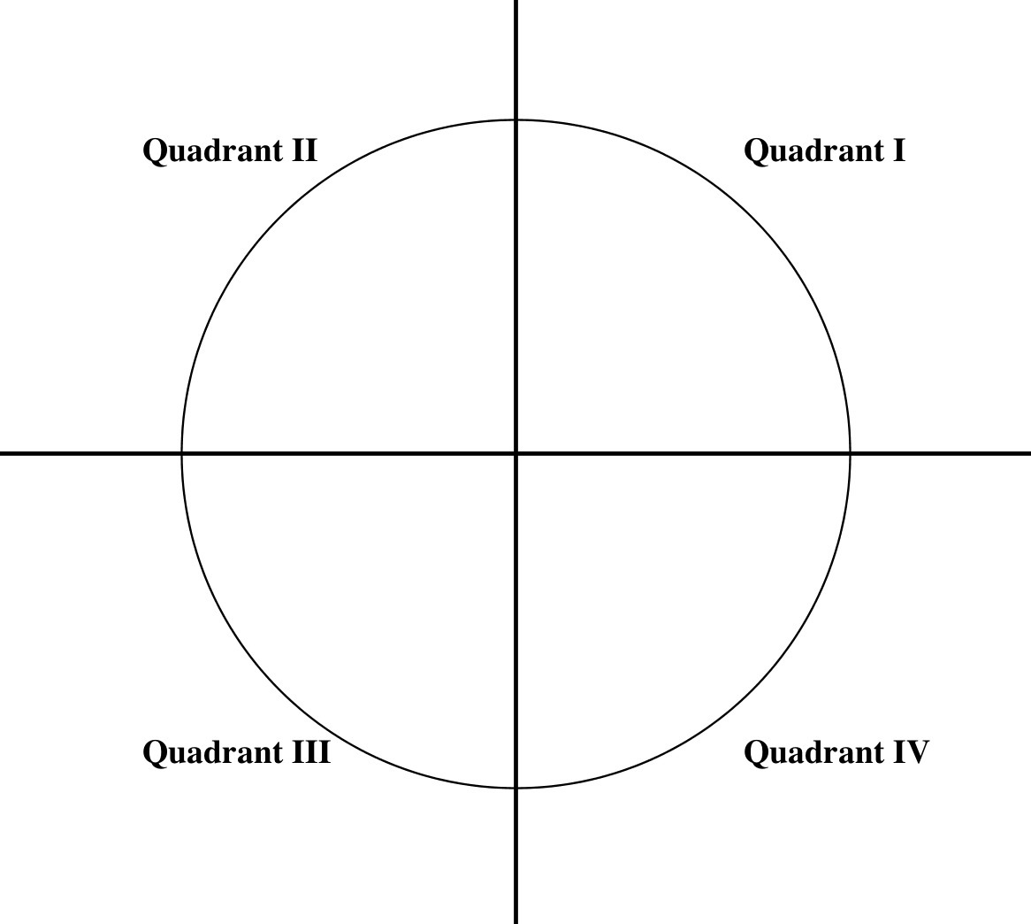Discussion

Exercises 3–5

1. Suppose that is the point on the unit circle obtained by rotating the initial ray through degrees. Find the measure of the reference angle for , then find and .
2. Suppose that is the point on the unit circle obtained by rotating the initial ray through , . Find the measure of the reference angle for , then find and .
3. Suppose that is the point on the unit circle obtained by rotating the initial ray through degrees. Find the measure of the reference angle for , then find and .

Discussion

Lesson Summary

In this lesson we formalized the idea of the height and co-height of a Ferris wheel and defined the sine and cosine functions that give the and coordinates of the intersection of the unit circle and the initial ray rotated through   
 degrees, for most values of with .

* The value of is the -coordinate of the intersection point of the terminal ray and the unit circle.
* The value of is the -coordinate of the intersection point of the terminal ray and the unit circle.
* The sine and cosine functions have domain of all real numbers and range .

Problem Set

1. Fill in the chart, and write in the reference angles and the values of the sine and cosine for the indicated rotation numbers.

|  |  |  |  |
| --- | --- | --- | --- |
| Amount of rotation,  , in degrees | Measure of  Reference Angle |  |  |
|  |  |  |  |
|  |  |  |  |
|  |  |  |  |
|  |  |  |  |
|  |  |  |  |
|  |  |  |  |
|  |  |  |  |

1. Using geometry, Jennifer correctly calculated that . Based on this information, fill in the chart:

|  |  |  |  |
| --- | --- | --- | --- |
| Amount of rotation,  , in degrees | Measure of  Reference Angle |  |  |
|  |  |  |  |
|  |  |  |  |
|  |  |  |  |
|  |  |  |  |

1. Suppose and What is the value of ?
2. Suppose and . What is the value of ?
3. If , what are two possible values of ?
4. Johnny rotated the initial ray through degrees, found the intersection of the terminal ray with the unit circle, and calculated that . Ernesto insists that Johnny made a mistake in his calculation. Explain why Ernesto is correct.
5. If and we know that , then what is the smallest possible positive value of ?
6. The vertices of triangle have coordinates , and .
   1. Argue that is a right triangle.
   2. What are the coordinates where the hypotenuse of intersects the unit circle ?
   3. Let denote the degrees of rotation from to . Calculate and .
7. The vertices of triangle have coordinates , and . The vertices of triangle are at the points ,, and .
   1. Argue that is a right triangle.
   2. What are the coordinates where the hypotenuse of intersects the unit circle ?
   3. Let denote the degrees of rotation from to . Calculate and .
   4. Argue that is a right triangle.
   5. What are the coordinates where the hypotenuse of intersects the unit circle ?
   6. Let denote the degrees of rotation from to . Calculate and .
   7. What is the relation between the sine and cosine of and the sine and cosine of ?
8. Use a diagram to explain why but

