Lesson 3: The Motion of the Moon, Sun, and Stars—Motivating Mathematics

Student Outcomes
- Students explore the historical context of trigonometry as a motion of celestial bodies in a presumed circular arc.
- Students describe the position of an object along a line of sight in the context of circular motion.
- Students understand the naming of the quadrants and why counterclockwise motion is deemed the positive direction of turning in mathematics.

Lesson Notes
This lesson provides us with one more concrete example of observable periodic phenomena before we abstractly define the sine and cosine function used to model circular motion—the observable path of the sun across the sky as seen from earth. The historical roots of trigonometry lie in the attempts of astronomers to understand the motion of the stars and planets and to measure distances between celestial objects.
We will consider the historical development of sine tables from ancient India, from before the sine function had its modern name. We avoid using the terms “sine” and “cosine” as long as possible, delaying their introduction until the end of this lesson when we relate the ancient measurements to the triangle trigonometry that students saw in high school Geometry, which leads into the formal definitions of these functions in the next lesson. Throughout this lesson, we will refer to the functions that became the sine and cosine functions using their original Sanskrit names jya and kojya, respectively. At the end of this lesson, we will explain how the name jya transformed into the modern name sine.
You may choose to have students do further research on the topics in this lesson, including the Babylonian astronomical diaries, Aryabhata I, jya, and early trigonometry. A few Wikipedia pages to use as a starting point for this research are listed at the end of the lesson.

Classwork
The lesson opens with a provocative question with the intent of uncovering what the students already know about the motion of the sun and the planets. If we consider just the system of the earth and the sun, disregarding the other planets, then the earth and sun both revolve around the center of mass of the system, called the barycenter. Because the mass of the sun, $1.99×{10}^{30} kg$, is far greater than the mass of the earth, $5.97×{10}^{24} kg$, the barycenter is very close to the center of the sun. Thus, scientists refer to the convention that the earth “goes around the sun.” However, the apparent motion of the sun in the sky is due to the daily rotation of the earth on its axis, not the motion of the earth orbiting the sun.
Opening (7 minutes)
Read the following prompts aloud and discuss as a class.
Opening
Why does it look like the sun moves across the sky?
The sun essentially stays still, but the earth rotates on its axis once every $24$ hours; so, if an observer was standing in one place for $24$ hours, it would appear that the sun becomes visible in the east, travels across the sky, and sets in the west.
Is the sun moving, or are you moving?
Technically, both are moving, but the sun moves imperceptibly while an observer on the face of the earth rotates away from the sun. I would say that the observer is moving.
In ancient Greek mythology, the god Helios was the personification of the sun. He rode across the sky every day in his chariot led by four horses. Why do your answers make it believable that in ancient times, people imagined the sun was pulled across the sky each day?
If we did not know that the earth rotated every day, then a reasonable explanation would be that the sun moved across the sky each day.

- Today, we know that the earth revolves around an axis once every $24$ hours, and that rotation causes a period of sunlight and a period of darkness that we call a “day.”
- For this lesson, we will imagine that we are stationary and the sun is moving. In fact, we can imagine that we are at the center of a giant Ferris wheel, and the sun is one of the passengers.
This section includes historical facts to lay the groundwork for the way we will approach the example from the beginnings of trigonometry. Although many ancient civilizations have left records of astronomical observations, including the Babylonians and ancient Greeks, we will focus our lesson on some work done in ancient India—primarily the work of Aryabhata I, born in the year A.D. $476$.
- Babylon was a city-state founded in $2286$ B.C. in Mesopotamia, located about $85$ miles south of Baghdad in modern day Iraq.
- The Babylonians wrote in cuneiform, a system of making marks on clay tablets with a stylus made from a reed with a triangular tip. Because clay is a fairly permanent medium, many tablets have survived until modern times, which means that we have a lot of information about how they approached mathematics and science. It wasn’t until $1836$ that the French scholar Eugene Burnouf began to decipher cuneiform so we could read these documents. For example, the tablet shown is known as Plimpton $322$ and dates back to $1800$ BC. It contains a table of Pythagorean triples $(a, b, c)$ written in cuneiform using the Babylonian base-$60$ number system.
Scaffolding:
The words Babylon, cuneiform, stylus, and decipher may need repeated choral rehearsal. The image below can be used to illustrate and explain the word cuneiform.
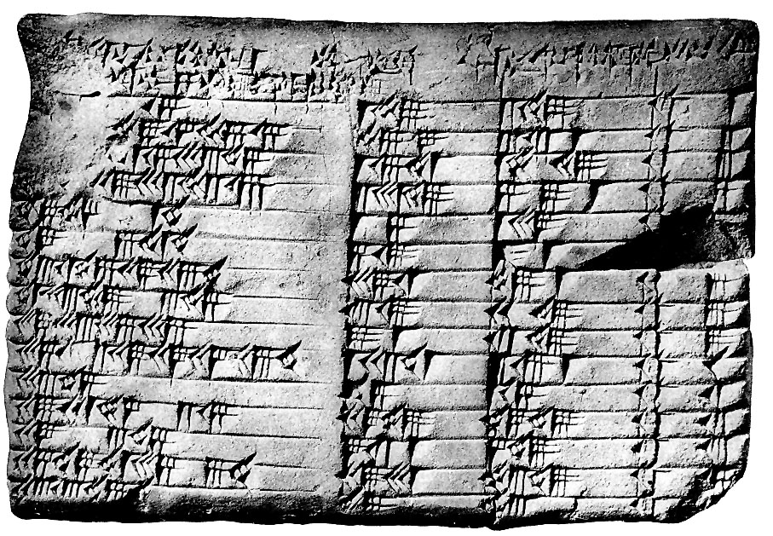
- Babylonian astronomers recorded astronomical phenomena in a set of tablets now known as The Babylonian Astronomical Diaries beginning around the year $750$ B.C. and continuing through the first century B.C.
- The Babylonians observed that stars move in large and roughly circular arcs. From our perspective on earth, the most prominent star, the sun, rises in the east, travels overhead, and then settles in the west prior to repeating its cycle in another twelve hours.
- Babylonian mathematics was influential on the mathematical development of the Egyptians and Greeks, and the Greeks traded goods and knowledge with ancient India. It was in ancient India that new mathematics was developed to describe these celestial observations. The work of the astronomer-mathematician Aryabhata I, born in A.D. $476$, is of particular interest to our discussion.
- In ancient times scholars assumed a geocentric model of the solar system, meaning that the earth was the center of the solar system, and all planets and stars and the sun rotated around earth. We will be assuming this model, even though it contradicts modern scientific convention. In A.D. $1532$, Nicolus Copernicus proposed a heliocentric model of the solar system, which was very controversial at the time but has allowed modern scientists to understand the nature of our solar system and our universe.
- We will assume the Babylonian conjecture—that stars and the sun travel on circular paths around the center of the earth. Then, we will model a star’s physical path relative to an observation point on earth using the mathematics developed by Aryabhata I.
After discussing, ask students to summarize the information to a neighbor. Use this as a moment to informally assess understanding by listening to conversations.
The information above is provided as background information for the teacher and ideally will be presented to students. At a minimum, set the stage for Example 1 by announcing to the class that we will be traveling back in time to the earliest uses of what we now call trigonometry. Ancient astronomers, who at the time believed that the sun and all other celestial bodies revolved around the earth realized that they could model a star’s physical path relative to an observation point on earth using mathematics. You may wish to introduce the terms geocentric and heliocentric to your students and post them on a word wall in your classroom. Also, discuss that while Greek and Babylonian mathematicians and astronomers tracked celestial bodies as they moved through the sky, this lesson will focus on the work of Aryabhata I (b. A.D. $476$) of India.

Discussion (7 minutes)
Using the historical context, students model the apparent motion of the sun with the earth as the center of its orbit. Guide the class through this example, using the board. Students should follow along in their notes, copying diagrams as necessary. The instructor should begin by drawing a large circle on the board, with its center (a point) clearly indicated:
$E$ (Earth)
$S$ (Sun)
- In this model, we consider an observer at a fixed point $E$ on earth, and we condense the sun to a point $S$ that moves in an apparent circular path around point $E$.
- Suppose that the observer faces north. To this person, the sun appears to travel counterclockwise around a semicircle, appearing (rising) in the east and disappearing (setting) in the west. Then, the path of the sun can be modeled by a circle with the observer at the center, and the portion where the sun can be seen is represented by the semicircle between the eastern-most and western-most points. Note to teacher: This set-up does put the center of the circle as a point on the surface of earth and not as the point at the center of the earth. We can disregard this apparent discrepancy because the radius of the earth, $3963$ miles, is negligible when compared to the $93$ million mile distance from the earth to the sun.
- A full revolution of the sun, $S$, around the circle represents a day, or $24$ hours.
- To our observer, the sun is not visible at night. How can we reflect this fact in our model?
  - When the sun travels along the lower semi-circle—i.e., below the line of the horizon—the sun is not visible to the observer. So we shade the lower half of the circle, which reflects night time. We will not consider the position of the sun when it cannot be seen.
Earth
Sun
(Visible by day)
Sun
Not visible at night

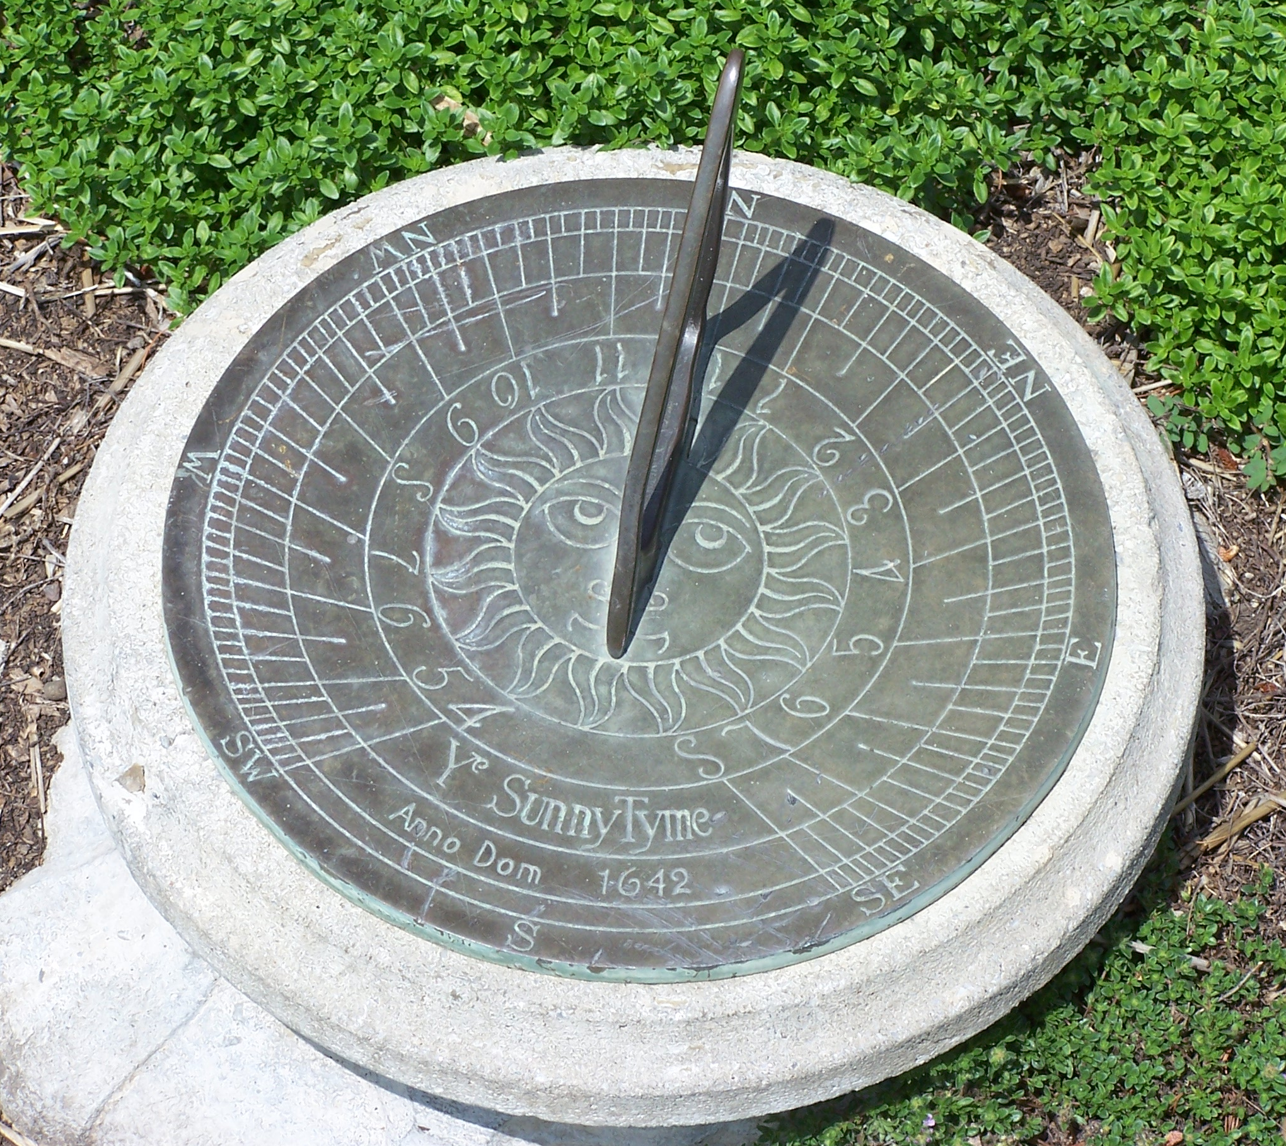
- Recall that the sun rises in the east and sets in the west, so its apparent motion in our model is counterclockwise. Indeed, this is where our notion of clockwise and counterclockwise comes from; if we are in the Northern Hemisphere, as the sun moves counterclockwise, shadows move clockwise. Thus, the shade on a sundial used to mark the passage of time moves in the opposite direction as the sun across the sky. This is why our clocks go “clockwise,” but the sun travels “counterclockwise.”
- Accordingly, to model the movement of the sun, we measure the angle of elevation of the sun as it moves counterclockwise, as shown:
$$r$$
$E$
$$S$$
$$θ$$
Discuss the information provided in the Student Materials.
In mathematics, counterclockwise rotation is considered to be the positive direction of rotation, which runs counter to our experience with a very common example of rotation: the rotation of the hands on a clock.
- Is there a connection between counterclockwise motion being considered to be positive and the naming of the quadrants on a standard coordinate system?
Yes! The quadrants are ordered according to the (counterclockwise) path the sun takes, beginning when it rises from the east.
$$II$$
$$I$$
$$III$$
$$IV$$
$$r$$
$E$
$$S$$
$$θ$$
Sun rises here
Sun sets here

- What does the circle’s radius, $r$, represent?
The radius length $r$ represents the distance between the center of the earth and the center of the sun.

- We can describe the position of the sun relative to the earth using only the distance $r$ and the angle of elevation of the sun with the horizon (the horizontal line through point $E$). Since we are assuming the sun travels along a circular path centered at $E$, the radius is constant. Thus, the location of the sun is determined solely by the angle of elevation $θ$.
- Remember that astronomers were interested in the “height” of the stars and planets above earth. Since we cannot just build a really tall ladder and take measurements, they had to devise other ways to estimate these distances. This notion of measuring the “height” of the stars and planets above Earth is similar to how we measured the height of the passenger car on a Ferris Wheel in the previous lessons.
Before introducing the work of Aryabhata that led to trigonometry, have students summarize the work in this example by responding to the question below and discussing their thoughts with a partner. Have a few students share out to the whole class as well.

- How has the motion of the sun influenced the development of mathematics?
The naming of the quadrants and the idea of measuring rotations counterclockwise make sense in terms of how we perceive the movement of stars and planets on Earth.

- How is measuring the “height” of the sun like measuring the Ferris wheel passenger car height in the previous lessons?
Both situations relate a vertical distance to a measurement of rotation from an initial reference point.

Discussion (4 minutes)
Scaffolding:
- The words Aryabhata, jya, and kojya can be chorally repeated by students. Point to these terms on the image while asking students to repeat them out loud.
- For advanced learners, describe the terms in words only and have them draw the diagram or label the appropriate parts of a diagram without having seen the image first.
In this section, we discuss the historical terms used by Aryabhata I in his astronomical work that led to trigonometry. Indian names are spelled phonetically in the Roman alphabet, so Aryabhata is pronounced “Ar-yah-bah-ta.”
- The best-known work of the Indian scholar Aryabhata I, born in A.D. $476$, is the Aryabhatiya, a compilation of mathematical and astronomical results that was not only used to support new developments in mathematics in India and Greece but also provides us with a snapshot of what was known at that time. We will be using his developments to model the position of the sun in the sky. Aryabhata I spoke and wrote in the Sanskrit language.
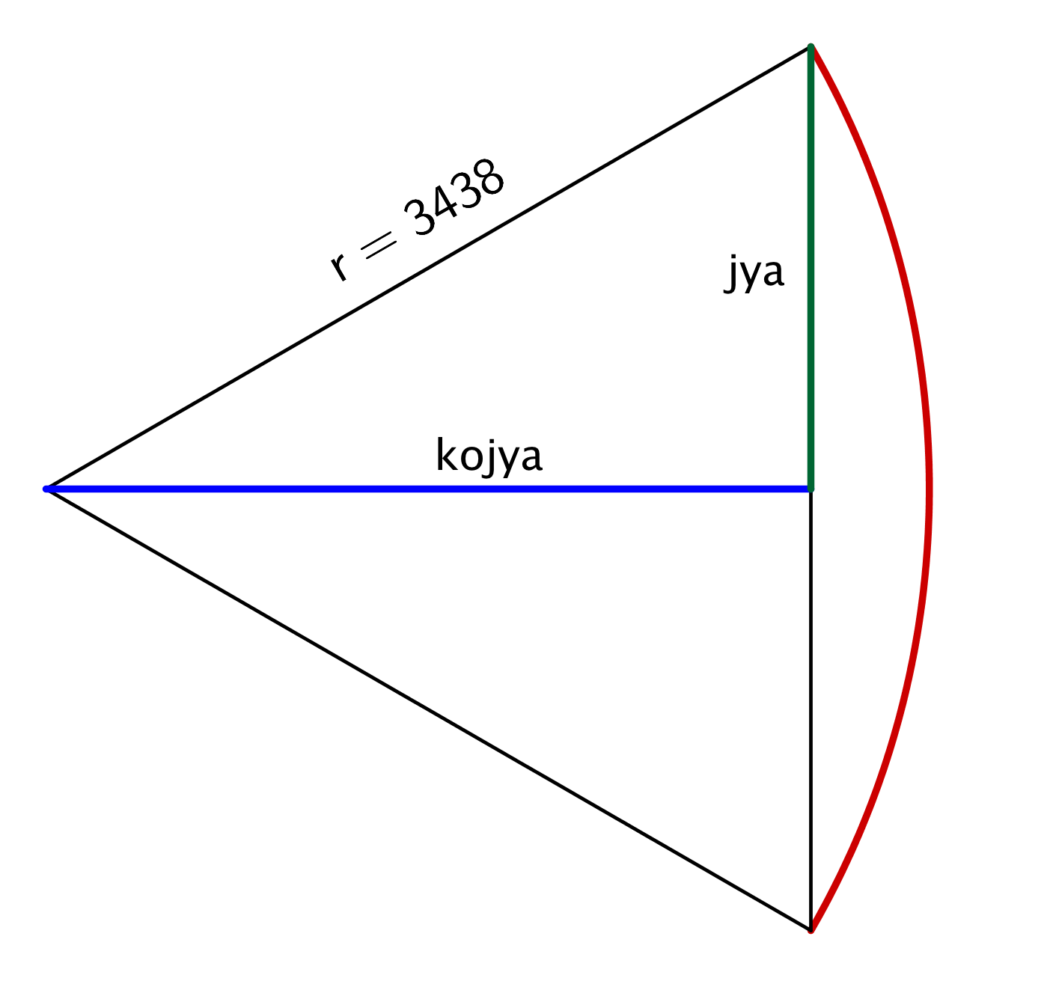
- An arc of a circle is like a bow, and the chord joining the ends of the arc is like a bowstring. The Sanskrit word for bow string is samastajya. Indian mathematicians often used the half-chord ardhajya, so Aryabhata I used the abbreviation jya (pronounced “jhah”) for half of the length of the chord joining the endpoints of the arc of the circle.
- The term koti-jya, often abbreviated in Indian texts as kojya, means the side of a right angled triangle, one of whose sides is the jya.
- Indian astronomers used a value of $r=3438$ to represent the distance from the earth to the sun because this is roughly the radius of a circle whose circumference is $360°=\left(360∙{60}^{'}\right)=21,600'$, measured in minutes.
Exercises 1–3 (12 minutes)
In his text Aryabhatiya, Aryabhata constructed a table of values of the jya in increments of $3\frac{3}{4}°$, which were used to calculate the positions of astronomical objects. The recursive formula he used to construct this table is as follows:
$$s_{1}=225 \\ s_{n+1}=s_{n}+s_{1}-\frac{(s_{1}+s_{2}+⋯+s_{n})}{s_{1}}$$
where $n$ counts the increments of $3\frac{3}{4}°$. Then, $jya\left(n∙3\frac{3}{4}°\right)=s_{n}$.
Exercises 1–4
- Calculate $jya(7\frac{1}{2}°)$, $jya(11\frac{1}{4}°)$, $jya(15°)$, and $jya(18\frac{3}{4}°)$ using Aryabhata’s formula, round to the nearest integer, and add your results to the table below. Leave the rightmost column blank for now.

$$n$$ | $$θ°$$ | $$jya\left(θ\right)$$ | $$3438 sin (θ)$$ |  | $$n$$ | $$θ°$$ | $$jya\left(θ\right)$$ | $$3438 sin (θ)$$
$$1$$ | $$3\frac{3}{4}°$$ | $$225$$ |  |  | $$13$$ | $$48\frac{3}{4}°$$ | $$2585$$
$$2$$ | $$7\frac{1}{2}°$$ |  |  |  | $$14$$ | $$52\frac{1}{2}°$$ | $$2728$$
$$3$$ | $$11\frac{1}{4}°$$ |  |  |  | $$15$$ | $$56\frac{1}{4}°$$ | $$2859$$
$$4$$ | $$15°$$ |  |  |  | $$16$$ | $$60°$$ | $$2978$$
$$5$$ | $$18\frac{3}{4}°$$ |  |  |  | $$17$$ | $$63\frac{3}{4}°$$ | $$3084$$
$$6$$ | $$22\frac{1}{2}°$$ | $$1315$$ |  |  | $$18$$ | $$67\frac{1}{2}°$$ | $$3177$$
$$7$$ | $$26\frac{1}{4}°$$ | $$1520$$ |  |  | $$19$$ | $$71\frac{1}{4}°$$ | $$3256$$
$$8$$ | $$30°$$ | $$1719$$ |  |  | $$20$$ | $$75°$$ | $$3321$$
$$9$$ | $$33\frac{3}{4}°$$ | $$1910$$ |  |  | $$21$$ | $$78\frac{3}{4}°$$ | $$3372$$
$$10$$ | $$37\frac{1}{2}°$$ | $$2093$$ |  |  | $$22$$ | $$82\frac{1}{2}°$$ | $$3409$$
$$11$$ | $$41\frac{1}{4}°$$ | $$2267$$ |  |  | $$23$$ | $$86\frac{1}{4}°$$ | $$3431$$
$$12$$ | $$45°$$ | $$2431$$ |  |  | $$24$$ | $$90°$$ | $$3438$$
$jya\left(7\frac{1}{2}°\right)=449$, $jya\left(11\frac{1}{4}°\right)=671$, $jya\left(15°\right)=890$, and $jya\left(18\frac{3}{4}°\right)=1105$

- Label the angle $θ$, $jya(θ)$, $kojya(θ)$, and $r$ in the diagram shown below.
$$II$$
$$I$$
$$III$$
$$IV$$
$E$
$$S$$
Sun rises here
Sun sets here

MP.7

  - How does this relate to something you’ve done before?
Jya and kojya are lengths of the sides of a right triangle. They are also like the height and co-height functions of the passenger car on a Ferris Wheel.

  - How does $jya(θ)$ relate to a length we already know?
From prior work with triangle trigonometry, $jya\left(θ\right)=r\sin{(θ)}$ and $kojya\left(θ\right)= r cos\left(θ\right)$.

- Use your calculator to compute $r sin (θ)$ for each value of $θ$ in the table from Exercise 1, where $r=3438$. Record this in the blank column on the right in Exercise 1, rounding to the nearest integer. How do Aryabhata’s approximated values from around the year A.D. $500$ compare to the value we can calculate with our modern technology?
The values are surprisingly close.

Discussion (3 minutes)
If we set $r=1$, then $jya\left(α\right)=\sin\left(α\right)$, and $kojya\left(α\right)=\cos\left(α\right)$; so, Aryabhata constructed the first known sine table in mathematics. This table was used to calculate the positions of the planets, the stars, and the sun in the sky.
If the first instance of the function we know now as the sine function started off with the Sanskrit name “jya,” how did it get to be called “sine”?
- We know that Aryabhata referred to this length as jya.
- Transcribed letter-by-letter into Arabic in the 10th century, jya became jiba. In medieval writing, scribes regularly omitted vowels to save time, space, and resources, so the Arabic scribes wrote just jb.
- Since jiba isn’t a real word in Arabic, later readers interpreted jb as jaib, which is an Arabic word meaning cove or bay.
- When translated into Latin around A.D. $1150$, jaib became sinus, which is the Latin word for bay.
- Sinus got shortened into sine in English.

Exercise 4 (7 minutes)
Have the students complete this exercise in groups. While part (a) is relatively straightforward, part (b) will require some thought and discussion.
Scaffolding:
Encourage struggling students to draw a semicircle to represent the path of the sun across the sky. Label the intersections with the horizontal and vertical axes as 6:00 a.m., 12:00 p.m., and 6:00 p.m.

- We will assume that the sun rises at 6:00 a.m., is directly overhead at 12:00 noon, and sets at 6:00 p.m. We measure the “height” of the sun by finding its vertical distance from the horizon line; the horizontal line that connects the eastern-most point, where the sun rises, to the western-most point, where the sun sets.
  - Using $r=3438$, as Aryabhata did, find the “height” of the sun at the times listed in the following table:
Time of day | Height
6:00 a.m.
7:00 a.m.
8:00 a.m.
9:00 a.m.
10:00 a.m.
11:00 a.m.
12:00 p.m.
Given this scenario, the sun will move $15°$ each hour. Then the heights will be:
6:00 a.m. $→jya\left(0°\right)=0$ 10:00 a.m. $→jya\left(60°\right)=2978$
7:00 a.m. $→jya\left(15°\right)=890$ 11:00 a.m. $→jya\left(75°\right)=3321$
8:00 a.m. $→jya\left(30°\right)=1719$ 12:00 p.m. $→jya\left(90°\right)=3438$
9:00 a.m. $→jya\left(45°\right)=2431$

  - Now, find the height of the sun at the times listed in the following table using the actual distance from the earth to the sun, $r=93$ million miles.
Time of day | Height
6:00 a.m.
7:00 a.m.
8:00 a.m.
9:00 a.m.
10:00 a.m.
11:00 a.m.
12:00 p.m.
The sun will move $15°$ each hour, and we calculate the height at angle $θ$ by $\frac{jya(θ)}{r}∙93$. Our units are millions of miles. Then, the heights will be:
6:00 a.m. $→93∙\frac{jya\left(0°\right)}{3438}=0.0$ miles 10:00 a.m. $→93∙\frac{jya\left(60°\right)}{3438}=80.6$ million miles
7:00 a.m. $→93∙\frac{jya\left(15°\right)}{3438}=24.1$ million miles 11:00 a.m. $→93∙\frac{jya\left(75°\right)}{3438}=89.8$ million miles
8:00 a.m. $→93∙\frac{jya\left(30°\right)}{3438}=46.5$ million miles 12:00 p.m. $→93∙\frac{jya\left(90°\right)}{3438}=93.0$ million miles
9:00 a.m $→93∙\frac{jya\left(45°\right)}{3438}=65.8$ million miles

Closing (2 minutes)
Have students respond to the following questions, either in writing, to a partner, or as a class. Use this as an opportunity to informally assess understanding of the lesson.
- Our exploration of the historical development of the sine table is based on observations of the motion of the planets and stars in Babylon and India. Is it based on a geocentric or heliocentric model? What does that term mean?
  - It is based on a geocentric model which assumes that celestial bodies rotate around the Earth.
- How is Aryabhata’s function jya related to the sine of an angle of a triangle?
  - When the rotation is an acute angle, the function jya is the same as the sine of an angle of a triangle.
- How does the apparent motion of the sun in the sky relate to the motion of a passenger car of a Ferris wheel?
  - Using an ancient (and outdated) geocentric model of the solar system, we can think of the sun as a passenger car on a gigantic Ferris wheel, with radius the distance from the earth to the sun.
The following facts are some important summary elements.
Lesson Summary
Ancient scholars in Babylon and India conjectured that celestial motion was circular; the sun and other stars orbited the earth in circular fashion. The earth was presumed the center of the sun’s orbit.
The quadrant numbering in a coordinate system is consistent with the counterclockwise motion of the sun, which rises from the east and sets in the west.
The 6th century Indian scholar Aryabhata created the first sine table, using a measurement he called jya. The purpose of his table was to calculate the position of the sun, the stars, and the planets.

Exit Ticket (3 minutes)

References:
http://en.wikipedia.org/wiki/Jya
http://en.wikipedia.org/wiki/Aryabhata
http://en.wikipedia.org/wiki/Babylonian_astronomical_diaries
T. Hayashi, “Aryabhata’s Rule and Table for Sine-Differences”, Historia Mathematica 24 (1997), 396–406.
The Crest of the Peacock, 3rd Edition, George Gheverghese Joseph, Princeton University Press, 2011.
An Introduction to the History of Mathematics, 6th Edition, Howard Eves, Brooks-Cole, 1990.
A History of Mathematics, 2nd Edition, Carl B. Boyer, Wiley & Sons, 1991.

Name Date
Lesson 3: The Motion of the Moon, Sun, and Stars—Motivating Mathematics

Exit Ticket

- Explain why counterclockwise is considered to be the positive direction of rotation in mathematics.

- Suppose that you measure the angle of elevation of your line of sight with the sun to be $67.5°$. If we use the value of $1$ astronomical unit (abbreviated AU) as the distance from the earth to the sun, use the portion of the jya table below to calculate the sun’s apparent height in astronomical units.
$$θ°$$ | $$jya\left(θ\right)$$
$$48\frac{3}{4}°$$ | $$2585$$
$$52\frac{1}{2}°$$ | $$2728$$
$$56\frac{1}{4}°$$ | $$2859$$
$$60°$$ | $$2978$$
$$63\frac{3}{4}°$$ | $$3084$$
$$67\frac{1}{2}°$$ | $$3177$$
$$71\frac{1}{4}°$$ | $$3256$$
Exit Ticket Sample Solutions

- Explain why counterclockwise is considered to be the positive direction of rotation in mathematics.
Clocks were invented based on the movement of the shadows across a sundial. These shadows then move in the direction we call clockwise. The sun, on the other hand, moves in the opposite direction as the shadows, so the sun appears to move counterclockwise with respect to us if we are facing north in the Northern Hemisphere. Since our observations are based on the movement of the sun, the direction of the sun’s path, starting in the east, rising, and setting in the west, determined our conventions for the direction of rotation considered positive in the coordinate plane.

- Suppose that you measure the angle of elevation of your line of sight with the sun to be $67.5°$. If we use the value of $1$ astronomical unit (abbreviated AU) as the distance from the earth to the sun, use the portion of the jya table below to calculate the sun’s apparent height in astronomical units.
$$θ°$$ | $$jya\left(θ\right)$$
$$48\frac{3}{4}°$$ | $$2585$$
$$52\frac{1}{2}°$$ | $$2728$$
$$56\frac{1}{4}°$$ | $$2859$$
$$60°$$ | $$2978$$
$$63\frac{3}{4}°$$ | $$3084$$
$$67\frac{1}{2}°$$ | $$3177$$
$$71\frac{1}{4}°$$ | $$3256$$
The only value we need from the table is $jya\left(67.5°\right)=3177.$ Since we are using a radius of $1$ astronomical unit, the apparent height will be smaller than $1.$ We have:
$$\left(\frac{jya(67.5)}{3438}\right)∙1 AU=\frac{3177}{3438}AU=0.924 AU.$$

Problem Set Sample Solutions

- An Indian astronomer noted that the angle of his line of sight to Venus measured $52\frac{1}{2}°$. We now know that the average distance from the Earth to Venus is $162$ million miles. Use Aryabhata’s table to estimate the apparent height of Venus. Round your answer to the nearest million miles.
By the table, $jya\left(52.5°\right)=2728$, so the apparent height is $162∙\frac{jya\left(52.5°\right)}{3438}=129$ million miles.

- Later, the Indian astronomer saw that the angle of his line of sight to Mars measured $82\frac{1}{2}°$. We now know that the average distance from the Earth to Mars is $140$ million miles. Use Aryabhata’s table to estimate the apparent height of Mars. Round your answer to the nearest million miles.
By the table, $jya\left(82.5°\right)=3409$, so the apparent height is $140∙\frac{jya\left(82.5°\right)}{3438}=139$ million miles.

- The moon orbits the earth in an elongated orbit, with an average distance of the moon from the earth of roughly $239,000$ miles. It takes the moon $27.32$ days to travel around the earth, so the moon moves with respect to the stars roughly $0.5°$ every hour. Suppose that angle of inclination of the moon with respect to the observer measures $45°$at midnight. As in Example 1, an observer is standing still and facing north. Use Aryabhata’s jya table to find the apparent height of the moon above the observer at the times listed in the table below, to the nearest thousand miles.
Time (hour:min) | Angle of elevation $θ$ | Height
12:00 a.m.
7:30 a.m.
3:00 p.m.
10:30 p.m.
6:00 a.m.
1:30 p.m.
9:00 p.m.
Students must realize that every $7.5$ hours, the moon travels $0.5°× 7.5=3\frac{3}{4}°$. Thus, we approximate the apparent height of the moon by $\frac{jya\left(θ\right)}{3438}∙239,000$ when the angle of elevation is $θ$.
12:00 a.m. $→θ=45°$; $239,000∙\frac{jya\left(45°\right)}{3438}≈169,000$ miles
7:30 a.m. $→θ=48\frac{3}{4}°$; $239,000∙\frac{jya\left(48\frac{3}{4}°\right)}{3438}≈180,000$ miles
3:00 p.m. $→θ=52\frac{1}{2}°$; $239,000∙\frac{jya\left(52\frac{1}{2}°\right)}{3438}≈190,000$ miles
10:30 p.m. $→θ=56\frac{1}{4}°$; $239,000∙\frac{jya\left(56\frac{1}{4}°\right)}{3438}≈199,000$ miles
6:00 a.m. $→θ=60°$; $239,000∙\frac{jya\left(60°\right)}{3438}≈207,000$ miles
1:30 p.m. $→θ=63\frac{3}{4}°$; $239,000∙\frac{jya\left(63\frac{3}{4}°\right)}{3438}≈214,000$ miles
9:00 p.m. $→θ=67\frac{1}{2}°$; $239,000∙\frac{jya\left(67\frac{1}{2}°\right)}{3438}≈221,000$ miles

- George wants to apply Aryabhata’s method to estimate the height of the International Space Station, which orbits earth at a speed of about $17,500$ miles per hour. This means that the space station makes one full rotation around the earth roughly every $90$ minutes. The space station maintains a low earth orbit, with an average distance from earth of $238$ miles.
  - George supposes that the space station is just visible on the eastern horizon at 12:00 midnight, so its apparent height at that time would be $0$ miles above the horizon. Use Aryabhata’s jya table to find the apparent height of the space station above the observer at the times listed in the table below.
Time (hour:min:sec) | Angle of elevation $θ$ | Height
12:00:00 a.m.
12:03:45 a.m.
12:07:30 a.m.
12:11:15 a.m.
12:15:00 a.m.
12:18:45 a.m.
12:22:30 a.m.
Students must realize that every $90$ minutes the space station travels one full revolution, so in $3\frac{3}{4}$ minutes, the Space Station travels through a rotation of $\frac{1}{90}∙\frac{15}{4}\left(360°\right)=15°$. Thus, we use $\frac{jya(n∙15)}{3438}∙238$ for the height at $n∙3\frac{3}{4}$ minutes after 12:00 a.m.
12:00:00 a.m. $→θ=0°$; $238∙\frac{jya\left(0°\right)}{3438}= 0$ miles
12:03:45 a.m. $→θ=15°$; $238∙\frac{jya\left(15°\right)}{3438}= 62$ miles
12:07:30 a.m. $→θ=30°$; $238∙\frac{jya\left(30°\right)}{3438}= 119$ miles
12:11:15 a.m. $→θ=45°$; $238∙\frac{jya\left(45°\right)}{3438}= 168$ miles
12:15:00 a.m. $→θ=60°$; $238∙\frac{jya\left(60°\right)}{3438}= 206$ miles
12:18:45 a.m. $→θ=75°$; $238∙\frac{jya\left(75°\right)}{3438}= 230$ miles
12:22:30 a.m. $→θ=90°$; $238∙\frac{jya\left(90°\right)}{3438}= 238$ miles

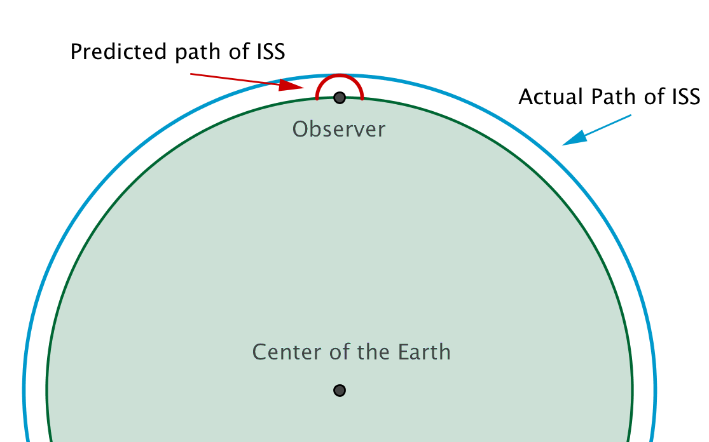
  - When George presents his solution to his classmate Jane, she tells him that his model isn’t appropriate for this situation. Is she correct? Explain how you know. (Hint: As we set up our model in the first discussion, we treated our observer as if he was the center of the orbit of the sun around the earth. In part (a) of this problem, we treated our observer as if she was the center of the orbit of the International Space Station around the earth. The radius of the earth is approximately $3963$ miles, the space station orbits about$238$ miles above the earth’s surface, and the distance from the earth to the sun is roughly $93,000,000$ miles. Draw a picture of the earth and the path of the space station, then compare that to the points with heights and rotation angles from part (a).)
MP.4
The semicircular path of the space station in this model will have radius $238$ miles, when it should have radius $3963+238=4201$ miles. In this model, the space station starts at a point $238$ miles to the east of the observer and crashes into the earth at a point $238$ miles to the west of the observer. Thus, this is not an appropriate model to use for the height of the International Space Station.
The problem is that the radius of the earth is negligible in comparison to the distance of $93,000,000$ miles from the surface of earth to the sun, but the radius of the earth is not negligible in comparison to the distance of$238$ miles from the surface of earth to the International Space Station.

In constructing the table, Aryabhata made adjustments to the values of his approximation to the jya to match his observational data. The first adjustment occurs in the calculation of $jya\left(30°\right)$. Thus, the entire table cannot be accurately constructed using this formula.

