Lesson 2: The Height and Co-Height Functions of a Ferris Wheel

Classwork
Opening Exercise
Suppose a Ferris wheel has a radius of $50$ feet. We will measure the height of a passenger car that starts in the $3$ o’clock position with respect to the horizontal line through the center of the wheel. That is, we consider the height of the passenger car at the outset of the problem (that is, after a $0°$ rotation) to be $0$ feet.
  - Mark the diagram to show the position of a passenger car at $30$ degree intervals as it rotates counterclockwise around the Ferris wheel.
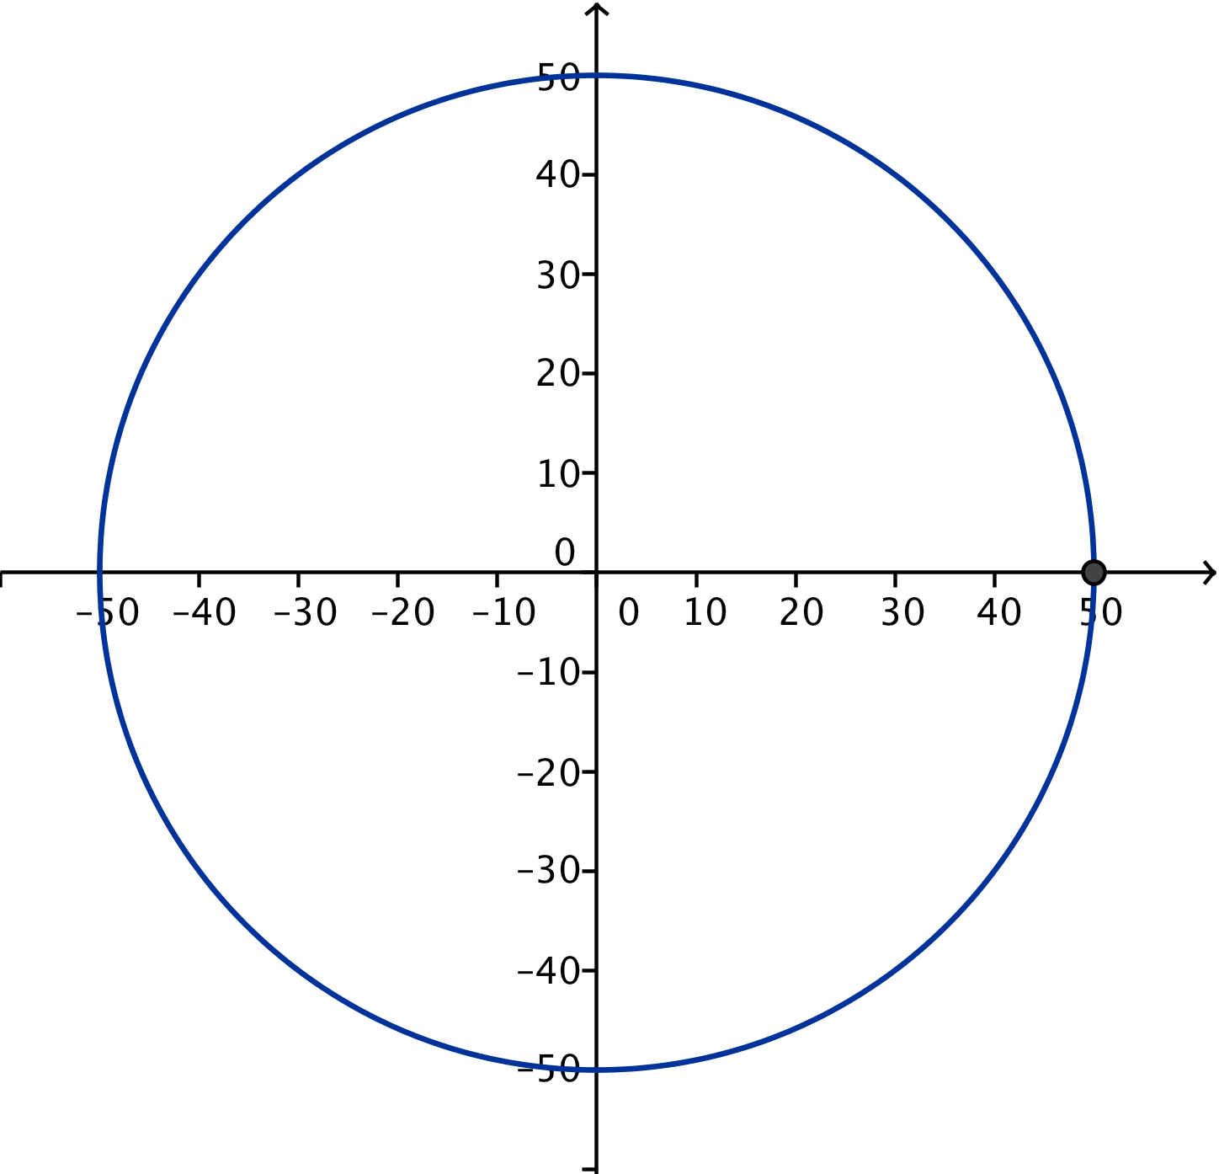

  - Sketch the graph of the height function of the passenger car for one turn of the wheel. Provide appropriate labels on the axes.
  - Explain how you can identify the radius of the wheel from the graph in part (b).

  - If the center of the wheel is $55$ feet above the ground, how high is the passenger car above the ground when it is at the top of the wheel?

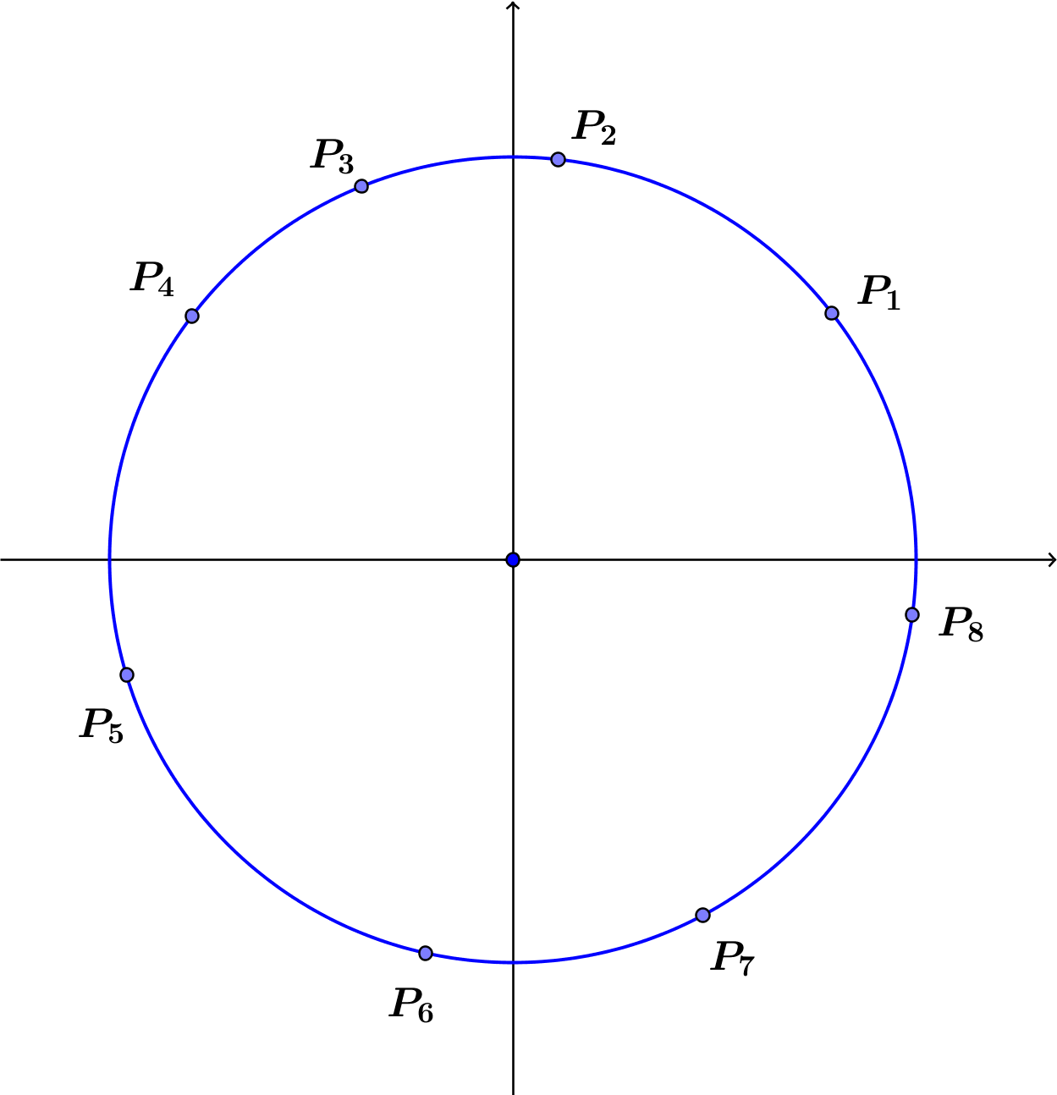
Exercises 1–3
- Each point $P_{1}$, $P_{2}$, … $P_{8}$ on the circle in the diagram at right represents a passenger car on a Ferris wheel.
  - Draw segments that represent the co-height of each car. Which cars have a positive co-height? Which cars have a negative co-height?

  - List the points in order of increasing co-height; that is, list the point with the smallest co-height first and the point with the largest co-height last.

- Suppose that the radius of a Ferris wheel is $100$ feet and the wheel rotates counterclockwise through one turn. Define a function that measures the co-height of a passenger car as a function of the degrees of rotation from the initial $3$ o’clock position.
  - What is the domain of the co-height function?

  - What is the range of the co-height function?

  - How does changing the wheel’s radius affect the domain and range of the co-height function?

- For a Ferris wheel of radius $100$ feet going through one turn, how do the domain and range of the height function compare to the domain and range of the co-height function? Is this true for any Ferris wheel?

Exploratory Challenge: The Paper Plate Model Again
Use a paper plate mounted on a sheet of paper to model a Ferris wheel, where the lower edge of the paper represents the ground. Use a ruler and protractor to measure the height and co-height of a Ferris wheel car at various amounts of rotation, measured with respect to the horizontal and vertical lines through the center of the wheel. Suppose that your friends board the Ferris wheel near the end of the boarding period and the ride begins when their car is in the three o’clock position as shown.
  - Mark horizontal and vertical lines through the center of the wheel on the card stock behind the plate as shown. We will measure the height and co-height as the displacement from the horizontal and vertical lines through the center of the plate.
Paper plate

  - Using the physical model you created with your group, record your measurements in the table, and then graph each of the two sets of ordered pairs (rotation angle, height) and (rotation angle, co-height) on separate coordinate grids below. Provide appropriate labels on the axes.
Rotation  (degrees) | Height  (cm) | Co-height (cm) |  | Rotation  (degrees) | Height  (cm) | Co-height (cm) |  | Rotation  (degrees) | Height  (cm) | Co-height (cm)
$$0$$ |  |  |  | $$135$$ |  |  |  | $$255$$
$$15$$ |  |  |  | $$150$$ |  |  |  | $$270$$
$$30$$ |  |  |  | $$165$$ |  |  |  | $$285$$
$$45$$ |  |  |  | $$180$$ |  |  |  | $$300$$
$$60$$ |  |  |  | $$195$$ |  |  |  | $$315$$
$$75$$ |  |  |  | $$210$$ |  |  |  | $$330$$
$$90$$ |  |  |  | $$225$$ |  |  |  | $$345$$
$$105$$ |  |  |  | $$240$$ |  |  |  | $$360$$
$$120$$
Co-height as a Function of Degrees of Rotation

Height as a Function of Degrees of Rotation

Closing
- Why do you think we named the new function the co-height?

- How are the graphs of these two functions alike? How are they different?

- What does a negative value of the height function tell us about the location of the passenger car at various positions around a Ferris wheel? What about a negative value of the co-height function?

Problem Set

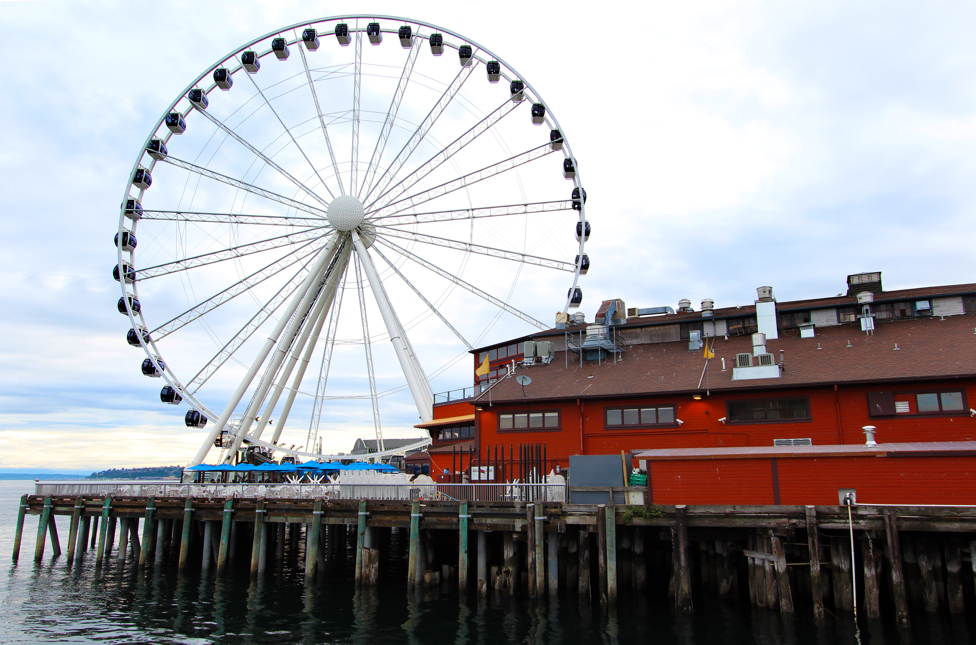
- The Seattle Great Wheel, with an overall height of $175$feet, was the tallest Ferris wheel on the west coast at the time of its construction in 2012. For this exercise, assume that the diameter of the wheel is $175$ feet.
  - Create a diagram that shows the position of a passenger car on the Great Wheel as it rotates counterclockwise at $45$degree intervals.
  - On the same set of axes, sketch graphs of the height and co-height functions for a passenger car starting at the $3$ o’clock position on the Great Wheel and completing one turn.
  - Discuss the similarities and differences between the graph of the height function and the graph of the co-height function.
  - Explain how you can identify the radius of the wheel from either graph.

- In 2014, the “High Roller” Ferris wheel opened in Las Vegas, dwarfing the Seattle Great Wheel with a diameter of $520$ feet. Sketch graphs of the height and co-height functions for one complete turn of the High Roller.

- Consider a Ferris wheel with a $50$-foot radius. We will track the height and co-height of passenger cars that begin at the $3$ o’clock position. Sketch graphs of the height and co-height functions for the following scenarios.
  - A passenger car on the Ferris wheel completes one turn, traveling counterclockwise.
  - A passenger car on the Ferris wheel completes two full turns, traveling counterclockwise.
  - The Ferris wheel is stuck in reverse, and a passenger car on the Ferris wheel completes two full clockwise turns.

- Consider a Ferris wheel with radius $40$ feet that is rotating counterclockwise. At which amounts of rotation are the values of the height and co-height functions equal? Does this result hold for a Ferris wheel with a different radius?

- Yuki is on a passenger car of a Ferris wheel at the 3 o’clock position. The wheel then rotates $135°$ counterclockwise and gets stuck. Lee argues that she can compute the value of the co-height of Yuki’s car if she is given one of the following two pieces of information:
    - The value of the height function of Yuki’s car, or
    - The diameter of the Ferris wheel itself.
Is Lee correct? Explain how you know.

