e
Lesson 2: The Height and Co-Height Functions of a Ferris Wheel

Student Outcomes
- Students model and graph two functions given by the location of a passenger car on a Ferris wheel as it is rotated a number of degrees about the origin from an initial reference position.

Lesson Notes
Students extend their work with the function that represents the height of a passenger car on a Ferris wheel from Lesson 1 to define a function that represents the horizontal displacement of the car from the center of the wheel, which we temporarily call the co-height function. In later lessons, the co-height function will be related to the cosine function. Students sketch graphs of various co-height functions and notice that these graphs are non-linear. Students explain why the graph of the co-height function is a horizontal translation of the graph of the height function and sketch graphs that model the position of a passenger car for various sized Ferris wheels. The work in the first three lessons of Module 2 serve to ground students in circular motion and set the stage for a formal definition of the sine and cosine functions in Lessons 4 and 5.
In Lesson 1, we measured the height of a passenger car of the Ferris wheel in relation to the ground and started tracking cars as passengers boarded at the bottom of the wheel. In this lesson, we change our point of view to measure height as vertical displacement from the center of the wheel, and we measure the co-height as the horizontal displacement from the center of the wheel. Additionally, although it is not realistic, we will track cars rotating around the wheel beginning from the 3 o’clock position. With these changes in perspective, the functions used to model the height and co-height functions are much closer to the basic sine and cosine functions that will be defined in Lesson 4.

Classwork
Opening Exercise (5 minutes)
Ask students to recall the quantities that change as a passenger car moves around a Ferris wheel. These were discussed and recorded in the opening discussion of Lesson 1. In this lesson, we will be modeling both the vertical position of the passenger car and the horizontal position of the car as the wheel rotates.

In this lesson, we will be changing our perspective to measure the height of the passenger car on the Ferris wheel from the horizontal line through the center of the wheel. This means that if we have a Ferris wheel with radius 50 feet, then the maximum value of the height function will be $50$, and the minimum value of the height function will be $-50$. We will also consistently consider that passengers board the Ferris wheel at the $3$ o’clock position, in preparation for the introduction of the actual sine and cosine functions in Lesson 4. Allow students to work in pairs or small groups on this exercise to ensure that all students understand this shift in how the heights are measured. After the students have completed the exercise, call for a few volunteers to show their sketches and to explain their reasoning.
Opening Exercise
Suppose a Ferris wheel has a radius of $50$ feet. We will measure the height of a passenger car that starts in the $3$ o’clock position with respect to the horizontal line through the center of the wheel. That is, we consider the height of the passenger car at the outset of the problem (that is, after a $0°$ rotation) to be $0$ feet.
MP.4
  - Mark the diagram to show the position of a passenger car at $30$ degree intervals as it rotates counterclockwise around the Ferris wheel.
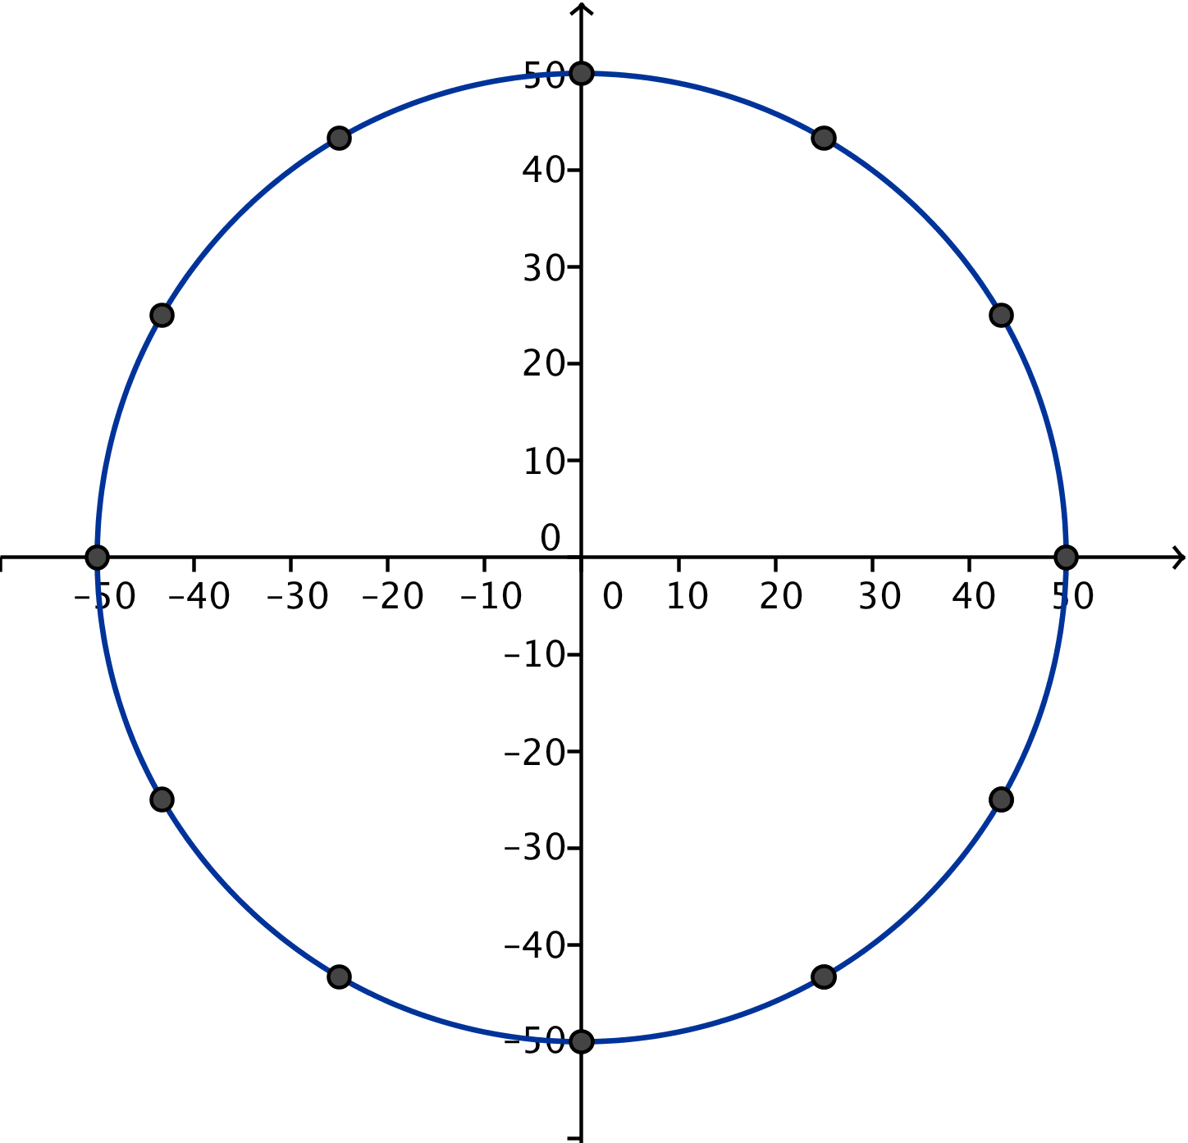

  - Sketch the graph of the height function of the passenger car for one turn of the wheel. Provide appropriate labels on the axes.
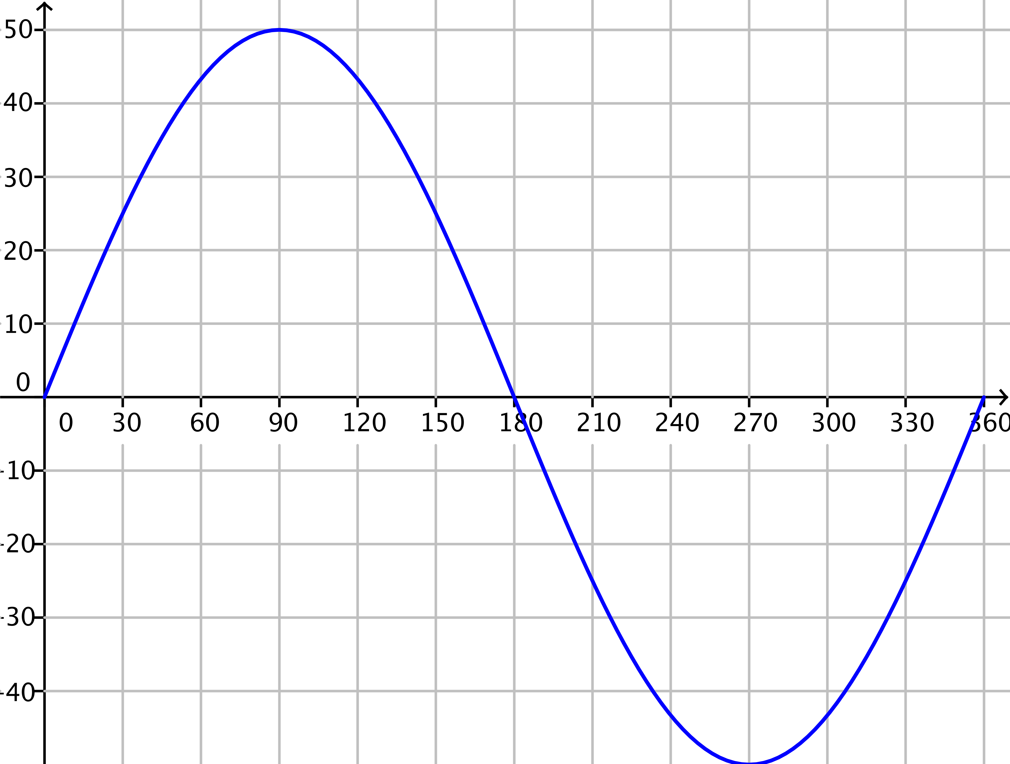

  - Explain how you can identify the radius of the wheel from the graph in part (b).
The graph of the height function for one complete turn shows a maximum height of $50$ feet and a minimum height of $-50$ feet, suggesting that the wheel’s diameter is $100$ feet and thus its radius is $50$ feet.

  - If the center of the wheel is $55$ feet above the ground, how high is the passenger car above the ground when it is at the top of the wheel?
The passenger car is $105$ feet above the ground when it is at the top of the wheel. Since the graph displays the height above the center of the wheel, we would need to add $55$ feet to $50$ feet to get the height (in feet) above the ground.
Discussion (8 minutes)
In Lesson 1 and in the Opening Exercise of this lesson, students modeled the height of a passenger car of a Ferris wheel, which we are now considering to be the vertical displacement of the car with respect to a horizontal line through the center of the wheel. We will now consider the horizontal position of the cars as they rotate around the wheel, which defines a function that we will call the “co-height” of the passenger car.
- Recall that we modeled the height of a passenger car as a function of degrees as the car rotated counterclockwise from the car’s starting point at a certain point on the wheel—either the bottom of the wheel or at the $3$ o’clock position. Is there another measurement that we can model as a function of degrees rotated counterclockwise from the car’s starting position?
  - The horizontal position of the passenger cars.
- In the Opening Exercise, we changed how we measure the height of a passenger car on the Ferris wheel, and we now consider the height to be the vertical displacement from the center of the wheel. Then, points near the top of the wheel have a positive height, and points near the bottom have a negative height. That is, we measure the height as the vertical distance from a horizontal line through the center of the wheel. With this in mind, how should we measure the horizontal distance?
  - We can measure the horizontal displacement from the vertical line through the center of the wheel.
- We will refer to the horizontal displacement of a passenger car from the vertical line through the center of the wheel as the co-height of the car.
- Where is the car when the co-height is zero?
  - The car is along the vertical line through the center of the wheel, so it is either at the top or the bottom of the wheel.
- How can we assign positive and negative values to the co-height?
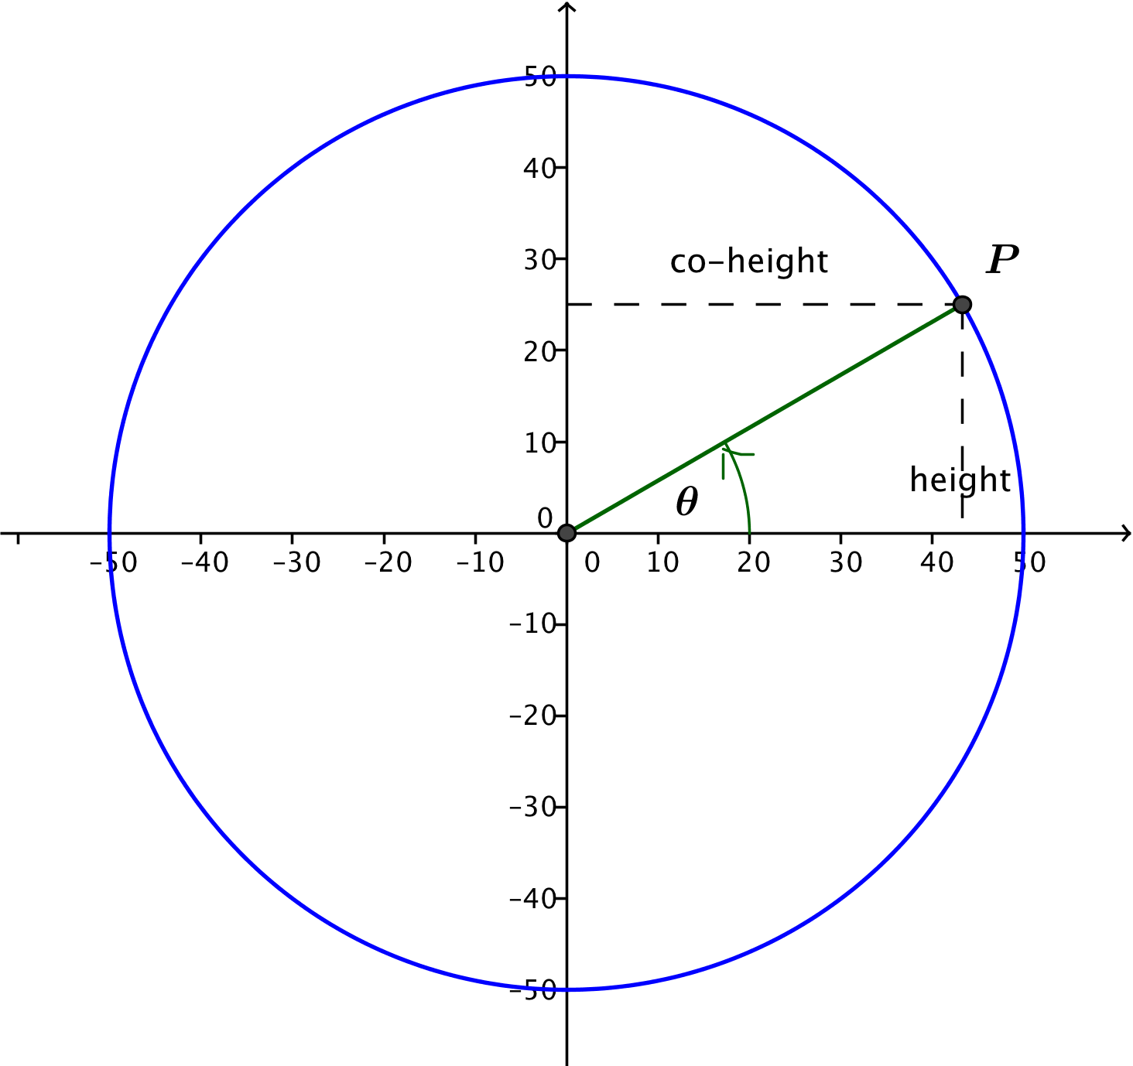
  - Assign a positive value for positions on the right of the vertical line through the center of the wheel, and assign a negative value for positions on the left of this line.
Scaffolding:
Have students record on chart paper the co-height and height of the car’s position when it is either on the horizontal or vertical axes and the number of degrees the car has rotated from its initial position at 3 o’clock. Post this chart for quick reference.

- Using our Opening Exercise, what is the starting value of the co-height?
  - Since the radius of the wheel is $50$ feet, then the initial co-height at the $3$o’clock position is $50$.

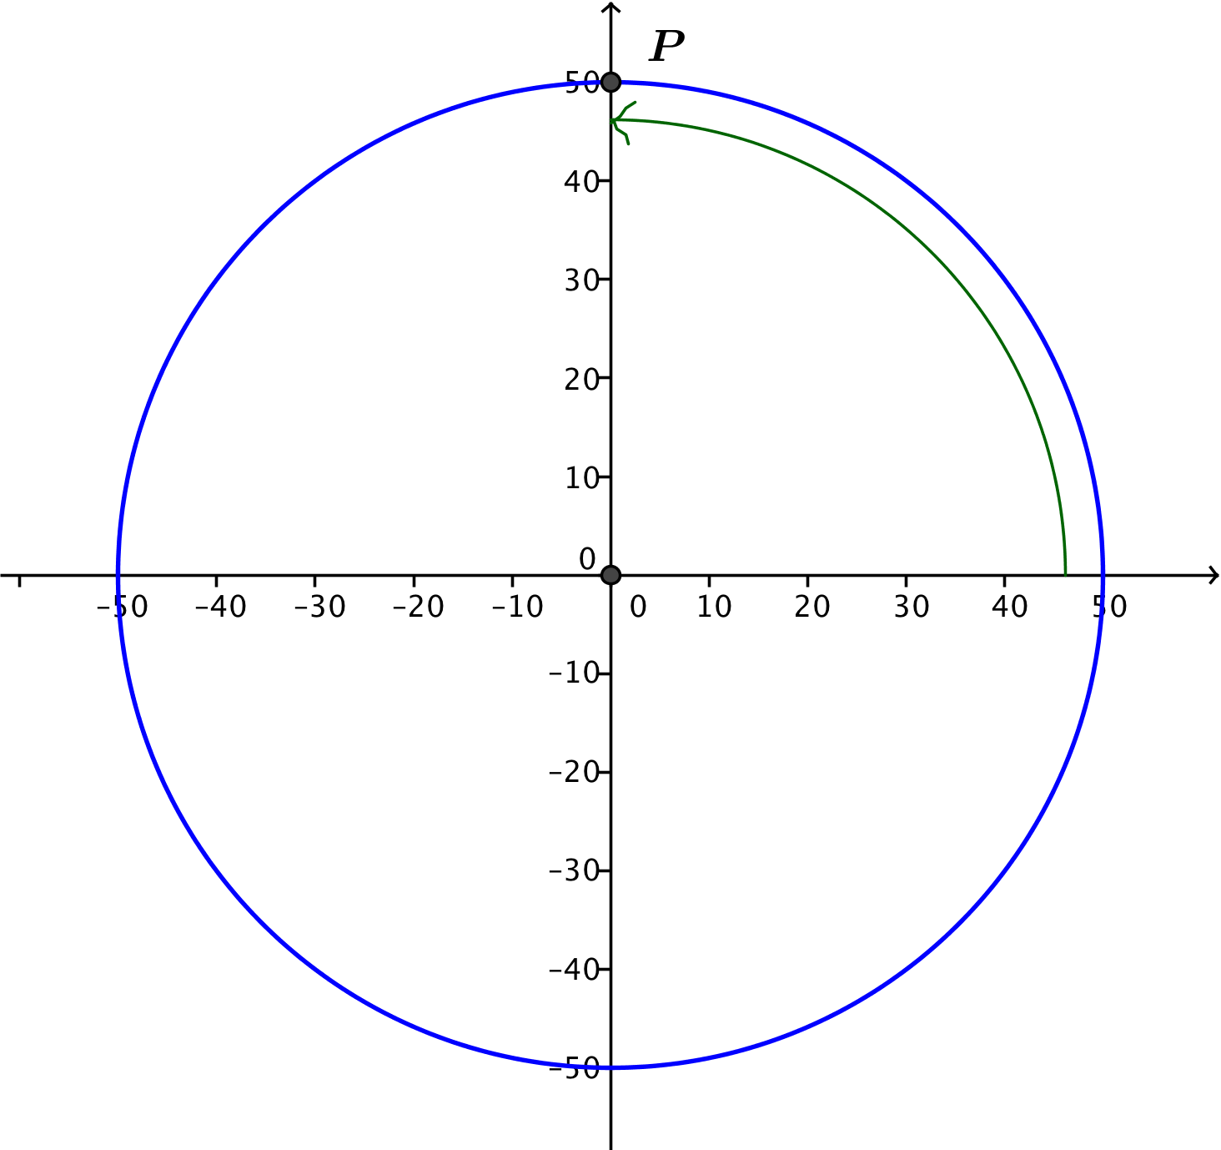
- Now suppose, that the passenger car has rotated $90$ degrees counterclockwise from its initial position of $3$ o’clock on the wheel. What is the co-height of the car in this position?
  - After rotating by $90°$ counterclockwise, the car is positioned at the top of the wheel, so it lies along the vertical line through the center of the wheel. Thus, the co-height is $0$ feet.
- Is there a maximum value of the co-height of a passenger car? Is there a minimum value of the co-height?
  - When the car is at the $3$ o’clock position, the co-height is equal to the radius of the wheel, which is the furthest horizontal position from the vertical axis on the positive side. So for our example, the maximum value of the co-height is $50$.
  - When the car has rotated $180$ degrees from its original position and is located at the $9$ o’clock position, the co-height is equal to the opposite of the radius. This is its minimum value. For our example, the minimum value of the co-height is $-50$.

Exercises 1–3 (5 minutes)
These exercises can either be completed alone or in pairs. They will provide you the opportunity to informally assess how well students understood the preceding discussion. After a few minutes, call on volunteers to share their answers with the class.
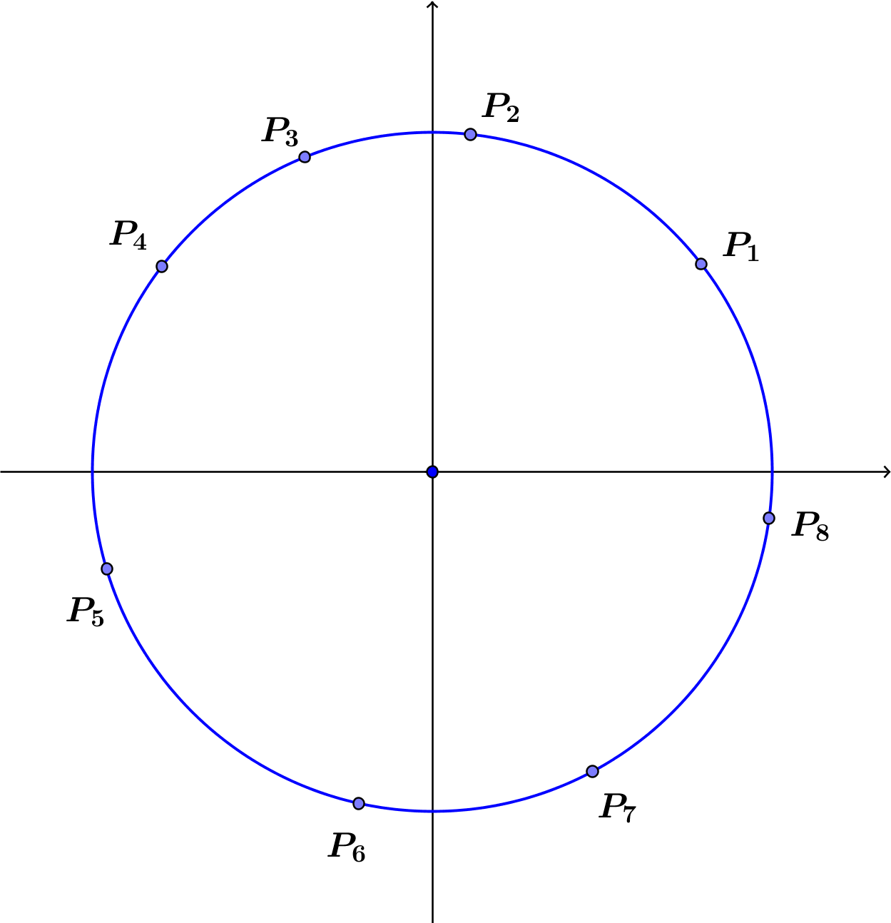
Exercises 1–3
- Each point $P_{1}$, $P_{2}$, … $P_{8}$ on the circle in the diagram at right represents a passenger car on a Ferris wheel.
  - Draw segments that represent the co-height of each car. Which cars have a positive co-height? Which cars have a negative co-height?
The cars corresponding to points $P_{1}, P_{2}, P_{7},$ and $P_{8}$ have a positive co-height. The cars corresponding to points $P_{3}, P_{4}, P_{5},$ and $P_{6}$ have a negative co-height.

  - List the points in order of increasing co-height; that is, list the point with the smallest co-height first and the point with the largest co-height last.
$$P_{5}, P_{4}, P_{3}, P_{6}, P_{2}, P_{7}, P_{1}, P_{8}$$

- Suppose that the radius of a Ferris wheel is $100$ feet and the wheel rotates counterclockwise through one turn. Define a function that measures the co-height of a passenger car as a function of the degrees of rotation from the initial $3$ o’clock position.
  - What is the domain of the co-height function?
The domain of the co-height function is $[0, 360]$, where we are measuring in terms of degrees of rotation.

  - What is the range of the co-height function?
Because the radius is $100$ ft. the range of the co-height function is $[-100, 100]$.

  - How does changing the wheel’s radius affect the domain and range of the co-height function?
Changing the radius does not change the domain of the co-height function.
The range of the co-height function depends on the radius; for a wheel of radius $r$, the range of the co-height function is $[-r, r]$.

- For a Ferris wheel of radius $100$ feet going through one turn, how do the domain and range of the height function compare to the domain and range of the co-height function? Is this true for any Ferris wheel?
The domain for each function is $[0,360]$, where rotations are measured in degrees. The range of each function is $\left[-100,100\right].$ For any Ferris wheel, the domain of the height and co-height functions is $[0,360]$. The range depends on the radius, $r$, of the wheel, but for both the height and co-height functions, the range is $[-r,r]$. Thus, the height and co-height functions for a Ferris wheel have the same domain and range.

Exploratory Challenge (20 minutes): The Paper Plate Model Again
Have students reconvene with the members of their paper plate model groups from Exploratory Challenge 2 in Lesson 1. Redistribute each group’s paper plate model, which was submitted at the conclusion of the previous lesson. In Lesson 1, students modeled a passenger car’s height relative to the ground (i.e., from the bottom of the paper). So that our model aligns with the sine and cosine functions that will be introduced in future lessons, we now measure a passenger car’s height and co-height relative to the horizontal and vertical axes through the center of the wheel. Instruct students to measure the height and co-height every $15$ degrees for a complete turn using their paper plate model. You may need to remind students that the Ferris wheel’s motion is counterclockwise. Monitor groups to make sure they are measuring from the axes through the center of the wheel. You may also need to remind students that we have set up our coordinate system so that locations below the horizontal axis through the center of the wheel have negative height values, and values left of the vertical axis through the center of the wheel have negative co-height values.
Students will work in small groups to build a physical model and measure angles, heights, and co-heights. The student pages provide scaffolds including a diagram they can mark up to help them understand how to measure the heights, co-heights, and angles, as well as a table to record their measurements. Students should record their measurements in the table, then they should graph the height and co-height functions separately on the axes below, providing appropriate labels on the axes.

Exploratory Challenge: The Paper Plate Model Again
Use a paper plate mounted on a sheet of paper to model a Ferris wheel, where the lower edge of the paper represents the ground. Use a ruler and protractor to measure the height and co-height of a Ferris wheel car at various amounts of rotation, measured with respect to the horizontal and vertical lines through the center of the wheel. Suppose that your friends board the Ferris wheel near the end of the boarding period, and the ride begins when their car is in the three o’clock position as shown.
  - Mark horizontal and vertical lines through the center of the wheel on the card stock behind the plate as shown. We will measure the height and co-height as the displacement from the horizontal and vertical lines through the center of the plate.

Paper plate

  - Using the physical model you created with your group, record your measurements in the table, and then graph each of the two sets of ordered pairs (rotation angle, height) and (rotation angle, co-height) on separate coordinate grids below. Provide appropriate labels on the axes.

Rotation  (degrees) | Height  (cm) | Co-  Height (cm) |  | Rotation  (degrees) | Height  (cm) | Co-  Height (cm) |  | Rotation  (degrees) | Height  (cm) | Co-  Height (cm)
$$0$$ |  |  |  | $$135$$ |  |  |  | $$255$$
$$15$$ |  |  |  | $$150$$ |  |  |  | $$270$$
$$30$$ |  |  |  | $$165$$ |  |  |  | $$285$$
$$45$$ |  |  |  | $$180$$ |  |  |  | $$300$$
$$60$$ |  |  |  | $$195$$ |  |  |  | $$315$$
$$75$$ |  |  |  | $$210$$ |  |  |  | $$330$$
$$90$$ |  |  |  | $$225$$ |  |  |  | $$345$$
$$105$$ |  |  |  | $$240$$ |  |  |  | $$360$$
$$120$$

Height as a Function of Degrees of Rotation
Co-height as a Function of Degrees of Rotation

While graphs will vary slightly from one group to the next, lead students to verbalize that it appears that the co-height graph is a horizontal translation of the height graph (and vice versa).
Encourage quantitative reasoning by asking students to relate features of the graph back to the scenario of a car rotating around a Ferris wheel. The following questions can guide that discussion.
- What do the zeros of the graph of the co-height function represent in this situation?
  - They represent the numbers of degrees of rotation where the passenger car is on the vertical line through the center of the wheel, and has a horizontal distance from the center equal to $0$. These are the highest and lowest positions of the car during the ride.
- What does the vertical intercept of the graph of the co-height function represent in this situation?
  - It represents the radius of the wheel. At the outset of the ride, the car is at the $3$ o’clock position, so it has rotated by $0$ degrees, and the distance from the center is equal to the radius of the wheel.
- How are the graphs of the height and co-height functions related to each other?
  - It looks like one graph is a horizontal translation of the other by $90°$.

Closing (2 minutes)
Students should respond to these questions in writing or with a partner. Use this as an opportunity to informally assess their understanding of the height and co-height functions.

Closing
- Why do you think we named the new function the co-height?
Both functions measure a distance from the passenger car to one of the axes at various numbers of degrees of rotation of the wheel, so the horizontal measurements are closely related to the vertical measurements.

- How are the graphs of these two functions alike? How are they different?
The graph of the co-height function appears to be a horizontal translation of the graph of the height function. Assuming we create both functions from the same initial passenger car position on the same Ferris wheel, the two functions will have the same domain and the same range, but the values of the functions are not the same for the same amount of rotation. When one function has a value of zero, the other has either a maximum value of $1$ or a minimum value of $-1$.

- What does a negative value of the height function tell us about the location of the passenger car at various positions around a Ferris wheel? What about a negative value of the co-height function?
A negative value of the height function tells us the passenger car is below the center of the Ferris wheel. A negative value of the co-height function tells us the passenger car is left of the center of the Ferris wheel.

Exit Ticket (5 minutes)

Name Date
Lesson 2: The Height and Co-Height Functions of a Ferris Wheel

Exit Ticket

Zeke Memorial Park has two different sized Ferris wheels, one with a radius of $75$ feet and one with a radius of $30$ feet. Indicate which graph (a)–(d) represents the following functions for the larger and the smaller Ferris wheels. Explain your reasoning.
Wheel with $75$-foot radius  Height function: __________  Co-height function: __________ | Wheel with $30$-foot radius  Height function: __________  Co-height function: __________

(a) | 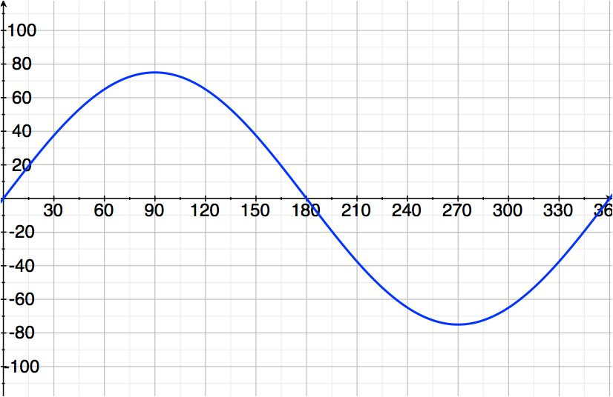 | (b) | 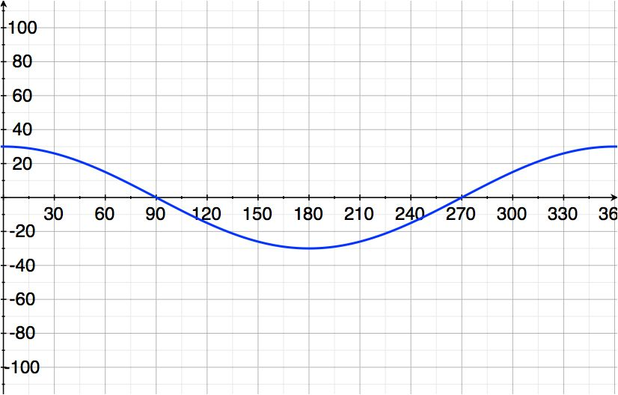
(c) | 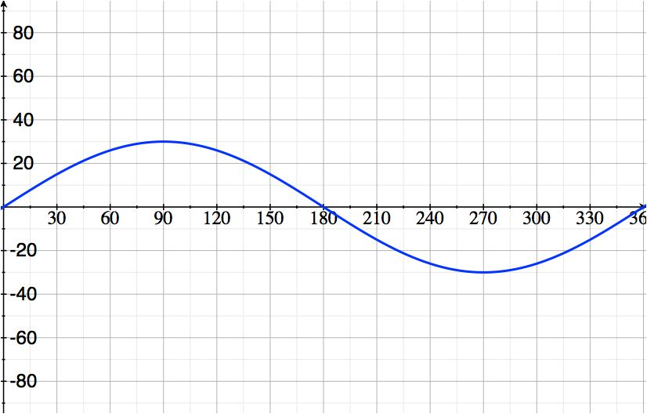 | (d) | 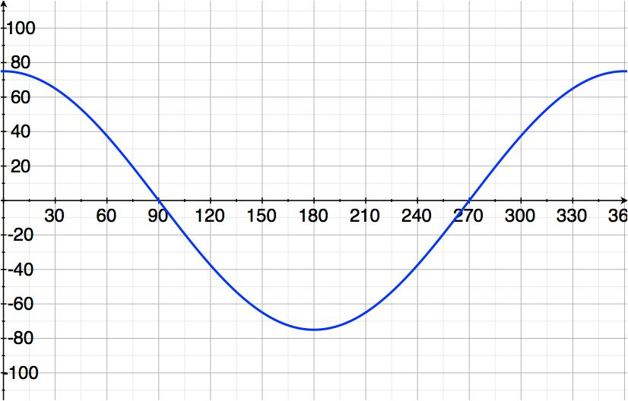

Exit Ticket Sample Solutions

Zeke Memorial Park has two different sized Ferris wheels, one with a radius of $75$ feet and one with a radius of $30$ feet. Indicate which graphs (a)–(d) represent the following functions for the larger and the smaller Ferris wheels. Explain your reasoning.
Wheel with $75$-foot radius  Height function: _____(a)_____  Co-height function: _____(d)_____ | Wheel with $30$-foot radius  Height function: ____(c)______  Co-height function: ____(b)______

(a) |  | (b)
(c) |  | (d)

The maximum value of a passenger car’s height function over one turn will correspond to the highest point on the wheel, which means that the maximum value of the function is the radius of the wheel. Thus, the graphs that have a maximum value of $75$ correspond to the larger Ferris wheel, and the graphs that have a maximum value of $30$ correspond to the smaller wheel. Since the cars begin at the$3$ o’clock position, the height graphs begin at height zero, while the co-height graphs begin with an initial co-height equal to the radius. Thus, graphs (a) and (d) correspond to the larger wheel, and graphs (b) and (c) correspond to the smaller wheel.

Problem Set Sample Solutions
This Problem Set asks students to confirm their understanding of the co-height function and its relationship to the height function.

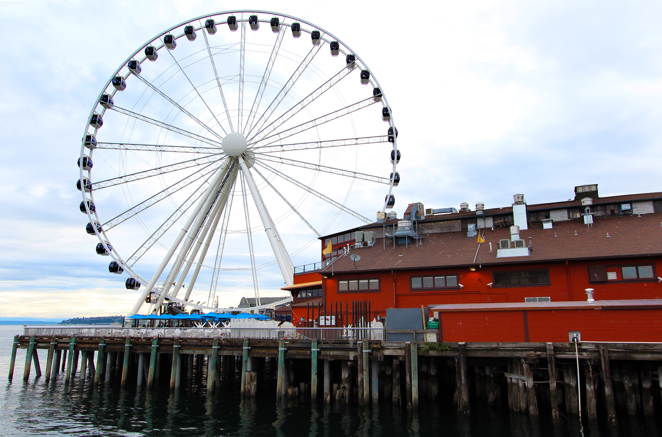
- The Seattle Great Wheel, with an overall height of $175$feet, was the tallest Ferris wheel on the west coast at the time of its construction in $2012$. For this exercise, assume that the diameter of the wheel is $175$ feet.

  - Create a diagram that shows the position of a passenger car on the Great Wheel as it rotates counterclockwise at $45$degree intervals.
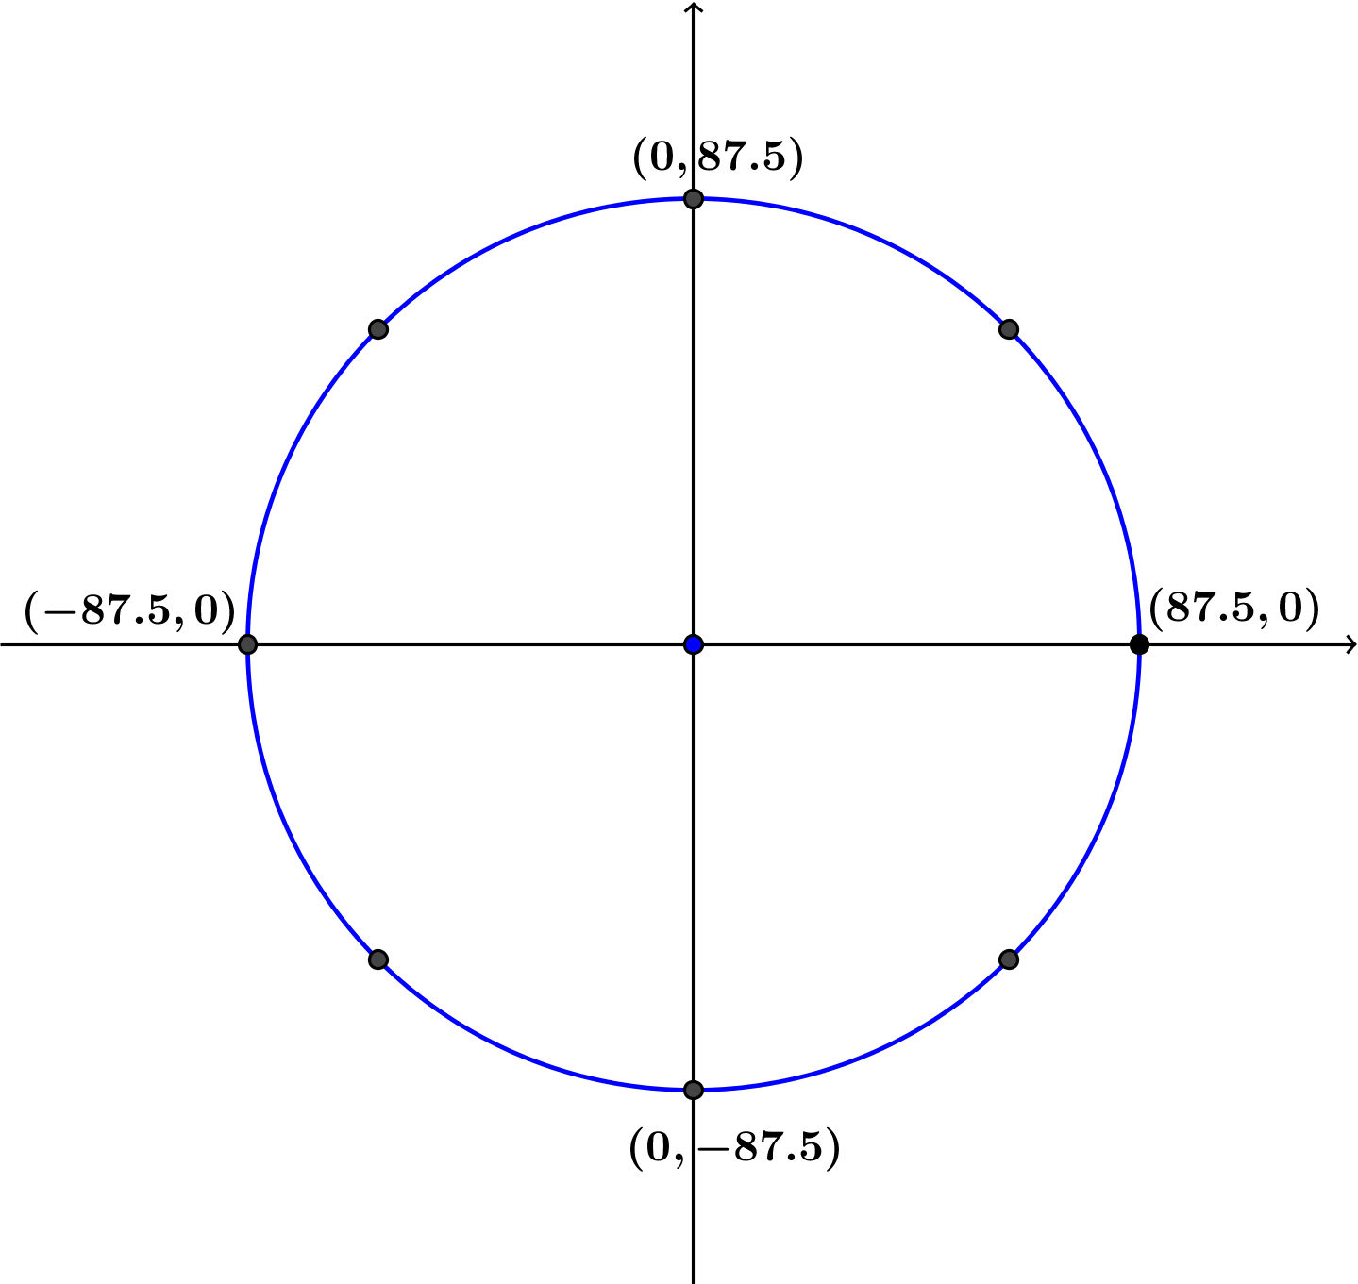
The Great Wheel has a diameter of $175$ feet, so the radius is $87.5$feet.

  - On the same set of axes, sketch graphs of the height and co-height functions for a passenger car starting at the $3$ o’clock position on the Great Wheel and completing one turn.
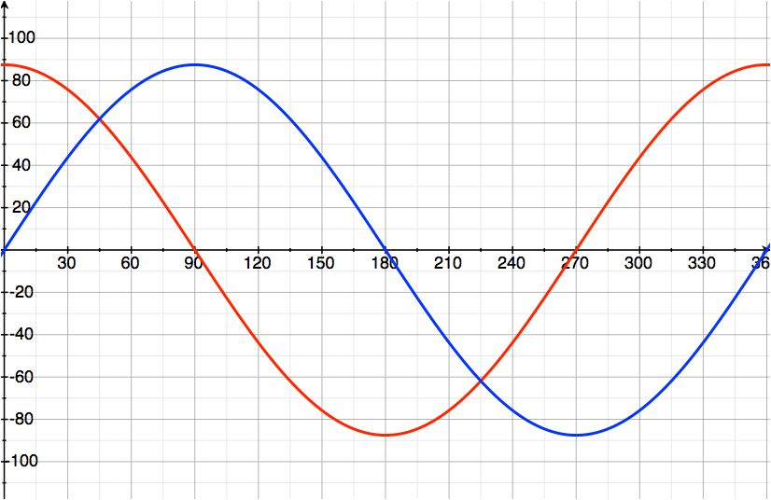
Below, the blue curve represents the height function, and the red curve represents the co-height function.

  - Discuss the similarities and differences between the graph of the height function and the graph of the co-height function.
Both the height and co-height functions have the same domain, $\left[0,360\right]$, and range, $[-87.5,87.5]$. Both functions have the same maximum value of $87.5$ and minimum value of $–87.5$, but they occur at different amounts of rotation. When one function takes on a value of zero, the other either takes on its maximum value of $87.5$ or its minimum value of $-87.5$. The co-height function starts at its maximum value, and the height function starts at zero. The graph of the co-height function is the graph of the height function translated horizontally to the left by $90$.

  - Explain how you can identify the radius of the wheel from either graph.
The radius of the wheel is the distance from the center of the wheel to a point on the wheel. We can easily measure this at one of the four points when the car is at the top or bottom of the wheel or at the far left or at the far right. Thus, the radius is the difference between the maximum value of either function and zero, so the radius is the maximum value of either the height or the co-height function.

- In 2014, the High Roller Ferris wheel opened in Las Vegas, dwarfing the Seattle Great Wheel with a diameter of $520$ feet. Sketch graphs of the height and co-height functions for one complete turn of the High Roller.
Height: | 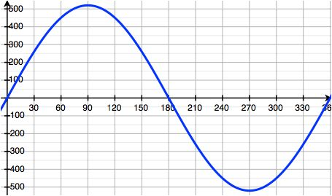
Co-Height: | 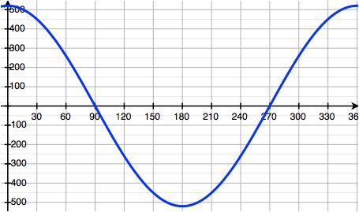

- Consider a Ferris wheel with a $50$-foot radius. We will track the height and co-height of passenger cars that begin at the $3$ o’clock position. Sketch graphs of the height and co-height functions for the following scenarios.
  - A passenger car on the Ferris wheel completes one turn, traveling counterclockwise.
Height: | 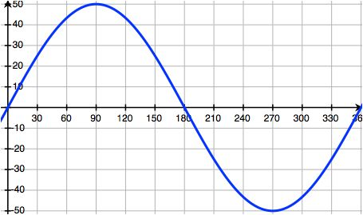
Co-Height: | 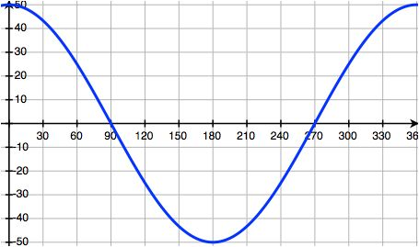

  - A passenger car on the Ferris wheel completes two full turns, traveling counterclockwise.
Height: | 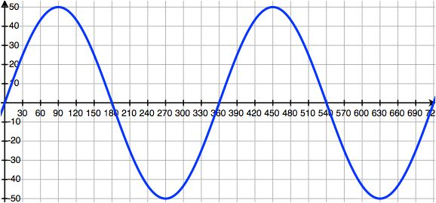
Co-Height: | 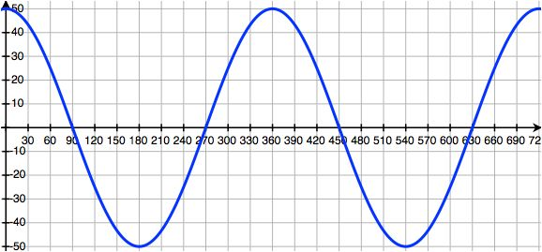
  - The Ferris wheel is stuck in reverse, and a passenger car on the Ferris wheel completes two full clockwise turns.

Height: | 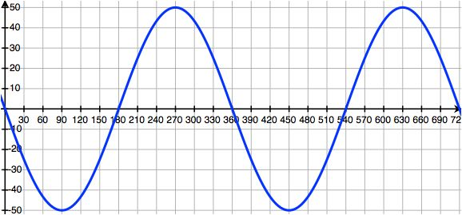
Co-Height:

- Consider a Ferris wheel with radius $40$ feet that is rotating counterclockwise. At which amounts of rotation are the values of the height and co-height functions equal? Does this result hold for a Ferris wheel with a different radius?
Consder the right triangle formed by the spoke of the wheel connecting the car to the center, the horizontal axis, and the perpenciular dropped from the car’s position to the horizontal axis. If the value of the height and co-height functions are equal, then the legs of this triangle have the same length, meaning that it is an isosceles right triangle. There are four locations for such a triangle, with the passenger car being located in the first, second, third, or fourth quadrant. However, in the second and fourth quadrants, either the co-height takes on a negative value or the height takes on a negative value, but not both. Thus, for the co-height and height to take on the same value, the passenger car must be in either the first or the third quadrant. In the first quadrant, the car has rotated through $45°$, and in the third quadrant, the car has rotated through $180°+45°=225 °.$
The same result holds for a Ferris wheel of any radius.

- Yuki is on a passenger car of a Ferris wheel at the 3 o’clock position. The wheel then rotates $135°$ counterclockwise and gets stuck. Lee argues that she can compute the value of the co-height of Yuki’s car if she is given one of the following two pieces of information:
    - The value of the height function of Yuki’s car, or
    - The diameter of the Ferris wheel itself.
Is Lee correct? Explain how you know.
Lee is correct. Since Yuki’s car started at the $3$ o’clock position, and then rotated $135°$, then the ending position is in the second quadrant. The spoke of the Ferris wheel connecting her car to the center of the wheel makes a $45°$ angle with the horizontal, which creates a $45°$–$45°$–$90°$ triangle as shown in the diagram below. Then the height and the co-height at this position are equal, since the legs of an isosceles right triangle are congruent. Thus, if Lee knows the value of the height function of Yuki’s car, then she knows the value of the co-height at this position.
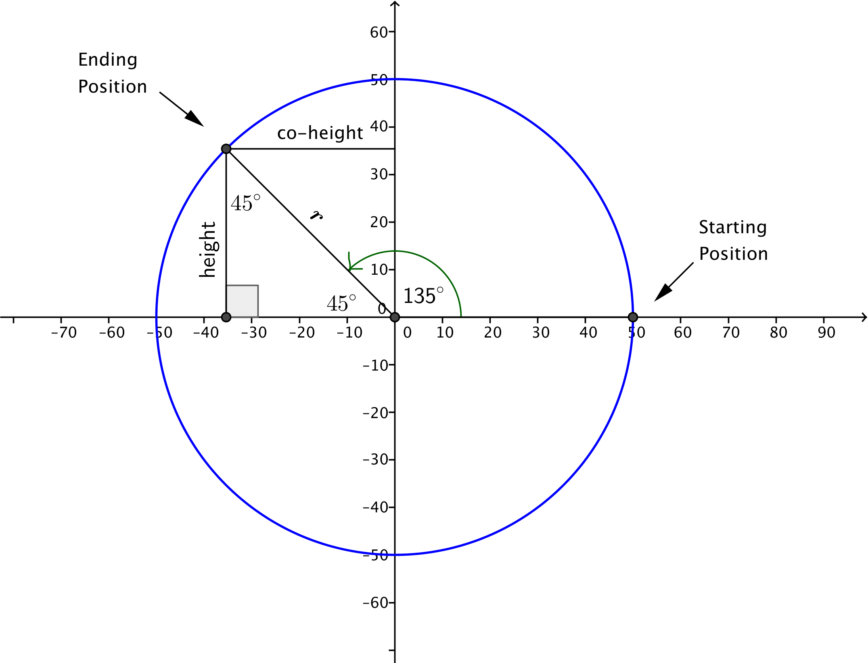

If Lee knows the diameter of the wheel, then she knows the radius, $r$, which is half of the diameter. Then she knows the length of a leg of an isosceles right triangle with hypotenuse of length $r$ is $\frac{\sqrt{2}}{2}r$. Thus, if Lee knows the length of the diameter of the wheel, then she can calculate Yuki’s co-height.

