Lesson 1: Ferris Wheels—Tracking the Height of a Passenger Car

Classwork
Exploratory Challenge 1: The Height of a Ferris Wheel Car
George Ferris built the first Ferris wheel in 1893 for the World’s Columbian Exhibition in Chicago. It had $30$ passenger cars, was $264$ feet tall, and rotated once every $9$ minutes when all the cars were loaded. The ride cost $\$0.50$.
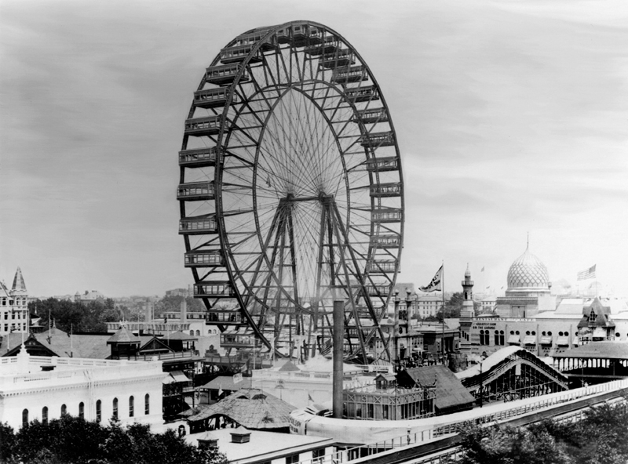
Source: The New York Times/Redux
  - Create a sketch of the height of a passenger car on the original Ferris wheel as that car rotates around the wheel $4$ times. List any assumptions that you are making as you create your model.

  - What type of function would best model this situation?

Exercises 1–5
- Suppose a Ferris wheel has a diameter of $150$ feet. From your viewpoint, the Ferris wheel is rotating counterclockwise. We will refer to a rotation through a full $360°$ as a “turn”.
  - Create a sketch of the height of a car that starts at the bottom of the wheel for two turns.

  - Explain how the features of your graph relate to this situation.

- Suppose a Ferris wheel has a diameter of $150$ feet. From your viewpoint, the Ferris wheel is rotating counterclockwise.
  - Your friends board the Ferris wheel, and the ride continues boarding passengers. Their car is in the three o’clock position when the ride begins. Create a sketch of the height of your friends’ car for two turns.

  - Explain how the features of your graph relate to this situation.

- How would your sketch change if the diameter of the wheel changed?

- If you translated the sketch of your graph down by the radius of the wheel, what would the $x$-axis represent in this situation?

- How could we create a more precise sketch?

Exploratory Challenge 2: The Paper Plate Model
Use a paper plate mounted on a sheet of paper to model a Ferris wheel, where the lower edge of the paper represents the ground. Use a ruler and protractor to measure the height of a Ferris wheel car above the ground for various amounts of rotation. Suppose that your friends board the Ferris wheel near the end of the boarding period and the ride begins when their car is in the three o’clock position as shown.
  - Mark the diagram below to estimate the location of the Ferris wheel passenger car every $15°$. The point on the circle below represents the passenger car in the $3$ o’clock position. Since this is the beginning of the ride, consider this position to be the result of rotating by $0°.$
Paper plate

  - Using the physical model you created with your group, record your measurements in the table, and then graph the ordered pairs (rotation, height) on the coordinate grid shown below. Provide appropriate labels on the axes.

Rotation  (degrees) | Height  (cm) |  | Rotation  (degrees) | Height  (cm) |  | Rotation  (degrees) | Height  (cm) |  | Rotation  (degrees) | Height  (cm)
$$0$$ |  |  | $$105$$ |  |  | $$225$$ |  |  | $$330$$
$$15$$ |  |  | $$120$$ |  |  | $$240$$ |  |  | $$345$$
$$30$$ |  |  | $$135$$ |  |  | $$255$$ |  |  | $$360$$
$$45$$ |  |  | $$150$$ |  |  | $$270$$
$$60$$ |  |  | $$180$$ |  |  | $$285$$
$$75$$ |  |  | $$195$$ |  |  | $$300$$
$$90$$ |  |  | $$210$$ |  |  | $$315$$
Height as a function of degrees of rotation

  - Explain how the features of your graph relate to the paper plate model you created.

Closing
- How does a function like the one that represents the height of a passenger car on a Ferris wheel differ from other types of functions you have studied such as linear, polynomial, and exponential functions?

- What is the domain of your Ferris wheel height function? What is the range?

- Provide a definition of periodic function in your own words. Why is the Ferris wheel height function an example of a periodic function?

- What other situations might be modeled by a periodic function?

Problem Set

- Suppose that a Ferris wheel is $40$ feet in diameter, rotates counterclockwise, and when a passenger car is at the bottom of the wheel it is located $2$ feet above the ground.
  - Sketch a graph of a function that represents the height of a passenger car that starts at the $3$ o’clock position on the wheel for one turn.
  - Sketch a graph of a function that represents the height of a passenger car that starts at the top of the wheel for one turn.
  - The sketch you created in part (a) represents a graph of a function. What is the domain of the function? What is the range?
  - The sketch you created in part (b) represents a graph of a function. What is the domain of the function? What is the range?
  - Describe how the graph of the function in part (a) would change if you sketched the graph for two turns.
  - Describe how the function in part (a) and its graph would change if the Ferris wheel had a diameter of $60$ feet.

- A small pebble is lodged in the tread of a tire with radius $25$ cm. Sketch the height of the pebble above the ground as the tire rotates counterclockwise through$5$ turns. Start your graph when the pebble is at the $9$ o’clock position.

- The graph you created in Exercise 2 represents a function.
  - Describe how the function and its graph would change if the tire’s radius was 24 inches instead of 25 cm.
  - Describe how the function and its graph would change if the wheel was turning in the opposite direction.
  - Describe how the function and its graph would change if we started the graph when the pebble was at ground level.

- Justice believes that the height of a Ferris wheel passenger car is best modeled with a piecewise linear function. Make a convincing argument why a piecewise linear function IS NOT a good model for the height of a car on a rotating Ferris wheel.

