Name Date

  - For each arc indicated below, find the degree measure of its subtended central angle to the nearest degree. Explain your reasoning.
(ii)
(iii)
(i)
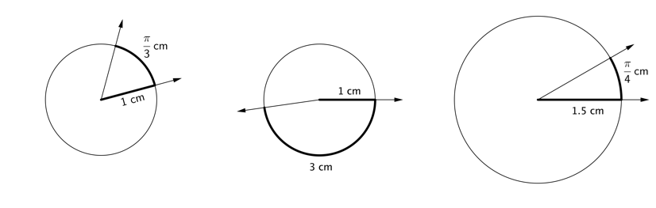

  - Elmo drew a circle with a radius of $1 \text{cm}$. He drew two radii with an angle of $60°$ between them and then declared that the radian measure of that angle was $\frac{π}{3}$ cm. Explain why Elmo is not correct in saying this.

  - Elmo next drew a circle with a radius of $1$ cm. He drew two radii that formed a $60°$ angle and then declared that the radian measure of that angle is $\frac{10π}{3}$. Is Elmo correct? Explain your reasoning.

  - Draw a diagram that illustrates why $\sin\left(\frac{4π}{3}\right)=-\frac{\sqrt{3}}{2}$ using the unit circle. Explain how the unit circle helps us to make this calculation.

- For each part, use your knowledge of the definition of radians and the definitions of sine, cosine, and tangent to place the expressions in order from least to greatest without using a calculator. Explain your reasoning.

  - $sin(1°)$ $sin(1)$ $sin(π)$ $sin(60°)$

  - $sin(25°)$ $cos(25°)$ $\sin\left(\frac{3π}{8}\right)$ $\cos\left(\frac{3π}{8}\right)$

  - $sin(100°)$ $cos(15°)$ $tan(15°)$ $tan(100°)$

  - $sin(x)$ $sin\left(x-\frac{3π}{2}\right)$ $\sin\left(\frac{11π}{4}+x\right)$ $\sin\left(\frac{109π}{107}\right)$

where $x$ is a very small positive number with $x<0.01$

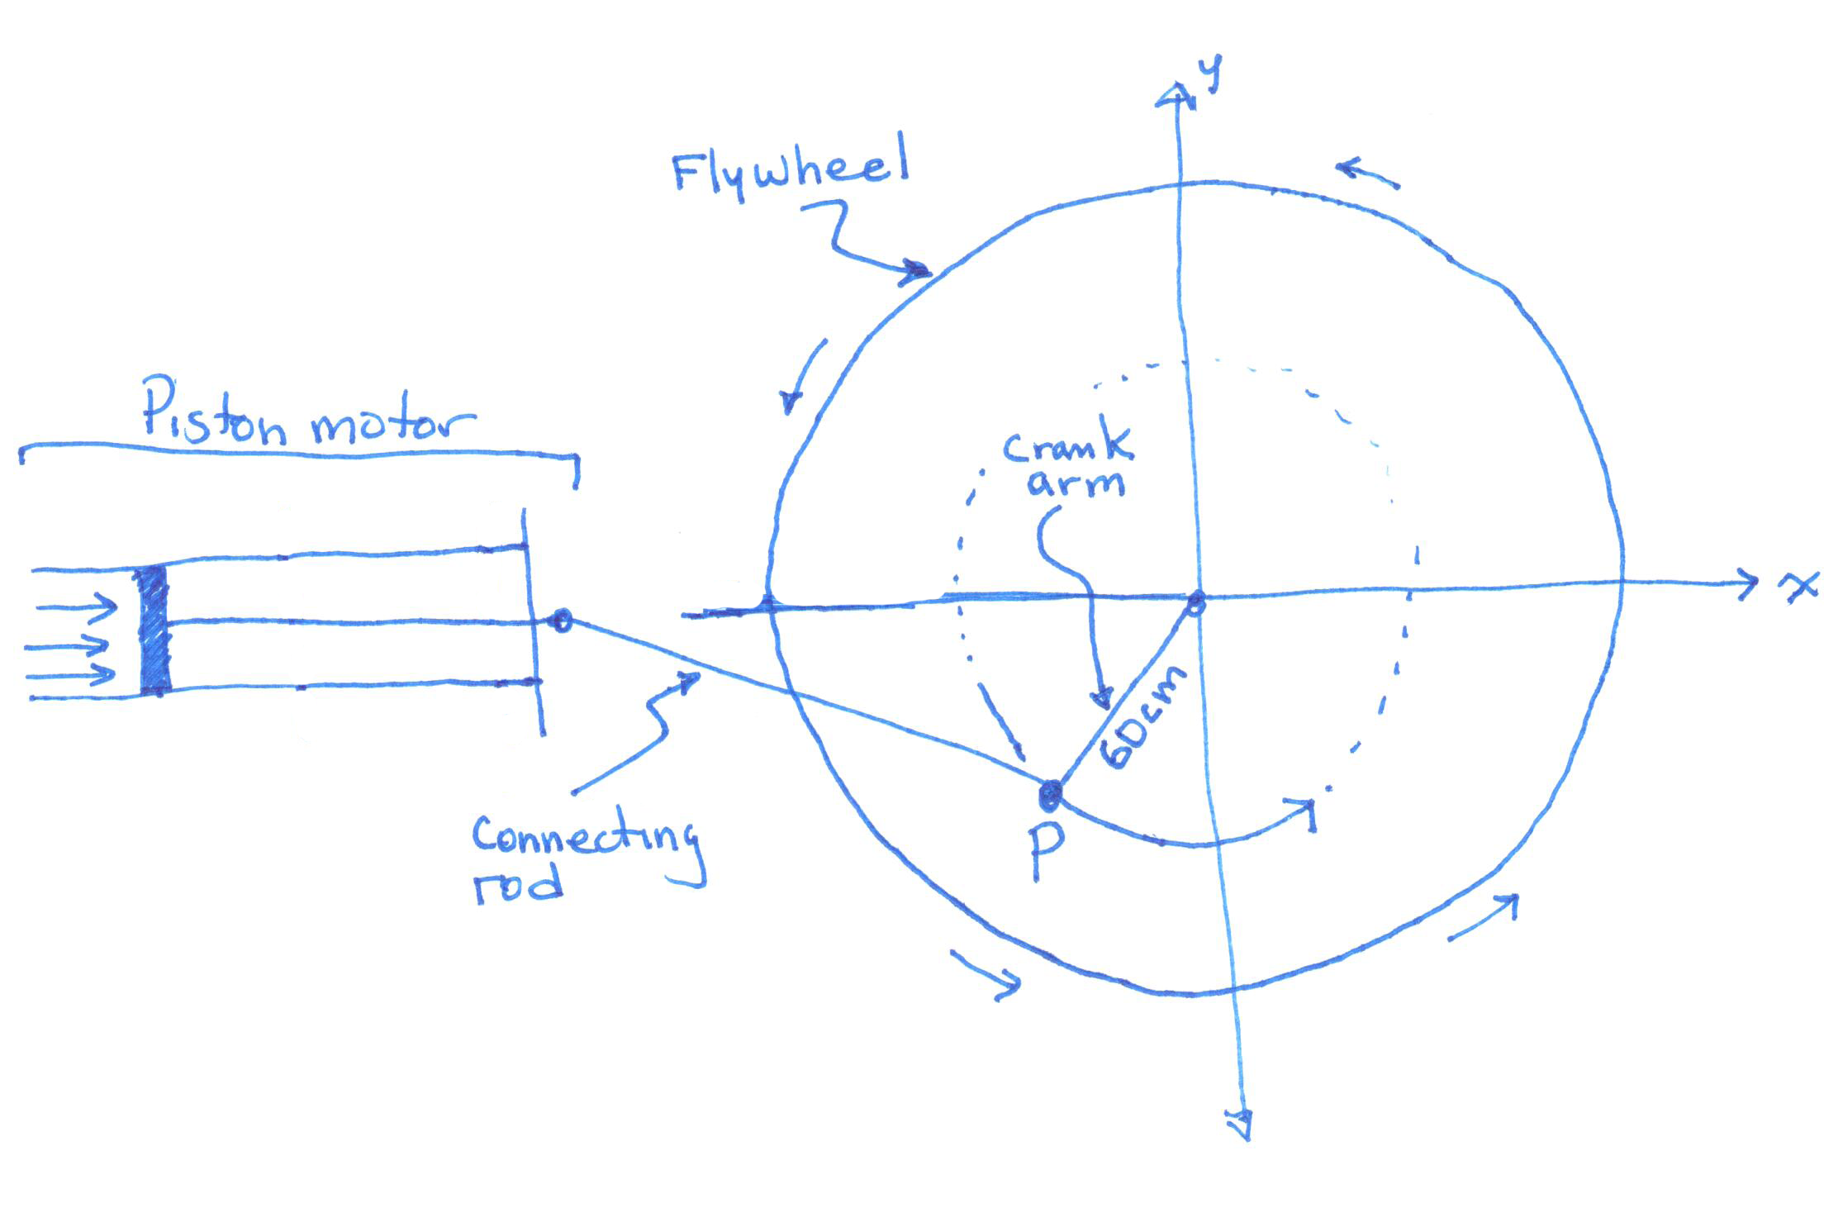
- An engineer was asked to design a powered crank to drive an industrial flywheel for a machine in a factory. To analyze the problem, she sketched a simple diagram of the piston motor, connecting rod, and crank arm attached to the flywheel, as shown below.

To make her calculations easier, she drew a coordinate axes with origin at the center of the flywheel, and she labeled the joint where the crank arm attaches to the connecting rod by the point $P$. As part of the design specifications, the crank arm is $60$ cm in length, and the motor spins the flywheel at a constant rate of $100$ revolutions per minute.

  - With the flywheel spinning, how many radians will the crank arm/connecting rod joint rotate around the origin over a period of $4$ seconds? Justify your answer.

  - With the flywheel spinning, suppose that the joint is located at point $P_{0}=(0,60)$ at time $t=0$ seconds; i.e., the crank arm and connecting rod are both parallel to the $x$-axis. Where will the joint be located $4$ seconds later?

- When plotting the graph of $y=sin⁡(x)$, with $x$ measured in radians, Fanuk draws arcs that are semicircles. He argues that semicircles are appropriate because, in his words, “Sine is the height of a point on a circle.”

Here is a picture of a portion of his incorrect graph.
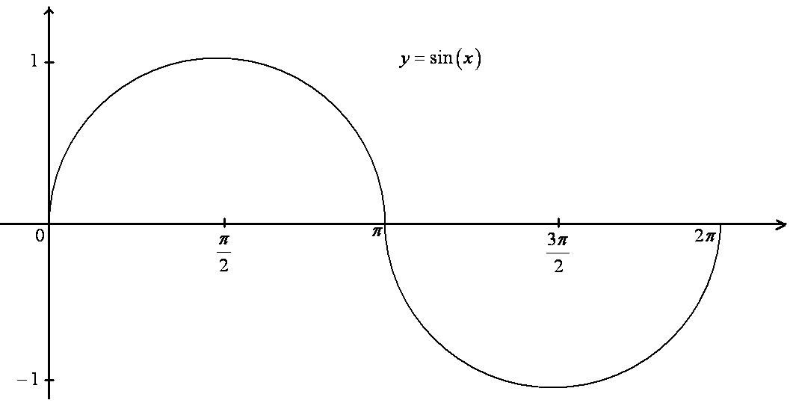
Fanuk claims that the first semicircular arc comes from a circle with center $\left(\frac{π}{2},0\right)$.

  - Explain why Fanuk's claim is incorrect.

JoJo knows that the arcs in the graph of the sine function are not semicircles, but she suspects each arc might be a section of a parabola.
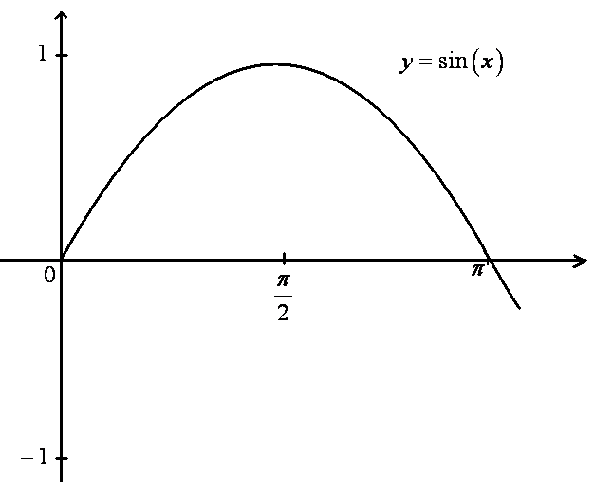
  - Write down the equation of a quadratic function that crosses the $x$-axis at $x=0$ and $x=π$, and has vertex $\left(\frac{π}{2},1\right)$.

  - Does the arc of a sine curve between $x=0$ and $x=π$ match your quadratic function for all values between $x=0$ and $x=π$? Is Jojo correct in her suspicions about the shape of these arcs? Explain.

  - Graph the function $f\left(x\right)=3\cos\left(2x\right)+1$ between $0$ and $2π$.

  - Graph and label the midline on your graph. Draw and label a segment to represent the period and specify its length.

  - Explain how you can find the midline, period, and amplitude in part (b) from the function
$f\left(x\right)=3\cos\left(2x\right)+1$.

  - Construct a periodic function that has period $8π$, a midline given by the equation $y=5$, and an amplitude of $\frac{1}{2}$.

A Progression Toward Mastery
Assessment  Task Item |  | STEP 1  Missing or incorrect answer and little evidence of reasoning or application of mathematics to solve the problem. | STEP 2  Missing or incorrect answer but evidence of some reasoning or application of mathematics to solve the problem. | STEP 3  A correct answer with some evidence of reasoning or application of mathematics to solve the problem, or an incorrect answer with substantial evidence of solid reasoning or application of mathematics to solve the problem. | STEP 4  A correct answer supported by substantial evidence of solid reasoning or application of mathematics to solve the problem.
1 | a  F-TF.A.1 | Student guesses an incorrect answer. Student knows that the answer to part (i) is in degrees. | Student gives correct answer in degrees for part (i) but gives incorrect answers for both parts (ii) and (iii).  OR  Student answers two of the three parts correctly but in radians instead of degrees. | Student gives correct degrees for parts (i) and (ii) but incorrect answer for part (iii). | Student correctly gives the central angle measurements in degrees: $60°$, $172°$, and $30°$.
 | b  F-TF.A.1 | Student uses another unit but not degrees or radians. | Student knows that the measurement is incorrect but does not understand that angle measures are independent of the arc used to measure them. | Student knows that the angle should be in radian or degrees. | Student understands that the angle measurement is independent of the size of the arc used to measure the angle.
 | c  F-TF.A.1 | Student says that Elmo is correct. | Student says that Elmo is incorrect but gives an incorrect reason for why he is incorrect. | Student knows that the angle measurement is wrong but does not know how to correct it.  OR  Student says the answer should be in degrees. | Student understands that the angle measurement is always between 0 and $π$ radians and knows that the correct answer is $\frac{π}{3}$.
 | d  F-TF.A.2 | Student does not draw a circle or angle. | Student draws a circle but draws an incorrect angle. | Student correctly draws the circle and graphs the point.  Student understands the degree measurement of the angle and that the answer has sines and cosines. Student possibly finds a reference angle of $\frac{π}{3}$. | Student correctly draws the diagram with a triangle indicating the sine and cosine on the legs and uses the reference angles to correctly evaluate the sine of $\frac{4π}{3}$.  Student understands that the reference angle is $\frac{π}{3},$ or $60$ degrees, knows which quadrant is referenced, and knows the correct signs for the trigonometric functions.
2 | a  F-TF.A.1  F-TF.A.2 | Student does not correctly determine pairwise relationships. | Student determines some pairwise relationships but not all. | Student’s diagram has one of the four expressions out of place.  Student  does not know that for small $x$, $sin(x)≈x$. | Student’s diagram correctly indicates the orderings. Student knows how to calculate all the values, draws a good picture of the sine graph, and understands for small $x$ that $sin(x)≈x$; $\sin\left(π\right)=0<\sin\left(1°\right)<\sin\left(1\right)< \sin\left(60°\right).$
 | b  F-TF.A.1  F-TF.A.2 | Student does not correctly determine pairwise relationships. OR  Student does not draw the graphs. | Student determines some pairwise relationships but not all.  OR  Student has one expression out of place. | Student’s diagram has one of the four expressions out of place.  Student knows that the sine and cosine graph cross at $\frac{π}{4}$. | Student’s diagram correctly indicates the orderings and has the correct relationship between $25°$ and $\frac{π}{4}$.  Student knows where the sine and cosine are increasing/decreasing; i.e., $\cos\left(\frac{3π}{8}\right)<\sin\left(25°\right)<\cos\left(25°\right)< \sin\left(\frac{3π}{8}\right)$.
 | c  F-TF.A.1  F-TF.A.2 | Student does not correctly determine pairwise relationships or draw the graphs.  OR  Student only guesses at values. | Student determines some pairwise relationships but not all.  OR  Student has one expression out of place but knows that tan of $100$ degrees is negative. | Student has all but the tan $15$ degrees correctly in place. | Student understands how to use known functions to determine the relation of the tangent to the sine and cosine; i.e.,  $\tan\left(100°\right)<\tan\left(15°\right)<\cos\left(15°\right)<sin⁡(100°)$.
 | d  F-TF.A.1  F-TF.A.2 | Student does not correctly determine pairwise relationships or draw the graphs.  OR  Student only guesses at values. | Student determines some pairwise relationships but does not know what to do with the$x$. | Student assumes that $x=0$. | Student understands how small changes in the value of $x$ affects the value of the functions; i.e.,  $$\sin\left(\frac{109π}{107}\right)<sin\left(x\right)<\sin\left(\frac{11π}{4}+x\right)<\sin\left(x-\frac{3π}{2}\right).$$
3 | a  F-TF.A.2 | Student does not know how to measure the number revolutions during $4$seconds in degrees or radians. | Student finds the number of rotations of the crank arm in$4$ seconds ($\frac{20}{3}$ revolutions). | Student finds the correct rotational measure of the crank arm in degrees (not radians). | Student finds the correct rotational measure of the crank arm in radians (i.e., $\frac{40π}{3}$ radians).
 | b  F-TF.A.2 | Student does not know that the answer is related to the sine or cosine function. | Student knows that the sine or cosine function is involved but does not have the values correct.  OR  Student provides the wrong function with incorrect amplitude. | Student has the sine or cosine function but is confused and does not have the correct arguments for the functions.  OR  Student has the amplitude incorrect. OR  Student has the correct answer but gives the wrong reason. | Student has the correct function and derives the correct value; student correctly understands how to mod out the rotations.
4 | a  F-IF.C.7e | Student does not know the shape of the sine graph. | Student draws a sine graph but has the wrong height. | Student has some good reasoning, such as: the sine does not have vertical tangents at $0$ or $π$. | Student correctly realizes that the radius gives the wrong height for the sine graph.
 | b  F-IF.C.7e | Student does not understand how to write a quadratic polynomial as a product of two linear factors.  OR  Student does not know that a quadratic function required. | Student knows that the answer should be in the form of a quadratic function  $f\left(x\right)=Ax^{2}+Bx+C$. | Student tries to solve for the coefficients of the quadratic function  $f\left(x\right)=Ax^{2}+Bx+C.$  Student correctly sets up some of the equation. | Student correctly expresses the polynomial in the form  $a(x-r_{1})(x-r_{2})$ and correctly solves for $a$.  Student knows that the quadratic function $f\left(x\right)=ax\left(x-π\right)$ is required, obtains  $a=-\frac{4}{π^{2}},$ and shows that this polynomial does not match the sine at some value. The required function is  $f(x)=-\frac{4}{π^{2}}x\left(x-π\right).$
 | c  F-IF.C.7e | Student does not know how to test for the required condition. | Student guesses at an answer, but he does test for the guess that is made. | Student selects a value to see if the quadratic function and the sine function match on that value but does not do the calculations correctly.  OR  Student has to try several values before getting one that works. | Student understands that the selection of a check value where the sine and quadratic functions differ is all that needs to be done and correctly guesses a value for which the sine is easy to calculate.
5 | a  F-IF.C.7e | Student does not draw the graph of a periodic function. | Student draws the graph of one function correctly. | Student draws the graphs of two function correctly. | Student draws the graphs of all three function correctly.
 | b  F-IF.C.7e | Student indicates neither midline nor period. | Student correctly indicates midline and/or period, but neither is labeled by the length of the period or the equation of the midline. | Student correctly draws midline and period segment, but only one is labeled correctly by the length of the period or equation of the midline. | Student correctly draws midline and period segment, and they are labeled by the correct length of the period/equation of the midline.
 | c  F-IF.C.7e | Student does not explain how to obtain any of the quantities. | Student correctly finds at least one of the quantities. | Student correctly finds all but one of the quantities. | Student correctly finds values for all the quantities and understands the relationship between the constant $ω$ and the period.
 | d  F-IF.C.7e | Student only guesses that a sine or cosine function is needed. | Student knows that a sine or cosine function will work but does not obtain the correct parameters. | Student correctly sketches the graph, but misses one of the parameters or has the graph incorrectly shifted.  OR  Student sketches the graph adequately but not the correct relationship between the constant $ω$ and the period. | Student provides the correct values for each of the parameters, understands that either a sine or cosine will work, and presents the correct relationship between the constant $ω$ and the period.

Name Date

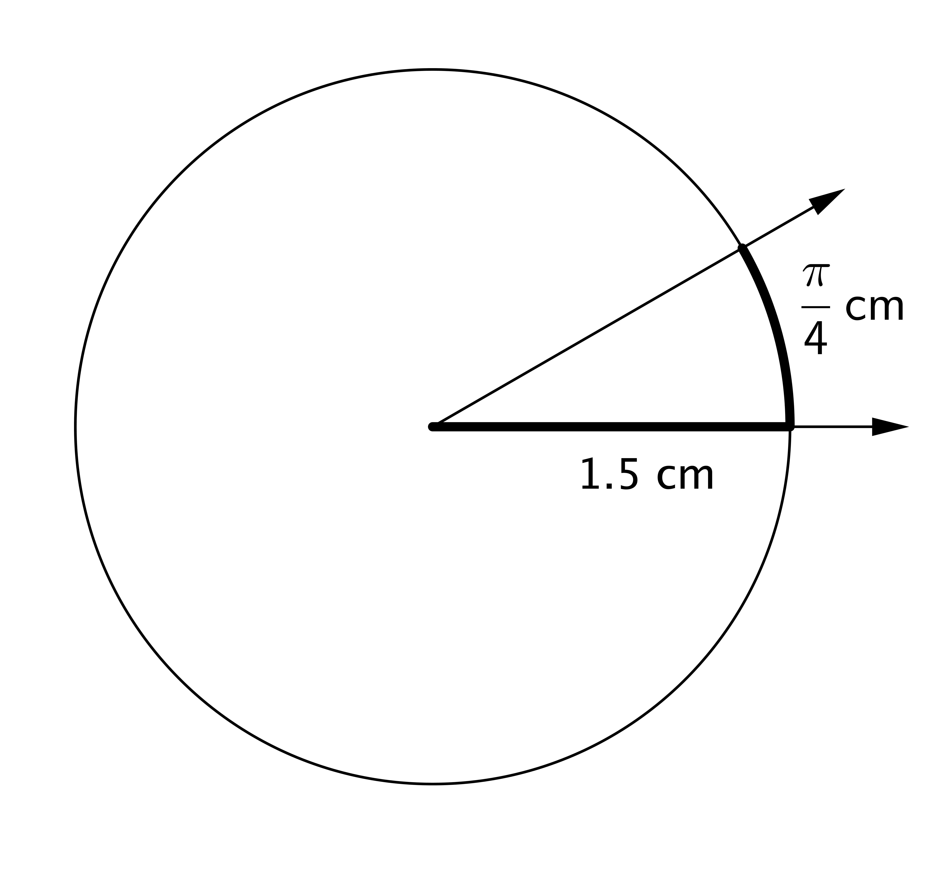
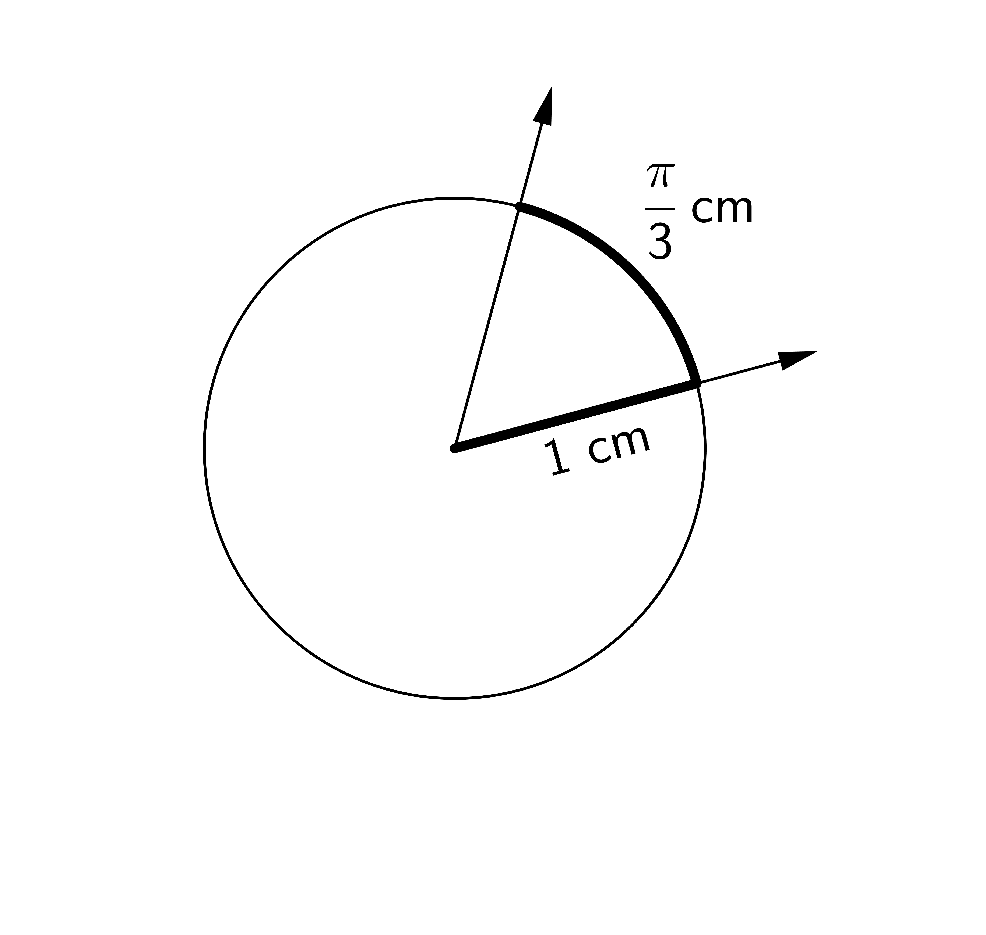
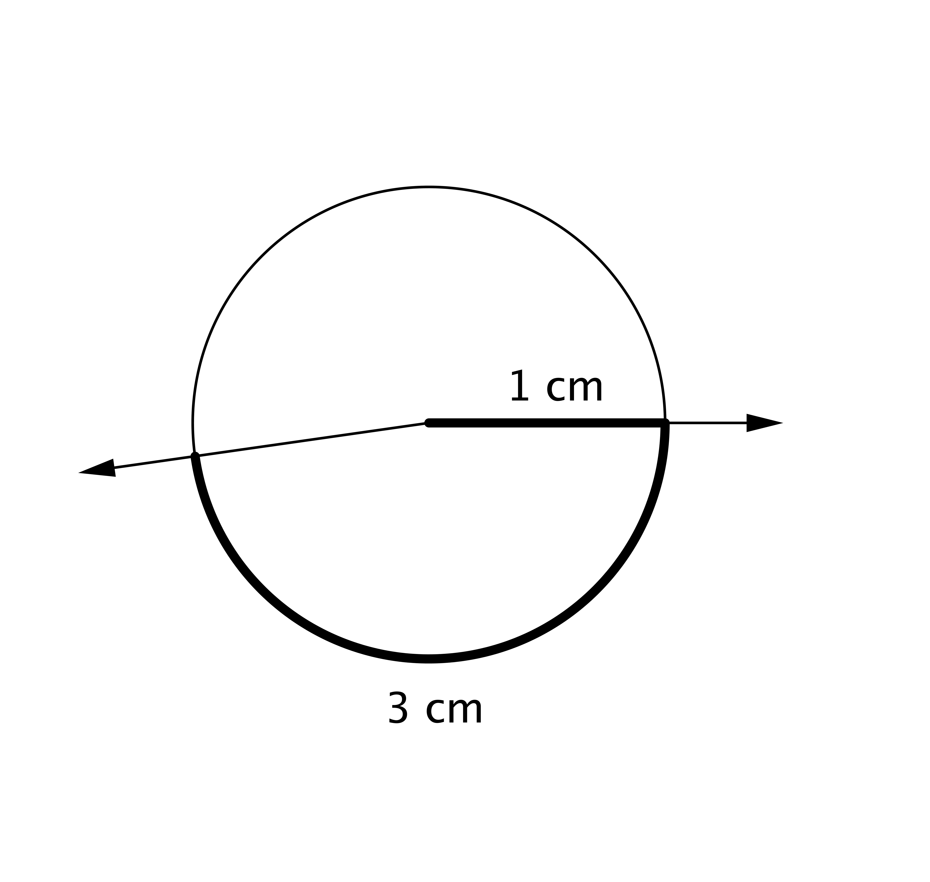
  - For each arc indicated below, find the degree measure of its subtended central angle to the nearest degree. Explain your reasoning.
(iii)
(ii)
(i)
- The measure of the angle in radians is $\frac{\frac{\text{π}}{\text{3}}\text{ cm}}{\text{1 cm}}$ rad, or $\frac{\text{π}}{\text{3}}$ rad. Therefore, the measure in degrees is $\frac{\text{π}}{\text{3}} \text{rad} \text{⋅ }\frac{\text{180˚}}{\text{π rad}} ,$ which is 60˚.
- The measure of the angle in radians is $\frac{\text{3 cm}}{\text{1 cm}}$ rad, or 3 rad. Therefore, the measure in degrees is $\text{3} \text{rad} \text{⋅ }\frac{\text{180˚}}{\text{π rad}} ,$ which is approximately 172˚.
- The measure of the angle in radians is $\frac{\frac{\text{π}}{\text{4}}\text{ cm}}{\text{1.5 cm}}$ rad, or $\frac{\text{π}}{\text{6}}$ rad. Therefore, the measure in degrees is $\frac{\text{π}}{\text{6}} \text{rad} \text{⋅ }\frac{\text{180˚}}{\text{π rad} } ,$ which is 30˚.

  - Elmo drew a circle with a radius of $1 \text{cm}$. He drew two radii with an angle of $60°$ between them and then declared that the radian measure of that angle was $\frac{π}{3}$ cm. Explain why Elmo is not correct in saying this.
Angle measurements are not given in length units. He is incorrect in declaring that the angle has units of centimeters.

  - Elmo next drew a circle with a radius of $1$ cm. He drew two radii that formed a $60°$ angle and then declared that the radian measure of that angle is $\frac{10π}{3}$. Is Elmo correct? Explain your reasoning.
This is not correct. The measure of the angle is $\frac{π}{3}$ radians—the measure of an angle is always between 0 and $π$ radians. The amount $\frac{10π}{3}$ can be thought of as the amount a ray (or a subset of a ray like a radius) has been rotated about the center. In this case, one of the radii can be chosen so that if it is rotated by $\frac{10π}{3}$ about the center of the circle, its image will be the other radius.

  - Draw a diagram that illustrates why $\sin\left(\frac{4π}{3}\right)=-\frac{\sqrt{3}}{2}$ using the unit circle. Explain how the unit circle helps us to make this calculation.
Rotating the initial ray (given by the positive x-axis) by $\frac{\text{4π}}{\text{3}}$ radians produces a ray in the third quadrant of the coordinate plane. It intersects the unit circle in a point whose y-value is $\text{sin}\left(\frac{\text{4π}}{\text{3}}\right)$. To find $\text{sin}\left(\frac{\text{4π}}{\text{3}}\right)$, draw a perpendicular line to the x-axis through the intersection point forming a right triangle (see diagram). The reference angle for this right triangle is $\frac{\text{4π}}{\text{3}}\text{- π} \text{=} \frac{\text{π}}{\text{3}}$ . Thus, $\text{sin}\left(\frac{\text{4π}}{\text{3}}\right) \text{=} \text{sin}\left(\frac{\text{π}}{\text{3}} \text{+} \text{π}\right) \text{=} -\text{sin}\left(\frac{\text{π}}{\text{3}}\right) \text{=} -\frac{\sqrt{\text{3}}}{\text{2}}$.

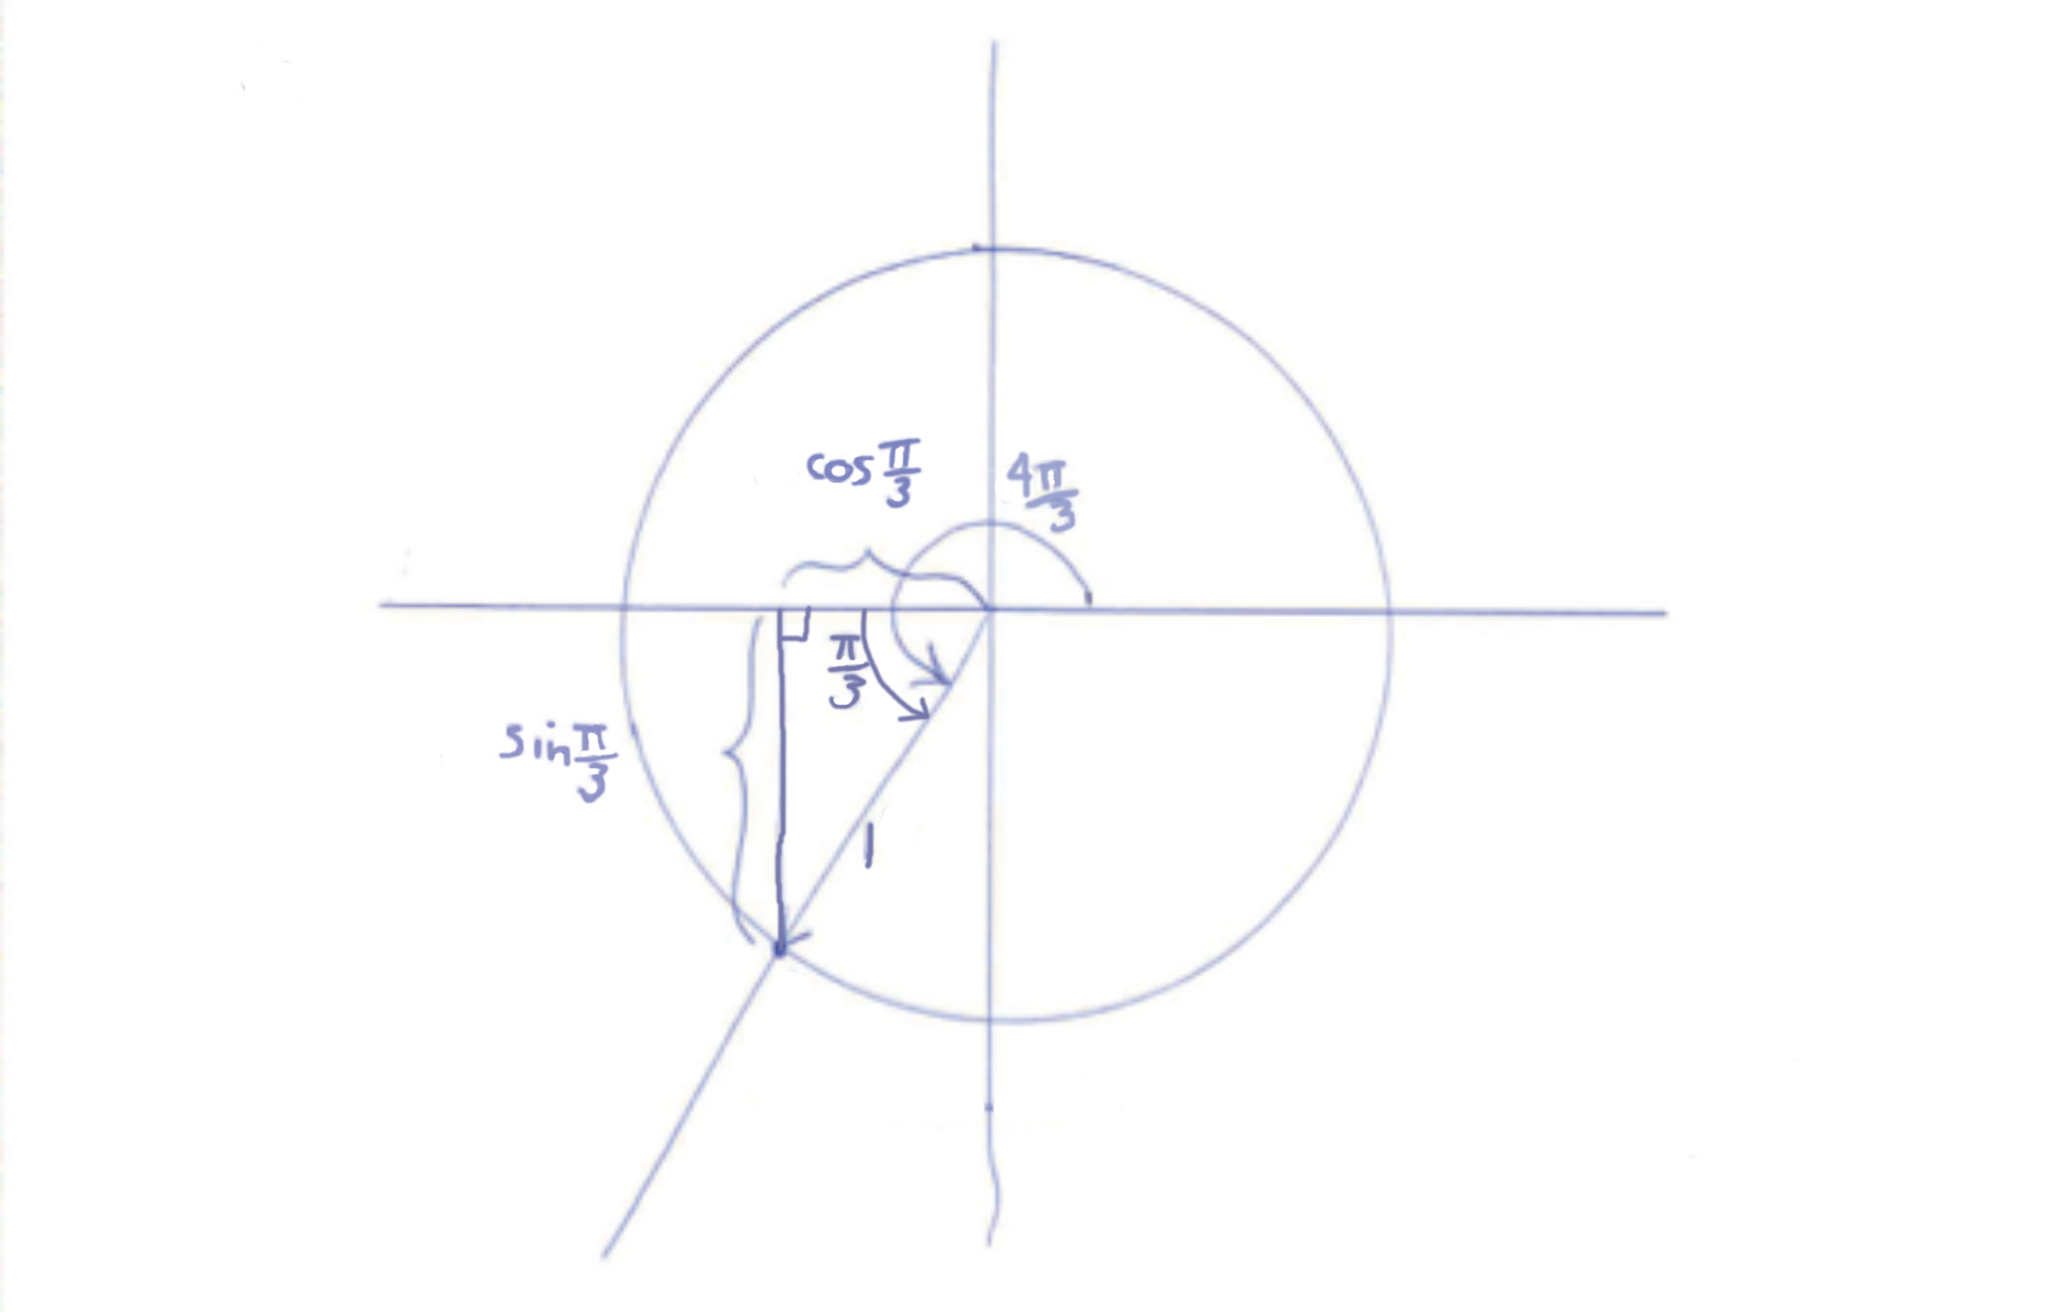

- For each part, use your knowledge of the definition of radians and the definitions of sine, cosine, and tangent to place the expressions in order from least to greatest without using a calculator. Explain your reasoning.

  - $sin(1°)$ $sin(1)$ $sin(π)$ $sin(60°)$
Note that one radian is about 57°. Since sin($\text{π}$) = 0,
$\text{sin}\left(\text{π}\right)\text{ < }\text{sin}\left(\text{1°}\right)\text{ < }\text{sin}\left(\text{1}\right)\text{ <}\text{sin}\left(\text{60°}\right).$

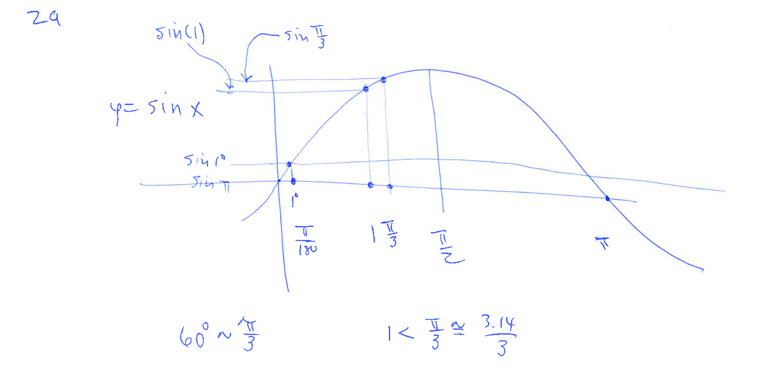

  - $sin(25°)$ $cos(25°)$ $\sin\left(\frac{3π}{8}\right)$ $\cos\left(\frac{3π}{8}\right)$
Note that $\frac{\text{3π}}{\text{8}}$ radians is 67.5°, which is only 22.5° from the vertical.
$\text{cos}\left(\frac{\text{3π}}{\text{8}}\right) \text{<} \text{sin}\left(\text{25°}\right) \text{<}\text{cos}\left(\text{25°}\right) \text{<} \text{sin}\left(\frac{\text{3π}}{\text{8}}\right).$

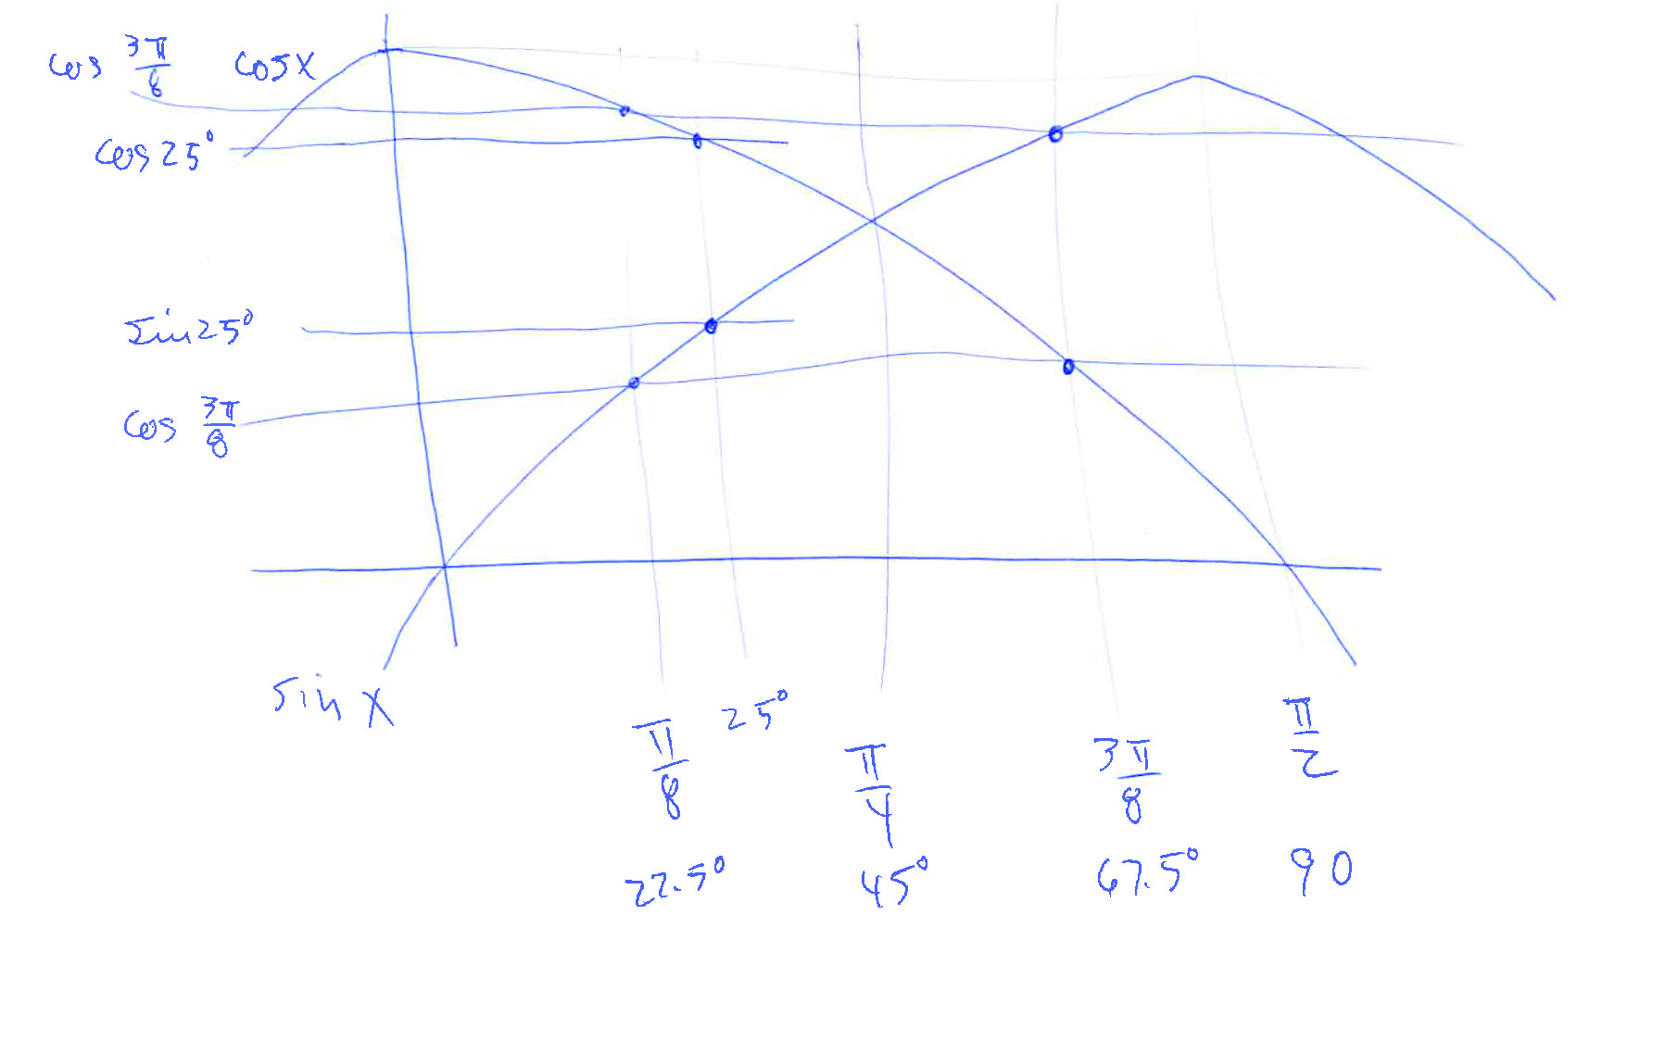

  - $sin(100°)$ $cos(15°)$ $tan(15°)$ $tan(100°)$
Note that $\text{tan}\left(\text{100°}\right)$ is negative; all other quantities are positive. Since $\text{tan}\left(\text{30°}\right) \text{=} \frac{\sqrt{\text{3}}}{\text{3}}$ and $\frac{\sqrt{\text{3}}}{\text{2}} \text{=} \text{cos}\left(\text{25°}\right)$,
$\text{cos}\left(\text{15°}\right) \text{<}\text{sin}\left(\text{100°}\right);$
also, $\text{tan}\left(\text{15°}\right) \text{<} \text{ tan}\left(\text{30°}\right) \text{<} \text{cos}\left(\text{25°}\right) \text{<} \text{cos}\left(\text{15°}\right).$
Putting it all together, we see that:
$\text{tan}\left(\text{100°}\right) \text{<}\text{ tan}\left(\text{15°}\right) \text{<} \text{cos}\left(\text{15°}\right) \text{<} \text{sin}\left(\text{100°}\right).$

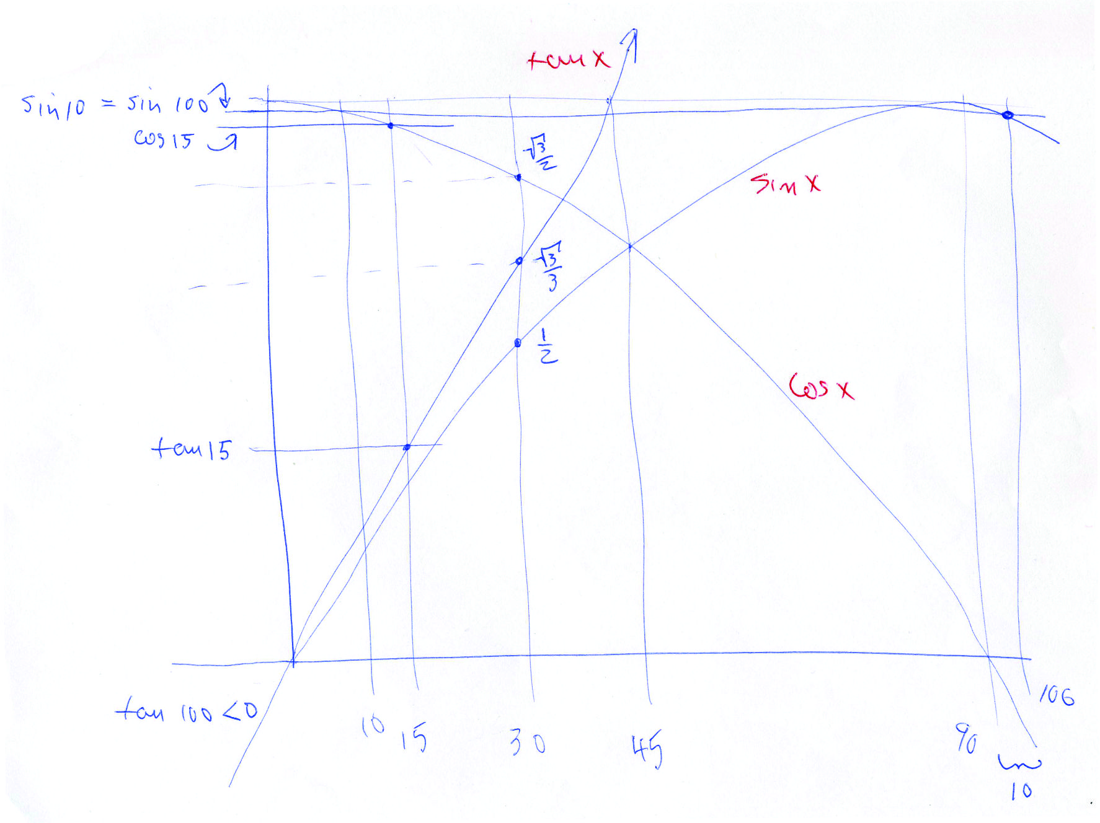

  - $sin(x)$ $sin\left(x-\frac{3π}{2}\right)$ $\sin\left(\frac{11π}{4}+x\right)$ $\sin\left(\frac{109π}{107}\right)$
where $x$ is a very small positive number with $x<0.01$
Since x is very small and positive, sin(x) is a small positive value, $\text{sin}\left(\text{x} -\frac{\text{3π}}{\text{2}}\right) \text{≈} \text{1}$, $\text{sin}\left(\frac{\text{11π}}{\text{4}}\text{+ }\text{x}\right) \text{≈} \frac{\text{1}}{\sqrt{\text{2}}}$, and $\text{sin}\left(\frac{\text{109π}}{\text{107}}\right)$is negative. So,
$${\text{sin}\left(\frac{\text{109π}}{\text{107}}\right) \text{<} \text{ sin}\left(\text{x}\right) \text{<} \text{ sin}\left(\frac{\text{11π}}{\text{4}}\text{+} \text{x}\right) \text{<} \text{ sin}\left(\text{x} -\frac{\text{3π}}{\text{2}}\right). }$$

- An engineer was asked to design a powered crank to drive an industrial flywheel for a machine in a factory. To analyze the problem, she sketched a simple diagram of the piston motor, connecting rod, and the crank arm attached to the flywheel, as shown below.

To make her calculations easier, she drew a coordinate axes with origin at the center of the flywheel, and she labeled the joint where the crank arm attaches to the connecting rod by the point $P$. As part of the design specifications, the crank arm is $60$ cm in length, and the motor spins the flywheel at a constant rate of $100$ revolutions per minute.

  - With the flywheel spinning, how many radians will the crank arm/connecting rod joint rotate around the origin over a period of $4$ seconds? Justify your answer.
$$\frac{\text{100 revolutions}}{\text{1 min}}\text{ ⋅ }\frac{\text{2π rad}}{\text{1 revolution}}\text{ ⋅ }\frac{\text{1 min}}{\text{60 sec}}\text{ ⋅ }\text{4 sec} \text{=} \frac{\text{40π}}{\text{3}}\text{ rad}.$$
Number of radians: $\frac{\text{40π}}{\text{3}}$

  - With the flywheel spinning, suppose that the joint is located at point $P_{0}(0,60)$ at time $t=0$ seconds; i.e., the crank arm and connecting rod are both parallel to the $x$-axis. Where will the joint be located 4 seconds later?
The x-coordinate is $\text{60}\text{cos}\left(\frac{\text{40π}}{\text{3}}\right) \text{=} \text{60}\text{cos}\left(\frac{\text{4π}}{\text{3}}\right)\text{ =} \text{60}\left(-\frac{\text{1}}{\text{2}}\right) \text{=} -\text{30}$, or –30 cm.
The y-coordinate is $\text{60}\text{sin}\left(\frac{\text{40π}}{\text{3}}\right) \text{=} \text{60}\text{sin}\left(\frac{\text{4π}}{\text{3}}\right) \text{=} \text{60}\left(-\frac{\sqrt{\text{3}}}{\text{2}}\right) \text{=} -\text{30}\sqrt{\text{3}}$, or $-\text{30}\sqrt{\text{3}}$cm.
Thus, the coordinates of the joint after 4 seconds will be$\left(-\text{30,}-\text{30}\sqrt{\text{3}}\right)$; so, it is located 30 cm to the left of the center of the flywheel and $\text{30}\sqrt{\text{3}}$ cm below the center of the flywheel.

- When plotting the graph of $y=sin⁡(x)$, with $x$ measured in radians, Fanuk draws arcs that are semicircles. He argues that semicircles are appropriate because, in his words, “Sine is the height of a point on a circle.”

Here is a picture of a portion of his incorrect graph.
Fanuk claims that the first semicircular arc comes from a circle with center $\left(\frac{π}{2},0\right)$.

  - Explain why Fanuk's claim is incorrect.
The first arc is NOT a semicircle from a circle with the point $\left(\frac{\text{π}}{\text{2}}\text{, 0}\right)$ as center. There is no consistent “radius” for the first curve of the sine graph. The distance between the purported center $\left(\frac{\text{π}}{\text{2}}\text{, 0}\right)$ and the point (0,0) on the curve is $\frac{\text{π}}{\text{2}}$, whereas the distance between $\left(\frac{\text{π}}{\text{2}}\text{, 0}\right)$ and $\left(\frac{\text{π}}{\text{2}}\text{, 1}\right)$ on the curve is 1.

JoJo knows that the arcs in the graph of the sine function are not semicircles, but she suspects each arc might be a section of a parabola.
  - Write down the equation of a quadratic function that crosses the $x$-axis at $x=0$ and $x=π$, and has vertex $\left(\frac{π}{2},1\right)$.
The form of the quadratic function needed is $\text{f(x)} \text{=} \text{ax(x}-\text{π)}$ for some a. Put $\text{x} \text{=} \frac{\text{π}}{\text{2}}$ and y = 1 to see $\text{a} \text{=}-\frac{\text{4}}{{\text{π}}^{\text{2}}}$. Thus, $\text{f(x)} \text{=}-\frac{\text{4}}{{\text{π}}^{\text{2}}}\text{x(x-π)}$.

  - Does the arc of a sine curve between $x=0$ and $x=π$ match your quadratic function for all values between $x=0$ and $x=π$? Is Jojo correct in her suspicions about the shape of these arcs? Explain.
The point $\left(\frac{\text{π}}{\text{4}},\frac{\text{1}}{\sqrt{\text{2}}}\right)$ lies on the arc of the sine curve. Does it also lie on the quadratic?
When x = $\frac{\text{π}}{\text{4}} ,$ we have $\text{f}\left(\frac{\text{π}}{\text{4}}\right) \text{=} \frac{\text{3}}{\text{4}}$ . These do not match! Also, note: $\text{f(x)} \text{= }-\frac{\text{4}}{{\text{π}}^{\text{2}}}\text{x(x}-\text{π) }$is the only quadratic function with zeros x = 0 and x = π and vertex $\left(\frac{\text{π}}{\text{2}}\text{, 1}\right)$. There is no quadratic curve of any kind that matches the arc of a sine curve.

  - Graph the function $f\left(x\right)=3\cos\left(2x\right)+1$ between $0$ and $2π$.

Note that the figure below includes the response to part (b).

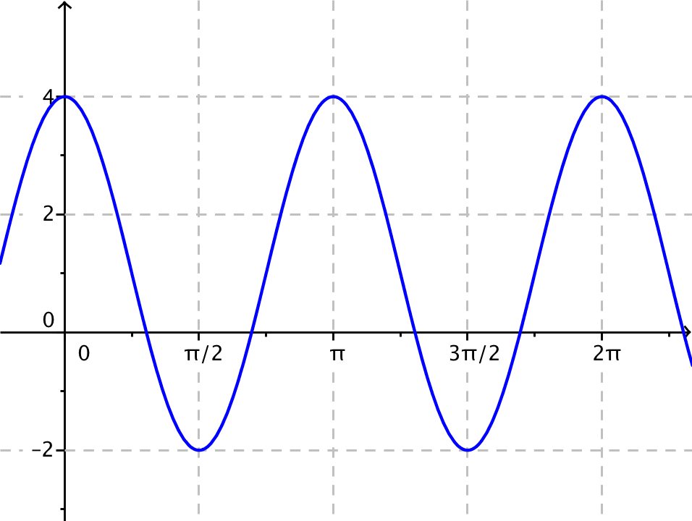
Period: π
Midline: Graph of y = 1.

  - Graph and label the midline on your graph. Draw and label a segment to represent the period and specify its length.

  - Explain how you can find the midline, period, and amplitude in part (b) from the function
$f\left(x\right)=3\cos\left(2x\right)+1$.
The midline is y = 1, where 1 is the constant added to the cosine function; the period satisfies the equation.
$$\text{2} \text{=} \frac{\text{2π}}{\text{p}}$$
where $p$ is the period. So $p=π$.

  - Construct a periodic function that has period $8π$, a midline given by the equation $y=5$, and an amplitude of $\frac{1}{2}$.
A sine or cosine function will work. Using the sine for our solution, we note that for the function in the following form:
$\text{f(x) = A sin(}\text{ω}\text{x)} \text{+} \text{c}$.
A is the amplitude, c is the vertical shift and the period p satisfies $\frac{\text{2π}}{\text{p}} \text{=} \text{ω}.$ So,
$$\text{f}\left(\text{x}\right) \text{=} \frac{\text{1}}{\text{2}}\text{sin}\left(\frac{\text{1}}{\text{4}}\text{x}\right) \text{+} \text{5}$$
will work. Replacing the sine with cosine works equally well.

The midline is $y=1$ where $1$ is the constant added to the cosine function; the period satisfies the equation
$$2=\frac{2π}{p}$$
where $p$ is the period. So $p=π$.

