Lesson 40: Obstacles Resolved—A Surprising Result

Classwork
Opening Exercise
Write each of the following quadratic expressions as a product of linear factors. Verify that the factored form is equivalent.
- $x^{2}+12x+27$

- $x^{2}-16$

- $x^{2}+16$

- $x^{2}+4x+5$

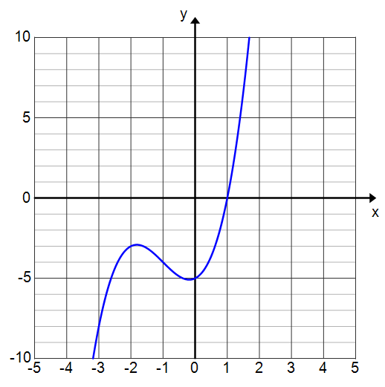
Example 1
Consider the polynomial $P\left(x\right)= x^{3}+ 3x^{2}+ x-5$ whose graph is shown to the right.
- Looking at the graph, how do we know that there is only one real solution?

- Is it possible for a cubic polynomial function to have no zeros?

- From the graph, what appears to be one solution to the equation $x^{3}+3x^{2}+x-5=0$?

- How can we verify that this is a solution?

- According to the Remainder Theorem, what is one factor of the cubic expression$x^{3}+3x^{2}+x-5$?

- Factor out the expression you found in part (e) from $x^{3}+3x^{2}+x-5$.

- What are all of the solutions to $x^{3}+3x^{2}+x-5=0$?

- Write the expression$x^{3}+3x^{2}+x-5$ in terms of linear factors.

Exercises 1–2
Write each polynomial in terms of linear factors. The graph of $y=x^{3}-3x^{2}+4x-12$ is provided for Exercise 2.
- $f\left(x\right)=x^{3}+5x$

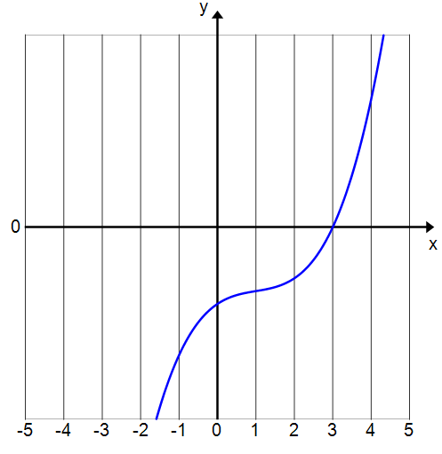
- $g\left(x\right)=x^{3}-3x^{2}+4x-12$

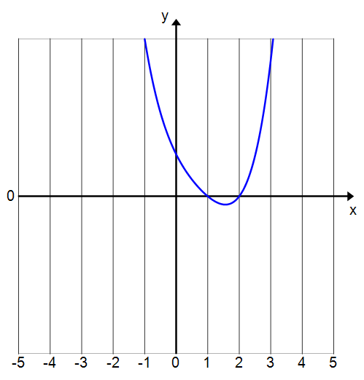
Example 2
Consider the polynomial function $P\left(x\right)=x^{4}-3x^{3}+6x^{2}-12x+8$, whose corresponding graph $y=x^{4}-3x^{3}+6x^{2}-12x+8$ is shown to the right. How many zeros does $P$ have?
- Part 1 of the Fundamental Theorem of Algebra says that this equation will have at least one solution in the complex numbers. How does this align with what we can see in the graph to the right?

- Identify one zero from the graph.

- Use polynomial division to factor out one linear term from the expression $x^{4}-3x^{3}+6x^{2}-12x+8$.

- Now we have a cubic polynomial to factor. We know by part $1$ of the Fundamental Theorem of Algebra that a polynomial function will have at least one real zero. What is that zero in this case?

- Use polynomial division to factor out another linear term of $x^{4}-3x^{3}+6x^{2}-12x+8$.

- Are we done? Can we factor this polynomial any further?

- Now that the polynomial is in factored form, we can quickly see how many solutions there are to the original equation $x^{4}-3x^{3}+6x^{2}-12x+8=0.$

- What if we had started with a polynomial function of degree $8$?

Lesson Summary
Every polynomial function of degree $n$, for $n≥1$, has $n$ roots over the complex numbers, counted with multiplicity. Therefore, such polynomials can always be factored into $n$ linear factors, and the obstacles to factoring we saw before have all disappeared in the larger context of allowing solutions to be complex numbers.
The Fundamental Theorem of Algebra:
- If $P$ is a polynomial function of degree $n≥1$, with real or complex coefficients, then there exists at least one number $r$ (real or complex) such that $P(r)=0$.
- If $P$ is a polynomial function of degree $n≥1$, given by $P\left(x\right)=a_{n}x^{n}+a_{n-1}x^{n-1} +…+a_{1}x+a_{0}$ with real or complex coefficients $a_{i}$, then $P$ has exactly $n$ zeros $r_{1}, r_{2}, …, r_{n}$ (not all necessarily distinct), such that $P(x)=a(x-r_{1})(x-r_{2})⋯(x-r_{n})$.

Problem Set

- Write each quadratic function below in terms of linear factors.
  - $f(x)=x^{2}-25$
  - $f(x)=x^{2}+25$
  - $f(x)=4x^{2}+25$
  - $f(x)=x^{2}-2x+1$
  - $f(x)=x^{2}-2x+4$

- Consider the polynomial function $P(x)=(x^{2}+4)(x^{2}+1)(2x+3)(3x-4)$.
  - Express P in terms of linear factors.
  - Fill in the blanks of the following sentence.
The polynomial $P$ has degree ________ and can, therefore, be written in terms of ________ linear factors. The function $P$has ________ zeros. There are _______ real zeros and ________ complex zeros. The graph of $y=P(x)$ has ________ $x$-intercepts.

- Express each cubic function below in terms of linear factors.
  - $f\left(x\right)=x^{3}-6x^{2}-27x$
  - $f\left(x\right)=x^{3}-16x^{2}$
  - $f(x)=x^{3}+16x$

- For each cubic function below, one of the zeros is given. Express each cubic function in terms of linear factors.
  - $f(x)={2x}^{3}-9x^{2}-53x-24$; $f(8)=0$
  - $f(x)=x^{3}+x^{2}+6x+6$; $f(-1) = 0$
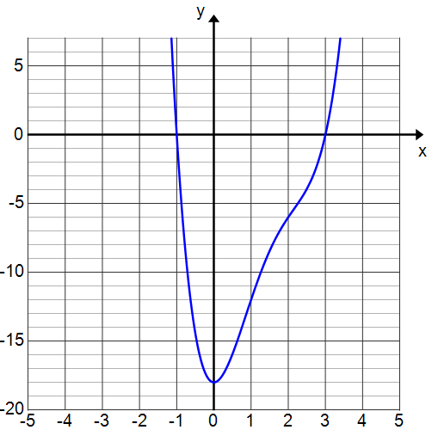
- Determine if each statement is always true or sometimes false. If it is sometimes false, explain why it is not always true.
  - A degree $2$ polynomial function will have two linear factors.
  - The graph of a degree $2$ polynomial function will have two $x$-intercepts.
  - The graph of a degree $3$ polynomial function might not cross the $x$-axis.
  - A polynomial function of degree $n$ can be written in terms of $n$linear factors.

- Consider the polynomial function $f(x)=x^{6}-9x^{3}+8$.
  - How many linear factors does $x^{6}-9x^{3}+8$ have? Explain.
  - How is this information useful for finding the zeros of $f$?
  - Find the zeros of $f$. (Hint: Let $Q=x^{3}$. Rewrite the equation in terms of $Q$ to factor.)

- Consider the polynomial function $P(x)=x^{4}-6x^{3}+11x^{2}-18$.
  - Use the graph to find the real zeros of $P$
  - Confirm that the zeros are correct by evaluating the function $P$ at those values.
  - Express $P$ in terms of linear factors.
  - Find all zeros of $P.$

- Penny says that the equation $x^{3}-8=0$ has only one solution, $x=2$. Use the Fundamental Theorem of Algebra to explain to her why she is incorrect.

- Roger says that the equation $x^{2}-12x+36=0$ has only one solution, $6$. Regina says Roger is wrong and that the Fundamental Theorem of Algebra guarantees that a quadratic equation must have two solutions. Who is correct and why?

