Lesson 38: Complex Numbers as Solutions to Equations

Student Outcomes
- Students solve quadratic equations with real coefficients that have complex solutions (N-CN.C.7). They recognize when the quadratic formula gives complex solutions and write them as $a+bi$ for real numbers $a$ and $b$. (A-REI.B.4b)

Lesson Notes

This lesson models how to solve quadratic equations over the set of complex numbers. Students relate the sign of the discriminant to the nature of the solution set for a quadratic equation. Continue to encourage students to make connections between the graphs of a quadratic equation, $y=ax^{2}+bx+c$, and the number and type of solutions to the equation $ax^{2}+bx+c=0.$

Classwork
Opening (2 minutes)
In Algebra I, students learned that when the quadratic formula resulted in an expression that contained a negative number in the radicand, the equation would have no real solution. Now, we have defined the imaginary unit as $i=\sqrt{-1}$. That allows us to solve quadratic equations over the set of complex numbers and see that every quadratic equation has at least one solution.
Scaffolding:
Advanced students may be able to handle a more abstract framing of—in essence—the same exercise. The exercise below offers the advanced student an opportunity to discover the discriminant and its significance on his or her own.
“Recall that a quadratic equation can have exactly two distinct real solutions, exactly one distinct real solution, or exactly two distinct complex solutions. What is the quadratic formula that we can use to solve an equation in the form $ax^{2}+bx+x=0,$ where $a$, $b$, and $c$ are real numbers and $a≠0$. Analyze this formula to decide when the equation will have two, one, or no real solutions.”
Solution: $$x=\frac{-b±\sqrt{b^{2}-4ac }}{2a}$$
The “type” of solutions to a quadratic equation hinges on the expression under the radical in the quadratic formula, namely, $b^{2}-4ac$. When $b^{2}-4ac<0$, both solutions will have imaginary parts. When $b^{2}-4ac>0$, the quadratic equation has two distinct real solutions. When $b^{2}-4ac=0$, the quadratic formula simplifies as $x=-\frac{b}{2a}$. In this case, there is only one real solution, which we call a zero of multiplicity two.

Opening Exercises (5 minutes)
Have students work on this opening exercise alone or in pairs. In this exercise, students apply the quadratic formula to three different relatively simple quadratic equations: one with two real roots, one with one real repeated root, and one with two imaginary roots. Students are then asked to explain the results in terms of the discriminant. Afterward, go over the answers with the class.
Review the quadratic formula $x=\frac{-b±\sqrt{b^{2}-4ac}}{2a}$ before beginning this exercise, and define the discriminant as the number under the radical; that is, the discriminant is the quantity $b^{2}-4ac.$

Opening Exercises
- Use the quadratic formula to solve the following quadratic equations. Calculate the discriminant for each equation.
  - $x^{2}-9=0$
The equation $x^{2}-9=0$ has two real solutions: $x=3$ and $x=-3$. The discriminant of $x^{2}-9=0$ is $36$.

  - $x^{2}-6x+9=0$
The equation $x^{2}-6x+9=0$ has one real solution: $x=3$. The discriminant of $x^{2}-6x+9=0$ is $0$.

  - $x^{2}+9=0$
The equation $x^{2}+9=0$ has two complex solutions: $x=3i$ and $x=-3i$. The discriminant of $x^{2}+9=0$ is $-36$.

- How does the value of the discriminant for each equation relate the number of solutions you found?
If the discriminant is negative, we get complex solutions. If the discriminant is zero, we get one real solution. If the discriminant is positive, we get two real solutions.

Discussion (8 minutes)
The expression under the radical in the quadratic formula $b^{2}-4ac$ is called the discriminant.
- Why do you think we call it the discriminant?
  - In English, a discriminant is a characteristic that allows “something” (e.g., an object, a person, a function) among a group of other “somethings” to be distinguished.
Scaffolding:
- English Language Learners may benefit from a Frayer diagram or other vocabulary exercise for the word “discriminant."
  - In this case, the discriminant distinguishes a quadratic equation by its number and type of solutions: one real solution (repeated), two real solutions, or two complex solutions.
- Let’s examine the situation when the discriminant is zero. Why does a quadratic equation with discriminant zero have only one real solution?
  - When the discriminant is zero, the quadratic formula gives the single solution $-\frac{b±0}{2a}=-\frac{b}{2a}$.
- Why is the solution when $b^{2}-4ac=0$a repeated zero?
  - If $b^{2}-4ac=0$, then $c=\frac{b^{2}}{4a}$, and we can factor the quadratic expression $ax^{2}+bx+c$ as follows:
$$ax^{2}+bx+c=ax^{2}+bx+\frac{b^{2}}{4a}= a\left(x^{2}+\frac{b}{a}x+\frac{b^{2}}{4a^{2}}\right)=a{\left(x+\frac{b}{2a}\right)}^{2}.$$
From what we know of factoring quadratic expressions from Lesson 11, $-\frac{b}{2a}$ is a repeated zero.
  - Analytically, the solutions can be thought of as $-\frac{b+0}{2a}$ and $-\frac{b-0}{2a}$, which are both $-\frac{b}{2a}$. So, there are two solutions that are the same number.
  - Geometrically, we can write the equation of the parabola as $y=a{\left(x+\frac{b}{2a}\right)}^{2}$, so the vertex of this parabola is $\left(-\frac{b}{2a}, 0\right)$, meaning the vertex of the parabola lies on the $x$-axis. Thus, the parabola is tangent to the $x$-axis and intersects the $x$-axis only at the point $\left(-\frac{b}{2a}, 0\right)$.
- For example, the graph of ${y=x}^{2}+6x+9$ intersects the $x$-axis only at $(-3, 0)$, as follows.
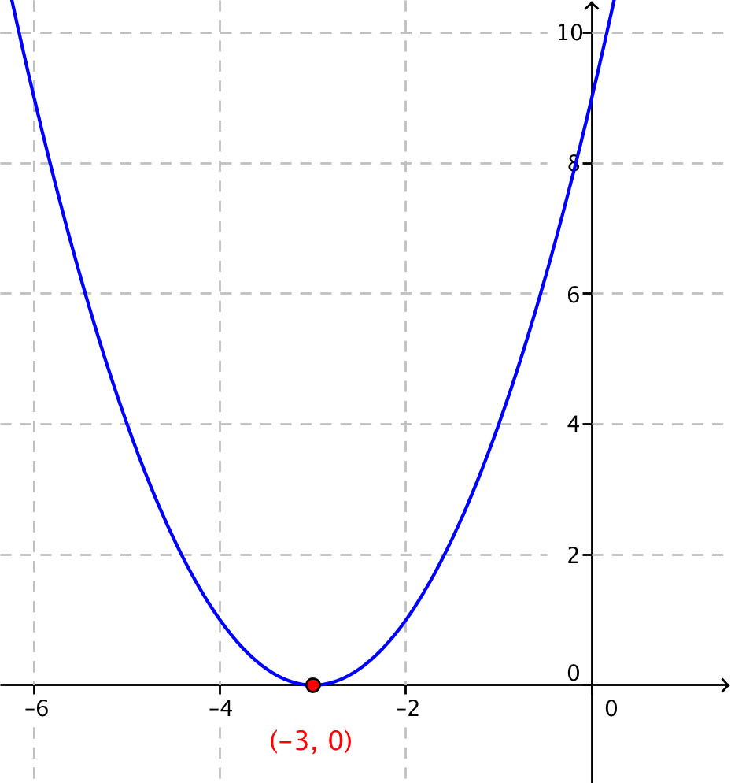

- Describe the graph of a quadratic equation with positive discriminant.
  - If the discriminant is positive, then the quadratic formula gives two different real solutions.
  - Two real solutions mean the graph intersects the $x$-axis at two distinct real points.
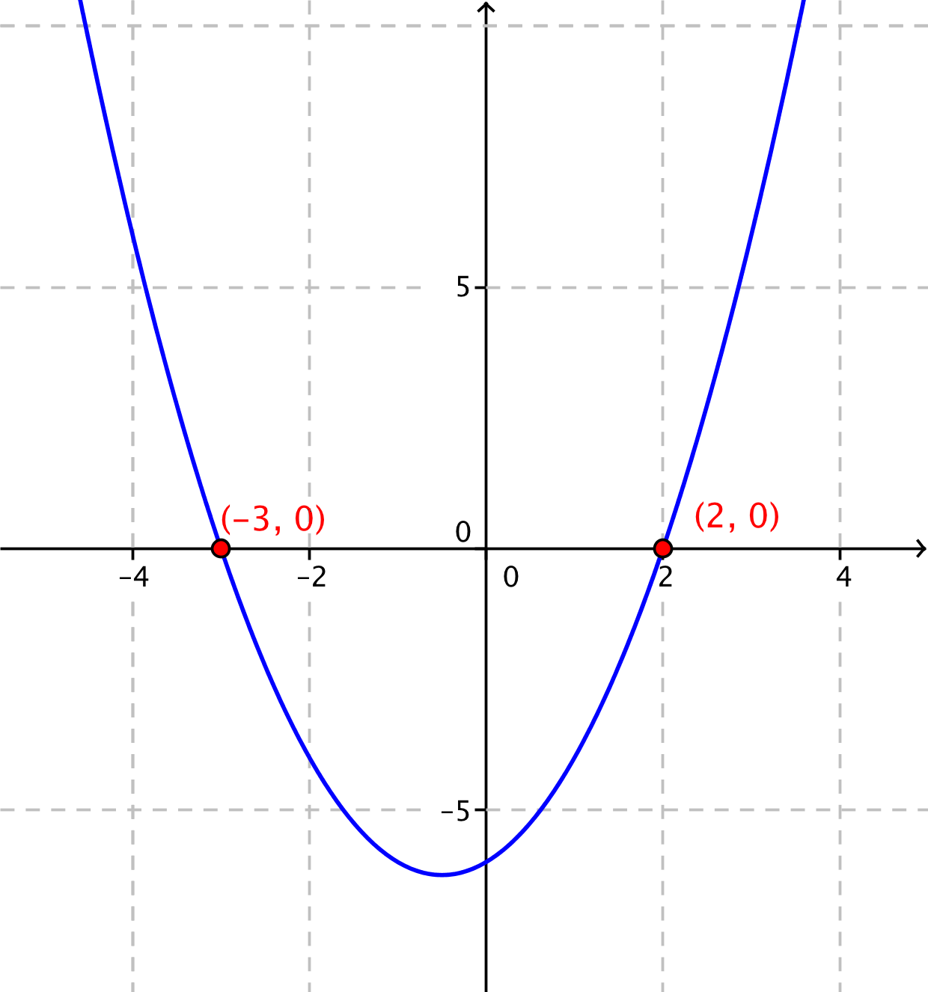
- For example, the graph of ${y=x}^{2}+x-6$ intersects the $x$-axis at $\left(-3, 0\right)$ and $(2, 0)$, as follows.

- Describe the graph of a quadratic equation with negative discriminant.
  - Since the discriminant is negative, the quadratic formula will give two different complex solutions.
  - Since there are no real solutions, the graph does not cross or touch the $x$-axis in the real plane.
- For example, the graph of $y=x^{2}+4$, shown below, does not intersect the $x$-axis.
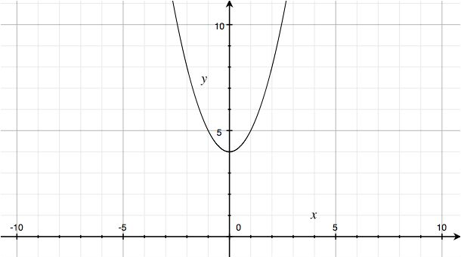

Example 1 (5 minutes)
Consider the equation $3x+x^{2}=-7$.
- What does the value of the discriminant tell us about number of solutions to this equation?
  - The equation in standard form is $x^{2}+3x+7=0$.
  - $a=1$, $b=3$, $c=7$
  - The discriminant is $3^{2}-4\left(1\right)\left(7\right)=-19$. The negative discriminant indicates that no real solutions exist. There are two complex solutions.
- Solve the equation. Does the number of solutions match the information provided by the discriminant? Explain.
  - Using the quadratic formula,
$x=\frac{-3+\sqrt{-19}}{2}$ or $x=\frac{-3-\sqrt{-19}}{2}$.
  - The solutions, in $a+bi$ form, are$-\frac{3}{2}+\frac{\sqrt{19}}{2}i$ and$-\frac{3}{2}-\frac{\sqrt{19}}{2}i$.
  - The two complex solutions are consistent with the rule for a negative discriminant.

Exercise (15 minutes)
Have students work individually on this exercise; then, have them work with a partner or in a small group to check their solutions. You could also conduct this exercise using personal white boards and have your students show their answers to each question after a few minutes. When many students are stuck, invite them to exchange papers with a partner to check for errors. Having students identify errors in their work or the work of others will help them to build fluency when working with these complicated expressions. Debrief this exercise by showing the related graph of the equation in the coordinate plane and verify that the number of solutions corresponds to the number of $x$-intercepts.
MP.3

Exercise
Compute the value of the discriminant of the quadratic equation in each part. Use the value of the discriminant to predict the number and type of solutions. Find all real and complex solutions.
  - $x^{2}+2x+1=0$

We have $a=1$, $b=2$, and $c=1$. Then
$b^{2}-4ac=2^{2}-4\left(1\right)\left(1\right)=0$.
Note that the discriminant is zero, so this equation has exactly one real solution.$$x=\frac{-\left(2\right)±\sqrt{0}}{2\left(1\right)}=-1$$
Thus, the only solution is $-1$.

  - $x^{2}+4=0$

We have $a=1$, $b=0$, and $c=4$. Then$$b^{2}-4ac=-16.$$
Note that the discriminant is negative, so this equation has two complex solutions.
$$x=\frac{-0±\sqrt{-16}}{2\left(1\right)}$$
Thus, the two complex solutions are$2i \text{and}-2i$.

  - $9x^{2}-4x-14=0$

We have $a=9$, $b=-4$, and $c=-14$. Then

$$b^{2}-4ac={\left(-4\right)}^{2}-4\left(9\right)\left(-14\right) \\ =16+504 \\ =520\text{.}$$
Note that the discriminant is positive, so this equation has two distinct real solutions.
Using the quadratic formula,
$$x=\frac{-\left(-4\right)±2\sqrt{130}}{2\left(9\right)}\text{.}$$
So, the two real solutions are $\frac{2+\sqrt{130}}{9}\text{and} \frac{2-\sqrt{130}}{9}$.

  - $3x^{2}+4x+2=0$

We have $a=3$, $b=4$, and $c=2.$ Then

$$b^{2}-4ac=4^{2}-4\left(3\right)\left(2\right) \\ =16-24 \\ =-8.$$

The discriminant is negative, so there will be two complex solutions. Using the quadratic formula,

$$x=\frac{-4±\sqrt{-8}}{2\left(3\right)}.$$

So, the two complex solutions are $-\frac{2}{3}+\frac{\sqrt{2}}{3}i \text{and}-\frac{2}{3}-\frac{\sqrt{2}}{3}i$.

  - $x=2x^{2}+5$
We can rewrite this equation in standard form with $a=2$, $b=-1$, and $c=5$:

$2x^{2}-x+5=0$.

Then

$$b^{2}-4ac={\left(-1\right)}^{2}-4\left(2\right)\left(5\right) \\ =1-40 \\ =-39\text{.}$$

The discriminant is negative, so there will be two complex solutions. Using the quadratic formula,

$$x=\frac{-\left(-1\right)±\sqrt{-39}}{2\left(2\right)} \\ x=\frac{1±i\sqrt{39}}{4}.$$

The two solutions are$\frac{1}{4}+\frac{\sqrt{39}}{4}i \text{and} \frac{1}{4}-\frac{\sqrt{39}}{4}i$.
Scaffolding:
You may assign advanced students to create quadratic equations that have specific solutions. For example, request a quadratic equation that has only the solution $-5$.
Answer: $x^{2}-10x+25=0$. This follows from the expansion of the left side of ${\left(x+5\right)}^{2}=0$. You may also request a quadratic equation with solution set $3+i$ and $3-i$. The answer is $x^{2}-6x+10=0$.

  - $8x^{2}+4x+32=0$
We can factor $4$ from the left side of this equation to obtain $4\left(2x^{2}+x+8\right)=0$, and we know that a product is zero when one of the factors are zero. Since $4≠0$, we must have $2x^{2}+x+8=0$. This is a quadratic equation with $a=2$, $b=1$, and $c=8$. Then$$b^{2}-4ac=1^{2}-4\left(2\right)\left(8\right)=-63\text{.}$$
The discriminant is negative, so there will be two complex solutions. Using the quadratic formula,

$$x=\frac{-1±\sqrt{-63}}{2\left(2\right)}$$

$$x=\frac{-1±3i\sqrt{7}}{4}\text{.}$$

The complex solutions are $-\frac{1}{4}+ \frac{3\sqrt{7}}{4}i$ and $-\frac{1}{4}- \frac{3\sqrt{7}}{4}i$ .

Closing (5 minutes)

As you summarize this lesson, ask your students to create a graphic organizer that allows them to compare and contrast the nature of the discriminant, the number and types of solutions to $ax^{2}+bx+c=0$, and the graphs of the equation $y=ax^{2}+bx+c$. Have them record a problem of each type from the previous exercise as an example in their graphic organizer.

Lesson Summary
- A quadratic equation with real coefficients and a real constant may have real or complex solutions.
- Given a quadratic equation $ax^{2}+bx+c=0$, the discriminant $b^{2}-4ac$ indicates whether the equation has two distinct real solutions, one real solution, or two complex solutions.
  - If $b^{2}-4ac>0,$ there are two real solutions to $ax^{2}+bx+c=0$.
  - If $b^{2}-4ac=0,$ there is one real solution to $ax^{2}+bx+c=0$.
  - If $b^{2}-4ac<0,$ there are two complex solutions to $ax^{2}+bx+c=0$.

Exit Ticket (5 minutes)

The Exit Ticket gives students the opportunity to demonstrate their mastery of this lesson’s content.

Name Date

Lesson 38: Complex Numbers as Solutions to Equations

Exit Ticket

Use the discriminant to predict the nature of the solutions to the equation $4x-3x^{2}=10$. Then, solve the equation.

Exit Ticket Sample Solutions

Use the discriminant to predict the nature of the solutions to the equation $4x-3x^{2}=10$. Then, solve the equation.
$$3x^{2}-4x+10=0$$
We have $a=3$, $b=-4,$ and $c=10.$ Then
$$b^{2}-4ac={\left(-4\right)}^{2}-4\left(3\right)\left(10\right) \\ =16-120 \\ =-104.$$
The value of the discriminant is negative, indicating that there are two complex solutions.
$$x=\frac{-\left(-4\right)±\sqrt{-104}}{2\left(3\right)} \\ x=\frac{4±2i\sqrt{26}}{6}$$Thus, the two solutions are $\frac{2}{3}+\frac{\sqrt{26}}{3}i$ and $\frac{2}{3}-\frac{\sqrt{26}}{3}i$.

Problem Set Sample Solutions
The Problem Set offers students more practice solving quadratic equations with complex solutions.

- Give an example of a quadratic equation in standard form that has…
  - Exactly two distinct real solutions.

Since $\left(x+1\right)\left(x-1\right)=x^{2}-1$, the equation $x^{2}-1=0$ has two distinct real solutions, $1$ and $-1$.

  - Exactly one distinct real solution.

Since ${\left(x+1\right)}^{2}=x^{2}+2x+1$, the equation $x^{2}+2x+1=0$ has only one real solution, $1$.

  - Exactly two complex (non-real) solutions.
Since $x^{2}+1=0$ has no solutions in the real numbers, this equation must have two complex solutions. They are $i$ and $-i$.

- Suppose we have a quadratic equation $ax^{2}+bx+c=0$ so that $a+c=0$. Does the quadratic equation have one solution or two distinct solutions? Are they real or complex? Explain how you know.

If $a+c=0$, then either $a=c=0$, $a>0$ and $c<0$, or $a<0$ and $c>0$.

The definition of a quadratic polynomial requires that $a≠0$, so either $a>0$ and $c<0$ or $a<0$ and $c>0$.

In either case, $ac<0$. Because $b^{2}$ is positive and $4ac$ is positive, we know $b^{2}-4ac>0$.
Therefore, a quadratic equation $ax^{2}+bx+c=0$ always has two distinct real solutions when $a+c=0$.

- Solve the equation $5x^{2}-4x+3=0$.
We have a quadratic equation with $a=5$, $b=-4$, and $c=3$.
$$x=\frac{-\left(-4\right)±2\sqrt{-11}}{2\left(5\right)}$$
So, the solutions are $\frac{2+i\sqrt{11}}{5}$ and $\frac{2-i\sqrt{11}}{5}$ .

- Solve the equation $2x^{2}+8x=-9$.
In standard form, this is the quadratic equation $2x^{2}+8x+9=0$ with $a=2$, $b=8$, and $c=9$.
$$x=\frac{-8±2\sqrt{-2}}{2\left(2\right)}=\frac{-4±i\sqrt{2}}{2}$$
Thus, the solutions are $2+\frac{i\sqrt{2}}{2}$ and $2-\frac{i\sqrt{2}}{2}$.

- Solve the equation $9x-9x^{2}=3+x+x^{2}$.
In standard form, this is the quadratic equation $10x^{2}-8x+3=0$ with $a=10$, $b=-8$, and $c=3$.
$$x=-\frac{-\left(-8\right)±2\sqrt{-14}}{2\left(10\right)}=\frac{8±2i\sqrt{14}}{20}$$
Thus, the solutions are $\frac{4+i\sqrt{14}}{10}$ and $\frac{4-i\sqrt{14}}{10}$.

- Solve the equation $3x^{2}-x+1=0$.
This is a quadratic equation with $a=3$, $b=-1$, and $c=1$.$$x=-\frac{-\left(-1\right)±\sqrt{-11}}{2\left(3\right)}=\frac{1±i\sqrt{11}}{6}$$
Thus, the solutions are $\frac{1+i\sqrt{11}}{6}$ and $\frac{1-i\sqrt{11}}{6}$.

- Solve the equation $6x^{4}+4x^{2}-3x+2=2x^{2}\left(3x^{2}-1\right)$.
When expanded, this is a quadratic equation with $a=6$, $b=-3$, and $c=2$.
$$6x^{4}+4x^{2}-3x+2=6x^{4}-2x^{2} \\ 6x^{2}-3x+2=0 \\ x=\frac{-\left(-3\right)±\sqrt{\left\{-39\right\}}}{2\left(6\right)}$$
So, the solutions are $x=\frac{3+i\sqrt{39}}{12}$ and $x=\frac{3-i\sqrt{39}}{12}$.

- Solve the equation $25x^{2}+100x+200=0$.
We can factor $25$ from the left side of this equation to obtain $25\left(x^{2}+4x+8\right)=0$, and we know that a product is zero when one of the factors is zero. Since $25≠0$, we must have $x^{2}+4x+8=0.$ This is a quadratic equation with $a=1$, $b=4$, and $c=8.$ Then
$$x=\frac{-4±4\sqrt{-1}}{2}\text{,}$$
and the solutions are $-2+2i$ and $-2-2i$.

- Write a quadratic equation in standard form such that $-5$ is its only solution.
$${\left(x+5\right)}^{2}=0 \\ x^{2}+10x+25=0$$

- Is it possible that the quadratic equation $ax^{2}+bx+c=0$ has a positive real solution if $a$, $b$, and $c$ are all positive real numbers?
MP.2
No. The solutions are $\frac{-b+\sqrt{b^{2}-4ac}}{2a}$ and $\frac{-b-\sqrt{b^{2}-4ac}}{2a}$. If $b$ is positive, the second one of these will be negative. So, we need to think about whether or not the first one can be positive. If $-b+\sqrt{b^{2}-4ac}>0$, then $\sqrt{b^{2}-4ac}>b$; so, $b^{2}-4ac>b^{2}$, and $-4ac>0$. This means that either $a$ or $c$ must be negative. So, if all three coefficients are positive, then there cannot be a positive solution to $ax^{2}+bx+c=0$.

- Is it possible that the quadratic equation $ax^{2}+bx+c=0$ has a positive real solution if $a$, $b$, and $c$ are all negative real numbers?
No. If $a$, $b$, and $c$ are all negative, then $-a$, $-b$, and $-c$ are all positive. The solutions of $ax^{2}+bx+c=0$ are the same as the solutions to $-ax^{2}-bx-c=0$, and by Problem 10, this equation has no positive real solution since it has all positive coefficients.

Extension:
- Show that if $k>3.2$, the solutions of $5x^{2}-8x+k=0$ are not real numbers.
We have $a=5$, $b=-8$, and $c=k$, then
$$b^{2}-4ac={\left(-8\right)}^{2}-4⋅5⋅k \\ =64-20k.$$
When the discriminant is negative, the solutions of the quadratic function are not real numbers.
$$0>64-20k \\ 20k>64 \\ k>\frac{64}{20} \\ k>3.2$$
Thus, if $k>3.2$, then the discriminant is negative and the solutions of $5x^{2}-8x+k=0$ are not real numbers.

- Let $k$ be a real number, and consider the quadratic equation $\left(k+1\right)x^{2}+4kx+2=0$.
  - Show that the discriminant of $\left(k+1\right)x^{2}+4kx+2=0$ defines a quadratic function of $k$.
The discriminant of a quadratic equation written in the form $ax^{2}+bx+c=0$ is $b^{2}-4ac$.
Here, $a=k+1$, $b=4k$, and $c=2$. We get
$$b^{2}-4ac={\left(4k\right)}^{2}-4⋅\left(k+1\right)⋅2 \\ =16k^{2}-8\left(k+1\right) \\ =16k^{2}-8k-8.$$
With $k$ unknown, we can write $f\left(k\right)=16k^{2}-8k-8$, which is a quadratic function of $k$.

  - Find the zeros of the function in part (a) and make a sketch of its graph.
If $f\left(k\right)=0$, then we have
$$0=16k^{2}-8k-8 \\ =2k^{2}-k-1 \\ =2k^{2}-2k+k-1 \\ =2k\left(k-1\right)+1\left(k-1\right) \\ =\left(k-1\right)\left(2k+1\right).$$
Then, $k-1=0$ or $2k+1=0$. So, $k=1$ or $k=-\frac{1}{2}$.

  - For what value of $k$ are there two distinct real solutions to the given quadratic equation?
The original quadratic equation has two distinct real solutions when the discriminant given by $f(k)$ is positive. This occurs for all real numbers $k$ such that $k<-\frac{1}{2}$ or $k>1$.

  - For what value of $k$ are there two complex solutions to the given quadratic equation?
There are two complex solutions when $f\left(k\right)<0$. This occurs for all real numbers $k$ such that $-\frac{1}{2}<k<1$.

  - For what value of $k$ is there one solution to the given quadratic equation?
There is one solution when $f\left(k\right)=0$. This occurs at $k=-\frac{1}{2}$ and $k=1$.

- We can develop two formulas that can help us find errors in calculated solutions of quadratic equations.
  - Find a formula for the sum $S$ of the solutions of the quadratic equation $ax^{2}+bx+c=0$.
The zeros of the quadratic equation are given by $x=\frac{-b±\sqrt{b^{2}-4ac}}{2a}$. Then
$$S=\frac{-b+\sqrt{b^{2}-4ac}}{2a}+\frac{-b-\sqrt{b^{2}-4ac}}{2a} \\ =\frac{-b+\sqrt{b^{2}-4ac}+ -b-\sqrt{b^{2}-4ac}}{2a} \\ =\frac{-b+ -b+\sqrt{b^{2}-4ac}-\sqrt{b^{2}-4ac}}{2a} \\ =\frac{-2b}{2a} \\ =-\frac{b}{a}.$$
Thus, $S=-\frac{b}{a}$.

  - Find a formula for the product $R$ of the solutions of the quadratic equation $ax^{2}+bx+c=0$.
$$R=\frac{-b+\sqrt{b^{2}-4ac}}{2a}⋅\frac{-b-\sqrt{b^{2}-4ac}}{2a}$$
Note that the numerators differ only in that one is a sum, and one is a difference. The formula
$\left(m+n\right)⋅\left(m-n\right)=m^{2}-n^{2}$ applies where $m=-b$ and $n=\sqrt{b^{2}-4ac}$. We get
$$R=\frac{{\left(-b\right)}^{2}-{\left(\sqrt{b^{2}-4ac}\right)}^{2}}{2a⋅2a} \\ =\frac{b^{2}-b^{2}+4ac}{4a^{2}} \\ =\frac{4ac}{4a^{2}} \\ =\frac{c}{a}.$$
So, the product is $R=\frac{c}{a}$.

  - June calculated the solutions $7$ and $-1$ to the quadratic equation $x^{2}-6x+7=0$. Do the formulas from parts (a) and (b) detect an error in her solutions? If not, determine if her solution is correct.
The sum formula agrees with June’s calculations. From June’s zeros,
$$7+ -1=6,$$and from the formula,
$$S=\frac{6}{1}=6.$$
However, the product formula does not agree with her calculations. From June’s zeros,
$$7⋅-1=-7,$$
and from the formula,
$$R=\frac{7}{1}=7.$$
June’s solutions are not correct: ${ \left(7\right)}^{2}-6\left(7\right)+7=49-42+7=14;$ so, $7$ is not a solution to this quadratic equation. Likewise, $1-6+7=2$, so $1$ is also not a solution to this equation. Thus, the formulas caught her error.
  - Paul calculated the solutions $3-i\sqrt{2}$ and $3+i\sqrt{2}$ to the quadratic equation $x^{2}-6x+7=0$. Do the formulas from parts (a) and (b) detect an error in his solutions? If not, determine if his solutions are correct.
In part (c), we calculated that $R=7$ and $S=6$. From Paul’s zeros,
$$S=3+i\sqrt{2}+3-i\sqrt{2}=6,$$
and for the product,
$$R=\left(3+i\sqrt{2}\right)⋅\left(3-i\sqrt{2}\right) \\ =3^{2}-{\left(i\sqrt{2}\right)}^{2} \\ =9—1⋅2 \\ =11.$$
This disagrees with the calculated version of $R$. So, the formulas do find that he made an error.

  - Joy calculated the solutions $3-\sqrt{2}$ and $3+\sqrt{2}$ to the quadratic equation $x^{2}-6x+7=0$. Do the formulas from parts (a) and (b) detect an error in her solutions? If not, determine if her solutions are correct.
Joy’s zeros will have the same sum as Paul’s, so $S=6$, which agrees with the sum from the formula. For the product of her zeros we get
$$R=\left(3-\sqrt{2}\right)\left(3+\sqrt{2}\right) \\ =9-2 \\ =7,$$
which agrees with the formulas.
Checking her solutions in the original equation, we find
$${\left(3-\sqrt{2}\right)}^{2}-6\left(3-\sqrt{2}\right)+7=\left(9-6\sqrt{2}+2\right)-18+6\sqrt{2}+7 \\ =0, \\ {\left(3+\sqrt{2}\right)}^{2}-6\left(3+\sqrt{2}\right)+7=\left(9+6\sqrt{2}+2\right)-18-6\sqrt{2}+7 \\ =0.$$
Thus, Joy has correctly found the solutions of this quadratic equation.

  - If you find solutions to a quadratic equations that match the results from parts (a) and (b), does that mean your solutions are correct?
MP.2
Not necessarily. We only know that if the sum and product of the solutions do not match $S$and $R$, then we have not found a solution. Evidence suggests that if the sum and product of the solutions do match $S$ and $R$, then we have found the correct solutions, but we do not know for sure until we check.

  - Summarize the results of this exercise.
For a quadratic equation of the form $ax^{2}+bx+c=0$, the sum of the solutions is given by $S=-\frac{b}{a}$, and the product of the solutions is given by $R=\frac{c}{a}$. So, multiplying and adding the calculated solutions will identify if we have made an error. Passing these checks, however, does not guarantee that the numbers we found are the correct solutions.

