Lesson 37: A Surprising Boost from Geometry

Student Outcomes
- Students define a complex number in the form $a+bi$, where $a$ and $b$ are real numbers and the imaginary unit $i$ satisfies $i^{2}=-1$. Students geometrically identify $i$ as a multiplicand effecting a $90°$ counterclockwise rotation of the real number line. Students locate points corresponding to complex numbers in the complex plane.
- Students understand complex numbers as a superset of the real numbers; i.e., a complex number $a+bi$ is real when $b=0$. Students learn that complex numbers share many similar properties of the real numbers: associative, commutative, distributive, addition/subtraction, multiplication, etc.

Lesson Notes
Students first receive an introduction to the imaginary unit $i$ and develop an algebraic and geometric understanding of the complex numbers (N-CN.A.1). The lesson then underscores that complex numbers also satisfy the properties of operations that real numbers do (N-CN.A.2). Finally, students perform exercises to reinforce their understanding of and facility with complex numbers in an algebraic arena. This lesson ties into the work in the next lesson, which involves complex solutions to quadratic equations (N-CN.C.7).
Complex numbers are neither imaginary, as in make believe, nor complex, as in complicated. Students first encounter them when they classify equations such as $x^{2}+1=0$ as having no real number solutions. At that point, we do not introduce the possibility that a solution exists within a superset of the real numbers called the complex numbers. At the end of this module, we briefly introduce the idea that every polynomial $P$ of degree $n$ has $n$ values $r_{i}$ for which $P\left(r_{i}\right)=0,$ where $n$ is a whole number and $r_{i}$ is a real or complex number. Further, in preparation for students’ work in Precalculus, we state (but do not expect students to know) that $P$ can be written as the product of $n$ linear factors, a result known as the Fundamental Theorem of Algebra. The usefulness of complex numbers as solutions to polynomial equations comes with a cost: While real numbers can be ordered (put in order from smallest to greatest), complex numbers cannot be compared; for example, the complex number $\frac{1}{2}+i\frac{\sqrt{3}}{2}$ is not larger or smaller than $\frac{\sqrt{2}}{2}+i\frac{\sqrt{2}}{2}$. However, this is a small price to pay. Students will begin to see just how important complex numbers are to geometry and computer science in Modules 1 and 2 in Precalculus. In college level science and engineering courses, complex numbers are used in conjunction with differential equations to model circular motion and periodic phenomena in two dimensions.

Classwork
Opening (1 minute)
We introduce a geometric context for complex numbers by demonstrating the analogous relationship between rotations in the plane and multiplication. The intention is for students to develop a deep understanding of $i$ through geometry.
- Today, we define a new number system that allows us to identify solutions to some equations that have no real number solutions. The complex numbers, as you will see, in fact share many properties with the real numbers with which you are familiar. We will be taking a geometric approach to introducing complex numbers.
Opening Exercise (5 minutes)
Have students work alone on this motivating Opening Exercise. This exercise provides the context and invites the necessity for defining an alternative number system, namely the complex numbers. Go over parts (a), (b), and (c) with the class; then, suggest that part (d) may be solvable using an alternative number system. Have students table this thought while beginning a geometrically-oriented discussion.
Scaffolding:
- There were times in the past when people would have said that an equation such as $x^{2}=2$ also had no solution.
Opening Exercise
Solve each equation for $x$.
- $x-1=0$ | $$1$$
- $x+1=0$ | $$-1$$
- $x^{2}-1=0$ | $$1, -1$$
- $x^{2}+1=0$ | No real solution

Discussion (20 minutes)
Before beginning, allow students to prepare graph paper for drawing images as the discussion unfolds. At the close of this discussion, have students work with partners to summarize at least one thing they learned; then, provide time for some teacher-guided note-taking to capture the definition of the imaginary unit and its connection to geometric rotation.
Recall that multiplying by $-1$ rotates the number line in the plane by $180°$ about the point $0$.
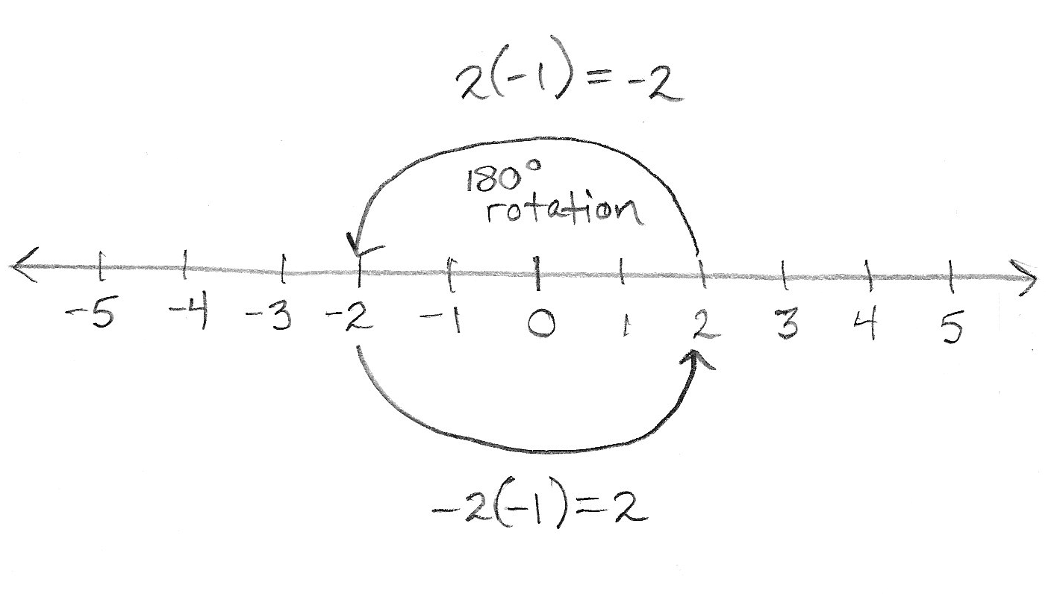
Scaffolding:
- You can demonstrate the rotation concept by drawing the number line carefully on a piece of white paper, drawing an identical number line on a transparency, putting a pin at zero, and rotating the transparency to show that the number line is rotating. For example, go from $2$ to $-2$. This, of course, is the same as multiplying by $-1$.
Pose this interesting thought question to students: Is there a number we can multiply by that corresponds to a $90°$ rotation?

Students may find that this is a strange question. First, such a number does not take the number line to itself, so we have to imagine another number line that is a $90°$ rotation of the original:
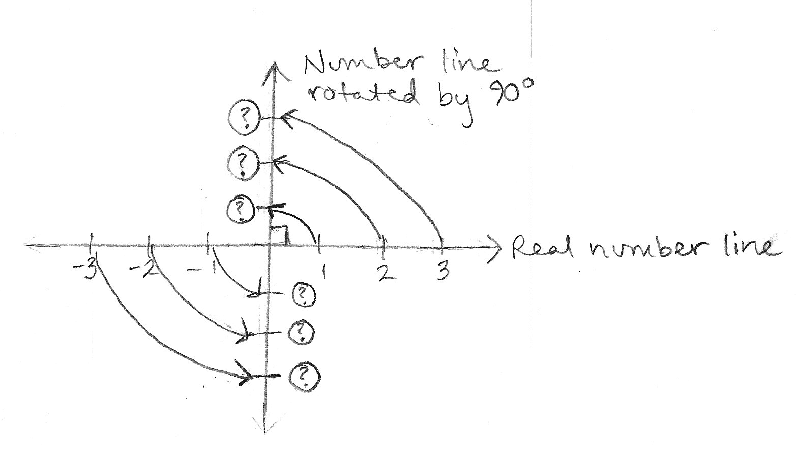
This is like the coordinate plane. However, how should we label the points on the vertical axis?
Well, since we imagined such a number existed, let’s call it the imaginary axis and subdivide it into units of something called $i$. Then, the point $1$ on the number line rotates to $1∙i$ on the rotated number line and so on, as follows:
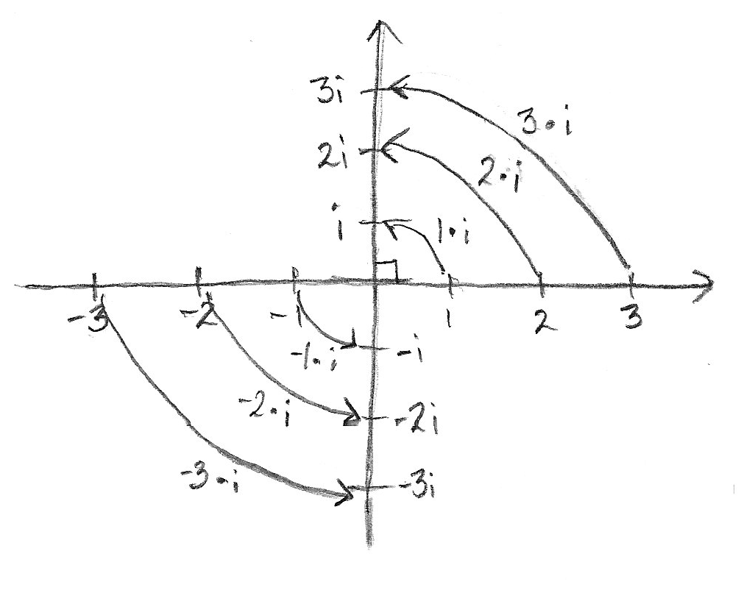

- What happens if we multiply a point on the vertical number line by $i$?
  - We rotate that point by $90°$ counterclockwise:
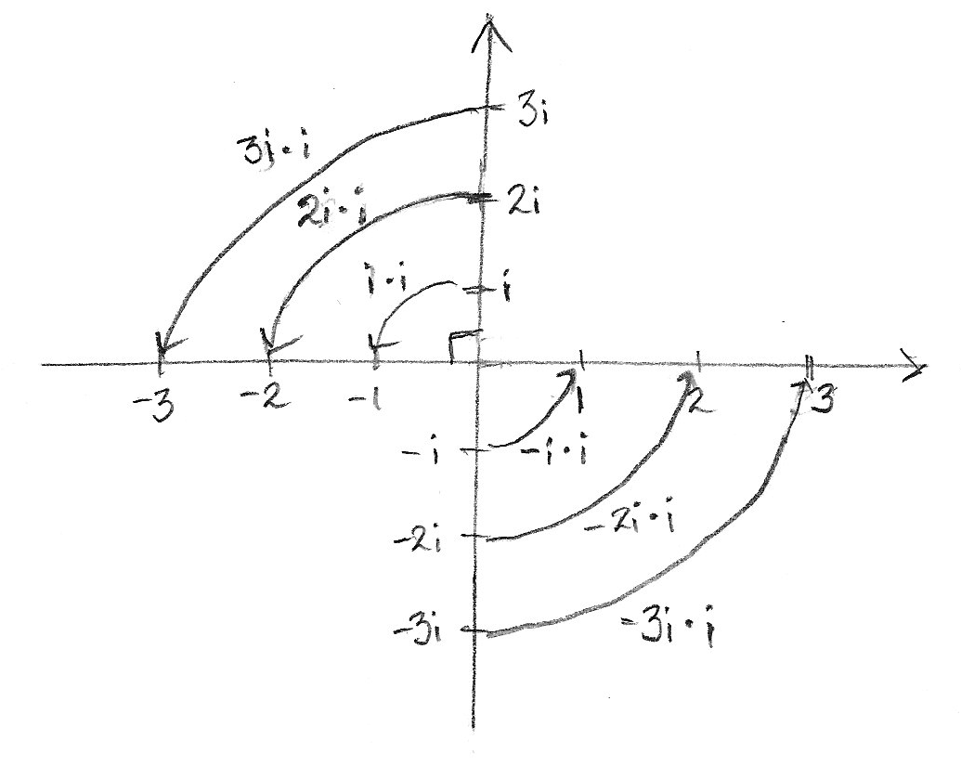
When we perform two $90°$ rotations, it is the same as performing a $180°$ rotation, so multiplying by $i$ twice results in the same rotation as multiplying by $-1$. Since two rotations by $90°$ is the same as a single rotation by $180°$, two rotations by $90°$ is equivalent to multiplication by $i$ twice, and one rotation by $180°$ is equivalent to multiplication by $-1,$ we have
MP.2
$$i^{2}∙x=-1∙x$$
for any real number $x;$ thus, $$i^{2}=-1.$$
- Why might this new number $i$ be useful?
  - Recall from the Opening Exercise that there are no real solutions to the equation
$$x^{2}+1=0.$$However, this new number $i$ is a solution.
$${\left(i\right)}^{2}+1=-1+1=0$$
In fact, “solving” the equation $x^{2}+1=0$, we get
$$x^{2}=-1 \\ \sqrt{x^{2}}=\sqrt{-1} \\ x=\sqrt{-1} \text{or} x=-\sqrt{-1}.$$
However, because we know from above that $i^{2}=-1$, and ${\left(-i\right)}^{2}={\left(-1\right)}^{2}{\left(i\right)}^{2}=-1$, we have two solutions to the quadratic equation $x^{2}=-1$, which are $i$ and $-i$.
These result suggests that “$i=\sqrt{-1}$.” That seems a little weird, but this new imagined number $i$ already appears to solve problems we could not solve before.

For example, in Algebra I, when we applied the quadratic formula to
$$x^{2}+2x+5=0,$$we found that
$x=\frac{-2+\sqrt{2^{2}-4\left(1\right)(5)}}{2(1)}$ or$x=\frac{-2-\sqrt{2^{2}-4\left(1\right)(5)}}{2(1)}$
$x=\frac{-2+\sqrt{-16}}{2}$ or$x=\frac{-2-\sqrt{-16}}{2}$.
Recognizing the negative number under the square root, we reported that the equation $x^{2}+2x+5=0$ has no real solutions. Now, however, we can write
$$\sqrt{-16}=\sqrt{16⋅-1}=\sqrt{16}⋅\sqrt{-1}=4i.$$
Therefore, $x=-1+2i$ or $x=-1-2i$, which means $-1+2i$ and $-1-2i$ are the solutions to $x^{2}+2x+5=0.$
The solutions $-1+2i$ and $-1-2i$ are numbers called complex numbers, which we can locate in the complex plane.
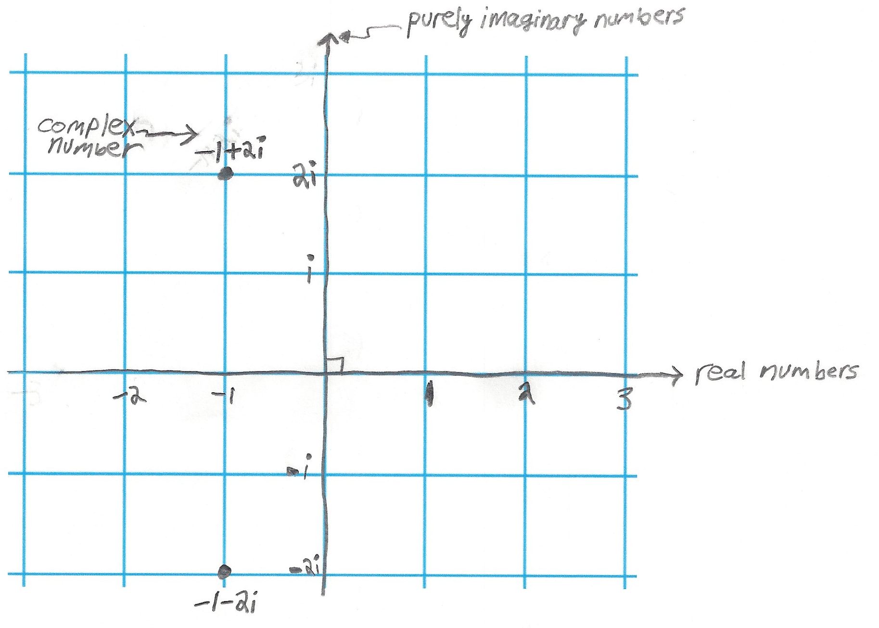
Scaffolding:
- Name a few complex numbers for students to plot on their graph paper. This will build an understanding of their locations in this coordinate system. For example, consider $-2i-3$, $-i$, $i$, $i-1$, and $\frac{3}{2}i+2$. Make sure students are also cognizant of the fact that real numbers are also complex numbers, e.g., $-\frac{3}{2}$, $0$, $1$, $π$.
In fact, all complex numbers can be written in the form
$$a+bi,$$
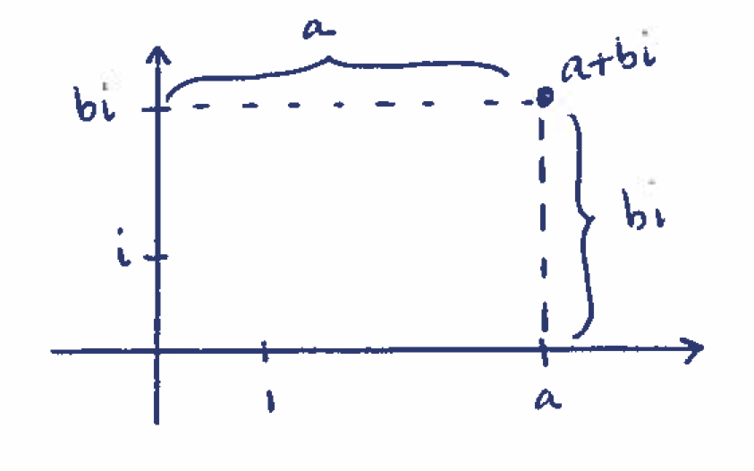
where $a$ and $b$ are real numbers. Just as we can represent real numbers on the number line, we can represent complex numbers in the complex plane. Each complex number $a+bi$ can be located in the complex plane in the same way we locate the point $(a,b)$ in the Cartesian plane. From the origin, translate $a$ units horizontally along the real axis and $b$ units vertically along the imaginary axis.
Since complex numbers are built from real numbers, we should be able to add, subtract, multiply, and divide them. They should also satisfy the commutative, associative, and distributive properties, just as real numbers do.
Let’s check how some of these operations work for complex numbers.
Examples 1–2 (4 minutes): Addition and Subtraction with Complex Numbers
Addition of variable expressions is a matter of re-arranging terms according to the properties of operations. Often, we call this “combining like terms.” These properties of operations apply to complex numbers.
$$\left(a+bi\right)+\left(c+di\right)=\left(a+c\right)+\left(b+d\right)i$$
MP.7

Example 1: Addition with Complex Numbers
Compute $\left(3+4i\right)+(7-20i)$.
$$\left(3+4i\right)+\left(7-20i\right)=3+4i+7-20i=\left(3+7\right)+\left(4-20\right)i=10-16i$$

Example 2: Subtraction with Complex Numbers
Compute $\left(3+4i\right)-(7-20i)$.
$\left(3+4i\right)-\left(7-20i\right)=3+4i-7+20i=\left(3-7\right)+\left(4+20\right)i=-4+20i$
Scaffolding:
If necessary, further examples of addition and multiplication with complex numbers are as follows:
    - $(6-i)+(3-2i)=9-3i$
- $(3+2i)(-3+2i)=-13$
- $(5+4i)(2-i)=14+3i$
- $(2+\sqrt{3} i)(-2+\sqrt{3} i)=-7$
- ${\left(1-6i\right)}^{2}=37-12i$
- $(-3-i)((2-4i)+(1+3i))=-10$

Examples 3-4 (6 minutes): Multiplication with Complex Numbers
Multiplication uses the properties of operations and the fact that $i^{2}=-1$. It is analogous to polynomial multiplication.
$$\left(a+bi\right)⋅\left(c+di\right)=ac+bci+adi+bdi^{2} \\ =\left(ac-bd\right)+\left(bc+ad\right)i$$
MP.7
Example 3: Multiplication with Complex Numbers
Compute $\left(1+2i\right)(1-2i)$.
$$\left(1+2i\right)\left(1-2i\right)=1+2i-2i-4i^{2} \\ =1+0-4\left(-1\right) \\ =1+4 \\ =5$$
Example 4: Multiplication with Complex Numbers
Verify that $-1+2i$ and $-1-2i$ are solutions to $x^{2}+2x+5=0$.
$-1+2i$:
$${\left(-1+2i\right)}^{2}+2\left(-1+2i\right)+5=1-4i+4i^{2}-2+4i+5 \\ =4i^{2}-4i+4i+1-2+5 \\ =-4+0+4 \\ =0$$$-1-2i$:
$${\left(-1-2i\right)}^{2}+2\left(-1-2i\right)+5=1+4i+4i^{2}-2-4i+5 \\ =4i^{2}+4i-4i+1-2+5 \\ =-4+0+4 \\ =0$$
So, both complex numbers $-1-2i$ and $-1+2i$ are solutions to the quadratic equation $x^{2}+2x+5=0$.
Closing (4 minutes)
Close by asking students to write or discuss with a neighbor some reasons for defining the set of complex numbers in the first place. Have them explain the importance of complex numbers satisfying the arithmetic properties of real numbers. How does geometry help explain $i$?
The Lesson Summary box presents key findings from today’s lesson.
Lesson Summary
Multiplying by $i$ rotates every complex number in the complex plane by $90°$ about the origin.
Every complex number is in the form $a+bi$, where $a$ is the real part and $b$is the imaginary part of the number. Real numbers are also complex numbers; the real number $a$ can be written as the complex number $a+0i$.
Adding two complex numbers is analogous to combining like terms in a polynomial expression.
Multiplying two complex numbers is like multiplying two binomials, except one can use$i^{2}=-1$ to further write the expression in simpler form.
Complex numbers satisfy the associative, commutative, and distributive properties.
Complex numbers can now allow us to find solutions to equations that previously had no real number solutions.

Exit Ticket (5 minutes)
In this Exit Ticket, students reduce a complex expression into its $a+bi$ form and then locate the corresponding point on the complex plane.

Name Date
Lesson 37: A Surprising Boost from Geometry

Exit Ticket

Express the quantities below in $a+bi$ form, and graph the corresponding points on the complex plane. If you use one set of axes, be sure to label each point appropriately.
$$\left(1+i\right)-(1-i)$$
$$(1+i)(1-i)$$
$$i\left(2-i\right)\left(1+2i\right)$$

Exit Ticket Sample Solutions

Express the quantities below in $a+bi$ form, and graph the corresponding points on the complex plane. If you use one set of axes, be sure to label each point appropriately.
$$\left(1+i\right)-\left(1-i\right) \\ \left(1+i\right)\left(1-i\right) \\ i\left(2-i\right)\left(1+2i\right)$$

$$\left(1+i\right)-\left(1-i\right)=0+2i \\ =2i$$

$$\left(1+i\right)\left(1-i\right)=1+i-i-i^{2} \\ =1-i^{2} \\ =1+1 \\ =2+0i \\ =2$$

$$i\left(2-i\right)\left(1+2i\right)=i\left(2+4i-i-2i^{2}\right) \\ =i(2+3i-2\left(-1\right)) \\ =i(2+3i+2) \\ =i(4+3i) \\ =4i+3i^{2} \\ =-3+4i$$

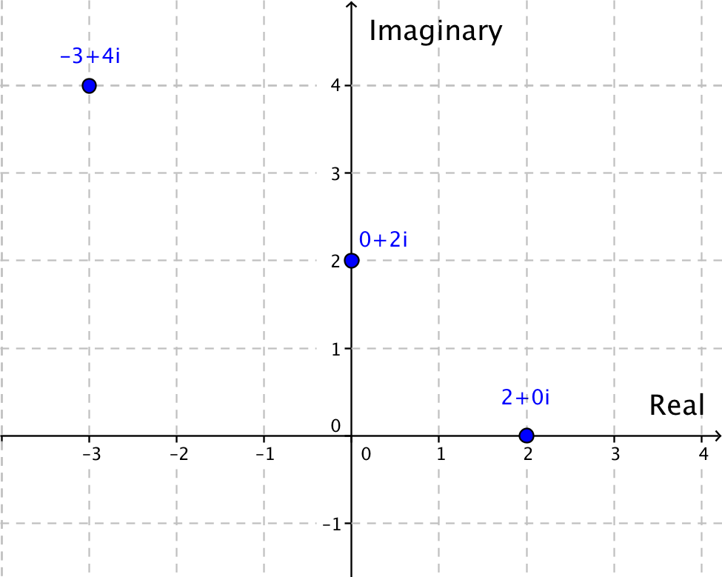

Problem Set Sample Solutions
This problem set offers your students an opportunity to practice and gain facility with complex numbers and complex number arithmetic.

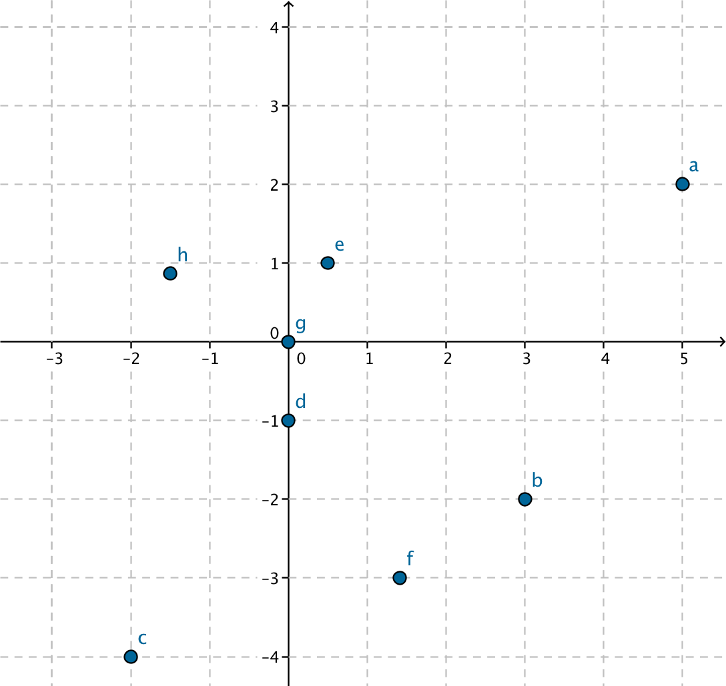
- Locate the point on the complex plane corresponding to the complex number given in parts (a)–(h). On one set of axes, label each point by its identifying letter. For example, the point corresponding to $5+2i$ should be labeled “a.”

  - $5+2i$
  - $3-2i$
  - $-2-4i$
  - $-i$
  - $\frac{1}{2}+i$
  - $\sqrt{2}-3i$
  - $0$
  - $-\frac{3}{2}+\frac{\sqrt{3}}{2}i$

- Express each of the following in $a+bi$ form.
  - $\left(13+4i\right)+(7+5i)$
$$\left(13+7\right)+\left(4+5\right)i=20+9i$$

  - $\left(5-i\right)-2(1-3i)$
$$5-i-2+6i=3+5i$$

  - ${\left(\left(5-i\right)-2\left(1-3i\right)\right)}^{2}$
$${\left(3+5i\right)}^{2}=9+30i+25i^{2} \\ =9+30i+\left(-25\right) \\ =-16+30i$$

  - $(3-i)(4+7i)$
$$12-4i+21i-7i^{2}=12+17i-\left(-7\right) \\ =19+17i$$

  - $\left(3-i\right)\left(4+7i\right)-\left(\left(5-i\right)-2\left(1-3i\right)\right)$
$$\left(19+17i\right)-\left(3+5i\right)=\left(19-3\right)+\left(17-5\right)i \\ =16+12i$$

- Express each of the following in $a+bi$ form.
  - $\left(2+5i\right)+(4+3i)$
$$\left(2+5i\right)+\left(4+3i\right)=\left(2+4\right)+\left(5+3\right)i \\ =6+8i$$

  - $\left(–1+2i\right)-(4-3i)$
$$\left(-1+2i\right)-\left(4-3i\right)=-1+2i-4+3i \\ =-5+5i$$

  - $\left(4+i\right)+\left(2-i\right)-(1-i)$
$$\left(4+i\right)+\left(2-i\right)-\left(1-i\right)=4+i+2-i-1+i \\ =5+i$$

  - $(5+3i)(3+5i)$
$$\left(5+3i\right)\left(3+5i\right)=5⋅3+3⋅3i+5⋅5i+3i⋅5i \\ =15+9i+25i+15i^{2} \\ =15+34i-15 \\ =0+34i \\ =34i$$

  - $-i\left(2-i\right)(5+6i)$
$$-i\left(2-i\right)\left(5+6i\right)=-i\left(10-5i+12i-6i^{2}\right) \\ =-i\left(10+7i+6\right) \\ =-i\left(16+7i\right) \\ =-16i-7i^{2} \\ =-16i+7 \\ =7-16i$$

  - $\left(1+i\right)\left(2-3i\right)+3i\left(1-i\right)-i$
$$\left(1+i\right)\left(2-3i\right)+3i\left(1-i\right)-i=\left(2+2i-3i-3i^{2}\right)+3i-3i^{2}-i \\ =2+2i-3i+3+3i+3-i \\ =8+i$$

- Find the real values of $x$ and $y$ in each of the following equations using the fact that if $a+bi=c+di$, then $a=c$ and $b=d$.
  - $5x+3yi=20+9i$
MP.7
$$5x=20 \\ x=4$$ | $$3yi=9i \\ y=3$$

  - $2\left(5x+9\right)=(10-3y)i$
$$2\left(5x+9\right)+0i=0+\left(10-3y\right)i$$
$$2\left(5x+9\right)=0 \\ x=-\frac{9}{5}$$ | $$0i=\left(10-3y\right)i \\ 10-3y=0 \\ y=\frac{10}{3}$$
MP.7
  - $3\left(7-2x\right)-5\left(4y-3\right)i=x-2(1+y)i$
$$3\left(7-2x\right)=x \\ 21-6x=x \\ 21=7x \\ x=3$$ | $$-5\left(4y-3\right)i=-2\left(1+y\right)i \\ -5\left(4y-3\right)=-2\left(1+y\right) \\ -20y+15=-2-2y \\ 17=18y \\ y=\frac{17}{18}$$

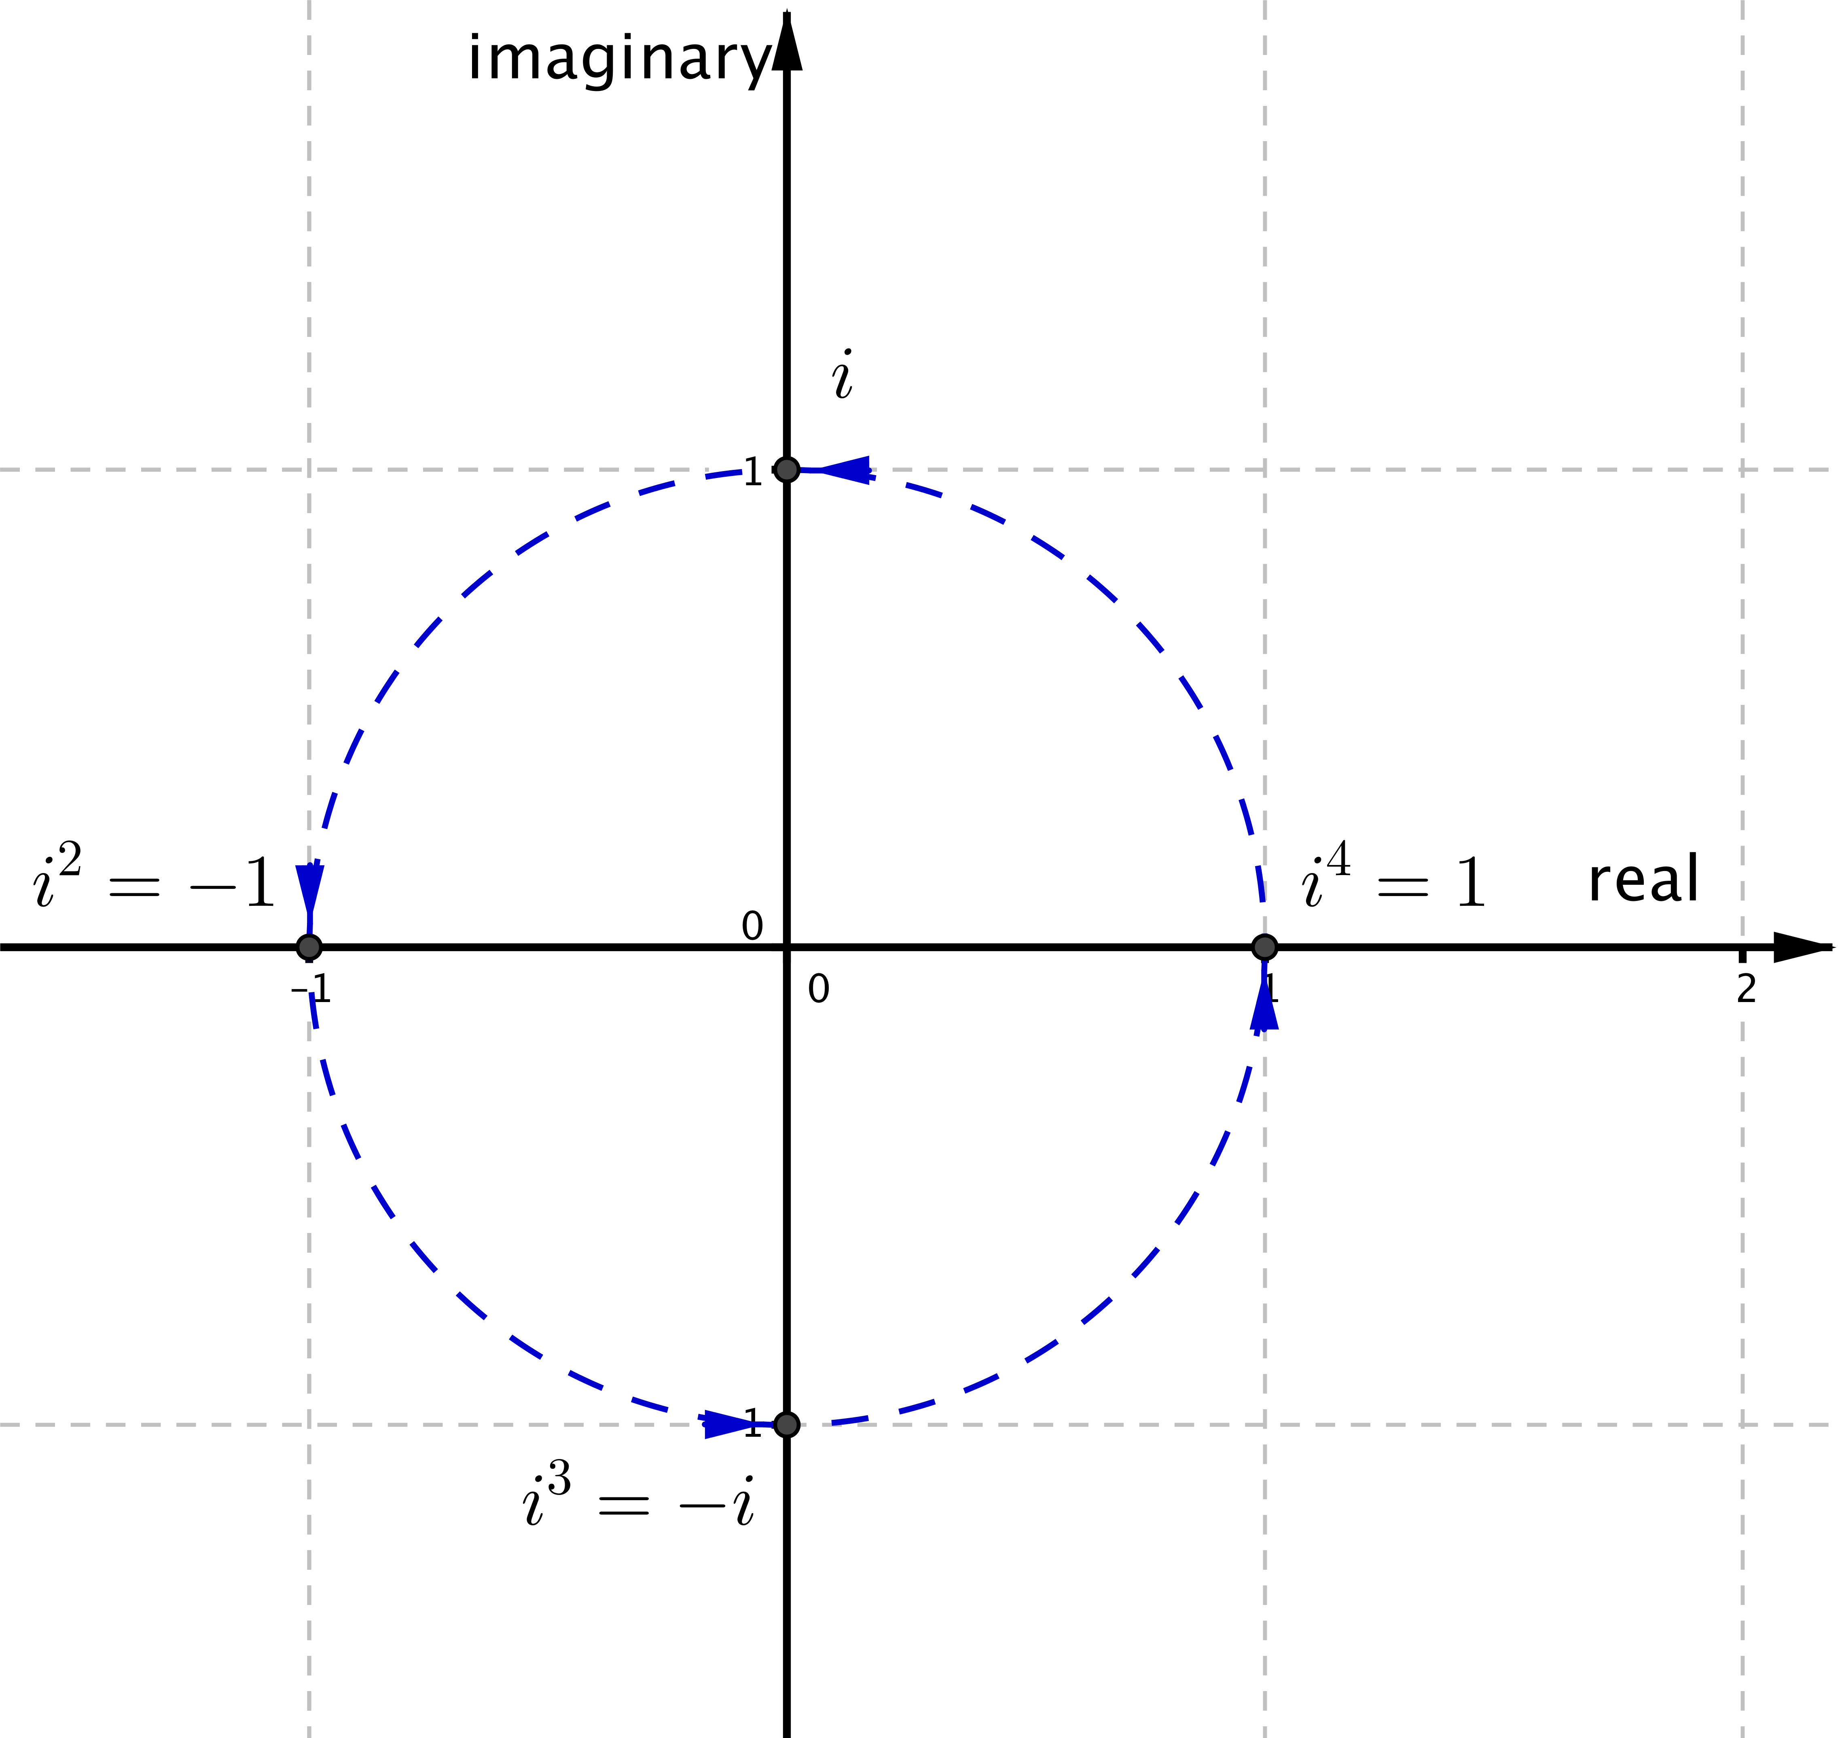
- Since $i^{2}=-1$, we see that
$$i^{3}=i^{2}⋅i=-1⋅i=-i \\ i^{4}=i^{2}⋅i^{2}=-1⋅-1=1. \\ P$$lot $i$, $i^{2}$, $i^{3}$, and $i^{4}$ on the complex plane and describe how multiplication by each rotates points in the complex plane.

Multiplying by $i$ rotates points by $90°$counterclockwise around $(0,0)$. Multiplying by $i^{2}=-1$ rotates points by $180°$ about $(0,0)$. Multiplying by $i^{3}=-i$ rotates points counterclockwise by $270°$ about the origin, which is equivalent to rotation by $90°$ clockwise about the origin. Multiplying by $i^{4}$ rotates points counterclockwise by $360°$, which is equivalent to not rotating at all. The points $i$, $i^{2}$, $i^{3}$, and $i^{4}$ are plotted below on the complex plane.

- Express each of the following in $a+bi$ form.
- $i^{5}$ | $$0+i$$
- $i^{6}$ | $$-1+0i$$
- $i^{7}$ | $$0-i$$
- $i^{8}$ | $$1+0i$$
- $i^{102}$ | $$-1+0i$$
A simple approach is to notice that every $4$ multiplications by $i$ result in four $90°$ rotations, which takes $i^{4}$ back to $1$. Therefore, divide $102$ by $4$, which is $25$ with a remainder $2$. So, $102 90°$ rotations will take $i^{102}$ onto $-1$.
MP.8
- Express each of the following in $a+bi$ form.
- ${\left(1+i\right)}^{2}$ | $$\left(1+i\right)\left(1+i\right)=1+i+i+i^{2} \\ =1+2i-1 \\ =2i$$
- ${\left(1+i\right)}^{4}$ | $${\left(1+i\right)}^{4}={\left({\left(1+i\right)}^{2}\right)}^{2} \\ ={\left(2i\right)}^{2} \\ =4i^{2} \\ =-4$$
- ${\left(1+i\right)}^{6}$ | $${\left(1+i\right)}^{6}={\left(1+i\right)}^{2}{\left(1+i\right)}^{4} \\ =\left(2i\right)\left(-4\right) \\ =-8i$$
- Evaluate $x^{2}-6x$ when $x=3-i$.
$$-10$$

- Evaluate $4x^{2}-12x$ when $x=\frac{3}{2}-\frac{i}{2}$.
$$-10$$

- Show by substitution that $\frac{5-i\sqrt{5}}{5}$ is a solution to ${5x}^{2}-10x+6=0$.
$${5\left(\frac{5-i\sqrt{5}}{5}\right)}^{2}-10\left(\frac{5-i\sqrt{5}}{5}\right)+6=\frac{1}{5}\left(5-i\sqrt{5}\right)\left(5-i\sqrt{5}\right)-2\left(5-i\sqrt{5}\right)+6 \\ =\frac{1}{5}\left(25-10i\sqrt{5}+5i^{2}\right)-2\left(5-i\sqrt{5}\right)+6 \\ =\frac{1}{5}\left(25-10i\sqrt{5}-5\right)-2\left(5-i\sqrt{5}\right)+6 \\ =5-2i\sqrt{5}-1-10+2i\sqrt{5}+6 \\ =0$$

- a. Evaluate the four products below.
  - Evaluate $\sqrt{9}⋅\sqrt{4}$. $3∙2=6$
  - Evaluate $\sqrt{9}⋅\sqrt{-4}.$ $3∙2i=6i$
  - Evaluate $\sqrt{-9}⋅\sqrt{4}.$ $3i∙2=6i$
MP.7
  - Evaluate $\sqrt{-9}⋅\sqrt{-4}.$ $3i∙2i=6i^{2}=-6$

  - Suppose $a$and $b$ are positive real numbers. Determine whether the following quantities are equal or not equal.
    - $\sqrt{a}∙\sqrt{b}$ and $\sqrt{-a}∙\sqrt{-b}$ not equal
    - $\sqrt{-a}∙\sqrt{b}$ and $\sqrt{a}∙\sqrt{-b}$ equal

