Lesson 36: Overcoming a Third Obstacle to Factoring—What If There Are No Real Number Solutions?

Student Outcomes
- Students understand the possibility that an equation—or a system of equations—has no real solutions. Students identify these situations and make the appropriate geometric connections.

Lesson Notes
Lessons 36–40 provide students with the necessary tools to find solutions to polynomial equations outside the realm of the real numbers. This lesson illustrates how to both analytically and graphically identify a system of equations that has no real number solution. In the next lesson, the imaginary unit $i$ is defined, and students begin to work with complex numbers through the familiar geometric context of rotation. Students will realize that the set of complex numbers inherits the arithmetic and algebraic properties from the real numbers. The work with complex solutions to polynomial equations in these lessons culminates with the Fundamental Theorem of Algebra in Lesson 40, the last lesson in this module.

Classwork
Opening (1 minutes)
This lesson illustrates how to identify a system of equations that has no real number solution, both graphically and analytically. In this lesson, we explore systems of equations that have no real number solutions.

Opening Exercise 1 (5 minutes)
Instruct students to complete the following exercise individually and then to pair up with a partner after a few minutes to compare their answers. Allow students to search for solutions analytically or graphically as they choose. After a few minutes, ask students to share their answers and solution methods. Both an analytic and a graphical solution should be presented for each system, either by a student or by the teacher if all students used the same approach. Circulate while students are working, and take note of which students are approaching the question analytically and which are approaching the question graphically.

Opening Exercise
Find all solutions to each of the systems of equations below using any method.
$$2x-4y=-1 \\ 3x-6y=4$$
$$y=x^{2}-2 \\ y=2x-5$$
$$x^{2}+y^{2}=1 \\ x^{2}+y^{2}=4$$

All three systems have no real number solutions, which is evident from the non-intersecting graphs in each. Instead of graphing the systems, students may have used an analytic approach such as the approach outlined in the Discussion below.
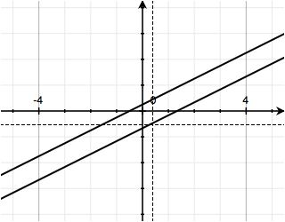
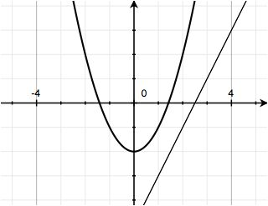
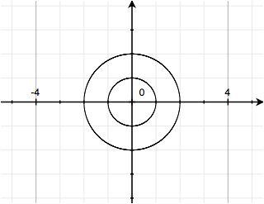

Discussion (10 minutes)
Ask students to explain their reasoning for each of the three systems in the Opening Exercise with both approaches shown for each part. This means that six students should have the opportunity to present their solutions to the class. It is important that you go through both the analytical and graphical approaches for each system so that students draw the connection between graphs that do not intersect and systems that have no analytic solution. Be sure that you have some way to display the graph of each system of equations as you lead students through this discussion.
Part (a):
- Looking at the graph of the first system $\left\{\begin{aligned} 2x-4y=-1 \\ 3x-6y=4\end{aligned}\right.$, how can we tell that there is no solution?
  - The two lines never intersect.
  - The two lines are parallel.
- Using an algebraic approach, how can we tell that there is no solution?
  - If we multiply both sides of the top equation by $3$ and the bottom equation by $2$, we see that an equivalent system can be written.
$$6x-12y=-3 \\ 6x-12y=8$$Subtracting the first equation from the second results in the false number sentence
$$0=11.$$
Thus, there are no real numbers $x$ and $y$ that satisfy both equations.

- The graphs of these equations are lines. What happens if we put them in slope-intercept form?
  - Rewriting both linear equations in slope-intercept form, the system from part (a) can be written as
$$y=\frac{1}{2}x+\frac{1}{4} \\ y=\frac{1}{2}x-\frac{2}{3}.$$
From what we know about graphing lines, the lines associated to these equations have the same slope and different $y$-intercepts, so they will be parallel. Since parallel lines do not intersect, the lines have no points in common and, therefore, this system has no solution.
Part (b):
- Looking at the graph of the second system $\left\{\begin{aligned}y=x^{2}-2 \\ y=2x-5\end{aligned}\right.$, how can we tell that there is no solution?
  - The line and the parabola never intersect.
- Can we confirm, algebraically, that the system in part (b) has no real solution?
  - Yes. Since $y=x^{2}-2$ and $y=2x-5$, we must have $x^{2}-2=2x-5$, which is equivalent to the quadratic equation $x^{2}-2x+3=0$. Solving for $x$ using the quadratic formula, we get
$$x=\frac{-\left(-2\right)±\sqrt{{\left(-2\right)}^{2}-4(1)(3)} }{2(1)}=1±\frac{\sqrt{-8}}{2}.$$Since the square root of a negative real number is not a real number, there is no real number $x$ that satisfies the equation $x^{2}-2x+3=0$; therefore, there is no point in the plane with coordinates $\left(x,y\right)$ that satisfies both equations in the original system.
Part (c):
- Looking at the graph of the final system $\left\{\begin{aligned}x^{2}+y^{2}=1 \\ x^{2}+y^{2}=4\end{aligned}\right.$, how can we tell that there is no solution?
  - The circles are concentric, meaning that they have the same center and different radii. Thus, they never intersect, and there are no points that lie on both circles.
- Can we algebraically confirm that the system in part (c) has no solution?
  - Yes. If we try to solve this system, we could subtract the first equation from the second, giving the false number sentence $0=3$. Since this statement is false, we know that there are no values of $x$ and $y$ that satisfy both equations simultaneously; thus, the system has no solution.
At this point, ask students to summarize in writing or with a partner what they have learned so far. Use this brief exercise as an opportunity to check for understanding.

Exercise 1 (4 minutes)
Have students work individually, and then check their answers with a partner. Make sure they write out their steps as done in the sample solutions. After a few minutes, invite students to share one or two solutions on the board.

Exercises 1–4
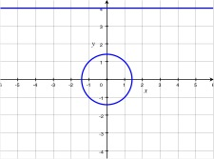
- Are there any real number solutions to the system $\left\{\begin{aligned} y=4 \\ x^{2}+y^{2}=2\end{aligned}\right.$? Support your findings both analytically and graphically.
$$x^{2}+{\left(4\right)}^{2}=2 \\ x^{2}+16=2 \\ x^{2}=-14$$
Since $x^{2}$ is non-negative for all real numbers$x$, there are no real numbers $x$ so that $x^{2}=-14$. Then, there is no pair of real numbers $\left(x,y\right)$ that solves the system consisting of the line $y=4$ and the circle $x^{2}+y^{2}=2$. Thus, the line $y=4$ does not intersect the circle $x^{2}+y^{2}=2$ in the real plane. This is confirmed graphically as follows.

Discussion (7 minutes)
Scaffolding:
Feel free to assign an optional extension exercise, such as: “Which of these equations will have no solution? Explain how you know in terms of a graph.”
$$x^{2}+5=0$$
$$x^{2}-4=0$$
$$x^{2}+1=0$$
$$x^{2}-10=0$$
Solution: $x^{2}+5=0$ and
$x^{2}+1=0$ will not have real solutions because the graphs of the equations $y=x^{2}+5$ and $y=x^{2}+1$ do not intersect the $x$-axis, the line given by $y=0$.

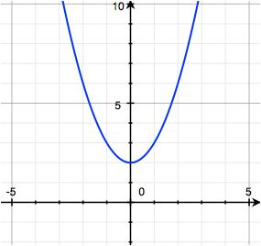
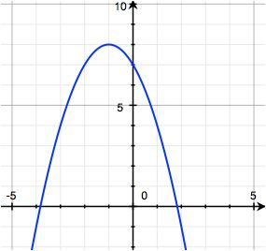
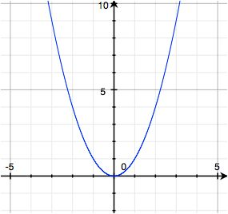
We are still withholding any mention of complex numbers or complex solutions; those will be introduced in the next lesson. Make sure your students understand that analytical findings can be confirmed graphically and vice-versa. We turn our focus to quadratic equations in one variable $x$ without real solutions and to how the absence of any real solution $x$ can be confirmed by graphing a system of equations with two variables $x$ and $y$.
Parabola 1
Parabola 2
Parabola 3

Present students with the following graphs of parabolas:
- Remember that a parabola with a vertical axis of symmetry is the graph of an equation of the form $y=ax^{2}+bx+c$ for some real number coefficients $a$, $b$, and $c$ with $a≠0$. We can consider the solutions of the quadratic equation $ax^{2}+bx+c=0$ to be the $x$-coordinates of solutions to the system of equations $y=ax^{2}+bx+c$ and $y=0$. Thus, when we are investigating whether a quadratic equation$ax^{2}+bx+c=0$ has a solution, we can think of this as finding the $x$-intercepts of the graph of $y=ax^{2}+bx+c$.
- Which of these three parabolas are represented by a quadratic equation $y=ax^{2}+bx+c$ that has no solution to $ax^{2}+bx+c=0$? Explain how you know.
  - Parabola 1 because its graph does not intersect the $x$-axis. No $x$-intercepts of the parabola means there are no solutions to the associated equation $ax^{2}+bx+c=0$.
- Now, consider Parabola 2, which is the graph of the equation $y=8-{\left(x+1\right)}^{2}$. How many solutions are there to the equation $8-{\left(x+1\right)}^{2}=0$? Explain how you know.
  - Because Parabola 2 intersects the $x$-axis twice, the system consisting of $y=8-{\left(x+1\right)}^{2}$and $y=0$ has two real solutions. The graph suggests that the system will have one positive solution and one negative solution.
- Now, consider Parabola 3, which is the graph of the equation $y=x^{2}$. How does the graph tell us how many solutions there are to the equation $x^{2}=0$? Explain how you know.
  - Parabola 3 touches the $x$-axis only at $\left(0, 0\right)$ so the parabola and the line with equation $y=0$ intersect at only one point. Accordingly, the system has exactly one solution, and there is exactly one solution to the equation $x^{2}=0.$
Pause, and ask students to again summarize what they have learned, either in writing or orally to a neighbor. Students should be making connections between the graph of the quadratic equation $y=ax^{2}+bx+c$ (which is a parabola), the number of $x$-intercepts of the graph, and the number of solutions to the system consisting of $y=0$ and $y=ax^{2}+bx+c$.

Exercises 2–4 (12 minutes)
Students should work individually or in pairs on these exercises. To solve these problems analytically, they need to understand that they can determine the $x$-coordinates of the intersection points of the graphs of these geometric figures by solving an equation. Make sure your students are giving their answers to these questions as coordinate pairs. Encourage students to solve the problems analytically and verify the solutions graphically.

- Does the line $y=x$ intersect the parabola $y=–x^{2}$? If so, how many times, and where? Draw graphs on the same set of axes.
Scaffolding:
- Consider having students follow the instructor along using a graphing calculator to show that the graph of $y=x$ intersects the graph of $y=-x^{2}$ twice, at the points indicated.
- Consider tasking advanced students to generate a system that meets certain criteria. For example, ask them to write the equations of a circle and a parabola that intersect once at $(0, 1)$. One appropriate answer is $x^{2}+y^{2}=1$ and $y=x^{2}+1$.
$$x=-x^{2} \\ x+x^{2}=0 \\ x\left(1+x\right)=0 \\ x=0 \text{ or } x=-1$$
If $x=0$, then $y=-x^{2}=0$, and if $x=-1$, then $y=-x^{2}=-{\left(-1\right)}^{2}=-1$.
The line $y=x$ intersects the parabola $y=-x^{2}$ at two distinct points: $(0, 0)$ and $(-1, -1)$.
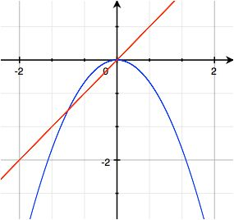

- Does the line $y=-x$ intersect the circle $x^{2}+y^{2}=1$? If so, how many times, and where? Draw graphs on the same set of axes.
$$x^{2}+{\left(-x\right)}^{2}=1 \\ 2x^{2}=1 \\ x^{2}=\frac{1}{2} \\ x=-\frac{\sqrt{2}}{2}\text{ or }x=\frac{\sqrt{2}}{2}$$
The line $y=-x$ intersects the circle $x^{2}+y^{2}=1$ at two distinct points: $\left(-\frac{\sqrt{2}}{2},\frac{\sqrt{2}}{2}\right)$ and $\left(\frac{\sqrt{2}}{2}, -\frac{\sqrt{2}}{2}\right)$.
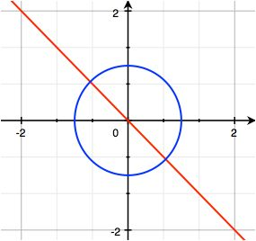

- Does the line $y=5$ intersect the parabola $y=4-x^{2}$? Why or why not? Draw the graphs on the same set of axes.
$$5=4-x^{2} \\ 1=-x^{2} \\ x^{2}=-1$$
A squared real number cannot be negative, so the line $y=5$ does not intersect the parabola $y=4-x^{2}$.
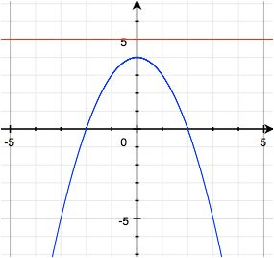

Before moving on, discuss these results as a whole class. Have students put both graphical and analytical solutions to each exercise on the board. Start to reinforce the connection that when the graphs intersect, the related system of equations has real solutions, and when the graphs do not intersect, there are no real solutions to the related system of equations.
Closing (2 minutes)
Have students discuss with their neighbors the key points from today’s lesson. Encourage them to discuss the relationship between the solution(s) to a quadratic equation of the form $ax^{2}+bx+c=0$ and the system
$$y=ax^{2}+bx+c \\ y=0.$$
They should discuss an understanding of the relationship between any solution(s) to a system of two equations and the $x$-coordinate of any point(s) of intersection of the graphs of the equations in the system.
The Lesson Summary below contains key findings from today’s lesson.
Lesson Summary
An equation or a system of equations may have one or more solutions in the real numbers, or it may have no real number solution.
Two graphs that do not intersect in the real plane describe a system of two equations without a real solution. If a system of two equations does not have a real solution, the graphs of the two equations do not intersect in the real plane.
A quadratic equation in the form $ax^{2}+bx+c=0$, where $a$, $b$, and $c$are real numbers and $a≠0$, that has no real solution indicates that the graph of $y=ax^{2}+bx+c$does not intersect the $x$-axis.

Exit Ticket (4 minutes)
In this Exit Ticket, students will show that a particular system of two equations has no real solutions. They will demonstrate this both analytically and graphically.

Name Date
Lesson 36: Overcoming a Third Obstacle—What If There Are No Real Number Solutions?

Exit Ticket

Solve the following system of equations or show that it does not have a real solution. Support your answer analytically and graphically.
$$y=x^{2}-4 \\ y=-(x+5)$$

Exit Ticket Sample Solutions

Solve the following system of equations or show that it does not have a real solution. Support your answer analytically and graphically.
$$y=x^{2}-4 \\ y=-(x+5)$$
We distribute over the set of parentheses in the second equation and rewrite the system.
$$y=x^{2}-4 \\ y=-\left(x+5\right)$$
The graph of the system shows a parabola and a line that do not intersect. As such, we know that the system does not have a real solution.
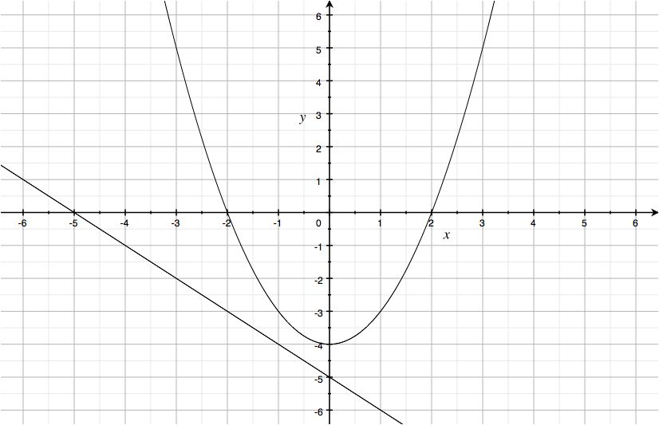
Algebraically,
$$x^{2}-4=-x-5 \\ x^{2}+x+1=0\text{.}$$
Using the quadratic formula with $a=1$, $b=1$, and $c=1$,
$$x=\frac{-1+\sqrt{1^{2}-4\left(1\right)\left(1\right)}}{2\left(1\right)} \text{or} x= \frac{-1-\sqrt{1^{2}-4\left(1\right)\left(1\right)}}{2\left(1\right)} \text{,}$$
which indicates that the solutions would be $\frac{-1+\sqrt{-3}}{2}$ and $\frac{-1-\sqrt{-3}}{2}$.
Since the square root of a negative number is not a real number, there is no real number $x$ that solves this equation. Thus, the system has no solution $\left(x,y\right)$ where $x$ and $y$ are real numbers.
Problem Set Sample Solutions

- For each part, solve the system of linear equations, or show that no real solution exists. Graphically support your answer.
  - $\begin{matrix}4x+2y=9 \\ x+y=3\end{matrix}$

Multiply the bottom equation by $4$.
$$4x+2y=9 \\ 4x+4y=12$$
Subtract top from bottom.
$$2y=3$$

We get $y=\frac{3}{2}$.
Substitute $\frac{3}{2}$ for $y$ in the original bottom equation.
$$x+\frac{3}{2}=3$$
We get $x=\frac{3}{2}$.
The lines from the system intersect at $\left(\frac{3}{2},\frac{3}{2}\right)$.

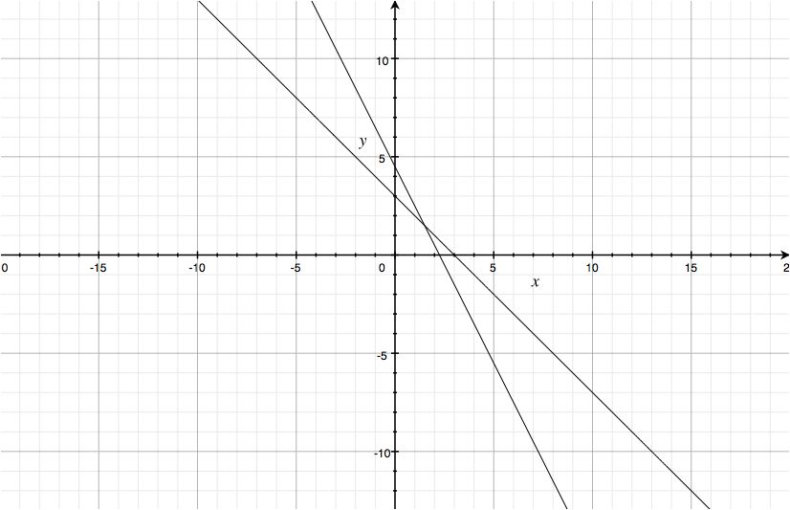

  - $\begin{matrix}2x-8y=9 \\ 3x-12y=0\end{matrix}$

Multiply the top equation by $3$ and the bottom equation by $2$ on both sides.
$$6x-24y=27 \\ 6x-24y=0$$
Subtracting the bottom equation from the top equation gives $27=0$, but $27=0$ is a false number sentence. Thus, there is no solution to the system. The graph of the system appropriately shows two parallel lines.
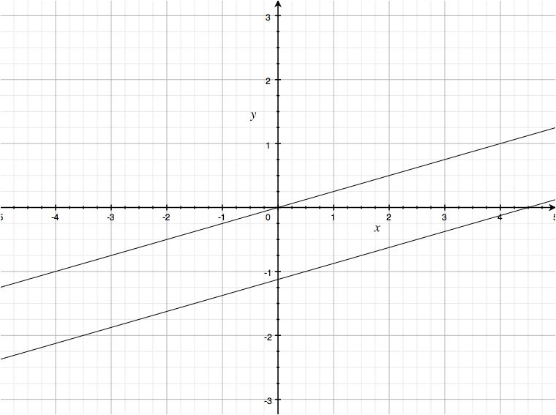

- Solve the following system of equations, or show that no real solution exists. Graphically confirm your answer.
$$3x^{2}+3y^{2}=6 \\ x-y=3$$
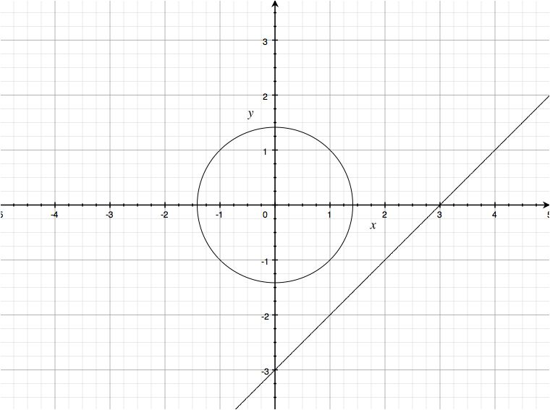
We can factor out $3$ from the top equation and isolate $y$ in the bottom equation to give us a better idea of what the graphs of the equations in the system look like. The first equation represents a circle centered at the origin with radius $\sqrt{2}$, and the second equation represent the line $y=x-3$, which is simply the $45°$ line through the origin, $y=x$, shifted down by $3$ units.
Algebraically,
$$3x^{2}+3{\left(x-3\right)}^{2}=6 \\ x^{2}+{\left(x-3\right)}^{2}=2 \\ x^{2}+\left(x^{2}-6x+9\right)=2 \\ 2x^{2}-6x+7=0$$
We solve for $x$ using the quadratic formula:
$$a=2, b=-6, c=7 \\ x=\frac{-\left(-6\right)±\sqrt{{\left(-6\right)}^{2}-4\left(2⋅7\right)}}{2⋅2} \\ x=\frac{6±\sqrt{36-56}}{4}.$$
The solutions would be $\frac{6+\sqrt{-20}}{4}$ and $\frac{6-\sqrt{-20}}{4}$ .Since both solutions for $x$ contain a square root of a negative number, no real solution $x$ exists; so, the system has no solution $\left(x,y\right)$ where $x$ and $y$ are real numbers.
- Find the value of $k$ so that the graph of the following system of equations has no solution.
$$3x-2y-12=0 \\ kx+6y-10=0$$
First, we rewrite the linear equations in the system in slope-intercept form.
$$y=\frac{3}{2}x-6 \\ y=-\frac{k}{6}x+\frac{10}{6}$$
There is no solution to this system when the lines are parallel. Two lines are parallel when they share the same slope and have different $y$-intercepts. Here, the first line has slope $\frac{3}{2}$ and $y$-intercept $-6$, and the second line has slope $-\frac{k}{6}$ and $y$-intercept $\frac{10}{6}$. The lines have different $y$-intercepts and will be parallel when $-\frac{k}{6}=\frac{3}{2}$.
$$\frac{3}{2}=-\frac{k}{6} \\ 2k=-18 \\ k=-9$$
Thus, there is no solution only when$k=-9$.

- Offer a geometric explanation to why the equation $x^{2}-6x+10=0$ has no real solutions.
The graph of $y=x^{2}-6x+10$ opens upward (since the leading coefficient is positive) and takes on its lowest value at the vertex $\left(3,1\right)$. Hence, it does not intersect the $x$-axis, and, therefore, the equation has no real solutions.

- Without his pencil or calculator, Joey knows that $2x^{3}+3x^{2}-1=0$ has at least one real solution. How does he know?
The graph of every cubic polynomial function intersects the $x$-axis at least once because the end behaviors are opposite: one end goes up and the other goes down. This means that the graph of any cubic equation $y=ax^{3}+bx^{2}+cx+d$must have at least one $x$-intercept. Thus, every cubic equation must have at least one real number solution.

- The graph of the quadratic equation ${y=x}^{2}+1$ has no $x$-intercepts. However, Gia claims that when the graph of ${y=x}^{2}+1$ is translated by a distance of $1$ in a certain direction, the new (translated) graph would have exactly one $x$-intercept. Further, if $y=x^{2}+1$ is translated by a distance greater than $1$ in the same direction, the new (translated) graph would have exactly two $x$-intercepts. Support or refute Gia’s claim. If you agree with her, in which direction did she translate the original graph? Draw graphs to illustrate.
MP.3
By translating the graph of $y=x^{2}+1$ DOWN by $1$ unit, the new graph has equation $y=x^{2}$, which has one $x$-intercept at $x=0$. When translating the original graph DOWN by more than $1$ unit, the new graph will cross the $x$-axis exactly twice.

- In the previous problem, we mentioned that the graph of ${y=x}^{2}+1$ has no $x$-intercepts. Suppose that $y=x^{2}+1$ is one of two equations in a system of equations and that the other equation is a line. Give an example of a linear equation such that this system has exactly one solution.
The line with equation $y=1$ is tangent to $y=x^{2}+1$ only at $\left(0,1\right)$; so, there would be exactly one real solution to the system.
$$y=x^{2}+1 \\ y=1$$
Another possibility is an equation of any vertical line, such as $x=-3$ or $x=4$, or $x=a$ for any real number $a$.

- In prior problems, we mentioned that the graph of $y=x^{2}+1$ has no $x$-intercepts. Does the graph of $y=x^{2}+1$ intersect the graph of ${y=x}^{3}+1$?
Setting these equations together, we can rearrange terms to get $x^{3}-x^{2}=0$, which is an equation we can solve by factoring. We have $x^{2}(x-1)=0$, which has solutions at $0$ and $1$. Thus, the graphs of these equations intersect when $x=0$ and when $x=1$. When $x=0$,$y=1$, and when $x=1$, $y=2$. Thus, the two graphs intersect at the points $(0,1)$ and$(1,2)$.

The quick answer: The highest term in both equations has degree $3$. The third degree term does not cancel when setting the two equations (in terms of $x$) equal to each other. All cubic equations have at least one real solution, so the two graphs intersect at least at one point.

