|  |
| --- |
|  |

Lesson 35: Are All Parabolas Similar?

Student Outcomes

* Students apply the geometric transformation of dilation to show that all parabolas are similar.

Lesson Notes

In the previous lesson, students used transformations to prove that all parabolas with the same distance between the focus and directrix are congruent. In the process, they made a connection between geometry, coordinate geometry, transformations, equations, and functions. In this lesson, students explore how dilation can be applied to prove that all parabolas are similar.

Students may express disagreement with or confusion about the claim that all parabolas are similar because the various graphical representations of parabolas they have seen do not appear to have the “same shape.” Because a parabola is an open figure as opposed to a closed figure, like a triangle or quadrilateral, it is not easy to see similarity among parabolas. Students must understand that we are strictly defining *similar* via similarity transformations; in other words, two parabolas are similar because there is a sequence of translations, rotations, reflections, and dilations that takes one parabola to the other. In the last lesson, we showed that every parabola is congruent to the graph of the equation   
 for some ; in this lesson, we need only consider dilations.

When students claim that two parabolas are not similar, they should be reminded that the parts of the parabolas they are looking at may well appear to be different in size or magnification, but the parabolas themselves are not different in shape. Remind students that similarity is established by dilation; in other words, by magnifying a figure in both the horizontal and vertical directions. By analogy, although circles with different radii have different curvature, every student should agree that any circle can be dilated to be the same size and shape as any other circle; thus, all circles are similar.

Quadratic curves such as parabolas belong to a family of curves known as *conic sections*. The technical term in mathematics for how much a conic section deviates from being circular is *eccentricity,* and two conic sections with the same eccentricity are similar. Circles have eccentricity , and parabolas have eccentricity . After this lesson, you might ask students to research and write a report on eccentricity.

*Scaffolding:*

* Allow students access to graphing calculators or software to focus on conceptual understanding if they are having difficulty sketching the graphs.
* Consider providing students with transparencies with a variety of parabolas drawn on them (as in prior lesson), such as , , and to help them illustrate these principles.

Classwork

Provide graph paper for students as they work the first five exercises. They will first examine three congruent parabolas and then make a conjecture about whether or not all parabolas are similar. Finally, they will explore this conjecture by graphing parabolas of the form that have different -values.

Exercises 1–5 (4 minutes)

Exercises 1–6

1. Write the equation of two parabolas that are congruent to and explain how you determined your equations.
2. Sketch the graph of and the two parabolas you created on the same coordinate axes.
3. Write the equation of two parabolas that are NOT congruent to . Explain how you determined your equations.
4. Sketch the graph of and the two non-congruent parabolas you created on the same coordinate axes.

**MP.3**

1. Use your work on Exercises 1–4 to answer the question posed in the lesson title: Are all parabolas similar? Explain your reasoning.

Discussion



After students have examined the fact that when we change the -value in the parabola equation, the resulting graph is is basically the same shape, you can further emphasize this point by exploring the graph of on a graphing calculator or graphing program on your computer. Use the same equation but different viewing windows so students can see that we can create an image of what appears to be a different parabola by transforming the dimensions of the viewing window. However, the images are just a dilation of the original that is created when we change the scale. See the images to the right. Each figure is a graph of the equation with different scales on the horizontal and vertical axes.

Exercise 6 (5 minutes)

In this exercise, students derive the analytic equation for a parabola given its graph, focus, and directrix. Students have worked briefly with parabolas with a vertical directrix in previous lessons, so this exercise will be an opportunity for the teacher to assess whether or not students are able to transfer and extend their thinking to a slightly different situation.

1. 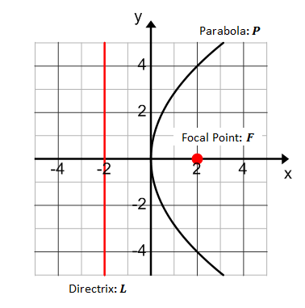The parabola at right is the graph of what equation?
   1. Label a pointon the graph of .
   2. What does the definition of a parabola tell us about the distance between the point and the directrix and the distance between the point and the focus?

**Let be any point on the graph of . Then, these distances are equal because is equidistant from and.**

* 1. Create an equation that relates these two distances.

**Distance from to :**

**Distance from to :**

**Therefore, any point on the parabola has coordinates that satisfy** .

* 1. Solve this equation for .

**The equation can be solved as follows.**

**Thus,**

.

* 1. Find two points on the parabola, and show that they satisfy the equation found in part (d).

**By observation, and are points on the graph of . Both points satisfy the equation that defines .**

**Discussion (8 minutes)**

After giving students time to work through the Exercises 1–5, ask the following questions to revisit concepts from Algebra I, Module 3.

* In the previous exercise, is a function of ?
  + *No, because the -value corresponds to two -values.*
* Is a function of ?
  + *Yes. If you rotate the Cartesian plane by , you can see that it would be a function. Alternately, if we take to be in the domain and to be in the range, then each -value on corresponds to exactly one -value, which is the definition of a function.*

These two questions remind students that just because we typically use the variable to represent the domain element of an algebraic function, this does not mean that it must always represent the domain element.

Next, transition to summarizing what was learned in the last two lessons. We have defined a parabola and determined the conditions required for two parabolas to be congruent. Use the following questions to summarize these ideas.

* What have we learned about the definition of a parabola?
  + *The points on a parabola are equidistant from the directrix and the focus.*
* What transformations can be applied to a parabola to create a parabola congruent to the original one?
  + *If the directrix and the focus are transformed by a rigid motion (e.g., translation, rotation, or reflection), then the new parabola defined by the transformed directrix and focus will be congruent to the original.*

Essentially, every parabola that has a distance of units between its focus and directrix is congruent to a parabola with focus and directrix What is the equation of this parabola?

Thus, all parabolas that have the same distance between the focus and the directrix are congruent.

The family of graphs given by the equation for describes the set of non-congruent parabolas, one for each value of .

Ask students to consider the question from the lesson title. Chart responses to revisit at the end of this lesson to confirm or refute their claims.

**Discussion**

**How many of you think that all parabolas are similar? Explain why you think so.**

**MP.3**

**In geometry, two figures were similar if a sequence of transformations would take one figure onto the other one.**

**What could we do to show that two parabolas are similar? How might you show this?**

**Since every parabola can be transformed into a congruent parabola by applying one or more rigid transformations, perhaps similar parabolas can be created by applying a dilation which is a non-rigid transformation.**

To check to see if all parabolas are similar, we only need to show that any parabola that is the graph of for   
 is similar to the graph of . This is done through a dilation by some scale factor at the origin . Note that a dilation of the graph of a function is the same as performing a horizontal scaling followed by a vertical scaling that students studied in Algebra I, Module 3.

**Exercises 7–10 (8 minutes)**

The following exercises review the function transformations studied in Algebra I that are required to define dilation at the origin. These exercises provide students with an opportunity to recall what they learned in a previous course so that they can apply it here. Students must read points on the graphs to determine that the vertical scaling is by a factor of for the graphs on the left and by a factor of for the graphs on the right. In Algebra I, Module 3, we saw that the graph of a function can be transformed with a non-rigid transformation in two ways: *vertical* and *horizontal scaling*.

A *vertical scaling* of a graph by a scale factor takes every -value of points on the graph of to . The result of the transformation is given by the graph of .

*Scaffolding:*

* Allow students access to graphing calculators or software to focus on conceptual understanding if they are having difficulty sketching the graphs.
* The graphs shown in Exercises 7 and 8 are , , and . The graphs shown in Exercises 9 and 10 are , , and .

A *horizontal scaling* of a graph by a scale factor takes every -value of points on the graph of to . The result of the transformation is given by the graph of .

**Exercises 7–10**

**Use the graphs below to answer Exercises 7 and 8.**

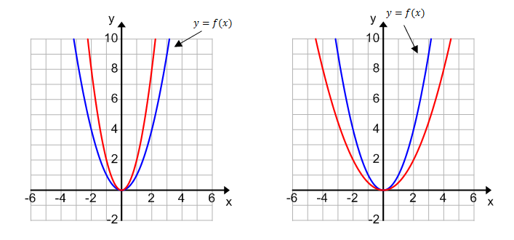

1. **Suppose the unnamed red graph on the left coordinate plane is the graph of the function . Describe as a vertical scaling of the graph of ; that is, find a value of so that. What is the value of ? Explain how you determined your answer.**

**The graph of is a vertical scaling of the graph of by a factor of . Thus, . By comparing points on the graph of to points on the graph of , you can see that the -values on are all twice the -values on .**

1. **Suppose the unnamed red graph on the right coordinate plane is the graph of the function . Describe as a vertical scaling of the graph of ; that is, find a value of so that . Explain how you determined your answer.**

**The graph of is a vertical scaling of the graph of by a factor of. Thus, . By comparing points on the graph of to points on the graph of , you can see that the -values on are all half of the -values on .**

**Use the graphs below to answer Exercises 9–10.**

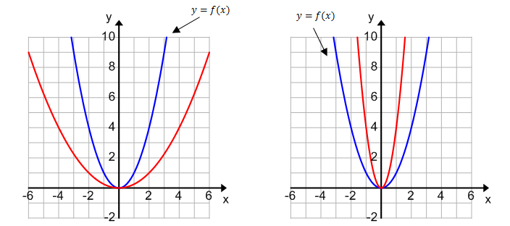

1. **Suppose the unnamed function graphed in red on the left coordinate plane is . Describe as a horizontal scaling of the graph of . What is the value of? Explain how you determined your answer.**

**The graph of is a horizontal scaling of the graph of by a factor of . Thus, . By comparing points on the graph of to points on the graph of , you can see that for the same -values, the -values on are all twice the -values on .**

1. **Suppose the unnamed function graphed in red on the right coordinate plane is. Describe as a horizontal scaling of the graph of . What is the value of? Explain how you determined your answer.**

**The graph of is a horizontal scaling of the graph of by a factor of . Thus, . By comparing points on the graph of to points on the graph of , you can see that for the same -values, the -values on are all half of the -values on .**

When you debrief these exercises, model marking up the diagrams to illustrate the vertical and horizontal scaling. A sample is provided below.

Marked up diagrams for vertical scaling in Exercises 7 and 8:

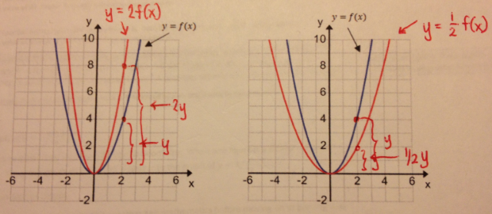

Marked up diagrams for horizontal scaling in Exercises 9 and 10:

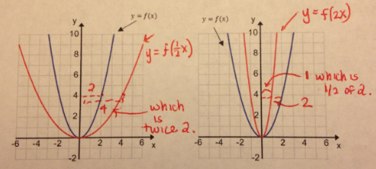

After working through Exercises 7–10, pose the following discussion question.

* If a dilation by scale factor involves both horizontal and vertical scaling by a factor of , how could we express the dilation of the graph of ?
  + *You could combine both types of scaling. Thus,*

Explain the definition of dilation at the origin as a combination of a horizontal and then vertical scaling by the same factor. Exercises 1–3 in the Problem Set will address this idea further.

Definition: A *dilation at the origin* is a horizontal scaling by followed by a vertical scaling by the same factor . In other words, this dilation of the graph of is the graph of the equation .

It will be important for students to clearly understand that this dilation of the graph of is the graph of the equation . Remind students of the following two facts that they studied in high school Geometry:

1. When one figure is a dilation of another figure, the two figures are similar.
2. A dilation at the origin is just a particular type of dilation transformation.

Thus, the graph of is similar to the graph of . Students may realize here that their thinking about “stretching” the graph creating a similar parabola is not quite enough to prove that all parabolas are similar because we must consider both a horizontal and vertical dilation in order to connect back to the geometric definition of similar figures.

Example 1 (5 minutes): Dilation at the Origin

This example helps students gain a level of comfort with the notation and mathematics before moving on to proving that all parabolas are similar.

Example 1

Let and let. Write a formula for the functionthat results from dilating at the origin by a factor of .

**The new function will have equation . Since , the new function will have equation   
. That is,**

What would the results be for **,** or **?** What about **?**

**For ,.**

**For ,.**

**For ,.**

*Scaffolding:*

Some students might find this derivation easier if you use the parabola . Then, the proof would be as follows:

If , then the graph of is similar to the graph of the equation

Simplifying the right side gives:

.

We want this new parabola to be similar to which it will be if

Therefore, let . Thus, dilating the graph of about the origin by a factor of , we have shown this parabola is similar to .

To further support students, supply written reasons, such as those provided, as you work through these steps on the board.

**For ,.**

After working through this example, the following questions will help prepare students for the upcoming proof using a general parabola from the earlier discussion.

* Based on this example, what can you conclude about these parabolas?
* *They are all similar to one another because they represent dilations of the graph at the origin of the original function.*
* Based on this example, what can you conclude about these parabolas?
* Is this enough information to prove ALL parabolas are similar?
* *No, we have only proven that these specific parabolas are similar.*
* How could we prove that all parabolas are similar?
* *We would have to use the patterns we observed here to make a generalization and algebraically show that it works in the same way.*

**Discussion (8 minutes): Prove All Parabolas Are Similar**

In this discussion, you will work through a dilation at the origin on a general parabola with equation to transform it to our basic parabola with equation by selecting the appropriate value of . At that point, we can argue that all parabolas are similar. Walk through the outline below slowly, and ask the class for input at each step, but expect that much of this discussion will be teacher-centered. For students not ready to show this result at an abstract level, have them work in small groups to show that a few parabolas, such as

, , and ,

are similar to by finding an appropriate dilation about the origin. Then, generalize from these examples in the following discussion.

* Recall from Lesson 34 that any parabola is congruent to an “upright” parabola of the form, where is the distance between the vertex and directrix. That is, given any parabola we can rotate, reflect and translate it so that it has its vertex at the origin and axis of symmetry along the -axis. We now want to show that all parabolas of the form are similar to the parabola . To do this, we will apply a dilation at the origin to the parabola.We just need to find the right value of for the dilation.
* Recall that the graph of is similar to the graph of .

If , then the graph of is similar to the graph of the equation , which simplifies to

We want to find the value of that dilates the graph of into That is, we need to choose the dilation factor so that becomes ; therefore, we want . Solving this equation for gives .

* Therefore, if we dilate the parabola about the origin by a factor of , we have

Thus, we have shown that the original parabola is similar to

* In the previous lesson, we showed that any parabola is congruent to a parabola for some value of . Now, we have shown that every parabola of the form is similar to our basic parabola Then, any parabola in the plane is similar to the basic parabola
* Further, all parabolas are similar to each other because we have just shown that they are all similar to the same parabola.

Closing (3 minutes)

Revisit the title of this lesson by asking students to summarize what they learned about the reason why all parabolas are similar. Then, take time to bring closure to this cycle of three lessons. The work students have engaged in has drawn together three different domains: geometry, algebra, and functions. In working through these examples and exercises and engaging in the discussions presented here, students can gain an appreciation for how mathematics can model real-world scenarios. The past three lessons show the power of using algebra and functions to solve problems in geometry.

Solving geometric problems using algebra and functions is one of the most powerful techniques we have to solve science, engineering, and technology problems.

Lesson Summary

* **We started with a geometric figure of a parabola defined by geometric requirements and recognized that it involved the graph of an equation we studied in algebra.**
* **We used algebra to prove that all parabolas with the same distance between the focus and directrix are congruent to each other, and in particular, they are congruent to a parabola with vertex at the origin, axis of symmetry along the -axis, and equation of the form .**
* **Noting that the equation for a parabola with axis of symmetry along the -axis is of the form for a quadratic function , we proved that all parabolas are similar using transformations of functions.**

Exit Ticket (4 minutes)

Name Date

Lesson 35: Are All Parabolas Similar?

Exit Ticket

1. Describe the sequence of transformations that will transform the parabola into the similar parabola .

Graph of Graph of



1. Are the two parabolas defined below similar or congruent or both? Justify your reasoning.

Parabola 1: The parabola with a focus of and a directrix line of

Parabola 2: The parabola that is the graph of the equation

Exit Ticket Sample Solutions

1. Describe the sequence of transformations that would transform the parabola into the similar parabola .

Graph of Graph of



Vertical scaling by a factor of , vertical translation up units, and a rotation clockwise about the origin.

1. Are the two parabolas defined below similar or congruent or both?

Parabola 1: The parabola with a focus of and a directrix line of

**MP.3**

Parabola 2: The parabola that is the graph of the equation

They are similar but not congruent because the distance between the focus and the directrix on Parabola 1 is units, but on Parabola 2, it is only units. Alternatively, students may describe that you cannot apply a series of rigid transformations that will map Parabola 1 onto Parabola 2. However, by using a dilation and a series of rigid transformations, the two parabolas can be shown to be similar since ALL parabolas are similar.

Problem Set Sample Solutions

1. Let . The graph of is shown below. On the same axes, graph the function , where . Then, graph the function , where .

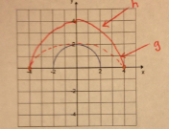

1. Let . The graph of is shown below. On the same axes, graph the function , where   
   . Then, graph the function , where .

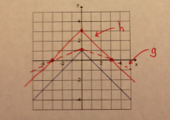

1. Based on your work in Problems 1 and 2, describe the resulting function when the original function is transformed with a horizontal and then a vertical scaling by the same factor, .

The resulting function is scaled by a factor of in both directions. It is a dilation about the origin of the original figure and is similar to it.

1. Let .
   1. What are the focus and directrix of the parabola that is the graph of the function ?

Since , we know and that is the distance between the focus and the directrix. The point is the vertex of the parabola and the midpoint of the segment connecting the focus and the directrix. Since the distance between the focus and vertex is , which is the same as the distance between the vertex and directrix; therefore, the focus has coordinates , and the directrix is .

* 1. Describe the sequence of transformations that would take the graph of to each parabola described below.
     1. Focus: , directrix:

This parabola is a reflection of the graph of across the -axis.

* + 1. Focus: , directrix:

This parabola is a clockwise rotation of the graph of .

* + 1. Focus: , directrix:

This parabola is a vertical translation of the graph of down unit.

* + 1. Focus: , directrix:

This parabola is a vertical scaling of the graph of by a factor of and a vertical translation of the resulting image downunit.

* + 1. Focus: , directrix:

This parabola is a vertical scaling of the graph of by a factor of and a vertical translation of the resulting image up unit.

* 1. Which parabolas are similar to the parabola that is the graph of ? Which are congruent to the parabola that is the graph of ?

All of the parabolas are similar. We have proven that all parabolas are similar. The congruent parabolas are (i), (ii), and (iii). These parabolas are the result of a rigid transformation of the original parabola that is the graph of . They have the same distance between the focus and directrix line as the original parabola.

1. Derive the analytic equation for each parabola described in Problem 4(b) by applying your knowledge of transformations.
2. Are all parabolas the graph of a function of in the -plane? If so, explain why, and if not, provide an example (by giving a directrix and focus) of a parabola that is not.

No, they are not. Examples include the graph of the equation , or a liststating a directrix and focus. For example, students may give the example of a directrix given by and focus or an even more interesting example, such as a directrix given by with focus . Any line and any point not on that line define a parabola.

1. Are the following parabolas congruent? Explain your reasoning.



They are not congruent but they are similar. I can see that the parabola on the left appears to contain the point , while the parabola on the right appears to contain the point . This implies that the graph of the parabola on the right is a dilation of the graph of the parabola on the left, so they are not congruent.

1. Are the following parabolas congruent? Explain your reasoning.



They are congruent. Both graphs contain the points , , and that satisfy the equation . The scales are different on these graphs, making them appear non-congruent.

1. Write the equation of a parabola congruent to that contains the point . Describe the transformations that would take this parabola to your new parabola.

There are many solutions. Two possible solutions:

Reflect the graph about the -axis to get .

OR

Translate the graph down four units to get .

1. Write the equation of a parabola similar to that does NOT contain the point , but does contain the point .

There are many solutions. One solution is . This parabola is congruent to and, therefore, similar to the original parabola, but the graph has been translated horizontally and vertically to contain the point , but not the point .