Lesson 35: Are All Parabolas Similar?

Classwork

Exercises 1–6

1. Write the equation of two parabolas that are congruent to and explain how you determined your equations.

1. Sketch the graph of and the two parabolas you created on the same coordinate axes.
2. Write the equation of two parabolas that are NOT congruent to . Explain how you determined your equations.
3. Sketch the graph of and the two non-congruent parabolas you created on the same coordinate axes.
4. Use your work on Exercises 1–4 to answer the question posed in the lesson title: Are all parabolas similar? Explain your reasoning.
5. 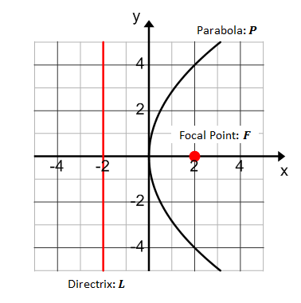The parabola at right is the graph of what equation?
   1. Label a pointon the graph of .
   2. What does the definition of a parabola tell us about the distance between the point and the directrix and the distance between the point and the focus?
   3. Create an equation that relates these two distances.
   4. Solve this equation for .
   5. Find two points on the parabola and show that they satisfy the equation found in part (d).

**Discussion**

How many of you think that all parabolas are similar? Explain why you think so.

What could we do to show that two parabolas are similar? How might you show this?

**Exercises 7–10**

Use the graphs below to answer Exercises 7 and 8.

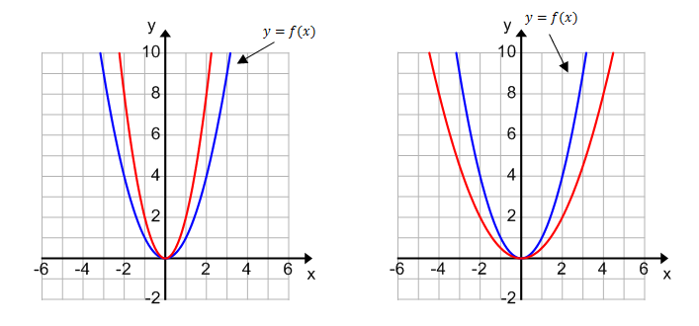

1. Suppose the unnamed red graph on the left coordinate plane is the graph of the function . Describe as a vertical scaling of the graph of ; that is, find a value of so that. What is the value of ? Explain how you determined your answer.
2. Suppose the unnamed red graph on the right coordinate plane is the graph of the function . Describe as a vertical scaling of the graph of ; that is, find a value of so that . Explain how you determined your answer.

Use the graphs below to answer Exercises 9–10.

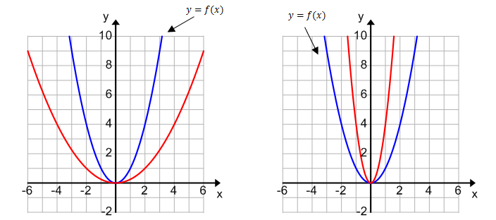

1. Suppose the unnamed function graphed in red on the left coordinate plane is . Describe as a horizontal scaling of the graph of . What is the value of? Explain how you determined your answer.
2. Suppose the unnamed function graphed in red on the right coordinate plane is. Describe as a horizontal scaling of the graph of . What is the value of? Explain how you determined your answer.

Definition: A dilation at the origin is a horizontal scaling by followed by a vertical scaling by the same factor . In other words, this dilation of the graph of is the graph of the equation .

Example 1

Let and let. Write a formula for the functionthat results from dilating at the origin by a factor of .

What would the results be for , or ? What about ?

Lesson Summary

* We started with a geometric figure of a parabola defined by geometric requirements and recognized that it involved the graph of an equation we studied in algebra.
* We used algebra to prove that all parabolas with the same distance between the focus and directrix are congruent to each other, and in particular, they are congruent to a parabola with vertex at the origin, axis of symmetry along the -axis, and equation of the form .
* Noting that the equation for a parabola with axis of symmetry along the -axis is of the form for a quadratic function , we proved that all parabolas are similar using transformations of functions.

Problem Set



1. Let . The graph of is shown below. On the same axes, graph the function , where Then, graph the function , where .



1. Let . The graph of is shown below. On the same axes, graph the function , where Then, graph the function , where .
2. Based on your work in Problems 1 and 2, describe the resulting function when the original function is transformed with a horizontal and then a vertical scaling by the same factor, .
3. Let
   1. What are the focus and directrix of the parabola that is the graph of the function ?
   2. Describe the sequence of transformations that would take the graph of to each parabola described below.
      1. Focus: , directrix:
      2. Focus: , directrix:
      3. Focus: , directrix:
      4. Focus: , directrix:
      5. Focus: , directrix:
   3. Which parabolas are similar to the parabola that is the graph of ? Which are congruent to the parabola that is the graph of ?
4. Derive the analytic equation for each parabola described in Problem 4(b) by applying your knowledge of transformations.
5. Are all parabolas the graph of a function of in the -plane? If so, explain why, and if not, provide an example (by giving a directrix and focus) of a parabola that is not.
6. Are the following parabolas congruent? Explain your reasoning.



1. Are the following parabolas congruent? Explain your reasoning.



1. Write the equation of a parabola congruent to that contains the point . Describe the transformations that would take this parabola to your new parabola.
2. Write the equation of a parabola similar to that does NOT contain the point but does contain the point .