Lesson 34: Are All Parabolas Congruent?

Classwork

Opening Exercise

Are all parabolas congruent? Use the following questions to support your answer.

* 1. Draw the parabola for each focus and directrix given below.



* 1. What do we mean by congruent parabolas?
  2. Are the two parabolas from part (a) congruent? Explain how you know.
  3. Are all parabolas congruent?
  4. Under what conditions might two parabolas be congruent? Explain your reasoning.

Exercises 1–5

1. Draw the parabola with the given focus and directrix.
2. Draw the parabola with the given focus and directrix.
3. Draw the parabola with the given focus and directrix.
4. What can you conclude about the relationship between the parabolas in Exercises 1–3?
5. Let be the number of units between the focus and the directrix, as shown. As the value of increases, what happens to the shape of the resulting parabola?

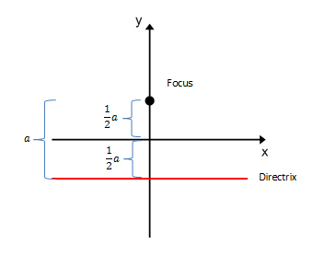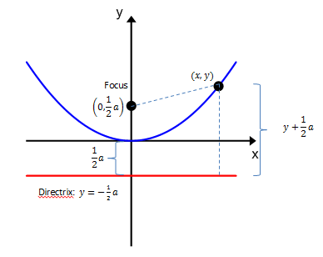

Example 1

Consider a parabola with distance between the focus with coordinates , and directrix .

What is the equation that represents this parabola?

**Discussion**

We have shown that any parabola with a distance between the focus and directrix has a vertex at the origin and is represented by a quadratic equation of the form .

Suppose that the vertex of a parabola with a horizontal directrix that opens upward is , and the distance from the focus to directrix is . Then, the focus has coordinates and the directrix has equation . If we go through the above derivation with focus and directrix we should not be surprised to get a quadratic equation. In fact, if we complete the square on that equation, we can write it in the form .

In Algebra I, Module 4, Topic B, we saw that any quadratic function can be put into vertex form: . Now we see that any parabola that opens upward can be described by a quadratic function in vertex form, where .

If the parabola opens downward, then the equation is , and the graph of any quadratic equation of this form is a parabola with vertex at , distance between focus and directrix, and opening downward. Likewise, we can derive analogous equations for parabolas that open to the left and right. This discussion is summarized in the box below.

**Vertex Form of a Parabola**

Given a parabola with vertex , horizontal directrix, and distance between focus and directrix, the analytic equation that describes the parabola is:

* if the parabola opens upward, and
* if the parabola opens downward.

Conversely, if , then

* The graph of the quadratic equation is a parabola that opens upward with vertex at and distance from focus to directrix, and
* The graph of the quadratic equation is a parabola that opens downward with vertex at and distance from focus to directrix.

Given a parabola with vertex , vertical directrix, and distance between focus and directrix, the analytic equation that describes the parabola is:

* if the parabola opens to the right, and
* if the parabola opens to the left.

Conversely, if , then

* The graph of the quadratic equation is a parabola that opens to the right with vertex at and distance from focus to directrix, and
* The graph of the quadratic equation is a parabola that opens to the left with vertex at and distance from focus to directrix.

**Example 2**

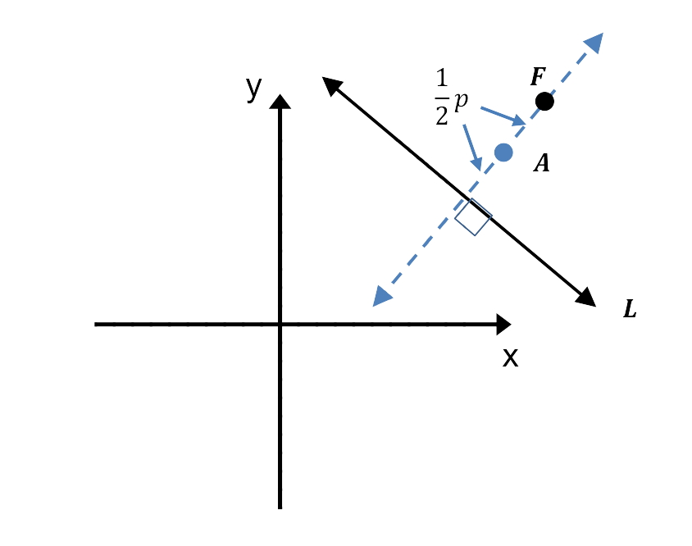**Theorem:** Given a parabola given by a directrix and a focus in the Cartesian plane, then is congruent to the graph of , where is the distance from to .

**Proof**

Exercises 6–9

1. Restate the results of the theorem from Example 2 in your own words.
2. Create the equation for a parabola that is congruent to . Explain how you determined your answer.
3. Create an equation for a parabola that IS NOT congruent to . Explain how you determined your answer.
4. Write the equation for two different parabolas that are congruent to the parabola with focus point and directrix line .

Problem Set

1. Show that if the point with coordinates is equidistant from and the line , then .
2. Show that if the point with coordinates is equidistant from the point and the line , then .
3. Find the equation of the set of points which are equidistant from and the -axis. Sketch this set of points.
4. Find the equation of the set of points which are equidistant from the origin and the line . Sketch this set of points.
5. Find the equation of the set of points which are equidistant from and the line . Sketch this set of points.
6. Find the equation of the set of points which are equidistant from and the -axis. Sketch this set of points.
7. Find the equation of the set of points which are equidistant from the origin and the line . Sketch this set of points.
8. Use the definition of a parabola to sketch the parabola defined by the given focus and directrix.
   1. Focus: Directrix:
   2. Focus: Directrix: -axis
   3. Focus: Directrix: -axis
   4. Focus: Directrix:
9. Find an analytic equation for each parabola described in Problem 8.
10. Are any of the parabolas described in Problem 9 congruent? Explain your reasoning.
11. Sketch each parabola, labeling its focus and directrix.
12. Determine which parabolas are congruent to the parabola that is the graph of the equation .
    1. c.



* 1. d.



1. Determine which equations represent the graph of a parabola that is congruent to the parabola shown to right.
2. Jemma thinks that the parabola whose graph is the equation is NOT congruent to the parabola whose graph is the equation . Do you agree or disagree? Create a convincing argument to support your reasoning.
3. Let be the parabola with focus and directrix.
   1. Write an equation whose graph is a parabola congruent to with a focus.
   2. Write an equation whose graph is a parabola congruent to with a focus .
   3. Write an equation whose graph is a parabola congruent to with the same directrix, but different focus.
   4. Write an equation whose graph is a parabola congruent to with the same focus, but with a vertical directrix.
4. Let be the parabola with focus and directrix .
   1. Sketch this parabola.
   2. By how many degrees would you have to rotate about the focus to make the directrix line horizontal?
   3. Write an equation in the form whose graph is a parabola that is congruent to .
   4. Write an equation whose graph is a parabola with a vertical directrix that is congruent to .
   5. Write an equation whose graph is , the parabola congruent to that results after is rotated clockwise about the focus.
   6. Write an equation whose graph is , the parabola congruent to that results after ’s directrix is rotated about the origin.

Extension:

1. Consider the function , where is a real number.
   1. Use polynomial division to rewrite in the form for some real numbers and .
   2. Find the -value where the maximum occurs for the function , without using graphing technology. Explain how you know.