Lesson 32: Graphing Systems of Equations

Student Outcomes
- Students develop facility with graphical interpretations of systems of equations and the meaning of their solutions on those graphs. For example, they can use the distance formula to find the distance between the centers of two circles and thereby determine whether the circles intersect in $0$, $1$, or $2$ points.
- By completing the squares, students can convert the equation of a circle in general form to the center-radius form and, thus, find the radius and center. They can also convert the center-radius form to the general form by removing parentheses and combining like terms.
- Students understand how to solve and graph a system consisting of two quadratic equations in two variables.

Lesson Notes
This lesson is an extension that goes beyond what is required in the standards. In particular, the standard A-REI.C.7 (solve a simple system consisting of a linear equation and a quadratic equation in two variables algebraically and graphically) does not extend to a system of two quadratic equations, which is a natural culmination of the types of systems formed by linear and quadratic equations. The lesson also addresses standard MP.8 (look for and express regularity in repeated reasoning).
The lesson begins with a brief review of the distance formula and its connection both to the Pythagorean Theorem and to the center-radius equation of a circle. The distance formula will be used extensively in the next few lessons, so be sure to review it with students. Students also briefly review how to solve and graph a system of a linear equation and an equation of a circle. They then move to the main focus of the lesson, which is graphing and solving systems of pairs of quadratic equations whose graphs include parabolas as well as circles

Materials
This lesson requires use of graphing calculators or computer software, such as the Wolfram Alpha engine, the GeoGebra package, or the Geometer’s Sketchpad software for graphing geometric figures, plus a tool for displaying graphs, such as a projector, smart board, white board, chalk board, or squared poster paper.

Classwork
Opening (1 minute)
Begin with questions that should remind students of the distance formula and how it is connected to the Pythagorean Theorem.
- Suppose you have a point $A$ with coordinates $(1, 3)$. Find the distance $AB$ if $B$ has coordinates:
- $(4, 2)$  Answer: $AB=\sqrt{10}$ | - $(-3, 1)$  Answer: $AB=2\sqrt{5}$ | - $(x, y)$  Answer: $AB=\sqrt{{\left(x-1\right)}^{2}+{\left(y-3\right)}^{2}}$

If the students cannot recall the distance formula (in the coordinate plane), they may need to be reminded of it.
The Distance Formula: Given two points $\left(x_{1},y_{1}\right)$ and $\left(x_{2},y_{2}\right),$ the distance $d$ between these points is given by the formula
$d=\sqrt{{\left(x_{2}-x_{1}\right)}^{2}+ {\left(y_{2}-y_{1}\right)}^{2}}$.
If $A$and $B$ are points with coordinates $\left(x_{1},y_{1}\right)$ and $\left(x_{2},y_{2}\right)$, then the distance between them is the length $AB$. Draw horizontal and vertical lines through $A$ and $B$ to intersect in point $C$ and form right triangle $∆ABC$. The length of the horizontal side is the difference in the $x$-coordinates $|x_{2}-x_{1}|$, and the length of the vertical side is the difference in the $y$-coordinates $\left|y_{2}-y_{1}\right|$. The Pythagorean Theorem gives the length of the hypotenuse as ${\left(AB\right)}^{2}={\left(x_{2}-x_{1}\right)}^{2}+{\left(y_{2}-y_{1}\right)}^{2}$. Taking the square root gives the distance formula.

Opening Exercise (3 minutes)
Make sure the students all have access to, and familiarity with, some technology (calculator or computer software) for graphing lines and circles in the coordinate plane. Have them work individually on the following exercise.
Opening Exercise
Scaffolding:
- Circulate to identify and help students who might have trouble managing the graphing tool.
Given the line $y=2x$, is there a point on the line at a distance $3$ from $(1, 3)$? Explain how you know.
Yes, there are two such points. They are the intersection of the line $y=2x$and the circle ${\left(x-1\right)}^{2}+{\left(y-3\right)}^{2}=9.$ (The intersection points are roughly $(0.07, 0.15)$ and $(2.73, 5.45)$.)
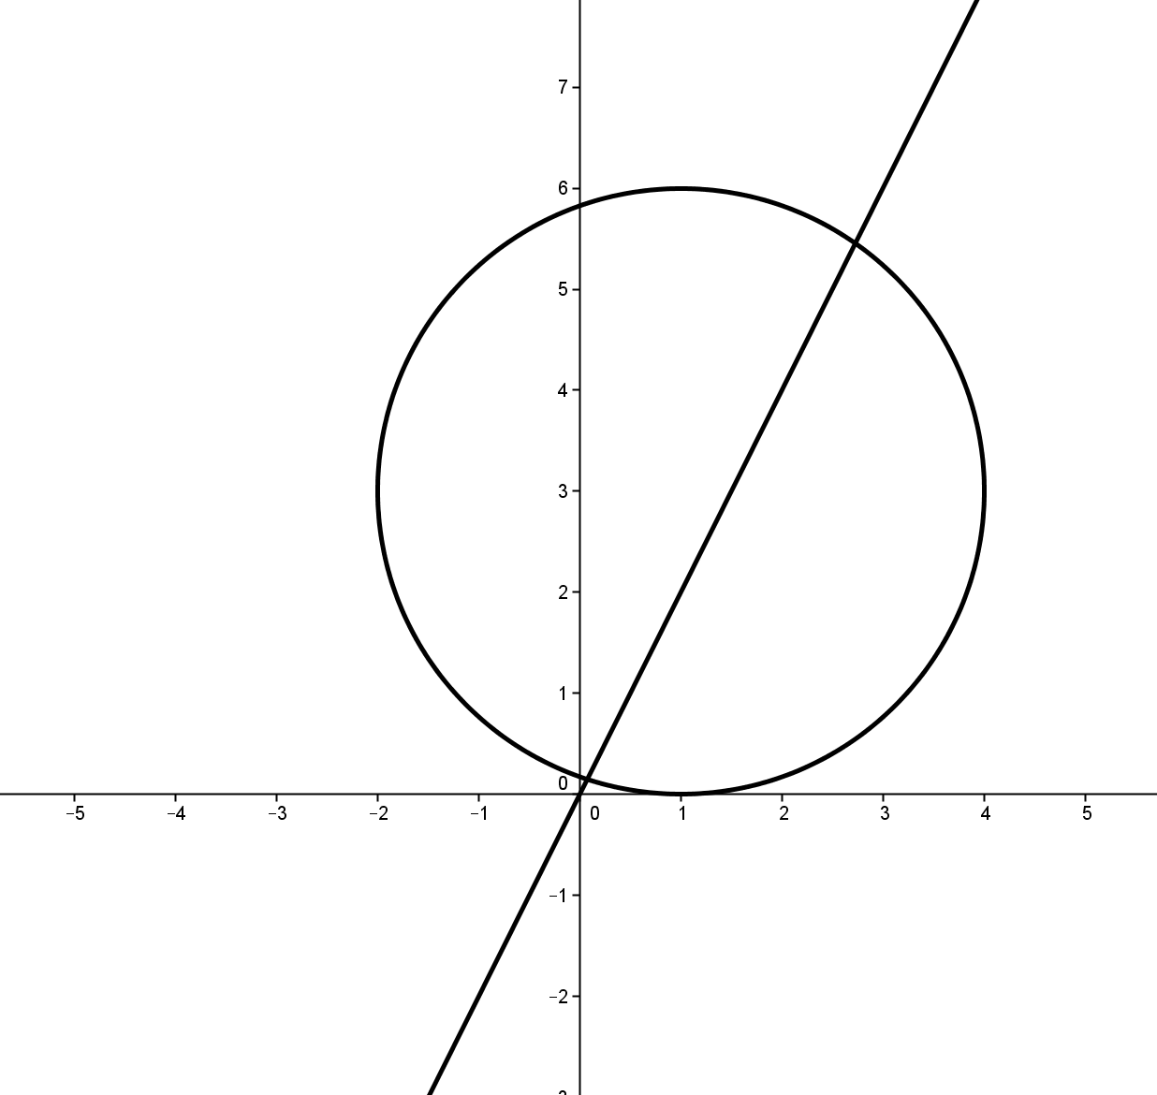
Draw a graph showing where the point is.
There are actually two such points. See the graph to the right.

Students should compare the graph they have drawn with that of a neighbor.

Exercise 1 (5 minutes)
This exercise reviews the solution of a simple system consisting of a linear equation and the equation of a circle from the perspective of the defining property of a circle (A-REI.C.7).
Exercise 1
Solve the system ${\left(x-1\right)}^{2}+{\left(y-2\right)}^{2}=2^{2}$ and $y=2x+2$.
Substituting $2x+2$ for $y$in the quadratic equation allows us to find the $x$-coordinates.
$${\left(x-1\right)}^{2}+{\left(\left(2x+2\right)-2\right)}^{2}=4 \\ \left(x^{2}-2x+1\right)+4x^{2}=4 \\ 5x^{2}-2x-3=0 \\ \left(x-1\right)\left(5x+3\right)=0$$
So, $x=1$ or $x=-\frac{3}{5}$, and the intersection points are $\left(-\frac{3}{5}, \frac{4}{5}\right)$ and $(1, 4)$.
What are the coordinates of the center of the circle?
$(1,2)$
What can you say about the distance from the intersection points to the center of the circle?
Because they are points on the circle and the radius of the circle is $2$, the intersection points are $2$ units away from the center. This can be verified by the distance formula.
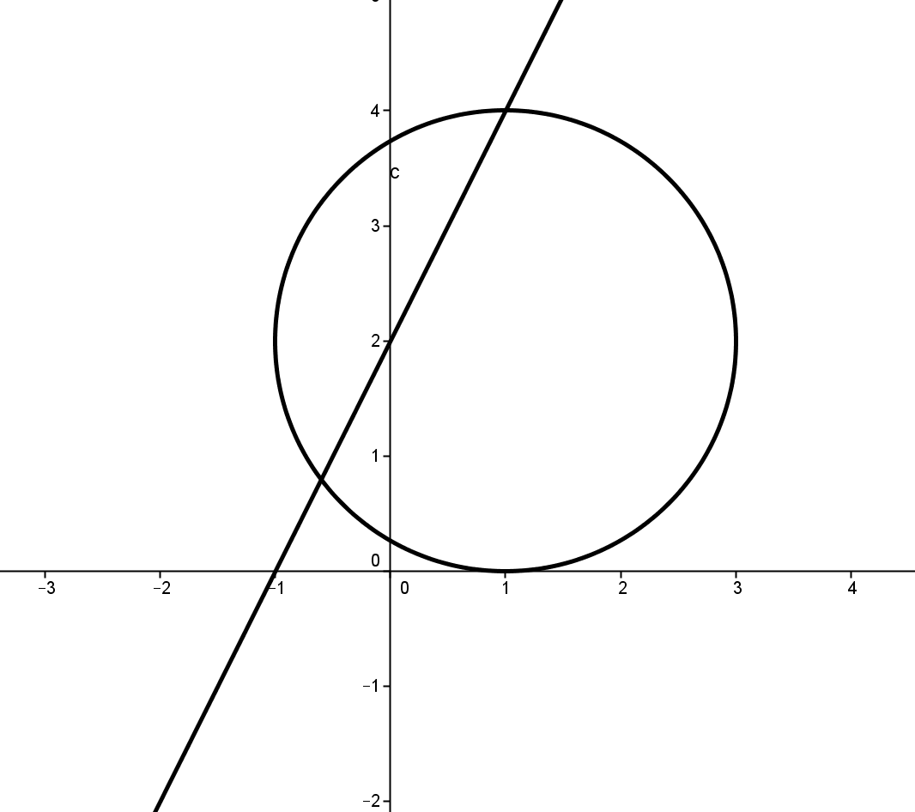
Using your graphing tool, graph the line and the circle.
See the graph at the right.

Example 1 (5 minutes)
It is important to keep in mind that not all quadratic equations in two variables represent circles.
Example 1
Rewrite $x^{2}+y^{2}-4x+2y=-1$ by completing the square in both $x$ and $y$. Describe the circle represented by this equation.
Rearranging terms gives $x^{2}-4x+y^{2}+2y=-1$.
Then, completing the square in both $x$ and $y$, we have
$$\left(x^{2}-4x+4\right)+\left(y^{2}+2y+1\right)=-1+4+1 \\ {\left(x-2\right)}^{2}+{\left(y+1\right)}^{2}=4\text{.}$$
This is the equation of a circle with center$(2, -1)$ and radius $2$.
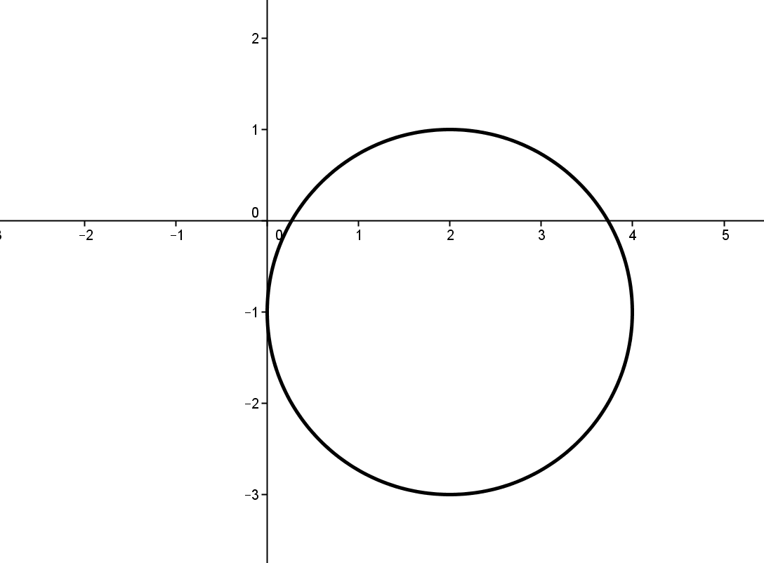
Using your graphing tool, graph the circle.
See the graph to the right.

In contrast, consider the following equation: $x^{2}+y^{2}-2x-8y=-19$.
Rearranging terms gives $x^{2}-2x+y^{2}-8y=-19$.
Then, completing the square in both $x$ and $y$, we have
$$\left(x^{2}-2x+1\right)+\left(y^{2}-8y+16\right)=-19+1+16 \\ {\left(x-1\right)}^{2}+{\left(y-4\right)}^{2}=-2\text{,}$$
which is not a circle, because then the radius would be $\sqrt{-2}$.
What happens when you use your graphing tool with this equation?
The tool cannot draw the graph. There are no points in the plane that satisfy this equation, so the graph is empty.

Exercise 2 (5 minutes)
Allow students time to think these questions over, draw some pictures, and discuss with a partner before discussing as a class.
Exercise 2
Consider a circle with radius$5$ and another circle with radius $3$. Let $d$ represent the distance between the two centers. We want to know how many intersections there are of these two circles for different values of $d$. Draw figures for each case.
  - What happens if $d=8$?
If the distance is $8$, then the circles will touch at only one point. We say that the circles are externally tangent.

  - What happens if $d=10$?
If the distance is $10$, the circles do not intersect, and one circle is outside of the other.

  - What happens if $d=1$?
If the distance is $1$, the circles do not intersect, but one circle lies inside the other.

  - What happens if $d=2$?
If the distance is $2$, the circles will touch at only one point, with one circle inside the other. We say that the circles are internally tangent.

  - For which values of $d$ do the circles intersect in exactly one point? Generalize this result to circles of any radius.
If $d=8$ or $d=2$, the circles will be tangent. In general, if $d$ is either the sum or the difference of the radii, then the circles will be tangent.

  - For which values of $d$ do the circles intersect in two points? Generalize this result to circles of any radius.
If $2<d<8$, the circles will intersect in two points. In general, if $d$ is between the sum and the difference of the radii then the circles will be tangent.

  - For which values of $d$ do the circles not intersect? Generalize this result to circles of any radius.
The circles do not intersect if $d<2$ or $d>8$. In general, if $d$ is smaller than the difference of the radii or larger than the sum of the radii, then the circles will not intersect.

Example 2 (5 minutes)
Example 2
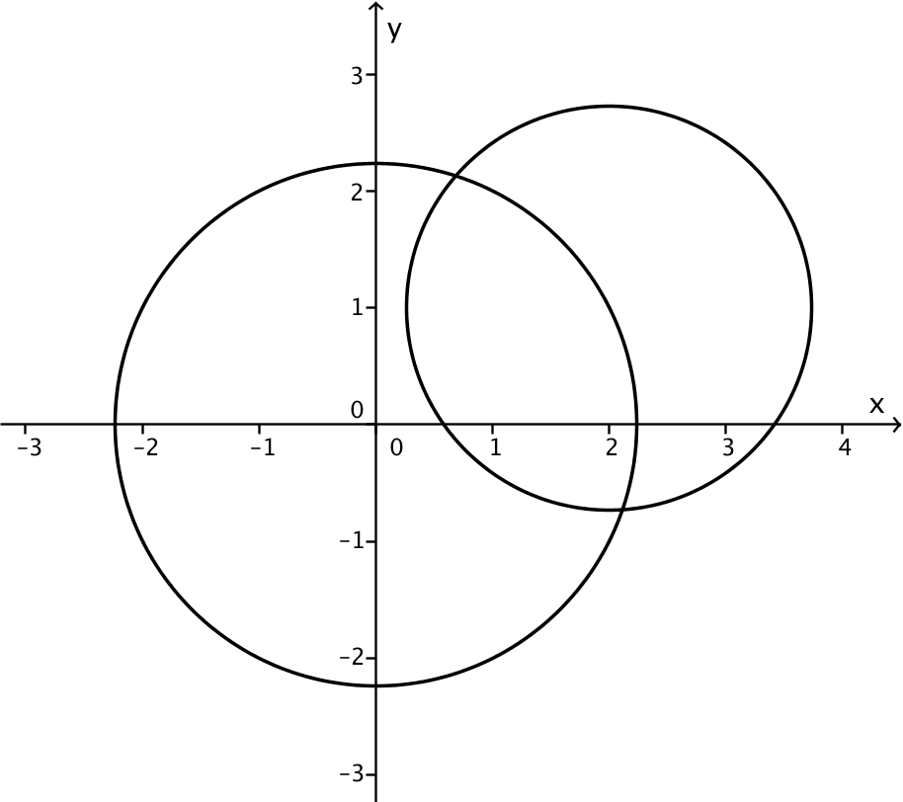
Find the distance between the centers of the two circles with equations below, and use that distance to determine in how many points these circles intersect.
$$x^{2}+y^{2}=5 \\ {\left(x-2\right)}^{2}+{\left(y-1\right)}^{2}=3$$
The first circle has center $(0,0)$, and the second circle has center $(2,1)$. Using the distance formula, the distance between the centers of these circles is
$d=\sqrt{{\left(2-0\right)}^{2}+{\left(1-0\right)}^{2}}=\sqrt{5}$.
Since the distance between the centers is between the sum and the difference of the two radii, that is, $\sqrt{5}-\sqrt{3}<\sqrt{5}<\sqrt{5}+\sqrt{3}$, we know that the circles must intersect in two distinct points.

- Find the coordinates of the intersection points of the circles.
  - Multiplying out the terms in the second equation gives:
$x^{2}-4x+4+y^{2}-2y+1=3$.
  - We subtract the first equation: $x^{2}+y^{2}=5$.
- The reason for subtracting is that we are removing repeated information in the two equations.
  - We get $-4x-2y=-7$, which is the equation of the line through the two intersection points of the circles.
- To find the intersection points, we find the intersection of the line $-4x-2y=-7$ and the circle $x^{2}+y^{2}=5$.
- As with the other systems of quadratic curves and lines, we solve the linear equation for $y$and substitute it into the quadratic equation to find two solutions for $x$: $x=\frac{7}{5}-\frac{\sqrt{51}}{10}$ and $x=\frac{7}{5}+\frac{\sqrt{51}}{10}$.

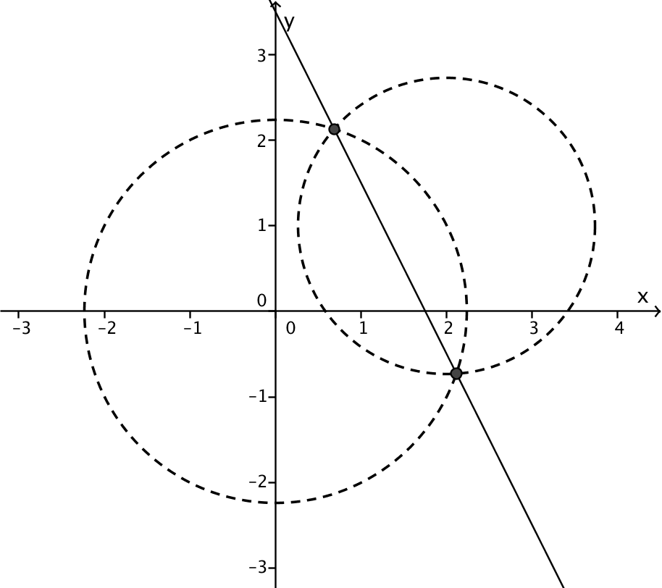
- The corresponding $y$-values are
$y=\frac{7}{10}+\frac{\sqrt{51}}{5}$ and $y=\frac{7}{10}-\frac{\sqrt{51}}{5}$.
- The graph of the circles and the line through the intersection points is shown to the right.

Exercise 3 (4 minutes)
This exercise concerns a system of equations that represents circles that do not intersect.
Exercise 3
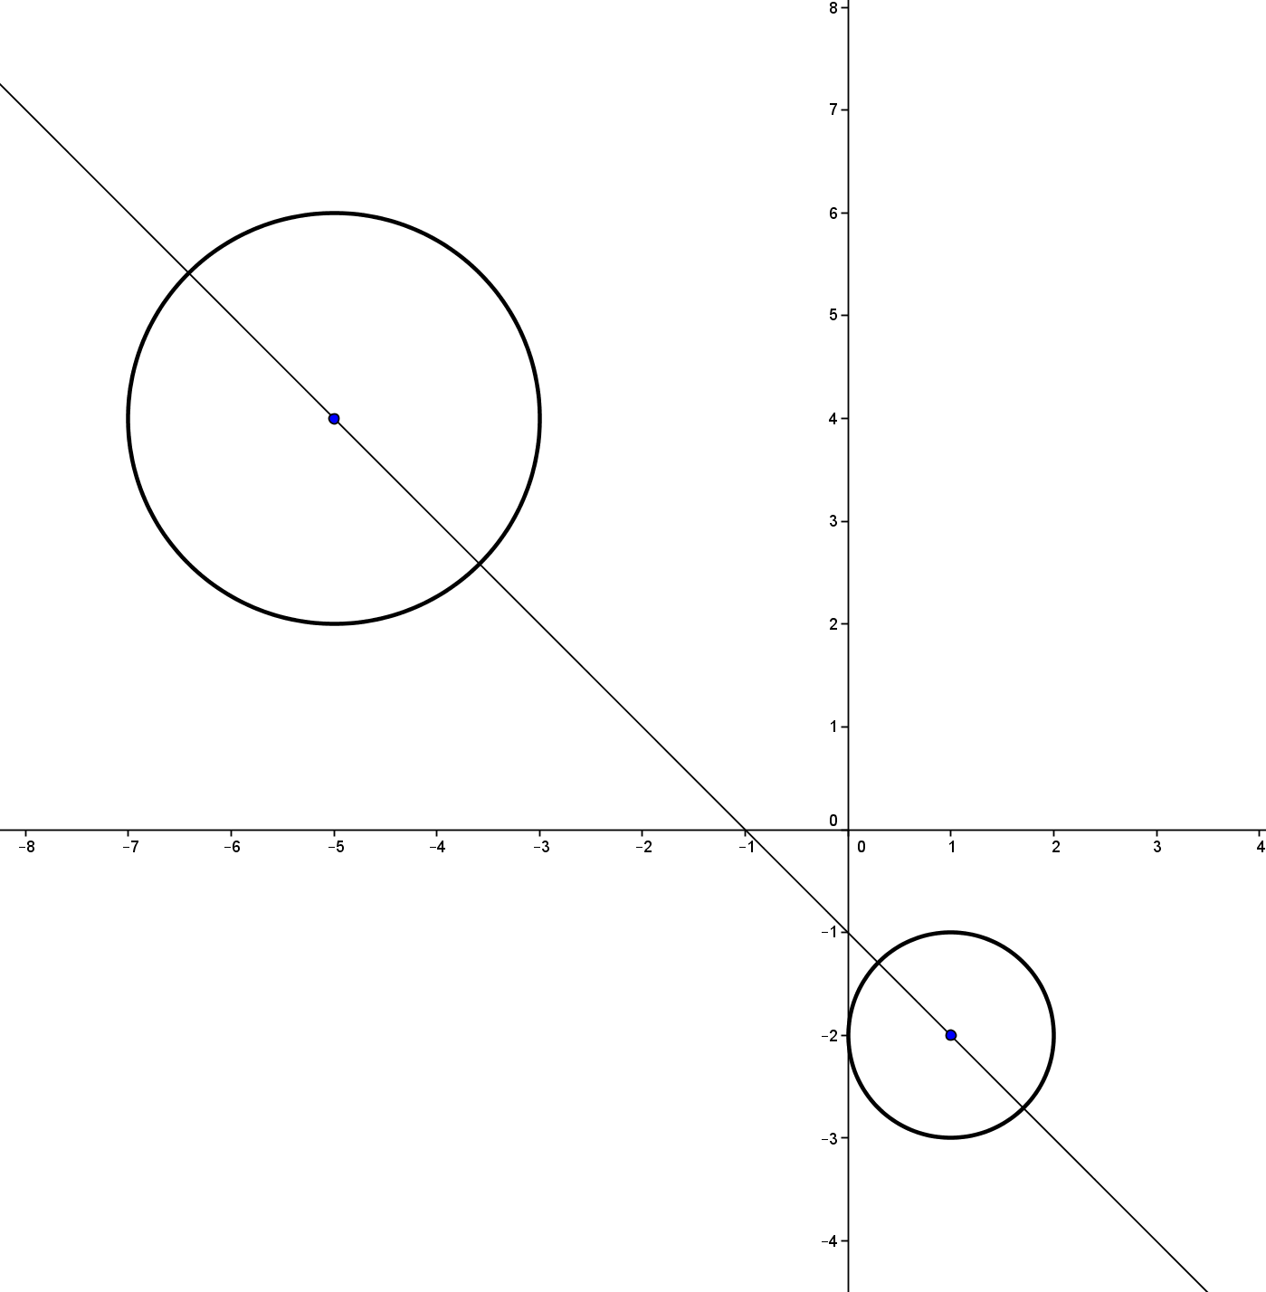
Use the distance formula to show algebraically and graphically that the following two circles do not intersect.
$${\left(x-1\right)}^{2}+{\left(y+2\right)}^{2}=1 \\ { \left(x+5\right)}^{2}+{\left(y-4\right)}^{2}=4$$

The centers of the two circles are $(1, -2)$ and $\left(-5, 4\right)$, and the radii are $1$ and $2$. The distance between the two centers is $\sqrt{6^{2}+6^{2}}=6\sqrt{2}$, which is greater than $1+2=3$. The graph to the right also shows that the circles do not intersect.

Example 3 (10 minutes)
Work through this example with the whole class, showing students how to find the tangent to a circle at a point and one way to determine how many points of intersection there are for a line and a circle.
Example 3
Point $A (3, 2)$is on a circle whose center is $C (-2, 3)$. What is the radius of the circle?
The distance from $A$ to $C$ is given by $\sqrt{{\left(3+2\right)}^{2}+{\left(2-3\right)}^{2}}=\sqrt{26}$, which is the length of the radius.
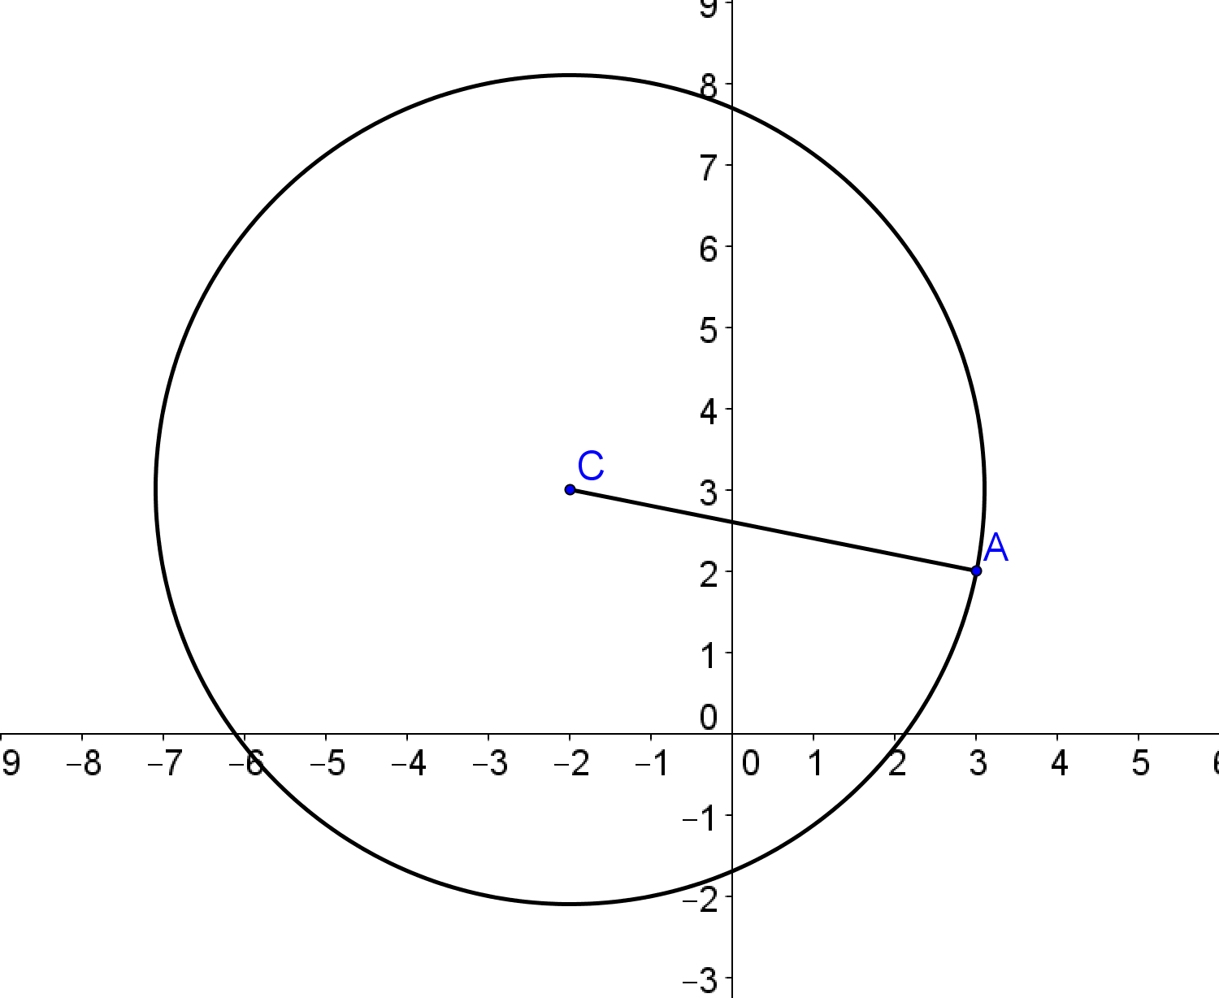
What is the equation of the circle? Graph it.
Given the center and the radius, we can write the equation of the circle as ${\left(x+2\right)}^{2}+{\left(y-3\right)}^{2}=26$.
The graph is shown at the right.

Use the fact that the tangent at $A (3, 2)$ is perpendicular to the radius at that point to find the equation of the tangent line. Then graph it.
The slope of the tangent line is the opposite reciprocal of the slope of $\overset{⃡}{AC}$. The slope of $\overset{⃡}{AC}$ is $\frac{3-2}{-2-3}=-\frac{1}{5}$, so the slope of the tangent line is $5$. Using the point-slope form of the equation of a line with slope $5$ and passing through point $\left(3,2\right)$ gives
$$y-2=5\left(x-3\right) \\ y=5x-13\text{.}$$
The equation of the tangent line is, therefore, $y=5x-13$.
Find the coordinates of point $B$, the second intersection of the line $\overset{⃡}{AC}$ and the circle.
The system ${\left(x+2\right)}^{2}+{\left(y-3\right)}^{2}=26$ and $5y=-x+13$ can be solved by substituting $x=13-5y$ into the equation of the circle, which yields ${\left(13-5y+2\right)}^{2}+{\left(y-3\right)}^{2}=26$. This gives $26\left(y-2\right)\left(y-4\right)=0$. Thus, the $y$-coordinate is either $2$ or $4$. If $y=2$, then $x=13-5∙2=3$, and if $y=4$, then $x=13-5∙4=-7$. Since $A$ has coordinates $(3, 2)$, it follows that $B$ has coordinates$(-7, 4)$.
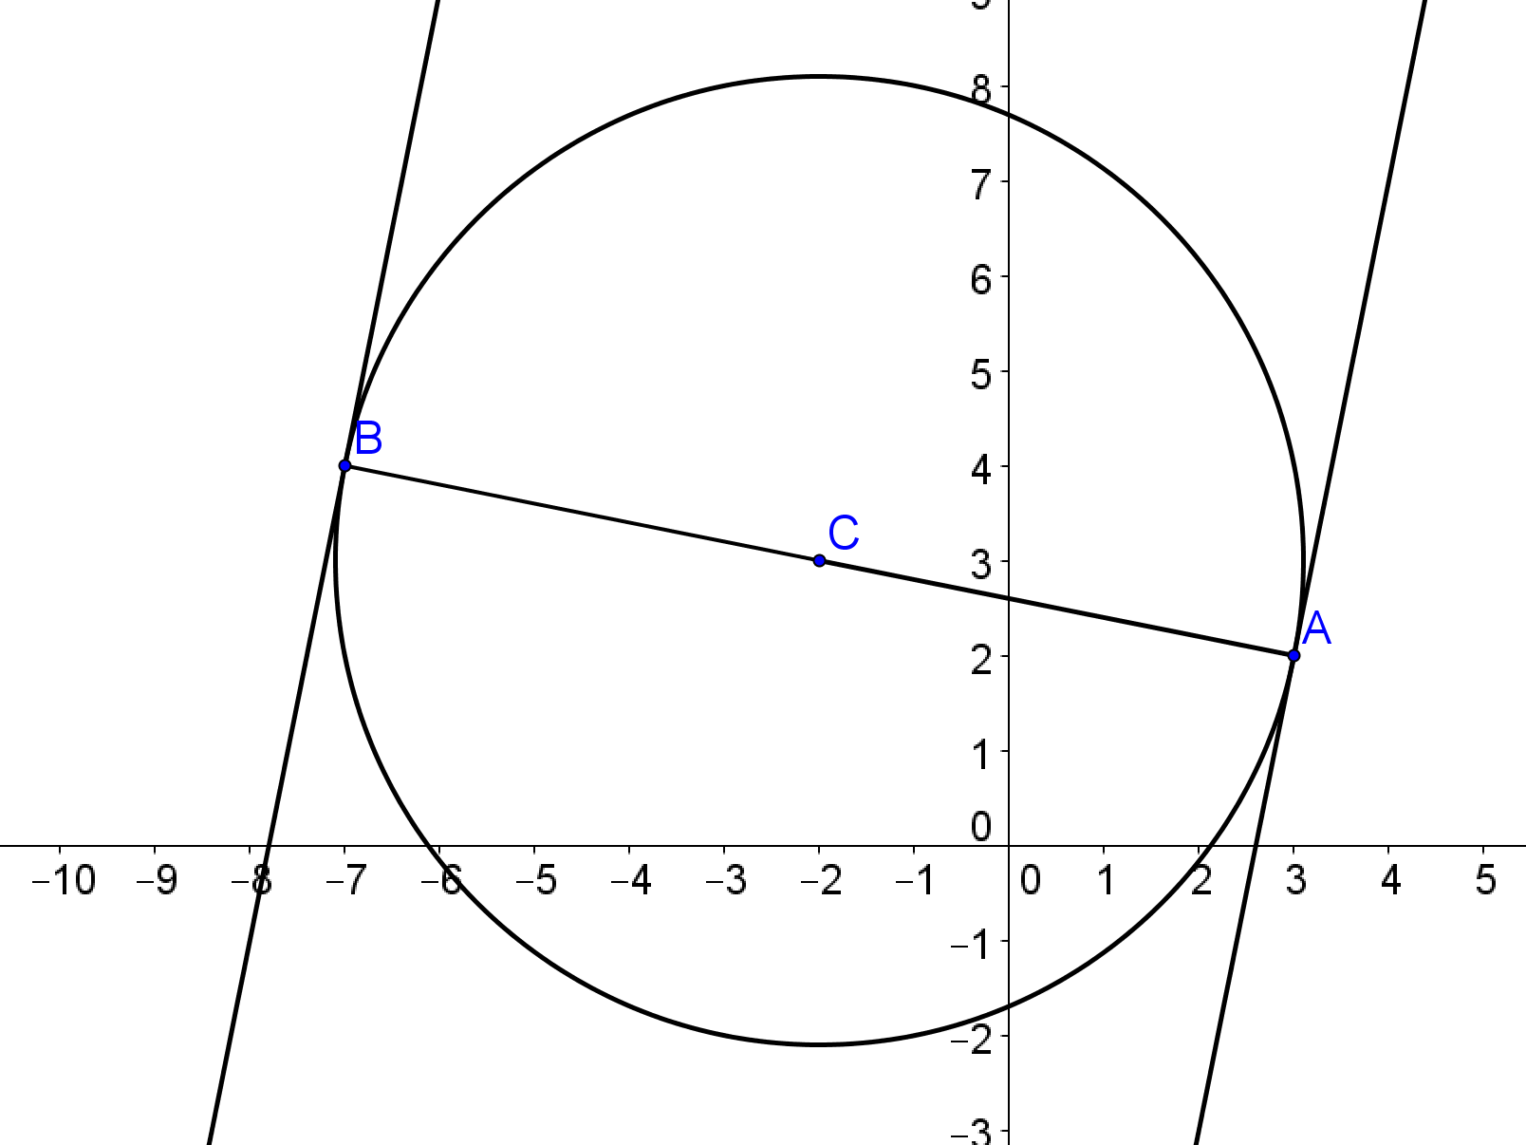
What is the equation of the tangent to the circle at $(-7, 4)$? Graph it as a check.
Using the point-slope form of a line with slope $5$ and point $\left(-7,4\right)$:
$$y-4=5\left(x+7\right) \\ y=5x+39\text{.}$$
The equation of the tangent line is, therefore, $y=5x+39$.
The graph is shown to the right.

The lines $y=5x+b$ are parallel to the tangent lines to the circle at points $A$ and $B$. How is the $y$-intercept $b$ for these lines related to the number of times each line intersects the circle?
When $b=-13$ or $b=39$, the line is tangent to the circle, intersecting in one point.
When $-13<b<39$, the line intersects the circle in two points.
When $b<-13$ or $b>39$, the line and circle do not intersect.

Closing (2 minutes)
Ask students to summarize how to convert back and forth between the center-radius equation of a circle and the general quadratic equation of a circle.
Ask students to speculate about what might occur with respect to intersections if one or two of the quadratic equations in the system are not circles.

Exit Ticket (5 minutes)

Name Date
Lesson 32: Graphing Systems of Equations

Exit Ticket

- Find the intersection of the two circles
$$x^{2}+y^{2}-2x+4y-11=0$$
and
$x^{2}+y^{2}+4x+2y-9=0$.

- The equations of the two circles in Question 1 can also be written as follows:
$${{\left(x-1\right)}^{2}+{\left(y+2\right)}^{2}=}^{ }16$$
and
${{\left(x+2\right)}^{2}+{\left(y+1\right)}^{2}=}^{ }14$.
Graph the circles and the line joining their points of intersection.

- Find the distance between the centers of the circles in Questions 1 and 2.
Exit Ticket Sample Solutions

- Find the intersection of the two circles
$$x^{2}+y^{2}-2x+4y-11=0$$
and
$x^{2}+y^{2}+4x+2y-9=0$.
Subtract the second equation from the first: $-6x+2y-2=0$.
Solve the equation for $y$: $y=3x+1$.
Substitute in the first equation: $x^{2}+{(3x+1)}^{2}-2x+4\left(3x+1\right)-11=0$.
Remove parentheses and combine like terms: $5x^{2}+8x-3=0$.
Substitute in the quadratic equation to find two values: $x=\frac{-4}{5}-\frac{\sqrt{31}}{5}$ and $x=\frac{-4}{5}+\frac{\sqrt{31}}{5}$.
The corresponding $y$-values are the following: $y=\frac{-7}{5}-\frac{3\sqrt{31}}{5}$ and $y=\frac{-7}{5}+\frac{3\sqrt{31}}{5}$.

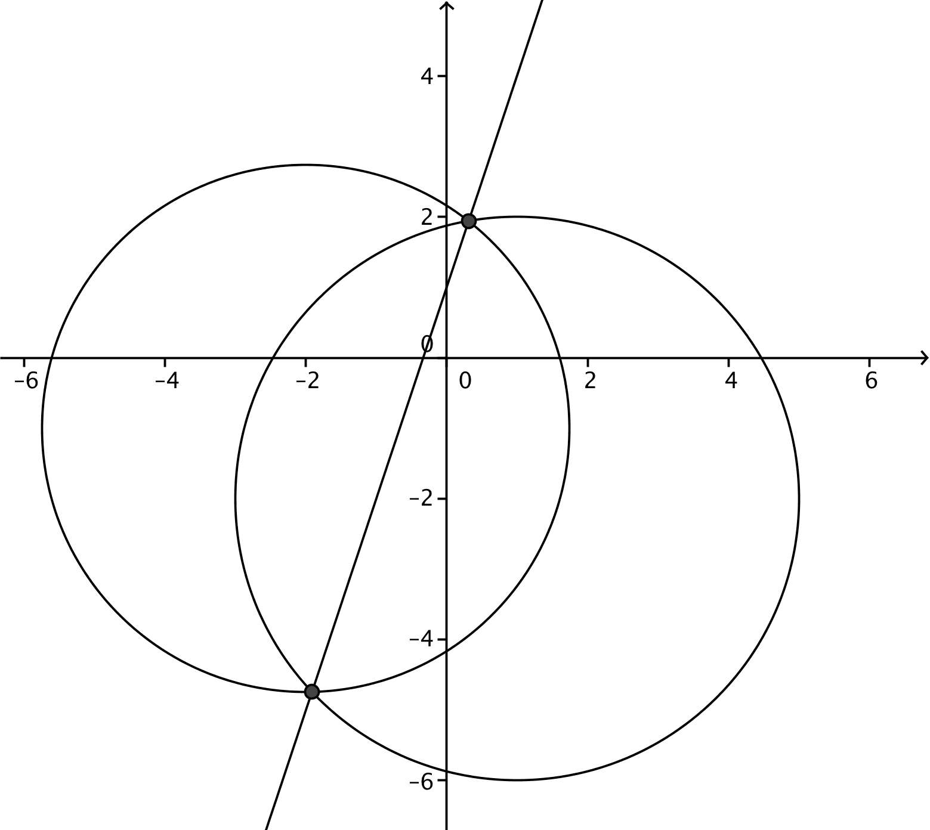
- The equations of the two circles in Question 1 can also be written as follows:
$${\left(x-1\right)}^{2}+{\left(y+2\right)}^{2}=16$$
and
${\left(x+2\right)}^{2}+{\left(y+1\right)}^{2}=14$.
Graph the circles and the line joining their points of intersection.

See the graph to the right.

- Find the distance between the centers of the circles in Questions 1 and 2.
The center of the first circle is $(1, -2)$, and the center of the second circle is $(-2, -1)$. We then have
$d=\sqrt{{\left(-2-1\right)}^{2}+{\left(-1+2\right)}^{2}}=\sqrt{9+1}=\sqrt{10}$.

Problem Set Sample Solutions
In this Problem Set, after solving some problems dealing with the distance formula, the students continue converting between forms of the equation of a circle and then move on to solving and graphing systems of quadratic equations, some of which represent circles and some of which do not.

- Use the distance formula to find the distance between the points $\left(-1,-13\right)$and $\left(3,-9\right)$.
Using the formula with $(-1,-13)$ and $\left(3,-9\right)$:
$$d=\sqrt{{\left(3-\left(-1\right)\right)}^{2}+ {\left(\left(-9\right)-\left(-13\right)\right)}^{2}} \\ d=\sqrt{4^{2}+ 4^{2}}=\sqrt{16+ 16}=\sqrt{16}∙\sqrt{2}=4\sqrt{2}\text{.}$$
Therefore, the distance is $4\sqrt{2}$.
- Use the distance formula to find the length of the longer side of the rectangle whose vertices are $\left(1,1\right)$, $\left(3,1\right)$, $\left(3,7\right)$, and $\left(1,7\right)$.
Using the formula with $\left(1,1\right)$ and $\left(1,7\right)$:
$$d=\sqrt{{\left(1-1\right)}^{2}+ {\left(7-1\right)}^{2}} \\ d=\sqrt{{\left(0\right)}^{2}+ {\left(6\right)}^{2}}=\sqrt{36}=6$$
Therefore, the length of the longer side is $6$.

- Use the distance formula to find the length of the diagonal of the square whose vertices are $\left(0,0\right)$, $\left(0,5\right)$,$\left(5,5\right)$, and $\left(5,0\right)$.
Using the formula with $\left(0,0\right)$and $\left(5,5\right)$:
$$d=\sqrt{{\left(5-0\right)}^{2}+ {\left(5-0\right)}^{2}} \\ d=\sqrt{{\left(5-0\right)}^{2}+ {\left(5-0\right)}^{2}}=\sqrt{25+ 25}=5\sqrt{2}$$
Therefore, the length of the diagonal is $5\sqrt{2}$.

Write an equation for the circles in Exercises 4–6 in the form${\left(x-h\right)}^{2}+{\left(y-k\right)}^{2}= r^{2}$, where the center is ($h, k$) and the radius is $r$ units. Then write the equation in the standard form $x^{2}+ax+y^{2}+by+c=0$, and construct the graph of the equation.
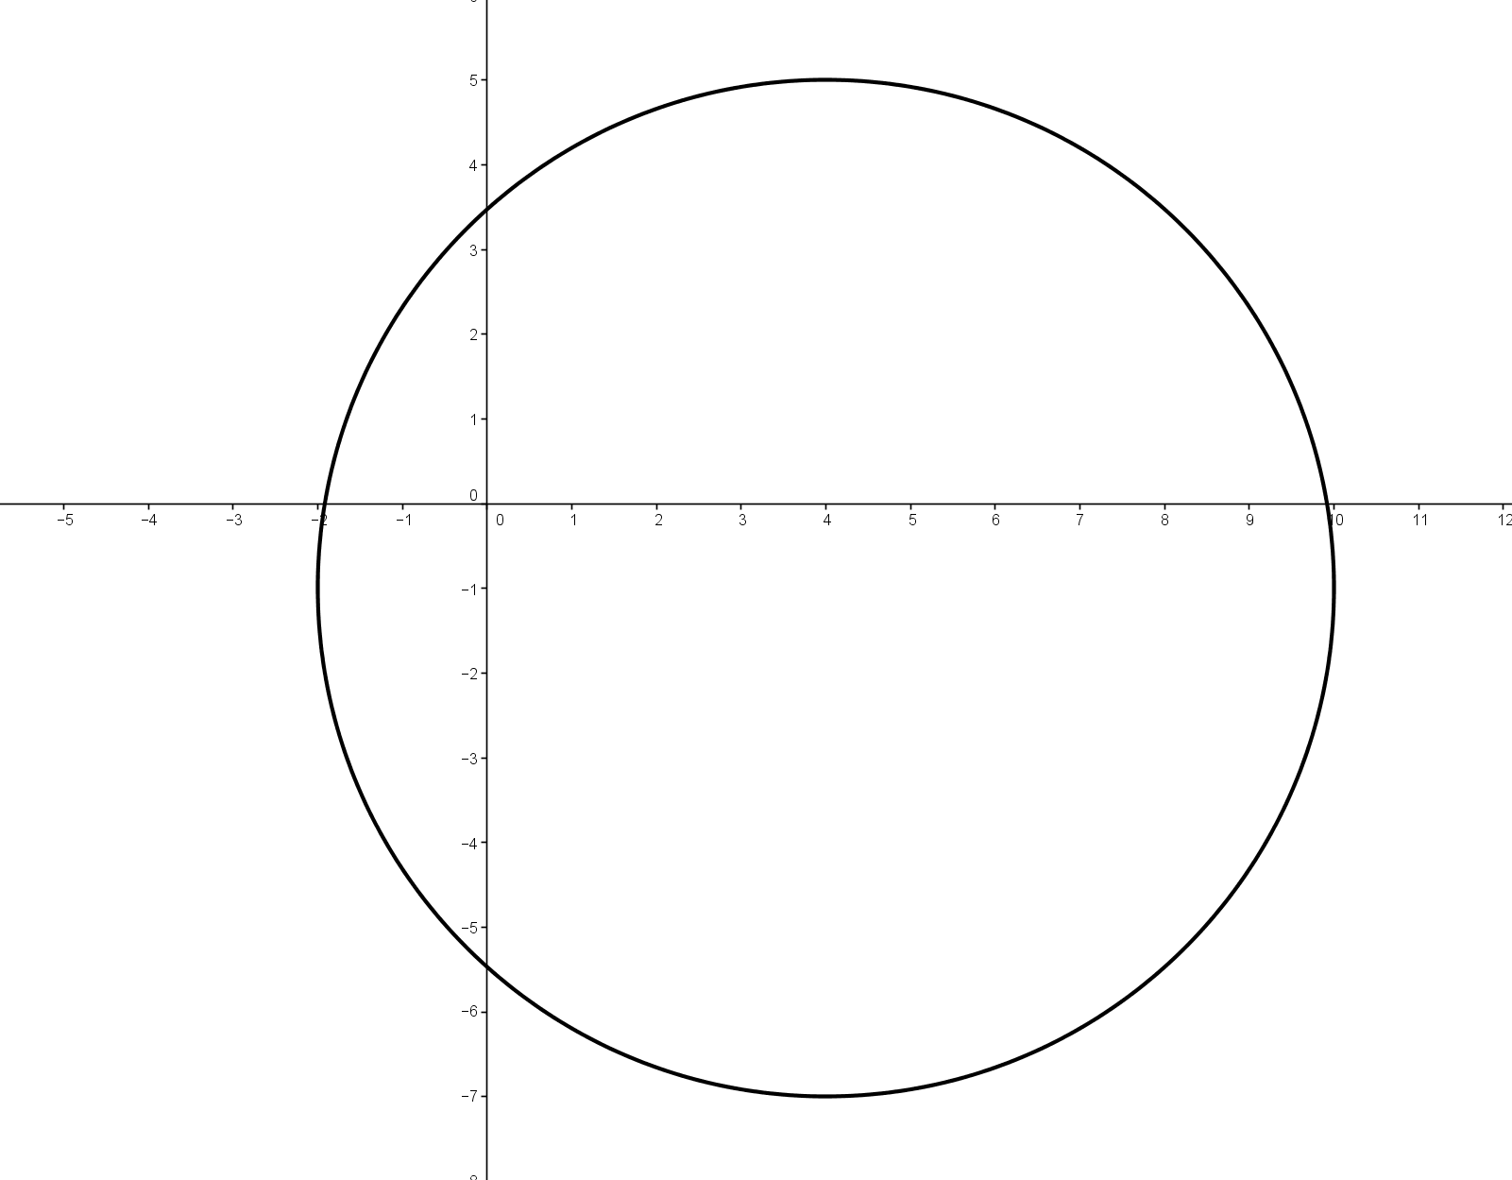
- A circle with center ($4, -1$) and radius $6$ units.
${\left(x-4\right)}^{2}+{\left(y+1\right)}^{2}=36$; standard form: $x^{2}-8x+y^{2}+2y-19=0$
The graph is shown to the right.

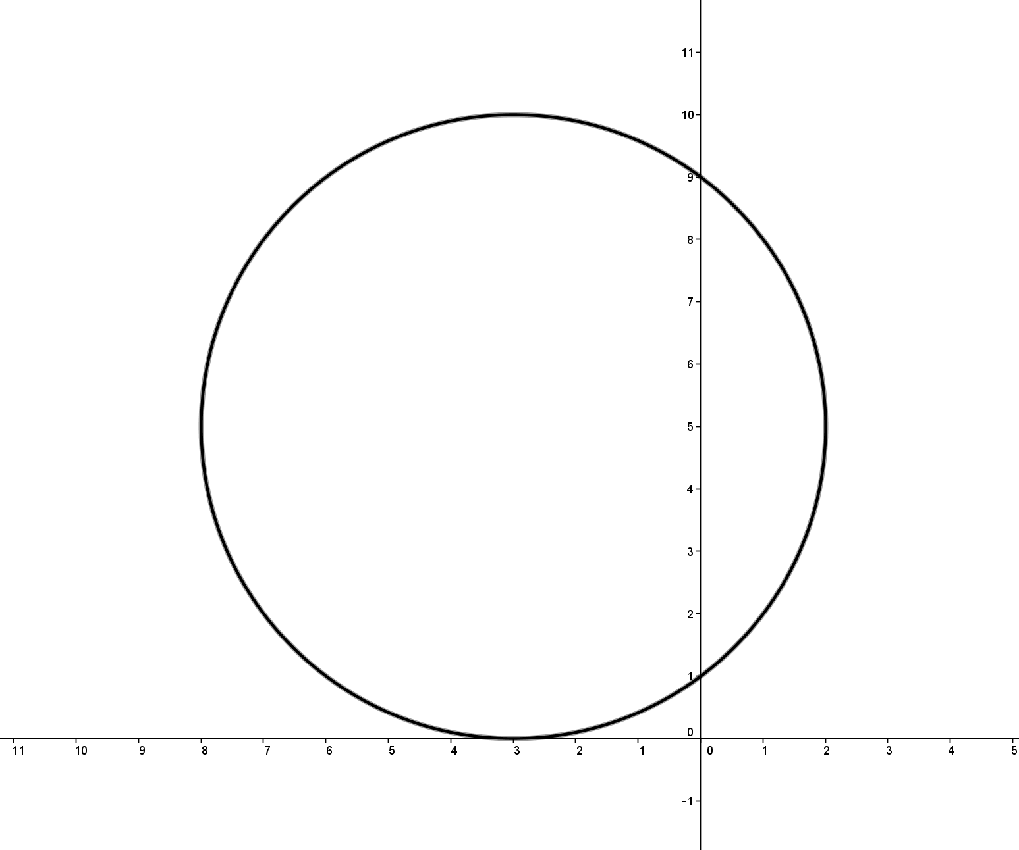
- A circle with center ($-3, 5$) tangent to the $x$-axis.
${\left(x+3\right)}^{2}+{\left(y-5\right)}^{2}=25$; standard form: $x^{2}+6x+y^{2}-10y+9=0$.
The graph is shown to the right.

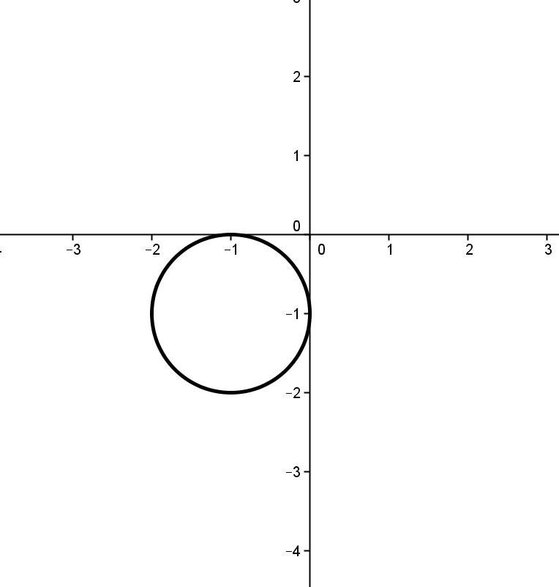
- A circle in the third quadrant, radius $1$ unit, tangent to both axes.
${\left(x+1\right)}^{2}+{\left(y+1\right)}^{2}=1$; standard form: $x^{2}+2x+y^{2}+2y+1=0$.
The graph is shown to the right.

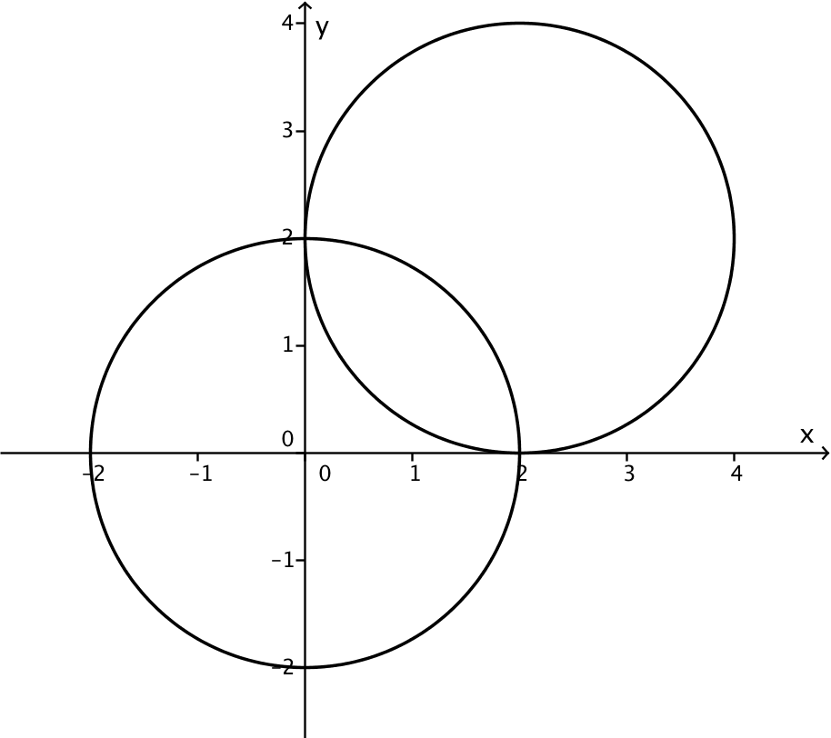
- By finding the radius of each circle and the distance between their centers, show that the circles $x^{2}+y^{2}=4$ and $x^{2}-4x+y^{2}-4y+4=0$intersect. Illustrate graphically.
The second circle is ${ \left(x-2\right)}^{2}+{\left(y-2\right)}^{2}=4$. Each radius is $2$, and the centers are at $\left(0,0\right)$and $\left(2,2\right)$. The distance between the centers is $2\sqrt{2}$, which is less than $4$, the sum of the radii.
The graph of the two circles is to the right.

- Find the points of intersection of the circles $x^{2}+y^{2}- 15=0$ and $x^{2}-4x +y^{2}+2y-5=0$. Check by graphing the equations.
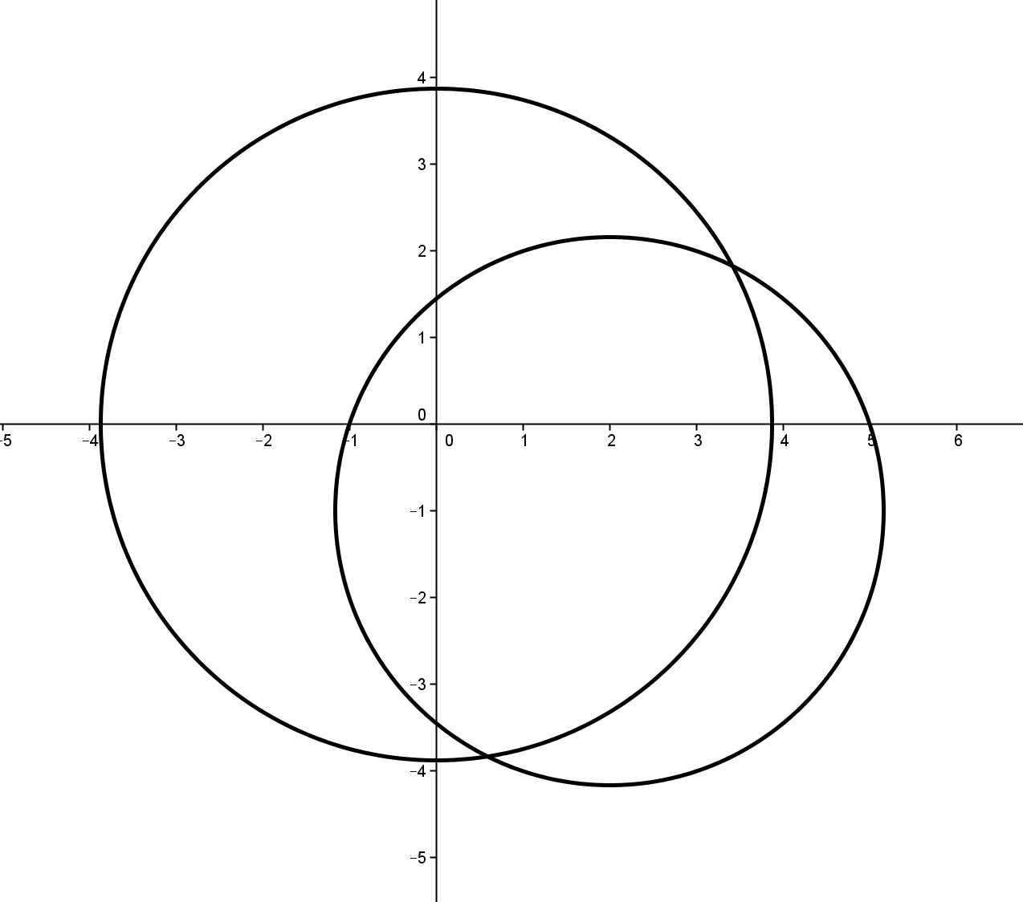
Write the equations as
$$x^{2}+y^{2}=15 \\ x^{2}+y^{2}-4x+2y=5$$
Subtracting the second equation from the first:
$4x-2y=10$,
which is equivalent to
$2x-y=5$.
Solving the system $x^{2}+y^{2}=15$ and $y=2x-5$ yields
$\left(2+\sqrt{2},-1+2\sqrt{2}\right)$and $\left(2-\sqrt{2},-1-2\sqrt{2}\right)$. The graph is to the right.

- Solve the system $y=x^{2}-2$and $x^{2}+y^{2}=4$. Illustrate graphically.
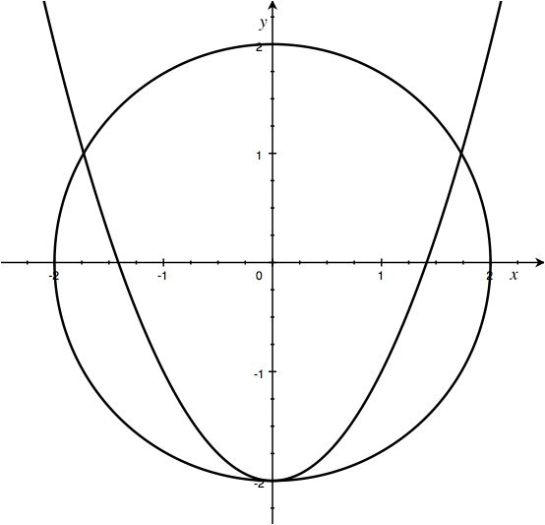
Substitute$x^{2}=y+2$ into the second equation:
$$y+2+y^{2}=4 \\ y^{2}+y-2=0 \\ \left(y-1\right)\left(y+2\right)=0$$
so $y=-2$ or $y=1$.
If $y=-2$, then $x^{2}=y+2=0$ and thus $x=0$.
If $y=1$, then $x^{2}=y+2=3$, so $x=\sqrt{3}$ or $x=-\sqrt{3}.$
Thus, there are three solutions $(0,-2)$, $\left(\sqrt{3}, 1\right)$, and $(-\sqrt{3}, 1)$. The graph is to the right.
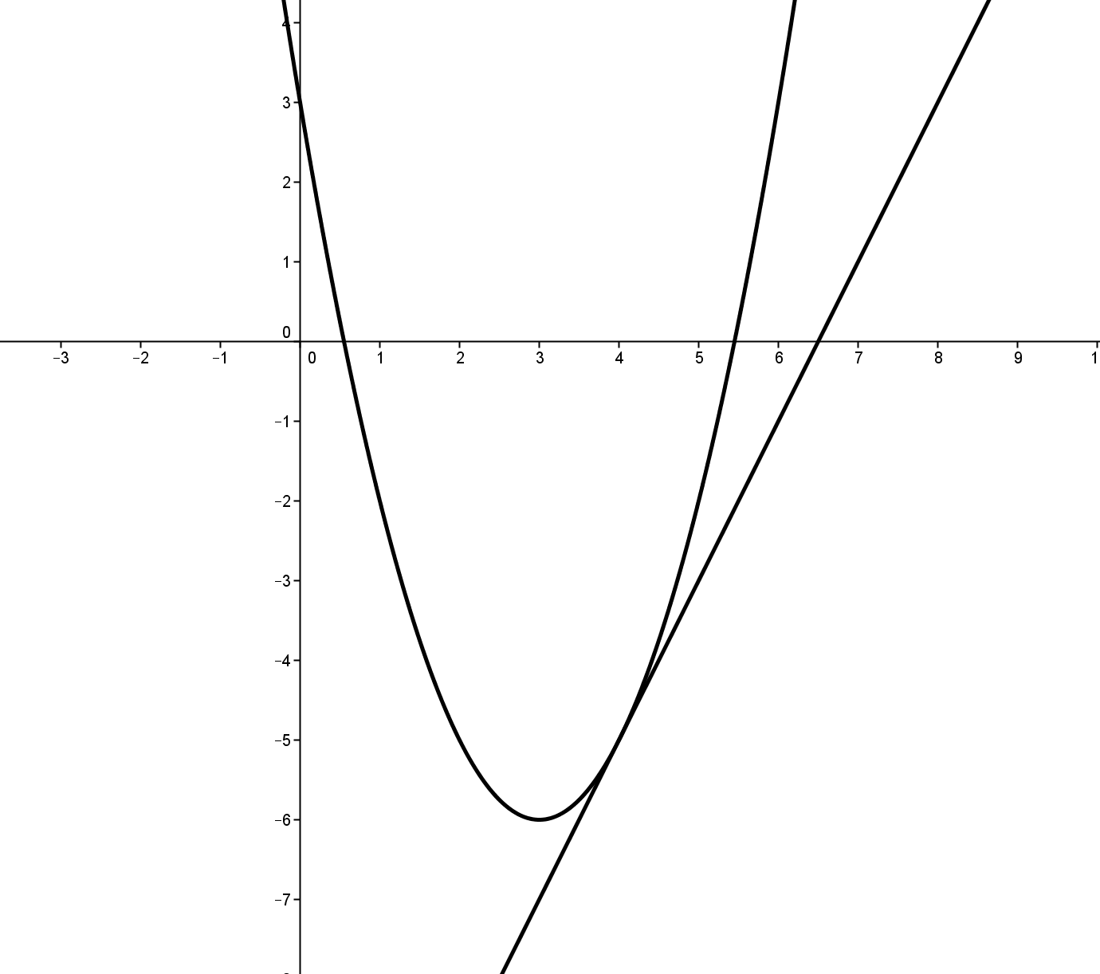
- Solve the system $y=2x-13$ and$y=x^{2}-6x+3$. Illustrate graphically.
Substitute $2x-13$ for $y$ in the second equation: $2x-13=x^{2}-6x+3$.
Rewrite the equation in standard form: $x^{2}-8x+16=0$.
Solve for $x$: $(x-4)(x-4)=0$.
The root is repeated, so there is only one solution $x=4$.
The corresponding$y$-value is $y=-5$, and there is only one solution, $(4,-5)$.
As shown to the right, the line is tangent to the parabola.

