Lesson 31: Systems of Equations

Student Outcomes
- Students solve systems of linear equations in two variables and systems of a linear and a quadratic equation in two variables.
- Students understand that the points at which the two graphs of the equations intersect correspond to the solutions of the system.

Lesson Notes
Students review the solution of systems of linear equations, move on to systems of equations that represent a line and a circle and systems that represent a line and a parabola, and make conjectures as to how many points of intersection there can be in a given system of equations. They sketch graphs of a circle and a line to visualize the solution to a system of equations, solve the system algebraically, and note the correspondence between the solution and the intersection. Then they do the same for graphs of a parabola and a line.
The principal standards addressed in this lesson are A-REI.C.6 (solve systems of linear equations exactly and approximately, e.g., with graphs, focusing on pairs of linear equations in two variables) and A-REI.C.7 (solve a simple system consisting of a linear equation and a quadratic equation in two variables algebraically and graphically). The standards MP.5 (use appropriate tools strategically) and MP.8 (look for and express regularity in repeated reasoning) are also addressed.

Materials
Graph paper, straightedge, compass, and a tool for displaying graphs (e.g., projector, smart board, white board, chalk board, or squared poster paper)

Classwork
Exploratory Challenge 1 (8 minutes)
In this exercise, the students review ideas about systems of linear equations from Module 4 in Grade 8 (A-REI.C.6). Consider distributing graph paper for students to use throughout this lesson. Begin by posing the following problem for students to work on individually:
Scaffolding:
Circulate to identify students who might be asked to display their sketches and solutions.
Exploratory Challenge 1
- Sketch the lines given by $x+y=6$ and $-3x+y=2$ on the same set of axes, and then solve the pair of equations algebraically to verify your graphical solution.

Once the students have made a sketch, ask one of them to use the display tool and draw the two graphs for the rest of the class to see. While the student is doing that, ask the other students how many points are shared (one) and what the coordinates of that point are.
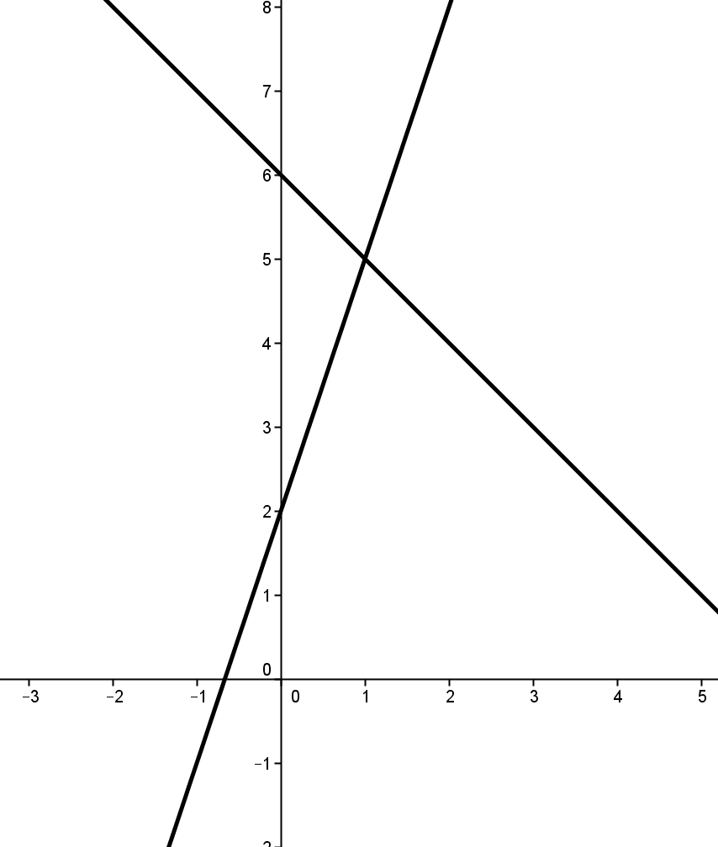
The point$(1, 5)$ should be easily identifiable from the sketch. See the graph to the right.

Point out that in this case, there is one solution. Now change the problem as follows. Then discuss the question as a class, and ask one or two students to show their sketches using the display tool.

- Suppose the second line is replaced by the line with equation $x+y=2$. Plot the two lines on the same set of axes, and solve the pair of equations algebraically to verify your graphical solution.
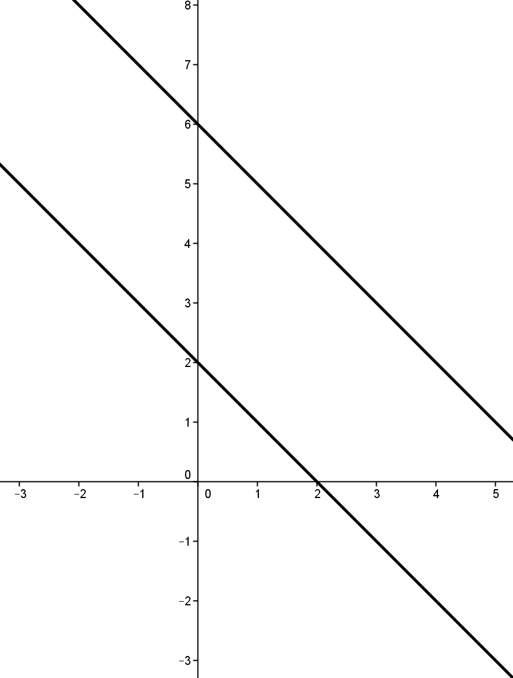

The lines are parallel, and there is no point in common. See the graph to the right.

Point out that in this case, there is no solution. Now change the problem again as follows, and again discuss the question as a class. Then ask one or two students to show their sketches using the display tool.

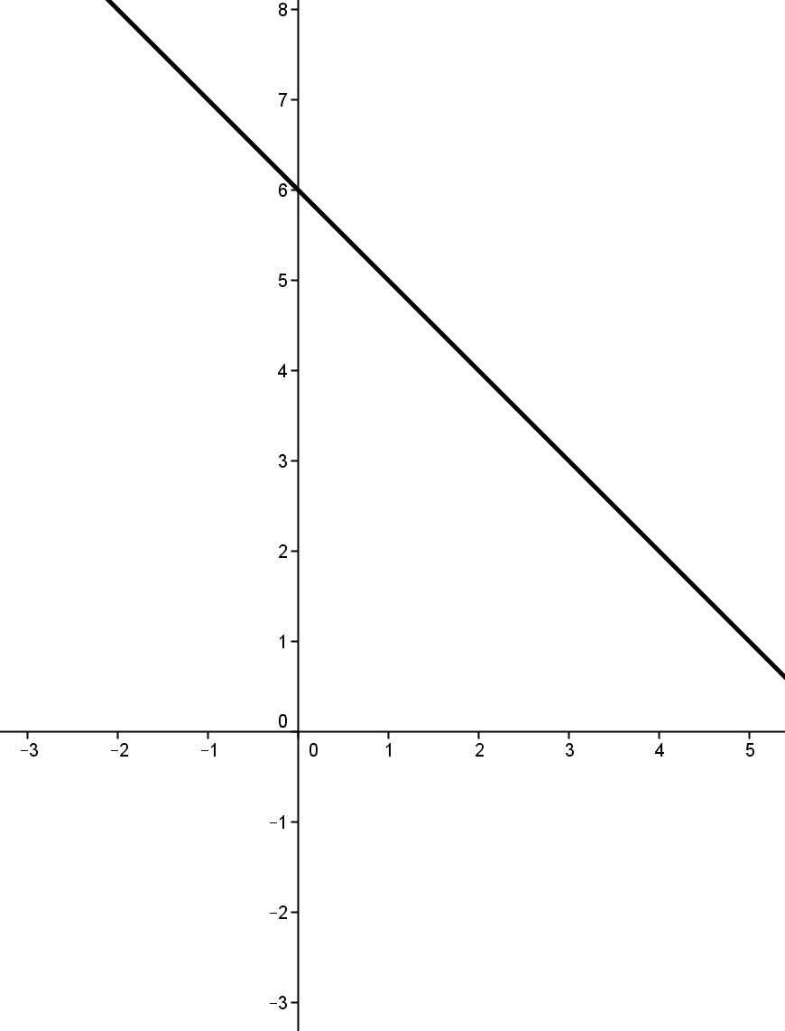
- Suppose the second line is replaced by the line with equation $2x=12-2y$. Plot the lines on the same set of axes, and solve the pair of equations algebraically to verify your graphical solution.

The lines coincide, and they have all points in common. See the graph to the right.

Point out that in this third case, there is an infinite number of solutions. Discuss the following problem as a class.

- We have seen that a pair of lines can intersect in $1$, $0$, or an infinite number of points. Are there any other possibilities?
No. Students should convince themselves and each other that these three options exhaust the possibilities for the intersection of two lines.

Exploratory Challenge 2 (12 minutes)
In this exercise, students move on to a system of a linear and quadratic equations (A-REI.C.6). Begin by asking students to work in pairs to sketch graphs and develop conjectures about the following item:
Scaffolding:
- Circulate to assist pairs of students who might be having trouble coming up with all three possibilities.
- For students who are ready, ask them to write equations for the graphs they have sketched.
Exploratory Challenge 2
- Suppose that instead of equations for a pair of lines, you were given an equation for a circle and an equation for a line. What possibilities are there for the two figures to intersect? Sketch a graph for each possibility.

Once the students have made their sketches, ask one pair to use the display tool and draw the graphs for the rest of the class to see.
They can intersect in $0$, $1$, or $2$ points as shown below.
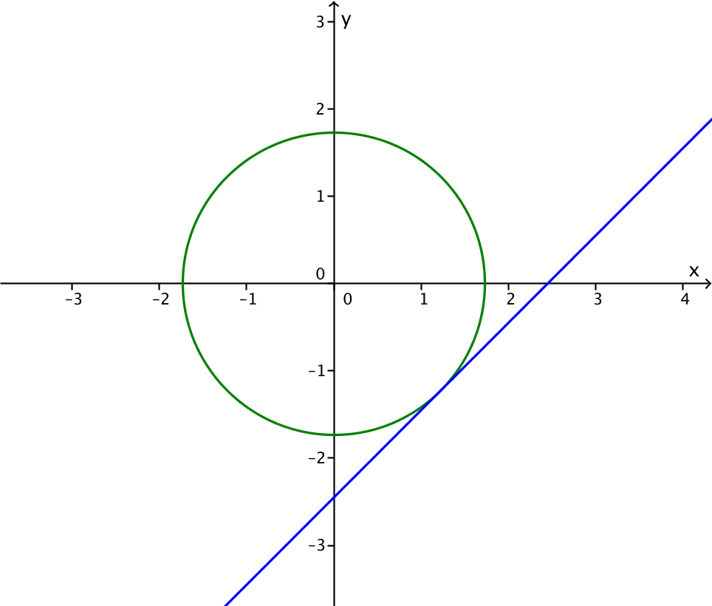
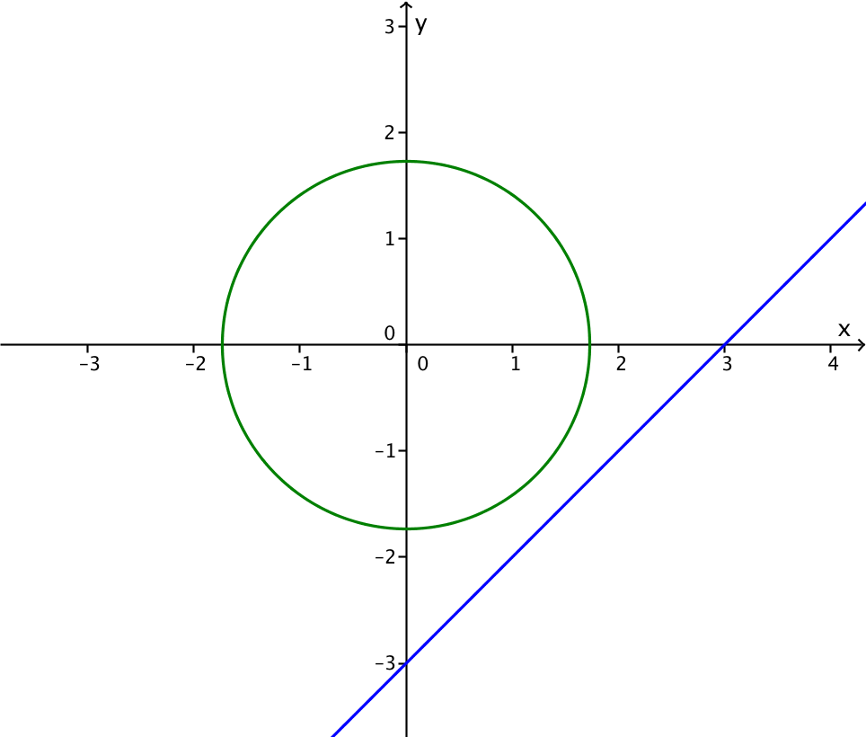
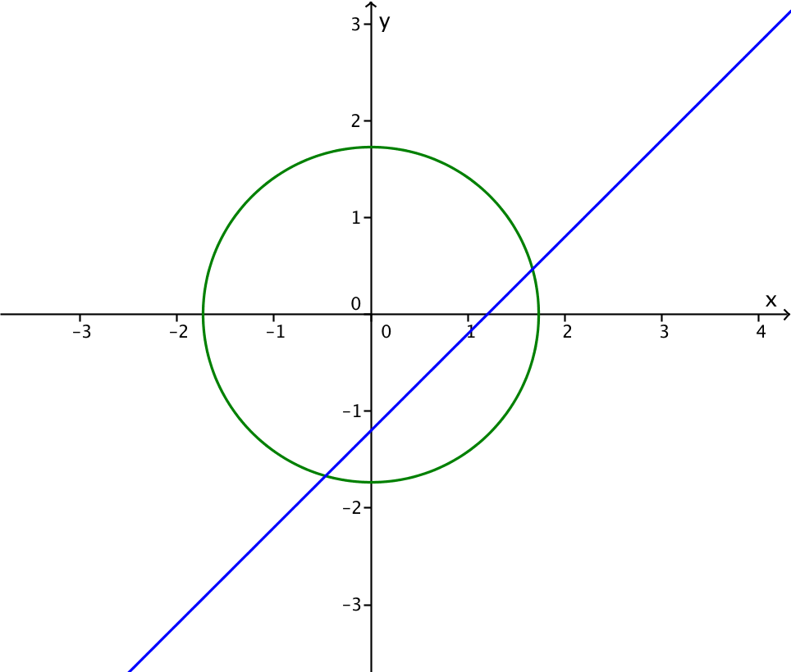

Next, the students should continue to work in pairs to sketch graphs and develop conjectures about the following item (A-REI.C.6):
Scaffolding:
- Again circulate to assist pairs of students who might be having trouble coming up with all three possibilities.
- Graph the parabola with equation $y=x^{2}$. What possibilities are there for a line to intersect the parabola? Sketch each possibility.

Once the students have made their sketches, ask one pair to use the display tool and draw the graphs for the rest of the class to see.

The parabola and line can intersect in $0$, $1$, or $2$ points as shown below. Note that, in contrast to the circle, where all the lines intersecting the circle in one point are tangent to it, lines intersecting the parabola in one point are either tangent to it or are parallel to the parabola’s axis of symmetry—in this case, the $y$-axis.
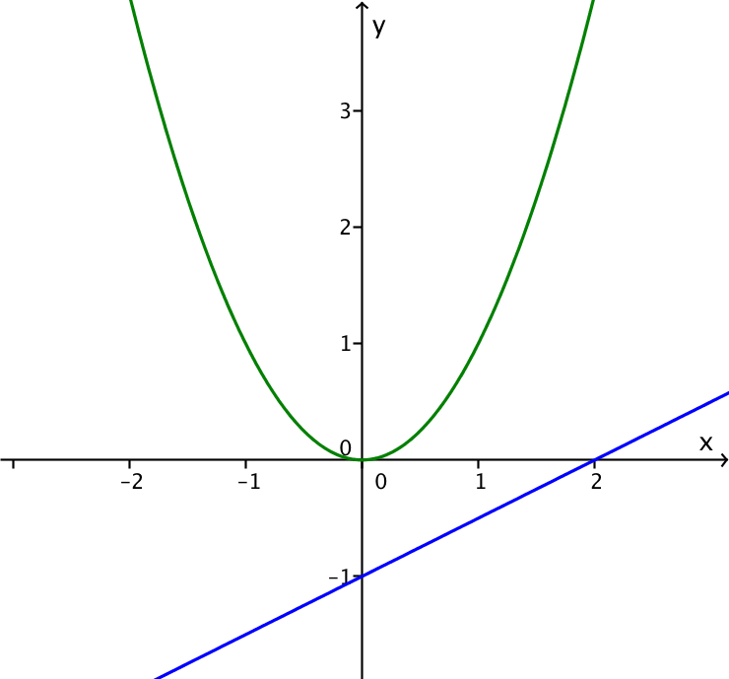
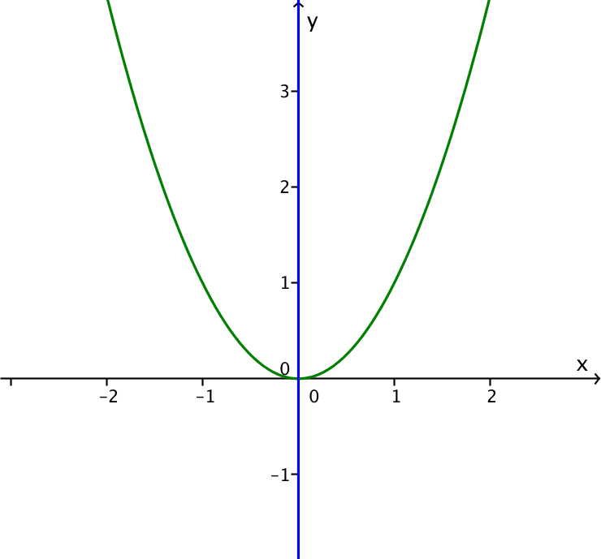
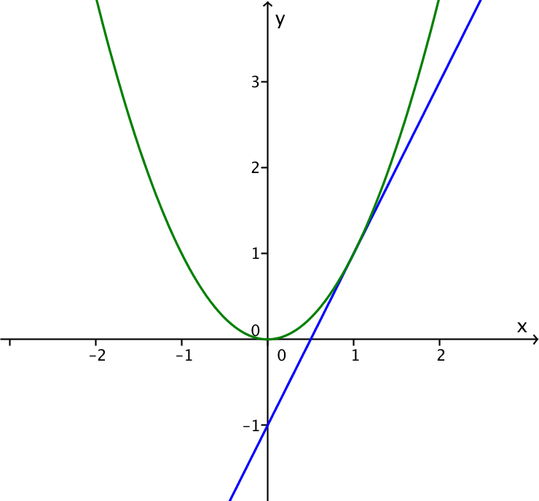
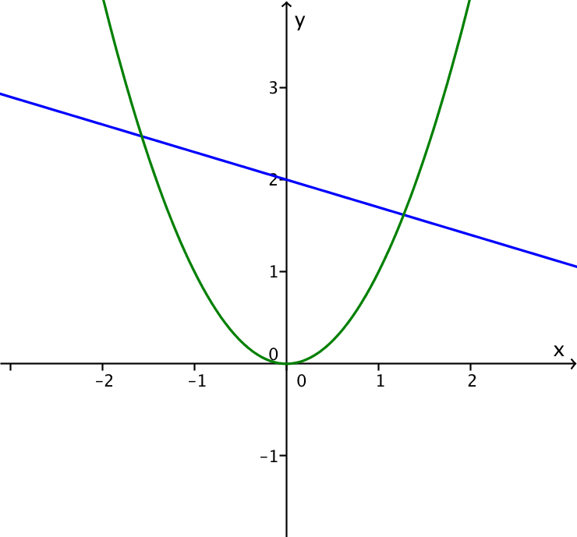

Next, ask the students to work on the following problem individually (A-REI.C.7):

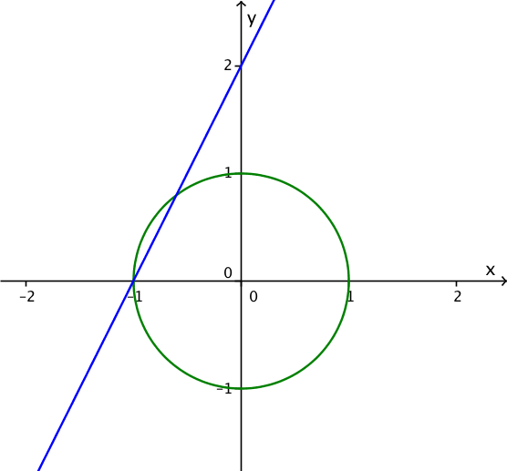
- Sketch the circle given by $x^{2}+y^{2}=1$ and the line given by $y=2x+2$ on the same set of axes. One solution to the pair of equations has a value of $y$ that is easily identifiable from the sketch. What is it?

The point$(-1, 0)$ should be easily identifiable from the sketch, but the
other point is not.

Once the students have made a sketch, ask one of them to use the display tool and draw the two graphs for the rest of the class to see. While the student is doing that, ask the other students how many points are shared (two) and what the coordinates of those points are.
The students should see that they can substitute the value for $y$ in the second equation into the first equation. In other words, they need to solve the following quadratic equation (A-REI.B.4).

- Solve $x^{2}+{(2x+2)}^{2}=1$
Factoring or using the quadratic formula, the students should find that the solutions to the quadratic equation are $-1$ and $-\frac{3}{5}$.
If $x=-1$, then $y=0$, as the sketch shows, so $\left(-1,0\right)$ is a solution. If $x=-\frac{3}{5}$, then $y=2\left(-\frac{3}{5}\right)+2=\frac{4}{5}$ , so $\left(-\frac{3}{5},\frac{4}{5}\right)$ is another solution.

Note that the problem above does not explicitly tell students to look for intersection points. Thus, the exercise assesses not only whether they can solve the system but also whether they understand that the intersection points of the graphs correspond to solutions of the system.
Students should understand that to solve the system of equations, we look for points that lie on the line and the circle. The points that lie on the circle are precisely those that satisfy $x^{2}+y^{2}=1$, and the points that lie on the line are those that satisfy $y=2x+2$. So points on both are the intersection.

Exercise 1 (8 minutes)
Pose the following three-part problem for students to work on individually and then discuss as a class.
Exercise 1
- Draw a graph of the circle with equation $x^{2}+y^{2}=9$.
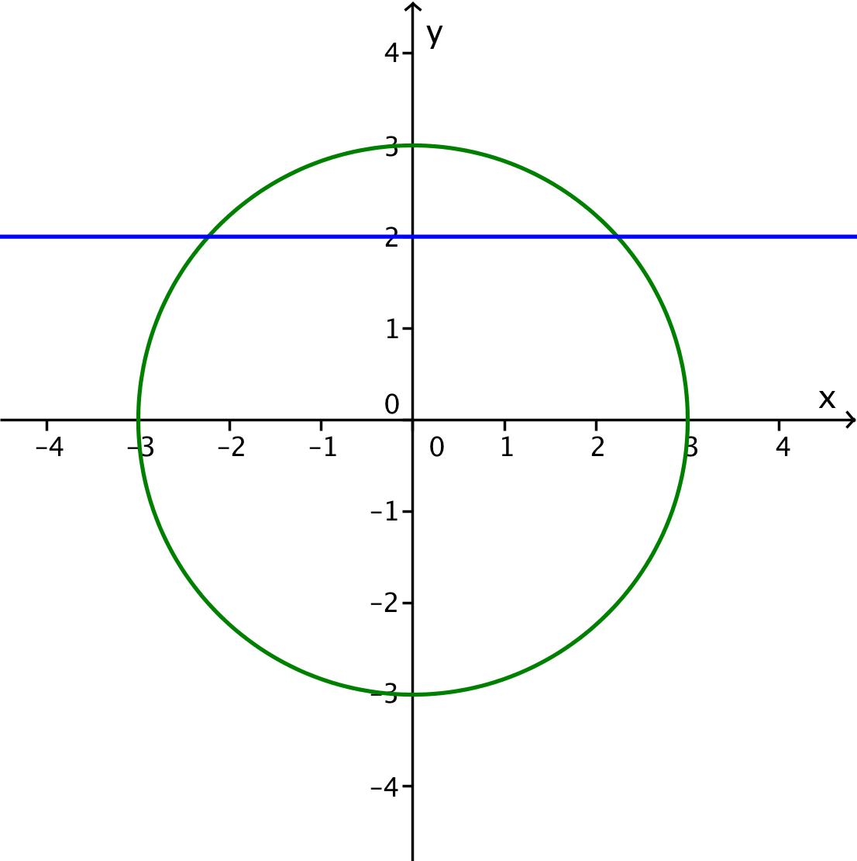
- What are the solutions to the system of circle and line when the circle is given by $x^{2}+y^{2}=9$ and the line is given by$y=2$?
Substituting $y=2$ in the equation of the circle yields $x^{2}+4=9$, so $x^{2}=5$, and
$x=\sqrt{5}$ or $x=-\sqrt{5}$. The solutions are $(-\sqrt{5}, 2)$ and $(\sqrt{5}, 2)$.

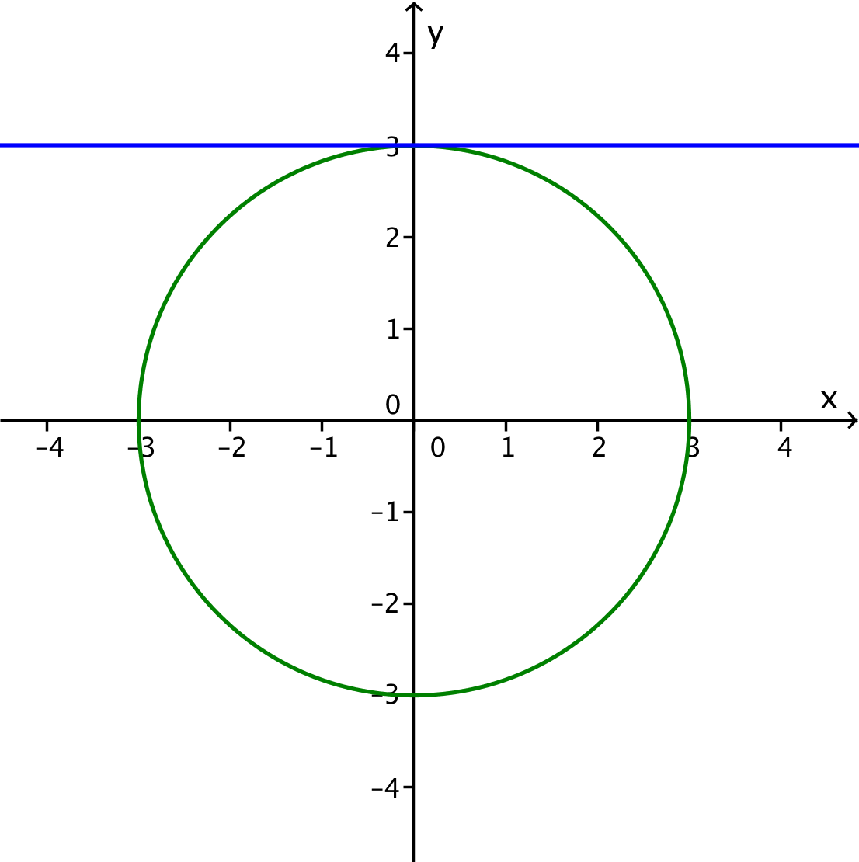
- What happens when the line is given by $y=3$?
Substituting $y=3$ in the equation of the circle yields $x^{2}+9=9$, so $x^{2}=0$. The line is tangent to the circle, and the solution is $(0, 3)$.

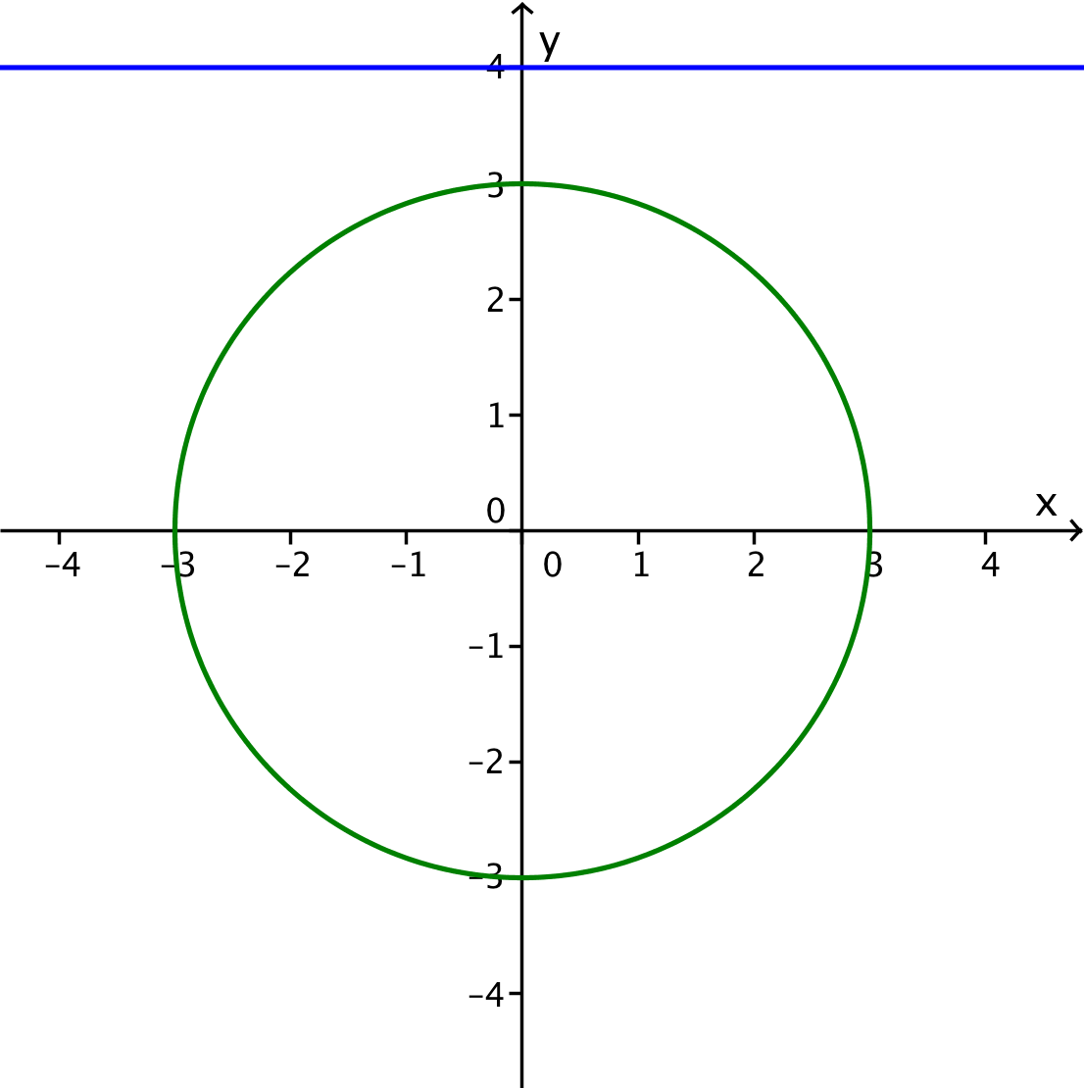
- What happens when the line is given by $y=4$?
Substituting $y=4$ in the equation of the circle yields $x^{2}+16=9$, so $x^{2}=-7$. Since there are no real numbers that satisfy $x^{2}=-7$, there is no solution to this equation. This indicates that the line and circle do not intersect.

Exercises 2–6 (8 minutes)
Scaffolding (for advanced learners):
- Create two different systems of one linear equation and one quadratic equation that have one solution at$(0, 2)$.
Students will need graph paper for this portion of the lesson. Complete Exercise 2 in groups so that students can check answers with each other. Then they can do Exercises 3 to 6 individually or in groups as they choose. Assist with the exercises if students have trouble understanding what it means to “verify your results both algebraically and graphically.”
Exercises 2–6
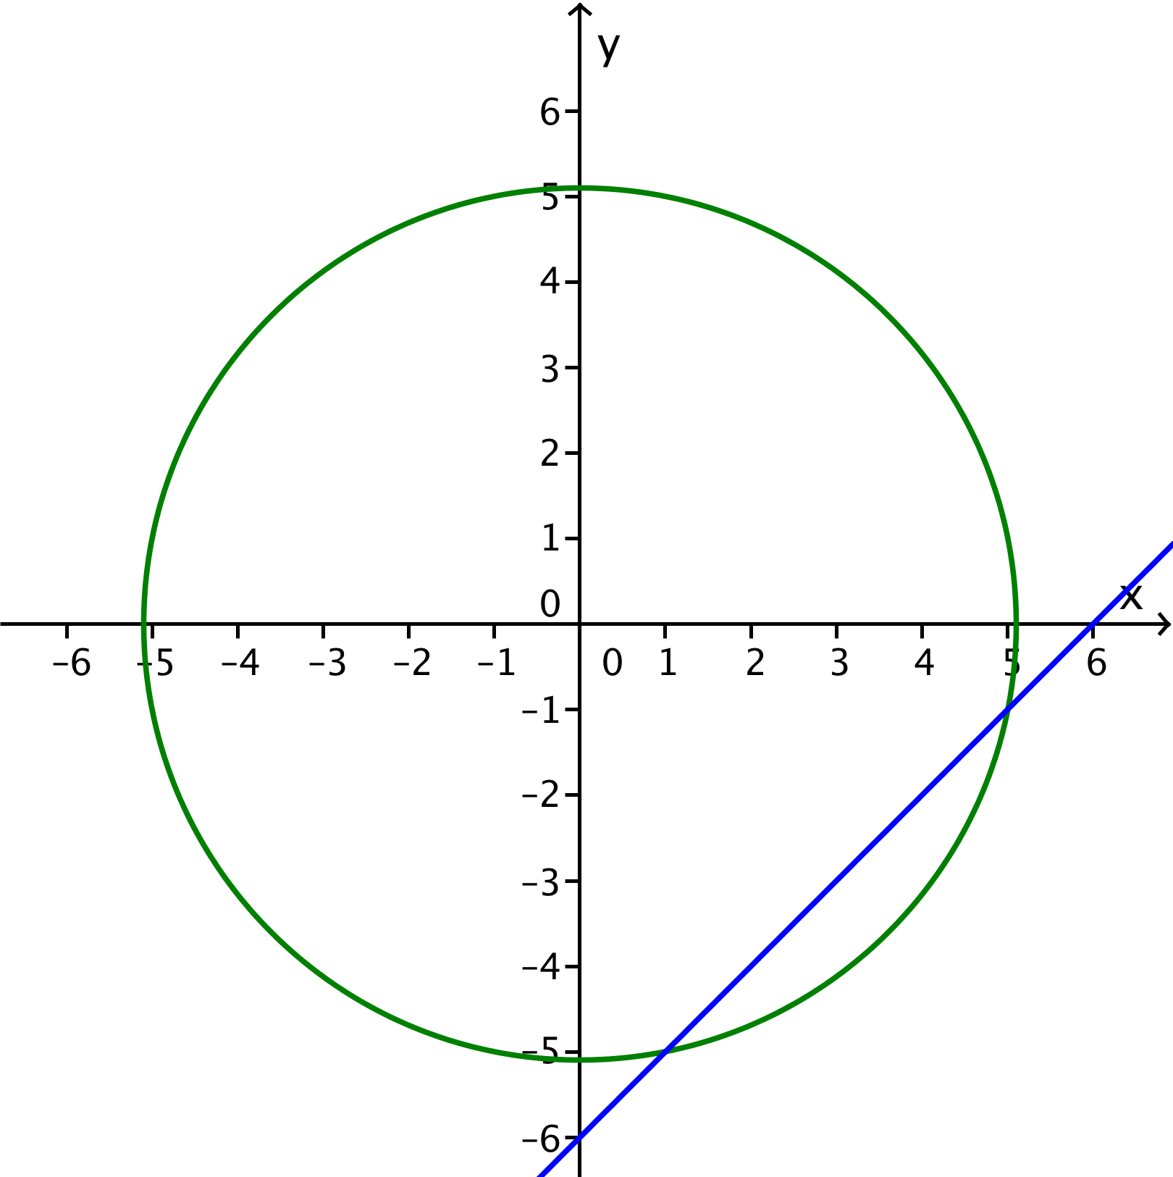
- By solving the equations as a system, find the points common to the line with equation
$x-y=6$ and the circle with equation $x^{2}+y^{2}=26$. Graph the line and the circle to show those points.

$(5, -1)$ and $(1, -5)$. See picture to the right.

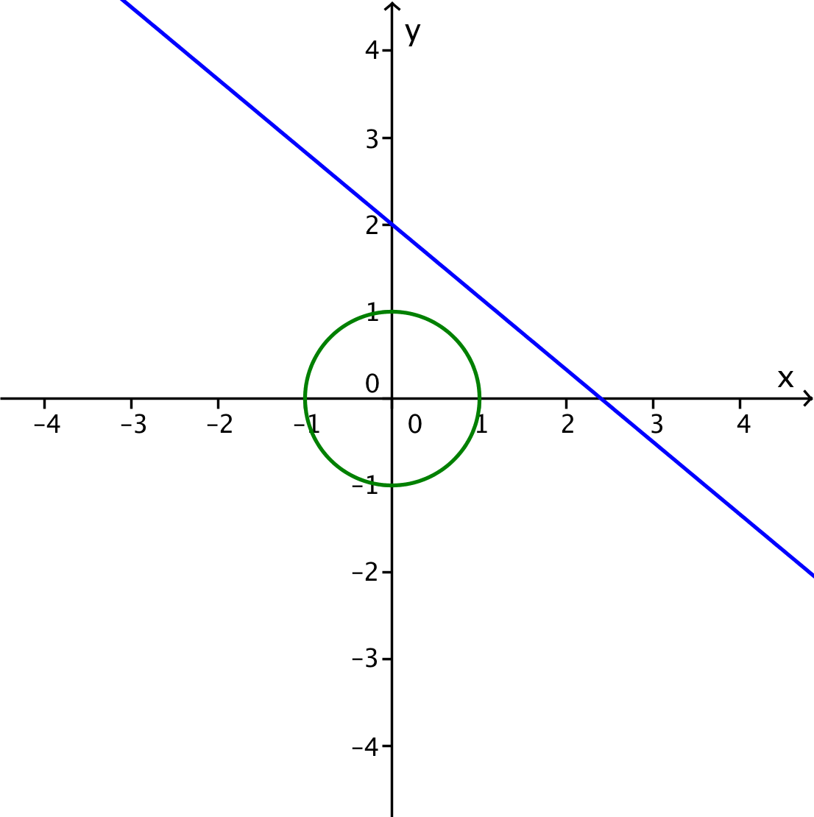
- Graph the line given by $5x+6y=12$ and the circle given by $x^{2}+y^{2}=1$. Find all solutions to the system of equations.

There is no real solution; the line and circle do not intersect. See picture to the right.

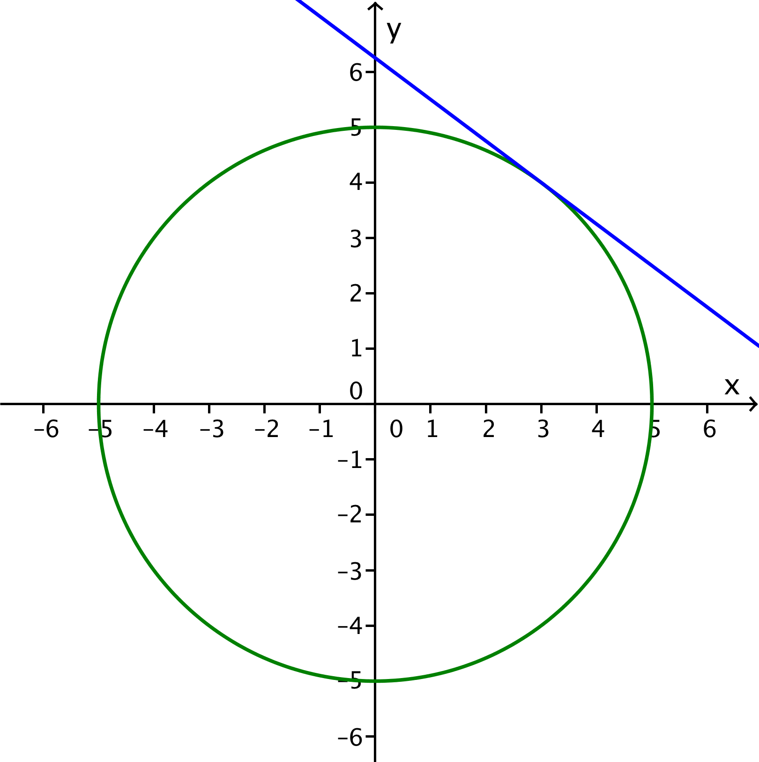
- Graph the line given by $3x+4y=25$ and the circle given by $x^{2}+y^{2}=25$. Find all solutions to the system of equations. Verify your result both algebraically and graphically.

The line is tangent to the circle at $(3, 4)$, which is the only solution. See picture to the right.

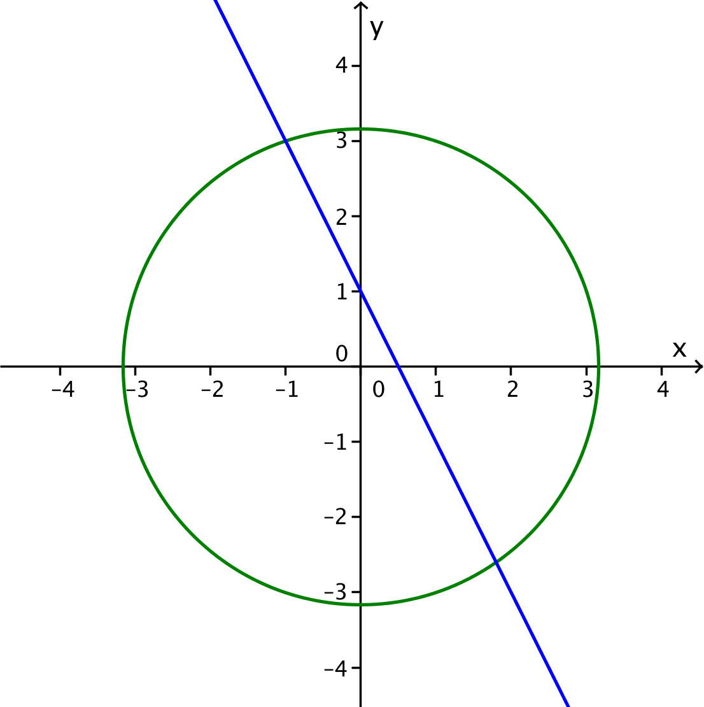
- Graph the line given by $2x+y=1$and the circle given by $x^{2}+y^{2}=10$. Find all solutions to the system of equations. Verify your result both algebraically and graphically.

The line and circle intersect at $(-1, 3)$ and $\left(\frac{9}{5}, -\frac{13}{5}\right)$, which are the two solutions. See picture to the right.

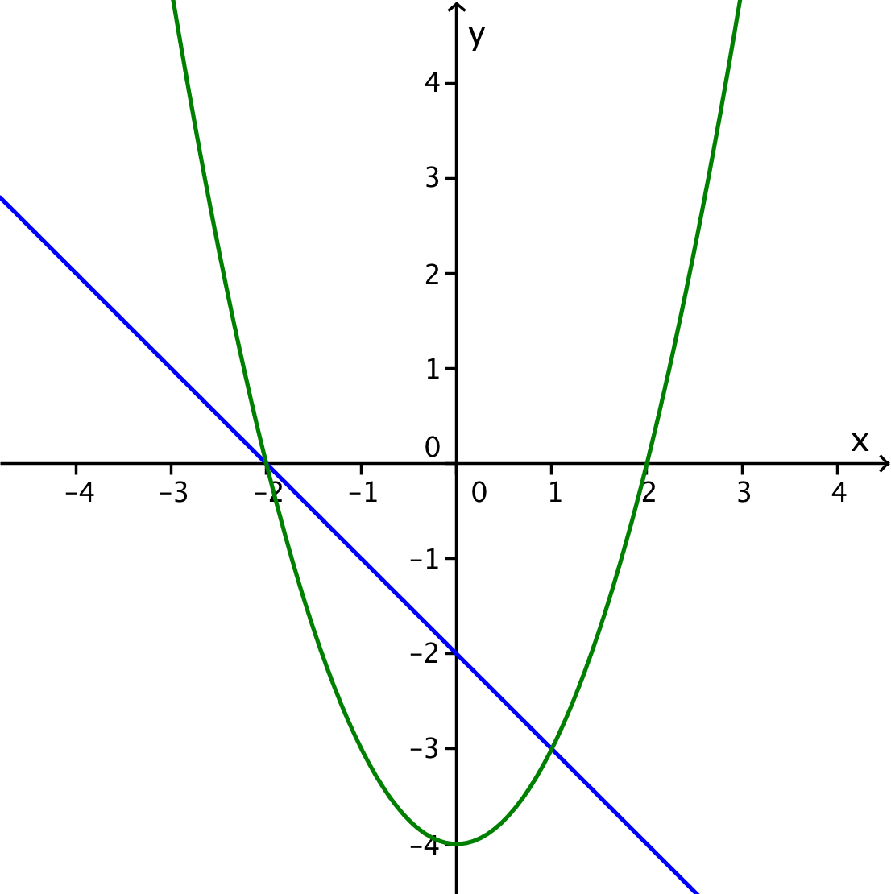
- Graph the line given by $x+y=-2$ and the quadratic curve given by $y=x^{2}-4$. Find all solutions to the system of equations. Verify your result both algebraically and graphically.

The line and the parabola intersect at$(1, -3)$ and $(-2, 0)$, which are the two solutions. See picture to the right.

Closing (4 minutes)
Ask students to respond to these questions with a partner or in writing. Share their responses as a class.
- How does graphing a line and a quadratic curve help you solve a system consisting of a linear and a quadratic equation?
Scaffolding:
- Perhaps create a chart with the summary that can serve as a reminder to the students.
MP.1
- What are the possibilities for the intersection of a line and a quadratic curve, and how are they related to the number of solutions of a system of linear and quadratic equations?
Present and discuss the Lesson Summary.
Lesson Summary
Here are some steps to consider when solving systems of equations that represent a line and a quadratic curve.
- Solve the linear equation for $y$ in terms of $x$. This is equivalent to rewriting the equation in slope-intercept form. Note that working with the quadratic equation first would likely be more difficult and might cause the loss of a solution.
- Replace $y$ in the quadratic equation with the expression involving $x$ from the slope-intercept form of the linear equation. That will yield an equation in one variable.
- Solve the quadratic equation for $x$.
- Substitute $x$ into the linear equation to find the corresponding value of $y$.
- Sketch a graph of the system to check your solution.

Be sure to note that in the case of the circle, the reverse process of solving the equation for the circle first—for either $x$ or $y$—and then substituting in the linear equation would have yielded an equation with a complicated radical expression and might have led students to miss part of the solution by considering only the positive square root.

Exit Ticket (5 minutes)
Name ___________________________________________________ Date____________________
Lesson 31: Systems of Equations

Exit Ticket

Make and explain a prediction about the nature of the solution to the following system of equations and then solve it.
$$x^{2}+y^{2}=25 \\ 4x+3y=0$$
Illustrate with a graph. Verify your solution and compare it with your initial prediction.

Exit Ticket Sample Solutions

Make and explain a prediction about the nature of the solution to the following system of equations and then solve it.
$$x^{2}+y^{2}=25 \\ 4x+3y=0$$
Illustrate with a graph. Verify your solution and compare it with your initial prediction.
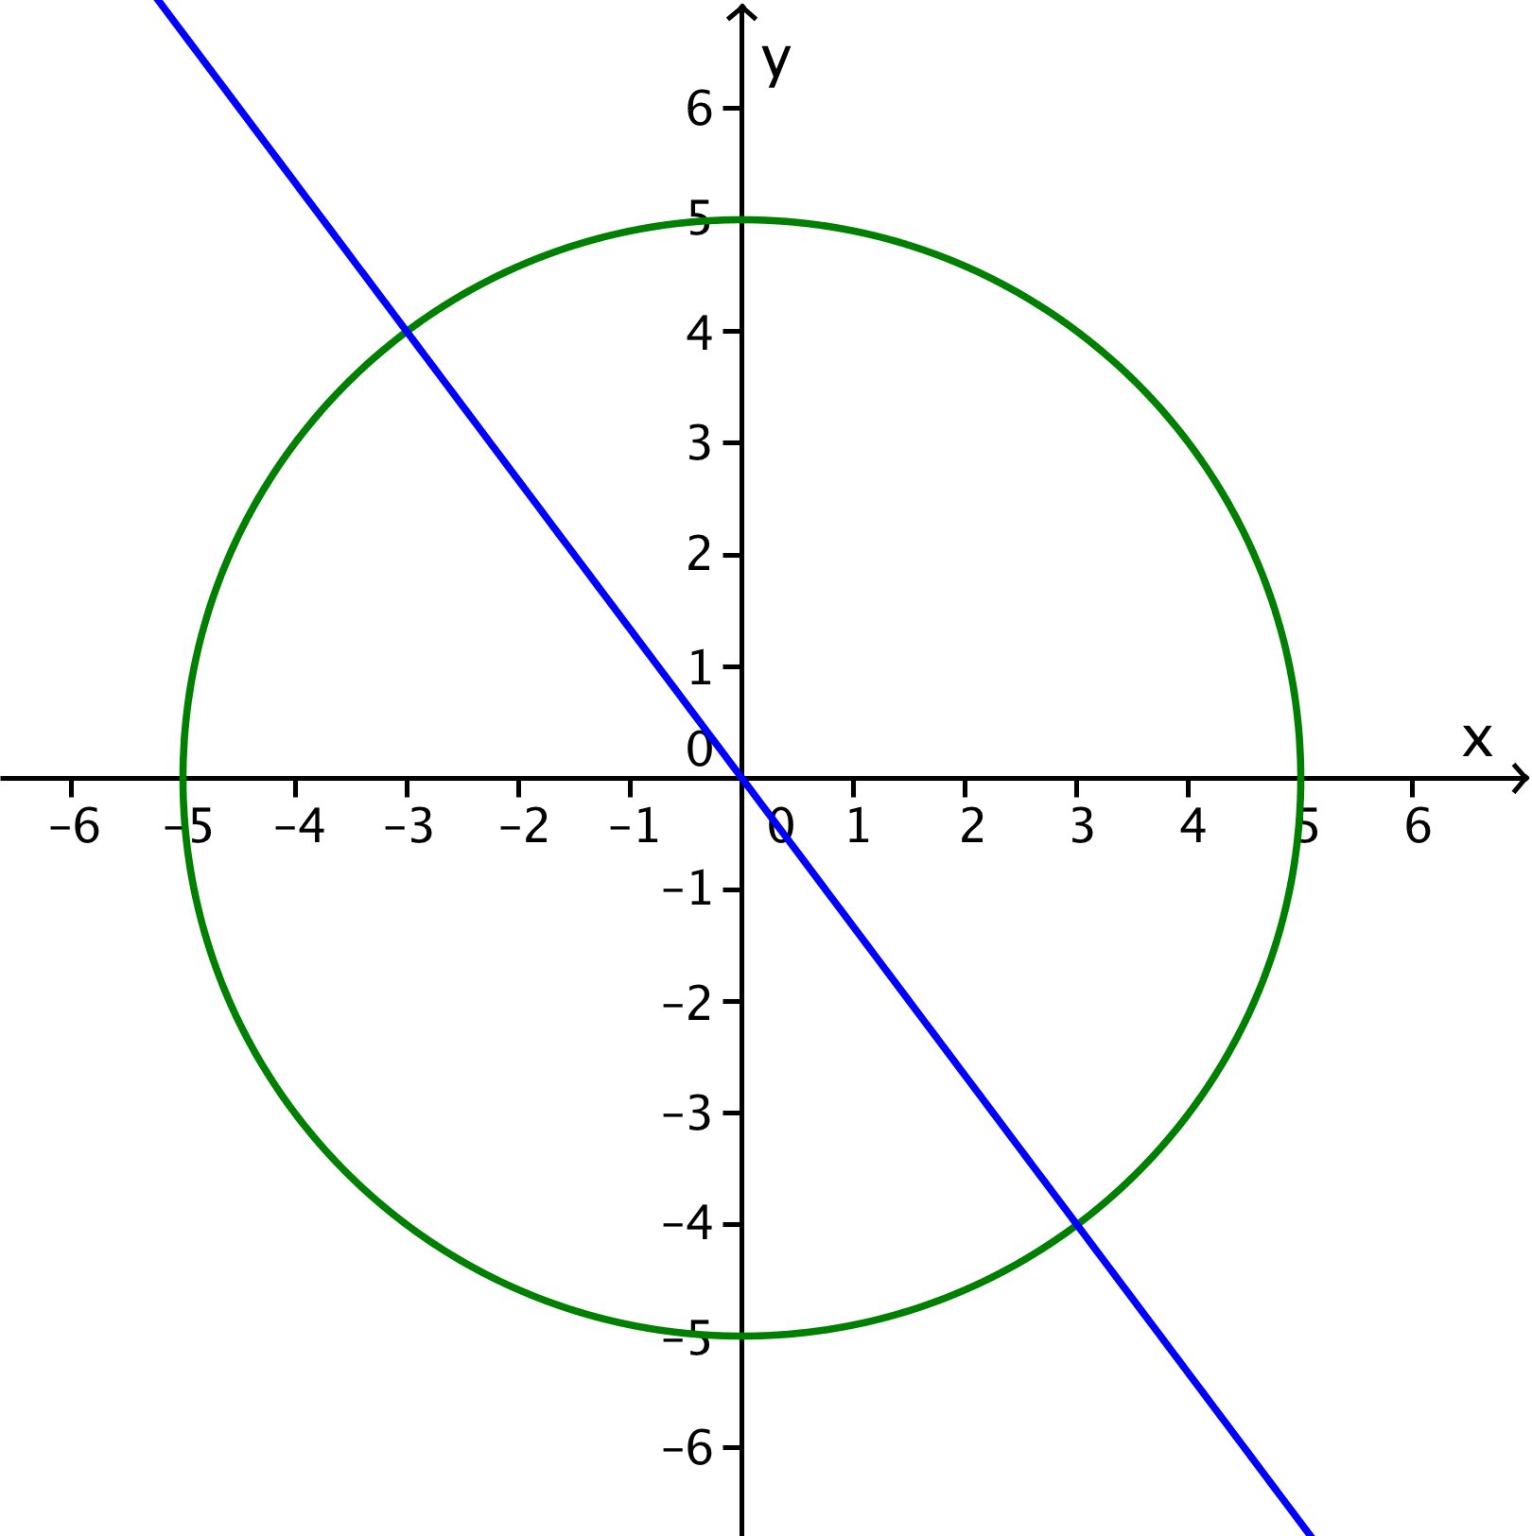
Prediction: By inspection of the equations, students should conclude that the circle is centered at the origin and that the line goes through the origin. So, the solution should consist of two points.
Solution: Solve the linear equation for one of the variables: $y=-\frac{4x}{3}$.
Substitute that variable in the quadratic equation: ${x^{2}+\left(-\frac{4x}{3}\right)}^{2}=25$.
Remove parentheses and combine like terms: $25x^{2}-25∙9=0$,
so $x^{2}-9 =0$.
Solve the quadratic equation in $x$: $\left(x+3\right)\left(x-3\right)=0$, which gives the roots $3$ and $-3$.
Substitute into the linear equation: If $x=3$, then $y=-4$; if$x=-3$, then$y=4$.
As the graph shows, the solution is the two points of intersection of the circle and the line: $\left(3,-4\right)$ and $\left(-3, 4\right)$.
An alternative solution would be to solve the linear equation for $x$ instead of $y$, getting the quadratic equation $\left(y+4\right)\left(y-4\right)=0$, which gives the roots $4$and $-4$ and the same points of intersection.
As noted before, solving the quadratic equation for $x$ or $y$ first is not a good procedure. It can lead to a complicated radical expression and loss of part of the solution.

Problem Set Sample Solutions
Problem 4 yields a system with no real solution, and the graph shows that the circle and line have no point of intersection in the coordinate plane. In Problems 5 and 6, the curve is a parabola. In Problem 5, the line intersects the parabola in two points, whereas in Problem 6, the line is tangent to the parabola, and there is only one point of intersection. Note that there would also have been only one point of intersection if the line had been the line of symmetry of the parabola.

- Where do the lines given by $y=x+b$ and $y=2x+1$ intersect?
Since we do not know the value of $b$, we cannot solve this problem by graphing, and we will have to approach it algebraically. Eliminating $y$ gives the equation
$$x+b=2x+1 \\ x=b-1$$
Since $x=b-1$, we have $y=x+b=\left(b-1\right)+b=2b-1$. Thus, the lines intersect at the point $(b-1, 2b-1)$.

- Find all solutions to the following system of equations.
${\left(x-2\right)}^{2}+{\left(y+3\right)}^{2}=4$
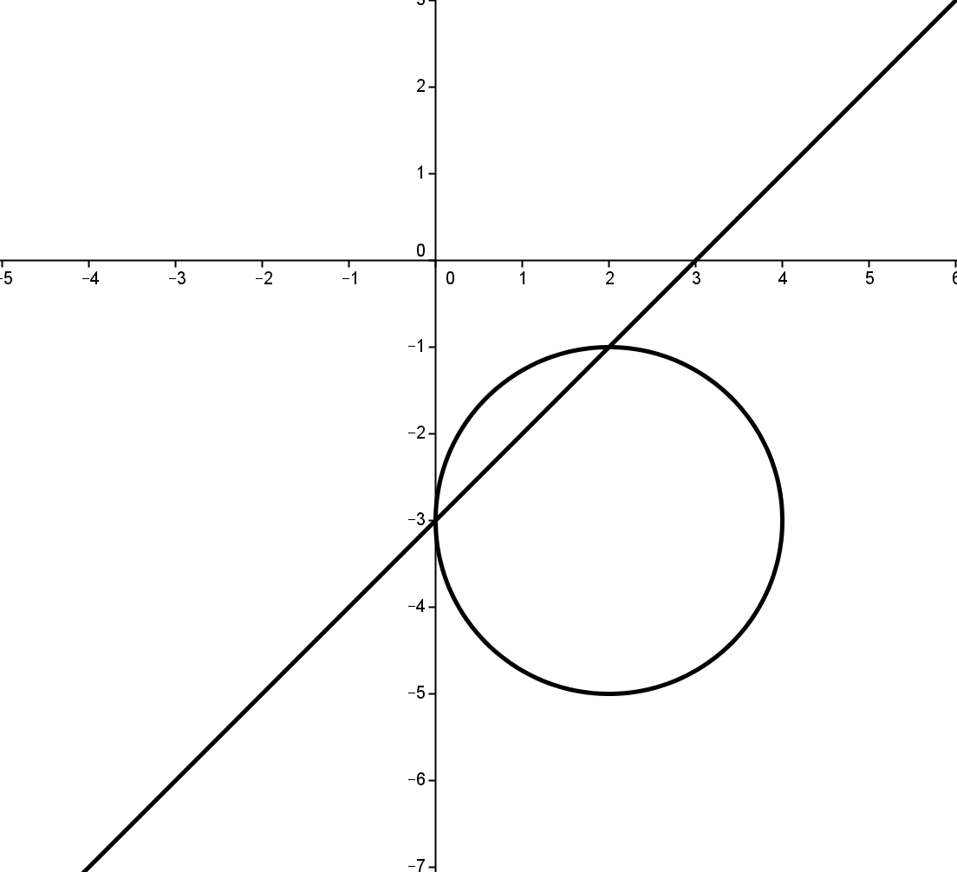
$x-y=3$
Illustrate with a graph.
Solve the linear equation for one of the variables: $x=y+3$.
Substitute that variable in the quadratic equation:
${\left(y+3-2\right)}^{2}+{\left(y+3\right)}^{2}=4$.
Rewrite the equation in standard form: $2y^{2}+8y+6=0$.
Solve the quadratic equation: $2\left(y+3\right)\left(y+1\right)=0$, so $y=-3$or $y=-1$.
If $y=-3$, then $x=0$. If $y=-1$, then $x=2$.
As the graph shows, the solution is the two points $\left(0, -3\right)$and $\left(2, -1\right)$.

- Find all solutions to the following system of equations.
$x+2y=0$
$x^{2}-2x+y^{2}-2y-3=0$
Illustrate with a graph.
Solve the linear equation for one of the variables: $x=-2y$.
Substitute that variable in the quadratic equation: ${\left(-2y\right)}^{2}-2\left(-2y\right)+y^{2}-2y-3=0$.
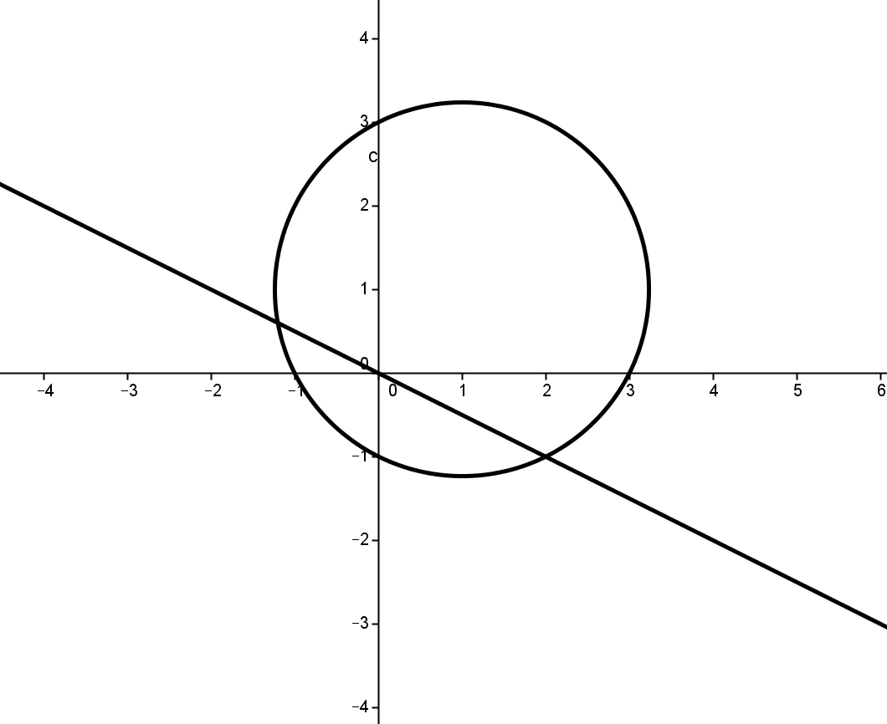
Rewrite the equation in standard form: $5y^{2}+2y-3=0$.
Solve the quadratic equation: $\left(5y-3\right)\left(y+1\right)=0$, so $y=\frac{3}{5}$or $y=-1$.
If $y=\frac{3}{5}$, then $x=-\frac{6}{5}$. If $y=-1$, then $x=2$.
As the graph shows, the solutions are the two points: $\left(-\frac{6}{5}, \frac{3}{5}\right)$ and $(2, -1)$.

- Find all solutions to the following system of equations.
$x+y=4$
${\left(x+3\right)}^{2}+{\left(y-2\right)}^{2}=10$
Illustrate with a graph.
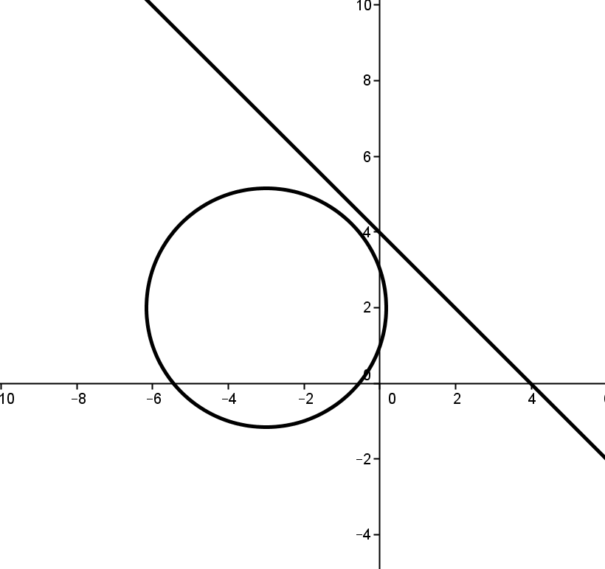
Solve the linear equation for one of the variables: $x=4-y$
Substitute that variable in the quadratic equation: ${\left(4-y+3\right)}^{2}+{\left(y-2\right)}^{2}=10$
Rewrite the equation in standard form: $2y^{2}-18y+43=0$
Solve the equation using the quadratic formula:
$$y=\frac{18+\sqrt{324-344}}{4} \text{or} y=\frac{18-\sqrt{324-344}}{4}$$
So we have$y=\frac{1}{2}\left(9+\sqrt{-5}\right)$ or $y=\frac{1}{2}\left(9-\sqrt{-5}\right)$
Therefore, there is no real solution to the system.
As the graph shows, the line and circle do not intersect$.$

- Find all solutions to the following system of equations.
$y=-2x+3$
$y=x^{2}-6x+3$
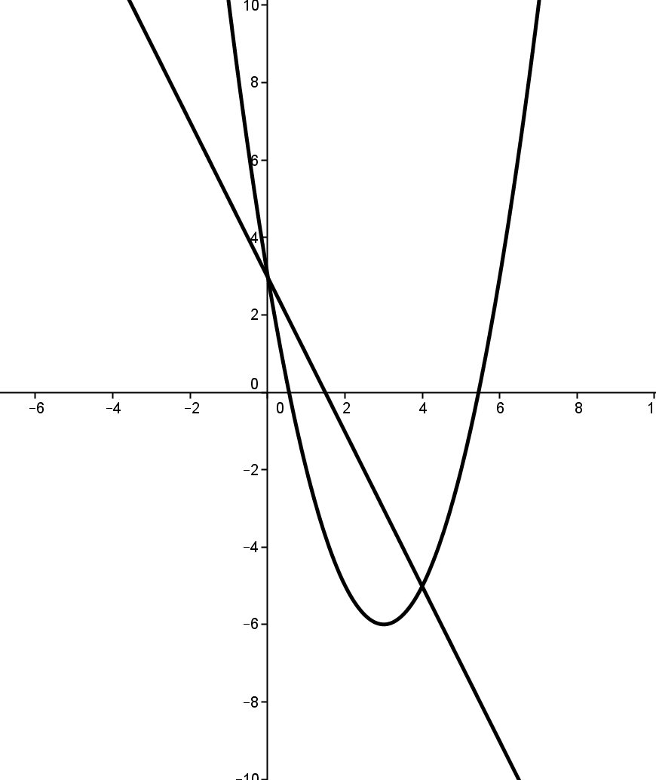
Illustrate with a graph.
The linear equation is already solved for one of the variables: $y=-2x+3$.
Substitute that variable in the quadratic equation: $-2x+3=x^{2}-6x+3$.
Rewrite the equation in standard form: $x^{2}-4x=0$.
Solve the quadratic equation: $x\left(x-4\right)=0$.
So, $x=0$ or $x=4$.
If $x=0$, then $y=3$. If $x=4$, then $y=-5$.
As the graph shows, the solutions are the two points $\left(0, 3\right)$ and$(4, -5)$.

- Find all solutions to the following system of equations.
$$-y^{2}+6y+x-9=0 \\ 6y=x+27$$
Illustrate with a graph.
Solve the second equation for $x$: $x=6y-27$.
Substitute in the first equation: ${-y}^{2}+6y+6y-27-9=0$.
Combine like terms: ${-y}^{2}+12y-36=0$.
Rewrite the equation in standard form and factor: $-{\left(y-6\right)}^{2}=0$.
Therefore, $y=6$. Then $x=6y-27$, so $x=9$.
There is only one solution $(9, 6)$, and as the graph shows, the line is tangent to the parabola.
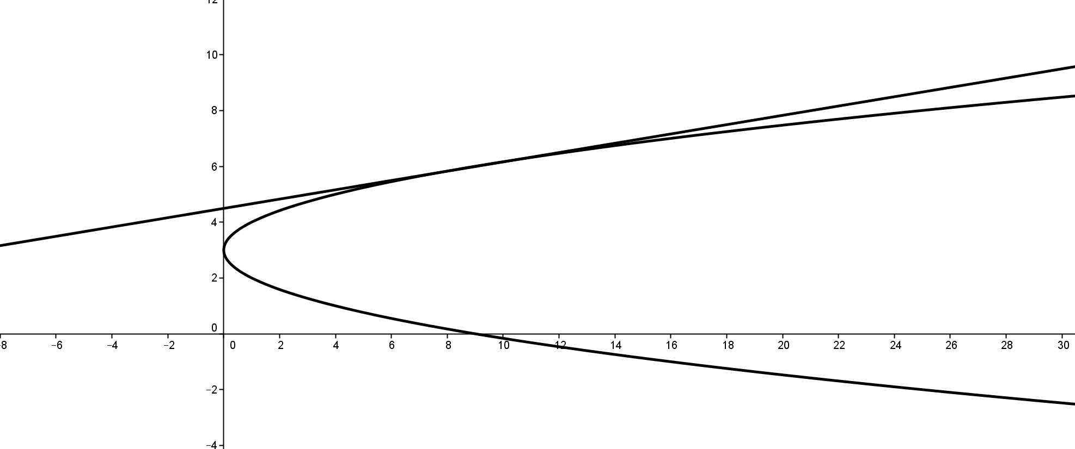

An alternative solution would be to solve the linear equation for $y$ instead of $x$, getting the quadratic equation $\left(x-9\right)\left(x-9\right)=0$, which gives the repeated root $x=9$and the same point of tangency $\left(9,6\right)$.
Another alternative solution would be to solve the quadratic equation for $x$, so that $x=y^{2}-6y+9$. Substituting in the linear equation would yield $6y=y^{2}-6y+9+27$. Converting that to standard form would give
$y^{2}-12y+36=0$, which gives the repeated root $y=6$, as in the first solution. Note that in this case, unlike when the graph of the quadratic equation is a circle, the quadratic equation can be solved for $x$ in terms of $y$ without getting a radical expression.

- If the following system of equations has two solutions, what is the value of $k$?
$x^{2}+y^{2}=25$
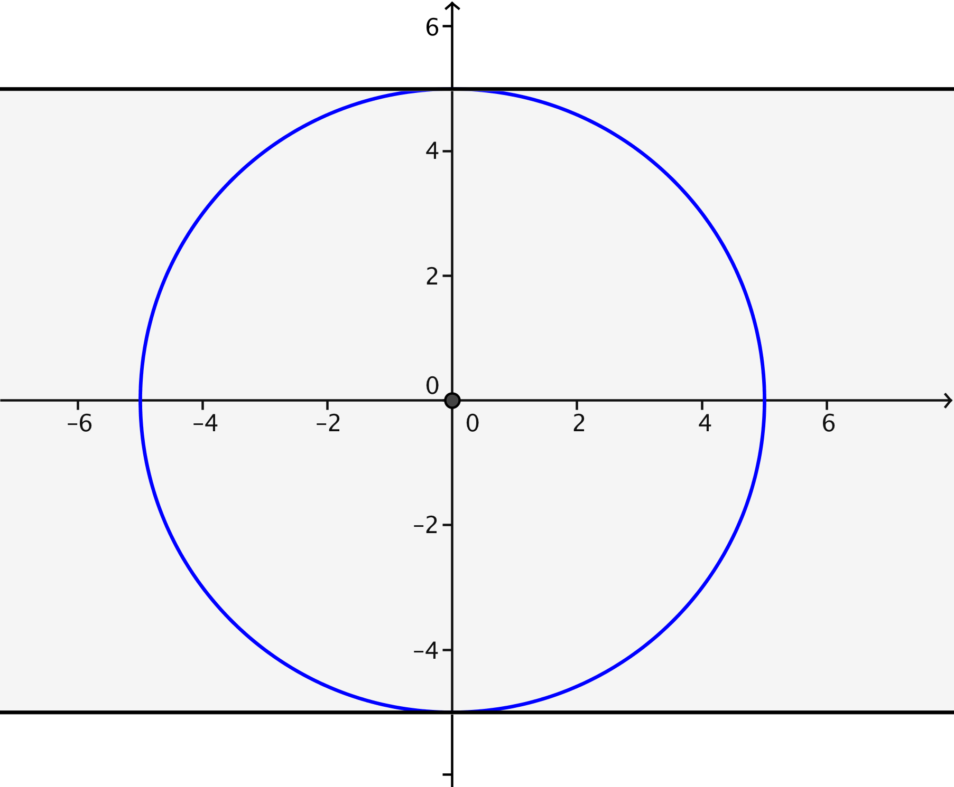
$y=k$
Illustrate with a graph.

The center of the circle is the origin, and the line is parallel to the $x$-axis. Therefore, as the graph shows, there are two solutions only when $-5<k<5$.

- If the following system of equations has exactly one solution, what is the value of $k$?
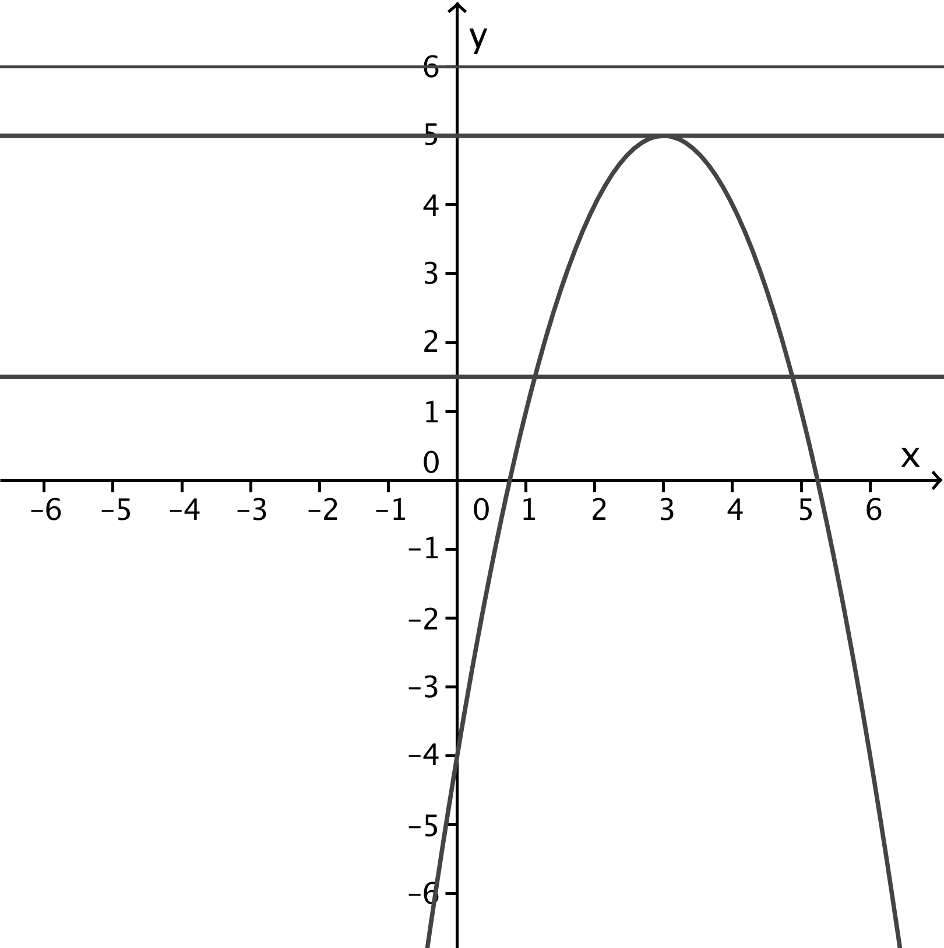
$y=5-{\left(x-3\right)}^{2}$
$y=k$
Illustrate with a graph.
The parabola opens down, and its axis of symmetry is the vertical line $x=3$. The line $y=k$ is a horizontal line and will intersect the parabola in either two, one, or no points. It intersects the parabola in one point only if it passes through the vertex of the parabola, which is $k=5$.

- If the following system of equations has no solutions, what is the value of $k$?
$x^{2}+{\left(y-k\right)}^{2}=36$
$y=5x+k$
Illustrate with a graph.
The circle has radius $6$ and center $(0,k)$. The line has slope $5$ and crosses the $y$-axis at $(0,k)$. Since for any value of $k$ the line passes through the center of the circle, the line intersects the circle twice. (In the figure on the left below $k=2$, and in the one on the right below, $k=-3$.) There is no value of $k$ for which there is no solution.
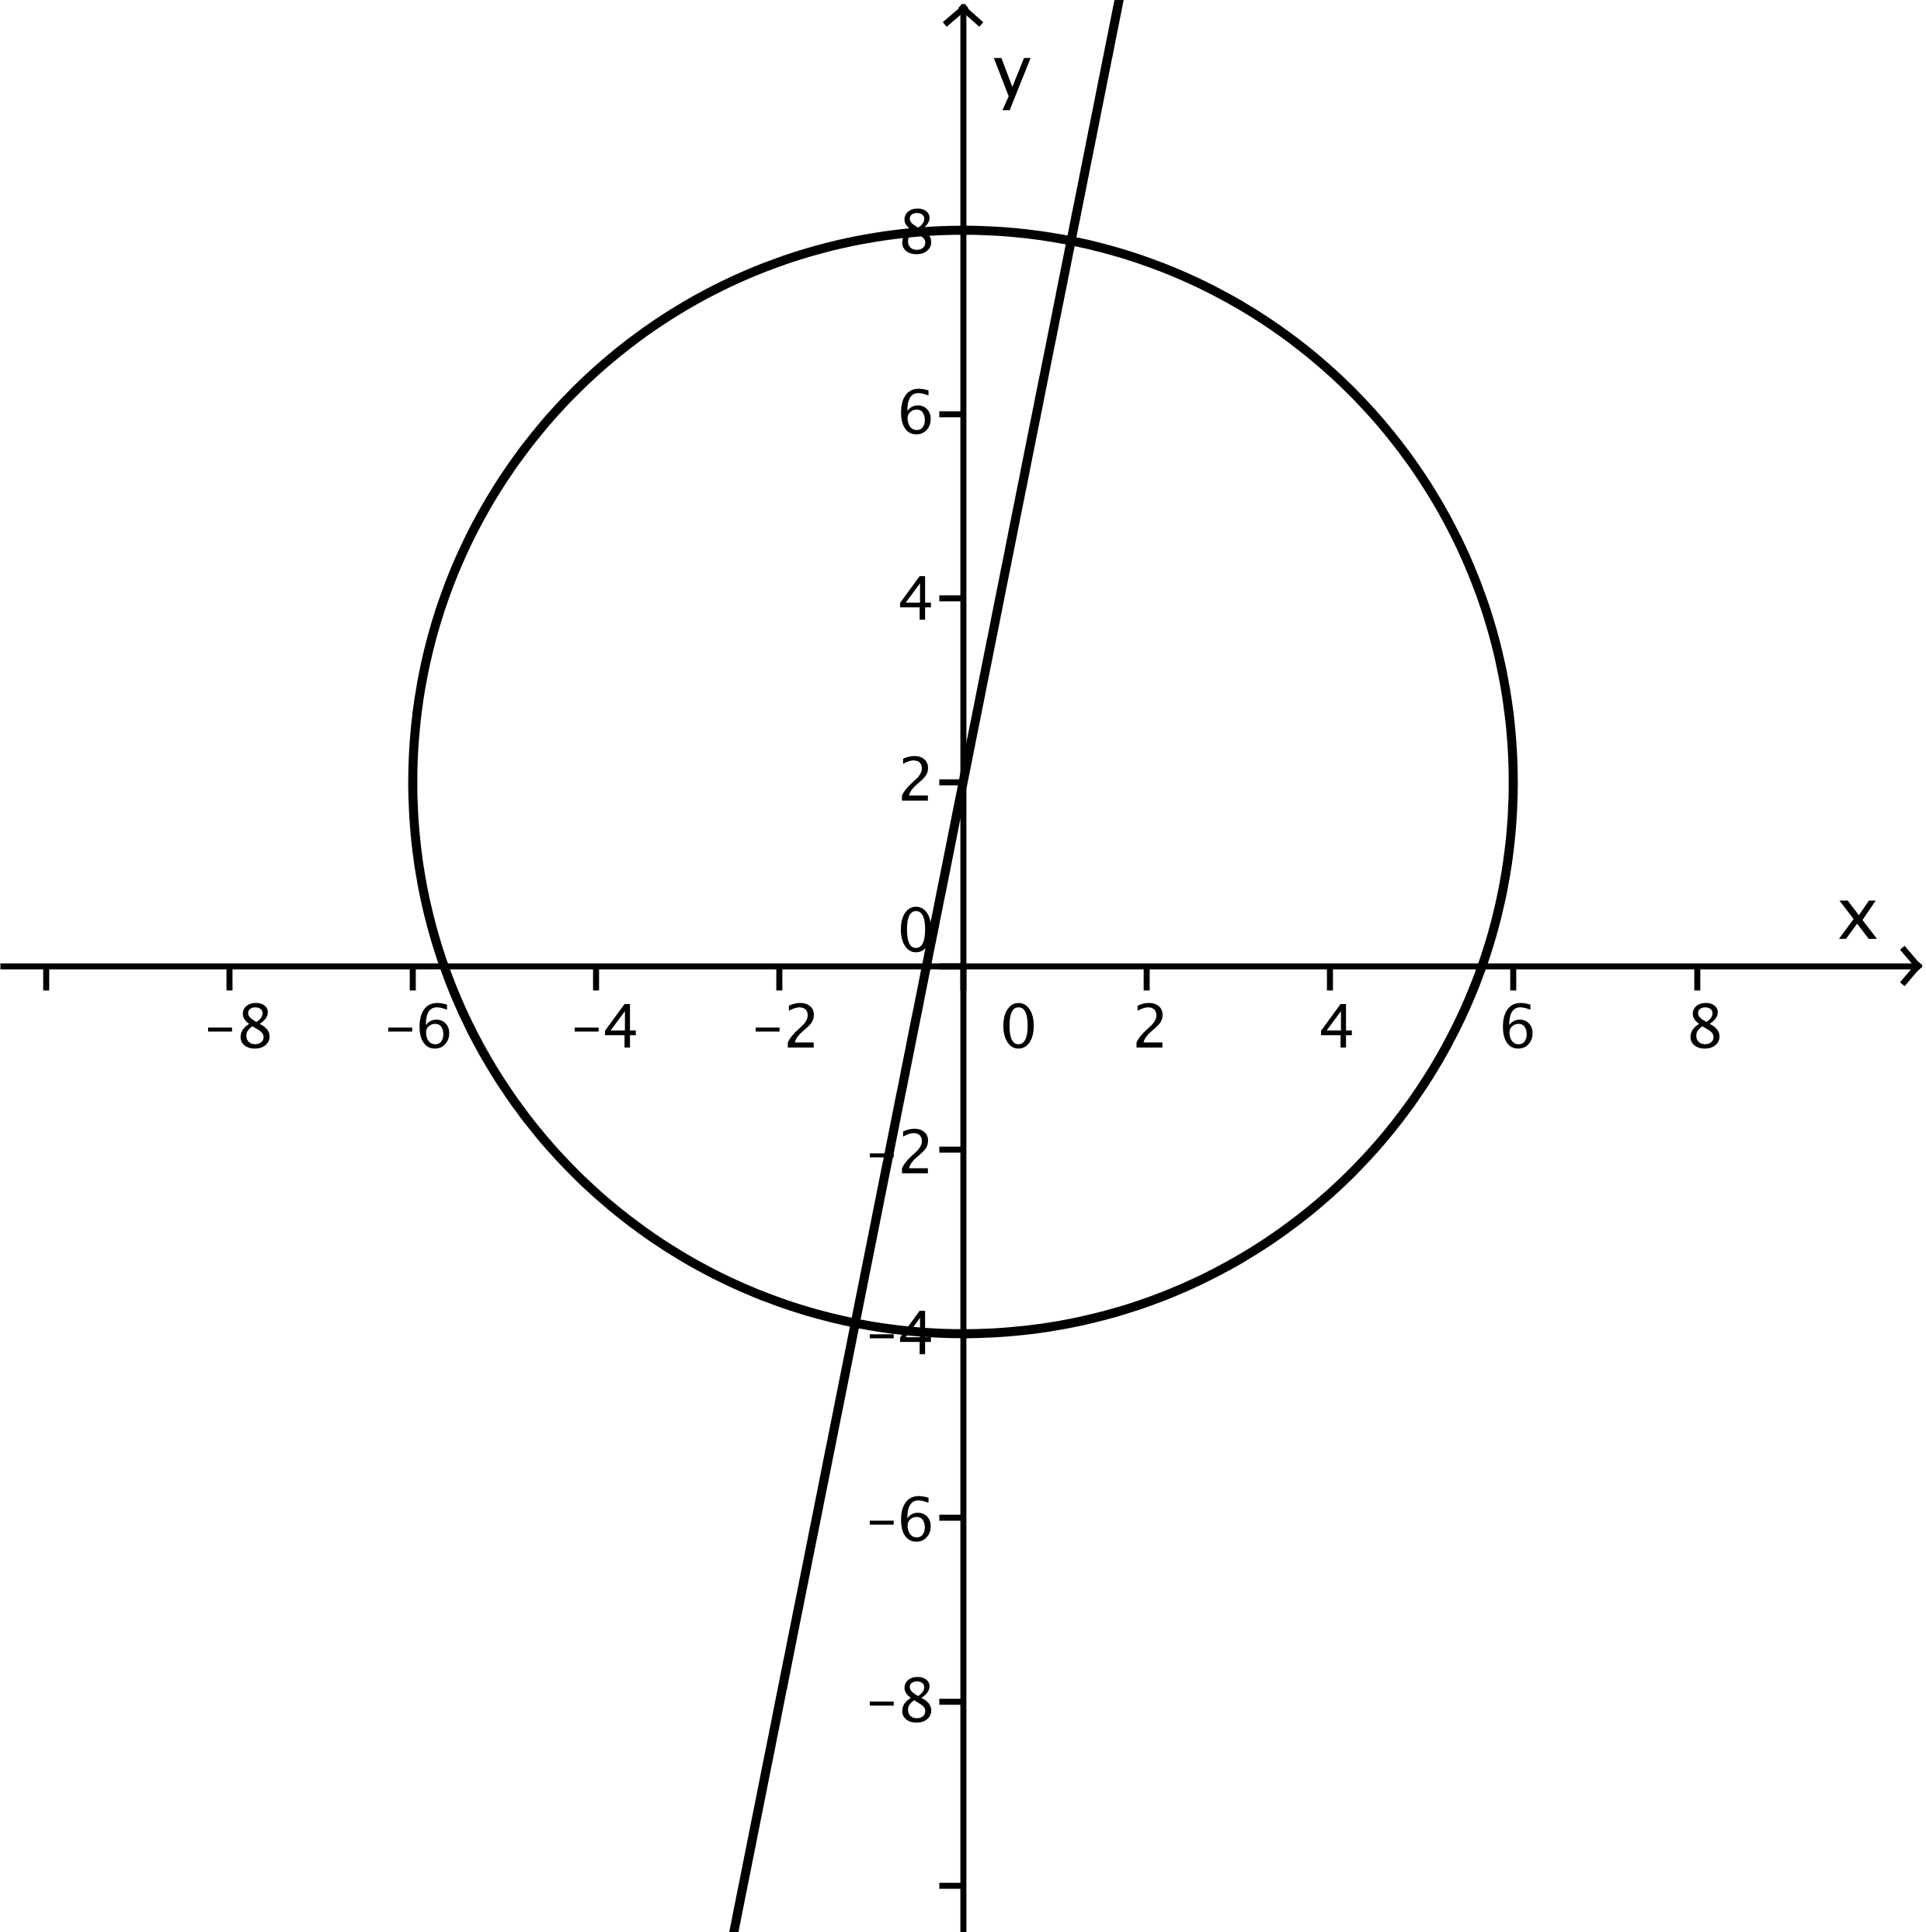
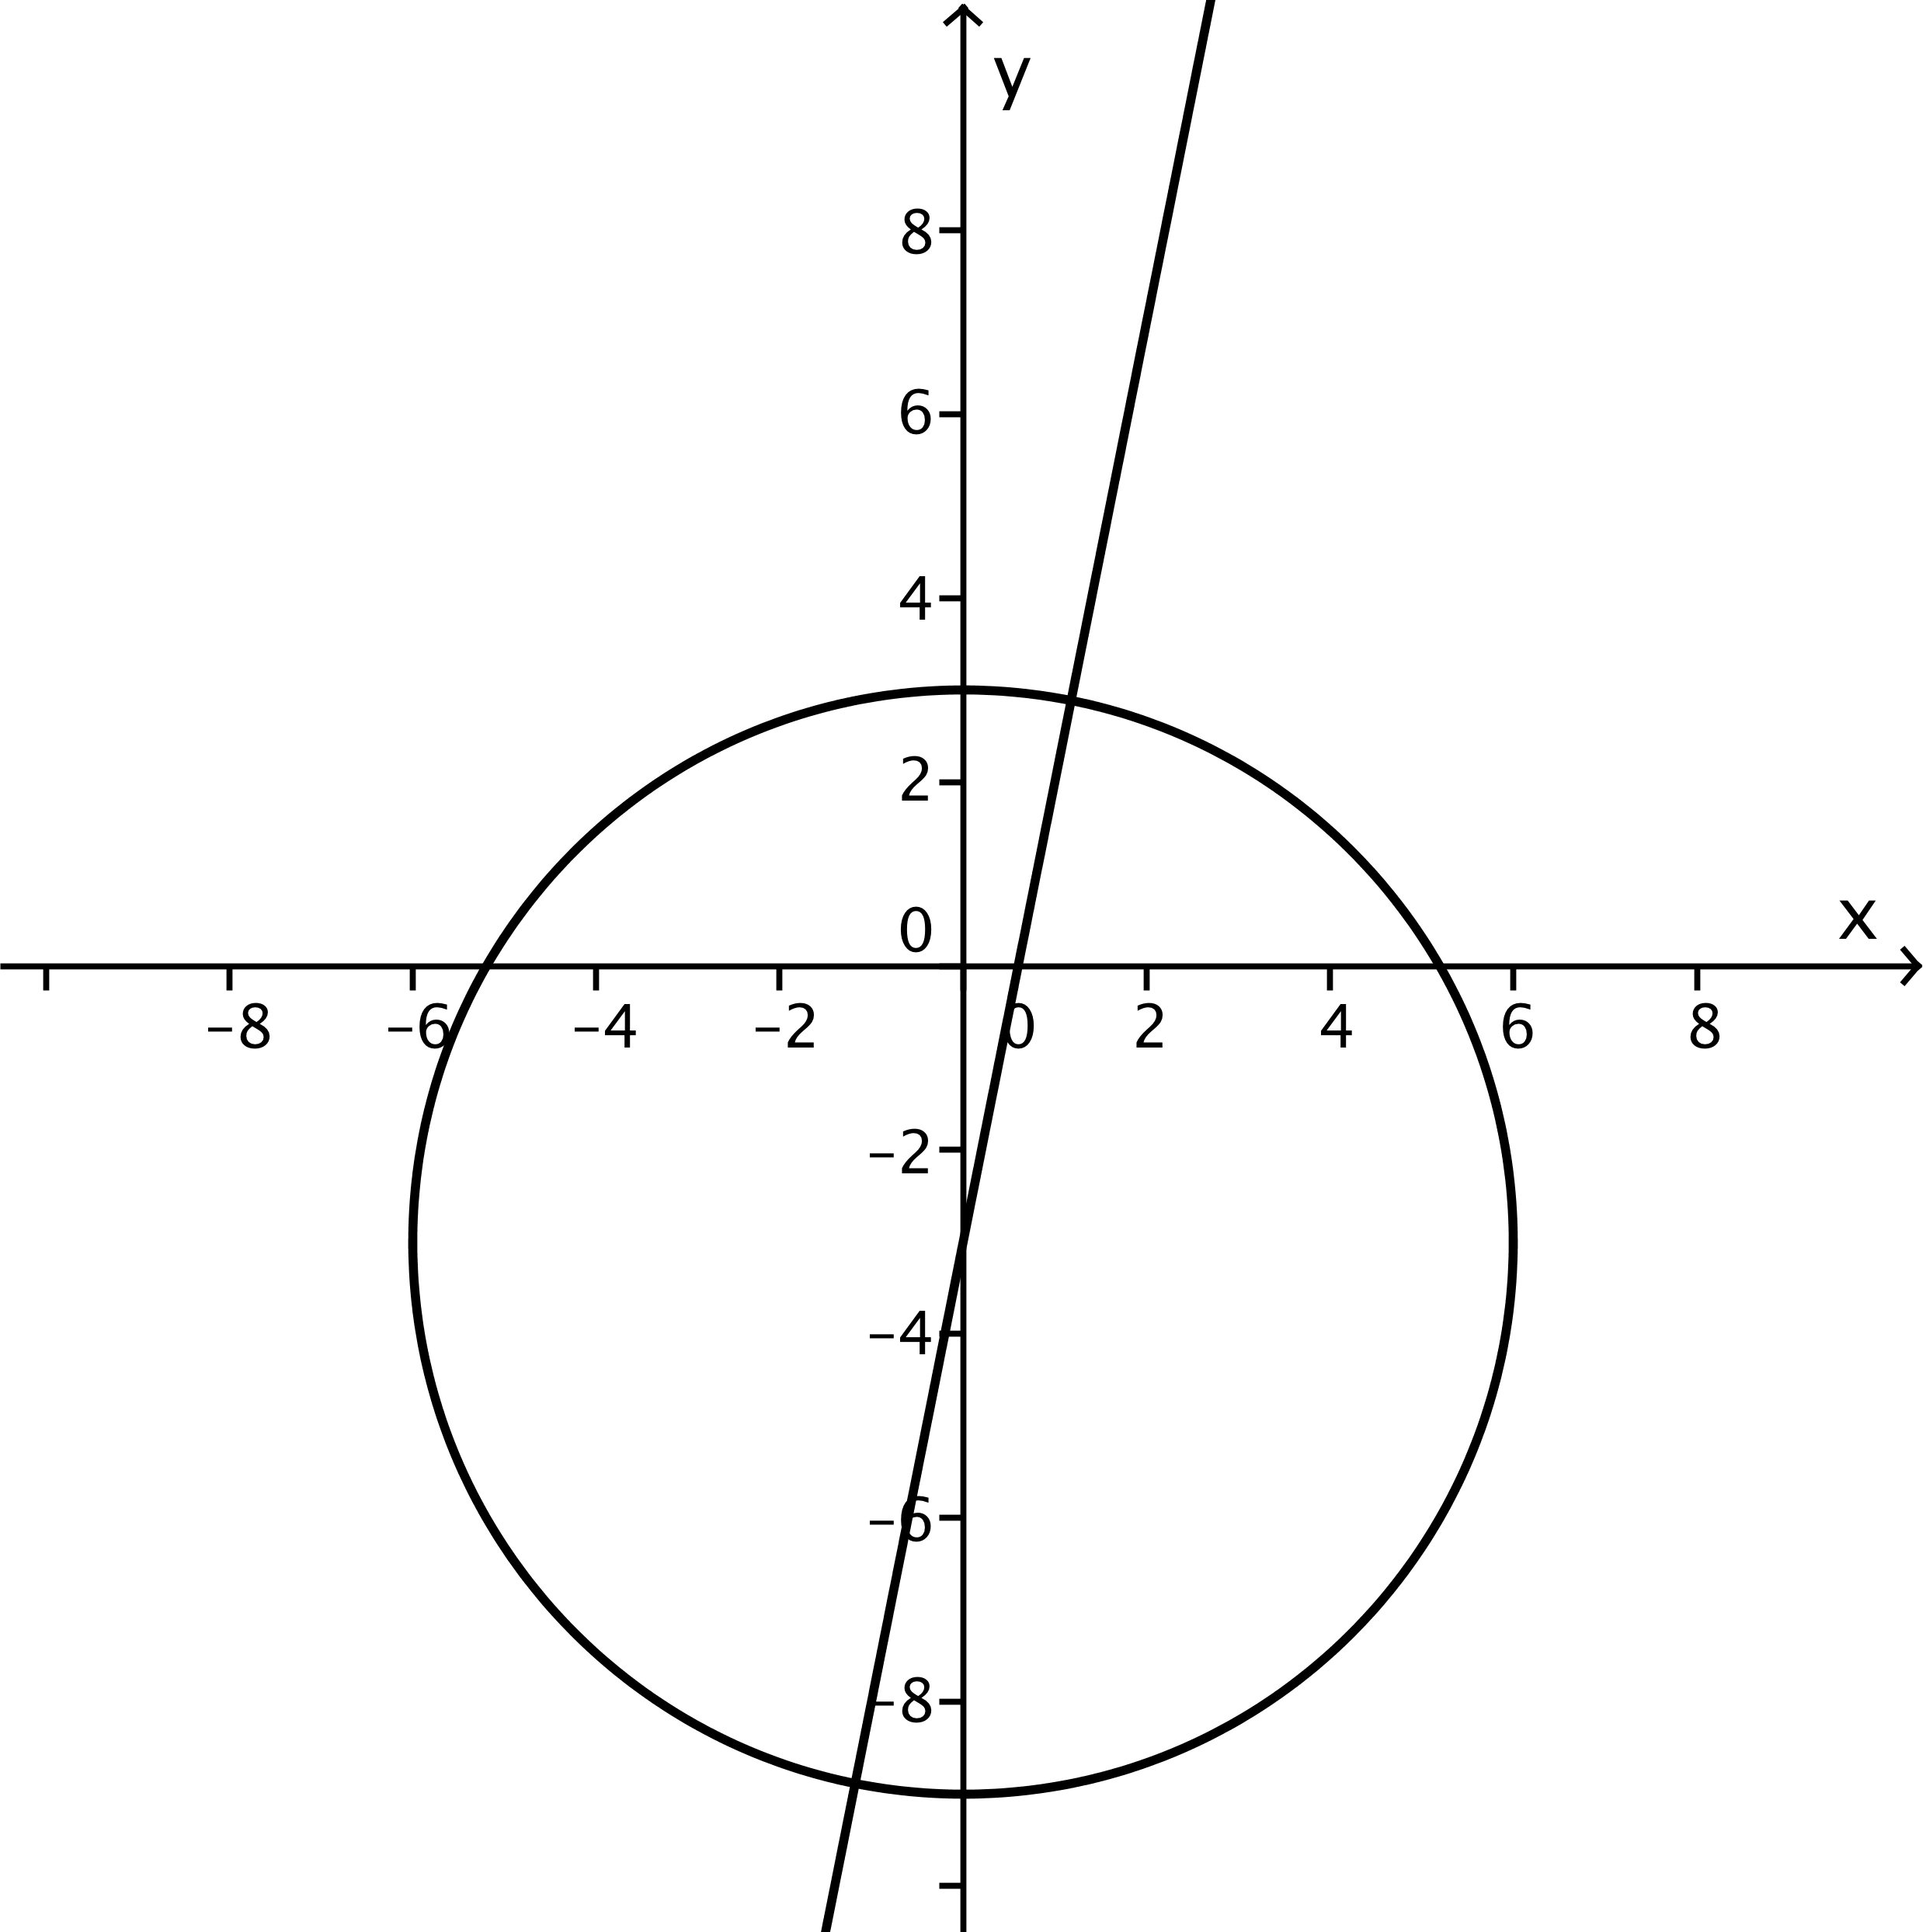
$$k=2$$
$$k=-3$$

