Lesson 26: Solving Rational Equations
Classwork
Exercises 1–2
Solve the following equations for $x$, and give evidence that your solutions are correct.
- $\frac{x}{2}+\frac{1}{3}=\frac{5}{6}$

- $\frac{2x}{9}+\frac{5}{9}=\frac{8}{9}.$

Example 1
Solve the following equation: $\frac{x+3}{12}=\frac{5}{6}.$

Exercises 3–7
- Solve the following equation: $\frac{3}{x}=\frac{8}{x-2}.$

- Solve the following equation for $a$: $\frac{1}{a+2}+\frac{1}{a-2}=\frac{4}{a^{2}-4}.$

- Solve the following equation. Remember to check for extraneous solutions.
$$\frac{4}{3x}+\frac{5}{4}=\frac{3}{x}$$

- Solve the following equation. Remember to check for extraneous solutions.
$$\frac{7}{b+3}+\frac{5}{b-3}=\frac{10b-2}{b^{2}-9}$$

- Solve the following equation. Remember to check for extraneous solutions.
$$\frac{1}{x-6}+\frac{x}{x-2}=\frac{4}{x^{2}-8x+12}$$

Lesson Summary
In this lesson, we applied what we have learned in the past two lessons about addition, subtraction, multiplication, and division of rational expressions to solve rational equations. An extraneous solution is a solution to a transformed equation that is not a solution to the original equation. For rational functions, extraneous solutions come from the excluded values of the variable.
Rational equations can be solved one of two ways:
- Write each side of the equation as an equivalent rational expression with the same denominator and equate the numerators. Solve the resulting polynomial equation, and check for extraneous solutions.
- Multiply both sides of the equation by an expression that is the common denominator of all terms in the equation. Solve the resulting polynomial equation, and check for extraneous solutions.

Problem Set

- Solve the following equations and check for extraneous solutions.
- $\frac{x-8}{x-4}=2$ | - $\frac{4x-8}{x-2}=4$ | - $\frac{x-4}{x-3}=1$
- $\frac{4x-8}{x-2}=3$ | - $\frac{1}{2a}-\frac{2}{2a-3}=0$ | - $\frac{3}{2x+1}=\frac{5}{4x+3}$
- $\frac{4}{x-5}-\frac{2}{5+x}=\frac{2}{x}$ | - $\frac{y+2}{3y-2}+\frac{y}{y-1}=\frac{2}{3}$ | - $\frac{3}{x+1}-\frac{2}{1-x}=1$
- $\frac{4}{x-1}+\frac{3}{x}-3=0$ | - $\frac{x+1}{x+3}-\frac{x-5}{x+2}=\frac{17}{6}$ | - $\frac{x+7}{4}-\frac{x+1}{2}=\frac{5-x}{3x-14}$
- $\frac{b^{2}-b-6}{b^{2}}-\frac{2b+12}{b}=\frac{b-39}{2b}$ | - $\frac{1}{p(p-4)}+1=\frac{p-6}{p}$ | - $\frac{1}{h+3}=\frac{h+4}{h-2}+\frac{6}{h-2}$
  - $\frac{m+5}{m^{2}+m}=\frac{1}{m^{2}+m}-\frac{m-6}{m+1}$

- Create and solve a rational equation that has $0$ as an extraneous solution.

- Create and solve a rational equation that has $2$ as an extraneous solution.

EXTENSION:
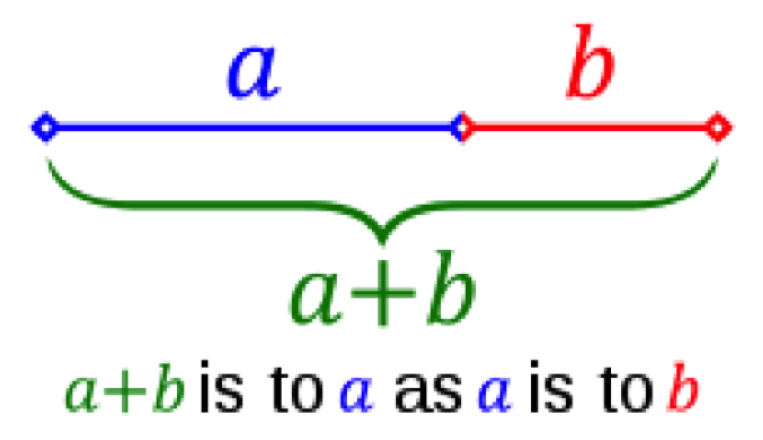
- Two lengths $a$ and $b$, where $a>b$, are in golden ratio if the ratio of $a+b$ is to $a$ is the same as $a$ is to $b$. Symbolically, this is expressed as $\frac{a}{b}=\frac{a+b}{a}$. We denote this common ratio by the Greek letter phi (pronounced “fee”) with symbol $φ$, so that if $a$ and $b$ are in common ratio, then $φ=\frac{a}{b}=\frac{a+b}{a}$. By setting $b=1$, we find that $φ=a$ and $φ$ is the positive number that satisfies the equation $φ=\frac{φ+1}{φ}$. Solve this equation to find the numerical value for $φ$.
- Remember that if we use $x$ to represent an integer, then the next integer can be represented by $x+1$.
  - Does there exist a pair of consecutive integers whose reciprocals sum to $\frac{5}{6}$? Explain how you know.
  - Does there exist a pair of consecutive integers whose reciprocals sum to $\frac{3}{4}$? Explain how you know.
  - Does there exist a pair of consecutive even integers whose reciprocals sum to $\frac{3}{4}$? Explain how you know.
  - Does there exist a pair of consecutive even integers whose reciprocals sum to $\frac{5}{6}$? Explain how you know.

