Lesson 19: The Remainder Theorem

Student Outcomes
- Students know and apply the Remainder Theorem and understand the role zeros play in the theorem.

Lesson Notes
In this lesson, students are primarily working on exercises that lead them to the concept of the Remainder Theorem, the connection between factors and zeros of a polynomial, and how this relates to the graph of a polynomial function. Students should understand that for a polynomial function $p$ and a number $a$, the remainder on division by $x-a$ is the value $p(a)$ and extend this to the idea that $p(a)=0$ if and only if $(x-a)$ is a factor of the polynomial (A-APR.B.2). There should be lots of discussion after each exercise.

Classwork
Exercises 1–3 (5 minutes)
Assign different groups of students one of the three problems from this exercise. Have them complete their assigned problem and then have a student from each group put their solution on the board. This gets the division out of the way and allows students to start to look for a pattern without making the lesson too tedious.
Scaffolding:
If students are struggling, you may choose to replace the polynomials in Exercises 2 and 3 with easier polynomial functions.
Examples:
$$g\left(x\right)=x^{2}-7x-11$$
a. Divide by $x+1$. b. Find $g(-1)$.
$$(x-8)-\frac{3}{x+1} g(-1)=-3$$

$$h\left(x\right)=2x^{2}+9$$
a. Divide by $x-3$. b. Find $h(3)$.
$$\left(2x+6\right)+\frac{27}{2x^{2}+9} h(3)=27$$
Exercises 1–3
- Consider the polynomial function $f\left(x\right)=3x^{2}+8x-4$.
- Divide $f$ by $x-2$. | - Find $f(2)$.
$$\frac{f\left(x\right)}{x-2}= \frac{3x^{2}+8x-4}{x-2} \\ =(3x+14)+\frac{24}{x-2}$$ | $$f(2) = 24$$

- Consider the polynomial function $g\left(x\right)=x^{3}-3x^{2}+6x+8$.
- Divide $g$ by $x + 1$. | - Find $g(-1)$.
$$\frac{g\left(x\right)}{x+1}=\frac{x^{3}-3x^{2}+6x+8}{x+1} \\ =(x^{2}-4x+10)-\frac{2}{x+1}$$ | $$g(-1) = -2$$

- Consider the polynomial function $h\left(x\right)=x^{3}+2x-3$.
- Divide $h$ by $x-3$. | - Find $h(3)$.
$$\frac{h\left(x\right)}{x-3}=\frac{x^{3}+2x-3}{x-3} \\ =(x^{2}+3x+11)+\frac{30}{x-3}$$ | $$h(3) = 30$$

Discussion (7 minutes)
- What is $f(2)$? What is $g(-1)$? What is $h(3)$?
  - $f(2)=24$; $g(-1)=-2$; $h(3)=30$
- Looking at the results of the quotient, what pattern do we see?
  - The remainder is the value of the function.
MP.8
- Stating this in more general terms, what can we say about the connection between dividing a polynomial $P$ by $x-a$ and the value of $P(a)$?
  - The remainder found after dividing $P$ by $x-a$ will be the same value as $P(a)$.
- Why would this be? Think about the quotient $\frac{13}{3}.$ We could write this as $13=4∙3+1$, where $4$ is the quotient and $1$ is the remainder.
- Apply this same principle to Exercise 1. Write the following on the board and talk through it.
$$\frac{f\left(x\right)}{x-2}=\frac{3x^{2}+8x-4}{x-2}=(3x+14)+\frac{24}{x-2}$$
- How can we rewrite $f$ using the equation above?
  - Multiply both sides of the equation by $x-2$ to get $f\left(x\right)=\left(3x+14\right)\left(x-2\right)+24$.
- In general we can say that if you divide polynomial $P$ by $x-a$, then the remainder must be a number; in fact, there is a (possibly non-zero degree) polynomial function $q$ such that the equation,
$$P\left(x\right) = q\left(x\right) ∙ \left(x-a\right) + r$$
$↑$ $↑$
quotient remainder
is true for all $x$.
- What is $P(a)$?
  - $P\left(a\right)=q\left(a\right)\left(a-a\right)+r=q\left(a\right)∙0+r=0+r=r$.

We have just proven the Remainder Theorem, which is formally stated in the box below.
Remainder Theorem:
Let $P$ be a polynomial function in $x$, and let $a$ be any real number. Then there exists a unique polynomial function $q$ such that the equation
$$P(x)=q(x)(x-a)+P(a)$$
is true for all $x$. That is, when a polynomial is divided by $(x-a)$, the remainder is the value of the polynomial evaluated at $a$.

- Restate the Remainder Theorem in your own words to your partner.
While students are doing this, circulate and informally assess student understanding before asking students to share their responses as a class.

Exercise 4 (5 minutes)
Students may need more guidance through this exercise, but allow them to struggle with it first. After a few students have found $k$, share various methods used.
Scaffolding:
Challenge early finishers with this problem:
Given that $x+1$ and $x-1$ are factors of $P\left(x\right)=x^{4}+2x^{3}-49x^{2}-2x+48$, write $P$ in factored form.
Answer:
$$\left(x+1\right)\left(x-1\right)\left(x+8\right)\left(x-6\right)$$
Exercise 4–6
- Consider the polynomial $P\left(x\right)=x^{3}+kx^{2}+x+6$.
  - Find the value of $k$ so that $x+1$ is a factor of $P$.
In order for $x+1$ to be a factor of $P$, the remainder must be zero. Hence, since
$x+1=x-(-1)$, we must have $P\left(-1\right)=0$, so that $0=-1+k-1+6$. Then $k=-4$.

  - Find the other two factors of $P$ for the value of $k$ found in part (a).
$$P\left(x\right)=\left(x+1\right)\left(x^{2}-5x+6\right)=\left(x+1\right)\left(x-2\right)\left(x-3\right)$$

Discussion (7 minutes)
- Remember that for any polynomial function $P$and real number $a$, the Remainder Theorem says that there exists a polynomial $P$ so that $P\left(x\right)=q\left(x\right)\left(x-a\right)+P(a)$.
- What does it mean if $a$ is a zero of a polynomial $P$?
  - $P\left(a\right)=0.$
- So what does the Remainder Theorem say if $a$ is a zero of $P$?
  - There is a polynomial $q$ so that $P\left(x\right)=q\left(x\right)\left(x-a\right)+0$.
- How does $\left(x-a\right)$ relate to $P$ if $a$ is a zero of $P?$
  - If $a$ is a zero of $P$, then $(x-a)$ is a factor of $P$.
- How does the graph of a polynomial function $y=P\left(x\right)$ correspond to the equation of the polynomial $P$?
  - The zeros are the $x$-intercepts of the graph of $P$. If we know a zero of $P$, then we know a factor of $P$.
- If we know all of the zeros of a polynomial function, and their multiplicities, do we know the equation of the function?
  - Not necessarily. It is possible that the equation of the function contains some factors that cannot factor into linear terms.
We have just proven the Factor Theorem, which is a direct consequence of the Remainder Theorem.
Factor Theorem:
Let $P$ be a polynomial function in $x$, and let $a$ be any real number. If $a$ is a zero of $P$ then $(x-a)$ is a factor of $P$.

- Give an example of a polynomial function with zeros of multiplicity $2$ at $1$ and $3$.
  - $P\left(x\right)={\left(x-1\right)}^{2}{\left(x-3\right)}^{2}$
- Give another example of a polynomial function with zeros of multiplicity $2$ at $1$ and $3$.
  - $Q\left(x\right)={\left(x-1\right)}^{2}{\left(x-3\right)}^{2}(x^{2}+1)$ or $R\left(x\right)=4{\left(x-1\right)}^{2}{\left(x-3\right)}^{2}$
- If we know the zeros of a polynomial, does the Factor Theorem tell us the exact formula for the polynomial?
  - No. But, if we know the degree of the polynomial and the leading coefficient, we can often deduce the equation of the polynomial.
Scaffolding:
Encourage students who are struggling to work on part (a) using two methods:
- by finding $P(1)$, and
- by dividing $P$ by $x-1$.
This will help to reinforce the ideas discussed in Exercises 1 and 2.
Exercise 5 (8 minutes)
As students work through this exercise, circulate the room to make sure students have made the connection between zeros, factors, and $x$-intercepts. Question students to see if they can verbalize the ideas discussed in the prior exercise.

- Consider the polynomial $P\left(x\right)=x^{4}+3x^{3}-28x^{2}-36x+144$.
  - Is $1$ a zero of the polynomial $P$?
No.
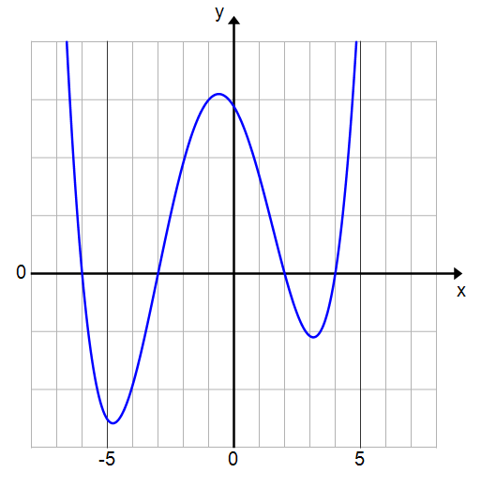
  - Is $x+3$ one of the factors of $P$?
Yes. $P\left(-3\right)=81-81-252+108+144=0$.

  - The graph of $P$ is shown to the right. What are the zeros of $P$?
Approximately $-6$,$-3$,$2$, and $4$.

  - Write the equation of $P$ in factored form.
$$P(x)=(x+6)(x+3)(x-2)(x-4)$$

- Is $1$ a zero of the polynomial $P$? How do you know?
  - No. $P(1)≠0.$
- What are two ways to determine the value of $P(1)$?
  - Fill in $1$ for $x$ into the function or divide $P$ by $x-1$. $P(1)$ will be equal to the remainder.
- Is $x+3$ a factor of $P$? How do you know?
  - Yes. Because $P(-3)=0$, then when $P$ is divided by $x+3$ the remainder is $0$, which means that $x+3$ is a factor of the polynomial $P$.
- How do you find the zeros of $P$ from the graph?
  - The zeros are the $x$-intercepts of the graph.
- How do you find the factors?
  - By using the zeros. If $x=a$ is a zero, then $x-a$ is a factor of $P$.
- Multiply out the expression in part (d) to see that it is indeed the original polynomial function.
Exercise 6 (6 minutes)
Allow students a few minutes to work on the problem and then share results.

- Consider the graph of a degree $5$ polynomial shown to the right, with $x$-intercepts $-4$, $-2$, $1$, $3$, and $5$.
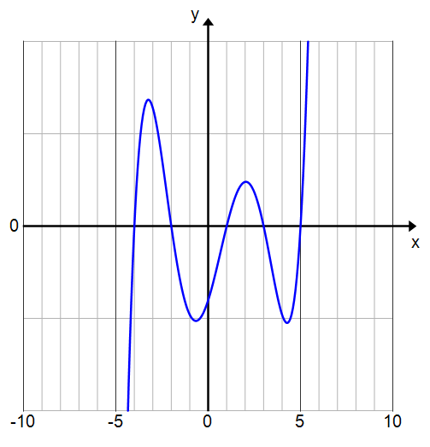
  - Write a formula for a possible polynomial function that the graph represents using $c$ as constant factor.
$$P\left(x\right)=c\left(x+4\right)(x+2)(x-1)\left(x-3\right)\left(x-5\right)$$

  - Suppose the $y$-intercept is $-4$. Adjust your function to fit the $y$-intercept by finding the constant factor $c$.
$$P\left(x\right)=\frac{1}{30}\left(x+4\right)(x+2)(x-1)\left(x-3\right)\left(x-5\right)$$

- What information from the graph was needed to write the equation?
  - The $x$-intercepts were needed to write the factors.
- Why would there be more than one polynomial function possible?
  - Because the factors could be multiplied by any constant and still produce a graph with the same $x$-intercepts.
  - Just as importantly—the graph only shows the behavior of the graph of a polynomial function between $-10$ and $10$. It is possible that the function has many more zeros or has other behavior outside this window. Hence, we can only say that the polynomial we found is one possible example of a function whose graph looks like the picture.
- Why can’t we find the constant factor $c$ by just knowing the zeros of the polynomial?
  - The zeros only determine the graph of the polynomial up to the places where the graph passes through the $x$-intercepts. The constant factor can be used to vertically scale the graph of the polynomial to fit the depicted graph.

Closing (2 minutes)
Have students summarize the results of the Remainder Theorem and the Factor Theorem.
- What is the connection between the remainder when a polynomial $P$ is divided by $x-a$ and the value of $P(a)$?
  - They are the same.
- If $x-a$ is factor, then _________.
  - The number $a$ is a zero of $P$.
- If $P(a)=0$, then ____________.
  - $(x-a)$ is a factor of $P$.
Lesson Summary
Remainder Theorem:
Let $P$ be a polynomial function in $x$, and let $a$ be any real number. Then there exists a unique polynomial function $q$ such that the equation
$$P(x)=q(x)(x-a)+P(a)$$
is true for all $x$. That is, when a polynomial is divided by $(x-a)$, the remainder is the value of the polynomial evaluated at $a$.
Factor Theorem:
Let $P$ be a polynomial function in $x$, and let $a$ be any real number. If $a$ is a zero of $P$, then $(x-a)$ is a factor of $P$.
Example: If $P\left(x\right)=x^{2}-3$ and $a=4$, then $P(x)=(x+4)(x-4)+13$ where $q(x)=x+4$ and $P(4)=13$.
Example: If $P(x)= x^{3} -5x^{2} +3x+9$, then $P\left(3\right)=27-45+9+9=0$, so $(x-3)$ is a factor of $P$.

Exit Ticket (5 minutes)
Name Date
Lesson 19: The Remainder Theorem

Exit Ticket

Consider the polynomial $P\left(x\right)=x^{3}+x^{2}-10x-10$.
- Is $x+1$ one of the factors of $P$? Explain.

- The graph shown has $x$-intercepts at $\sqrt{10}$, $-1$, and $-\sqrt{10}$. Could this be the graph of $P\left(x\right)=x^{3}+x^{2}-10x-10$? Explain how you know.
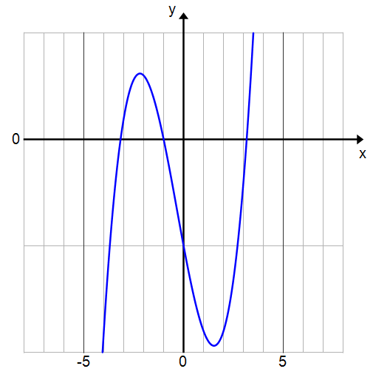
Exit Ticket Sample Solutions

Consider polynomial $P\left(x\right)=x^{3}+x^{2}-10x-10$.
- Is $x+1$ one of the factors? Explain.
$$P\left(-1\right)={\left(-1\right)}^{3}+{\left(-1\right)}^{2}-10\left(-1\right)-10=-1+1+10-10=0$$
Yes, $x+1$ is a factor of $P$ because $P(-1)=0$. Or, using factoring by grouping, we have
$P\left(x\right)=x^{2}\left(x+1\right)-10\left(x+1\right)=(x+1)(x^{2}-10)$.

- The graph shown has $x$-intercepts at $\sqrt{10}$, $-1$, and $-\sqrt{10}$. Could this be the graph of $P\left(x\right)=x^{3}+x^{2}-10x-10$? Explain how you know.

Yes, this could be the graph of $P$. Since this graph has $x$-intercepts at $\sqrt{10}$, $-1$, and $-\sqrt{10}$, the Factor Theorem says that $(x-\sqrt{10})$, $(x-1)$, and $(x+\sqrt{10} )$ are all factors of the equation that goes with this graph. Since $\left(x-\sqrt{10}\right)\left(x+\sqrt{10}\right)\left(x-1\right)=x^{3}+x^{2}-10x-10$, the graph shown is quite likely to be the graph of $P$.

Problem Set Sample Solutions

- Use the Remainder Theorem to find the remainder for each of the following divisions.
- $\left(x^{2}+3x+1\right)÷\left(x+2\right)$ | - $(x^{3}-6x^{2}-7x+9)÷(x-3)$
$$-1$$ | $$-39$$
- $(32x^{4}+24x^{3}-12x^{2}+2x+1)÷\left(x+1\right)$  $$-5$$ | - $(32x^{4}+24x^{3}-12x^{2}+2x+1)÷\left(2x-1\right)$  Hint for part (d): Can you rewrite the division expression so that the divisor is in the form $\left(x-c\right)$ for some constant $c$?  $$4$$

- Consider the polynomial $P\left(x\right)=x^{3}+6x^{2}-8x-1$. Find $P(4)$ in two ways.
$P\left(4\right)=4^{3}+6{\left(4\right)}^{2}-8\left(4\right)-1=127$ $\frac{x^{3}+6x^{2}-8x-1}{x-4}$ has a remainder of $127$ so $P(4)=127$.

- Consider the polynomial function $P\left(x\right)=2x^{4}+3x^{2}+12$.
  - Divide $P$ by $x+2$ and rewrite $P$ in the form $(divisor)(quotient)+remainder$.
$$P\left(x\right)=\left(x+2\right)\left(2x^{3}-4x^{2}+11x-22\right)+56$$

  - Find $P(-2)$.
$$P(-2)=\left(-2+2\right)\left(q\left(-2\right)\right)+56=56$$
- Consider the polynomial function $P\left(x\right)=x^{3}+42$.
  - Divide $P$ by $x-4$ and rewrite $P$ in the form $(divisor)(quotient)+remainder$.
$$P\left(x\right)=\left(x-4\right)\left(x^{2}+4x+16\right)+106$$

  - Find $P(4)$.
$$P(4)=\left(4-4\right)\left(q\left(4\right)\right)+106=106$$

- Explain why for a polynomial function $P$, $P(a)$ is equal to the remainder of the quotient of $P$ and $x-a$.
The polynomial $P$ can be rewritten in the form $P(x)=(x-a)(q(x))+r$, where $q(x)$ is the quotient function and $r$ is the remainder. Then $P(a)=\left(a-a\right)\left(q\left(a\right)\right)+r$. Therefore, $P(a)=r$.

- Is $x-5$ a factor of the function $f\left(x\right)=x^{3}+x^{2}-27x-15$? Show work supporting your answer.
Yes, because $f(5)=0$ means that dividing by $x-5$ leaves a remainder of $0$.

- Is $x+1$ a factor of the function $f\left(x\right)=2x^{5}-4x^{4}+9x^{3}-x+13$? Show work supporting your answer.
No, because $f(-1)=-1$ means that dividing by $x+1$ has a remainder of $-1$.

- A polynomial function $p$ has zeros of $2$, $2$, $-3$, $-3$,$-3$, and $4$. Find a possible formula for $p$ and state its degree. Why is the degree of the polynomial not $3$?
One solution is $p\left(x\right)={\left(x-2\right)}^{2}{\left(x+3\right)}^{3}(x-4)$. The degree of $p$ is $6$. This is not a degree $3$ polynomial function because the factor $(x-2)$ appears twice and the factor $(x+3)$ appears $3$ times, while the factor $(x-4)$ appears once.

- Consider the polynomial function $P\left(x\right)=x^{3}-8x^{2}-29x+180$.
  - Verify that $P(9)=0$. Since $P(9)=0$, what must one of the factors of $P$ be?
$P\left(9\right)=9^{3}-8\left(9^{2}\right)-29\left(9\right)+180=0$; $x-9$

  - Find the remaining two factors of $P$.
$$P(x)=(x-9)(x-4)(x+5)$$

  - State the zeros of $P$.
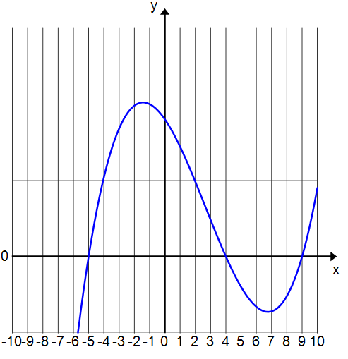
$x=9$,$4$,$-5$

  - Sketch the graph of $P$.

- Consider the polynomial function $P\left(x\right)=2x^{3}+3x^{2}-2x-3$.
  - Verify that $P(-1)=0$. Since, $P(-1)=0$, what must one of the factors of $P$ be?
$P\left(-1\right)=2{\left(-1\right)}^{3}+3{\left(-1\right)}^{2}-2\left(-1\right)-3=0$; $x+1$

  - Find the remaining two factors of $P$.
$$P(x)=(x+1)(x-1)(2x+3)$$

  - State the zeros of $P$.
$$x=-1\text{,} 1\text{,} -\frac{3}{2}$$

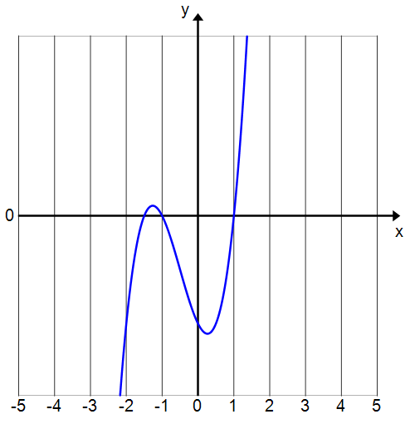
  - Sketch the graph of $P$.

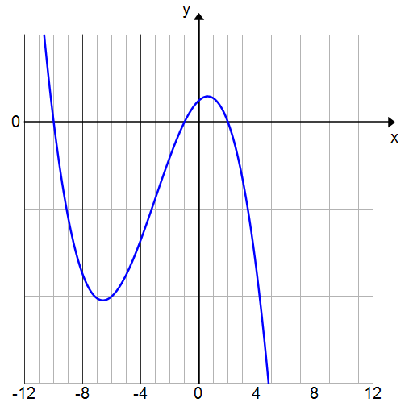
- The graph to the right is of a third degree polynomial function $f$.
  - State the zeros of $f$.
$$x=-10\text{,} -1\text{,} 2$$

  - Write a formula for $f$ in factored form using $c$ for the constant factor.
$$f(x)=c(x+10)(x+1)(x-2)$$

  - Use the fact that $f(-4)=-54$ to find the constant factor.
$$-54=c\left(-4+10\right)\left(-4+1\right)\left(-4-2\right) \\ c=-\frac{1}{2}$$
$$f(x)=-\frac{1}{2}(x+10)(x+1)(x-2)$$

  - Verify your equation by using the fact that $f(1)=11$.
$$f(1)=-\frac{1}{2}\left(1+10\right)\left(1+1\right)\left(1-2\right)=-\frac{1}{2}\left(11\right)\left(2\right)\left(-1\right)=11$$

- Find the value of $k$ so that $(x^{3}-kx^{2}+2)÷(x-1)$ has remainder $8$.
$$k=-5$$

- Find the value $k$ so that $(kx^{3}+x-k)÷(x+2)$ has remainder $16$.
$$k=-2$$

- Show that $x^{51}-21x+20$ is divisible by $x-1$.
Let $P\left(x\right)=x^{51}-21x+20$.
Then $P\left(1\right)=1^{51}-21\left(1\right)+20=1-21+20=0$.
Since $P(1)=0$, the remainder of the quotient$(x^{51}-21x+20)÷\left(x-1\right)$ is $0$.
Therefore, $x^{51}-21x+20$ is divisible by $x-1$.

- Show that $x+1$ is a factor of $19x^{42}+18x-1$.
Let $P(x)=19x^{42}+18x-1$.
Then $P\left(-1\right)=19{\left(-1\right)}^{42}+18\left(-1\right)-1=19-18-1=0.$
Since $P(-1)=0$, $x+1$ must be a factor of $P$.

Note to Teacher: The following problems have multiple correct solutions. The answers provided here are polynomials with the lowest degree that meet the specified criteria. As an example, the answer to Exercise 16 is given as $p\left(x\right)=(x+2)(x-1)$, but the following are also correct responses: $q\left(x\right)=14(x+2)(x-1)$, $r\left(x\right)={\left(x+2\right)}^{4}{\left(x-1\right)}^{8}$, and $s\left(x\right)=\left(x^{2}+1\right)\left(x+2\right)\left(x-1\right).$

Write a polynomial function that meets the stated conditions.
- The zeros are $-2$ and $1$.
$p\left(x\right)=(x+2)(x-1)$ or, equivalently, $p\left(x\right)=x^{2}+x-2$

- The zeros are $-1$,$2$, and $7$.
$p\left(x\right)=\left(x+1\right)\left(x-2\right)\left(x-7\right)$ or, equivalently, $p\left(x\right)=x^{3}-8x^{2}+5x+14$

- The zeros are$-\frac{1}{2}$ and$\frac{3}{4}$.
$p\left(x\right)=\left(x+\frac{1}{2}\right)\left(x-\frac{3}{4}\right)$ or, equivalently, $p\left(x\right)=x^{2}-\frac{x}{4}-\frac{3}{8}$

- The zeros are $-\frac{2}{3}$ and $5$, and the constant term of the polynomial is $-10$.
$p\left(x\right)=\left(x-5\right)\left(3x+2\right)$ or, equivalently, $p\left(x\right)=3x^{2}-13x-10$.

- The zeros are $2$ and $-\frac{3}{2}$, the polynomial has degree $3$ and there are no other zeros.
$p\left(x\right)={(x-2)}^{2}(2x+3)$ or, equivalently, $p\left(x\right)=(x-2{)(2x+3)}^{2}$

