Lesson 19: The Remainder Theorem

Classwork

Exercises 1–3

1. Consider the polynomial function .

|  |  |
| --- | --- |
| * 1. Divide by . | * 1. Find |

1. Consider the polynomial function .

|  |  |
| --- | --- |
| * 1. Divide by . | * 1. Find . |

1. Consider the polynomial function .

|  |  |
| --- | --- |
| * 1. Divide by . | * 1. Find . |

Exercises 4–6

1. Consider the polynomial .
   1. Find the value of so that is a factor of .
   2. Find the other two factors of for the value of found in part (a).
2. Consider the polynomial .
   1. Is a zero of the polynomial ?
   2. Is one of the factors of ?

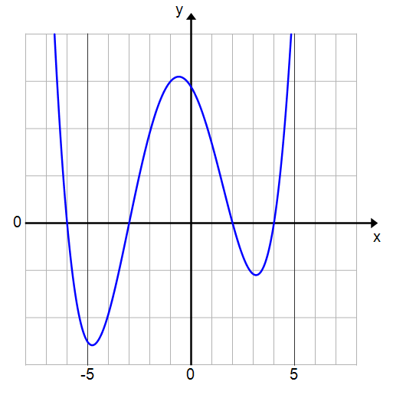

* 1. The graph of is shown to the right. What are the zeros of ?
  2. Write the equation of in factored form.

1. Consider the graph of a degree polynomial shown to the right, with -intercepts , , , and .
   1. 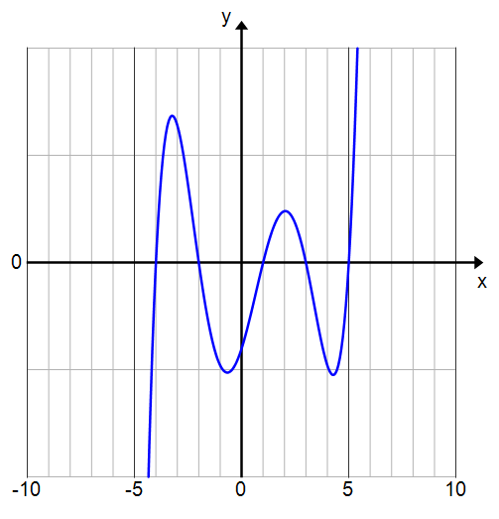Write a formula for a possible polynomial function that the graph represents using as constant factor.
   2. Suppose the -intercept is . Adjust your function to fit the -intercept by finding the constant factor .

Problem Set

Lesson Summary

**Remainder Theorem:**

Let be a polynomial function in , and let be any real number. Then there exists a unique polynomial function such that the equation

is true for all . That is, when a polynomial is divided by , the remainder is the value of the polynomial evaluated at .

**Factor Theorem:**

Let be a polynomial function in , and let be any real number. If is a zero of , then is a factor of .

Example: If and , then where and .

Example: If , then , so is a factor of

1. Use the Remainder Theorem to find the remainder for each of the following divisions.
   1. Hint for part (d): Can you rewrite the division expression so that the divisor is in the form for some constant ?
2. Consider the polynomial . Find in two ways.
3. Consider the polynomial function .
   1. Divide by and rewrite in the form .
   2. Find .
4. Consider the polynomial function .
   1. Divide by and rewrite in the form .
   2. Find .
5. Explain why for a polynomial function , is equal to the remainder of the quotient of and .
6. Is a factor of the function ? Show work supporting your answer.
7. Is a factor of the function ? Show work supporting your answer.
8. A polynomial function has zeros of , ,,,, and . Find a possible formula for and state its degree. Why is the degree of the polynomial not ?
9. Consider the polynomial function .
   1. Verify that . Since , what must one of the factors of be?
   2. Find the remaining two factors of .
   3. State the zeros of .
   4. Sketch the graph of



1. Consider the polynomial function .
   1. Verify that . Since , what must one of the factors of be?
   2. Find the remaining two factors of .
   3. State the zeros of .
   4. Sketch the graph of



1. 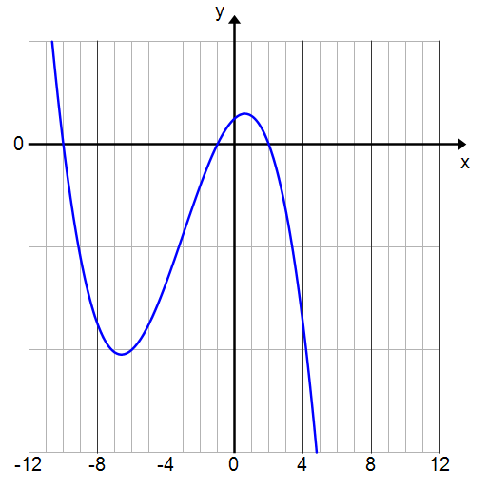The graph to the right is of a third degree polynomial function .
   1. State the zeros of .
   2. Write a formula for in factored form using for the constant factor.
   3. Use the fact that to find the constant factor.
   4. Verify your equation by using the fact that .
2. Find the value of so that has remainder .
3. Find the value so that ) has remainder .
4. Show that is divisible by .
5. Show that is a factor of *.*

Write a polynomial function that meets the stated conditions.

1. The zeros are and .
2. The zeros are , , and
3. The zeros are and.
4. The zeros are and , and the constant term of the polynomial is
5. The zeros are and , the polynomial has degree and there are no other zeros.