Both
Lesson 18: Overcoming a Second Obstacle in Factoring—What If There Is a Remainder?

Student Outcomes
- Students rewrite simple rational expressions in different forms, including representing remainders when dividing.

Lesson Notes
Students have worked on dividing two polynomials using both the reverse tabular method and long division. In this lesson, they will continue that work but with quotients that have a remainder. In addition to the two methods of division already presented in this module, students will also use the method of inspection as stated in standard A-APR.D.6. The method of inspection is an opportunity to emphasize the mathematical practice of making use of structure (MP.7). The purpose of the Opening Exercise is to get students thinking about this idea of structure by leading them from writing rational numbers as mixed numbers to writing rational expressions as “mixed expressions.”

Classwork
Opening Exercise (3 minutes)
Have students work through the Opening Exercise briefly by themselves, and then summarize the exercise as a whole class by displaying all three methods. This will start students thinking about the different ways of rewriting an improper fraction as a mixed number. We will use methods 2 and 3 later today to write rational expressions as “mixed expressions.”
Scaffolding:
- If students are struggling with the different methods of rewriting a rational number as a mixed number, provide them with extra examples such as the following.
$$\frac{10}{7}=1\frac{3}{7}$$
$$\frac{26}{3}=8\frac{2}{3}$$
Opening Exercise
Write the rational number $\frac{13}{4}$as a mixed number.
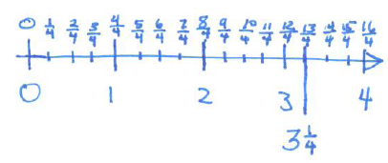
Method 1:

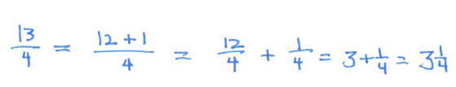
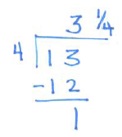
Method 2: Method 3:

Example 1 (8 minutes)
Work through the example as a class. Relate the process of inspection used in part (b) below to method 2 used in the Opening Exercise. Then, demonstrate how the quotient could have been found using the reverse tabular method or long division.
Example 1
- Find the quotient by factoring the numerator.  $$\frac{x^{2}+3x+2}{x+2}$$ | - Find the quotient.  $$\frac{x^{2}+3x+5}{x+2}$$
$$\frac{x^{2}+3x+2}{x+2}=\frac{\left(x+1\right)\left(x+2\right)}{x+2} \\ =x+1$$ | See below.

Solutions for part (b):
Method 1: Inspection
- We already know that $\frac{x^{2}+3x+2}{x+2}=x+1$, as long as $x≠-2$. How could we use this fact to find $\frac{x^{2}+3x+5}{x+2}$?
  - Since $3+2=5$, there must be $3$ left over after performing division.
- How could we rewrite the problem in a way that is more convenient?
MP.7
  - $\frac{x^{2}+3x+5}{x+2}=\frac{{(x}^{2}+3x+2)+3}{x+2}=\frac{x^{2}+3x+2}{x+2}+\frac{3}{x+2}$
- So, what are the quotient and remainder?
  - The quotient is $x+1$ with a remainder of $3$.
- Since the $3$ is left over and has not been divided by the $x+2$, it is still written as a quotient.
  - $\frac{x^{2}+3x+5}{x+2}=\frac{x^{2}+3x+2+3}{x+2}=\frac{x^{2}+3x+2}{x+2}+\frac{3}{x+2}=(x+1)+\frac{3}{x+2}$
Method 2: Reverse Tabular Method
$3$ remains and is yet to be divided. So the remainder is $3$.
 | $$x$$ | $$1$$
 | $$x^{2}$$ | $$x$$ | $$x$$
$$x^{2}$$ | $$2x$$ | $$2$$ | $$2$$
$$3x$$ | $$5=2+3$$

$$\frac{x^{2}+3x+5}{x+2}=(x+1)+\frac{3}{x+2}$$
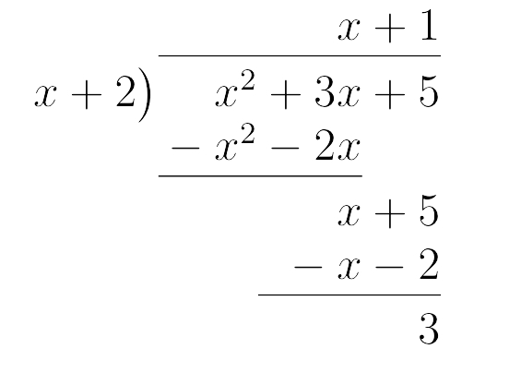
Method 3: Long division
Work the problem as a class using long division. Remind the students that we used the same process in method 3 of the Opening Exercise.

Example 2 (7 minutes)
Repeat the process for this example. Work through the process of inspection as a pair/share exercise. Then, ask the students to repeat the process using either the reverse tabular method or long division. Share the work from both methods.
Example 2
- Find the quotient by factoring the numerator.  $$\frac{x^{3}-8}{x-2}$$ | - Find the quotient.  $$\frac{x^{3}-4}{x-2}$$
$$= \frac{\left(x-2\right)\left(x^{2}+2x+4\right)}{x-2} \\ = x^{2}+2x+4$$

- In pairs, see if you can determine how to use the quotient from (a) to find the quotient of $\frac{x^{3}-4}{x-2}$ .
Give students a couple of minutes to discuss and then elicit responses.
- How did you rewrite the numerator?
  - $\frac{x^{3}-4}{x-2}=\frac{x^{3}-8+4}{x-2}=\frac{x^{3}-8}{x-2}+\frac{4}{x-2}$
- Why is this a useful way to rewrite the problem?
MP.7
  - We know that $\frac{x^{3}-8}{x-2}=x^{2}+2x+4$.
- So what are the quotient and remainder of $\frac{x^{3}-4}{x-2}$?
  - The quotient is $x^{2}+2x+4$ with a remainder of $4$.
Therefore, $\frac{x^{3}-4}{x-2}={(x}^{2}+2x+4)+\frac{4}{x-2}$.

Give students a couple of minutes to rework the problem using either the reverse tabular method or long division and then share student work.
 | $$x^{2}$$ | $$2x$$ | $$4$$ | 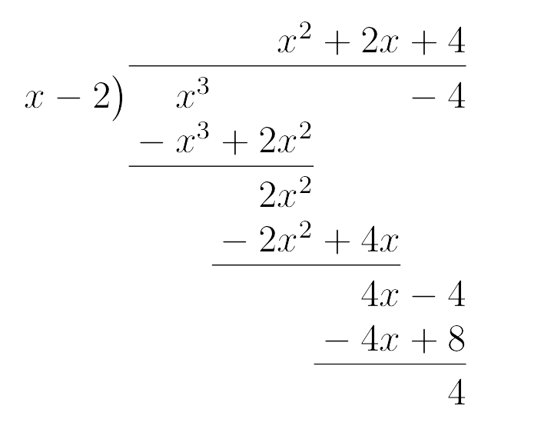
The remainder is $4$. | $$x^{3}$$ | $$2x^{2}$$ | $$4x$$ | $$x$$
$$x^{3}$$ | $$-2x^{2}$$ | $$-4x$$ | $$-8$$ | $$-2$$
$$0x^{2}$$ | $$0x$$ | $$-4=-8+4$$

- Which method is easier? Allow students to discuss advantages and disadvantages of the three methods.

Exercise (5 minutes)
Have students practice finding quotients by factoring the numerator using the cards on the page after next. Cut out the cards and hand each student a card. The students must move around the room and match their card with the same quotient. You could then have students stay in these pairs to work on the exercises.

Exercises 1–10 (15 minutes)
Allow students to work through the exercises either independently or in pairs. Some students may need to be reminded how to complete the square.
Scaffolding:
- Some students may have difficulty with inspection. Encourage them to use the reverse tabular method first, and then see if they can use that to rewrite the numerator.
- Early finishers can be given more challenging inspection problems such as the following.
$$\frac{x^{2}-5x+9}{x-1}=\left(x-4\right)+\frac{5}{x-1}$$

$$\frac{2x^{2}-5}{x-3}=2\left(x+3\right)+\frac{13}{x-3}$$
Exercises 1–10
Find each quotient by inspection.
- $\frac{x+4}{x+1}$ | - $\frac{2x-7}{x-3}$ | - $\frac{x^{2}-21}{x+4}$
$$1+\frac{3}{x+1}$$ | $$2-\frac{1}{x-3}$$ | $$(x-4)-\frac{5}{x+4}$$
Find each quotient by using the reverse tabular method.
- $\frac{x^{2}+4x+10}{x-8}$ | - $\frac{x^{3}-x^{2}+3x-1}{x+3}$ | - $\frac{x^{2}-2x-19}{x-1}$
$$(x+12)+\frac{106}{x-8}$$ | $$x^{2}-4x+15-\frac{46}{x+3}$$ | $$(x-1)-\frac{20}{x-1}$$

Find each quotient by using long division.
- $\frac{x^{2}-x-25}{x+6}$ | - $\frac{x^{4}-8x^{2}+12}{x+2}$ | - $\frac{4x^{3}+5x-8}{2x-5}$
$$(x-7)+\frac{17}{x+6}$$ | $$(x^{3}-2x^{2}-4x+8)-\frac{4}{x+2}$$ | $$(2x^{2}+5x+15)+\frac{67}{2x-5}$$
Rewrite the numerator in the form ${\left(x-h\right)}^{2}+k$ by completing the square. Then find the quotient.
- $\frac{x^{2}+4x-9}{x+2}$
$$(x+2)-\frac{13}{x+2}$$

The mental math exercises on the next page can be used for building fluency. All numerators factor nicely so that there are no remainders. The exercise can be timed and restrictions can be imposed (such as, “Only write your answer in the box next to the expression.”).
It is always a good idea to keep fluency exercises quick and stress-free for students. Here is one way to do that: Tell them that the activity will not be turned in for a grade, but they will be timed. Give them 2 minutes to write down as many answers as possible (using a stopwatch or a stopwatch feature on your phone). Afterwards, go through the solutions with them quickly; allow them only to mark the ones they did correct/incorrect—do not let them copy the correct answers down. Celebrate the student who got the greatest number correct, and then provide another 2–4 minutes for students to work on the remaining problems that they did not get right.
Mental Math Exercises
$$\frac{x^{2}-9}{x+3}$$  $$x-3$$ | $$\frac{x^{2}-4x+3}{x-1}$$  $$x-3$$ | $$\frac{x^{2}-16}{x+4}$$  $$x-4$$ | $$\frac{x^{2}-3x-4}{x+1}$$  $$x-4$$
$$\frac{x^{3}-3x^{2}}{x-3}$$  $$x^{2}$$ | $$\frac{x^{4}-x^{2}}{x^{2}-1}$$  $$x^{2}$$ | $$\frac{x^{2}+x-6}{x+3}$$  $$x-2$$ | $$\frac{x^{2}-4}{x+2}$$  $$x-2$$
$$\frac{x^{2}-8x+12}{x-2}$$  $$x-6$$ | $$\frac{x^{2}-36}{x+6}$$  $$x-6$$ | $$\frac{x^{2}+6x+8}{x+4}$$  $$x+2$$ | $$\frac{x^{2}-4}{x-2}$$  $$x+2$$
$$\frac{x^{2}-x-20}{x+4}$$  $$x-5$$ | $$\frac{x^{2}-25}{x+5}$$  $$x-5$$ | $$\frac{x^{2}-2x+1}{x-1}$$  $$x-1$$ | $$\frac{x^{2}-3x+2}{x-2}$$  $$x-1$$
$$\frac{x^{2}+4x-5}{x-1}$$  $$x+5$$ | $$\frac{x^{2}-25}{x-5}$$  $$x+5$$ | $$\frac{x^{2}-10x}{x}$$  $$x-10$$ | $$\frac{x^{2}-12x+20}{x-2}$$  $$x-10$$
$$\frac{x^{2}+5x+4}{x+4}$$  $$x+1$$ | $$\frac{x^{2}-1}{x-1}$$  $$x+1$$ | $$\frac{x^{2}+16x+64}{x+8}$$  $$x+8$$ | $$\frac{x^{2}+9x+8}{x+1}$$  $$x+8$$

Closing (2 minutes)
Consider asking students to respond in pairs or in writing.
- In the pair/share exercise, how did we use the structure of the expressions to help us to simplify them?
  - We were able to factor the numerator. Since the numerator and denominator contained a common factor, we were able to simplify the expression.
- How did we use structure in Exercise 10?
  - We rewrote the expression by completing the square and then used inspection.
- How does this use of structure help us when working with algebraic expressions?
  - We can rewrite expressions into equivalent forms that may be more convenient.
- What methods were used to find the quotients?
  - Inspection, reverse tabular method, long division
- What are some pros and cons of the methods?
  - You may not see the answer when trying to divide by inspection but quick to do if you see the structure of the expression. Long division or tabular method can be time consuming but generally rely on a known process and not insight.

Exit Ticket (5 minutes)
Name Date
Lesson 18: Overcoming a Second Obstacle in Factoring—What If There Is a Remainder?

Exit Ticket

- Find the quotient of $\frac{x-6}{x-8}$ by inspection.

- Find the quotient of $\frac{9x^{3}-12x^{2}+4}{x-2}$ by using either long division or the reverse tabular method.
Exit Ticket Sample Solutions

- Find the quotient of $\frac{x-6}{x-8}$ by inspection.
$$1+\frac{2}{x-8}$$

- Find the quotient of $\frac{9x^{3}-12x^{2}+4}{x-2}$ by using either long division or the reverse tabular method.
$$(9x^{2}+6x+12)+\frac{28}{x-2}$$

Problem Set Sample Solutions

- For each pair of problems, find the first quotient by factoring the numerator. Then, find the second quotient by using the first quotient.
 | $$\frac{3x-6}{x-2}$$ | $$\frac{3x-9}{x-2}$$
 | $$3$$ | $$3-\frac{3}{x-2}$$
 | $$\frac{x^{2}-5x-14}{x-7}$$ | $$\frac{x^{2}-5x+2}{x-7}$$
 | $$x + 2$$ | $$(x+2)+\frac{16}{x-7}$$
 | $$\frac{x^{3}+1}{x+1}$$ | $$\frac{x^{3}}{x+1}$$
 | $$x^{2}-x+1$$ | $${(x}^{2}-x+1)-\frac{1}{x+1}$$
 | $$\frac{x^{2}-13x+36}{x-4}$$ | $$\frac{x^{2}-13x+30}{x-4}$$
 | $$x-9$$ | $$(x-9)-\frac{6}{x-4}$$
Find each quotient by using the reverse tabular method.
- $\frac{x^{3}-9x^{2}+5x+2}{x-1}$ | - $\frac{x^{2}+x+10}{x+12}$
$$(x^{2}-8x-3)-\frac{1}{x-1}$$ | $$(x-11)+\frac{142}{x+12}$$

- $\frac{2x+6}{x-8}$ | - $\frac{x^{2}+8}{x+3}$
$$2+\frac{22}{x-8}$$ | $$(x-3)+\frac{17}{x+3}$$
Find each quotient by using long division.
- $\frac{x^{4}-9x^{2}+10x}{x+2}$ | - $\frac{x^{5}-35}{x-2}$
$$(x^{3}-2x^{2}-5x+20)-\frac{40}{x+2}$$ | $$(x^{4}+2x^{3}+4x^{2}+8x+16)-\frac{3}{x-2}$$
- $\frac{x^{2}}{x-6}$ | - $\frac{x^{3}+2x^{2}+8x+1}{x+5}$
$$(x+6)+\frac{36}{x-6}$$ | $$(x^{2}-3x+23)-\frac{114}{x+5}$$
- $\frac{x^{3}+2x+11}{x-1}$ | - $\frac{x^{4}+3x^{3}-2x^{2}+6x-15}{x}$
$$(x^{2}+x+3)+\frac{14}{x-1}$$ | $$(x^{3}+3x^{2}-2x+6)-\frac{15}{x}$$
- Rewrite the numerator in the form ${\left(x-h\right)}^{2} + k$ by completing the square. Then, find the quotient.
$$\frac{x^{2}-6x-10}{x-3}$$
$$x-3-\frac{19}{x-3}$$

