Lesson 17: Modeling with Polynomials—An Introduction

Student Outcomes
- Students interpret and represent relationships between two types of quantities with polynomial functions.

Lesson Notes
In this lesson, students delve more deeply into modeling by writing polynomial equations that can be used to model a particular situation. Students are asked to interpret key features from a graph or table within a contextual situation (F-IF.B.4) and select the domain that corresponds to the appropriate graph or table (F-IF.B.5).

Classwork
Opening Exercise (8 minutes)
Give students time to work independently on the Opening Exercise before discussing as a class.
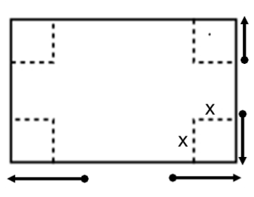
Opening Exercise
In Lesson 16, we created an open-topped box by cutting congruent squares from each corner of a piece of construction paper.
  - Express the dimensions of the box in terms of $x$.
Length: $L=45.7-2x$
Width: $W=30.5-2x$
Height: $H=x$

  - Write a formula for the volume of the box as a function of $x$. Give the answer in standard form.
$$V\left(x\right)=x\left(45.7-2x\right)\left(30.5-2x\right)$$
$$V(x)=4x^{3}-152.4x^{2}+1393.85x$$

- How does this compare with the regression function found yesterday?
  - Answers will vary. Compare each parameter in the function.
- Which function is more accurate? Why?
  - The one found today. The one found yesterday depended on measurements that may not have been exact.

Mathematical Modeling Exercises 1–13 (30 minutes)
Allow students to work through the exercises in groups. Circulate the room to monitor students’ progress. Then, discuss results.
Mathematical Modeling Exercises 1–13
The owners of Dizzy Lizzy’s, an amusement park, are studying the wait time at their most popular roller coaster. The table below shows the number of people standing in line for the roller coaster $t$ hours after Dizzy Lizzy’s opens.
$t$ (hours) | $$0$$ | $$1$$ | $$2$$ | $$4$$ | $$7$$ | $$8$$ | $$10$$ | $$12$$
$P$ (people in line) | $$0$$ | $$75$$ | $$225$$ | $$345$$ | $$355$$ | $$310$$ | $$180$$ | $$45$$
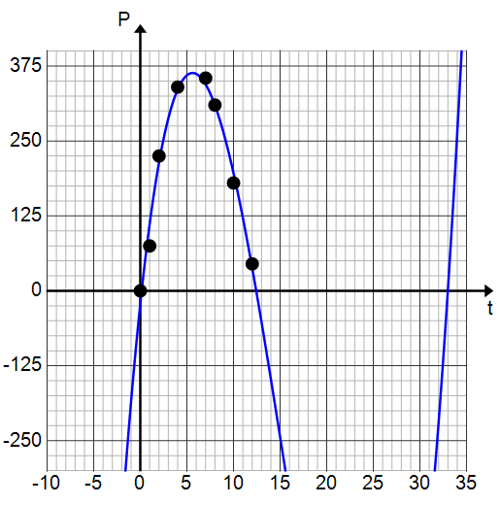
Jaylon made a scatterplot and decided that a cubic function should be used to model the data. His scatterplot and curve are shown below.
Scaffolding:
Have early finishers find a quadratic model for comparison. Which model seems to be a better fit? Why?
Answers will vary, but one model would be
$P(t)=-10.134t(t-12)$. Students should see that the quadratic model does not seem to fit the data as well as the cubic model. They could confirm this using the regression feature of a graphing calculator.

- Do you agree that a cubic polynomial function is a good model for this data? Explain.
Yes. The curve passes through most of the points and seems to fit the data.

- What information would Dizzy Lizzy's be interested in learning about from this graph? How could they determine the answer?
The company should be interested in the time when the line is the longest and how many people are in line at that time. To find this out, they can find a model that could be used to predict the number of people in line at any time during the day. They could then estimate the maximum point from the graph.

- Estimate the time at which the line is the longest. Explain how you know.
From the graph, the line is longest at $5.5$ hours because the relative maximum value of the function occurs at $5.5$ hours.

- Estimate the number of people in line at that time. Explain how you know.
From the graph, there are roughly $372$ people in line when $t=5.5$; that is the approximate relative maximum value of $P$.

- Estimate the $t$-intercepts of the function used to model this data.
The $t$-intercepts are roughly $0$, $12.5$, and $33$.

- Use the $t$-intercepts to write a formula for the function of the number of people in line, $f$, after $t$ hours.
$f(t)=ct(t-12.5)(t-33)$, where $c$ is a constant that has not yet been determined.
- Use the maximum point to find the leading coefficient. Explain your reasoning.
Since we have estimated $f\left(5.5\right)=372$, we can plug $5.5$ into the function above, and we find that $f\left(5.5\right)=1058.75c=372$. Solving for $c$, we find that $c≈0.35$. The function that could model the data is then given by $f\left(t\right)=0.35t\left(t-12.5\right)\left(t-33\right)$.

- What would be a reasonable domain for your function $f$? Why?
MP.3
A reasonable domain for $f$ would be $0≤x≤12.5$ because the opening of the park corresponds to $t=0$, and after $12.5$ hours the park closes so there are no people waiting in line.

- Use your function $f$ to calculate the number of people in line $10$ hours after the park opens.
The formula developed in Exercise 7 gives $f(10)=201$ people.

- Comparing the value calculated above to the actual value in the table, is your function $f$an accurate model for the data? Explain.
The value of the function differs from the value from the table by about $21$ people, so it is not a perfect fit for the data, but it is otherwise very close. It appears to overestimate the number of people in line.

- Use the regression feature of a graphing calculator to find a cubic function to model the data.
The calculator gives $g(t)=0.43t^{3}-17.78t^{2}+156.63t-24.16$.

- Graph your function and the one generated by the graphing calculator and use the graphing calculator to complete the table. Round your answers to the nearest integer.
$t$ (hours) | $$0$$ | $$1$$ | $$2$$ | $$4$$ | $$7$$ | $$8$$ | $$10$$ | $$12$$
$P$ (people in line) | $$0$$ | $$75$$ | $$225$$ | $$345$$ | $$355$$ | $$310$$ | $$180$$ | $$45$$
$f$ (your equation) | $$0$$ | $$129$$ | $$228$$ | $$345$$ | $$350$$ | $$315$$ | $$201$$ | $$44$$
$g$ (regression eqn.) | $$-24$$ | $$115$$ | $$221$$ | $$345$$ | $$349$$ | $$311$$ | $$194$$ | $$38$$

- Based on the results from the table, which model was more accurate at $t=2$ hours? $t=10$ hours?
MP.2
At $t=2$ hours, the function found by hand was more accurate. It was off by $3$ people whereas the calculator function was off by $4$ people. At $t=10$ hours, the graphing calculator fuction was more accurate. It was off by $14$ people whereas the function found by hand was off by $21$ people.

Closing (2 minutes)
- What type of functions were used to model the data? Were they good models?
  - Cubic polynomial functions; yes, both functions were reasonably accurate.
- What information did we use to find the function by hand?
  - We used the $x$-intercepts and the relative maximum point.
- Did we have to use the relative maximum specifically to find the leading coefficient?
  - No. We could have chosen a different point on the curve.
- How did polynomials help us solve a real-world problem?
  - We were able to model the data using a polynomial function. The function allows us to estimate the number of people in line at any time $t$ and also to estimate the time when the line is the longest and the maximum number of people are in line.
Exit Ticket (5 minutes)
Name Date
Lesson 17: Modeling with Polynomials—An Introduction

Exit Ticket

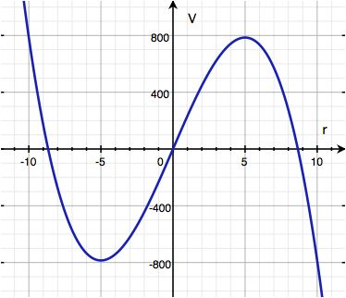
Jeannie wishes to construct a cylinder closed at both ends. The figure at right shows the graph of a cubic polynomial function used to model the volume of the cylinder as a function of the radius if the cylinder is constructed using $150π$ ${cm}^{3}$ of material. Use the graph to answer the questions below. Estimate values to the nearest half unit on the horizontal axis and to the nearest $50$ units on the vertical axis.
- What are the zeros of the function?

- What are the relative maximum and the relative maximum values of the function?

- The equation of this function is $V\left(r\right)=c(r^{3}-72.25r)$ for some real number $c$. Find the value of $c$ so that this formula fits the graph.

- Use the graph to estimate the volume of the cylinder with $r=2 cm$.

- Use your formula to find the volume of the cylinder when $r=2 cm$. How close is the value from the formula to the value on the graph?

Exit Ticket Sample Solutions
Jeannie wishes to construct a cylinder closed at both ends. The figure at right shows the graph of a cubic polynomial function used to model the volume of the cylinder as a function of the radius if the cylinder is constructed using $150π$ $cm^{3}$ of material. Use the graph to answer the questions below. Estimate values to the nearest half unit on the horizontal axis and to the nearest $50$ units on the vertical axis.
- What are the zeros of the function?
Approximately $0$, $-8.5$, and $8.5$. (Students might round up to $-9$ and $9$.)

- What are the relative maximum and the relative maximum values of the function?
The relative maximum value is $800$ $cm^{3}$ at $r=5 cm$ and the relative minimum value is $-800 cm^{3}$ at $r=-5 cm$.

- The equation of this function is $V(r)=c(r^{3}-72.25r)$ for some real number $c$. Find the value of $c$ so that this formula fits the graph.
Substituting $r=5 cm$ and $V\left(r\right)=800 cm^{3}$ and solving for $c$ gives $c≈-3.4$.

- Use the graph to estimate the volume of the cylinder with $r=2 cm$.
Estimating from the graph, the volume of a cylinder of radius $2$ cm is $450 cm^{3}$.

- Use your formula to find the volume of the cylinder when $r=2 cm$. How close is the value from the formula to the value on the graph?
Using the formula: $V\left(2\right)=-3.4\left(2^{3}-72.25\left(2\right)\right)=464.1$. Therefore, the volume of the cylinder when $r=2 cm$ is $464.1 cm^{3}$. This value is close to the value of $450 cm^{3}$ found using the graph but not exact, particularly because we cannot read much detail from the graph.

Problem Set Sample Solutions
Problem 2 requires the use of a graphing calculator. If students do not have the means to complete this, the last two parts could be done in class.

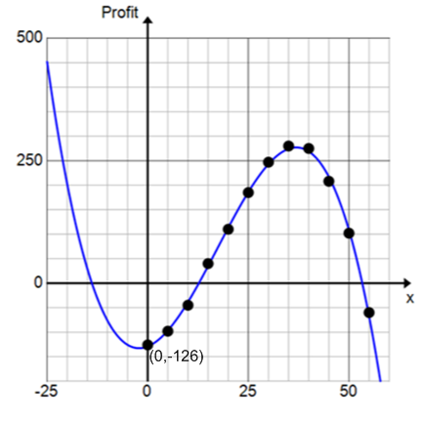
- Recall the math club fundraiser from yesterday’s Problem Set. The club members would like to find a function to model their data, so Kylie draws a curve through the data points as shown below.
  - What type of function does it appear that she has drawn?
Degree $3$ polynomial (or cubic polynomial)

  - The function that models the profit in terms of the number of t-shirts made has the form $P\left(x\right)=c(x^{3}-53x^{2}-236x+9828)$. Use the vertical intercept labeled on the graph to find the value of the leading coefficient $c$.
$c≈-0.01282$,
so$P(x)=-0.01282(x^{3}-53x^{2}-236x+9828)$
  - From the graph, estimate the profit if the math club sells $30$ t-shirts.
The profit is approximately $\$250$ if the club sells $30$ t-shirts.

  - Use your function to estimate the profit if the math club sells $30$ t-shirts.
$P(30)=230.14$. The equation predicts a profit of $\$230.14$.

  - Which estimate do you think is more reliable? Why?
The estimate from the graph is probably more reliable because the equation required estimating the $x$-intercepts. If these estimates were off, it could have affected the equation.

- A box is to be constructed so that it has a square base and no top.
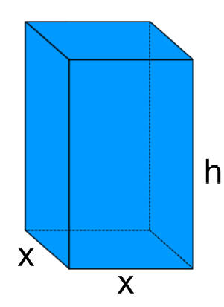
  - Draw and label the sides of the box. Label the sides of the base as $x$ and the height of the box as $h$.

  - The surface area is $108 cm^{2}$. Write a formula for the surface area $S$ and then solve for $h$.
$$S=x^{2}+4xh=108$$
$$h=\frac{108-x^{2}}{4x}$$

  - Write a formula for the function of the volume of the box in terms of $x$.
$$V\left(x\right)=x^{2}h=x^{2}\left(\frac{108-x^{2}}{4x}\right)=\frac{108x^{2}-x^{4}}{4x}=\frac{108x-x^{3}}{4}$$

  - Use a graphing utility to find the maximum volume of the box.
$$108 cm^{3}$$

  - What dimensions should the box be in order to maximize its volume?
$$6 cm × 6 cm × 3 cm$$

