Lesson 17: Modeling with Polynomials—An Introduction

Classwork
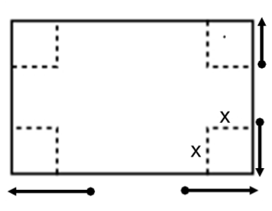
Opening Exercise
In Lesson 16, we created an open-topped box by cutting congruent squares from each corner of a piece of construction paper.
- Express the dimensions of the box in terms of $x$.
- Write a formula for the volume of the box as a function of $x$. Give the answer in standard form.

Mathematical Modeling Exercises 1–13
The owners of Dizzy Lizzy’s, an amusement park, are studying the wait time at their most popular roller coaster. The table below shows the number of people standing in line for the roller coaster $t$ hours after Dizzy Lizzy’s opens.
$t$ (hours) | $$0$$ | $$1$$ | $$2$$ | $$4$$ | $$7$$ | $$8$$ | $$10$$ | $$12$$
$P$ (people in line) | $$0$$ | $$75$$ | $$225$$ | $$345$$ | $$355$$ | $$310$$ | $$180$$ | $$45$$
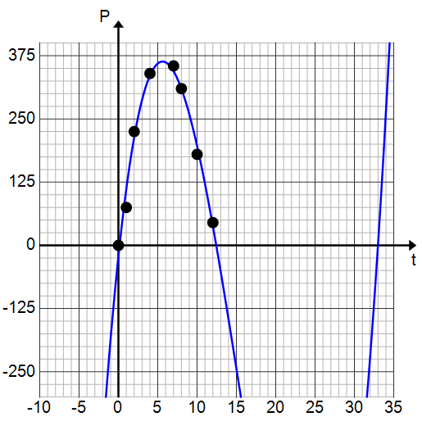
Jaylon made a scatterplot and decided that a cubic function should be used to model the data. His scatterplot and curve are shown below.

- Do you agree that a cubic polynomial function is a good model for this data? Explain.

- What information would Dizzy Lizzy’s be interested in learning about from this graph? How could they determine the answer?

- Estimate the time at which the line is the longest. Explain how you know.

- Estimate the number of people in line at that time. Explain how you know.

- Estimate the $t$-intercepts of the function used to model this data.

- Use the $t$-intercepts to write a formula for the function of the number of people in line, $f$, after $t$ hours.

- Use the maximum point to find the leading coefficient. Explain your reasoning.

- What would be a reasonable domain for your function $f$? Why?

- Use your function $f$ to calculate the number of people in line $10$ hours after the park opens.

- Comparing the value calculated above to the actual value in the table, is your function $f$ an accurate model for the data? Explain.

- Use the regression feature of a graphing calculator to find a cubic function to model the data.

- Graph your function and the one generated by the graphing calculator and use the graphing calculator to complete the table. Round your answers to the nearest integer.

$t$ (hours) | $$0$$ | $$1$$ | $$2$$ | $$4$$ | $$7$$ | $$8$$ | $$10$$ | $$12$$
$P$ (people in line) | $$0$$ | $$75$$ | $$225$$ | $$345$$ | $$355$$ | $$310$$ | $$180$$ | $$45$$
$f$ (your equation)
$g$ (regression eqn.)

- Based on the results from the table, which model was more accurate at $t=2$ hours? $t=10$ hours?

Problem Set

- Recall the math club fundraiser from yesterday’s problem set. The club members would like to find a function to model their data, so Kylie draws a curve through the data points as shown below.
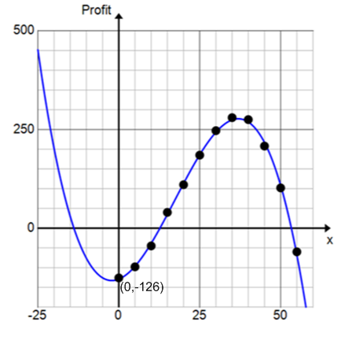

  - What type of function does it appear that she has drawn?
  - The function that models the profit in terms of the number of t-shirts made has the form $P\left(x\right)=c(x^{3}-53x^{2}-236x+9828)$. Use the vertical intercept labeled on the graph to find the value of the leading coefficient $c$.
  - From the graph, estimate the profit if the math club sells $30$ t-shirts.
  - Use your function to estimate the profit if the math club sells $30$ t-shirts.
  - Which estimate do you think is more reliable? Why?

- A box is to be constructed so that it has a square base and no top.
  - Draw and label the sides of the box. Label the sides of the base as $x$ and the height of the box as $h$.
  - The surface area is $108$ cm². Write a formula for the surface area $S$ and then solve for $h$.
  - Write a formula for the function of the volume of the box in terms of $x$.
  - Use a graphing utility to find the maximum volume of the box.
  - What dimensions should the box be in order to maximize its volume?

