Lesson 16: Modeling with Polynomials—An Introduction

Student Outcomes
- Students transition between verbal, numerical, algebraic, and graphical thinking in analyzing applied polynomial problems.

Lesson Notes
Creating an open-topped box of maximum volume is a very common problem seen in calculus. The goal is to optimize resources by enclosing the most volume possible given the constraint of the size of the construction material; here we use paper. The dimensions given can be adjusted depending on the size of the paper chosen; hence, the dimensions are omitted from the figure on the student pages. This is the first part of a two-day lesson on modeling. Lesson 16 will focus more on students writing equations to model a situation.

Classwork
Opening (5 minutes)
Each group has a piece of construction paper that measures $45.7 cm × 30.5 cm$. Other sizes of paper may be used if necessary, but ensure that each group is using the same sized paper. Cut out congruent squares from each corner and fold the sides in order to create an open-topped box. Our goal is to create a box with the maximum possible volume.
Ask students to make conjectures about what size cut will create the box with the largest volume. Demonstrate if desired using the applet http://mste.illinois.edu/carvell/3dbox/.
MP.3

Mathematical Modeling Exercise (30 minutes)
While the students work on their boxes, put the following table on the board. As students measure their boxes and calculate the volume, they should be recording the values in the table. Stop students once each group has recorded its values, and have the discussion below before allowing them to continue working.
Mathematical Modeling Exercise
You will be assigned to a group, which will create a box from a piece of construction paper. Each group will record its box’s measurements and use said measurement values to calculate and record the volume of its box. Each group will contribute to the following class table on the board.
Group | Length | Width | Height | Volume
$$1$$
$$2$$
$$3$$
$$4$$
Using the given construction paper, cut out congruent squares from each corner and fold the sides in order to create an open-topped box as shown on the figure below.
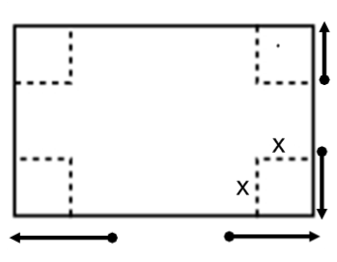

- Measure the length, width, and height of the box to the nearest tenth of a centimeter.
Answers will vary. Sample answer:
Length: $L=35.7$ cm
Width: $W=20.5$ cm
Height: $H=5.0$ cm

- Calculate the volume.
Answers will vary. Sample answer:
Volume: $V=L∙W∙H=3,659.25$ cm³

- Have a group member record the values on the table on the board.

Discuss the results and compare them with the conjectures made before cutting the paper.
- Who was able to enclose the most volume?
- Why would our goal be to enclose the most volume?
  - We are optimizing our resources by enclosing more volume than the other groups using the same size paper.
Have students continue with the exercise.

- Create a scatterplot of volume versus height using technology.
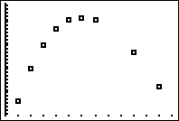
Scaffolding:
Some students may have difficulty working with technology. Place them in a group with a student who can assist them through the steps.

- What type of polynomial function could we use to model this data?
Cubic or quadratic; we cannot tell from just this portion of the graph.

- Use the regression feature to find a function to model the data. Does a quadratic or a cubic regression provide a better fit to the data?
Answers will vary based on the accuracy of the measurements, but the cubic regression should be a better fit.
Sample answer: $V\left(x\right)=4x^{3}-152.4x^{2}+1,398.8x$

- Find the maximum volume of the box.
The maximum volume is $3,770.4$ cm³

- What size square should be cut from each corner in order to maximize the volume?
A $6\text{ cm}×6 \text{cm}$ square should be cut from each corner.

- What are the dimensions of the box of maximum volume?
The dimension are $33.7\text{ cm}×18.5 \text{cm}×6\text{ cm}$

- What are the possible values for the height of the box?
  - From $0$ to $15.25$ cm
- What is the domain of the volume function?
  - The domain is the interval $0<x<15.25$.
- Is constructing a box in such a way that its volume is maximized always the best option?
  - No. A box may need to have particular dimensions (such as a shoe box).

Closing (5 minutes)
You can use the applet http://www.mathopenref.com/calcboxproblem.html to summarize what the students discovered.
- Revisit their original conjecture either in writing or with a neighbor. Was it accurate? How would you change it now?
Have students share responses.
- Why would our goal be to maximize the volume?
  - Maximizing resources, enclosing as much volume as possible using the least amount of material.
- Is constructing a box in such a way that its volume is maximized always the best option?
  - No. A box may need to have particular dimensions (such as a shoe box). In some cases, the base of the box may need to be stronger, so the material is more expensive. Minimizing cost may be different than maximizing the volume.

Exit Ticket (5 minutes)
Name Date
Lesson 16: Modeling with Polynomials—An Introduction

Exit Ticket

Jeannie wishes to construct a cylinder closed at both ends. The figure below shows the graph of a cubic polynomial function used to model the volume of the cylinder as a function of the radius if the cylinder is constructed using $150π$ cm² of material. Use the graph to answer the questions below. Estimate values to the nearest half unit on the horizontal axis and to the nearest $50$ units on the vertical axis.
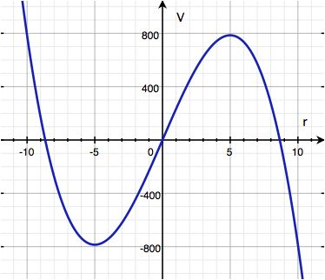
- What is the domain of the volume function? Explain.

- What is the most volume that Jeannie’s cylinder can enclose?

- What radius yields the maximum volume?

- The volume of a cylinder is given by the formula $V=πr^{2}h$. Calculate the height of the cylinder that maximizes the volume.

Exit Ticket Sample Solutions

Jeannie wishes to construct a cylinder closed at both ends. The figure below shows the graph of a cubic polynomial function used to model the volume of the cylinder as a function of the radius if the cylinder is constructed using
$150π$ cm² of material. Use the graph to answer the questions below. Estimate values to the nearest half unit on the horizontal axis and the nearest $50$ units on the vertical axis.

- What is the domain of the volume function? Explain.
The domain is approximately$0≤r≤8.5$ because a negative radius does not make sense, and a radius larger than $8.5$ gives a negative volume, which also does not make sense.

- What is the most volume that Jeannie’s cylinder can enclose?
Approximately $800$ cm³

- What radius yields the maximum volume?
Approximately $5$ cm

- The volume of a cylinder is given by the formula $V=πr^{2}h$. Calculate the height of the cylinder that maximizes the volume.
Approximately $10.2$ cm

Problem Set Sample Solutions
For a bonus, ask your students what is meant by the caption on the t-shirt. (Hint that they can do a web search to find out.)

- For a fundraiser, members of the math club decide to make and sell “Pythagoras may have been Fermat’s first problem but not his last!” t-shirts. They are trying to decide how many t-shirts to make and sell at a fixed price. They surveyed the level of interest of students around school and made a scatterplot of number of t-shirts sold ($x$) versus profit shown below.
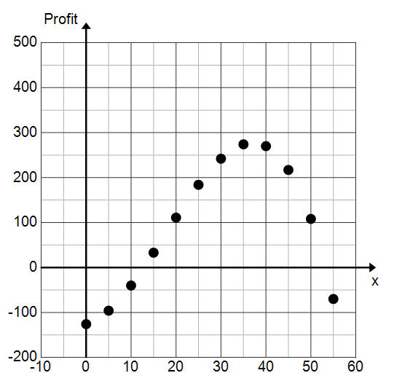
  - Identify the $y$-intercept. Interpret its meaning within the context of this problem.
The $y$-intercept is approximately $-125$. The $-125$ represents the money that they must spend on supplies in order to start making t-shirts. That is, they will lose $\$125$ if they sell $0$ t-shirts.

  - If we model this data with a function, what point on the graph of that function represents the number of t-shirts they need to sell in order to break even? Why?
The break-even point is the first $x$-intercept of the graph of the function because at this point profit changes from negative to positive. When profit is $0$, the club is breaking even.

  - What is the smallest number of t-shirts they can sell and still make a profit?
Approximately $12$ or $13$ t-shirts

  - How many t-shirts should they sell in order to maximize the profit?
Approximately $35$ t-shirts

  - What is the maximum profit?
Approximately $\$280$

  - What factors would affect the profit?
The price of the t-shirts, the cost of supplies, the number of people who are willing to purchase a t-shirt

  - What would cause the profit to start decreasing?
Making more t-shirts than can be sold.

- The following graph shows the temperature in Aspen, Colorado during a 48-hour period beginning at midnight on Thursday, January 21, 2014. (Source: National Weather Service)
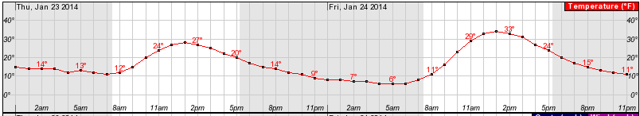

- We can model the data shown with a polynomial function. What degree polynomial would be a reasonable choice?
Since the graph has $4$ turning points ($2$ relative minima, $2$ relative maxima), a degree $5$ polynomial could be used. Students could also argue that the final point is another minimum point and that a degree $6$ polynomial could be used.

- Let $T$ be the function that represents the temperature, in degrees Fahrenheit, as a function of time $t$, in hours. If we let $t=0$ correspond to midnight on Thursday, interpret the meaning of $T(5)$. What is $T(5)$?
The value $T(5)$ represents the temperature at $5$ am on Thursday. From the graph, $T(5) = 13$.

- What are the relative maximum points? Interpret their meanings.
The relative maximum points are approximately $T(13)=28$ and $T(37)=34$. These points represent the high temperature on Thursday and Friday and the times at which they occurred. The high on Thursday occurred at $1:00$ (when $t=13$) and was $28°F$. The high on Friday occurred at $1:00$ (when $t=37$) and was $34°F$.

