Lesson 16: Modeling with Polynomials—An Introduction

Classwork
Mathematical Modeling Exercise
You will be assigned to a group, which will create a box from a piece of construction paper. Each group will record its box’s measurements and use said measurement values to calculate and record the volume of its box. Each group will contribute to the following class table on the board.
Group | Length | Width | Height | Volume
$$1$$
$$2$$
$$3$$
$$4$$

Using the given construction paper, cut out congruent squares from each corner and fold the sides in order to create an open-topped box as shown on the figure below.
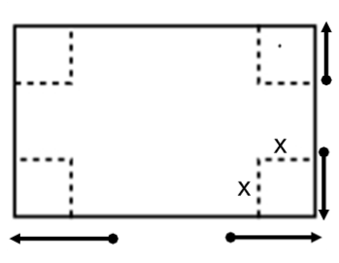

- Measure the length, width, and height of the box to the nearest tenth of a centimeter.

- Calculate the volume.

- Have a group member record the values on the table on the board.

- Create a scatterplot of volume versus height using technology.

- What type of polynomial function could we use to model this data?

- Use the regression feature to find a function to model the data. Does a quadratic or a cubic regression provide a better fit to the data?

- Find the maximum volume of the box.

- What size square should be cut from each corner in order to maximize the volume?

- What are the dimensions of the box of maximum volume?

Problem Set

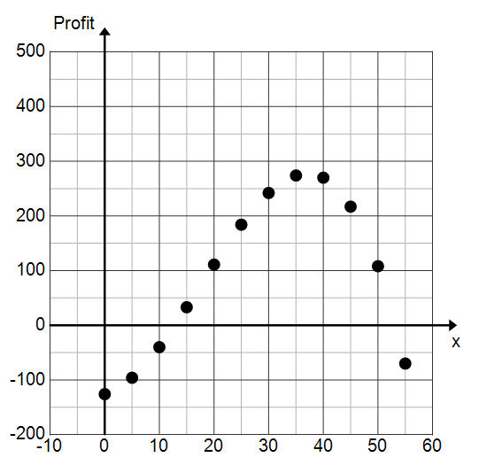
- For a fundraiser, members of the math club decide to make and sell “Pythagoras may have been Fermat’s first problem but not his last” t-shirts. They are trying to decide how many t-shirts to make and sell at a fixed price. They surveyed the level of interest of students around school and made a scatterplot of number of t-shirts sold ($x$) versus profit shown below.

  - Identify the $y$-intercept. Interpret its meaning within the context of this problem.
  - If we model this data with a function, what point on the graph of that function represents the number of t-shirts they need to sell in order to break even? Why?
  - What is the smallest number of t-shirts they can sell and still make a profit?
  - How many t-shirts should they sell in order to maximize the profit?
  - What is the maximum profit?
  - What factors would affect the profit?
  - What would cause the profit to start decreasing?

- The following graph shows the temperature in Aspen, Colorado during a 48-hour period beginning at midnight on Thursday, January 21, 2014. (Source: National Weather Service)
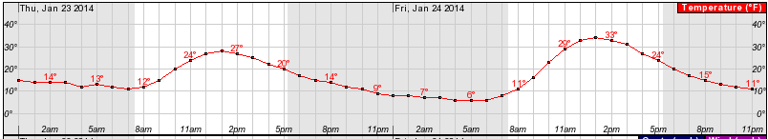
  - We can model the data shown with a polynomial function. What degree polynomial would be a reasonable choice?
  - Let $T$ be the function that represents the temperature, in degrees Fahrenheit, as a function of time $t$, in hours. If we let $t=0$ correspond to midnight on Thursday, interpret the meaning of $T(5)$. What is $T(5)$?
  - What are the relative maximum points? Interpret their meanings.

