Lesson 13: Mastering Factoring

Student Outcomes
- Students will use the structure of polynomials to identify factors.

Lesson Notes
In previous lessons in this module, students have practiced the techniques of factoring by completing the square, by applying the quadratic formula, and by grouping. In this lesson, students are going to look for structure in more complicated polynomial expressions that will allow factorization. But first, students are going to review several factoring techniques; some they learned about in the last lesson, and others they learned about in previous classes.

Opening Exercise (8 minutes)
In this exercise, students should begin to factor polynomial expressions by first analyzing their structure, a skill that is developed throughout the lesson. Suggest that students work on their own for five minutes and then compare answers with a neighbor; allow students to help each other out for an additional three minutes, if needed.
MP.7
Opening Exercise
Factor each of the following expressions. What similarities do you notice between the examples in the left column and those on the right?
- $x^{2}-1$ | - $9x^{2}-1$
$$(x-1)(x+1)$$ | $$(3x-1)(3x+1)$$
- $x^{2}+8x+15$ | - $4x^{2}+16x+15$
$$(x+5)(x+3)$$ | $$(2x+5)(2x+3)$$
- $x^{2}-y^{2}$ | - $x^{4}-y^{4}$
$$(x-y)(x+y)$$ | $$(x^{2}-y^{2})(x^{2}+y^{2})$$
Students should notice that the structure of each of the factored polynomials is the same; for example, the factored forms of part (a) and part (b) are nearly the same, except that part (b) contains $3x$ in place of the $x$ in part (a). In parts (c) and (d), the factored form of part (d) contains $2x,$ where there is only an $x$ in part (c). The factored form of part (f) is nearly the same as the factored form of part (e), with $x^{2}$ replacing $x$ and $y^{2}$ replacing $y$.

Discussion (2 minutes)
Scaffolding:
If students are unfamiliar with the difference of squares formula, work through a table of numeric examples and ask them to look for patterns.
$$a$$ | $$b$$ | $$a+b$$ | $$a-b$$ | $$a^{2}-b^{2}$$
3 | 1 | 4 | 2 | 8
4 | 1 | 5 | 3 | 15
5 | 2 | 7 | 3 | 21
6 | 4 | 10 | 2 | 20
Students may benefit from teacher modeling.
The difference of two squares formula,
$$a^{2}-b^{2}=\left(a+b\right)\left(a-b\right),$$
can be used to factor an expression even when the two squares are not obvious.
Consider the following examples.

Example 1 (3 minutes)
Example 1
Write $9-16x^{4}$ as the product of two factors.
$$9-16x^{4}=({3)}^{2}-{\left(4x^{2}\right)}^{2} \\ =(3-4x^{2})(3+4x^{2})$$

Example 2 (3 minutes)
Example 2
Factor $4x^{2}y^{4}-25x^{4}z^{6}$.
$$4x^{2}y^{4}-25x^{4}z^{6}= {\left(2xy^{2}\right)}^{2}-{\left(5x^{2}z^{3}\right)}^{2} \\ =\left(2xy^{2}+5x^{2}z^{3}\right)\left(2xy^{2}-5x^{2}z^{3}\right) \\ = \left[x\left(2y^{2}+5xz^{3}\right)\right]\left[x\left(2y^{2}-5xz^{3}\right)\right] \\ =x^{2}\left(2y^{2}+5xz^{3}\right)\left(2y^{2}-5xz^{3}\right)$$
Have students discuss with each other the structure of each polynomial expression in the previous two examples and how it helps us to factor the expressions.
There are two terms that are subtracted, and each term can be written as the square of an expression.

Example 3 (3 minutes)
Consider the quadratic polynomial expression $9x^{2}+12x-5$. We can factor this expression by considering $3x$ as a single quantity as follows:
$$9x^{2}+12x-5= {\left(3x\right)}^{2}+4\left(3x\right)-5.$$
Ask students to suggest the next step in factoring this expression.
Now, if we rename $u=3x$, we have a quadratic expression of the form $u^{2}+4u-5$, which we can factor:
$$u^{2}+4u-5=\left(u-1\right)\left(u+5\right).$$
Replacing $u$ by $3x$, we have the following form of our original expression:
$$9x^{2}+12x-5=\left(3x-1\right)\left(3x-5\right).$$
Exercise 1 (4 minutes)
Allow students to work in pairs or small groups on the following exercises.
Exercise 1
- Factor the following expressions:
  - $4x^{2}+4x-63$
$$4x^{2}+4x-63={\left(2x\right)}^{2}+2\left(2x\right)-63 \\ =(2x+9)(2x-7)$$

  - $12y^{2}-24y-15$
$$12y^{2}-24y-15=3\left(4y^{2}-8y-5\right) \\ =3\left({\left(2y\right)}^{2}-4\left(2y\right)-5\right) \\ =3\left(2y+1\right)\left(2y-5\right)$$

Example 4 (10 minutes)
We can use the example of factoring $x^{3}-8$ to scaffold the discussion of factoring $x^{3}+8$. Students should be pretty familiar by now with factors of $x^{3}-8$. Let them try the problem on their own to check their understanding.
- Suppose we want to factor $x^{3}-8$.
- Ask students if they see anything interesting about this expression.
If they do not notice it, guide them toward both pieces being perfect cubes.
- We can rewrite $x^{3}-8$ as $x^{3}-2^{3}.$
- Guess a factor.
  - Anticipate that they will suggest $x-2$ and $x+2$ as possible factors, or guide them to these suggestions.
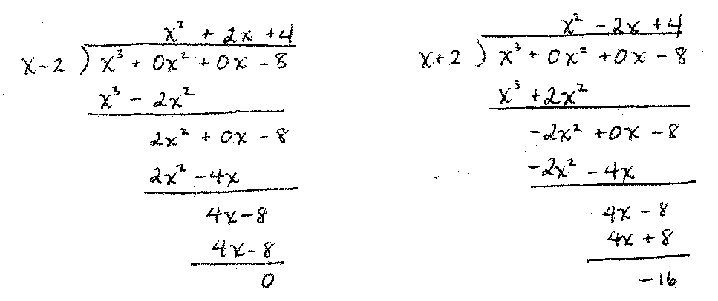
- Ask half of the students to divide $\left(x^{3}-8\right)÷(x-2)$ and the other half to divide $\left(x^{3}-8\right)÷\left(x+2\right).$They should discover that $x-2$ is a factor, but $x+2$ is not.
- Use the results of the previous step to factor $x^{3}-8.$
  - $x^{3}-8=(x-2)(x^{2}+2x+4)$
- Repeat the above process for $x^{3}-27$.
  - $x^{3}-27=\left(x-3\right)\left(x^{2}+3x+9\right)$
- Make a conjecture about a rule for factoring $x^{3}-a^{3}$.
  - $x^{3}-a^{3}=\left(x-a\right)\left(x^{2}+ax+a^{2}\right)$
- Verify the conjecture: Multiply out $\left(x-a\right)\left(x^{2}+ax+a^{2}\right)$ to establish the identity for factoring a difference of cubes.
While we can factor a difference of squares such as the expression $x^{2}-9$, we cannot similarly factor a sum of squares such as $x^{2}+9$. Do we run into a similar problem when trying to factor a sum of cubes such as $x^{3}+8$?
Again, ask students to propose potential factors of $x^{3}+8$. Lead students to $x+2$ if they do not guess it automatically.
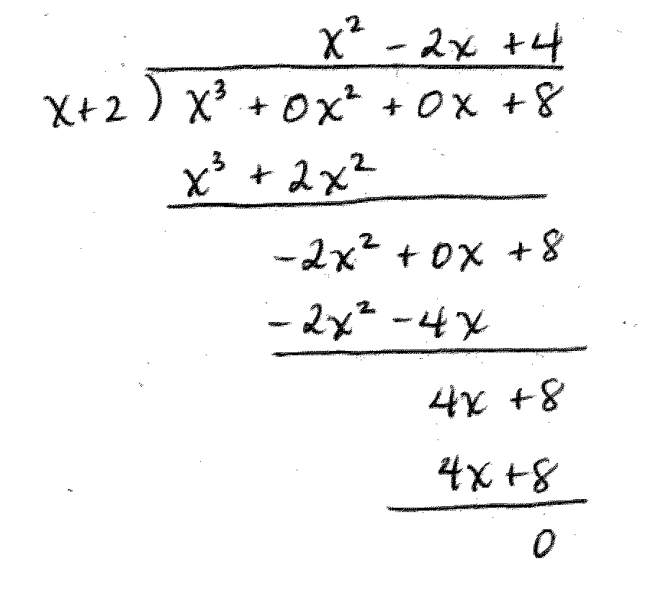
Work through the polynomial long division for ${(x}^{3}+8)÷\left(x+2\right)$ as shown.

- Conclude that $x^{3}+8=(x+2)(x^{2}-2x+4)$.

- Make a conjecture about a rule for factoring $x^{3}+a^{3}$.
  - $x^{3}+a^{3}=\left(x+a\right)\left(x^{2}-ax+a^{2}\right)$

- Verify the conjecture: Multiply out the expression $\left(x+a\right)\left(x^{2}-ax+a^{2}\right)$ to establish the identity for factoring a sum of cubes.

Exercises 2–4 (5 minutes)
Exercises 2–4
Factor each of the following, and show that the factored form is equivalent to the original expression.
- $a^{3}+27$
$(a+3)(a^{2}-3a+9)$
Scaffolding:
Ask advanced students to generate their own factoring problems using the structure of $a^{3}+b^{3}$ or $a^{3}-b^{3}$.

- $x^{3}-64$
$$(x-4)(x^{2}+4x+16)$$

- ${2x}^{3}+128$
$$2\left(x^{3}+64\right)= 2(x+4)(x^{2}-4x+16)$$

Closing (2 minutes)
Ask students to summarize the important parts of the lesson in writing, to a partner, or as a class. Use this as an opportunity to informally assess understanding of the lesson. The following are some important summary elements.
Lesson Summary
In this lesson we learned additional strategies for factoring polynomials.
- The difference of squares identity $a^{2}-b^{2}=\left(a-b\right)\left(a+b\right)$ can be used to to factor more advanced binomials.
- Trinomials can often be factored by looking for structure and then applying our previous factoring methods.
- Sums and differences of cubes can be factored by the formulas
$$x^{3}+a^{3}=\left(x+a\right)\left(x^{2}-ax+a^{2}\right) \\ x^{3}-a^{3}=\left(x-a\right)\left(x^{2}+ax+a^{2}\right).$$

Exit Ticket (5 minutes)
Name Date
Lesson 13: Mastering Factoring

Exit Ticket

- Factor the following expression and verify that the factored expression is equivalent to the original.
$$4x^{2}-9a^{6}$$

- Factor the following expression and verify that the factored expression is equivalent to the original
$16x^{2}-8x-3$
Exit Ticket Sample Solutions

- Factor the following expression and verify that the factored expression is equivalent to the original: $4x^{2}-9a^{6}$.
$$\left(2x-3a^{3}\right)\left(2x+3a^{3}\right)=4x^{2}+6a^{3}x-6a^{3}x-9a^{6} \\ =4x^{2}-9a^{6}$$

- Factor the following expression and verify that the factored expression is equivalent to the original: $16x^{2}-8x-3$.
$$\left(4x-3\right)\left(4x+1\right)=16x^{2}+4x-12x-3 \\ =16x^{2}-8x-3$$

Problem Set Sample Solutions

- If possible, factor the following expressions using the techniques discussed in this lesson.
- $25x^{2}-25x-14$ | $$(5x-7)(5x+2)$$
- $9x^{2}y^{2}-18xy+8$ | $$(3xy-4)(3xy-2)$$
- $45y^{2}+15y-10$ | $$5(3y+2)(3y-1)$$
- $y^{6}-y^{3}-6$ | $$(y^{3}-3)(y^{3}+2)$$
- $x^{3}-125$ | $$(x-5)(x^{2}+5x+25)$$
- $2x^{4}-16x$ | $$2x(x-2)(x^{2}+2x+4)$$
- $9x^{2}-25y^{4}z^{6}$ | $$\left(3x-5y^{2}z^{3}\right)\left(3x+5y^{2}z^{3}\right)$$
- $36x^{6}y^{4}z^{2}-25x^{2}z^{10}$ | $$x^{2}z^{2}(6x^{2}y^{2}-5z^{4})(6x^{2}y^{2}+5z^{4})$$
- $4x^{2}+9$ | Cannot be factored.
- $x^{4}-36$ | $$\left(x-\sqrt{6}\right)\left(x+\sqrt{6}\right)\left(x^{2}+6\right)$$
- $1+27x^{9}$ | $$\left(1+3x^{3}\right)\left(1-3x^{3}+9x^{6}\right)$$
- $x^{3}y^{6}+8z^{3}$ | $$\left(xy^{2}+2z\right)\left(x^{2}y^{4}-2xy^{2}z+4z^{2}\right)$$

- Consider the polynomial expression $y^{4}+4y^{2}+16$.
  - Is $y^{4}+4y^{2}+16$ factorable using the methods we have seen so far?
No. This will not factor into the form $(y^{2}+a)(y^{2}+b)$ using any of our previous methods.

  - Factor $y^{6}-64$ first as a difference of cubes, then factor completely: ${\left(y^{2}\right)}^{3}-4^{3}$.
$$y^{6}-64=\left(y^{2}-4\right)\left(y^{4}+4y^{2}+16\right) \\ =(y-2)(y+2)(y^{4}+4y^{2}+16)$$

  - Factor $y^{6}-64$ first as a difference of squares, then factor completely: ${\left(y^{3}\right)}^{2}-8^{2}.$
$$y^{6}-64=\left(y^{3}-8\right)\left(y^{3}+8\right) \\ =\left(y-2\right)\left(y^{2}+2y+4\right)\left(y+2\right)\left(y^{2}-2y+4\right) \\ =(y-2)(y+2)(y^{2}-2y+4)(y^{2}+2y+4)$$

  - Explain how your answers to parts (b) and (c) provide a factorization of $y^{4}+4y^{2}+16$.
Since $y^{6}-64$ can be factored two different ways, those factorizations are equal. Thus we have
$$\left(y-2\right)\left(y+2\right)\left(y^{4}+4y^{2}+16\right)=\left(y-2\right)\left(y+2\right)\left(y^{2}-2y+4\right)\left(y^{2}+2y+4\right)\text{.}$$
If we specify that $y≠2$ and $y≠-2$, we can cancel the common terms from both sides:
$$\left(y^{4}+4y^{2}+16\right)=\left(y^{2}-2y+4\right)\left(y^{2}+2y+4\right)\text{.}$$
Multiplying this out, we see that
$$\left(y^{2}-2y+4\right)\left(y^{2}+2y+4\right)=y^{4}+2y^{3}+4y^{2}-2y^{3}-4y^{2}-8y+4y^{2}+8y+16 \\ =y^{4}+4y^{2}+16$$
for every value of $y$.

  - If a polynomial can be factored as either a difference of squares or a difference of cubes, which formula should you apply first, and why?
Based on this example, a polynomial should first be factored as a difference of squares and then as a difference of cubes. This will produce factors of lower degree.

- Create expressions that have a structure that allows them to be factored using the specified identity. Be creative and produce challenging problems!
  - Difference of squares
$$x^{14}y^{4}-225z^{10}$$

  - Difference of cubes
$$27x^{9}y^{6}-1$$

  - Sum of cubes
$x^{6}z^{3}+64y^{12}$

