Lesson 7: Mental Math

Student Outcomes
- Students perform arithmetic by using polynomial identities to describe numerical relationships.

Lesson Notes
Students continue exploring the usefulness of polynomial identities to perform arithmetic calculations. This work reinforces the essential understanding of A.APR and A.SEE standards. The lesson concludes by discussing prime and composite numbers and using polynomial identities to check whether a number is prime or composite. This lesson ties into the work in the next lesson which further investigates prime numbers.
The tree diagram analysis, touched upon later in the lesson, offers a connection to some of the probability work that will occur later in this course.

Classwork
Opening (1 minute)
Students will perform arithmetic that they might not have thought possible without the assistance of a calculator or computer. To motivate this lesson, mention a multiplication problem of the form $(a-b)(a+b)$ that is difficult to calculate without pencil and paper, such as $87⋅93$. Perhaps even time students to see how long it takes them to do this calculation without a calculator.
- Today we use the polynomial identities derived in Lesson 6 to perform a variety of calculations quickly using mental arithmetic.

Opening Exercise (3 minutes)
Have students complete the following exercises. Ask students to discuss their ideas with a partner, and then have them summarize their thoughts on the lesson handout. These two exercises build upon the concept of division of polynomials developed in previous lessons by addressing both multiplication and division.
Opening Exercise
  - How are these two equations related?
$\frac{x^{2}-1}{x+1}=x-1$ and $x^{2}-1=(x+1)(x-1)$
They represent the same relationship between the expressions $x^{2}-1$, $x-1$, and $x+1$. One shows the relationship as division and the other as multiplication.

  - Explain the relationship between the polynomial identities $x^{2}-1=(x+1)(x-1)$ and $x^{2}-a^{2}=(x-a)(x+a)$.
The expression $x^{2}-1$ is of the form $x^{2}-a^{2}$, with $a=1$. Note that this works with $a=-1$ as well.
Discussion (8 minutes)
Call on a student to share his or her solutions to the Opening Exercise. Then invite other students to add their thoughts to the discussion. This discussion should show students how to apply the difference of two squares identity to quickly find the product of two numbers. Use the questions below to prompt a discussion.
- Consider $(x-1)(x+1)=x^{2}-1$. If $x=100$, what number sentence is represented by this identity? Which side of the equation is easier to compute?
  - This is $99 × 101={100}^{2}-1$.
  - Computing ${100}^{2}-1$ is far easier than the original multiplication.
- Now let’s consider the more general $x^{2}-a^{2}=(x-a)(x+a)$. Keep $x=100$, and test some small positive integer values for $a$. What multiplication problem does each one represent?
- How does the identity $\left(x-a\right)\left(x+a\right)=x^{2}-a^{2}$ make these multiplication problems easier?
  - Let $x=100$ and $a=5$.
$$(x-a)(x+a)=x^{2}-a^{2}$$
$$95⋅105=\left(100-5\right)\left(100+5\right)={100}^{2}-5^{2}$$
Therefore, $95⋅105={100}^{2}-5^{2}=10,000-25=9,975$.
Let $x=100$ and $a=7$.
$$(x-a)(x+a)=x^{2}-a^{2} \\ 93⋅107=\left(100-7\right)\left(100+7\right)={100}^{2}-7^{2}$$
Therefore, $93⋅107={100}^{2}-7^{2}=10,000-49=9,951$.

- Do you notice any patterns?
  - The products in these examples are differences of squares.
  - The factors in the product are exactly ‘$a$’ above and ‘$a$’ below $100$.
- How could you use the difference of two squares identity to multiply $92∙108$? How did you determine the values of$x$ and$a$?
  - You could let $x=100$ and $a=8$. We must figure out each number’s distance from $100$ on the number line.
- How would you use the difference of two squares identity to multiply $87∙93$? What values should you select for $x$ and $a$? How did you determine them?
  - We cannot use $100$, but these two numbers are $3$ above and $3$ below $90$. So we can use
$$\left(90-3\right)\left(90+3\right)={90}^{2}-3^{2}=8,100-9=8,091.$$
  - In general, $x$ is the mean of the factors, and $a$ is half of the absolute value of the difference between the factors.
Depending on the level of your students, you may wish to wait until after Exercise 1 to make a generalized statement about how to determine the $x$ and $a$ values used to solve these problems. They may need to experiment with some additional problems before they are ready to generalize a pattern.

Exercise 1 (4 minutes)
Have students work individually and then check their answers with a partner. Make sure they write out their steps as in the sample solutions. After a few minutes, invite students to share one or two solutions on the board.
Exercises 1–3
- Compute the following products using the identity $x^{2}-a^{2}=(x-a)(x+a)$. Show your steps.
- $6⋅8$ | $$6⋅8=\left(7-1\right)\left(7+1\right) \\ =7^{2}-1^{2} \\ =49-1 \\ =48$$
- $11⋅19$ | $$11⋅19=\left(15-4\right)\left(15+4\right) \\ =15^{2}-4^{2} \\ =225-16 \\ =209$$
- $23⋅17$ | $$23⋅17=\left(20+3\right)\left(20-3\right) \\ =20^{2}-3^{2} \\ =400-9 \\ =391$$
- $34⋅26$ | $$34⋅26=\left(30+4\right)\left(30-4\right) \\ =30^{2}-4^{2} \\ =900-16 \\ =884$$

Discussion (5 minutes)
At this point make sure your students have a clear way to determine how to write a product as the difference of two squares. Then put these problems on the board.
$56∙63$ $24∙76$ $998∙1,002$
Give them a few minutes to struggle with these problems. While it is possible to use the identity to rewrite each expression, the first two problems do not make for an easy calculation when written as the difference of two squares. The third problem is easy even though the numbers are large.
MP.3
- Which product is easier to compute using mental math? Explain your reasoning.
  - The last one is the easiest. In the first one, the numbers have a mean of $59.5$ which is not easy to square mentally. The second example would be ${50}^{2}-{26}^{2}$, which is not so each to calculate mentally.
- Can the product of any two positive integers be written as the difference of two squares?
  - Yes, but not all of them will be rewritten in a form that makes computation easy.
- If you wanted to impress your friends with your mental math abilities and they gave you these three problems to choose from, which one would you pick and why?
$509∙493$ $511∙489$ $545∙455$
  - This middle one is the easiest since the numbers are $11$ above and below the number $500$.

Discussion (10 minutes)
At this point, we can introduce the power of algebra over the calculator.
- The identity $x^{2}-a^{2}$ is just the $n=2$ case of the identity
$x^{n}-a^{n}=(x-a)(x^{n-1}+ax^{n-2}+a^{2}x^{n-2}+…a^{n-1})$.
- How might we use this general identity to quickly count mentally?
To see how, let’s doodle. A tree is a figure made of points called vertices and segments called branches. My tree splits into two branches at each vertex.

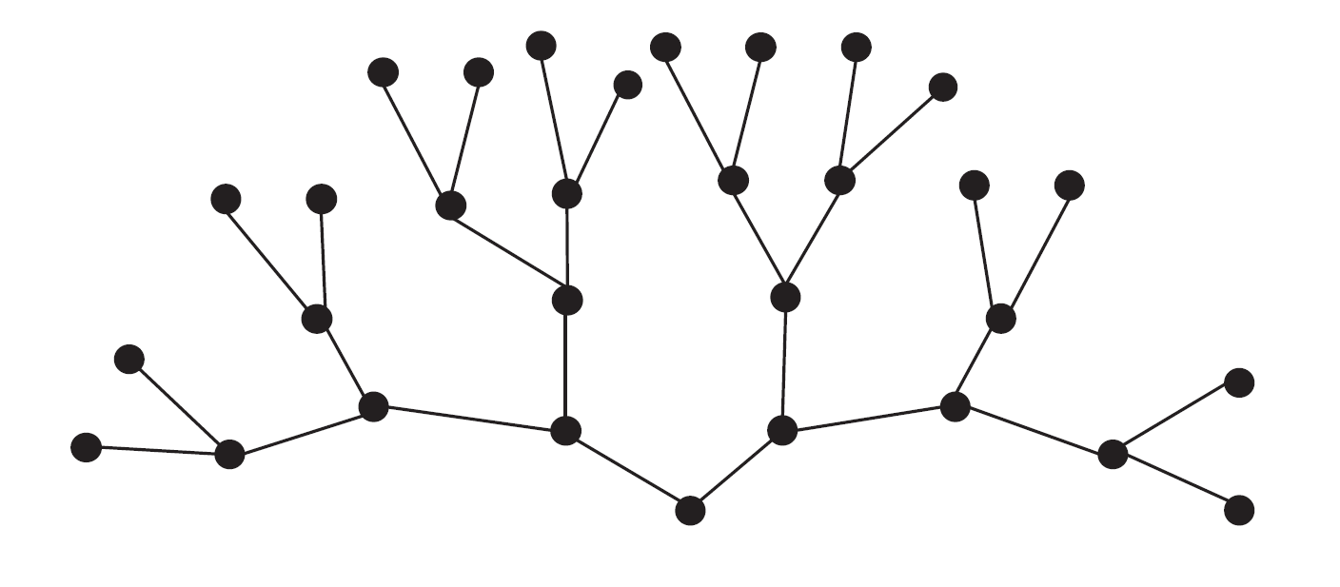

- How many vertices does my tree have?
Allow students to count the vertices for a short while, but don’t dwell on the answer.
- It is difficult to count the vertices of this tree, so let’s draw it in a more organized way.

Present the following drawing of the tree, with vertices aligned in rows corresponding to their levels.
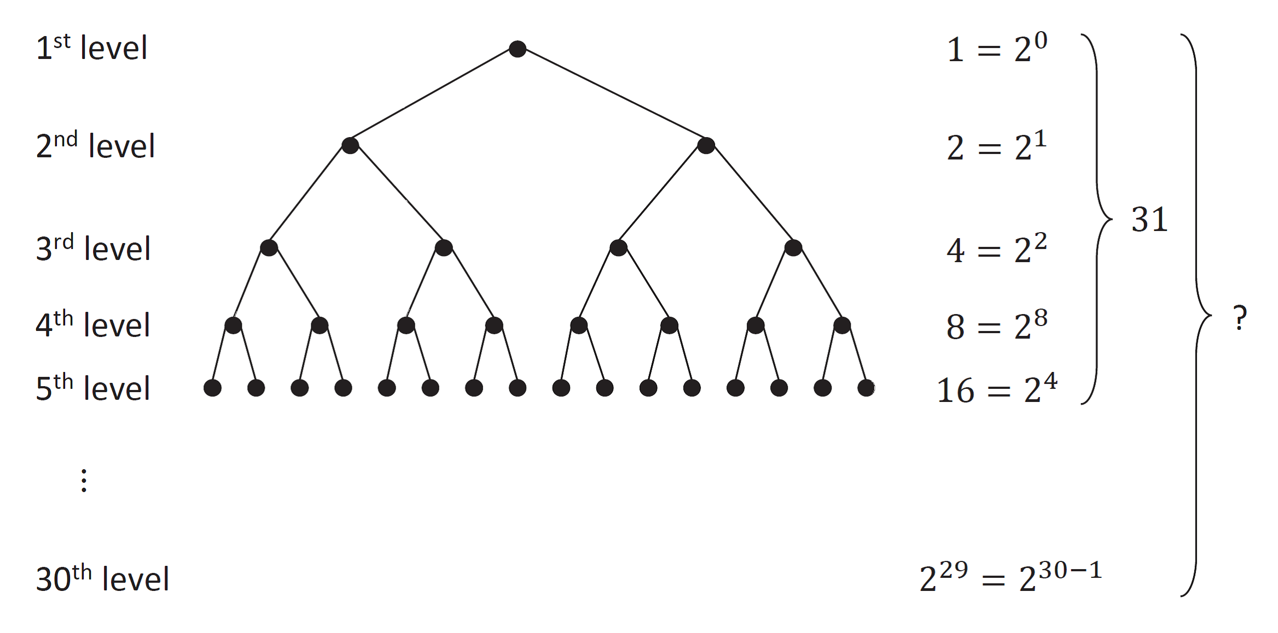

For the following question, give students time to write or share their thinking with a neighbor.
- How many vertices are in each level? Find a formula to describe the number of vertices in level $n$.
  - The number of vertices in each level follows this sequence: $\{1, 2, 4, 8, 16,…\}$, so in level $n$ there are $2^{n-1}$ vertices.
- How many vertices are there in all $5$ levels? Explain how you know.
  - The number of vertices in our tree, which has five levels, is $2^{4}+2^{3}+2^{2}+2+1$. First, we recognize that $2-1=1$, so we can rewrite our expression as ${(2-1)(2}^{4}+2^{3}+2^{2}+2+1)$. If we let $x=2$, this numerical expression becomes a polynomial expression.
$2^{4}+2^{3}+2^{2}+2+1=\left(2-1\right)\left(2^{4}+2^{3}+2^{2}+2+1\right)$$$=\left(x-1\right)\left(x^{4}+x^{3}+x^{2}+x+1\right) \\ =x^{5}-1 \\ =2^{5}-1 \\ =31$$
MP.3
- How could you find the total number of vertices in a tree like this one with $n$ levels? Explain.
  - Repeating what we did with $n=5$ in the previous step, we have
$$2^{n-1}+2^{n-2}+⋯+2+1=\left(2-1\right)\left(2^{n-1}+2^{n-2}+⋯+2+1\right) \\ =\left(x-1\right)\left(x^{n-1}+x^{n-2}+⋯+x+1\right) \\ =x^{n}-1 \\ =2^{n}-1\text{.}$$
Thus, a tree like this one with $n$ levels has $2^{n}-1$ vertices.

- Now, suppose I drew a tree with $30$ levels:

- How many vertices would a tree with $30$ levels have?
  - According to the formula we developed in the last step, the number of vertices is
$$2^{n}-1=2^{30}-1.$$
- Would you prefer to count all $1,073,741,823$ vertices?
  - No.
Discussion (5 minutes)
This discussion is designed to setup the general identity for $x^{n}-a^{n}$ to identify some composite numbers in the next lesson.
- Recall that a prime number is a positive integer greater than $1$ whose only positive integer factors are $1$ and itself. A composite number can be written as the product of positive integers with at least one factor that is not $1$ or itself.
- Suppose that $a$, $b$, and $n$ are positive integers with $b>a$. What does the identity $x^{n}-a^{n}=(x-a)(x^{n-1}+ax^{n-2}+a^{2}x^{n-2}+…{+ a}^{n-1})$ suggest about whether or not the number $b^{n}-a^{n}$ is prime?
Scaffolding:
If students are struggling with the words “prime” and “composite,” try doing a quick T-chart activity in which students classify numbers as prime or composite on either side of the T.
  - We see that $b^{n}-a^{n}$ is divisible by $b-a$ and that
$${b^{n}-a^{n}=(b-a)(b}^{n-1}+ab^{n-2}+…{+ a}^{n-1}).$$
  - If $b-a=1$, then we do not know if $b^{n}-a^{n}$ is prime because we do not know if $b^{n-1}+ab^{n-2}+…{+ a}^{n-1}$is prime. For example, ${15}^{2}-{14}^{2}=225-196=29$ is prime, but ${17}^{2}-{16}^{2}=289-256=33$ is composite.
  - But, if $b-a>1$ then we know that that $b^{n}-a^{n}$ is not prime.
- Use the identity for $b^{n}-a^{n}$ to determine whether or not $143$ is prime. Check your work using a calculator.
  - Let $b=12$, $a=1$, and $n=2$. Since $b-a$ is a factor of $b^{n}-a^{n}$, and $b-a=12-1=11$, we know that $11$ is a factor of $143$, which means that $143$ is not prime. The calculator shows $143=11∙13$.
- We could have used a calculator to determine that $11⋅13=143$, so that $143$ is not prime. Will a calculator help us determine whether $2^{100}-1$ is prime? Try it.
  - The calculator will have difficulty calculating a number this large.
- Can we determine whether or not $2^{100}-1$ is prime using identities from this lesson?
  - We can try to apply the following identity.
$$x^{n}-1=\left(x-1\right)\left(x^{n-1}+x^{n-2}+…+1\right)$$
  - If we let $n=100$, then this identity does not help us because 1 divides both composites and primes.
$$2^{100}-1=(2-1)(2^{99}+2^{98}+…2+1)$$
- But, what if we look at this problem a bit differently?
$$2^{100}-1={\left(2^{4}\right)}^{25}-1={16}^{25}-1=\left(16-1\right)\left({16}^{24}+{16}^{23}+…+16+1\right)$$
  - We can see now that $2^{100}-1$ is divisible by $15$, so $2^{100}-1$ is not prime.
- What can we conclude from this discussion?
  - If we can write a positive integer as the difference of squares of non-consecutive integers, then that integer is composite.

Exercises 2–3 (4 minutes)

- Find two additional factors of $2^{100}-1$.
$$2^{100}-1={\left(2^{5}\right)}^{20}-1 \\ ={32}^{20}-1 \\ =\left(32-1\right)\left(32^{19}+32^{18}+…+32+1\right)$$ | $$2^{100}-1={\left(2^{2}\right)}^{50}-1 \\ =4^{50}-1 \\ =\left(4-1\right)\left(4^{49}+4^{48}+…+4+1\right)$$
Thus $31$ is a factor and so is $3$.
- Show that $8^{3}-1$ is divisible by $7$.
$$8^{3}-1=(8-1)(8^{2}+8+1)$$

Closing (2 minutes)
Ask students to write a mental math problem that they can now do easily and to explain why the calculation can be done simply.
Ask students to summarize the important parts of the lesson, either in writing, to a partner, or as a class. Use this opportunity to informally assess their understanding of the lesson. The following are some important summary elements:
Lesson Summary
Based on the work in this lesson, we can convert differences of squares into products (and vice versa) using
$x^{2}-a^{2}=\left(x-a\right)\left(x+a\right)$.
If $x$, $a$, and $n$ are integers and $n>1$, then numbers of the form $x^{n}-a^{n}$ are not prime because
$x^{n}-a^{n}=\left(x-a\right)\left(x^{n-1}+ax^{n-2}+a^{2}x^{n-3}+⋯+{a^{n-2}x+a}^{n-1}\right)$.
.

Exit Ticket (3 minutes)
Name Date
Lesson 7: Mental Math

Exit Ticket

- Explain how to use the patterns in this lesson to quickly compute $\left(57\right)\left(43\right).$

- Jessica believes that ${10}^{3}-1$ is divisible by $9.$ Use your work from this lesson to support or refute her claim.

Exit Ticket Sample Solutions

- Explain how you could use the patterns in this lesson to quickly compute $\left(57\right)\left(43\right)$.
Subtract $49$ from $2,500$. That would be $2,451$. You can use the identity $x^{2}-a^{2}=\left(x+a\right)\left(x-a\right)$. In this case, $x=50$ and $a=7$.
MP.3
- Jessica believes that ${10}^{3}-1$ is divisible by $9$. Support or refute her claim using your work in this lesson.
Since we recognize that $9=10-1$, then $\frac{10^{3}-1}{9}$ fits the pattern of $\frac{x^{3}-a^{3}}{x-a}$ where $x=10$and $a=1$. Therefore,
$\frac{10^{3}-1}{9}=\frac{10^{3}-1}{10-1}=10^{2}+10+1\text{,}$
and Jessica is correct.

Problem Set Sample Solutions

- Using an appropriate polynomial identity, quickly compute the following products. Show each step. Be sure to state your values for $x$ and $a$.
- $41⋅19$ | $a=11$, $x=30$  $$\left(x+a\right)\left(x-a\right)=x^{2}-a^{2} \\ \left(30+11\right)\left(30-11\right)=30^{2}-11^{2} \\ =900-121 \\ =779$$
- $993⋅1,007$ | $a=7$,$x=1,000$  $$\left(x-a\right)\left(x+a\right)=x^{2}-a^{2} \\ \left(1,000-7\right)\left(1,000+7\right)=1,000^{2}-7^{2} \\ =1,000,000-49 \\ =999,951$$
- $213⋅187$ | $a=13$,$x=200$  $$\left(x-a\right)\left(x+a\right)=x^{2}-a^{2} \\ \left(200-13\right)\left(200+13\right)={200}^{2}-{13}^{2} \\ =40,000-169 \\ =39,831$$
- $29⋅51$ | $a=11$,$x=40$  $$\left(x-a\right)\left(x+a\right)=x^{2}-a^{2} \\ \left(40-11\right)\left(40+11\right)=40^{2}-{11}^{2} \\ =1,600-121 \\ =1,479$$
- $125⋅75$ | $a=25$,$x=100$  $$\left(x-a\right)\left(x+a\right)=x^{2}-a^{2} \\ \left(100-25\right)\left(100+25\right)=100^{2}-{25}^{2} \\ =10,000-625 \\ =9,375$$

- Give the general steps you take to determine $x$ and $a$ when asked to compute a product such as those in Problem 1.
The number $x$ is the mean (“average” is also acceptable) of the two factors, and $a$ is the positive difference between $x$ and either factor.
- Why is $17⋅23$ easier to compute than $17⋅22$?
The mean of $17$ and $22$ is $19.5$, whereas the mean of $17$ and $23$ is the integer $20$. I know that the square of $20$ is $400$ and the square of $3$ is $9$. However, I cannot quickly compute the squares of $19.5$ and $2.5$.

- Rewrite the following differences of squares as a product of two integers.
- $81-1$ | $$81-1=9^{2}-1^{2} \\ =\left(9-1\right)\left(9+1\right) \\ =8⋅10$$
- $400-121$ | $$400-121=20^{2}-11^{2} \\ =\left(20-11\right)\left(20+11\right) \\ =9⋅31$$

- Quickly compute the following differences of squares.
- $64^{2}-14^{2}$ | $$64^{2}-14^{2}=\left(64-14\right)\left(64+14\right) \\ =50⋅78 \\ =3,900$$
- $112^{2}-{88}^{2}$ | $$112^{2}-88^{2}=\left(112-88\right)\left(112+88\right) \\ =24⋅200 \\ =4,800$$
- $785^{2}-{215}^{2}$ | $$785^{2}-215^{2}=(785-215)(785+215) \\ =570⋅1,000 \\ =570,000$$

- Is $323$ prime? Use the fact that $18^{2}=324$ and an identity to support your answer.
No, $323$is not prime because it is equal to ${18}^{2}-1$. Therefore, $323=(18-1)(18+1)$.
Note: This problem can also be solved through factoring.

- The number $2^{3}-1$is prime and so are $2^{5}-1$ and $2^{7}-1$. Does that mean $2^{9}-1$ is prime? Explain why or why not.
$$2^{9}-1={\left(2^{3}\right)}^{3}-1 \\ =(2^{3}-1)({\left(2^{3}\right)}^{2}+2^{3}\left(1\right)+1^{2})$$
The factors are $7$ and $73$. As such, $2^{9}-1$ is not prime.

- Show that $9,999,999,991$is not prime without using a calculator or computer.
Note that $9,999,999,991=10,000,000,000-9$. Since $10^{10}$ is the square of $10^{5}$, $10,000,000,000$ is the square of $100,000$. Since $9$ is the square of $3$; $9,999,999,991=100,000^{2}-3^{2}$; which is divisible by $100,000-3$ and by $100,000+3$.

- Show that $999,973$ is not prime without using a calculator or computer.
Note that $999,973=1,000,000-27$. Since $27=3^{3}$ and $1,000,000=100^{3}$ are both perfect cubes, we have $999,973=100^{3}-3^{3}$. Therefore, we know that $999,973$ is divisible by $100-3=97$.

- Find a value of $b$ so that the expression $b^{n}-1$ is always divisible by $5$ for any positive integer $n$. Explain why your value of $b$ works for any positive integer $n$.
There are many correct answers. If $b=6$, then the expression $6^{n}-1$ will always be divisible by $5$ because $5=6-1$. This will work for any value of $b$ that is one more than a multiple of $5$, such as $b=101$ or $b=11.$

- Find a value of $b$ so that the expression $b^{n}-1$ is always divisible by $7$ for any positive integer $n$. Explain why your value of $b$ works for any positive integer $n$.
There are many correct answers. If $b=8$, then the expression $8^{n}-1$ will always be divisible by $7$ because $7=8-1$. This will work for any value of $b$ that is one more than a multiple of $7$, such as $b=50$ or $b=15$.

- Find a value of $b$ so that the expression $b^{n}-1$ is divisible by both $7$ and 9 for any positive integer $n$. Explain why your value of $b$ works for any positive integer $n$.
There are multiple correct answers, but one simple answer is $b=64.$ Since $64=8^{2}$, $64^{n}-1={\left(8^{2}\right)}^{n}-1$ has a factor of $8^{2}-1$, which factors into $\left(8-1\right)\left(8+1\right)= 7∙9$.

