Lesson 12
Objective: Position solid shapes to create a model of a familiar place.

Suggested Lesson Structure
 Fluency Practice (3 minutes)
 Application Problem (5 minutes)
 Concept Development (14 minutes)
 Student Debrief (3 minutes)
Total Time (25 minutes)
Fluency Practice (3 minutes)
- March and Count to 7! PK.CC.1 (3 minutes)
March and Count to 7! (3 minutes)
Note: This fluency activity supports rote counting through 7 in preparation for GPK–Module 3.
T: Let’s march! Count with me. (Demonstrate marching while counting to 7. Start calling up the students one by one to march as their counting gets stronger.) Join in and follow me when I call your name! Armen. 1, 2, 3, 4, fiiive, 6, 7. Paula. 1, 2, 3, 4, fiiive, 6, 7. Ester. 1, 2, 3, 4, fiiive, 6, 7. Bobby! 1, 2, 3, 4, fiiive, 6, 7.
Application Problem (5 minutes)
Materials: (T) The Secret Birthday Message by Eric Carle
Read the book to the children. On the rock page, ask children what the oval stands for, or models. Repeat for the triangle, circle, and rectangle pages.
Note: This book depicts a boy using landmarks to find his birthday present. The landmarks are represented by shapes, preparing children to use shapes to represent objects in their classroom.
Concept Development (14 minutes)
Part 1: Concept Introduction
Materials: (T) Foam or wooden 3-D shapes (including small centimeter cubes), large blank piece of construction paper, 1 small doll or animal counter
1. Say, “Let’s use our shapes to make a model of our classroom.” Lead a walk around the classroom, carrying the box of 3-D shapes.
2. As you walk, stop when you get to a prominent piece of furniture or “landmark.” For example, say, “Is there a shape in this box that we could use to model this bookcase?” Invite a student to choose an appropriate shape and hold onto it.
3. Say, “Let’s sit down with the shapes we are going to use to make a model of our classroom.”
4. Place a large, blank piece of construction paper (representing the classroom) in the center of the floor. Ask, “Who has the shape that looks like our bookcase, the one we chose to model our bookcase?”
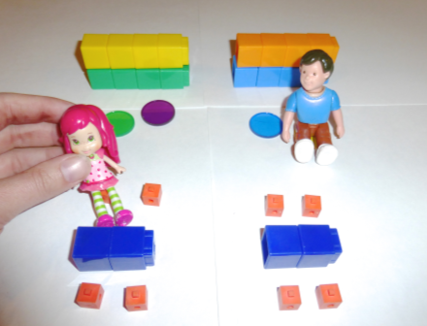
5. Invite the student with the bookcase shape to position it on the construction paper. Lead a discussion about placement, and help the student orient the shape to match the room layout. Reinforce position words as more students place their shapes, e.g., “You put the bookcase next to the door.”
6. Repeat until all the shapes are positioned on the paper.
7. Use a small doll or animal counter to walk through the model. Encourage students to call out what the doll is walking by in the model. “The doll is walking to the art table. The doll is in the reading center.”
Part 2: Practice

NOTES ON
MULTIPLE MEANS
OF ENGAGEMENT:
After sharing their classroom models with their families, encourage students to make a model of a room from their home or a place in the community with their families. This will strengthen the home–school connection and cultivate excitement.

Materials: (S) Various solid shapes
1. What are some other places we could use the shapes to model or build? (The cafeteria, the gym, their bedrooms, the playground.)
2. Send students to their prepared tables to make a model using the solid shapes.
3. Circulate as students share with a partner what the solid shapes represent in their model. “This sphere is a ball on the playground.” “The block next to the ball is the slide.”
Student Debrief (3 minutes)
Lesson Objective: Position solid shapes to create a model of a familiar place.
The Student Debrief is intended to invite reflection and active processing of the total lesson experience. It is also an opportunity for informal assessment. Consider taking anecdotal notes or using a simple checklist to note each child’s progress towards meeting the lesson objective.
As students complete the Practice portion of the Concept Development, listen for misconceptions or misunderstandings that can be addressed in the Debrief. You may choose to use any combination of the questions below to help students express ideas, make connections, and use new vocabulary (model).

CENTER CONNECTION:
Use the dramatic play center as a place to make additional maps. Invite children to make 3-D and 2-D models of the current scene in the dramatic play area (e.g., doctor’s office, restaurant, zoo). Provide support as they choose materials and encourage them to use position words to describe their models.

- What did we make today?
- What important words would you use to describe our model?
- Think about the playground. (Hold up a rectangular box.) Finish my sentence: This shape could be a model of…. (Continue with other 3-D shapes.)

