Topic C
Three-Dimensional Shapes
PK.G.3, PK.MD.2, PK.G.1
Focus Standards: | PK.G.3 | Analyze, compare, and sort two- and three-dimensional shapes and objects, in different sizes, using informal language to describe their similarities, differences, and other attributes (e.g., color, size, and shape).
Instructional Days: | 4
Coherence -Links to: | GK–M2 | Two-Dimensional and Three-Dimensional Shapes
 | GK–M6 | Analyzing, Comparing, and Composing Shapes
In Topic C, children identify, analyze, sort, compare, and position three-dimensional (3-D) shapes (PK.G.1–3). This topic focuses on analyzing three-dimensional shapes (real world, wooden, or foam) by considering their two-dimensional faces and describing their functional properties (e.g., stacking or rolling) in order to build with them.
Lesson 9 follows the same format as Lesson 1 as students explore and sort solid shapes (sphere, rectangular block, cylinder, cone, cube, triangular block or pyramid) pulled from a mystery bag. Then, students act as shape detectives with a partner and hunt for shapes throughout the classroom, matching each three-dimensional shape to its wooden or foam block counterpart (e.g., soup can to a wooden cylinder). While teachers may use mathematical names to identify shapes (e.g., cube), students might informally identify three-dimensional shapes, calling a sphere a ball or a cylinder a can. When comparing shapes informally, students notice that some three-dimensional shapes have “a lot of flat parts and some don’t have any,” or “some have pointy parts and some are round.”
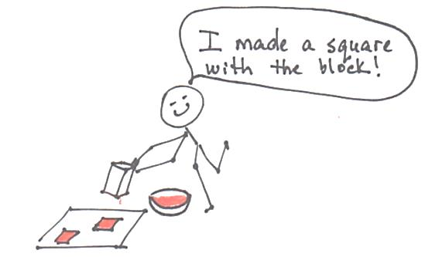
In Lesson 10, students consider and compare the parts of three-dimensional shapes. They analyze the happy faces of two-dimensional paper shapes in different sizes and orientations (PK.G.2), and match them to their solid counterparts: “Look! The circle happy face fits this shape!” Then, using three-dimensional foam shapes as stamps, students identify the “footprint” that their shape is making as it marches along a path. Such activities build geometric reasoning skills and understanding of shape and structure.
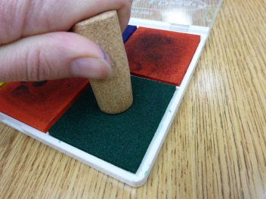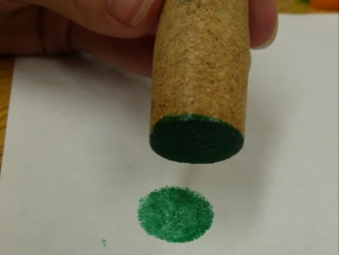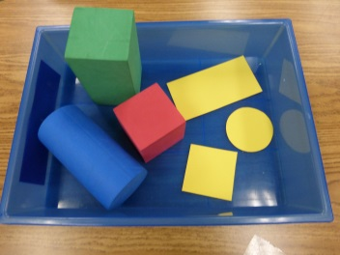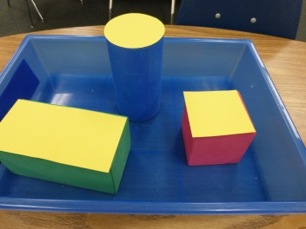
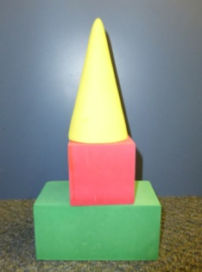
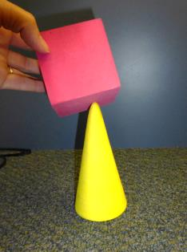
In Lesson 11, students develop spatial visualization skills as they examine and describe the functionality of different solid shapes in order to build with them (blocks). Students experiment with how each shape moves, and based on these experiments, create buildings, rooms, towers, or bridges. In the context of play, the attention to attributes becomes inherently important as students notice, for example, that while a cone could be used at the top of their structure, it is difficult to use this solid as a support for other shapes. Hence, students see that solids with multiple faces are the most versatile building block. As students articulate their thinking, they begin to see how the parts relate to the whole construction. For example, a student might say, “I can stack boxes because they are flat on the top and bottom.” The teacher is encouraged to photograph and celebrate the children’s unique creations.
Lesson 12 again highlights spatial visualization skills as students synthesize their understanding of position words and the structure of three-dimensional shapes to construct a simple model of a familiar place, such as the classroom or their bedroom. Using a rectangular block for a bed and a cube to represent a desk gives the child a foundational experience with abstraction—something crucial to their mathematical development.
In Topic C Fluency Practice, anticipating the work in Module 3 wherein students explore numbers through 10, students practice rote counting to 6 and 7 through fun, energizing activities such as playing the drums and marching.

A Teaching Sequence Towards Mastery of Three-Dimensional Shapes
Objective 1: Find and describe solid shapes using informal language without naming.
(Lesson 9)
Objective 2: Identify, analyze, sort, compare, and match solid shapes to their two-dimensional faces.
(Lesson 10)
Objective 3: Identify, analyze, sort, compare, and build with solid shapes.
(Lesson 11)
Objective 4: Position solid shapes to create a model of a familiar place.
(Lesson 12)

