Lesson 8

Objective: Construct a circle.

Suggested Lesson Structure
 Fluency Practice (5 minutes)
 Concept Development (15 minutes)
 Application Problem (2 minutes)
 Student Debrief (3 minutes)
Total Time (25 minutes)

Fluency Practice (5 minutes)
- Make Five Small Balls PK.CC.3a (5 minutes)

Make Five Small Balls (5 minutes)

Materials: (S) Small ball of clay
Note: Students will improve at partitioning their clay over the three days. Call that to their attention, “Look how much better you are at making balls that are about the same!” If certain students were less successful yesterday making four balls, suggest they can make two, three, four, or five balls the same size. This will make comparing the size of the balls in the final question easier.
T: Show me your ball of clay!
S: (Do so.)
T: How many balls of clay do you have?
S: 1!
T: Use the whole piece of clay to make two smaller balls of clay that are about the same size.
S: (Do so.)
Repeat, making five balls. Ask, “Which balls were bigger, when we made two balls or five balls?”

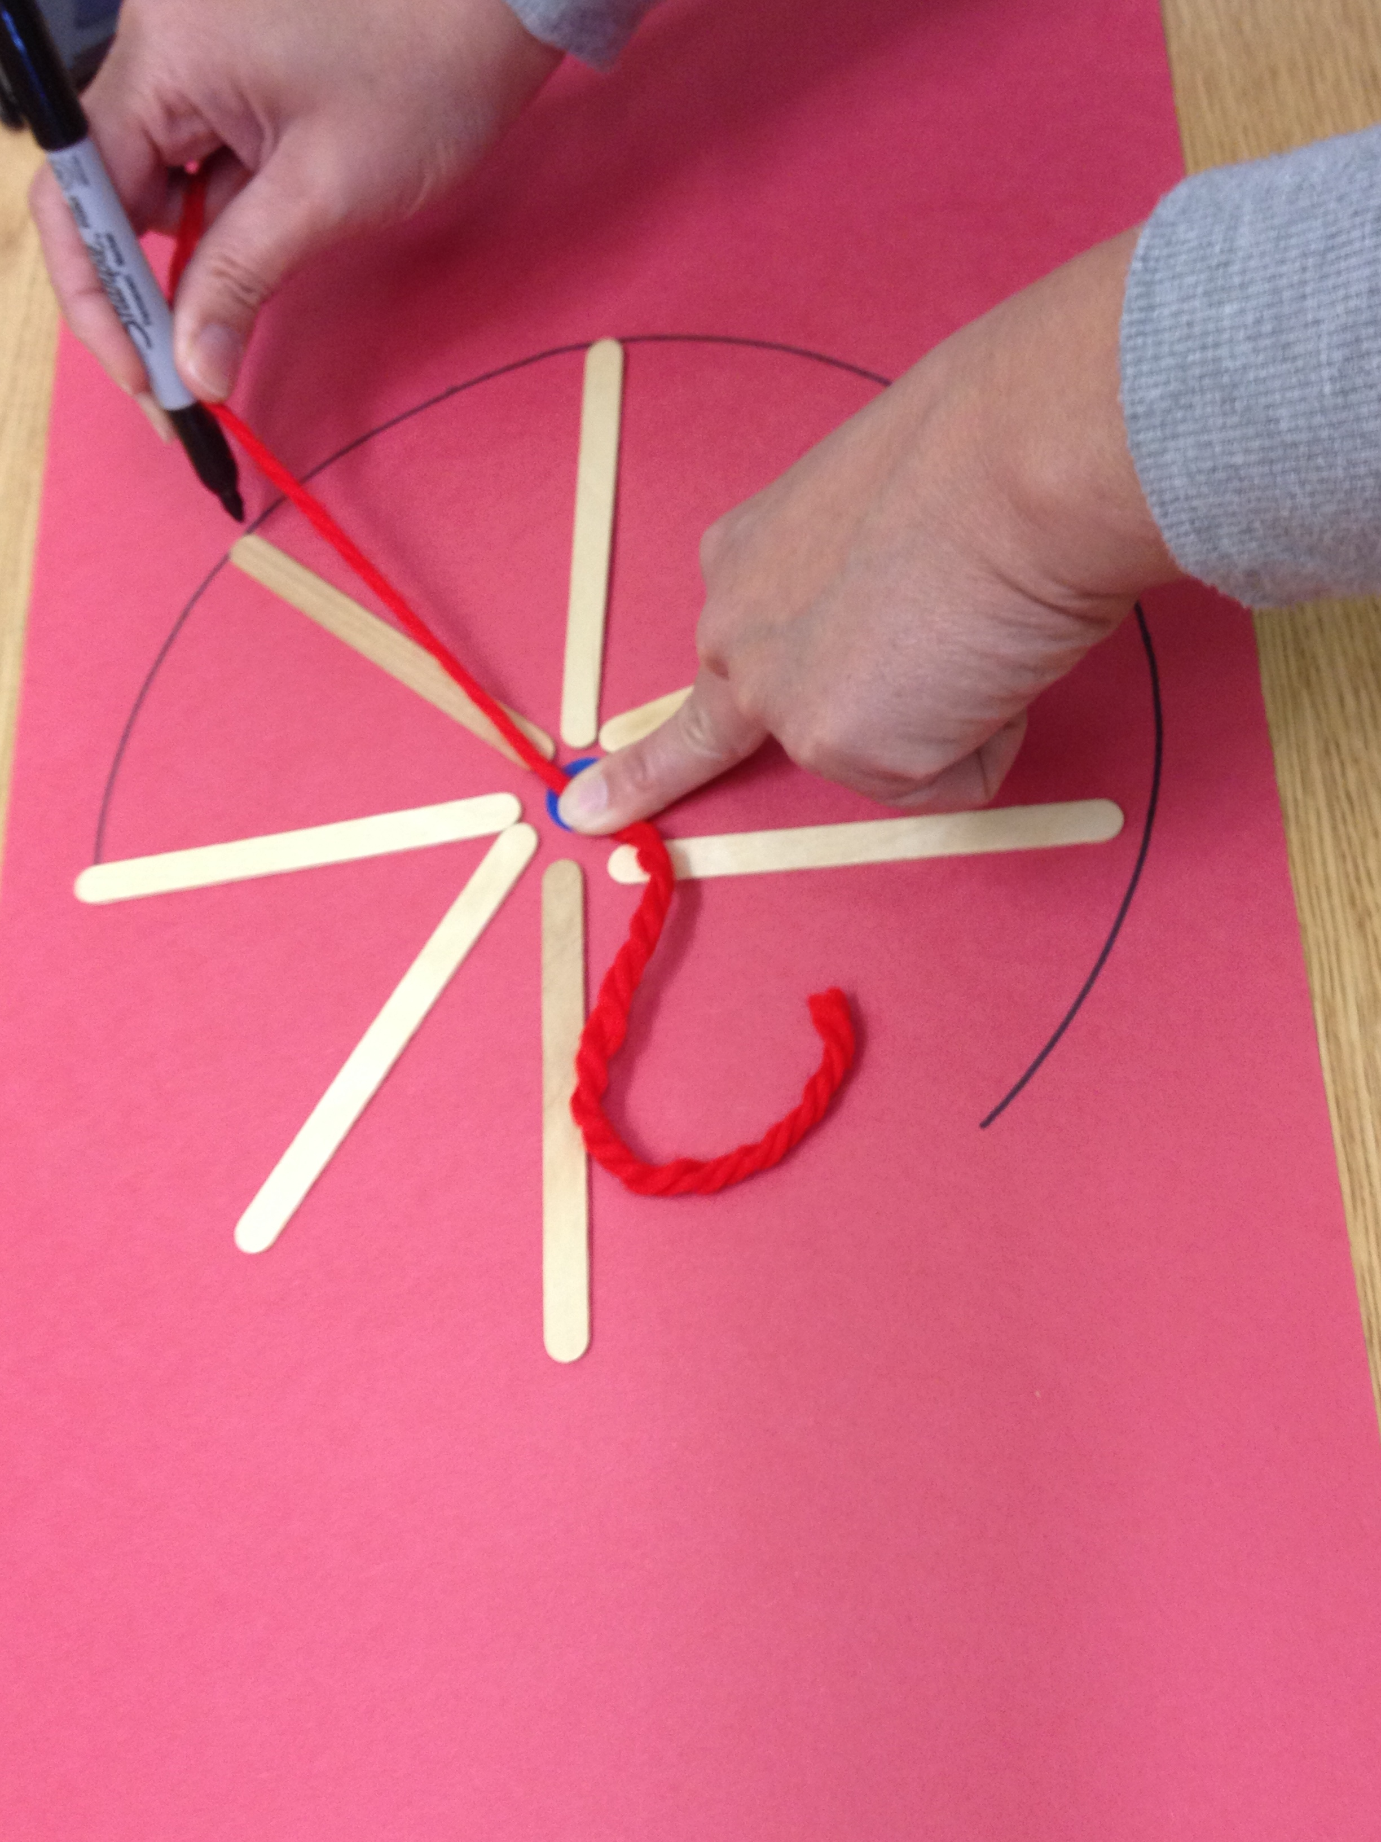
Concept Development (15 minutes)

Part 1: Concept Introduction
Materials: (T) 1 large piece of construction paper, circle template (teacher created), 8 craft sticks, 16 linking cubes, dot stickers, wheel (Template 1), oval (Template 2)
Note: The circle template will need to be made by teachers on a paper large enough for a 4.5" craft stick radius for this lesson. Once measured, use a string and pen to make the template. Oval template provided.
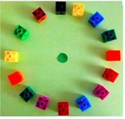
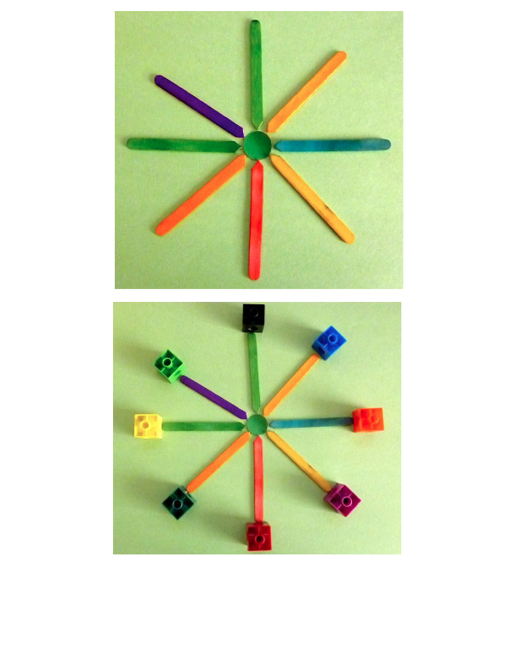
1. Put a dot sticker in the middle of the large piece of construction paper. Say, “We are going to make another shape today by putting these pretend lollipops around this dot.” Demonstrate placing a stick with one end touching the dot sticker and a linking cube at the other end.
2. Invite students forward to repeat putting “lollipops” around the dot sticker eight times. Help students space sticks and linking cubes evenly around the dot.
3. Ask, “What shape did we make?” Acknowledge and discuss responses.
4. Say, “We made a lollipop circle!” Remove the sticks and fill in the gaps with eight more linking cubes. “We made a linking cube circle!”
5. Hold up the circle and wheel template. Say, “I want to put a dot sticker in the middle of this circle like the wheel. Can I use the sticks to help me place my dot sticker?” Guide the students to place the sticks with one end touching the edge of the circle leaving a space in the middle that fits the dot sticker.
6. Lead a short discussion on how wheels are circles and how they roll. Discuss all the things that use wheels.
7. Display the paper oval. Point to the center. Ask the students why this would not make a good wheel and why it is not a circle. Use craft sticks to demonstrate that the edges of the oval are not all the same distance from the center.

NOTES ON
MULTIPLE MEANS
OF REPRESENTATION:
Circulate and check for understanding while giving directions for building circles. Students having difficulty following verbal directions would benefit from a model of each step. This could be a concrete model provided by the teacher, or a buddy who will model each step of the building process.

Part 2: Practice
Materials: (S) Circle template (teacher created), 8 craft sticks, 16 linking cubes, dot stickers
Note: To prepare the paper circle template use the template made for Concept Introduction to cut several circle templates at once.
1. Send students to prepared circles with dot stickers already in place and tell them, “It’s your turn to build a circle!”
2. Say, “First, make a wheel by putting your sticks around the circle from the dot to the edge.”
3. Say, “Now, put one cube on the outer end of each stick to make a wheel.”
4. Guide students to fill in the spaces with the rest of their cubes and remove the sticks to see their circle. “The cubes are on the circle!”
5. Encourage students to say informally that they made circles that will roll like wheels because all the cubes are one stick from the dot.
6. When all the students are finished building their circles, lead a gallery walk around the room to look at all the circles. Record creations with digital pictures.

Application Problem (2 minutes)
Materials: (T) 2 circles, 2 squares, 2 ovals
Claude is building a new bicycle. He needs to choose two tires for his bike. Which tires would you tell him to use? Why?
Note: This question asks children to consider the attributes of a shape and apply that knowledge to a real world scenario. For children who have experience with bicycles, it may be easy to select the circle because it is shaped like a wheel. Support students as they search for language to explain their choice.

Student Debrief (3 minutes)
Lesson Objective: Construct a circle.
The Student Debrief is intended to invite reflection and active processing of the total lesson experience. It is also an opportunity for informal assessment. Consider taking anecdotal notes or using a simple checklist to note each child’s progress towards meeting the lesson objective.
As students complete the Practice portion of the Concept Development, listen for misconceptions or misunderstandings that can be addressed in the Debrief. You may choose to use any combination of the questions below to help students express ideas, make connections, and use new vocabulary.
- What tools did you use today to make circles? Why did you use craft sticks that were exactly the same?

CENTER CONNECTION:
Add pattern blocks and pattern block templates to the block center. Children will enjoy using shapes to build (compose) familiar objects. Many students will begin to see the relationships between the shapes and how larger shapes can be broken down into smaller shapes (decomposition).

- Why do circles roll? Why don’t ovals roll as well as circles?
- Why is it best for Claude to choose circles for his tires?
- Why is an oval not a circle?

wheel
oval

