Lesson 6
Objective: Construct a triangle.

Suggested Lesson Structure
 Fluency Practice (4 minutes)
 Application Problem (4 minutes)
 Concept Development (14 minutes)
 Student Debrief (3 minutes)
Total Time (25 minutes)
Fluency Practice (4 minutes)
- Make Three Small Balls PK.CC.3a (4 minutes)
Make Three Small Balls (4 minutes)
Materials: (S) Small ball of clay
Note: This fluency activity prepares the materials for today’s lesson. It also demonstrates, though not explicitly, that as you make more units, the units become smaller!
T: Show me your ball of clay! How many balls of clay do you have?
S: 1!
T: Use the whole piece of clay to make two smaller balls of clay that are about the same size.
S: (Do so.)
T: How many balls of clay do you have now?
S: 2!
T: Put your two balls of clay back together to make one bigger ball of clay.
S: (Do so.)
T: Now, make your one ball of clay into three balls of clay that are about the same size.
S: (Do so.)
T: How many balls of clay do you have now?
S: 3!
T: Great! We are going to use these balls of clay for our lesson today, so keep them on your table.

Application Problem (4 minutes)
Materials: (T) Cutouts of different shapes (Lesson 1 Template 2, including 1 triangle for each child in the group), music (optional)
Spread out the shapes in the middle of the circle so children can easily access them from all points.
Say, “Jose is having a party! He wants everyone to bring a shape with three sides. Can you find a shape with exactly three sides?”
When children have found their triangles, have them share the name of the shape with a partner. Consider playing music and having children dance to celebrate the triangle party. Repeat the process.
Note: This activity focuses children’s attention on the fact that triangles have three sides, a fact they will use to construct triangles in the Concept Development.
Concept Development (14 minutes)
Part 1: Concept Introduction
Materials: (T) 10 straws or stirrer sticks of various lengths, 3 small balls of clay (from the fluency activity)
1. Draw three triangles on the board (of different sizes and orientations). Ask, “What shape do you see?” Listen for the descriptions to include attributes: “It’s a triangle because I see three sides!”
2. Hold up 10 straws. Count out the three straws together, clapping once for each straw counted, “1, 2, 3.”
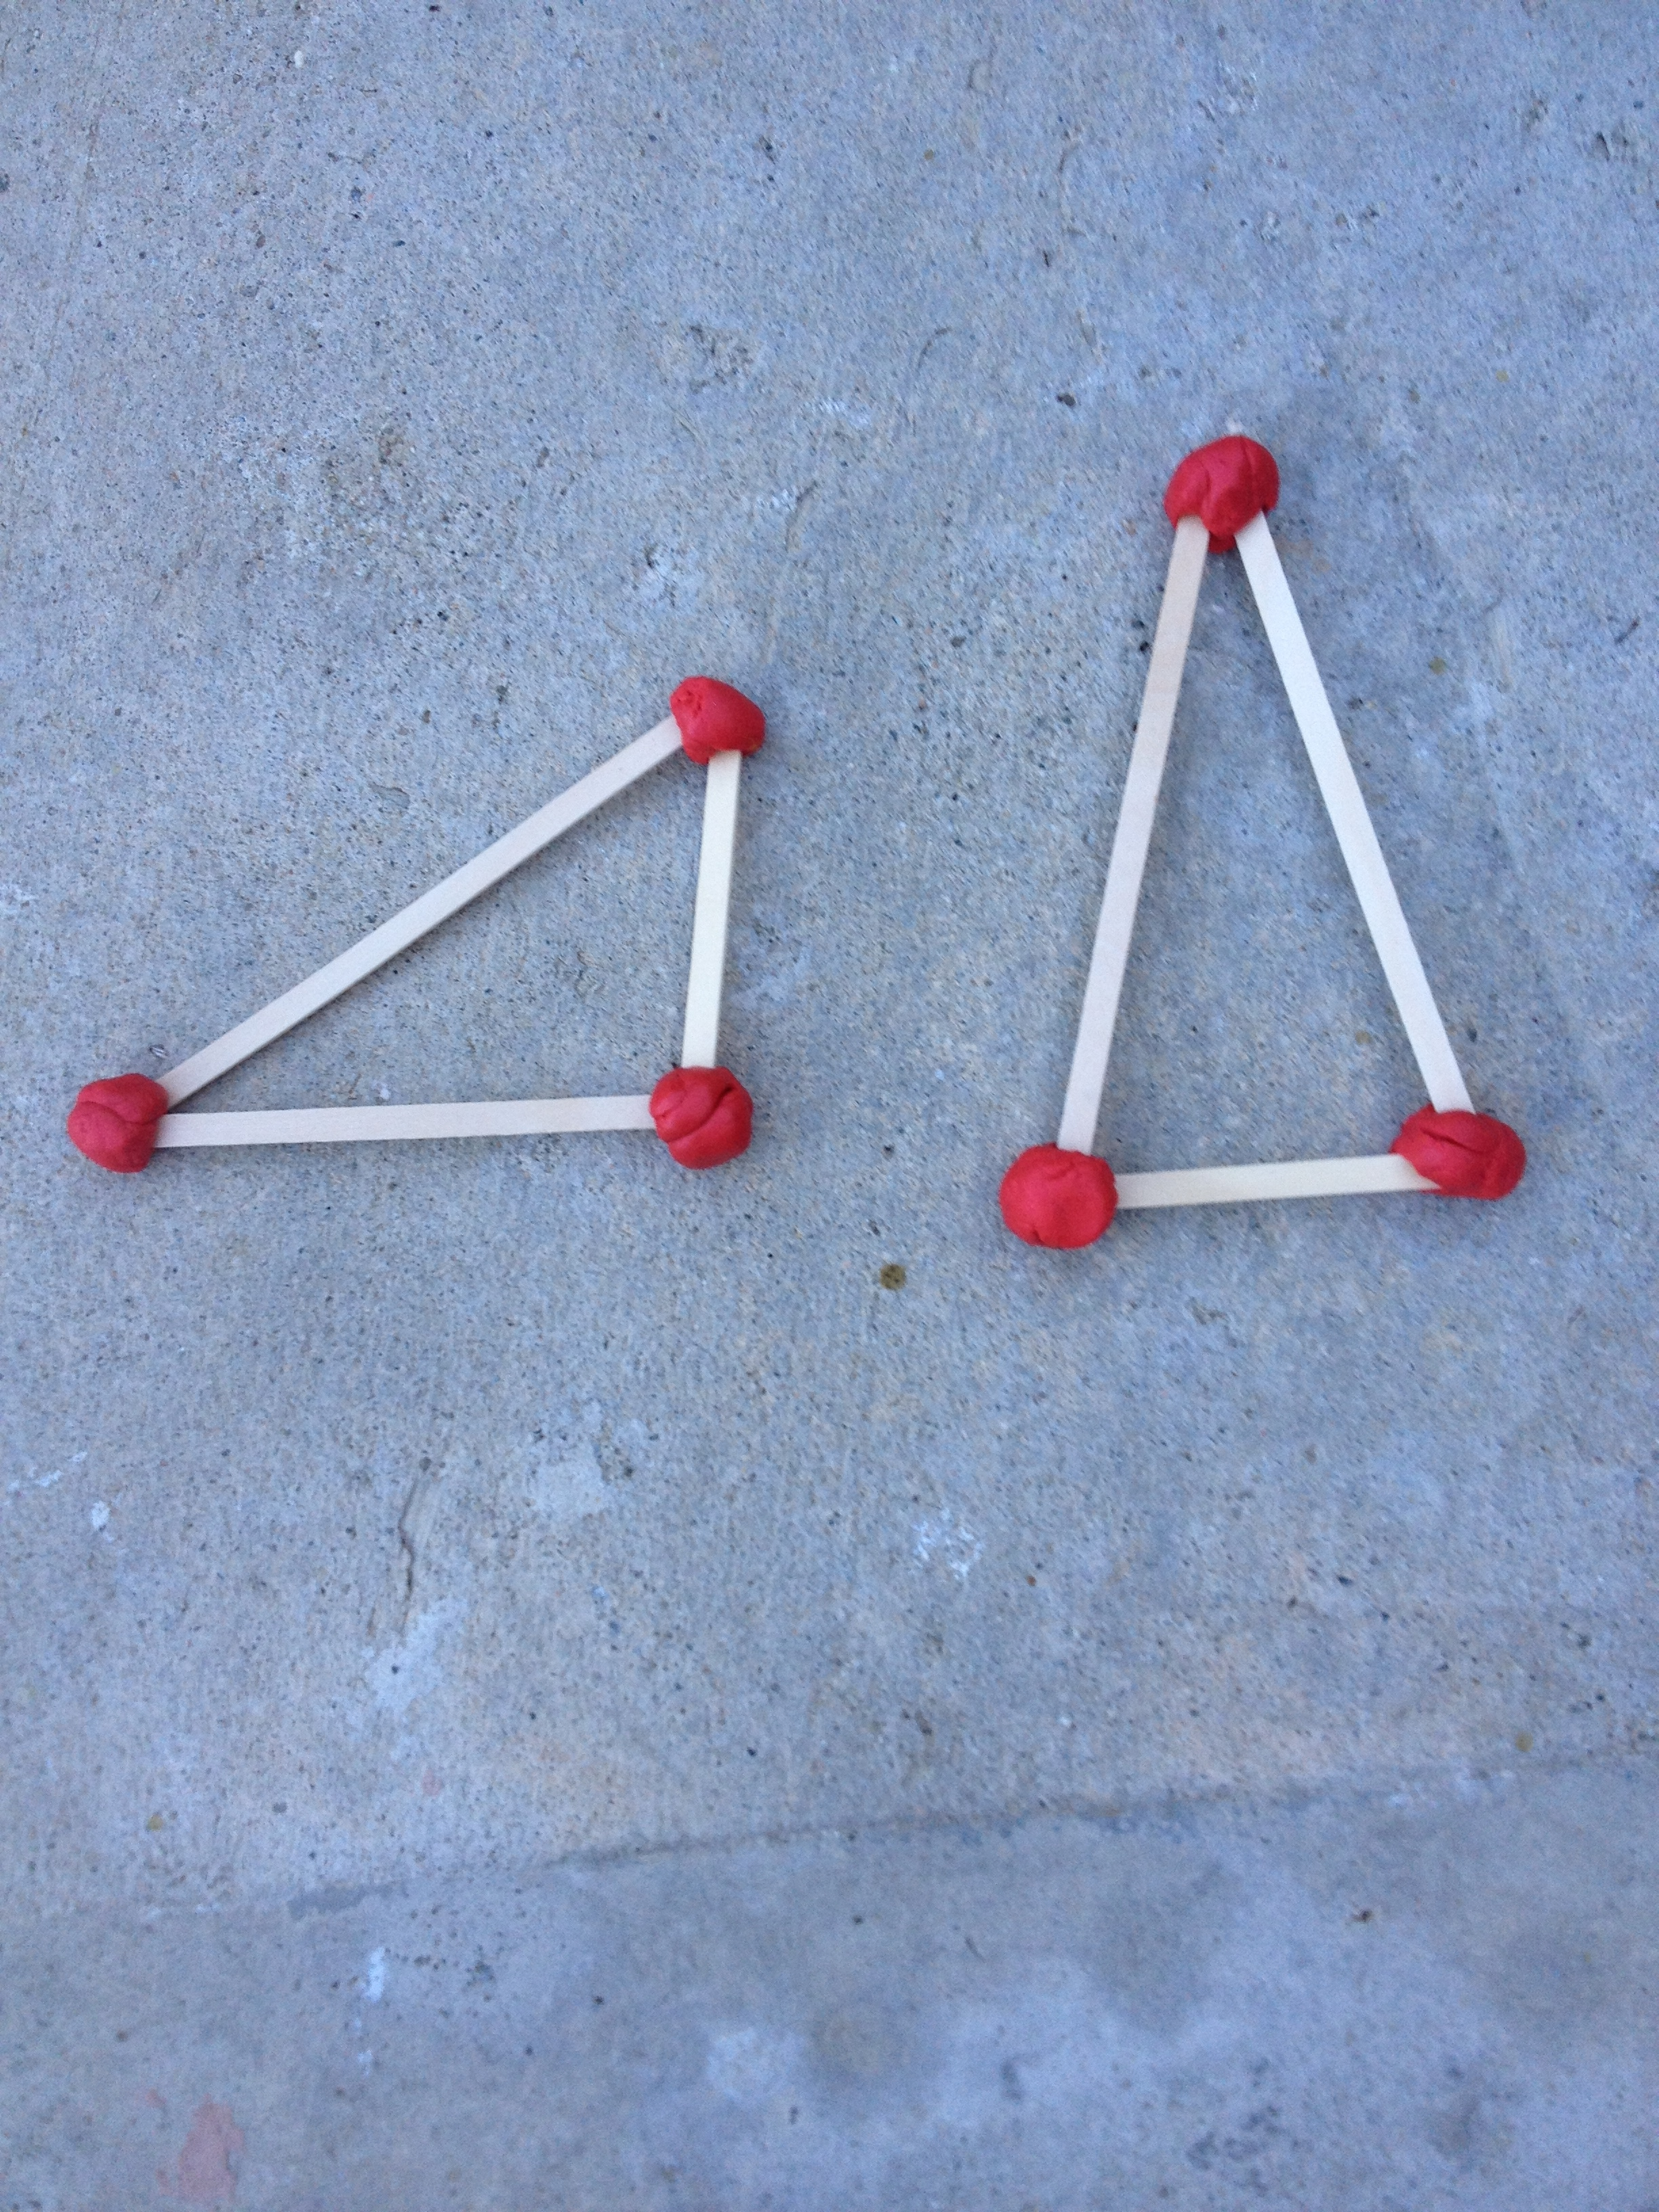
3. Ask, “How can we use these three straws to build a triangle?” Guide students to build the three sides of the triangle. Notice how the lengths of the sides do not have to be the same.
4. Ask, “What can we do to hold the three sides of the triangle together?” Guide students to see the three corners where the straws meet and remind them of the three balls of clay from the fluency activity.
5. Count the three balls of clay together, clapping once for each clay ball counted, “1, 2, 3.” Show students how to use the clay balls to hold the straws together at the three corners, making a triangle.
6. Say, “We can make triangles with three straws and three balls of clay! All triangles have three sides and three corners!”
Part 2: Practice
Materials: (S) 3 small balls of clay (from the fluency activity), per table: caddy with straws (or stirrer sticks) of different lengths
- Send students to prepared tables and tell them, “It’s your turn to build a triangle!”
- Say, “Count the number of straws you need to make a triangle from the materials on the table.”

NOTES ON
MULTIPLE MEANS
OF ENGAGEMENT:
Students who are ready for a challenge could be given three straws to cut and manipulate on their own to create a variant triangle.
3. Say, “Let’s check to see if we have everything we need. If you have three sides, clap three times. If you have three corners, clap three times.”
4. Guide students to build triangles with straws and clay balls. Circulate and provide assistance to those who are struggling.
5. As they complete their triangles, encourage students to count the sides and corners, “1, 2, 3.”
6. If time permits, lead a gallery walk through the classroom, and point out the different sizes, orientations, and shapes of the triangles.
Student Debrief (3 minutes)
Lesson Objective: Construct a triangle.
The Student Debrief is intended to invite reflection and active processing of the total lesson experience. It is also an opportunity for informal assessment. Consider taking anecdotal notes or using a simple checklist to note each child’s progress towards meeting the lesson objective.
As students complete the Practice portion of the Concept Development, listen for misconceptions or misunderstandings that can be addressed in the Debrief. You may choose to use any combination of the questions below to help students express ideas, make connections, and use new vocabulary.
- What tools did we use today to make a triangle? How many straws did we need? How many clay balls?

CENTER CONNECTION:
Set up the art center with clay and straws or stirrers of different lengths. Invite children to build lots of different triangles. Provide triangle stencils or attribute blocks for children to trace.
- (Hold up one of the triangles built by the students.) Is this a triangle even though there is no inside part? (A shape is made up of its sides and corners.)
- (Turn any triangle so the point is not on top.) Is it still a triangle if I turn it like this?
- Do you think it is possible to make a rectangle with straws? How about a circle?

