Lesson 2
Objective: Identify, analyze, sort, compare, and position triangles.

Suggested Lesson Structure
 Fluency Practice (6 minutes)
 Application Problem (3 minutes)
 Concept Development (13 minutes)
 Student Debrief (3 minutes)
Total Time (25 minutes)
Fluency Practice (6 minutes)
- The Ants Go Marching PK.CC.3c (3 minutes)
- Count the Corners PK.CC.3b (3 minutes)
The Ants Go Marching (3 minutes)
Materials: (T) Song sheet for “The Ants Go Marching” with verses through the number 5 (Fluency Template)
Note: By participating in a story situation in which students join the group one by one, students again experience a growing pattern, or a pattern of 1 more in a fun way.
Sing the song “The Ants Go Marching,” and invite students to act out each verse: One student walks to show one by one, two students walk side by side to show two by two, and so on, until five students are walking side by side.
Before singing each verse, ask students to count the “ants” as they line up, i.e., “1 ant.” “1 ant, 2 ants.” Guide students to notice that the line widens as the numbers increase, asking, “Is the line wider when there are more ants?”
Repeat the activity using different children as “ants.” It is important for children to visually experience the pattern of 1 more as an observer as well as take part in the action.
Count the Corners (3 minutes)
Materials: (T) Triangle cutouts (Lesson 1 Template 2), 3 beans
Note: The three corners of a triangle are emphasized by placing a bean on each one preparing students to focus on the attributes of a triangle (three corners and three straight sides) in the lesson.
T: Let’s put the beans on the corners of this shape. Is this a corner? (Slide finger along a straight side.)
S: No!
T: Is this a corner? (Put your finger on a corner.)
S: Yes!
T: What is it?
S: A corner.
T: Let’s mark the corners by putting one bean on each corner. Count for me.
S: (Place beans as they count.) 1 corner, 2 corners, 3 corners!
Next, remove a bean and ask, “How many corners have a bean?” and then, “How many corners do not have a bean?” Continue playfully taking beans off and putting beans on. Repeat the same process using different triangles oriented in different ways.
Application Problem (3 minutes)
Materials: (T) Illustration with many shapes (from, e.g., Ship Shapes by Stella Blackstone or My Painted House, My Friendly Chicken, and Me by Maya Angelou), protective plastic cover or sheet, dry erase marker; or a photocopy of the target illustration
Introduce the illustration and share the name of the book, author, and illustrator. Ask children to point out shapes they see in the illustration. Ask for volunteers to show straight lines and curved lines. Using the protective plastic sheet, highlight the lines they choose with the dry erase marker. As you highlight lines of different shapes, have the class hop once for each straight line highlighted in triangles and rectangles or curve their body to show highlighted curved lines in a circle.
Note: By identifying straight and curved lines in the illustration, children will be prepared to use those as distinguishing attributes in the coming shape sort. By hopping for each side of a triangle or rectangle, students will slowly start identifying the number of sides with the shape.
Concept Development (13 minutes)
Part 1: Concept Introduction
Materials: (T) Triangle cutouts (Lesson 1 Template 2), non-examples (Template 1), tape or magnets, small basket or container
Note: Prior to the lesson, cut out all shapes.
- Show students an exemplar triangle and say, “Tell me about this shape.” Guide students to notice that it has three straight sides and three corners. Say, “We call this shape a triangle,” and afix it to the board.
- Choose another triangle (narrow or wide) and say, “Tell me about this shape.” Guide students to see that it also has three straight sides and three corners. Tell them, “This is a triangle, too. I’m going to put it under this other triangle.”
- Examine a few more triangles, affixing each to the board at varying angles. Describe to students what you are noticing, using self-talk: “Look! I see a pattern! This triangle has three sides and three corners. This one also has three sides and corners.”

NOTES ON
MULTIPLE MEANS
OF REPRESENTATION:
Highlight key vocabulary for English language learners. While students are describing the defining characteristics of each triangle, point to the sides and corners to give students a visual model of the new vocabulary. It would also be helpful for students to practice touching and counting the sides and corners.

- Tape a circle on the board. Say, “Tell me about this shape.” Guide students to see that it is round and has no straight sides or corners. Ask, “Is this a triangle?”
- Tell students, “This is not a triangle, so I’m going to take it off the board and put it in this basket. My board is only for triangles!”
- Follow Steps 4–5 with a rectangle. Ask, “Is this a triangle?” Draw students’ attention to its four sides and four corners.
- Continue discussing and sorting shapes, putting only triangles on the board and all other shapes in the basket. Guide students to identify triangles by saying, “It is a triangle because it has three sides and three corners.”
Part 2: Practice
Materials: (T) Tree mat (Template 2), 1 triangle cutout (S) Tree mat (Template 2); 1 triangle, 1 rectangle, and 1 circle cutout
Affix a tree mat to the board. Place the three shapes and a tree mat at each student’s table before sending students to their seats.
Note: Although Simon Says is not explicitly stated in Step 2, intersperse it throughout the game for a fun twist on using position words.
- Instruct students to stand next to their chairs. Say, “Let’s play Simon Says using a triangle!”
- Model and say the following:
- Find the triangle on your table. Put it on your chair, like this. Put the triangle back.
- Put a shape that is not a triangle under your chair, like this.
- Put the triangle in your hand, like this.
- Now, put the triangle in your other hand, like this.
- Sit down. Stand up. (Repeat.)
- Hold a shape that is not a triangle up in the air. Now put it down on the table.
- Hold it up. Put it down. (Repeat.)
3. Say, “Now, put the triangle anywhere on your tree mat.” Circulate and comment on the various positions, e.g., “Shawn put her triangle under the tree. Simon put his triangle on the tree.” Encourage students to continue moving their triangle to different positions on the mat, discussing each new position with a partner.

Student Debrief (3 minutes)

CENTER CONNECTION:
Have children search for triangles and non-triangles in the library center. Shape books offer obvious examples, but look for triangles in children’s favorite books, too. For example, there are triangles hidden in Goodnight, Goodnight, Construction Site by Sheri Duskey Rinker and The Family Book by Todd Parr.

Lesson Objective: Identify, analyze, sort, compare, and position triangles.
The Student Debrief is intended to invite reflection and active processing of the total lesson experience. It is also an opportunity for informal assessment. Consider taking anecdotal notes or using a simple checklist to note each child’s progress towards meeting the lesson objective.
As students complete the Practice portion of the Concept Development, listen for misconceptions or misunderstandings that can be addressed in the Debrief. You may choose to use any combination of the questions below to help students express ideas, make connections, and use new vocabulary (triangle, on, off, in, up, down, under).
- What words did we use today to talk about triangles?
- What position words did you use to talk about where you put your triangle?
- (Show a variant of a triangle.) What shape is this? How do you know?
- (Show a circle or rectangle.) Why can’t we call this a triangle?

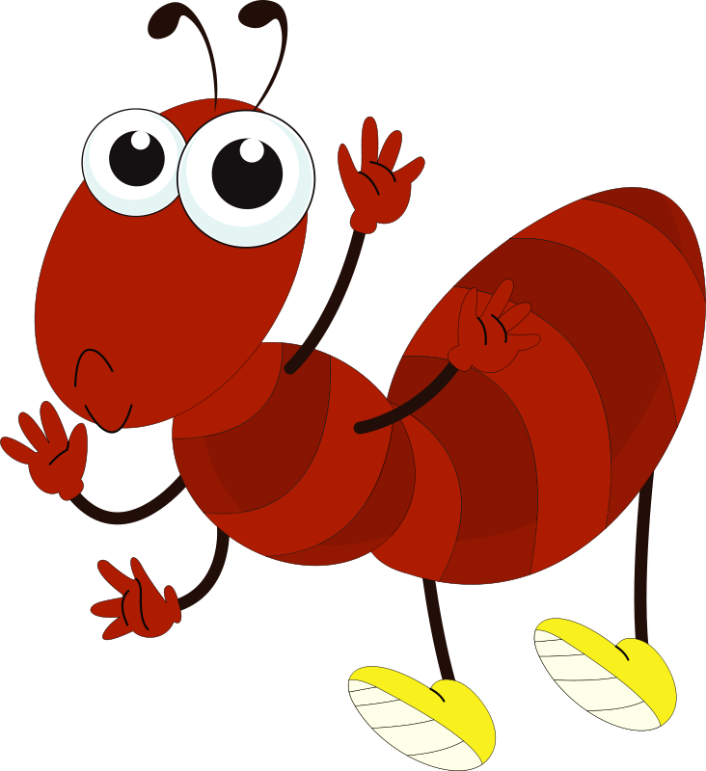
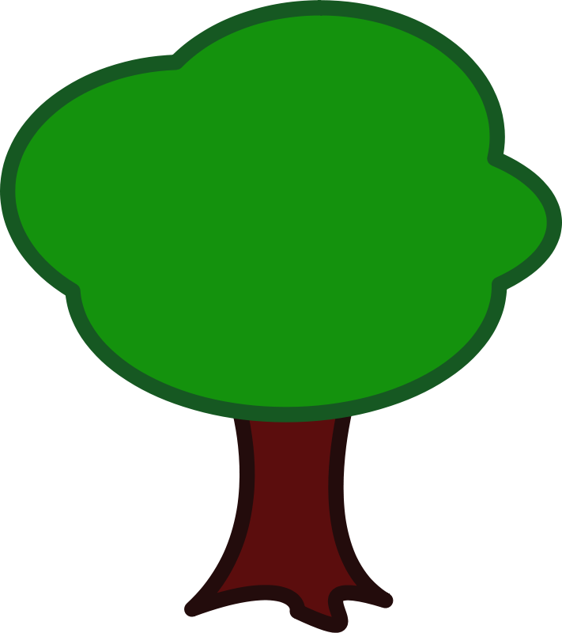
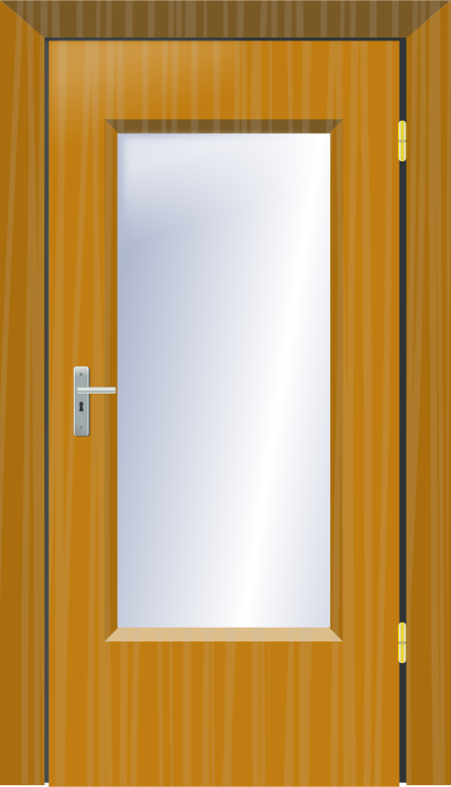

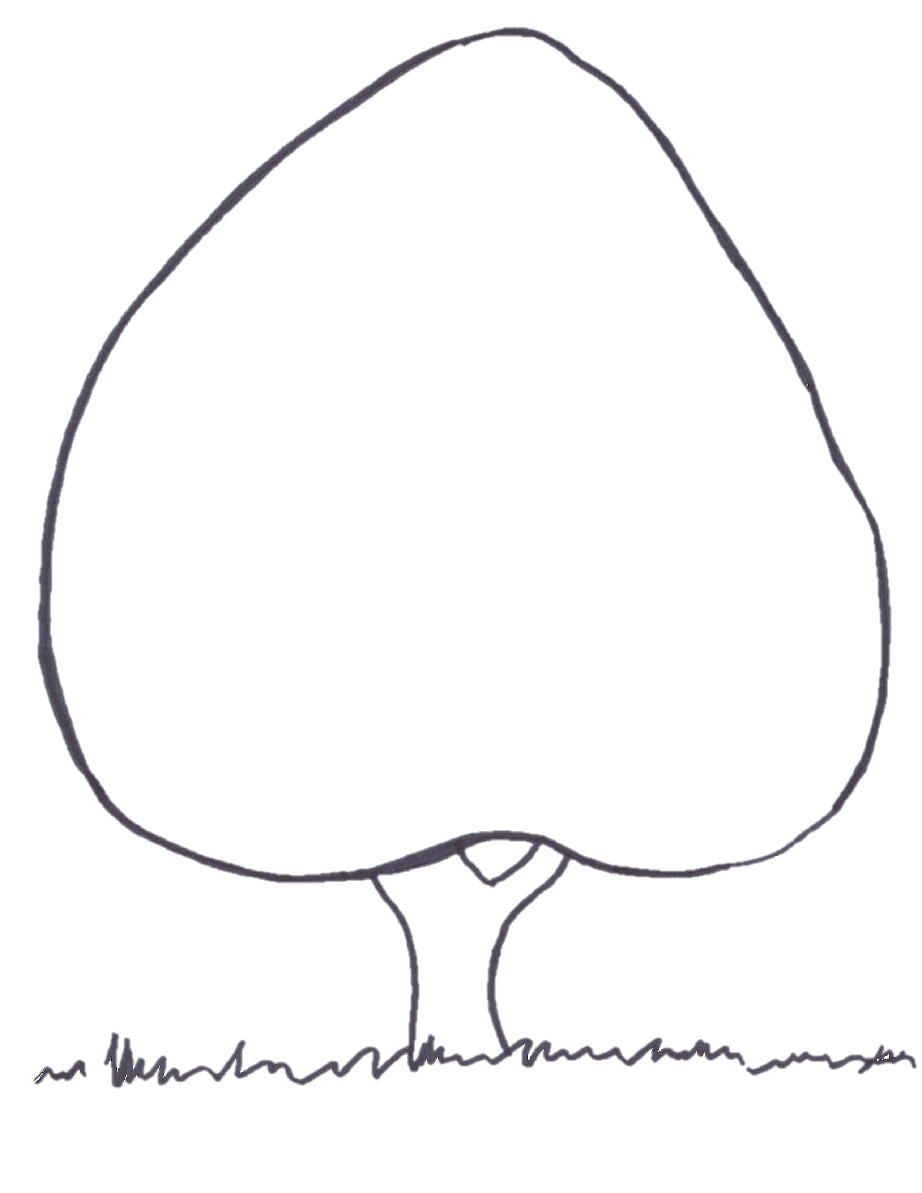

“The Ants Go Marching”
triangle non-examples
tree mat

