Lesson 1
Objective: Find and describe circles, rectangles, squares, and triangles using informal language without naming.

Suggested Lesson Structure
 Fluency Practice (6 minutes)
 Application Problem (3 minutes)
 Concept Development (13 minutes)
 Student Debrief (3 minutes)
Total Time (25 minutes)
Fluency Practice (6 minutes)
- Counting on Fingers PK.CC.3a (3 minutes)
- Farmer Brown PK.CC.1 (3 minutes)
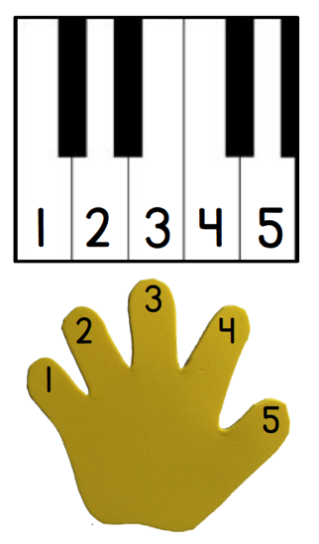
Counting on Fingers (3 minutes)
Materials: (S) Piano mat (Fluency Template)
Note: Moving back and forth between the piano mat (Fluency Template) and the “bear den” fists, helps students to use their fingers and experience counting to 5 in two different ways.
T: Let’s count on our fingers using our piano!
S: (Drop 1 finger from left to right, starting with the left pinky) 1, 2, 3, 4, 5.
T: Let’s count on our fingers starting with all the bears in the den (show fist).
S: (Lift 1 finger from left to right, starting with the left pinky) 1, 2, 3, 4, 5.
T: Let’s go back and forth again. (Repeat the process first on the keyboard and then without.)
Farmer Brown (3 minutes)
Materials: (T) Growing Up with Ella by Ella Jenkins (optional CD), apple tree, 5 green paper apples
Note: As Module 2 opens, continue to strengthen students’ counting within 5 as foundational work for Module 3 wherein they count to 10.
Farmer Brown had 5 green apples hanging on the tree. (Twice.)
Then, he took 1 apple and he ate it greedily, leaving 4 green apples hanging on the tree.
Farmer Brown had 4 green apples hanging on the tree. (Twice.)
Then, he took 1 apple and he ate it greedily, leaving 3 green apples hanging on the tree.
Farmer Brown had 3 green apples hanging on the tree. (Twice.)
Then, he took 1 apple and he ate it greedily, leaving 2 green apples hanging on the tree.
Farmer Brown had 2 green apples hanging on the tree. (Twice.)
Then, he took 1 apple and he ate it greedily, leaving 1 green apple hanging on the tree.
Farmer Brown had 1 green apple hanging on the tree. (Twice.)
Then, he took 1 apple and he ate it greedily, leaving no green apples hanging on the tree.
Continue until there are no apples. Count to replace the apples on the tree, placing 2 apples on one side of the tree and 3 apples on the other. Count up to 5 apples without a break in the count: 1 apple, 2 apples, 3 apples, 4 apples, 5 apples. This allows students to see two groups while counting the total. This arrangement will open the fluency work for Lesson 2.
Application Problem (3 minutes)
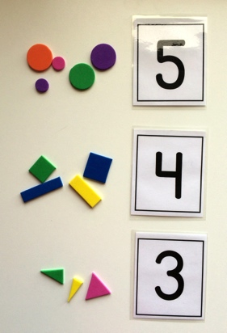
Materials: (T) Bag with 5 circles, bag with 3 triangles, bag with 4 rectangles, numeral cards (Template 1)
Three teachers brought shapes to school to show their students. Each teacher brought one bag of shapes. Help me count how many shapes each teacher brought.
Hand bags to three students. Students remove the objects from bag as classmates count. After counting each set of objects, invite a volunteer to select the numeral that matches.
Note: Students bridge the number work of Module 1 with the geometry work of Module 2 by counting sets of shapes. Children may provide names for the shapes in this activity. Don’t discourage their use of precise language, but continue to use the term shape for all.
Concept Development (13 minutes)
Part 1: Concept Introduction
Materials: (T) Mystery bag containing large shape cutouts (Template 2, save shapes for use in later lessons), tape, chart paper divided into 3 sections
- Tell students, “Let’s see what’s inside my mystery bag!” Pull out a triangle: “This is a shape.”
- Ask students to count the number of straight sides and count the number of corners. (If students say the names of the shape, acknowledge that the name of the shape is one way to describe it). Then, tape the triangle in one section of the chart paper.

NOTES ON
MULTIPLE MEANS
FOR ACTION AND EXPRESSION:
Provide a variety of ways for students to participate in the discussion. Allow students who are non-verbal or are uncomfortable sharing with the group to bring an object to the rug and place the object in the correct section. Model the language for the child as they place the object. For example, “The book is the same shape as these other shapes.” Another possibility for students who are uncomfortable sharing with the large group would be to have students turn and talk to a partner.

Note: When taping rectangles, triangles, and squares into their respective sections, position them at different angles. This visual will support students as they develop the understanding that the orientation of a shape does not alter its classification—a triangle is still a triangle, regardless of its position.
- Repeat the process with the remaining shapes, ending with the circle. (“It has no straight sides or corners!” “It is round!” “It looks like the clock.”) Sort the shapes on the chart by emphasizing the attributes of each shape. “I will put this shape in this section of the chart because it has three corners like the other shapes in this section.”
- Tell students, “I wonder if we can find any of these shapes in our classroom? Let’s go on a shape hunt with our eyes!”
- Allow students to look around the room and discuss shapes they find, e.g., “The clock is round just like these shapes.”
Part 2: Practice
Materials: (T) Shape sort chart (Template 3); tape; baggie containing cutouts of circles, rectangles, and triangles or the small shapes cards (Template 4, save for later use) (S) Per pair: shape sort chart (Template 3); tape; baggie containing cutouts of circles, rectangles, and triangles or the small shape cards (Template 4, save for later use)
Prior to the activity, cut out the small shapes and assemble in baggies. Before sending children to prepared tables, gather them in a circle to model the activity.
1. Show students the shape sort template and the baggie. Tell them, “You’re going to work with a partner to sort these shapes!”
2. Model how to match the attributes of the cutout shapes to the attributes of the figures at the top of the columns.
MP.7
3. Send students to their tables to work with their partners. Circulate and encourage them to talk to each other about the shapes.
4. To keep a record of student work, have children tape or glue the shapes to the page. Otherwise, keep the shapes loose for more practice.

Student Debrief (3 minutes)

CENTER CONNECTION:
Create a center where children can use the shape sort chart (Template 3) to find and sort shapes. Children may find shapes in print materials, in small manipulatives (e.g., buttons, foam stickers), or classroom objects. Advanced students may be ready to trace the faces of classroom objects. Encourage and support their exploration, seeking ways that they can record their findings on the template.

Lesson Objective: Find and describe circles, rectangles, squares, and triangles using informal language without naming.
The Student Debrief is intended to invite reflection and active processing of the total lesson experience. It is also an opportunity for informal assessment. Consider taking anecdotal notes or using a simple checklist to note each child’s progress towards meeting the lesson objective.
As students complete the Practice portion of the Concept Development, listen for misconceptions or misunderstandings that can be addressed in the Debrief. You may choose to use any combination of the questions below to help students express ideas, make connections, and use new vocabulary (shape, straight, side, corner).
- When we looked around the room on our shape hunt, what looked like this shape (hold up circle)? What looked like this shape (hold up triangle)? What looked like this shape (hold up rectangle)? Provide all students with an opportunity to share through a turn and talk.
- When we sorted our shapes, did all the shapes in this column (pointing to chart) look exactly the same?
- How did you talk about each shape today?
- Can you think of other objects at home that are shaped like these?
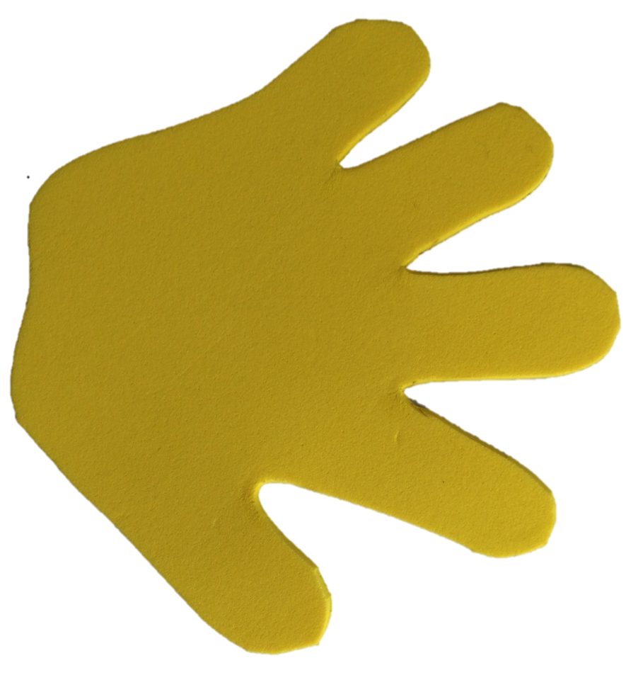
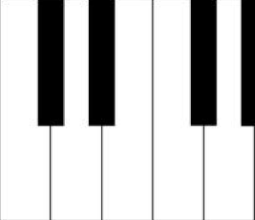
1
2
3
4
5
1
2
3
4
5
To create numeral cards: 1) Print. 2) Fold lengthwise so the outline on the numeral side matches the outline on the dot side. 3) While the paper is folded, cut out individual cards. Do not cut along the fold! 4) Laminate with cards folded so that numeral and dots match. |  | 1
 |  | 2
 |  | 3

4
5

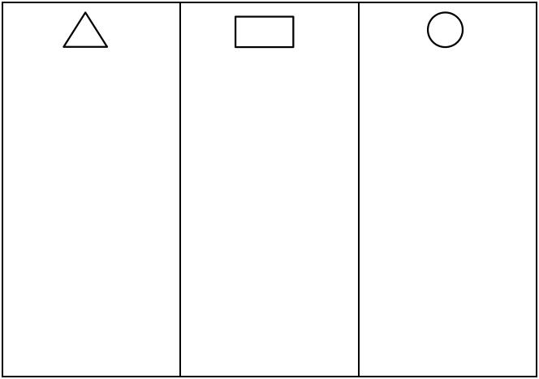
__________________
shape sort chart
Note: These shapes are provided as cards for easy cutting. However, students should have experience with concrete shapes, as well. Teachers may wish to use pattern blocks and cutouts of shapes from construction paper. When preparing shapes, always be sure to include exemplars (like those pictured in the top row) and variants (like the triangles and rectangles in the bottom two rows).

piano mat with numerals
numeral cards
large triangle cutouts (exemplars and variants)
large rectangle cutouts (exemplars and variants)
large circle cutouts (exemplars)
small shape cards

