Topic A
Two-Dimensional Shapes
PK.G.1, PK.G.2, PK.G.3, PK.MD.2
Focus Standards: | PK.G.1 | Describe objects in the environment using names of shapes, and describe the relative positions of these objects using terms such as top, bottom, up, down, in front of, behind, over, under, and next to.
 | PK.G.2 Thethe PK.G.3 | Correctly name shapes regardless of size.
 | PK.G.3 | Analyze, compare, and sort two- and three-dimensional shapes and objects, in different sizes, using informal language to describe their similarities, differences, and other attributes (e.g., color, size, and shape).
Instructional Days: | 5
Coherence -Links to: | GK–M2 | Two-Dimensional and Three-Dimensional Shapes
 | GK–M6 | Analyzing, Comparing, and Composing Shapes
In Topic A, children identify, analyze, sort, compare, and position two-dimensional (2-D) circles, rectangles, and triangles both in collections of objects and within their school environment. Through sorting activities, children explore and discuss the attributes of each shape (e.g., sides and corners) (PK.G.3).
In Lesson 1, children sort shapes based on their defining attributes, specifically, the number of straight sides and corners. Then, they go on a brief shape hunt in the classroom, using their innate ability to recognize shapes in their environment (PK.G.1). For example, they see a round clock and match it to its corresponding two-dimensional shape, a circle: “The clock is round, just like this shape.” Matching the two objects (e.g., clock and circle) is the first step in helping young children to describe shapes.
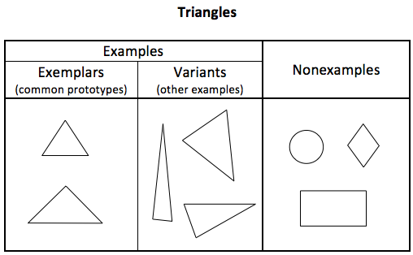
Students identify, sort, describe, and analyze triangles in Lesson 2, and then rectangles and squares in Lesson 3 (PK.G.3). As they analyze a collection of shape cutouts, they begin to notice attributes that are true of all the shapes in the sorted group: “All the triangles we put in this group have three corners and three straight sides.” This activity helps students to recognize that triangles can come in many varied forms (e.g., long, skinny, wide, up-side-down) (PK.G.2). Once students have successfully sorted the shapes, they play a game with shapes and relational words, such as in, on, off, under, up, and down, then position each shape on a tree work mat (PK.G.1). Carefully choosing shapes using the chart pictured to the right as a guide helps students to consistently identify shapes based on their attributes, regardless of size or orientation.
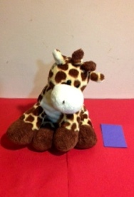
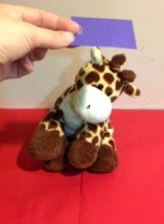
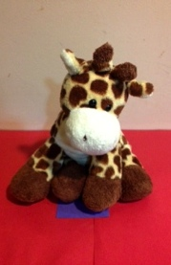
Lesson 3 focuses on rectangles, again using attributes (sides and corners) to sort a collection of shapes, whereby only rectangles are placed on the board, with all other shapes placed in the basket. They see that a square is a special rectangle with four sides of the same length. Similarly to Lesson 2, students position their shapes above, below, and next to a stuffed animal (PK.G.1).
Next, in Lesson 4, students sort a collection of circles and other shapes, including ovals as non-circles. Students will likely describe circles as going “around and around” or having no straight sides and no corners. They position their shapes behind, in front of, and between a stuffed animal and a tree work mat.
The last lesson of this topic celebrates what students have learned about various two-dimensional shapes and spatial orientation. While listening to music, students go on a shape walk through the classroom, freezing when the music stops and naming the shape closest to where they are standing. Then, with partners, they use a small doll to “walk” through a park scene. Similarly, when the music stops, students describe the shape closest to their doll and use position words to tell about the shape’s location in the park. Some students may notice that some objects in the scene are composed of more than one shape. The seesaw, for example, is a rectangle on a triangle. Through these observations, students begin to relate the parts to the whole, foreshadowing the construction of shapes from parts to whole in Topic B.
In Topic A Fluency Practice, students strengthen their counting skills within 5 using both their piano mats and their “bear den” fists (i.e., the Math Way). Counting often occurs in the context of geometry, such that students sort and count the number of shapes, as in Count the Triangles, or students count the number of corners and sides on a given shape.
A Teaching Sequence Towards Mastery of Two-Dimensional Shapes
Objective 1: Find and describe circles, rectangles, squares, and triangles using informal language without naming.
(Lesson 1)
Objective 2: Identify, analyze, sort, compare, and position triangles.
(Lesson 2)
Objective 3: Identify, analyze, sort, compare, and position rectangles and squares.
(Lesson 3)
Objective 4: Identify, analyze, sort, compare, and position circles.
(Lesson 4)
Objective 5: Identify, analyze, sort, compare, and position circles, rectangles, squares, and triangles.
(Lesson 5)

