Grade PK • Module 2 • Topics A–C
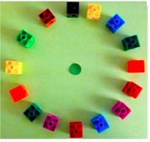
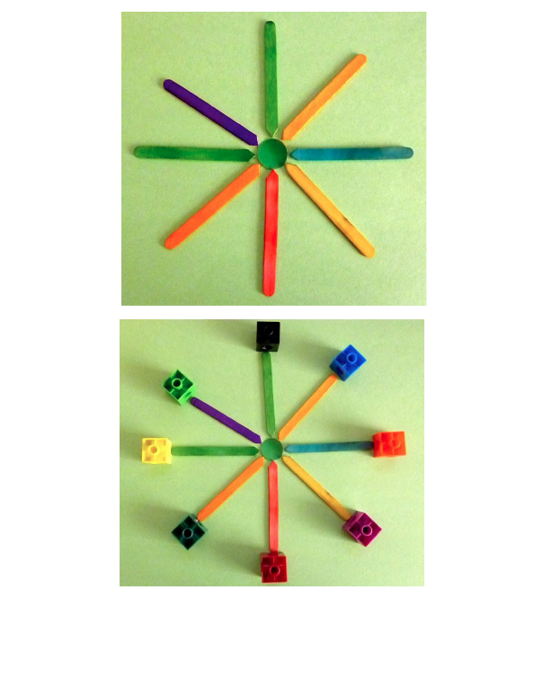
Family Math Newsletter
Shapes
In Module 2, children explore two- and three-dimensional shapes and objects. They identify these shapes by first noticing the characteristics, “This shape has four straight sides and four corners!” After this analysis, they learn the names, “It’s a rectangle!” Position words such as next to help them to make statements like, “The blue rectangle is next to the orange square.”
Students build a circle with craft sticks and realize that all the points on a circle are the same distance from the center.
Key Standards
- Describe real world objects using shape names and position words.
- Correctly name shapes, regardless of size.
- Analyze, compare, and sort two-dimensional and three-dimensional shapes and objects.
- Create and build shapes.
Looking Back
In Module 1, students learned to sort and practiced touching and counting groups of up to 5 objects.
Looking Ahead
In Module 3, children will learn to touch and count groups of up to 10 objects and identify numerals to 10.

Vocabulary
- Circle
- Corner
- Face
- Flat
- Pointy
- Rectangle
- Roll
- Round
- Shape
- Side
- Slide
- Square
- Stack

How to Help at Home
- Have a shape scavenger hunt. Look for circles, rectangles, squares, or triangles in the world around you. Use language to describe and name each shape. “Look! Our door has four sides and four corners. It looks like this rectangle!”
- Practice position vocabulary by playing Simon Says. “Simon says put your toy car above the table. Simon says put your hands on your head.”
- Build a model with 3-D objects in your home, using the Suggested Words and Key terms off to the side as much as possible in conversations with your child to practice math vocabulary and explore how shapes work together. Ask questions to analyze solid shapes. “How can we stack this can of soup on this box of cereal? We don’t want it to roll off!” “Does this ball have any flat faces? Do you think we could stack something on top of it?
- Straight
- Triangle
- Top
- Bottom
- Up
- Down
- In front of
- Next to
- Behind
- Over
- Under

Suggested Words and Key Terms

Spotlight on Math Models
Constructing Shapes
Students will have hands-on experiences with characteristics like sides and corners as they construct two-dimensional shapes.
Sample  Application Problem  (from Module 2, Lesson 10)  Mr. McGregor’s Garden  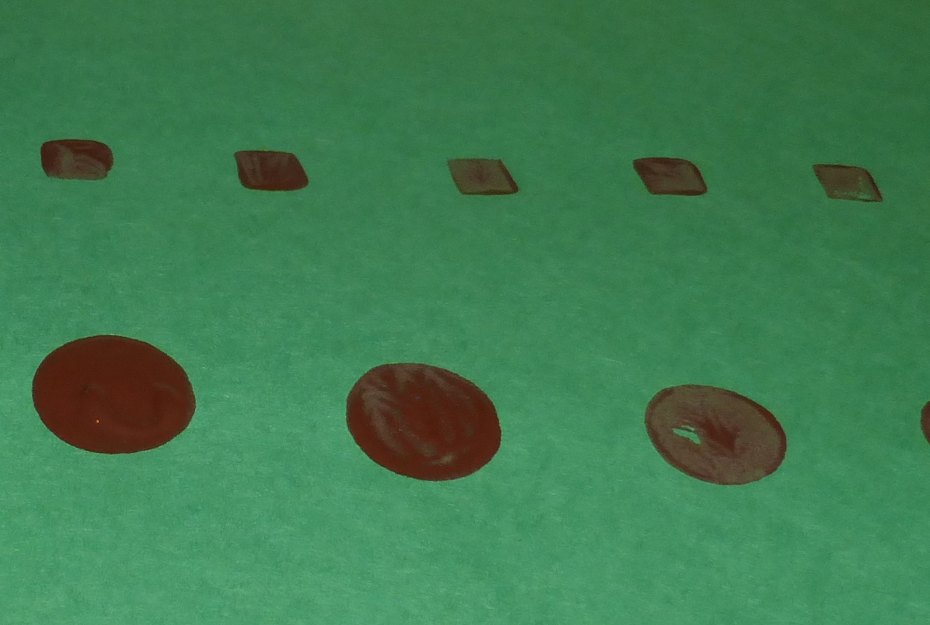  “Mr. McGregor is very angry. Someone has been walking through his garden. Let’s be detectives and see if we can find the shapes that made this mess!”  Children look at a group of foam solids (e.g., a cylinder, a cube, and a sphere) and guess which shapes may have made each “footprint.” They explain why they think the object they chose might be the culprit and then test to see if the face matches.  Note: This activity allows children to use their new understanding of the relationship between 2-D and 3-D shapes to guess the culprit and test their hypothesis. This requires them to carefully observe the solids and explain their reasoning. | Key mathematical models are used throughout a student’s elementary years.  Children begin their exploration of shapes by sorting various examples of triangles, rectangles (including squares), and circles. They learn to name the shapes, think about their parts, or attributes (e.g., sides and corners), and relate those parts to the whole shape. “This triangle has three sides and three corners.”  Children then use straws and balls of clay to construct the shapes they learned about. By using different lengths of straws and varying the orientation of their shapes, children begin to build an understanding of defining attributes. (For example, some triangles are wide and some are narrow, but any closed shape with three sides and three corners is a triangle.)  Children understand shapes better when they can physically create them. This activity also shows them the idea that new shapes can be created by combining parts of other shapes, which relates to the concept of addition (3 and 2 can be put together to make 5). This part–whole relationship of numbers is an important step in understanding addition.

