10.4.2 | Lesson 23

Introduction
In this lesson, students prepare to consider film treatments of Macbeth through a variety of activities. Students consider how Act 1.1 and 1.3 develop characters, plot, and central ideas. Students also discuss how the Witches are depicted in the visual arts, focusing on “Macbeth and the Witches,” by Joseph Anton Koch. Students then analyze a second painting, Henry Fuseli’s “The Three Witches,” as part of their assessment. Student learning is assessed via a Quick Write at the end of the lesson: Analyze how Henry Fuseli draws on and transforms the Witches from Shakespeare’s Macbeth. What does Fuseli emphasize or omit in his treatment of these characters?
For homework, students conduct a brief search to find five interesting facts about Akira Kurosawa or samurai films to share with the class.

Standards
Assessed Standard(s)
RL.9-10.7 | Analyze the representation of a subject or a key scene in two different artistic mediums, including what is emphasized or absent in each treatment (e.g., Auden’s “Musée des Beaux Arts” and Breughel’s Landscape with the Fall of Icarus).
Addressed Standard(s)
None.

Assessment
Assessment(s)
Student learning is assessed via a Quick Write at the end of the lesson. Students respond to the following prompt, citing textual evidence to support analysis and inferences drawn from the text or painting.
- Analyze how Henry Fuseli draws on and transforms the Witches from Shakespeare’s Macbeth. What does Fuseli emphasize or omit in his treatment of these characters?
High Performance Response(s)
A High Performance Response should:
- Describe how Shakespeare depicts the Witches (e.g., Shakespeare, through the words of Banquo, describes the Witches as “withered” and “wild in their attire,” each with a “choppy finger laying / Upon her skinny lips” (Act 1.3, lines 41, 46–47). He says they “look not like th’ inhabitants o’ th’ Earth” (Act 1.3, line 42) and that they “should be women, / And yet [their] beards forbid [Banquo] to interpret / That [they] are so” (Act 1.3, lines 47–49). The Three Witches are not portrayed as fully developed individuals, but rather as a group of very similar creatures.).
- Describe how Fusili depicts the Witches (e.g., He paints them as three old women, wearing loose white clothing and caps or bonnets. Their clothing seems as though it might be smeared with blood. Each Witch holds a right index finger to her lips, while her left hand is outstretched, as though pointing at something. The Witches appear to be looking upward at something other than what they are pointing at. The Witches have an eerie white light about them that is in contrast to the dark, shadowy background. Very little of the Witches’ hair is visible, although strands of something light appear to be coming from the bonnet of the Witch in the back. This might be hair or might be some other matter or light. The Witches’ hands are wrinkled and have crooked fingers. The Witches’ faces have sharp, almost masculine features. The Witches are posed identically, wear very similar clothing, and are grouped so that they are almost a single unit rather than individuals.).
- Compare and contrast the depictions (e.g., Shakespeare says that the Witches look wild and unearthly, but Fuseli’s Witches look like old women. Shakespeare says the Witches have “beards” that make it difficult for Banquo to determine their gender, but Fuseli’s Witches are beardless. Nonetheless, Fuseli’s Witches have somewhat masculine features. Both depictions include the chapped, wrinkled hands and fingers on the Witches’ lips and both depictions show figures with an unearthly appearance. Both depictions present the Witches as a supernatural group rather than as individual characters. Fuseli adds a dark, shadowy background with some sort of dark, flying creature, perhaps a bat, floating behind the Witches.).
- Explain how the differences emphasize different aspects of the Witches (e.g., Shakespeare emphasizes the Witches’ wildness and ambiguous gender, making them seem very different from ordinary people, while Fuseli’s picture makes them seem more like old women. Fuseli emphasizes the evil associated with the Witches by adding the dark, flying creature in the background and by using mostly black and white, with a little red, as the main colors of the picture. Both emphasize the Witches’ “choppy” fingers and age. Both create mysterious, eerie figures. Both emphasize the group rather than the individual, suggesting that the Witches are more important for their symbolic value than for their personal attributes.).

Vocabulary
Vocabulary to provide directly (will not include extended instruction)
- None.*
Vocabulary to teach (may include direct word work and/or questions)
- None.*
Additional vocabulary to support English Language Learners (to provide directly)
- None.*
*Because this is not a close reading lesson, there is no specified vocabulary. However, in the process of returning to the text, students may uncover unfamiliar words. Teachers can guide students to make meaning of these words by following the protocols described in 1e of this document http://www.engageny.org/sites/default/files/resource/attachments/9-12_ela_prefatory_material.pdf.

Lesson Agenda/Overview
Student-Facing Agenda | % of Lesson
Standards & Text:
- Standards: RL.9-10.7
- Text: Macbeth by William Shakespeare, Act 1.1 and 1.3
Learning Sequence:  - Introduction of Lesson Agenda  - Homework Accountability  - Interpreting Literature Visually  - Quick Write  - Closing | - 10%  - 20%  - 50%  - 15%  - 5%

Materials
- Student copies of the 10.4 Common Core Learning Standards Tool (refer to 10.4.1 Lesson 1)
- Copy of Joseph Anton Koch’s “Macbeth and the Witches” to be projected for class consideration
- Copies of Joseph Anton Koch’s “Macbeth and the Witches” for use in small groups
- Copies of the Stylistic Choices Tool for each student
- Copies of a picture for students to analyze (e.g., Henry Fuseli’s “The Three Witches”) or one copy to be projected for class consideration
- Student copies of the Short Response Rubric and Checklist (refer to 10.4.1 Lesson 1)

Learning Sequence
How to Use the Learning Sequence
Symbol | Type of Text & Interpretation of the Symbol
10% | Percentage indicates the percentage of lesson time each activity should take.
no symbol | Plain text indicates teacher action.
 | Bold text indicates questions for the teacher to ask students.
 | Italicized text indicates a vocabulary word.
 | Indicates student action(s).
 | Indicates possible student response(s) to teacher questions.
 | Indicates instructional notes for the teacher.
Activity 1: Introduction of Lesson Agenda 10%
Begin by reviewing the agenda and the assessed standard for this lesson: RL.9-10.7. In this lesson, students discuss how Shakespeare’s use of the Witches in Act 1 develops characters, plot, and central ideas. Students also analyze Joseph Anton Koch’s painting, “Macbeth and the Witches,” as a class before independently analyzing another painting, Henry Fuseli’s “The Three Witches,” in order to consider how artists can interpret a literary work visually.
- Students look at the agenda.
Distribute or ask students to take out their copies of the 10.4 Common Core Learning Standards Tool. Inform students that in this lesson they begin to work with a new standard: RL.9-10.7. Ask students to individually read this standard on their tools and assess their familiarity with and mastery of it.
- Students read and assess their familiarity with standard RL.9-10.7.
Instruct students to talk in pairs about what they think the standard means. Lead a brief discussion about the standard.
- Student responses should include:
  - Analyze an important scene in two different types of art.
  - Analyze what is highlighted or left out of each representation of the scene.
Activity 2: Homework Accountability 20%
Instruct students to meet in pairs to discuss how Shakespeare uses Act 1.1 and 1.3 to develop characters, plot, and central ideas, referring to their completed Act 1 Witches’ Scenes Review Tools.
- Students refer to their Act 1 Witches’ Scenes Review Tools to discuss Shakespeare’s treatment of the Witches in Act 1.
- See the Model Act 1 Witches’ Scenes Review Tool for possible student responses.
Lead a brief whole-class discussion of student responses.
Activity 3: Interpreting Literature Visually 50%
Without telling the students the name of the painting, display a full-color reproduction of Joseph Anton Koch’s “Macbeth and the Witches” (or another painting of the same subject, such as Clarkson Frederick Stanfield’s “Macbeth and the Witches” or Théodore Chassériau’s “Macbeth and Banquo Meeting the Witches on the Heath”).
What is depicted in this picture?
- Two men on horseback are meeting three people on a windy day near the ocean.
Inform students that the painting is called “Macbeth and the Witches” and was painted by Joseph Anton Koch.
Distribute or project color copies of the print, as well as the Stylistic Choices Tool, to each group. Instruct students to view the painting carefully before completing the Stylistic Choices Tool in small groups.
- Students work together to study and discuss the picture to complete the tool.
- See the Model Stylistic Choices Tool for possible student responses.
- Consider reminding students of their work with RL.9-10.7 in 9.1.3 Lesson 13, when they considered Marc Chagall’s treatment of Romeo and Juliet.
Lead a brief, whole-class discussion of student responses.
Activity 4: Quick Write 15%
Project Henry Fuseli’s “The Three Witches” or distribute full-color copies to each student, along with a blank copy of the Stylistic Choices Tool. Instruct students to respond briefly in writing to the following prompt:
Analyze how Henry Fuseli draws on and transforms the Witches from Shakespeare’s Macbeth. What does Fuseli emphasize or omit in his treatment of these characters?
Instruct students to examine the painting, using the Stylistic Choices Tool as a guide, and to review Act 1 along with their notes and annotations. Remind students to use the Short Response Rubric and Checklist to guide their written responses.
- Students listen and read the Quick Write prompt.
- Display the prompt for students to see, or provide the prompt in hard copy.
Transition students to the independent Quick Write.
- Students independently answer the prompt using evidence from the text and the painting and using the Stylistic Choices Tool as a guide.
- See the High Performance Response at the beginning of this lesson.
Activity 5: Closing 5%
Display and distribute the homework assignment. For homework, instruct students to conduct a brief search to find five interesting facts about either Akira Kurosawa or samurai films to share with the class.
- Half of the class should research Kurosawa and the other half should research the film genre.

Homework
Conduct a brief search to find five interesting facts about either Akira Kurosawa or samurai films to share with the class.

Model Act 1 Witches’ Scenes Review Tool
Name: |  | Class: |  | Date:

Directions: Reread the scenes listed below and then answer Questions 1 through 4 for each scene.
Scene | 1. What information does the scene provide about the Witches? How are they described? | 2. How does the scene develop other characters? | 3. How does the scene develop the plot? | 4. How does the scene develop central ideas?
Act 1.1 (from “When shall we three meet again?” to “Hover through the fog and filthy air.”) | They are probably evil – The setting is spooky, with thunder and lightning.  They are supernatural: they have “familiars” – Graymalkin and Paddock. (lines 9–10)  They are ambiguous, saying, “Fair is foul, and foul is fair.” (line 12) | Macbeth is first presented as a figure of interest to the Witches, so he is associated with evil early on. | This scene explains that a battle is taking place. The Witches will meet again “When the battle’s lost and won.” (line 4) | Evil is present from the very beginning.  Ambiguity (truth vs. deception)
Act 1.3, lines 1–81 (from “Where hast thou been, sister?” to “Speak, I charge you.”) | The Witches are violent (one has been “killing swine” (line 2)) and spiteful (one is punishing the husband of a woman who would not give her chestnuts (lines 4–27, from “A sailor’s wife had chestnuts in her lap” to “Look what I have”)).  The Witches have some supernatural powers (they control the winds and can keep the sailor from sleeping), but it is limited. The First Witch says of the sailor and his ship, “Though his bark cannot be lost, Yet it shall be tempest-tossed” (lines 25–26).  The Witches can see the future: They recognize Macbeth as “Thane of Cawdor” and “king hereafter” and also know that Banquo will not be king but that his descendants will be kings.  Banquo describes the Witches as “withered” and “wild in their attire,” each with a “choppy finger laying / Upon her skinny lips” (lines 41, 46–47). He says they “look not like th’ inhabitants o’ th’ Earth” and that they “should be women, / And yet [their] beards forbid [Banquo] to interpret / That they are so” (lines 47–49). | Macbeth is associated with the Witches again when he says, “So foul and fair a day I have not seen” (line 39).  The interactions with the Witches reveal that Macbeth might already have been thinking about how to become king. Banquo notices that he “start[s] and seem[s] to fear / Things that do sound so fair” (lines 54–55).  Banquo tells them that he “neither beg[s] nor fear[s] / [Their] favors nor [their] hate” (lines 63–64), but he is cautious of the Witches, questioning them and calling them “imperfect speakers” (line 73).  When Macbeth and Banquo learn that Macbeth has been named Thane of Cawdor, Banquo remains suspicious of the Witches, saying, “oftentimes, to win us to our harm, / The instruments of darkness tell us truths, / Win us with honest trifles, to betray ’s / In deepest consequence” (lines 135–138), but Macbeth ignores this caution.  Macbeth recognizes that the “supernatural soliciting / Cannot be ill, cannot be good” and goes on to describe how the news has prompted him to consider a “suggestion / Whose horrid image” shatters him, yet that he can’t help thinking about it (lines 143–144, 147–148). | The Witches greet Macbeth with “All hail, Macbeth! Hail to thee, Thane of Cawdor! / All hail, Macbeth, that shall be king hereafter!” (lines 52–53) and tell Banquo, “Thou shalt get kings, though thou be none” (line 70). The prophetic words give Macbeth a clear motive to murder both Duncan and Banquo.  We learn that Macbeth has been named Thane of Cawdor when Ross announces, “He [Duncan] bade me, from him, call thee Thane of Cawdor” (line 110). | The idea of fate vs. agency is introduced – how much control does the sailor have? It is developed when Banquo and Macbeth learn that Macbeth has been named Thane of Cawdor: Did the Witches cause this to happen or only know it would happen?  Truth vs. deception continues to develop here as Banquo and Macbeth struggle to make sense of the Witches’ prophecies and Banquo recognizes that there might be an element of deceit in them.

Stylistic Choices Tool
Name: |  | Class: |  | Date:

Directions: Reread Act 1.3, lines 39–81, from “So foul and fair a day I have not seen” to “Speak, I charge you.” Then examine a selected painting carefully before answering the following questions.
Name of Painting: Artist:
1. Who is in the painting and what do you notice about how they are presented? (E.g., Are they moving? Still?)

2. Where are the characters in relation to one another? What can you infer from their positions in the painting?

3. Who is most important in the painting? How can you tell?

4. What symbols or imagery can you identify?

5. What are the main colors in the picture?

6. What is the quality of the colors? (E.g., Are they bright? Dark? Muted?)

7. What mood do the symbols, imagery, and colors create in the painting?

8. What, if anything, has the artist chosen not to represent and/or change in this painting? Consider what you know about the characters from the play.

9. How does your knowledge of what the artist chose to omit and/or change influence your understanding of the painting?

Model Stylistic Choices Tool
Name: |  | Class: |  | Date:

Directions: Reread Act 1.3, lines 39-81, from “So foul and fair a day I have not seen” to “Speak, I charge you.” Then examine a selected painting carefully before answering the following questions.
Name of Painting: “Macbeth and the Witches” Artist: Joseph Anton Koch
1. Who is in the painting and what do you notice about how they are presented? (E.g., Are they moving? Still?)
Macbeth and Banquo are riding on horses when they meet the Three Witches.
The Three Witches are standing by the water and pointing at the men.
Soldiers are in the background, behind Macbeth and Banquo.
Creatures are flying through the sky as though they are coming out of the clouds toward the people.
2. Where are the characters in relation to one another? What can you infer from their position in the painting?
The characters are on opposite sides of the painting, still quite far from one another, so the Witches are probably greeting the men but the men have not yet questioned the Witches.
The Witches and men are far apart from one another, and the men’s horses seem to be reacting negatively to the Witches, suggesting that there is a problem.
Soldiers are far in the background. You can infer that they would not be very helpful in this situation.
Creatures floating in the sky above the Witches and people suggest that supernatural elements might be controlling or influencing events in some way.
3. Who is most important in the painting? How can you tell?
The man in the red cape (Macbeth?) is most important because he is wearing the most colorful clothing and is placed high on a horse.
The Witches are most important. The cape that is blowing over their heads makes them take up more space and the wind and waves are all blowing in the same direction that they are pointing.
4. What symbols or imagery can you identify?
The weather and the sea look wild and violent, representing the events of the play.
The ship in the background behind the Witches, and the strong winds, suggest the powers the Witches have and suggest supernatural powers.
The soldiers far behind Macbeth and Banquo symbolize human powers.
In the sky, a stream of other supernatural creatures flies in front of the mountain and the fort on top of it.
The figures in the sky are holding a crown, which is important because the Witches tell Macbeth that he will be King of Scotland.
The remains of the destroyed castle suggest ruin.
5. What are the main colors in the picture?
Yellow (cream), white, black, red, and green.
6. What is the quality of the colors? (E.g., Are they bright? Dark? Muted?)
The colors are dark and muted.
7. What mood do the symbols, imagery, and colors create in the painting?
The symbols and imagery, along with the dark, muted colors, create a frightening, ominous mood.
8. What, if anything, has the artist chosen not to represent and/or change in this painting? Consider what you know about the characters from the play.
The artist has changed the setting of the meeting from the heath (a wide, empty space) to beside the ocean.
The artist included creatures flying through the sky, but they were not mentioned in the play.
The artist included soldiers in the background, following Macbeth and Banquo.
9. How does your knowledge of what the artist chose to omit and/or change influence your understanding of the painting?
Setting the scene by the ocean allows the artist to include the sinking ship, which recalls the Witches’ ability to control the winds and the spell they cast on the sailor married to the woman who would not give the Witch her chestnuts.
Adding the flying creatures adds to the sense that the supernatural is very powerful.
Including the soldiers emphasizes the roles of Macbeth and Banquo as leaders and important figures.

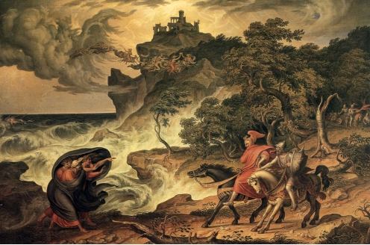
Joseph Anton Koch’s “Macbeth and the Witches”
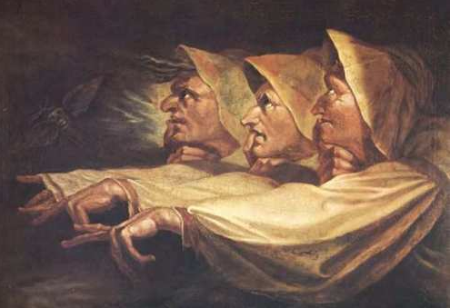
Henry Fuseli’s “The Three Witches”
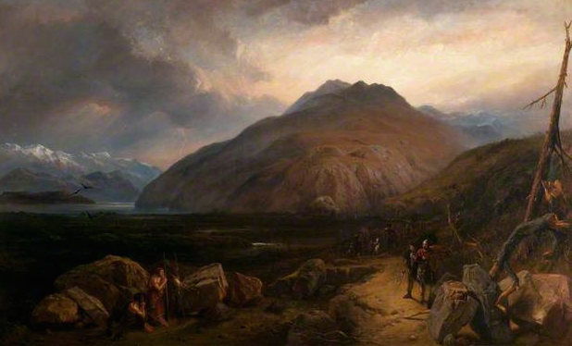
Clarkson Frederick Stanfield’s “Macbeth and the Witches”
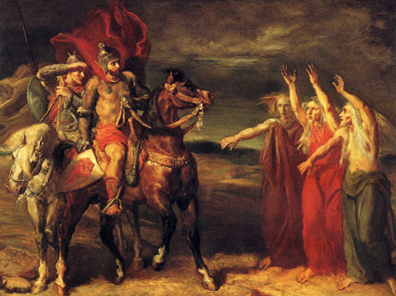
Théodore Chassériau’s “Macbeth and Banquo Meeting the Witches on the Heath”

