Lesson 35
Objective: Count 5, 4, 3, 2, 1 using a story.

Suggested Lesson Structure
 Fluency Practice (6 minutes)
 Application Problem (4 minutes)
 Concept Development (12 minutes)
 Student Debrief (3 minutes)
Total Time (25 minutes)
Fluency Practice (6 minutes)
- Counting on Fingers PK.CC.3ab (3 minutes)
1
2
3
4
5

- Farmer Brown PK.OA.2 (3 minutes)
Counting on Fingers (3 minutes)
Materials: (S) Stickers for each child’s left pinky
Note: This variation of piano counting prepares students to count the Math Way freely, without the support of a template or reference point such as a table. Perspective is important when demonstrating how to count the Math Way (from left pinky to right pinky). When sitting beside students (both facing the same direction), model the count starting from the left pinky. When facing students, model the count starting from the right pinky, as children tend to mirror the teacher from this perspective. Place a sticker or stamp on each child’s left pinky to help identify the starting point.
T: Say, “It’s almost spring, and all the bears (wiggle fingers) are sleeping inside their dens (make two fists on a surface).” Are all the bears inside the dens?
S: Yes!
T: When spring comes the bears start to wake up and come out of their dens. (Show 1 bear emerging by extending your left pinky finger.) Show on your fingers how many came out.
S: 1 (show their left pinky finger extended).
T: Another bear comes out of the den. (Students extend their ring finger next to their pinky.) How many are out now?
S: 1, 2. 2!
Repeat the story until 3 bears have come out of the cave. This could be a stopping point for today, or proceed to count to 5.
Farmer Brown (3 minutes)
Materials: (T) Growing Up with Ella by Ella Jenkins (optional CD), apple tree, 4 green paper apples
Note: The familiar context of an apple tree, and the repetition in the lyrics facilitates the development of fluency in counting down. Knowing the lyrics better on this second day allows students to devote more of their cognitive energy to the countdown sequence.
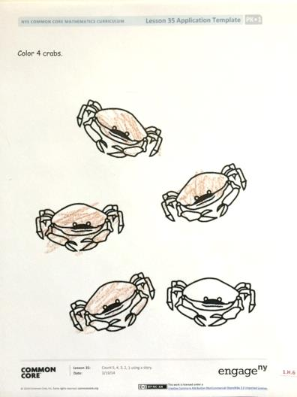
Sing the song as before in Lesson 34, but now start from 4 green apples.
Application Problem (4 minutes)
Materials: (S) Crab coloring page (Template 1)
Tell students, “Five little crabs are swimming in the ocean. Four of them want to swim to the shore. Color 4 crabs.”
Note: The link between drawing and math is important to instill in students from the beginning of their formal math learning. Students may not be ready to draw crabs independently, but by coloring in 4 of the 5 crabs, they practice the fine motor skills needed for future math drawings while counting out a group of 4. In the Debrief, students will notice that they colored 1 less than 5.

NOTES ON
MULTIPLE MEANS
OF ENGAGEMENT:
Send home copies of “Five Little Crabs” to provide students an opportunity to practice with their families. Frequent opportunities for practice promote effort and success.

Concept Development (12 minutes)
Part 1: Concept Introduction
Materials: (T) “Five Little Crabs” (Template 2), 5 crabs (Template 1, cut out), yellow or brown piece of construction paper, blue washcloth, underwater mat (Lesson 15 Template 1)
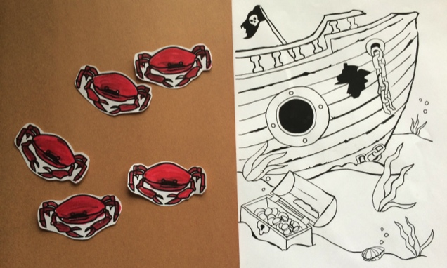
Many songs can be used for this activity, such as “Five Little Ducks Went Out to Play,” “Five Little Monkeys Jumping on the Bed,” and “Five Green and Speckled Frogs.”
1. Put 5 crabs on top of the sand (construction paper) alongside the underwater mat and blue washcloth.
2. Tell students, “Let’s play Five Little Crabs! Let’s count the crabs.” Guide students in counting, “1 crab, 2 crabs, 3 crabs, 4 crabs, 5 crabs. There are 5 crabs.”
3. Act out the first line of the rhyme, using the washcloth as the wave to wash away 1 crab into the water. Have students count the crabs, “1 crab, 2 crabs, 3 crabs, 4 crabs. There are 4 crabs.”
4. Act out the next line, and have students count, “1 crab, 2 crabs, 3 crabs. There are 3 crabs.”
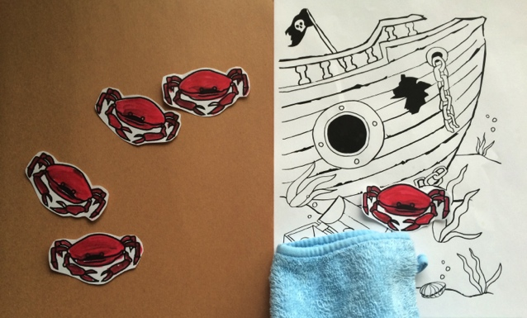
5. Repeat for the remaining verses. Then, show all 5 crabs in the water and have students count down as you put 1 crab at a time back on the shore, “5, 4, 3, 2, 1!”
6. Show 5 fingers lifted, and tell students, “Let’s count down to 1 the Math Way. Your fingers are crabs. Show me the 5 crabs.”
7. Read the rhyme again and for each verse, guide students in folding down 1 finger, starting with the thumb, and ask, “How many are there now?”
Part 2: Practice
Materials: (S) Per pair: piece of yellow or brown construction paper (for the sand), 5 flat counters (crabs)
- Tell students, “Now you get to play Five Little Crabs on your own!” Have partners count out 5 crabs on their mat and say, “1 crab, 2 crabs, 3 crabs, 4 crabs, 5 crabs. There are 5 crabs.”
- Tell students, “Partner A will be the wave and wash away 1 crab at a time. Partner B will touch and count how many crabs are on the sand.”
- Read the first verse as Partner A removes 1 crab and Partner B counts.
- Have partners switch and continue the process to 1, repeating Steps 2–3.
- Have the students see if they can count, “5, 4, 3, 2, 1” while moving the crabs but without saying the unit, crab. Next, see if they can simply say the count without the unit.
- Partners switch roles.
Student Debrief (3 minutes)

CENTER CONNECTION:
Use the dramatic play center as a place for students to dramatize “Five Little Crabs.” Support students if they ask for help reciting the rhyme, but encourage them to tell the story in their own words if they can remember it. For some students, this kinesthetic practice will solidify the idea of counting backwards and help them begin to visualize the pattern of 1 less.

Lesson Objective: Count 5, 4, 3, 2, 1 using a story.
The Student Debrief is intended to invite reflection and active processing of the total lesson experience. It is also an opportunity for informal assessment. Consider taking anecdotal notes or using a simple checklist to note each child’s progress towards meeting the lesson objective.
As students complete the Practice portion of the Concept Development, listen for misconceptions or misunderstandings that can be addressed in the Debrief. You may choose to use any combination of the questions below to help students express ideas, make connections, and explore new concepts.
- How did you count in the “Five Little Crabs” rhyme?
- What is different about counting up from 1 to 5 and counting back from 5 to 1? What is the same?
- (Show Template 1 with 4 crabs colored in.) How many total crabs are there? Did you color 1 more or 1 less than 5? What would it look like if you colored in 1 less than 4? 1 less than 3?
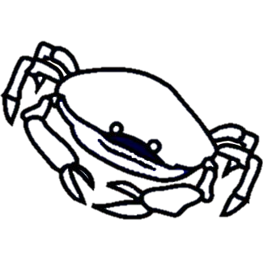
Color 4 crabs.
Five Little Crabs
5 little crabs, wiggling on the shore,
Swoosh went the waves, and then there were 4!
4 little crabs, happy as can be,
Swoosh went the waves, and then there were 3!
3 little crabs, their legs turning blue,
Swoosh went the waves, and then there were 2!
2 little crabs, having lots of fun,
Swoosh went the waves, and then there was 1.
1 little crab, looking all alone,
Swoosh went the waves, and carried him home.

crab coloring page
“Five Little Crabs”

