Lesson 34
Objective: Build descending number stairs at the concrete and pictorial levels.

Suggested Lesson Structure
 Fluency Practice (4 minutes)
 Application Problem (4 minutes)
 Concept Development (14 minutes)
 Student Debrief (3 minutes)
Total Time (25 minutes)
Fluency Practice (4 minutes)
- Snowball Toss PK.OA.2 (4 minutes)
Snowball Toss (4 minutes)
Materials: (S) 8½" × 11" scrap paper cut in quarters
Note: This activity prepares students to compare counting up and counting down and encourages part–whole thinking.
Students make 5 snowballs each from a quarter of a sheet of scrap paper. Conduct the activity as described in Lesson 33, but this time students begin the countdown sequence at 5. Students toss their “snowballs” one by one into the center of the rug at their teacher’s signal, pausing to answer, “How many did you throw?” and “How many are you still holding?” Once the snowballs are thrown, have them calmly go get 5 snowballs and repeat the fun.
Application Problem (4 minutes)
Materials: (T) Growing Up with Ella by Ella Jenkins (optional CD), apple tree, 3 green paper apples
Note: The familiar context of the apple tree and the repetition in the lyrics of the song facilitate the development of fluency in counting down. Learning the lyrics will allow students to devote more of their cognitive energy to the countdown sequence in the future.
Begin with 3 green apples on the tree. Teach students the lyrics, starting from 3. Invite students to act out the story as they sing, showing numbers on fingers while removing a paper apple from the tree.
Farmer Brown had 3 green apples hanging on the tree. (Twice.)
Then, he took 1 apple and he ate it greedily, leaving 2 green apples hanging on the tree.
Farmer Brown had 2 green apples hanging on the tree. (Twice.)
Then, he took 1 apple and he ate it greedily, leaving 1 green apple hanging on the tree.
Farmer Brown had 1 green apple hanging on the tree. (Twice.)
Then, he took 1 apple and he ate it greedily, leaving no green apples hanging on the tree.
Concept Development (14 minutes)
Part 1: Concept Introduction
Materials: (T) 15 pennies, 5–1 staircase mat (Template)
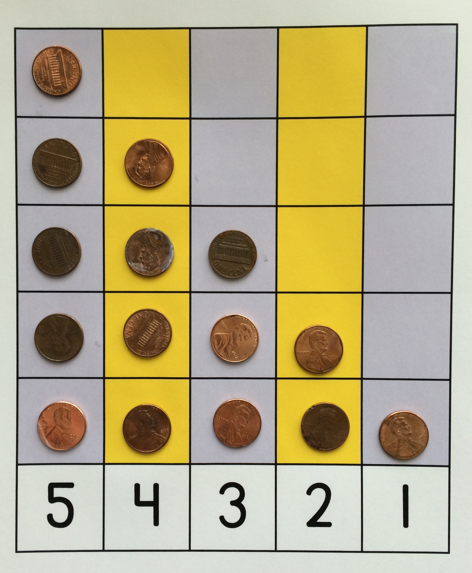
1. Show students the 5–1 staircase mat. Point to the 5 column and ask, “How many pennies should we put here to fill this column?”
2. Guide students to count as you fill in the column. “1 penny, 2 pennies, 3 pennies, 4 pennies, 5 pennies.”
3. Prompt students to think about counting down from 5 to 1 by asking, “Remember the staircase we built for our friend to go downstairs? How can we fill in the pennies to make them look like the staircase for our friend to go down?”
5. Guide students to ideas such as, “Make 1 penny be missing,” “Just have 4 pennies,” “Make an empty space on top,” “Make the next stair 1 less,” etc. Count out 4 pennies in the 4 column as the class counts.
6. Continue this process to number 1. Guide students to see that each column has 1 less penny than the previous column by asking open questions such as, “What is happening to the numbers when we place 1 less penny in each line?”

NOTES ON
MULTIPLE MEANS
FOR ACTION AND EXRESSION:
Offer students a choice to show their understanding of the relationship between the number of objects in the group and the numbers in a variety of ways. For example, students can show their understanding using their fingers, jumps, or hops as they count down from 5 to 1.
MP.7
7. Have students count the number of pennies in each column, “5 pennies, 4 pennies, …1 penny.” Then point to each number and have students count, “5, 4, 3, 2, 1.”

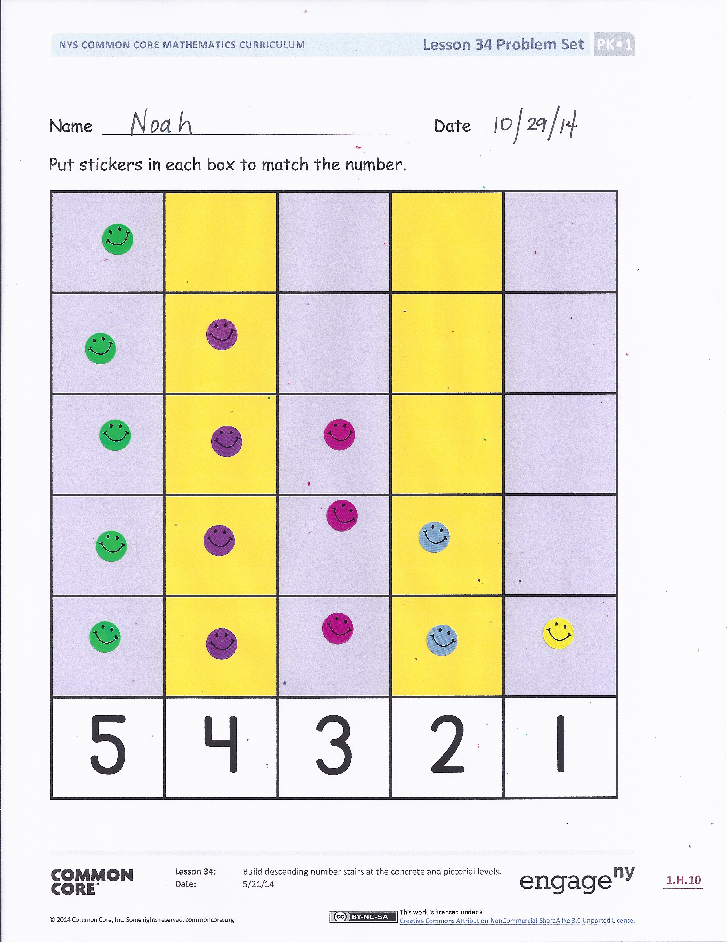
Part 2: Practice
Materials: (S) 15 stickers, Problem Set
Before sending children to prepared tables, model the activity.
1. Tell students, “Let’s make a sticker sheet! Touch and count stickers to fill the number boxes. We’re going to start at 5 and go down to 1.”
2. Ask students how many stickers they should put in the first column.
3. Ask students how many stickers they should put in the next column. If they don’t know, tell them to cover one of the 5 stickers or look at the numeral below.
4. Repeat this questioning to ensure that students understand how to fill in all columns.
5. Guide students to see and talk about the relationship between the size of the sticker groups and the numbers, noticing that the number of stickers in each column is getting smaller.
6. As students complete each column, have them go back to 5 and count, “5 stickers. 5 stickers, 4 stickers. 5 stickers, 4 stickers, 3 stickers,” and so on. Then, invite them to count down without saying the unit, touching and saying the numbers: “5, 4, 3, 2, 1.”
7. Early finishers can cut out the columns and put them in order from left to right from 1 to 5 and then from 5 to 1, counting aloud as they go.
Student Debrief (3 minutes)
Lesson Objective: Build descending number stairs at the concrete and pictorial levels.
The Student Debrief is intended to invite reflection and active processing of the total lesson experience. It is also an opportunity for informal assessment. Consider taking anecdotal notes or using a simple checklist to note each child’s progress towards meeting the lesson objective.

CENTER CONNECTION:
Set up a separate center with different types of small counters for students who need extra practice. Have them use different counters to complete the 5–1 staircase template. Support them as they count backwards.

As students complete the Practice portion of the Concept Development, listen for misconceptions or misunderstandings that can be addressed in the Debrief. You may choose to use any combination of the questions below to help students express ideas, make connections, and use new vocabulary.
- Look at your sticker sheet. How is it like the stairs we made yesterday?
- What happens when we move from 5 to 4 stickers? What is 1 less than 4?
- Let’s use our sticker sheets to count back from 5. (Point and count.) 5 stickers, 4 stickers, 3 stickers, 2 stickers, 1 sticker.

Name Date
Put stickers in each box to match the number.
5 | 4 | 3 | 2 | 1

5 | 4 | 3 | 2 | 1

5–1 staircase mat

