Lesson 32
Objective: Count up: What comes after?

Suggested Lesson Structure
 Fluency Practice (7 minutes)
 Concept Development (15 minutes)
 Student Debrief (3 minutes)
Total Time (25 minutes)
Fluency Practice (7 minutes)
- Show Me 1 More PK.CC.3c (3 minutes)
- The Ants Go Marching PK.CC.3c (4 minutes)
Show Me 1 More (3 minutes)
Note: Children will use their understanding of the 1 more pattern to answer what comes after questions in today’s lesson. Perspective is important when demonstrating how to count the Math Way. When sitting beside students (both facing the same direction) or using the piano mat, model the count starting from the left pinky. When facing students, model the count starting form the right pinky, as children tend to mirror the teacher from this perspective.
Provide piano mats to students who still need the visual support, but encourage most students to try without the template today.
Ask children to show 1 finger the Math Way. Say, “1. 1 more is 2.” Have students repeat as they show 2. Continue the 1 more pattern to 5.
The Ants Go Marching (4 minutes)
Materials: (T) Song sheet for “The Ants Go Marching” with verses through the number 5 (Lesson 29 Fluency Template)
Note: By participating in a story situation in which students join the group one by one, students begin to experience a growth pattern, or a pattern of 1 more in a fun way.
Conduct the activity as before in Lesson 31. Continue the parade to 5 if students have not already done so. Take a moment to acknowledge students’ growth and improvement.

Concept Development (15 minutes)
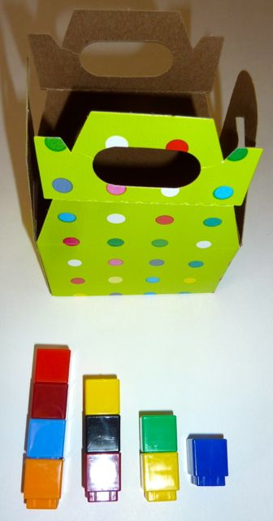
Part 1: Concept Introduction
Materials: (T) Party box, linking cubes connected in towers of 1, 2, 3, and 4
(S) 1 linking cube
- Tell students, “Let’s play a game called What Comes After. Hidden inside this party box are number towers of 1, 2, 3, and 4.”
- Give each student 1 cube. Tell them, “When it is your turn, reach into the box and take out a number tower.
- Choose a student to model. Ask the student to pull a tower out of the box. Ask, “How many are there?” Students count chorally, “1, 2, 3.”
- Emphasize that the last number counted tells how many. Say, “Yes, there are 3 cubes.”
- Have the student put 1 more cube on top of the tower. Use parallel talk: “She is putting on 1 more. Let’s start at 3 and count 1 more.” Students count chorally, “3, 4.”
- Ask, “What comes after 3?” Lead students in saying and repeating, “4 comes after 3!”
- Have the student take back her cube. Put the number tower back in the box. Choose another student and continue to play until all students have had a turn.
Part 2: Practice
Materials: (T) Problem Set, stickers (S) Problem Set, 15 stickers

NOTES ON
MULTIPLE MEANS
OF ENGAGEMENT:
Provide options for a variety of learners. Scaffold strategies from concrete to pictorial to abstract. During Part 2, some students may need to use the linking cubes to help them answer the what comes after question and count the correct number of stickers. Other students will be able to quickly visualize how many stickers they need without touching and counting.
Pair students and send them to prepared tables with their Problem Sets.
- Show students the Problem Set and stickers. Tell them, “Let’s make sticker stairs on this grid!”
- Briefly model the activity, asking, “How many stickers will you put above the number 1?”
- Guide children to put the correct number of stickers above the number 2, putting 1 more than the number in the previous column.
- Guide Partner A to ask, “What comes after 1?”
- Guide Partner B to respond, “2 comes after 1.”
- Continue the process for 3, 4, and 5.
- After partners fill in their grid sheets to show stairs, encourage them to point and say, “2 comes after 1. 3 comes after 2. 4 comes after 3. 5 comes after 4.”
MP.7

Student Debrief (3 minutes)
Lesson Objective: Count up: What comes after?
The Student Debrief is intended to invite reflection and active processing of the total lesson experience. It is also an opportunity for informal assessment. Consider taking anecdotal notes or using a simple checklist to note each child’s progress towards meeting the lesson objective.
As students complete the Practice portion of the Concept Development, listen for misconceptions or misunderstandings that can be addressed in the Debrief. You may choose to use any combination of the questions below to help students express ideas, make connections, and use new vocabulary (after).
- How many cubes did we put on our towers that helped tell us what came after?

CENTER CONNECTION:
Use the party box and cube towers from Part 1 in a center. Have students take turns choosing a tower and telling what comes after.

- How is your sticker sheet the same as the stairs you made yesterday?
- Show your friend what comes after 2 using your sticker sheet. Point to where it shows what comes after 2. Point to where it shows what comes after 4.
- (Show 3 fingers. With students watching, hide them behind your back.) I am going to add 1 more finger. Show me the number of fingers I have now.

Name Date
Put a sticker in each box to match the number.
1 | 2 | 3 | 4 | 5

