Lesson 28
Objective: Count 1, 2, 3, 4, 5 with stories.

Suggested Lesson Structure
 Fluency Practice (6 minutes)
 Application Problem (3 minutes)
 Concept Development (13 minutes)
 Student Debrief (3 minutes)
Total Time (25 minutes)
Fluency Practice (6 minutes)
- Imaginary Piano PK.CC.3a (3 minutes)
- Merry-Go-Round PK.CC.4 (3 minutes)
Imaginary Piano (3 minutes)
Note: This activity prepares students to count the Math Way without the template in the Concept Development.
Conduct the acivity similarly to Counting the Math Way on the Piano in Lesson 27, but now eliminate the piano template. Students count from 1 to 5 starting with the left pinky, moving progressively to the thumb. Invite them to imagine their piano template and see the numerals in their mind as they say the number words. If students have difficulty, practice counting just to 3 today. Continue to 5 in the next lesson.
Merry-Go-Round (3 minutes)
Materials: (S) Paper plates with a dot sticker or line to mark the starting point, 1–5 teddy bear counters, die with 6 replaced by 4 or 5, or numeral cards 1─5 (Lesson 21 Template 2)
Note: Students maintain the skill of counting in circular configurations within a familiar context. If using numeral cards, students become more proficient in numeral recognition and forming quantities to match a numeral.
Last time, in Lesson 21, the teacher rolled the die (or showed a numeral card) and students gave that number of teddy bear counters a ride on the merry-go-round (paper plate). This time, students can practice independently by rolling their own die or selecting a numeral card from a shuffled stack.
Working with numeral cards creates a simple way to differentiate for students who struggle with numeral recognition. Some students can work on 1─5 while others get a deck of cards 1─3, for example.
Application Problem (3 minutes)
Select one student to stand in front of group. “Pretend Ananya is a snake slithering through the desert by herself. How many snakes are slithering through the desert?”
Select another student to come to the front. “James joined Ananya and said, ‘Let’s slither together.’ (Students slither side by side.) How many snakes are slithering through the desert now?”
Continue with 3─5. Each time a friend joins, have them stand side by side. In preparation for the Concept Development, have students think about what happens to the sand when snakes slither through it.
Note: By participating in a story situation in which students join the group one by one, students begin to experience a growing pattern, or a pattern of 1 more in a fun way.
Concept Development (13 minutes)
Part 1: Concept Introduction
Materials: (T) Tray filled with sand
Place a tray filled with sand on the rug, and gather students in a circle to model the activity using the Math Way of counting.
- Tell students to pretend that the teacher’s pinky finger is a snake: “I’m sliding my pinky finger through the sand from the top of the tray to the bottom (like a tally mark) to show Ananya the snake’s path in the sand.”
- Smooth the sand to erase the path. Say, “James joined Ananya, and they slithered together through the desert. How many snakes are slithering through the desert now?”
- Slide two fingers from the left hand (pinky, ring finger) through the sand, from the top of the tray to the bottom (like 2 tally marks) to show two snakes’ paths.
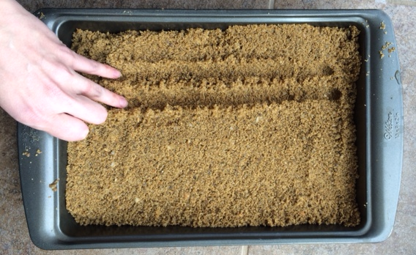
- Continue with 3–5 snakes, modeling how to use the fingers on the left hand only to show the growing group of snakes. Smooth the sand after each turn.
- Say, “We can see how many snakes were slithering just by looking at the lines in the sand. Let’s count the lines.”
- Ask students to count the number of lines each time, e.g., “1 line, 2 lines, 3 lines.” Emphasize that the number of lines equals the number of snakes slithering through the desert.

Part 2: Practice
Materials: (S) Per pair: tray filled with sand
Place a tray filled with sand for each pair of children at tables.

NOTES ON
MULTIPLE MEANS
FOR ACTION AND EXPRESSION:
Sliding fingers in the sand may be challenging for some students. Encourage students who are having difficulty to use any correct combination of fingers. If students are having difficulty, provide opportunities to practice counting the Math Way during another time of the day.
- Pair students and tell them that they are going to pretend some snakes are slithering through the desert, beginning with 1.
- Instruct Partner A to slide 1 finger through the sand using his or her left hand (i.e., the Math Way). Ask your partner, “How many snakes are slithering through the desert?”
- Partner B counts the number of “tally marks” through the sand. Guide Partner B to respond in a complete sentence: “One snake is slithering.”
- Partner A smooths the sand, and partners switch roles. Another snake joins in, and now 2 snakes are slithering on the beach. Partners follow Steps 2–3.
- As the students work, circulate and describe what they are doing using parallel talk: “Dustin is sliding 3 fingers through the sand. He is pretending that 3 snakes are slithering through the sand.”
Student Debrief (3 minutes)
Lesson Objective: Count 1, 2, 3, 4, 5 with stories.
The Student Debrief is intended to invite reflection and active processing of the total lesson experience. It is also an opportunity for informal assessment. Consider taking anecdotal notes or using a simple checklist to note each child’s progress towards meeting the lesson objective.
As students complete the Practice portion of the Concept Development, listen for misconceptions or misunderstandings that can be addressed in the Debrief. You may choose to use any combination of the questions below to help students express ideas, make connections, and use new vocabulary.

CENTER CONNECTION:
Invite children to continue showing snakes slithering in the sensory center. They can practice sliding their fingers through different materials (e.g., oatmeal, shaving cream, finger paint) to represent snakes, lizards, or anything that catches their imagination.

- Can you show me the 5 snakes on your fingers?
- Show me 1 snake on your finger. Show another snake. How many snakes do you have now? How many paths would your snakes make?
- How would your counting be different if your story started with 5 snakes and the snakes went home one at a time?

