Lesson 27
Objective: Play a game involving numbers to 5.

Suggested Lesson Structure
 Fluency Practice (5 minutes)
 Application Problem (3 minutes)
 Concept Development (14 minutes)
 Student Debrief (3 minutes)
Total Time (25 minutes)
Fluency Practice (5 minutes)
- Counting the Math Way on the Piano PK.CC.3a (2 minutes)
- Mix and Match with Dots and Numerals PK.CC.2 (3 minutes)
Counting the Math Way on the Piano (2 minutes)
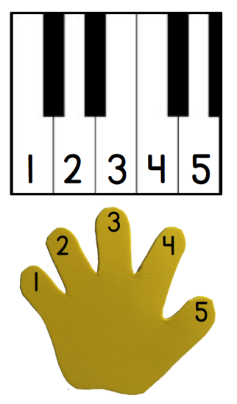
Materials: (T) Stickers (for students who still need them) (S) Piano mat with numerals (Lesson 23 Fluency Template)
Note: In addition to internalizing the number line, students now learn to associate a numeral with each finger by using the numeral version of the mat. This new variation of counting on the piano anticipates the work with 1 more (Topic G) by connecting a higher pitch voice with the growing numbers.
Conduct the activity as described in Lessons 23 and 24, but now have students start out in a low-pitch voice, and get a little higher as they say each number: 1 would be the deepest pitch, 3 would be a regular pitch, and 5 would be the highest, squeakiest pitch. As you give the directions, it is helpful to say the numbers in the pitch that you are indicating, in case students are unsure of the meanings of the descriptors.
Remove the piano mat for students who are able to drop their fingers and count independently.
Mix and Match with Dots and Numberals (3 minutes)
Materials: (T) Music (optional) (S) Numeral cards 1–5 (Lesson 21 Template 2), dot cards 1–5 (Lesson 16 Template 2)
Note: This activity gives students a preview of today’s work matching dots and numerals so that they can be successful in playing the game.
- Distribute one dot or numeral card to each child.
- Start the music, if using it. Students wander about the room, scanning for a student who has the numeral or dot card that matches their own.
- Stop the music, or give a signal. Students whose cards match link arms. Check to ensure all matches are correct.
- Have students trade their cards with another student, then play again.
If class size is large, play the game in rotations. While one group is participating have the remaining students act as teacher’s helpers, observing and confirming matches with a thumbs up. Choose the most advanced students to participate first, and struggling learners last. That way they will have had one or more times to observe.
Application Problem (3 minutes)
Materials: (S) Baggie containing a representation of either 1, 2, 3, 4, or 5 (e.g., 3 bear counters, picture of 2 cows, foam numeral 5)
Distribute a bag to each student and have the group sit in a large circle. Give children a short period of time to explore the contents of their bags. If students have a bag that shows 1, ask them to stand and show the contents of their bag to the class. Repeat with numbers 2─5.
Note: This activity gives students another opportunity to see different ways of showing numbers 1─5. Students will see similar representations in the bingo game.
Concept Development (14 minutes)

NOTES ON
MULTIPLE MEANS
OF ENGAGEMENT:
Provide boards that match the teacher’s enlarged example to students who need extra support to understand the game.

Part 1: Concept Introduction
Materials: (T) Large bingo board on chart paper (Template 1), chips, numeral cards 1–5 (Lesson 21 Template 2)
(S) Bingo board (Template 1), baggie with chips
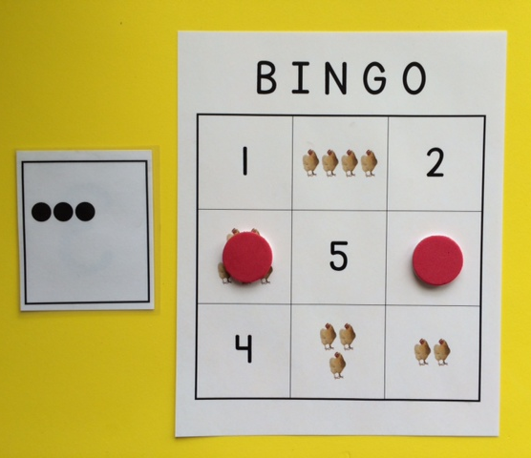
- Distribute a bingo board and baggie with chips to each student. Place a large bingo board in the center of the carpet. “Let’s play bingo! What do you see on your bingo board?”
- Guide students to see different representations of the numbers 1–5. Explain that they should say “Bingo!” when they have three chips in a row.
- Choose a numeral card. Say, “I chose the number 4, so you put your chip on a space that has the same number of objects.” Invite a volunteer to place a chip on the large bingo board. Have students do the same on their boards.
- Choose a dot card. “I chose this many dots, you put your chip on the number that matches.” Invite a volunteer to place a chip on the matching numeral on the large bingo board. Have students do the same on their boards.
- Continue to select cards and demonstrate on the large board. Monitor student boards to help them say, “Bingo!”
Part 2: Practice

NOTES ON
MULTIPLE MEANS
OF ENGAGEMENT:
If students need an extra challenge, create boards with 4 rows and 4 columns. Change the rules so that these students must get 4 in a row to win the game.

Materials: (T) Numeral cards 1–5 (Lesson 21 Template 2)
(S) Bingo board (Templates 1–5)
- Have students pass their board to the person on the right. Remove the teacher model, and play again.
- Watch as children play, occasionally pointing out strategic choices on their boards.
- Each time bingo is called, point out the different ways a line of 3 chips can look (vertical, horizontal, or diagonal).
Student Debrief (3 minutes)
Lesson Objective: Play a game involving numbers to 5.
The Student Debrief is intended to invite reflection and active processing of the total lesson experience. It is also an opportunity for informal assessment. Consider taking anecdotal notes or using a simple checklist to note each child’s progress towards meeting the lesson objective.
As students complete the Practice portion of the Concept Development, listen for misconceptions or misunderstandings that can be addressed in the Debrief. You may choose to use any combination of the questions below to help students express ideas, make connections, and use new vocabulary.
- (Choose a numeral card.) Which box on your bingo board matches this number? Is it the same box as your friends’? Are there the same number of (e.g., apples and chickens) in that box?

CENTER CONNECTION:
Give children an opportunity to continue playing the game during centers. One student can take on the role of the teacher, picking a card and calling out the number. Children who are ready can even create their own game boards.

- Which numbers on your bingo board were the hardest to find? Why?
- Did you feel lucky sometimes? Did you feel unlucky sometimes? Why or why not?

B I N G O
5 |  | 3
 | 4 | 1
2

B I N G O
 | 4
 | 3 | 1
5 | 2

B I N G O
 | 3
2 | 5 | 1
 | 4
B I N G O
1 |  | 2
 | 5 | 3
4

B I N G O
1 |  | 2
 | 5 | 3
4

bingo board
bingo board
bingo board
bingo board
bingo board

