Lesson 24
Objective: Look at a numeral and count out a group of objects to match (abstract to concrete).

Suggested Lesson Structure
 Fluency Practice (6 minutes)
 Application Problem (4 minutes)
 Concept Development (12 minutes)
 Student Debrief (3 minutes)
Total Time (25 minutes)
Fluency Practice (6 minutes)
- Counting the Math Way on the Piano PK.CC.3a (3 minutes)
- Baggie Buddies PK.CC.2 (3 minutes)
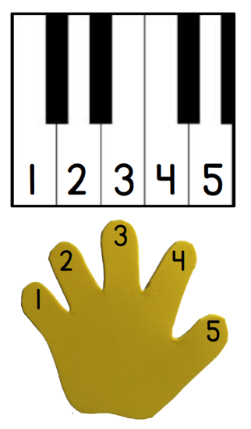
Counting the Math Way on the Piano (3 minutes)
Materials: (T) Stickers (for students who still need them) (S) Piano mat with numerals (Lesson 23 Fluency Template)
Note: In addition to internalizing the number line, students now learn to associate a numeral with each finger by using the numeral version of the template. This variation of counting on the piano anticipates the work with 1 more (Topic G) by connecting an increase in the volume of voices as students count with numbers getting larger.
Conduct activity as described in Lesson 23, but now have students get a little louder as they count: 1 starts as a whisper, 3 would be a classroom voice, 5 would be a shout. As a variation, take away the template and try again.
Baggie Buddies (3 minutes)
Note: This fluency activity maintains students’ ability to match quantities with numerals to 5.
As before in Lesson 14, the teacher shows a group of objects. Students answer a how many question and retrieve the correct numeral from their bag, but now the activity includes numerals to 5.

Application Problem (4 minutes)
Materials: (T) Numeral cards 1─5 (Lesson 21 Template 2) (S) 6 craft sticks
Tell students they are going to be cooking sausages at Sam’s Sausage Shack. Give each student a set of craft sticks and say that they are sausages. Show the students 3 fingers and ask them, “Here are 3 hungry people. How many sausages does Sam need to cook so everybody can have 1?” Ask them to lay down exactly the number of sticks (sausages) that are needed. Select one student to show the matching numeral. Repeat the process with numbers of sausages up to 5.
Note: This activity asks students to count a group of sticks to match different representations of the numbers 1–5. Such practice helps deepen their understanding of cardinality, as they see that the same number can be represented in different ways. They discuss how the representations are related in the Debrief.
Concept Development (12 minutes)
Part 1: Concept Introduction
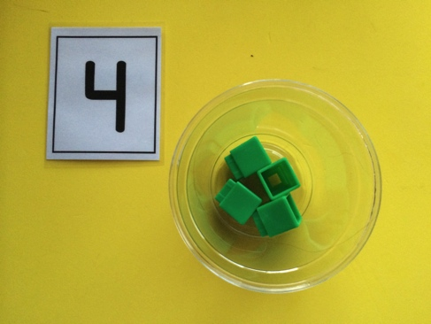
Materials: (T) 8 cubes, numeral cards 1─5 (Lesson 21 Template 2),
1 clear plastic cup
- Tell students that they are going to be waiters and waitresses, serving drinks in a restaurant. Invite a child (waiter) forward to select a numeral card, showing it to the class. Ask all students to name the number. This number represents the number of ice cubes (linking cubes) needed in each drink.
- Count out that number of cubes using self-talk to describe your thinking, e.g., “I’ll make a group of 4 ice cubes. I’ll count and stop when I get to 4: 1 (drop one cube into cup), 2 (drop second cube), 3 (drop third cube), 4 (drop fourth cube). Stop.”

NOTES ON
MULTIPLE MEANS
OF REPRESENTATION:
For students who are struggling with counting a group of objects using one-to-one correspondence, provide a variety of scaffolds. Some students will need hand over hand guidance to ensure one-to-one correspondence. Kinesthetic learners might benefit from pairing the numeral with the same number of jumps, stomps, or finger taps before counting out the group of cubes.

- Ask students if the group matches the number. If they are unsure, show how to match the cubes to the dots on the back of the card.
- Repeat with another number. Encourage students to say, “Stop!” when they hear the target number.
- Silently show the number 5. Invite a child forward to count out a group of 5 ice cubes. Repeat with numerals 1–4.

Part 2: Practice
Materials: (S) Baggie containing 8 cubes, numeral cards 1–5, clear plastic cup
- Pair students and send them to prepared tables as waiters and waitresses.
- Tell Partner A to take a card from the stack and show the number without saying it. Tell Partner B to make a group of that many ice cubes. Then, partners switch roles.
MP.6
- Encourage students to use the dots on the back of the cards if they need help remembering.
- As the students work, circulate and describe what they are doing using parallel talk, e.g., “Gianna saw the number 4, so she is counting a group of 4 ice cubes.”
Student Debrief (3 minutes)
Lesson Objective: Look at a numeral and count out a group of objects to match (abstract to concrete).
The Student Debrief is intended to invite reflection and active processing of the total lesson experience. It is also an opportunity for informal assessment. Consider taking anecdotal notes or using a simple checklist to note each child’s progress towards meeting the lesson objective.
As students complete the Practice portion of the Concept Development, listen for misconceptions or misunderstandings that can be addressed in the Debrief. You may choose to use any combination of the questions below to help students express ideas, make connections, use new vocabulary, and explore new concepts.
- (Show the numeral 5.) I want to make a group of this many. How many cubes should I put in my group? (Repeat with 1–4.)

CENTER CONNECTION:
Use the kitchen center to make groups like in Lesson 23. Today, have the “diners” use numeral cards to show the number of vegetables they want instead of dot cards.

- (Show 4 cubes, 4 sticks, the dot configuration for 4, and the numeral 4.) Which of these tells how many cubes I have? (Help students realize that all of these represent the quantity 4.)
- (Show a numeral card.) Can you make a group of this many objects at home? What would be in your group?

