Lesson 23
Objective: Make a group of up to 5 objects and match the numeral (concrete to abstract).

Suggested Lesson Structure
 Fluency Practice (6 minutes)
 Application Problem (3 minutes)
 Concept Development (13 minutes)
 Student Debrief (3 minutes)
Total Time (25 minutes)

Fluency Practice (6 minutes)
- Counting the Math Way on the Piano PK.CC.3a (3 minutes)
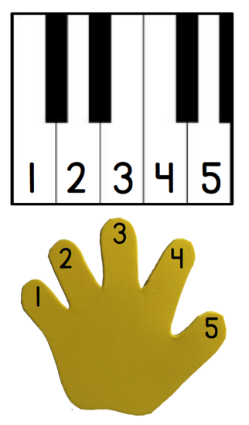
- Hop-Hop PK.CC.2 (3 minutes)

Counting the Math Way on the Piano (3 minutes)
Materials: (T) Stickers (for students who still need them) (S) Piano mat with numerals (Fluency Template)
Note: In addition to internalizing the number line, students now learn to associate a numeral with each finger by using the numeral version of the template.
Distribute templates and give students a moment to notice what is different about the piano mat (it now has numerals). It may be necessary to ask some guiding questions. Acknowledge their improvement, and invite them to celebrate with silent applause before starting the counting exercise.
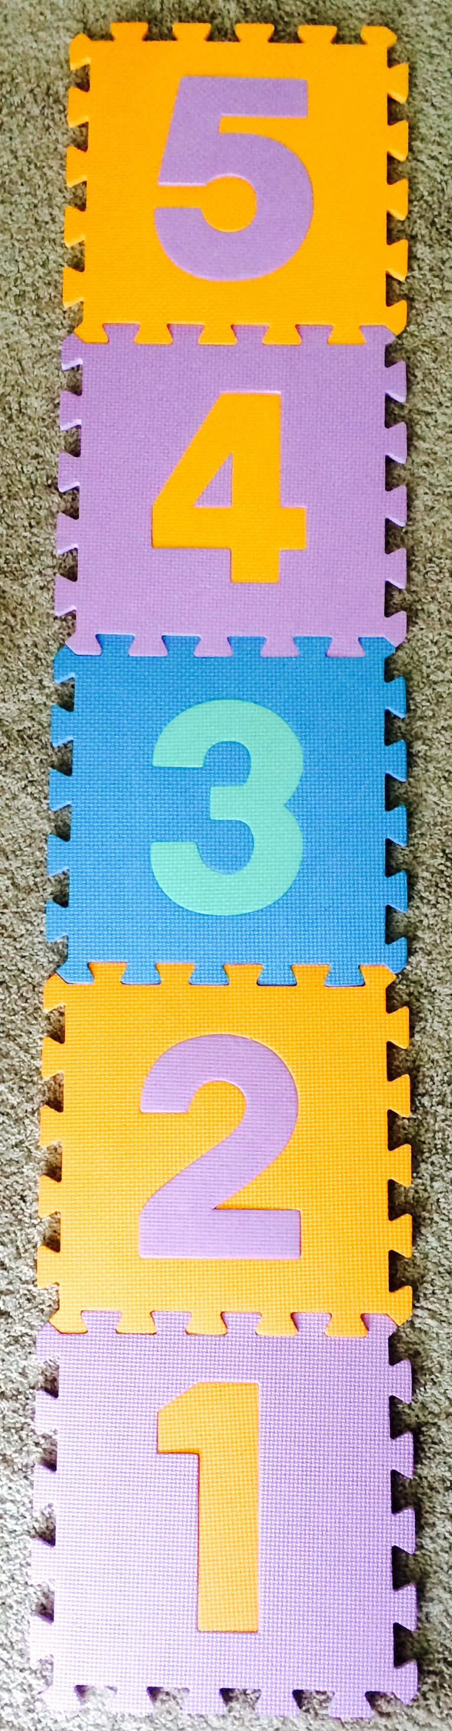
As students count 1, have them drop their left pinky on the piano. Continue to 5.

Hop-Hop (3 minutes)

Materials: (T) Hopscotch mat to 5, bean bag
Note: This fluency activity is intended to maintain students’ ability to count and match quantities with numerals to 5. Using the numbered hopscotch mat allows students to see numbers along a trajectory.
This is similar to Lesson 22, but with a hopscotch mat to 5. Invite students to notice what is different about today’s activity from yesterday’s (guide children in recalling yesterday’s activity).
Have a student toss the bean bag onto the mat. All students say the number and hop that number of times.

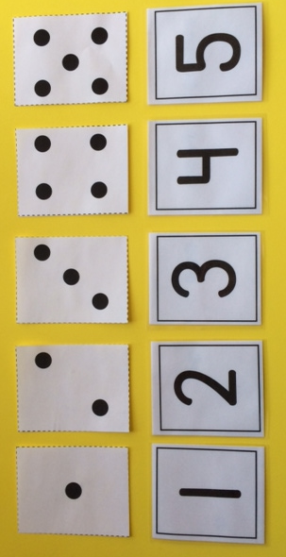
Application Problem (3 minutes)
Materials: (T) Dot cards 1─5 (dice configuration, Lesson 16 Template 2) (S) Baggie with numeral cards 1─5 (Lesson 21 Template 2)
Hold up a dot card showing 1, 2, 3, 4, or 5 (one at a time) and ask the students, “Which matches this number of dots?” Have students find the matching number card in their bag and hold it up. Make sure to say the number so they can hear it and visualize the dots while matching the numeral. Ask students to then look around the classroom for objects to count and find the matching numeral (e.g., 2 doors, 5 windows).
Note: This Application Problem reviews the numerals learned in the last lesson, which students will use in the upcoming Concept Development.

Concept Development (13 minutes)

Part 1: Concept Introduction
Materials: (T) 7 cotton puffballs, 7 craft sticks, die with dots 1─5 (place tape over one of the dots on the 6 face), foam numerals or numeral cards 1–5 (Lesson 21 Template 2)
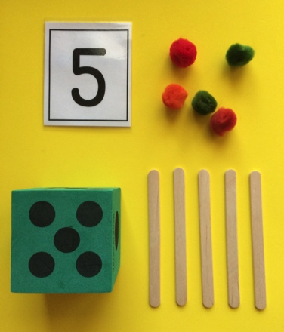
1. Display the numerals 1, 2, 3, 4, and 5.
2. Roll the die and ask students, “How many dots do you see?”
3. Example after students respond:
- Touch and chorally count each dot, “1, 2, 3, 4, 5.”
- Have students point to the matching numeral.
- Have students count as you lay down 5 puffballs.
- Ask students, “How many puffballs are in this group?” Lead them to respond, “There are 5 puffballs.”
- Have students count as you lay down 5 sticks.
- Ask students, “How many sticks are in this group?” Lead them to respond, “There are 5 sticks.”
4. Guide students to see that what is the same about the dots, the group of puffballs, and the group of sticks is the number 5; the number 5 tells how many objects are in each group.
Part 2: Practice
Materials: (S) Per pair: tray with 7 cotton puffballs, 7 craft sticks, die with dots 1─5, foam numerals or numeral cards 1–5 (Lesson 21 Template 2)
- Pair students and send them to tables with a tray.

NOTES ON
MULTIPLE MEANS
OF ENGAGEMENT:
In order to sustain effort and persistance, adjust the lesson structure for the needs of the students. Some students may need to move forward in small steps with frequent opportunities for practice. Others are ready for the challenge of a more open-ended task.

- Instruct students to take turns rolling the die, counting how many, and making groups with the same number of puffballs and sticks.
- Instruct students to pick up the matching numeral and say the number.
MP.6
- Encourage students to ask and answer how many questions. Circulate and use parallel talk: “I hear Aleem asking, ‘How many sticks are in your group?’”
- Check that the number in each group matches the dot configuration and numeral and that students are moving their puffballs and sticks into new groups as they count.

Student Debrief (3 minutes)
Lesson Objective: Make a group of up to 5 objects and match the numeral (concrete to abstract).
The Student Debrief is intended to invite reflection and active processing of the total lesson experience. It is also an opportunity for informal assessment. Consider taking anecdotal notes or using a simple checklist to note each child’s progress towards meeting the lesson objective.
As students complete the Practice portion of the Concept Development, listen for misconceptions or misunderstandings that can be addressed in the Debrief. You may choose to use any combination of the questions below to help students express ideas, make connections, use new vocabulary, and explore new concepts.

CENTER CONNECTION:
The kitchen center is a perfect place to practice making groups of 5 or less. The “diners” can show how many vegetables they want by showing a foam numeral. The “chef” can count out the right number of vegetables for each salad using the numeral to match.
Look for opportunities for children to make groups of 5 or fewer in centers supporting thematic units.

- What tools did we use to count in our lesson today?
- How did you know how many puffballs or sticks to put in a group?
- (Show student tray with die showing 4 dots, 4 sticks, and 5 puffballs.) Let’s look at David and Reese’s work. What number tells how many should be in each group? Do the number of sticks and puffballs match the dots? (Lay the puffballs on top of the dots, if needed.)
- What differences do you see between the shapes of the numbers 4 and 5? Do they both have straight lines? Curves?

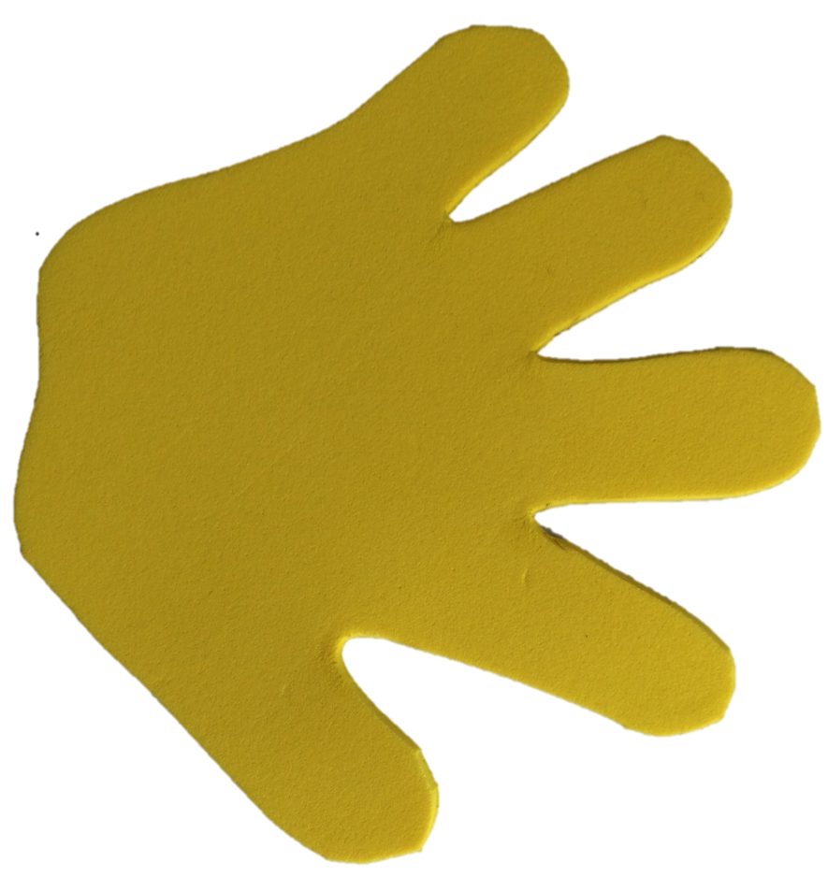
1
2
3
4
5
1
2
3
4
5

piano mat with numerals

